

**BUDT703:** Database Management Systems

**TEAM MEMBERS:** Shriya Goyal, Megha Mudigonda, Rasika Pande, Devika Raheja

**MENTOR:** Prof. Adam Lee

**Team OnTrack Analytics**

**Mission Statement:**

Our mission is to analyze Amtrak's on-time performance over the past three fiscal years to uncover key insights into travel trends, identify growth opportunities, and develop strategies for enhancing ridership across the network

**Mission Objectives:**

* To analyze the on-time performance of states over a three-year period (2021, 2022, 2023) and determine which states consistently perform the best
* To analyze the relationship between ridership levels and Amtrak Guest Rewards enrollment to understand loyalty trend alignment with passenger volume
* To examine the relationship between staffing and on time performance reliability by analyzing employment trends in high-performing states.
* To evaluate the correlation between budget allocations and ridership levels at different stations to ensure resource efficiency.

**OnTrack Analyst:**

OnTrack Analytics is a consultant group with 4 employees, commissioned by the Amtrak team to create a database to analyze the performance over the years. Amtrak is responsible for passenger rail service, route management, and operational planning across the United States.

**Business terms, Facts and Identifiers:**

* Each station city is described by a unique stationCityCode and stationCityName, which are associated with a specific state using stateCode.
* Amtrak tracks budget planning for each station city. Each budget is identified by its type (design, construction and deployment) and includes attributes such as the year of allocation, the allocated amount, the planned budget for the next year, and the total utilized amount for that year.
* Procurement expenditures are recorded annually for each station city, described by the year and the total expenditure for that year.
* Ridership statistics are tracked yearly for each station city and include the total number of passengers for that year.
* Each state is identified by a unique state code and its name, representing the states where Amtrak operates.
* Each train route is identified by a unique route ID, and further described by the route type, frequency, starting station, and ending station and state code, representing the state where the route primarily operates.
* Amtrak tracks on-time performance for each route annually as a percentage of trains that arrived on time.
* Employment data is recorded yearly, including the total number of employees and the total wages paid during that year.
* Amtrak also tracks rewards issued to customers for loyalty programs in each state, recorded annually with the total rewards issued for that year.
* Amtrak maintains a route mapping system where a route can go through multiple states, and a single state can be associated with multiple train routes. This relationship is tracked using stateCode and routeID

**ERD Diagram:**

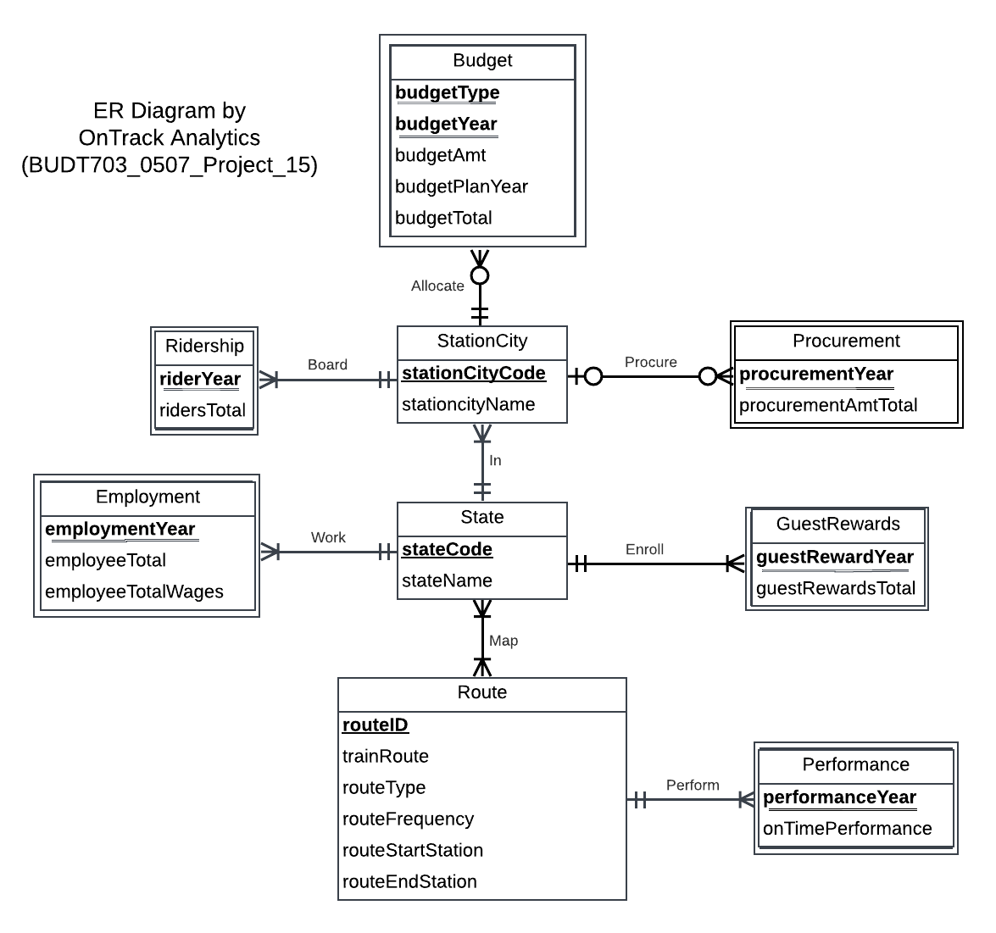

**Relational Schema:**

State(**stateCode**, stateName)

StationCity(**stationCityCode**, stationCityName, *stateCode*)

Route(**routeID**, trainRoute routeType, routeFrequency, routeStartStation, routeEndStation*)*

Performance*(****routeID*,** **performanceYear**, onTimePerformance)

Map(***stateCode , routeID***)

Employment(***stateCode***, **employmentYear**, employeeTotal, employeeTotalWages)

GuestRewards(***stateCode***, **guestRewardsYear**, guestRewardsTotal)

Ridership(***stationCityCode***, **riderYear**, ridersTotal)

Procurement(***stationCityCode***, **procurementYear**, procurementAmtTotal)

Budget(***stationCityCode***, **budgetType**, **budgetYear**, budgetAmt, budgetPlanYear, budgetTotal)

**Business Rules for relational integrity:**

**Business Rules:**

[R1] If a state is deleted, no action will be taken for associated station cities, meaning cities in that state will remain with the existing state information

[R2] If a state code is updated, the related station city records should reflect the change to maintain consistency

[R3] If a state is deleted, all associated employment records should be deleted (CASCADE), as employment data in that state is no longer valid.

[R4] If a state code is updated, the related employment records should also update to reflect this change.

[R5] If a state is deleted, the station state field in related guest rewards records will remain unchanged.

[R6] If a state code is updated, the related guest rewards records should also update to reflect this new state code.

[R7] If a station city is deleted, all ridership records for that city should be deleted (CASCADE) because they are dependent on the city’s existence.

[R8] If a city code is updated, the related ridership records should also update to maintain consistency with the new city code.

[R9] If a station city is deleted, all procurement records related to that city are deleted (CASCADE), as they are directly tied to the city’s operations.

[R10] If a city code is updated, the related procurement records should also update to reflect the change.

[R11] If a station city is deleted, the associated budget records will also be deleted, as budget allocations are specific to the station.

[R12] If a city code is updated, the related budget records should also update to reflect the new city code.

[R13] If a route is deleted, the associated performance will also be deleted, as performance is specific to the route.

[R14] If a route is updated, the related performance should also be updated to reflect the efficiency of the new route.

[R15] If a route is deleted, associated map entries are not to be deleted to maintain data integrity and prevent loss of related information.

[R16] When a route’s information is updated, the associated map entries must reflect the updated routeID

[R17] State cannot be deleted if it has associated map entries (NO ACTION) to ensure data integrity.

[R18] When a state’s information is updated, the associated map entries must reflect the updated stateCode

**Referential Integrity Actions:**

| **Relation** | **Foreign Key** | **Base Relation** | **Primary Key** | **Business Rule** | **ON DELETE** | **Business Rule** | **ON UPDATE** |
| --- | --- | --- | --- | --- | --- | --- | --- |
| StationCity | stateCode | State | stateCode | R1 | NO ACTION | R2 | CASCADE |
| Employment | stateCode | State | stateCode | R3 | CASCADE | R4 | CASCADE |
| GuestRewards | stateCode | State | stateCode | R5 | NO ACTION | R6 | CASCADE |
| Ridership | stationCityCode | StationCity | stationCityCode | R7 | CASCADE | R8 | CASCADE |
| Procurement | stationCityCode | StationCity | stationCityCode | R9 | CASCADE | R10 | CASCADE |
| Budget | stationCityCode | StationCity | stationCityCode | R11 | CASCADE | R12 | CASCADE |
| Performance | routeID | Route | routeID | R13 | CASCADE | R14 | CASCADE |
| Map | routeID | Route | routeID | R15 | NO ACTION | R16 | CASCADE |
| Map | stateCode | State | stateCode | R17 | NO ACTION | R18 | CASCADE |

**Sample Table Data View:**

* ***STATE TABLE:***

Sample Data:

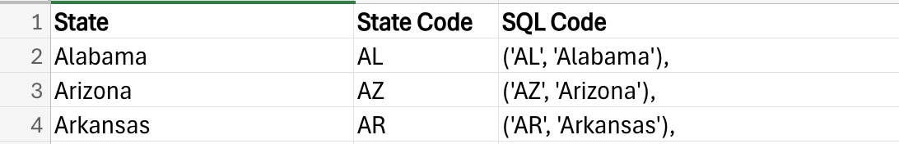

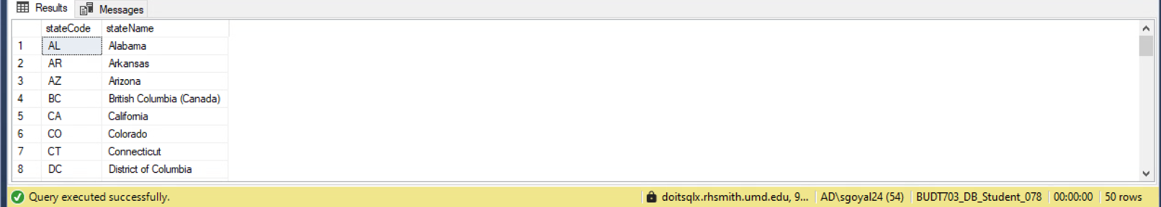

* ***STATION-CITY TABLE:***

Sample Data:

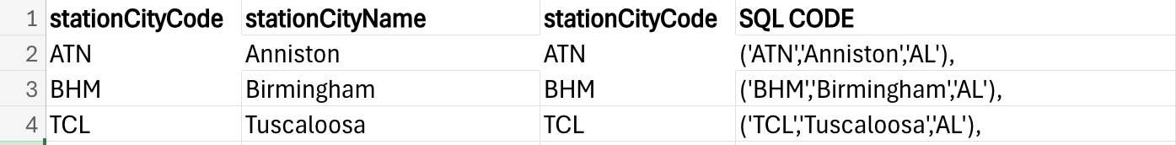

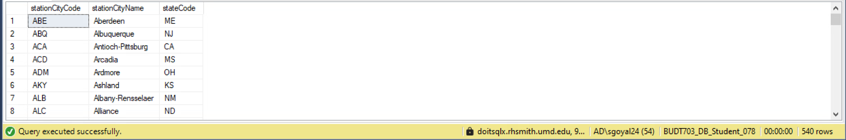

* ***ROUTE TABLE:***

Sample Data:



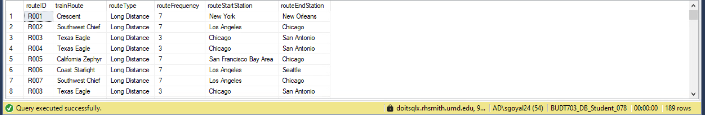

* ***PERFORMANCE TABLE:***

Sample Data:

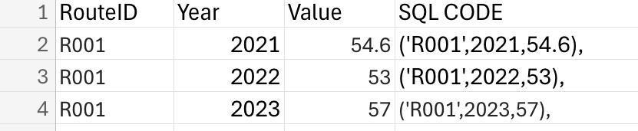

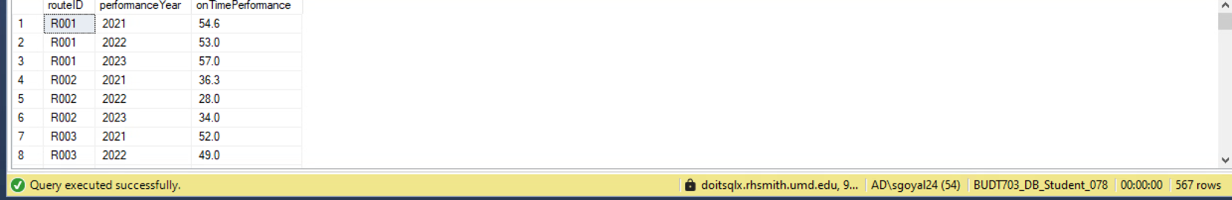

* ***MAP TABLE:***

Sample Data:

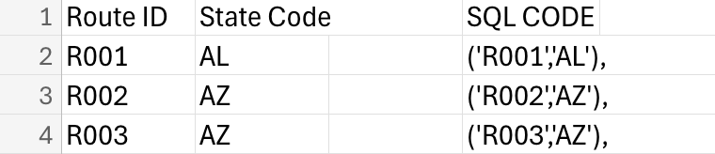

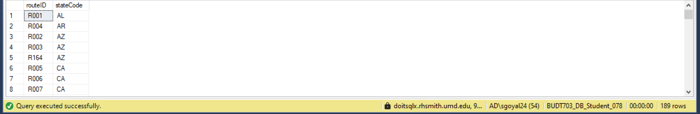

* ***EMPLOYMENT TABLE:***

Sample Data:

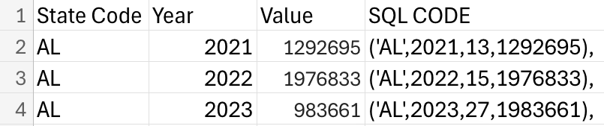

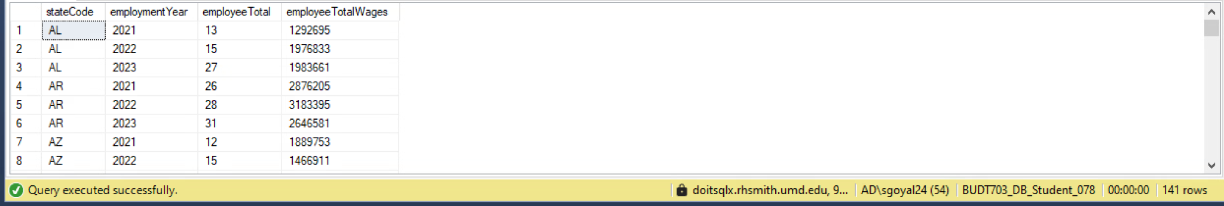

* ***GUEST REWARDS TABLE:***

Sample Data:

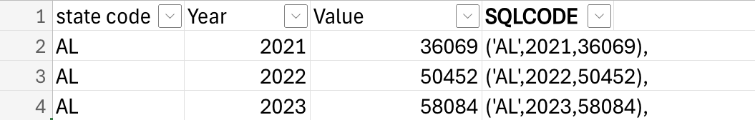

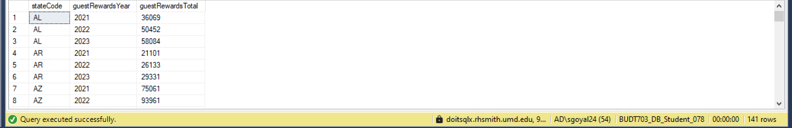

* ***RIDERSHIP TABLE:***

Sample Data:

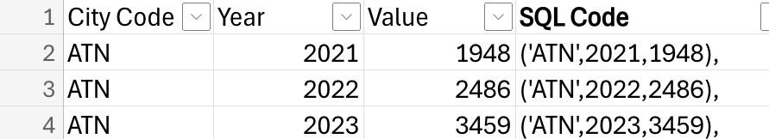

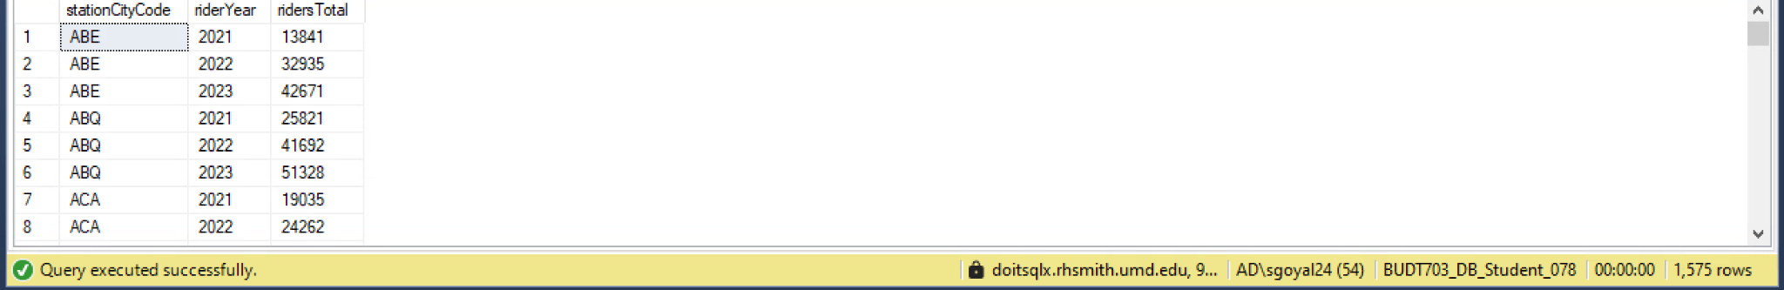

* ***PROCUREMENT TABLE:***

Sample Data:

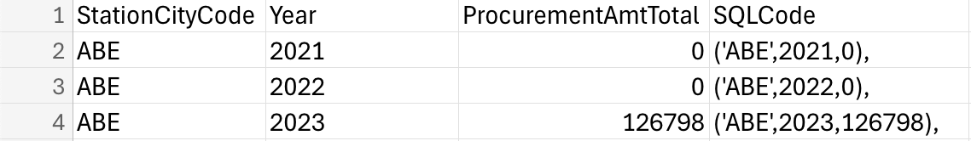

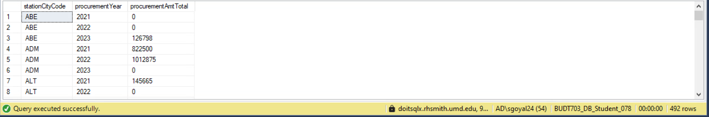

* ***BUDGET TABLE:***

Sample Data:



