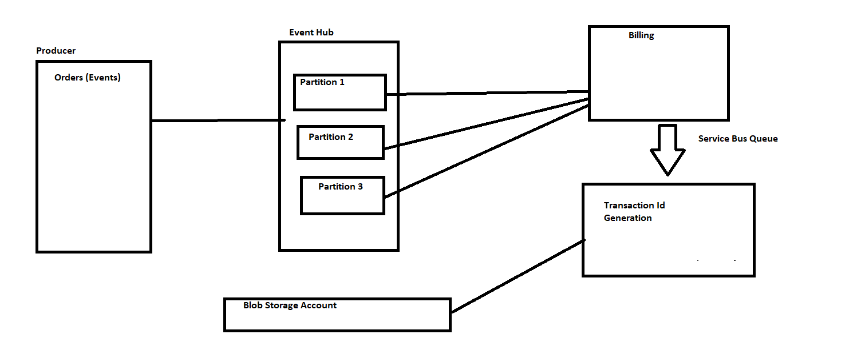

Here this diagram is a scenario of online order and transaction ID generation after payment.

At first ,there are events which is assumed here for some orders. Since Event hubs can process large amount of events at single time. So all the orders or the events are going to the event hub .In event hub there are partitions in which the events are stored .In this partitions the information about the events can last for 7 days. Now from event hub with the help of consumer group all the information is passed on to the receiver which is assumed to be billing here. Now from billing we will have a service bus queue which helps to pass information in FIFO manner and we can use service bus queue trigger that helps in generation of transaction IDs in the same manner. Now This transaction Id’s needs to be stored for a longer period of time .So we can use blob storage (blob append storage) which helps in storing all these transaction IDs for a longer run time.