**R&D R&D Report on IP Addressing and Subnetting  
*Including IPv4, IPv6, CIDR Notation, and Host Calculations***

Prepared by:

Virat Pandey

Celebal Technology

Cloud Infrastructure & Security Internship

Research & Development Document

June 15, 2025



# **Table of contents**

1. Introduction
2. Overview of IP Addressing
3. IPv4 Addressing  
     3.1 Classes and Ranges  
     3.2 Subnet Masks & Default (Natural) Masks  
     3.3 CIDR Notation  
     3.4 Subnetting IPv4 (with Examples)  
     3.5 Usable and Total Host Calculations
4. IPv6 Addressing  
     4.1 IPv6 Format and Features  
     4.2 IPv6 Subnetting and CIDR
5. Comparison: IPv4 vs IPv6
6. Real-World Use Cases & Importance in Cloud Networking
7. Conclusion
8. References



# **Introduction**

Every device that connects to a network — whether it’s a smartphone, virtual machine, web server, or IoT sensor needs a **unique identifier** to communicate. That identifier is known as an **IP address (Internet Protocol address)**. In modern networking, **IP addressing** and **subnetting** form the foundation of how devices are logically organized, located, and managed across local and global networks.

This report explores both **IPv4 and IPv6 addressing**, their formats, usage, and the critical process of **subnetting**, which allows networks to be broken into smaller, manageable parts. Through subnetting, administrators can **efficiently allocate IP ranges**, improve performance, and enforce security boundaries a key requirement in cloud networking and enterprise infrastructures.

Understanding how to work with **subnet masks, CIDR notation**, and calculate **usable hosts** within a subnet is not just theoretical it’s a practical skill used in **cloud infrastructure design, firewall configuration, VPN planning, and network automation.**

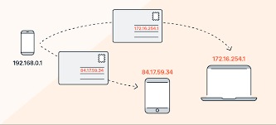This R&D report provides a detailed yet practical explanation of IP addressing concepts and subnetting techniques, enabling you to plan and create subnets, calculate host ranges, and transition between IPv4 and IPv6 environments confidently.

# **Overview of IP Addressing**

**IP addressing** is a method used to assign unique identifiers to devices on a network. These addresses help systems locate each other and exchange data across local networks (LANs) or global networks like the Internet. Just as a postal address helps deliver a letter to the right house, an **IP address** helps deliver digital data to the correct device.

There are currently two versions of IP in use:

* **IPv4 (Internet Protocol version 4)** – the most widely used version, based on 32-bit addresses
* **IPv6 (Internet Protocol version 6)** – developed as an upgrade to IPv4, using 128-bit addresses to handle future needs

IP addresses are not just random numbers — they are **structured**, follow **networking rules**, and are grouped using **subnetting** to optimize performance and resource allocation.

**🔹 Why IP Addressing Matters:**

* Enables **device identification** on a network
* Supports **routing and communication** between systems
* Used to configure **security policies**, **DNS**, and **load balancing**
* Essential for **cloud computing**, **virtual networks**, and **IoT**

“IP addresses serve as the core element of network communication by allowing devices to send and receive data across digital environments.” — Microsoft Learn [1]

# **IPv4 Addressing**

IPv4 (Internet Protocol version 4) is the most widely used version of IP addressing. It uses **32-bit numeric addresses**, written in the familiar **dotted decimal format** like 192.168.1.1. These addresses are divided into **classes** and can be broken down into **network** and **host portions**.

### **3.1. Physical Layer (Layer 1)**

IPv4 addresses are traditionally categorized into five classes (A to E), based on the leading bits of the address and the intended purpose. This classification helps determine how many hosts and networks can be supported.

| **Class** | **Starting Bits** | **Range** | **Default Subnet Mask** | **Usage** |
| --- | --- | --- | --- | --- |
| A | 0xxxxxxx | 1.0.0.0 to 126.255.255.255 | 255.0.0.0 | Very large networks (Govt.) |
| B | 10xxxxxx | 128.0.0.0 to 191.255.255.255 | 255.255.0.0 | Medium-sized networks |
| C | 110xxxxx | 192.0.0.0 to 223.255.255.255 | 255.255.255.0 | Small networks (LANs, SMBs) |
| D | 1110xxxx | 224.0.0.0 to 239.255.255.255 | Not applicable | Multicast |
| E | 1111xxxx | 240.0.0.0 to 255.255.255.255 | Not applicable | Reserved/Experimental |

*“*

### **3.2. Subnet Masks & Default (Natural) Masks**

A **subnet mask** is used to determine which part of an IP address identifies the **network** and which part identifies the **host**. It is essentially a 32-bit number that “masks” the IP address to separate the **network portion** from the **host portion**.

Every IP address must have an associated subnet mask — even if it's a default one — to define its scope in a network.

**🔹 Default (Natural) Masks by Class**

Each IPv4 class has a **default subnet mask**, also known as the **natural mask**, which assumes no subnetting has been applied:

| **Class** | **Default Subnet Mask** | **CIDR Notation** | **Max Hosts** |
| --- | --- | --- | --- |
| A | 255.0.0.0 | /8 | ~16 million hosts |
| B | 255.255.0.0 | /16 | ~65,000 hosts |
| C | 255.255.255.0 | /24 | 254 hosts |

* In **Class A**, only the **first octet** defines the network
* In **Class B**, the **first two octets** define the network
* In **Class C**, the **first three octets** define the network

**🔹 Subnet Mask Example**

For IP 192.168.1.10 with subnet mask 255.255.255.0:

* **Network address:** 192.168.1.0
* **Host range:** 192.168.1.1 to 192.168.1.254
* **Broadcast address:** 192.168.1.255

“Subnet masks allow you to divide a network into smaller segments and are essential for controlling traffic and increasing security.” — Microsoft Learn [1]

### **3.3 CIDR Notation (Classless Inter-Domain Routing)**

**CIDR (Classless Inter-Domain Routing)** is a modern method of representing IP addresses and subnet masks using **slash notation** (e.g., /24). Unlike classful addressing, CIDR allows for **flexible allocation of IP addresses** by removing strict class boundaries.

CIDR notation consists of:

<IP Address>/<Prefix Length>

Example: 192.168.10.0/24

* The **prefix length** (e.g., /24) tells us how many bits are used for the **network portion**
* The remaining bits are used for **host addresses**

| **CIDR** | **Subnet Mask** | **No. of Hosts (Usable)** | **Block Size** |
| --- | --- | --- | --- |
| /8 | 255.0.0.0 | 16,777,214 | 16 million+ |
| /16 | 255.255.0.0 | 65,534 | 65K+ |
| /24 | 255.255.255.0 | 254 | 256 |
| /30 | 255.255.255.252 | 2 | 4 |

Usable Hosts = 2^host bits - 2 (for network and broadcast)

**🔹 Benefits of CIDR**

* **More efficient IP allocation**
* **Supports variable-length subnetting**
* **Avoids IP wastage common in classful addressing**

### **3.4 Subnetting IPv4**

**Subnetting** is the process of dividing a large IP network into smaller, more manageable **sub-networks (subnets)**. It improves **network performance, security, and IP utilization** — especially in large-scale or cloud environments.

Subnetting works by **borrowing bits** from the host portion of an IP address and adding them to the network portion — effectively increasing the number of networks and reducing the number of hosts per subnet.

**🔹 Why Subnet?**

* To separate departments, servers, or environments (e.g., Web/App/DB tiers)
* To limit broadcast domains
* To create secure zones within a network

**Example 1: Subnetting a Class C Network**

**IP Address:** 192.168.1.0  
**Default Subnet Mask:** 255.255.255.0 (/24)  
**Requirement:** Split into **4 equal subnets**

**➤ Step 1: Determine how many bits to borrow**

* 4 subnets → 2 bits (because 2² = 4)
* New subnet mask = /26 → 255.255.255.192

**➤ Step 2: Subnet blocks (each block = 64 IPs)**

| **Subnet** | **Range** | **Usable IPs** | **Broadcast** |
| --- | --- | --- | --- |
| **Subnet 1** | **192.168.1.0/26** | **192.168.1.1 – 192.168.1.62** | **192.168.1.63** |
| **Subnet 2** | **192.168.1.64/26** | **192.168.1.65 – 192.168.1.126** | **192.168.1.127** |
| **Subnet 3** | **192.168.1.128/26** | **192.168.1.129 – 192.168.1.190** | **192.168.1.191** |
| **Subnet 4** | **192.168.1.192/26** | **192.168.1.193 – 192.168.1.254** | **192.168.1.255** |

Total IPs per subnet = 64  
 Usable hosts = 62 (minus 2: network & broadcast)

“Subnetting helps efficiently distribute IP addresses and enhances network performance by segmenting traffic.” — Microsoft Learn [1]

### **3.5 Usable and Total Host Calculations**

One of the key reasons for subnetting is to control **how many devices (hosts)** can exist in each subnet. To do that, you need to calculate the **total number of IPs in a subnet** and the **number of usable host addresses**.

Total IPs = 2ⁿ

Usable IPs = 2ⁿ - 2

Where **n = number of bits available for the host portion**

The **2 IPs are subtracted** because:

* 1 IP is reserved for the **network address** (all 0s)
* 1 IP is reserved for the **broadcast address** (all 1s)

**Example 1: /24 Subnet**

* IP: 192.168.0.0/24 → 32 total bits, 24 for network → 8 bits for host
* Total IPs = 2⁸ = 256
* Usable IPs = 256 - 2 = **254 usable hosts**

**Example 2: /30 Subnet (Point-to-Point)**

* IP: 10.0.0.0/30 → 2 bits for host
* Total IPs = 2² = 4
* Usable IPs = 4 - 2 = **2 usable hosts**

| **CIDR** | **Host Bits** | **Total IPs** | **Usable IPs** |
| --- | --- | --- | --- |
| /24 | 8 | 256 | 254 |
| /25 | 7 | 128 | 126 |
| /26 | 6 | 64 | 62 |
| /30 | 2 | 4 | 2 |

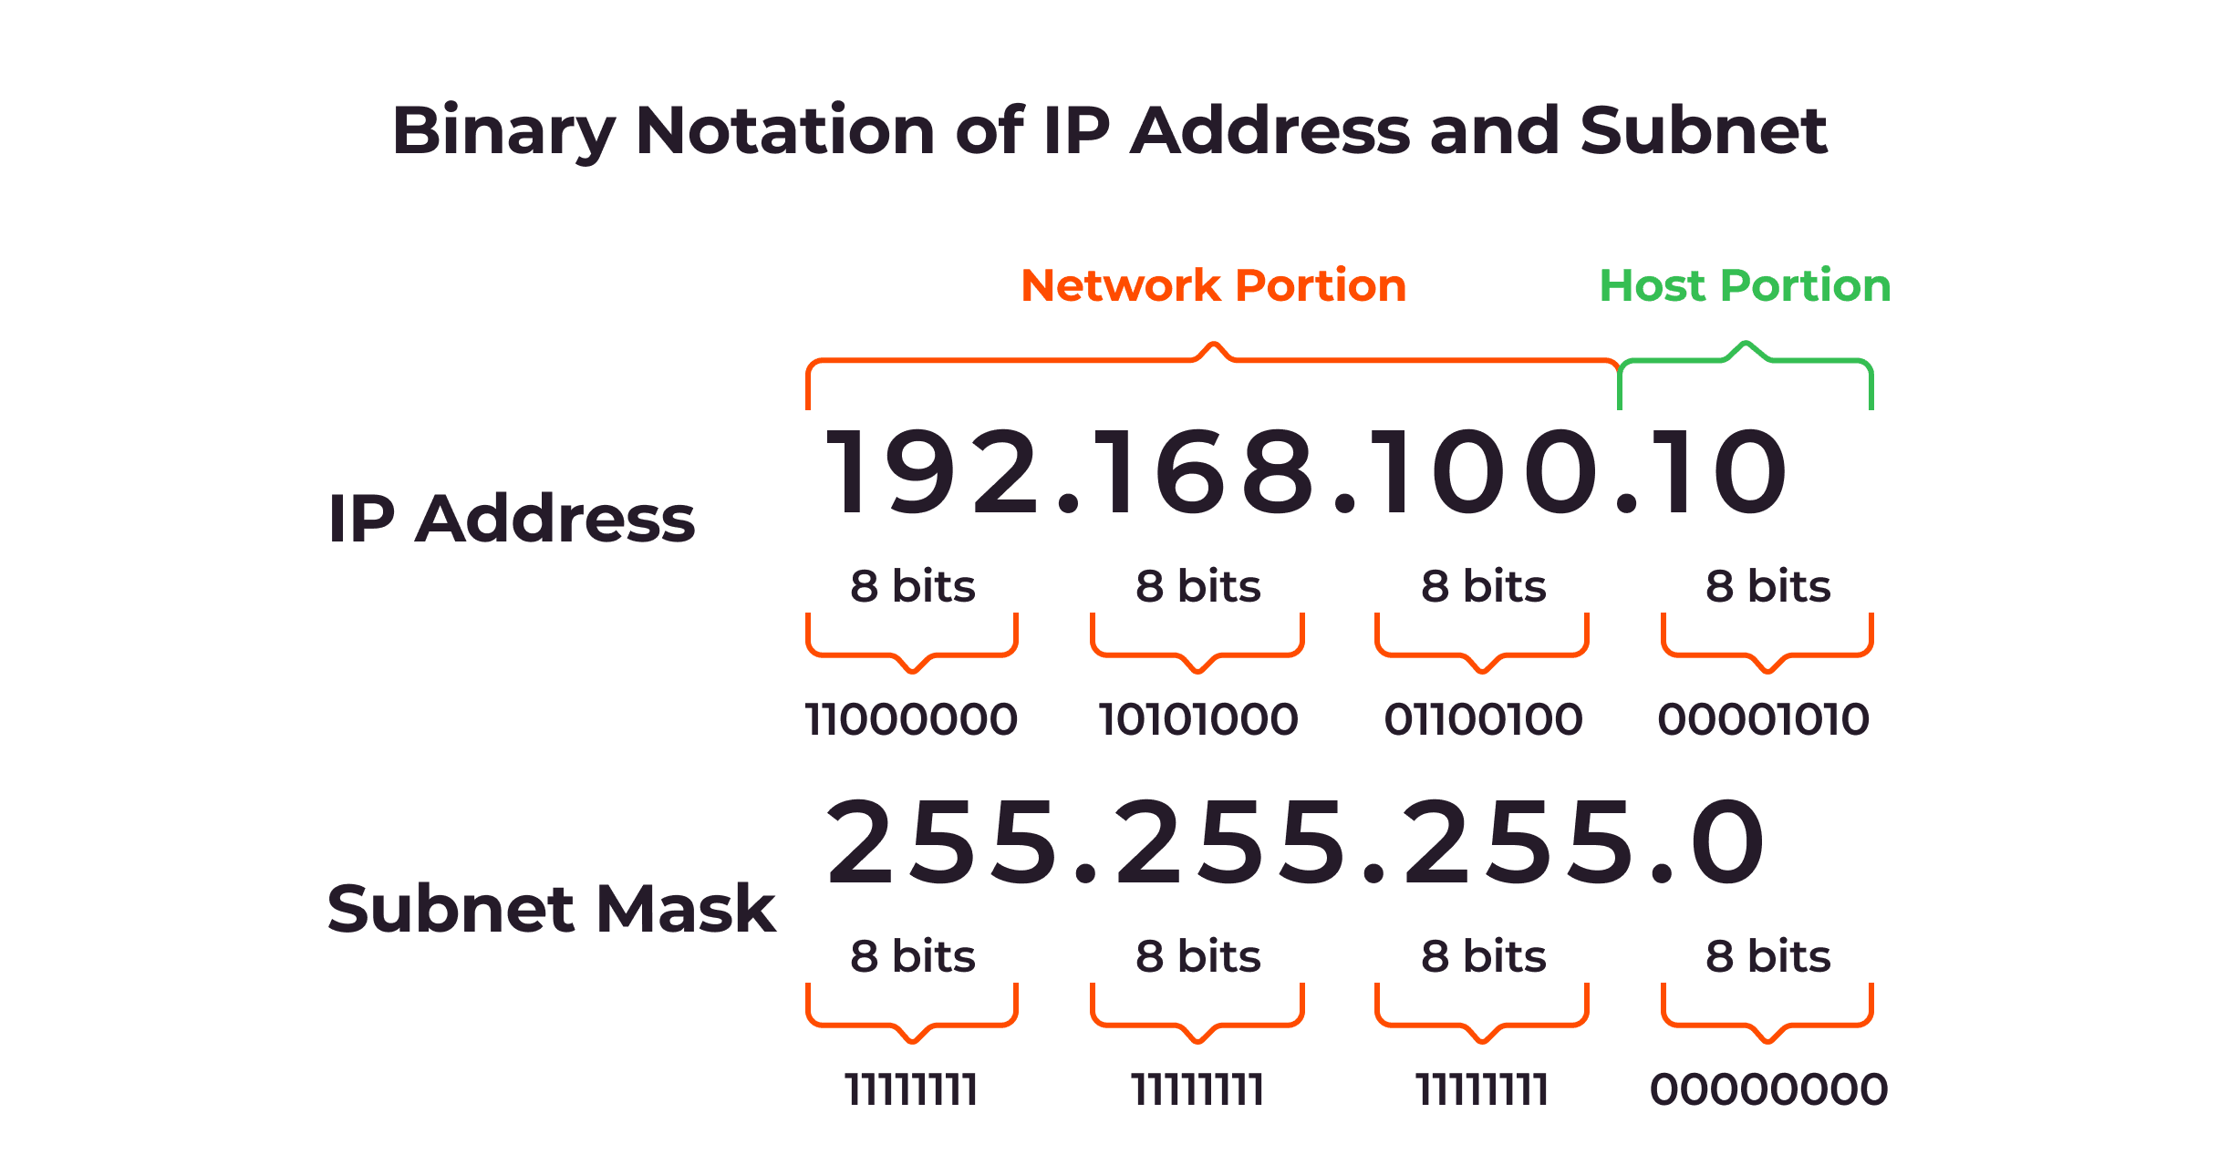

## **IPv6 Addressing**

As the number of internet-connected devices continues to grow, **IPv4's 32-bit addressing space** has proven insufficient. To overcome this limitation, **IPv6 (Internet Protocol version 6)** was introduced, providing a **128-bit address space** and a modern structure that supports future scalability and advanced networking.

An IPv6 address looks very different from IPv4. It uses **hexadecimal notation** and is written in **eight groups of four hex digits**, separated by colons:

Example: 2001:0db8:85a3:0000:0000:8a2e:0370:7334

IPv6 provides **2¹²⁸ unique addresses**, which is enough to assign trillions of addresses to every device on Earth.

**🔹 Key Features of IPv6**

* **128-bit address space** (vs 32-bit in IPv4)
* **No need for NAT** (Network Address Translation)
* Built-in support for **auto-configuration**
* **Hierarchical addressing** improves routing efficiency
* Simplified header structure for better performance
* Built-in security via **IPsec (Internet Protocol Security)**

**Types of IPv6 Addresses:**

| **Type** | **Prefix** | **Use** |
| --- | --- | --- |
| Unicast | Typically 2000::/3 | One-to-one communication |
| Multicast | FF00::/8 | One-to-many communication |
| Link-local | FE80::/10 | Device communication within the same network |
| Loopback | ::1 | Device sending data to itself |

**🔹 Abbreviation Rules**

IPv6 allows address compression:

* Leading zeros in any block can be **removed**
* Consecutive blocks of zeros can be **replaced with :: once**

Example:  
Original: 2001:0db8:0000:0000:0000:0000:0000:0001  
Compressed: 2001:db8::1

“IPv6 is the future of internet addressing, designed to support secure, scalable, and performance-optimized communication.” — Microsoft Learn [1]

### **4.2 IPv6 Subnetting and CIDR**

Just like IPv4, **IPv6 also supports subnetting** but thanks to its massive address space, subnetting in IPv6 is **simpler and more standardized**. It uses **CIDR (Classless Inter-Domain Routing)** notation just like IPv4, but with 128-bit addresses.

The most commonly used IPv6 subnet size is **/64**, which provides a huge number of host addresses per subnet specifically, **2⁶⁴ IP addresses**.

<IPv6 Address>/<Prefix Length>

Example: 2001:db8:abcd::/64

* The **prefix length** determines the number of bits used for the **network ID**
* The remaining bits are used for the **host ID**
* A **/64** is the standard prefix length for a single subnet

**Example: Creating Subnets in IPv6**

**Original Network:** 2001:db8:abcd::/48

You want to create multiple /64 subnets:

| **Subnet** | **Range** |
| --- | --- |
| Subnet 1 | 2001:db8:abcd:0000::/64 |
| Subnet 2 | 2001:db8:abcd:0001::/64 |
| Subnet 3 | 2001:db8:abcd:0002::/64 |
|  |  |

Just like in IPv4, you're **borrowing bits from the host portion** to create multiple logical subnets.

**🔹 Why IPv6 Subnetting Is Easier:**

* No need to calculate usable hosts (you always have enough!)
* Cleaner network design with **/64 standard blocks**
* Supports **hierarchical and route-efficient addressing**
* **No network/broadcast addresses**, so no address loss

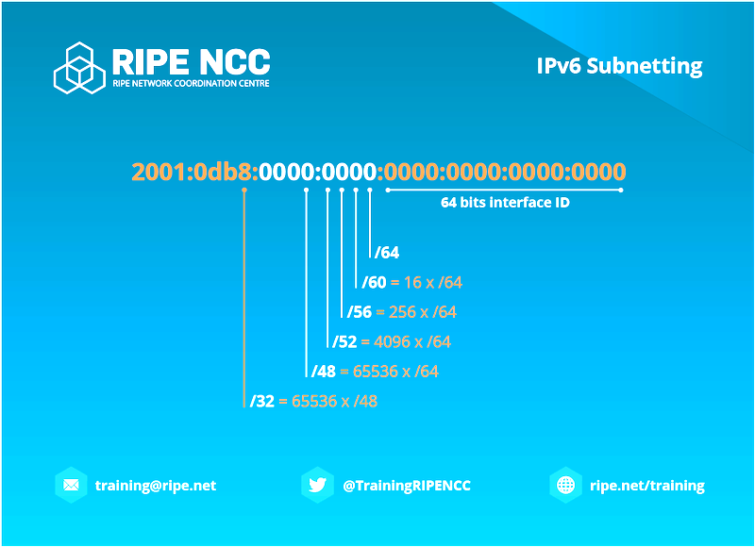

## **IPv4 vs IPv6 Comparison**

While both IPv4 and IPv6 serve the same fundamental purpose **identifying devices and enabling communication across networks** they differ greatly in format, capacity, functionality, and future readiness.

The following table highlights the major differences:

|  |  |  |  |  |
| --- | --- | --- | --- | --- |
| Aspect | |  | | --- | | **IPv4** |  |  | | --- | |  | | IPv6 |
| Address Length | |  | | --- | | 32-bit |  |  | | --- | |  | | |  | | --- | | 128-bit |  |  | | --- | |  | |
| Address Format | |  | | --- | | Decimal (e.g., 192.168.1.1) |  |  | | --- | |  | | |  | | --- | | Hexadecimal (e.g., 2001:db8::1) |  |  | | --- | |  | |
| Total Addresses | |  | | --- | | ~4.3 billion |  |  | | --- | |  | | |  | | --- | | ~3.4×10³⁸ (undeniably vast) |  |  | | --- | |  | |
| Header Complexity | More complex | |  | | --- | | Simplified header |  |  | | --- | |  | |
| Subnetting | Manual and variable | |  | | --- | | Standardized with /64 in most cases |  |  | | --- | |  | |
| |  | | --- | | Broadcast Support |  |  | | --- | |  | | Yes | |  | | --- | | No (uses multicast instead) |  |  | | --- | |  | |
| Security | |  | | --- | | Optional (IPSec supported) |  |  | | --- | |  | | |  | | --- | | Built-in IPsec support |  |  | | --- | |  | |
| |  | | --- | | NAT Required |  |  | | --- | |  | | |  | | --- | | Yes, often required due to address limits |  |  | | --- | |  | | |  | | --- | | Not required due to huge address space |  |  | | --- | |  | |
| Deployment | |  | | --- | | Widely deployed |  |  | | --- | |  | | Gradually replacing IPv4 |

**🔹 Summary:**

* **IPv4** is still dominant, especially in legacy systems, private networks, and some regions
* **IPv6** is the **future-proof protocol**, designed for the expanding internet, IoT, and cloud environments
* Modern networks especially in **cloud infrastructure** are often **dual-stacked** (supporting both IPv4 and IPv6)

“IPv6 is not just an upgrade it's a redesign of the internet addressing system built for scale, efficiency, and security.” — Microsoft Learn [1]

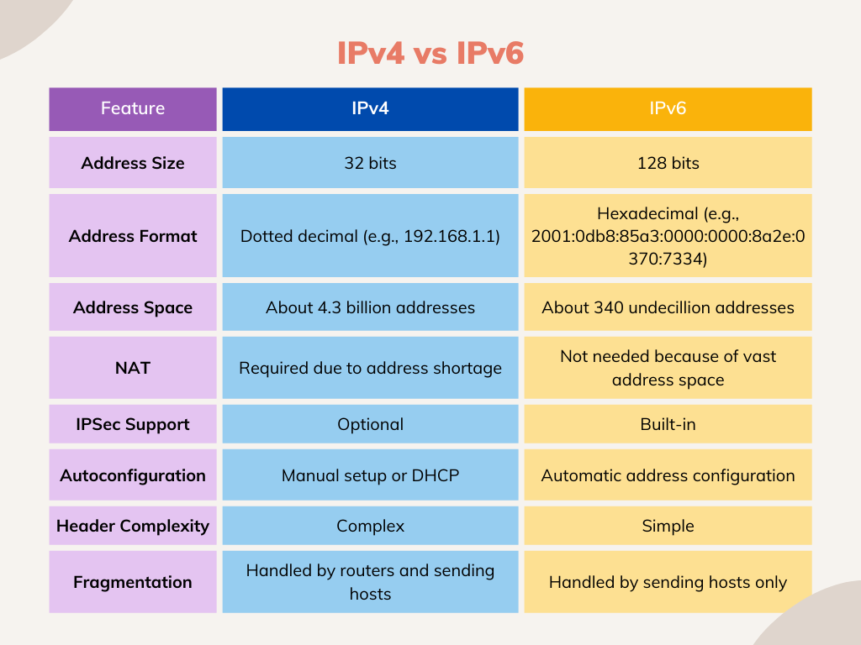

## **Real-World Use Cases & Importance in Cloud Networking**

IP addressing and subnetting are not just academic concepts — they are **fundamental tools used daily** in the design, configuration, and management of real-world networks, especially in **cloud platforms like Microsoft Azure, AWS, and Google Cloud**.

Understanding how to allocate IP addresses, create subnets, and calculate usable hosts is critical when working with **virtual networks (VNets), subnets, firewalls, and VPNs** in modern infrastructure.

**🔹 Use Cases in Real-World Environments:**

* **Virtual Network Design (VNets):**  
  Cloud platforms require clear IP range definitions (like 10.0.0.0/16) to isolate services by subnets (e.g., Web, App, DB tiers).
* **Network Security:**  
  Subnets are used to apply **Network Security Groups (NSGs)** or **firewall rules**, ensuring only specific traffic can reach certain segments.
* **Scalable IP Planning:**  
  Using CIDR and subnetting allows organizations to allocate address spaces for current and future use without waste.
* **VPNs and Site-to-Site Tunnels:**  
  Subnets ensure seamless integration of on-premises networks with cloud infrastructure.
* **IPv6 Readiness:**  
  Cloud providers like Azure and AWS offer IPv6 support for global accessibility, especially important for IoT and edge services.

# **Conclusion**

IP addressing and subnetting lie at the very heart of network design and operation. From the legacy 32‑bit world of IPv4 where classes, default masks, and careful CIDR planning govern every device address to the expansive, 128‑bit landscape of IPv6 where automatic addressing, built‑in security, and standardized /64 subnets simplify modern deployments these concepts ensure devices can find one another, communicate efficiently, and remain secure.

Mastering how to:

* Distinguish between network and host portions via subnet masks (natural and custom)
* Apply CIDR notation for flexible, scalable IP allocation
* Subnet large address spaces into logical segments with correct host calculations
* Transition between IPv4 and IPv6 environments  
  …is more than theory. It empowers you to:
* Design robust **cloud VNets** and on‑premises networks
* Implement precise **security boundaries** with NSGs/firewalls
* Optimize IP usage to support current and future growth without waste
* Diagnose connectivity issues at both the IP and ICMP level

In today’s cloud‑driven internship tasks configuring subnets for Web, App, and DB tiers; setting up secure VPNs; enabling IPv6 connectivity these skills directly translate into **real‑world network stability, performance, and security**. As you continue building infrastructure, remember: effective subnetting is the blueprint that turns sprawling address spaces into well‑organized, manageable networks.

Every time we send a message, browse a website, or connect to a cloud service, we rely on networks working silently in the background. But what really makes these systems talk to each other smoothly? That’s where the **OSI Model** comes in a framework designed to make complex communication systems understandable and manageable.

# **References**

1. Microsoft. (2024). *IP addressing and subnetting*. Microsoft Learn.  
   <https://learn.microsoft.com/en-us/troubleshoot/windows-client/networking/tcpip-addressing-and-subnetting>
2. Microsoft. (2024). *Introduction to IPv6*. Microsoft Learn.  
   <https://learn.microsoft.com/en-us/troubleshoot/windows-client/networking/tcpip-addressing-and-subnetting>
3. Microsoft. (2024). *CIDR and subnet masks*. Microsoft Learn.  
   <https://learn.microsoft.com/en-us/troubleshoot/windows-client/networking/tcpip-addressing-and-subnetting>