The Dhan Bank application is a modern, efficient, and scalable banking system designed to provide users with a seamless digital banking experience. The app leverages cutting-edge technologies, ensuring high-performance transaction processing, robust security, and user-friendly interfaces. It aims to bridge the gap between traditional banking and modern, real-time banking needs by offering a wide range of services to both individual customers and businesses. Below is a detailed explanation of the application’s core features, architecture, and user roles.

1. Core Features

a. Real-time Transaction Processing
- The app is built to handle high transaction volumes in real-time. This ensures that users can make instant payments, transfers, and transactions without delays.
- The app supports various types of financial transactions such as money transfers, bill payments, and account withdrawals, which are processed efficiently using a microservices architecture.

b. Security and Compliance
- The app adheres to industry standards for data security and compliance with global regulatory requirements like PCI DSS and GDPR.
- It implements multi-layered security protocols such as two-factor authentication (2FA), encryption, and role-based access controls to protect sensitive user data.
- Regular audits and security testing are conducted to ensure that the system is up to date with the latest security standards.

c. User-Centric Interface
- The application boasts an intuitive and responsive user interface, built using ReactJS. This ensures that the app is easy to navigate on any device, be it a mobile phone, tablet, or desktop.
- Tailwind CSS is used to create a flexible, mobile-first, and visually appealing design that adapts to different screen sizes.

d. Account Management
- Users can view their bank accounts, transaction history, and balance in real-time. Each user can have multiple accounts, and the app allows easy switching between accounts.
- The app supports features like overdraft protection, automatic transfers, and bill payments, enhancing the overall user experience.

e. Banking Transactions
- Money Transfers: Users can transfer money between accounts, to other banks, or to external services. Real-time processing ensures instant transfers.
- Bill Payments: The app integrates with utility providers, allowing users to easily pay for electricity, water, gas, etc., directly through the platform.
- Fund Deposits and Withdrawals: The app supports deposits from external sources and ATM withdrawals, with instant balance updates.

f. Customer Support
- The app has a live chat feature for customer support, allowing users to get help in real-time. There is also a contact us section where users can raise inquiries, provide feedback, or report issues.

g. Notifications and Alerts
- The app sends notifications for successful transactions, low balances, upcoming bills, or any suspicious activity. Notifications are customizable based on user preferences.

2. Architecture Overview

a. Frontend (Client-Side)
- The frontend is built using ReactJS and TailwindCSS for styling. It provides a responsive, user-friendly interface that works across devices.
- Components are modular, ensuring that the interface can be easily maintained and updated without affecting the entire system.

b. Backend (Server-Side)
- The backend is built using Node.js with Express.js for handling HTTP requests and managing routes.
- REST APIs are designed to handle various operations like transferring money, retrieving account information, and processing payments.
- The backend integrates with databases to store user data, transaction history, account details, and security information. It uses MongoDB for non-relational data storage, ensuring flexibility and scalability.

c. Database
- MongoDB is used to store user-related data (personal details, account information, etc.), transaction history, and other metadata.
- For transactions and payment records, the system ensures data integrity by implementing ACID transactions at the database level.
- Redis is used for caching frequently accessed data, ensuring fast response times for critical operations like checking account balances or viewing transaction history.

d. Microservices
- The application follows a microservices architecture to enhance scalability and flexibility.
- Different modules like account management, transaction processing, security management, and customer support are separated into distinct services. This allows each service to scale independently based on demand.

e. Authentication & Authorization
- JWT (JSON Web Tokens) are used for authentication, ensuring secure login and token-based authorization for accessing the app's features.

3. User Roles

a. Customers
- Customers are the primary users of the app. They can manage their bank accounts, perform transactions, track spending,

b. Bank Employees (Admin Panel)
- Bank employees use an admin dashboard to monitor transactions, handle customer requests, and resolve issues.
- Admins have access to detailed customer information

4. Scalability and Performance
- The app is designed to handle alot of users and transactions concurrently. The use of microservices and distributed systems ensures that the app can scale as the user base grows.
- The backend leverages load balancing, caching, and database sharding to maintain performance even during peak usage times.
- With the help of cloud infrastructure (like AWS or Google Cloud), the app is highly available and can be horizontally scaled by adding more instances based on demand.

5. Security Features
- Data Encryption: All sensitive data (like user information, transaction details, etc.) is encrypted using industry-standard encryption protocols (e.g., using bcrypt).

Conclusion:
The Dhan Bank application is a robust, scalable, and secure digital banking platform designed for modern users. It leverages advanced technologies to handle high-volume, real-time transactions while ensuring top-notch security and compliance. By offering an intuitive user experience and incorporating features like real-time processing, secure transactions, and multi-channel support, Dhan Bank is poised to redefine modern banking for its users.

Features of the Application with Different Module Details

User Module:
- Registration: Users can sign up with email, phone, and personal details.
- Login: After registration, users log in using their credentials.
- Account Creation: Users can create different types of accounts (e.g., Savings, Current).
  - Aadhar Number and Document Upload for verification.
- Account Management: After admin approval, users can access and manage their accounts.
- Deposits:
  - Cash Deposit: Directly adds funds to the user’s account.
  - Check Deposit: Submitted for admin verification.
- Transfer Funds: Users can transfer money to other accounts.
- View Transactions: View the history of deposits, withdrawals, and transfers.

Admin Module:
- Account Verification: Admin can approve or reject user account creation requests.
- Check Verification: Admin verifies checks before funds are deposited into the user's account.
Screenshots of Application UI

- Landing page
{http://localhost:5173/}
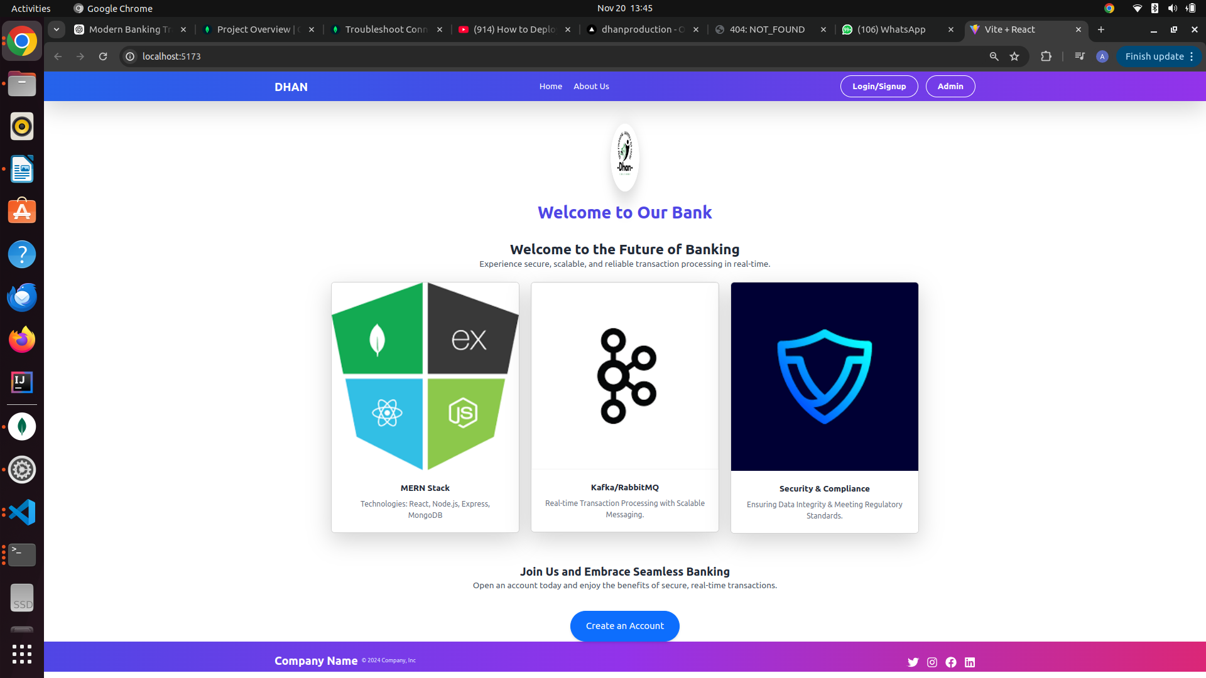
- Login Page
a)user
{http://localhost:5173/Login}
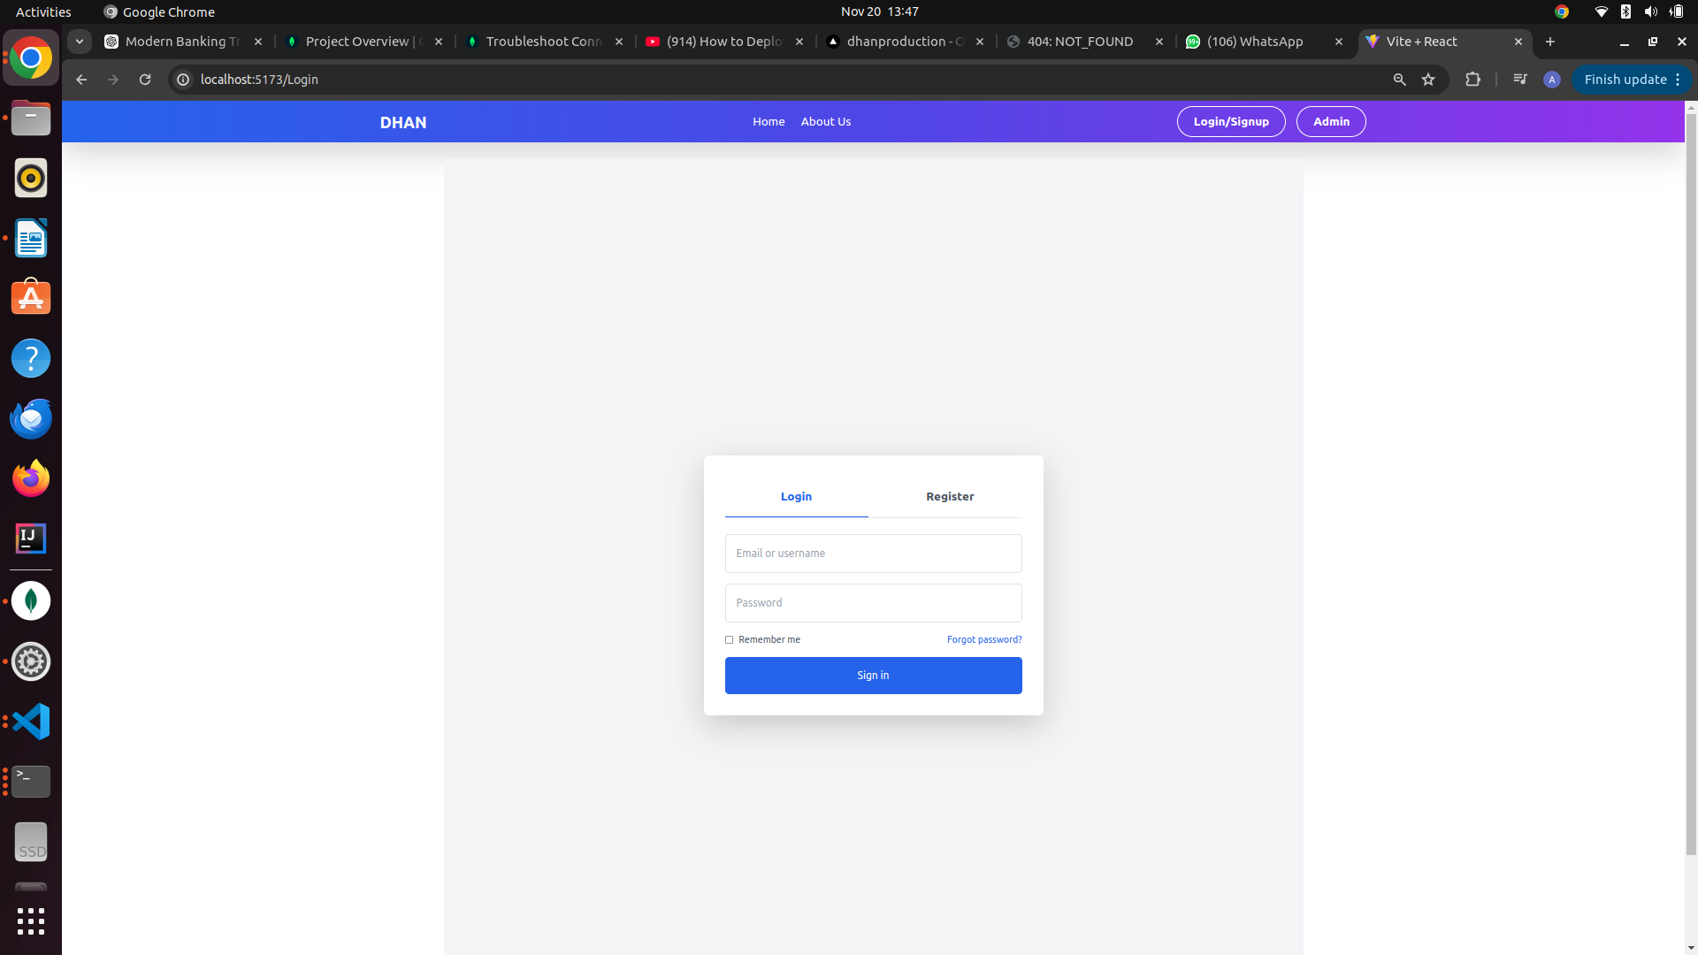
b)admin{http://localhost:5173/admin}
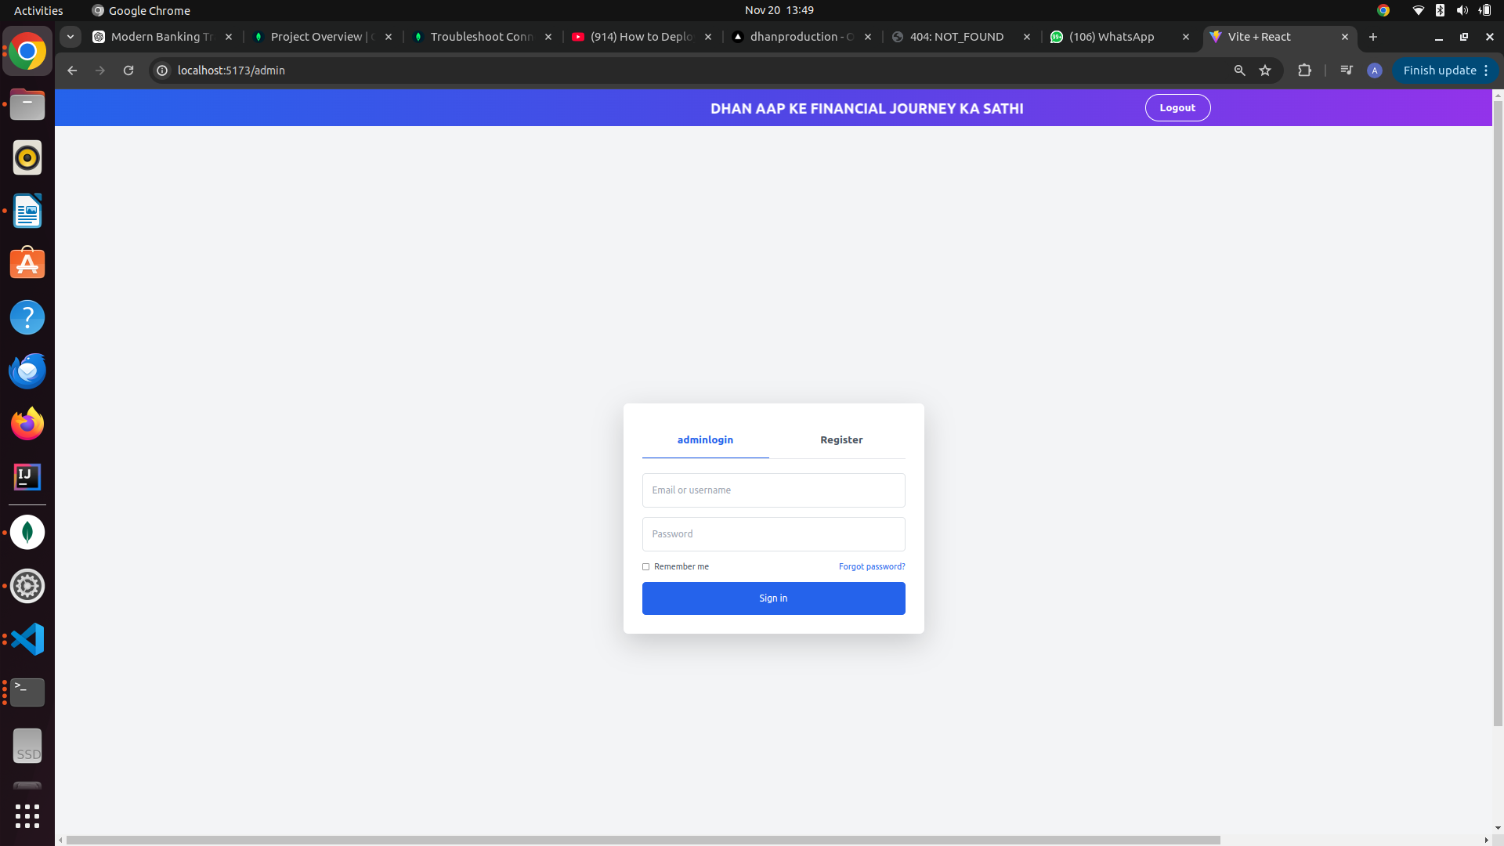
- Registration Page
a)user
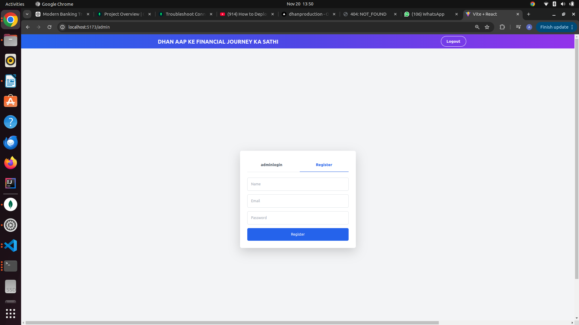
b)admin

- Dashboard (with account details)
a)user

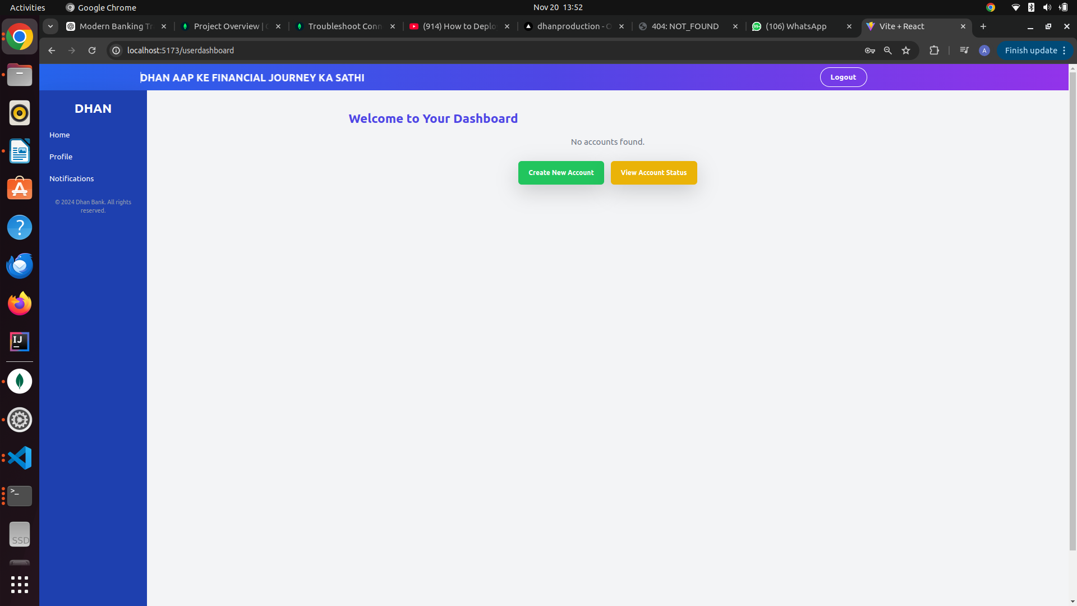

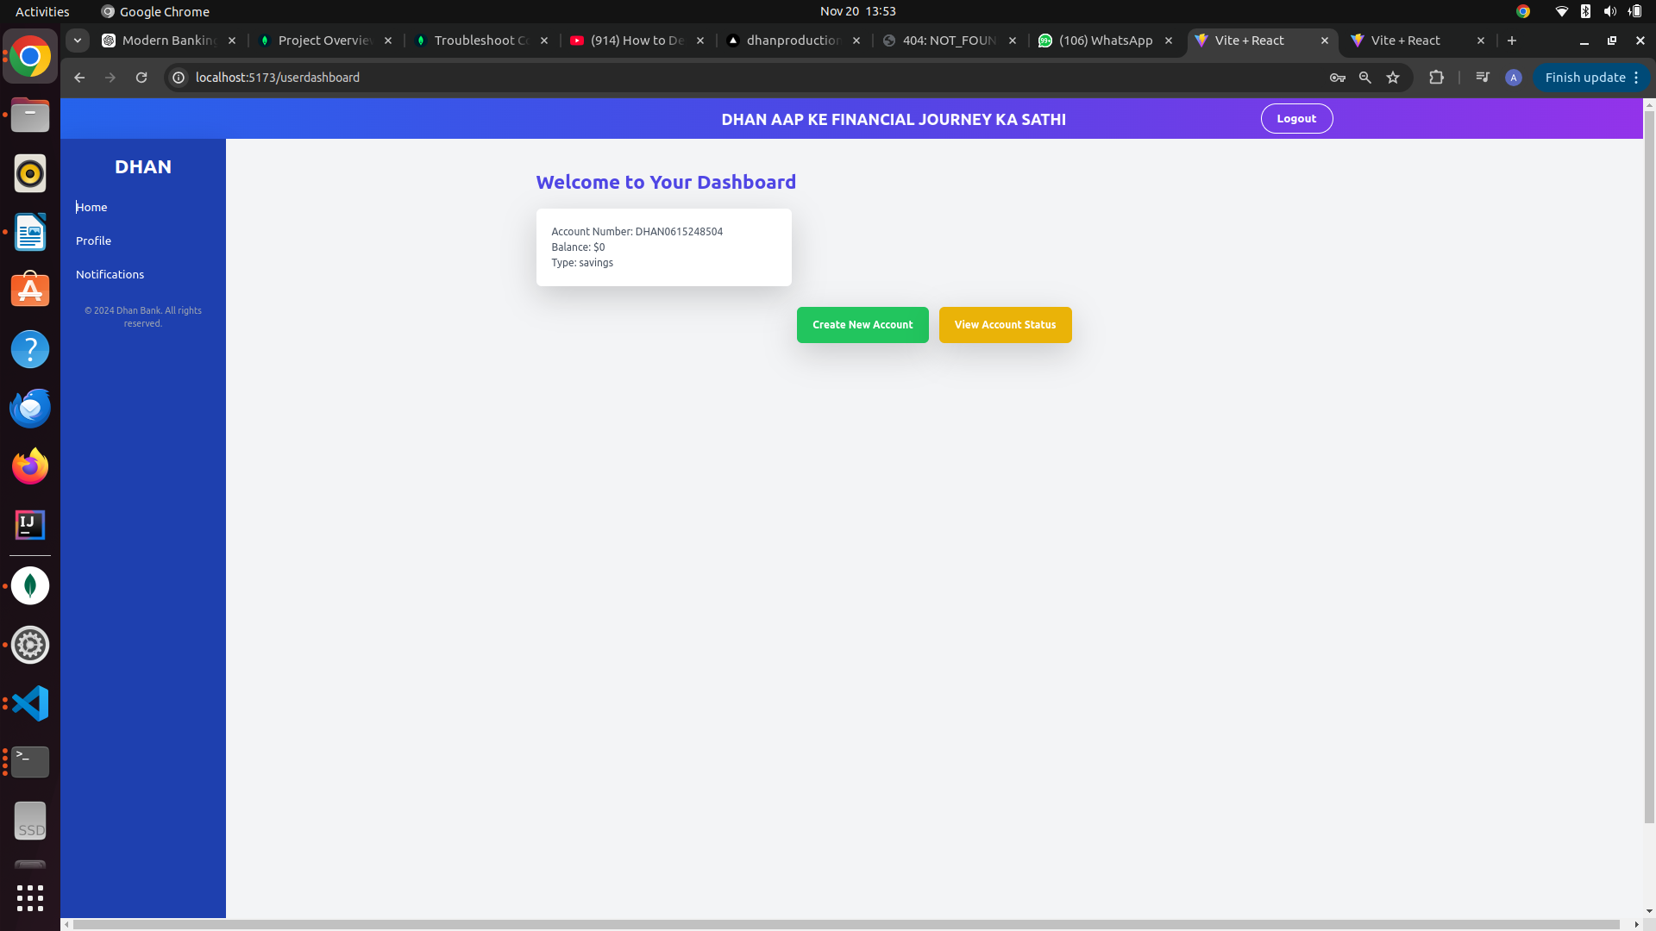
- b)admin
- Account Creation Page (with form to enter Aadhar, type of account, and document upload)

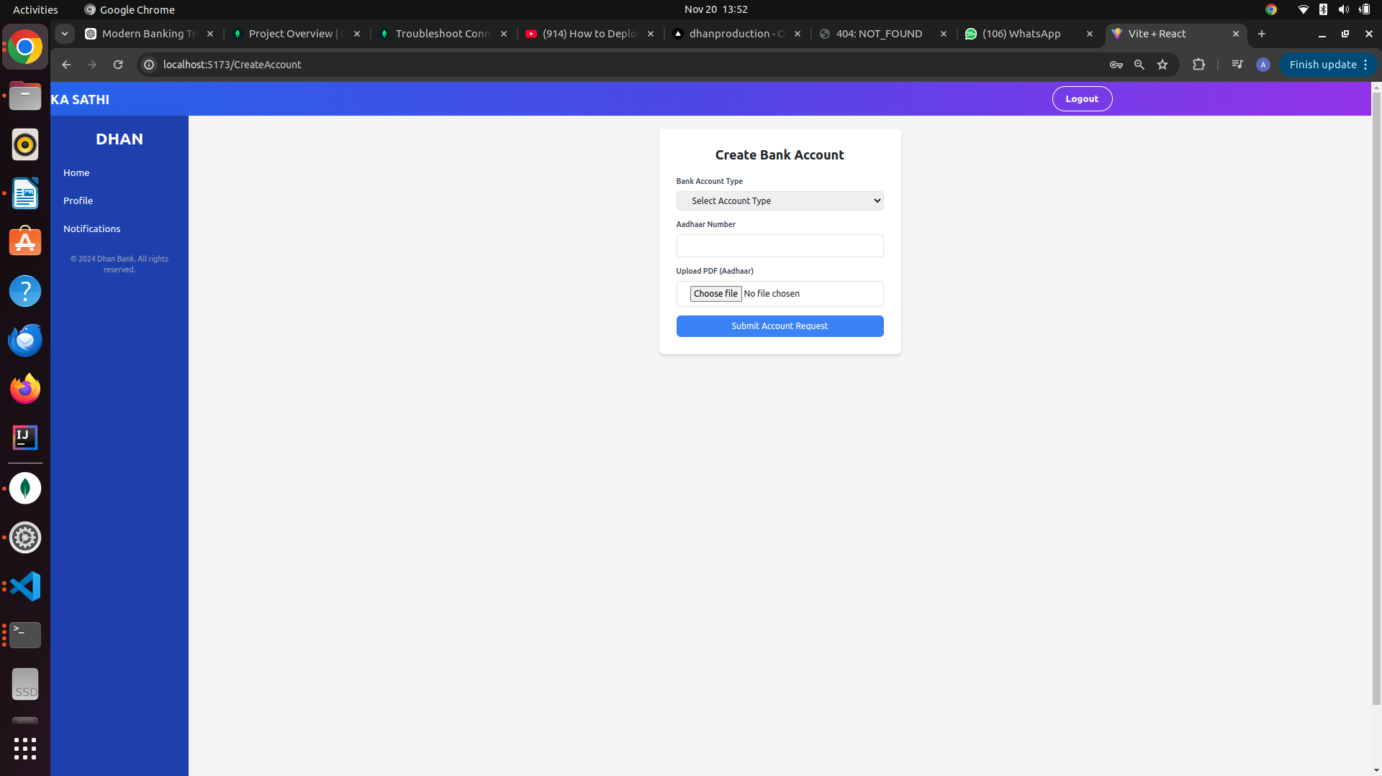
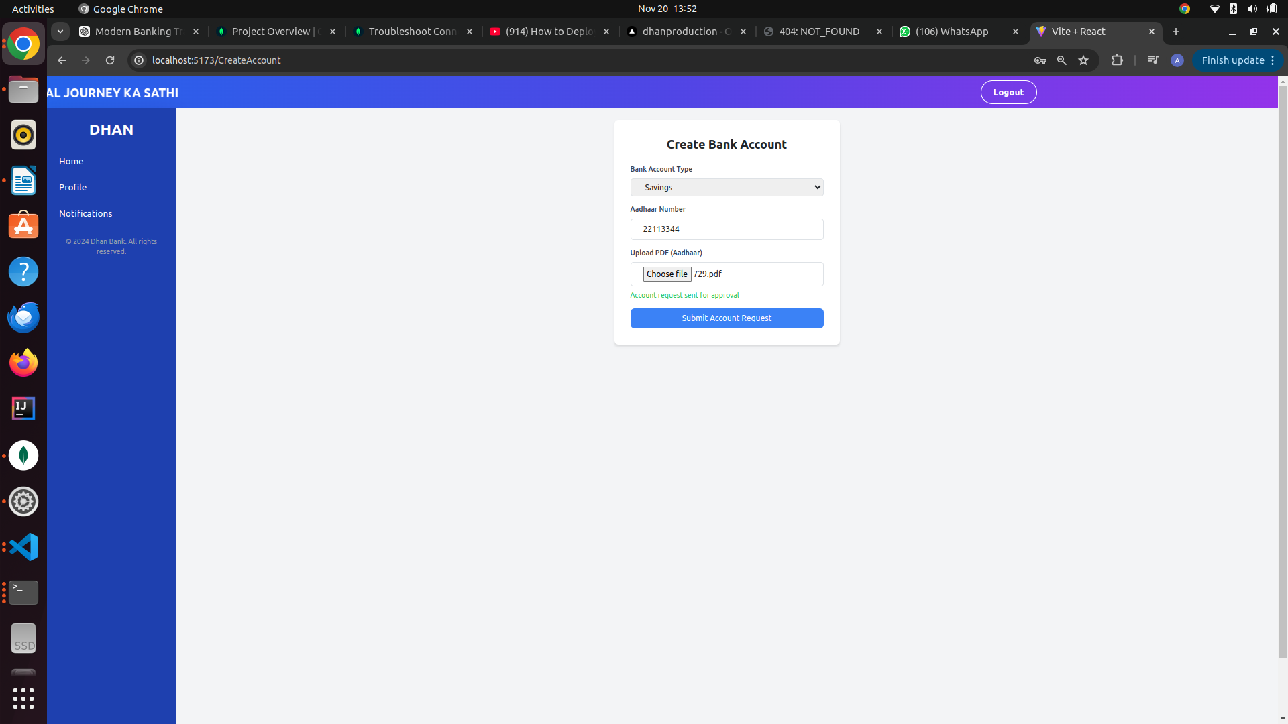
- Pending Accounts Page (for admin to approve or reject)

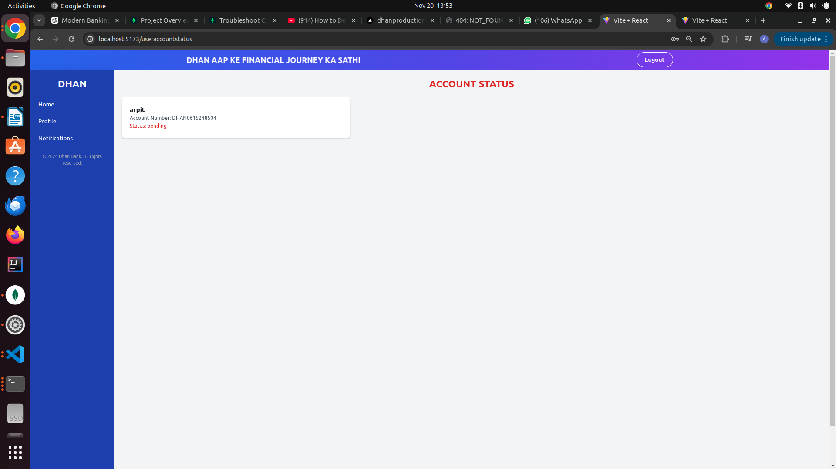
a)user
b)admin

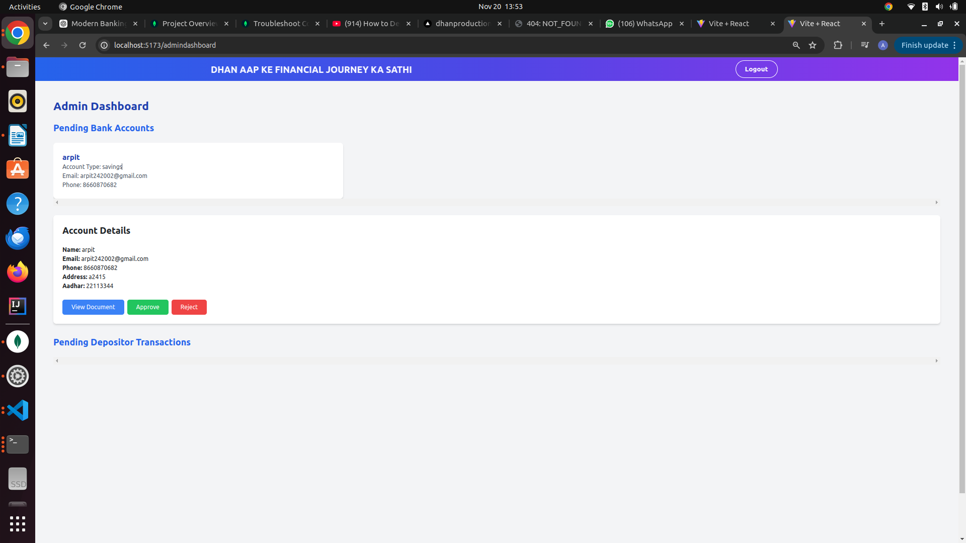

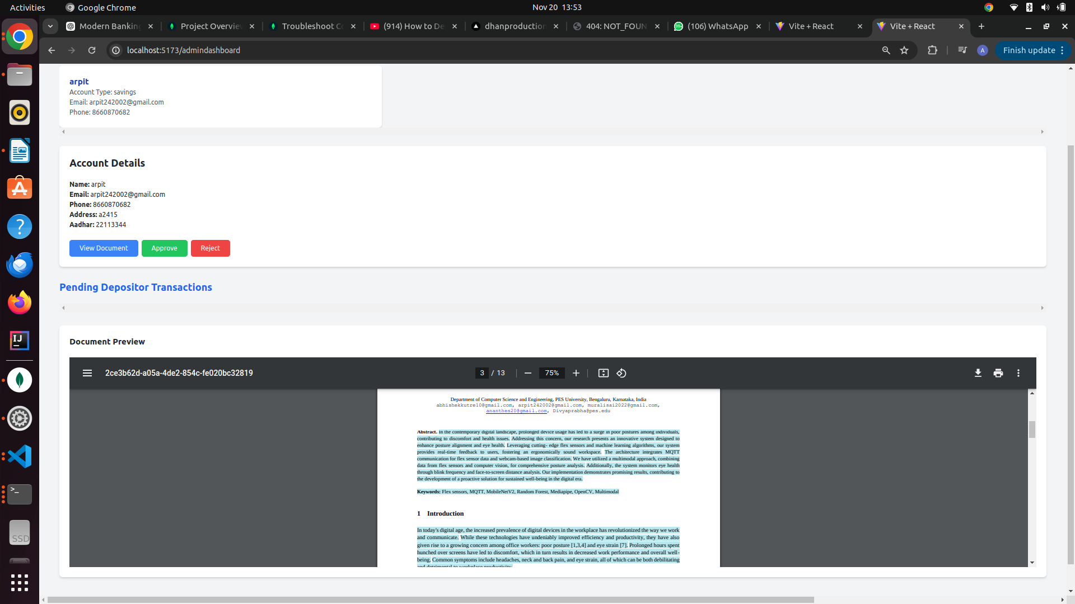

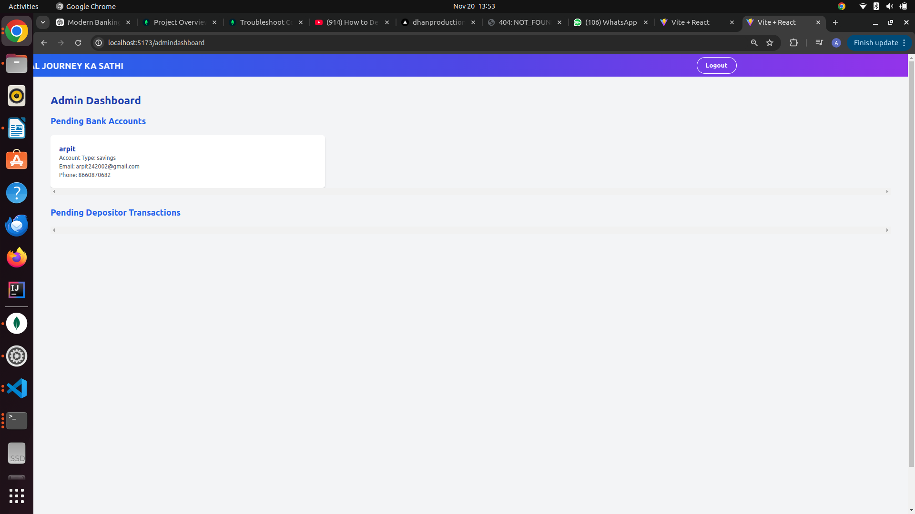

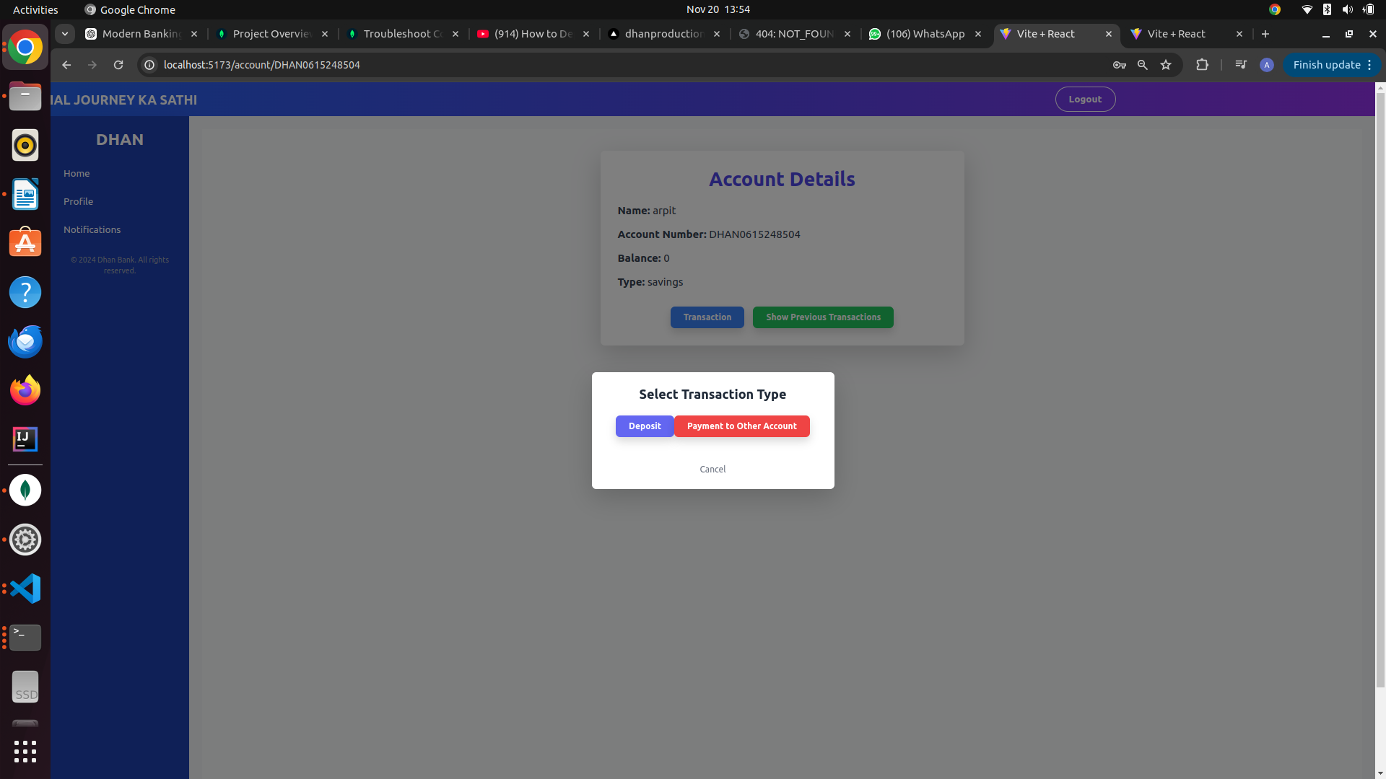
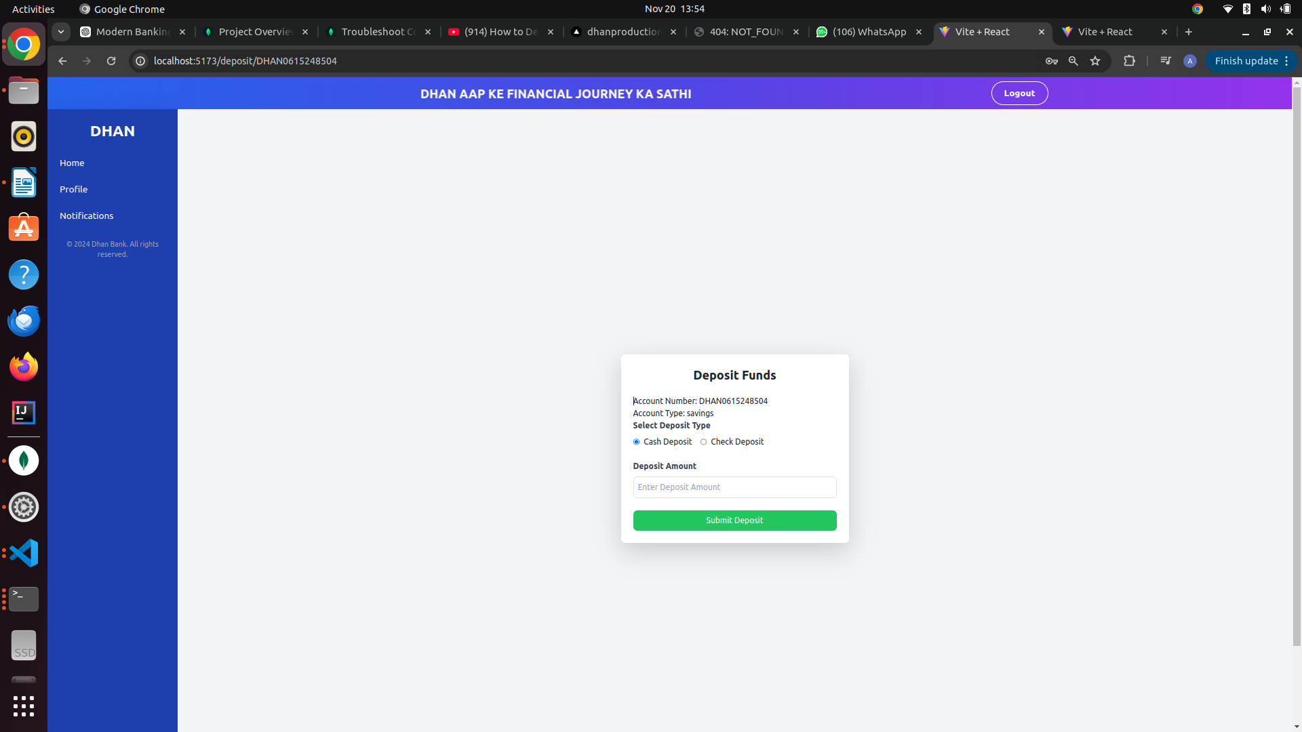

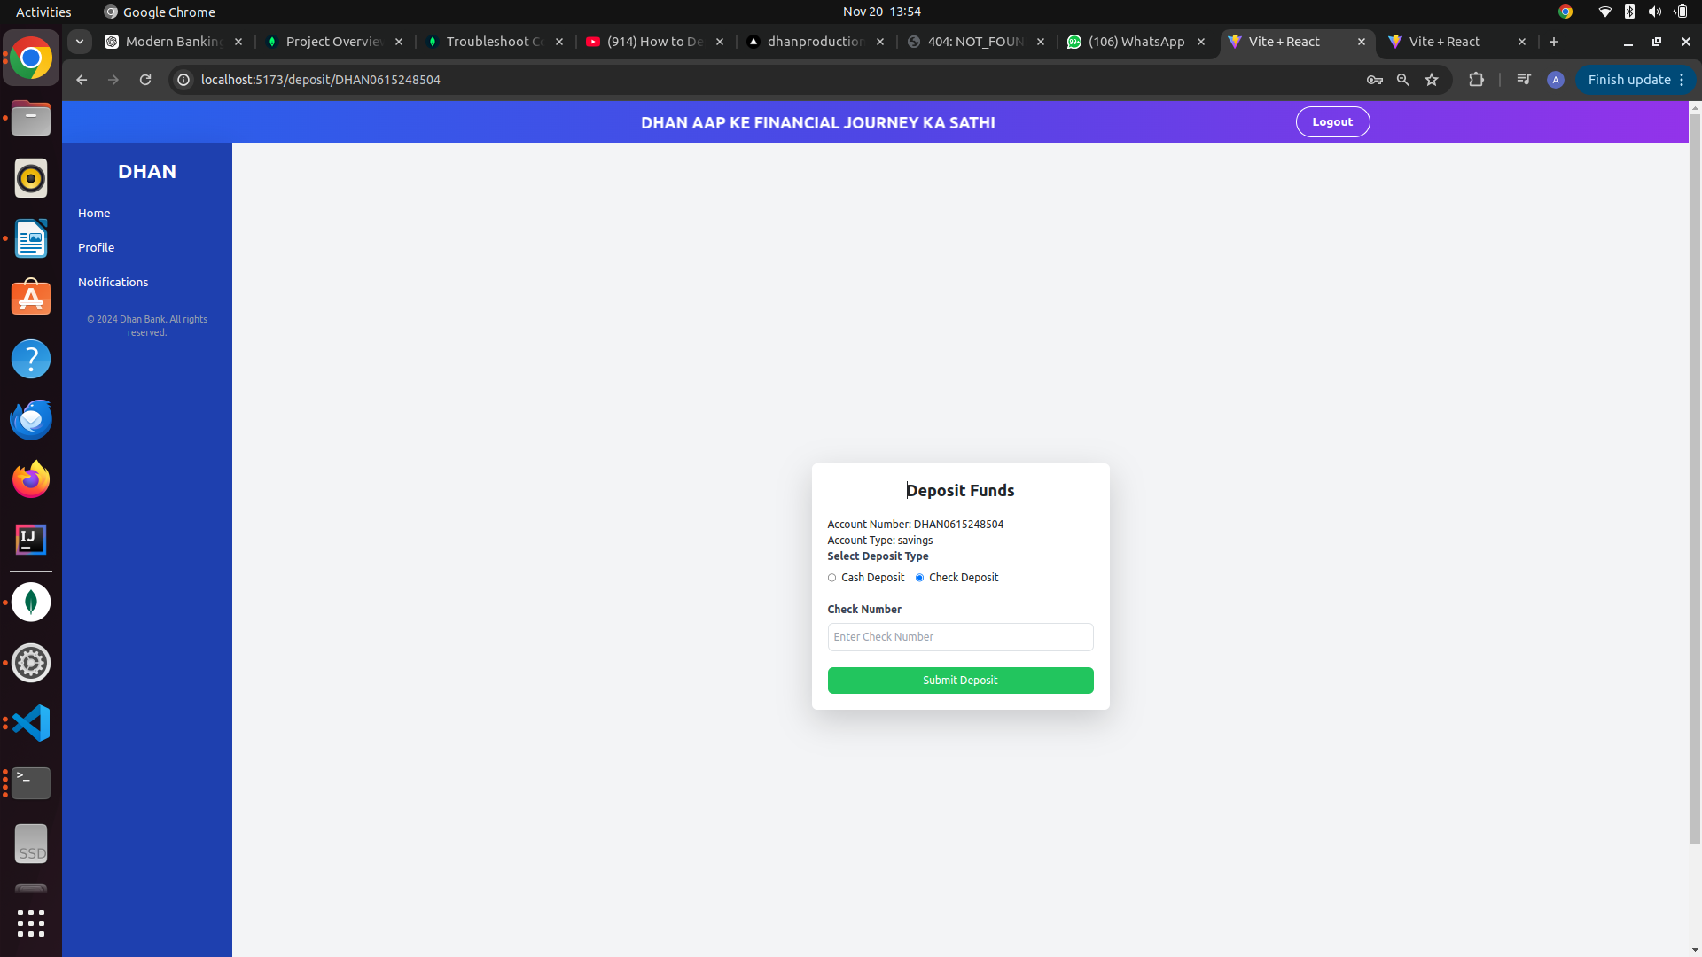
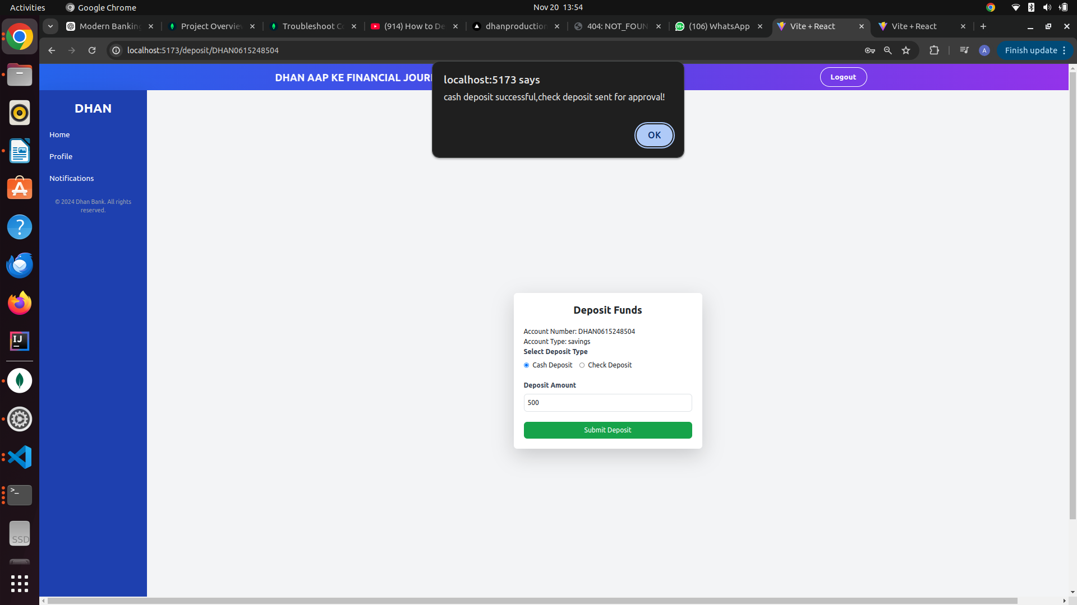

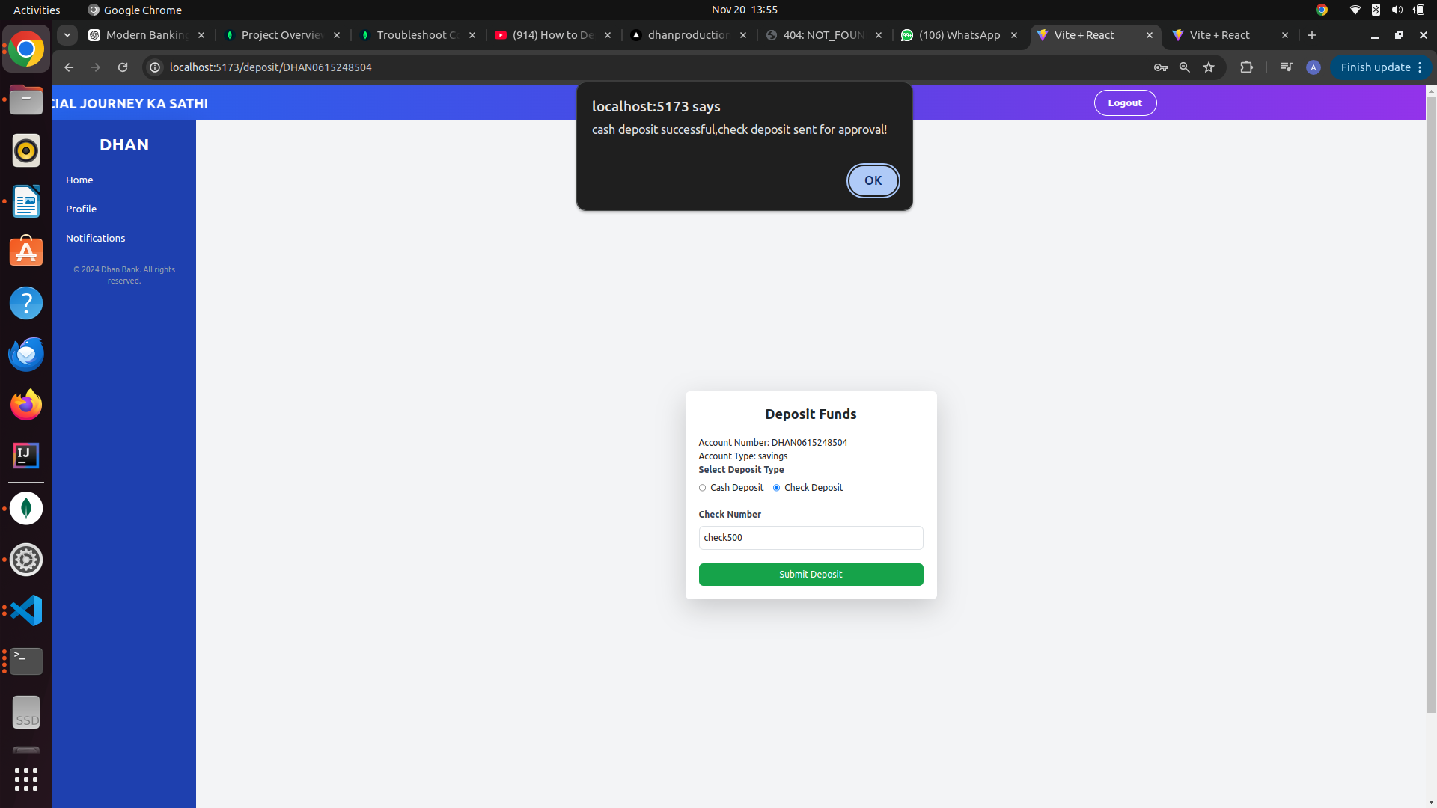

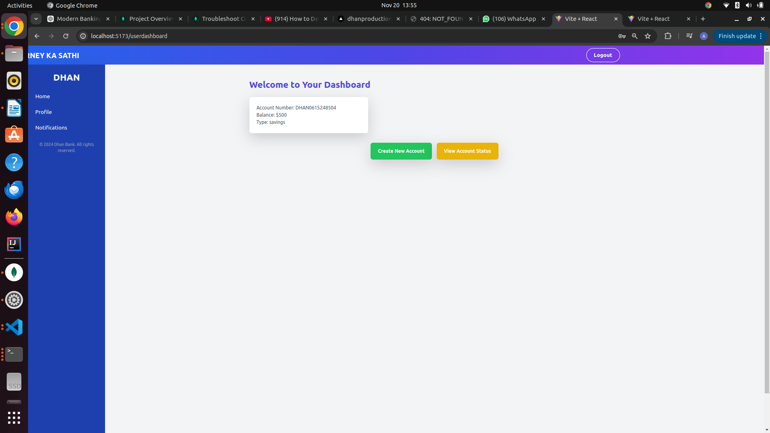
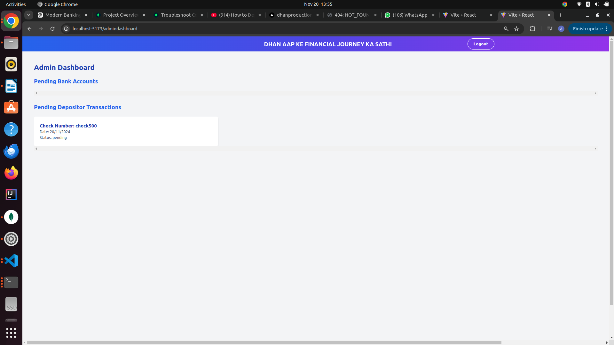
Dashboard after cash deposite ADMIN APPROVE CHECK

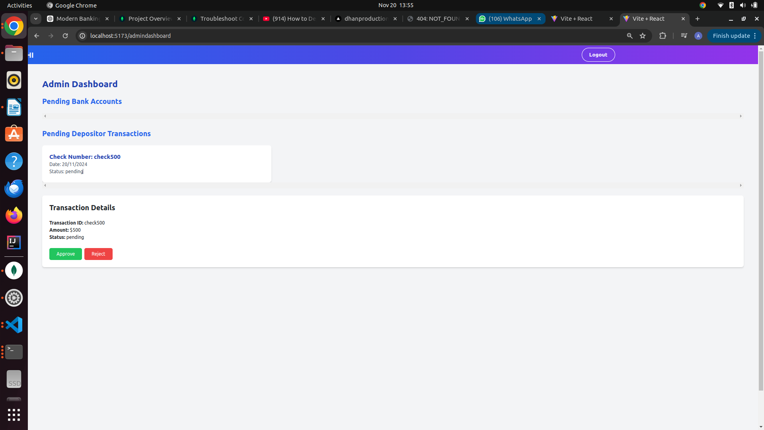

- Transaction History Page (to display previous transactions)

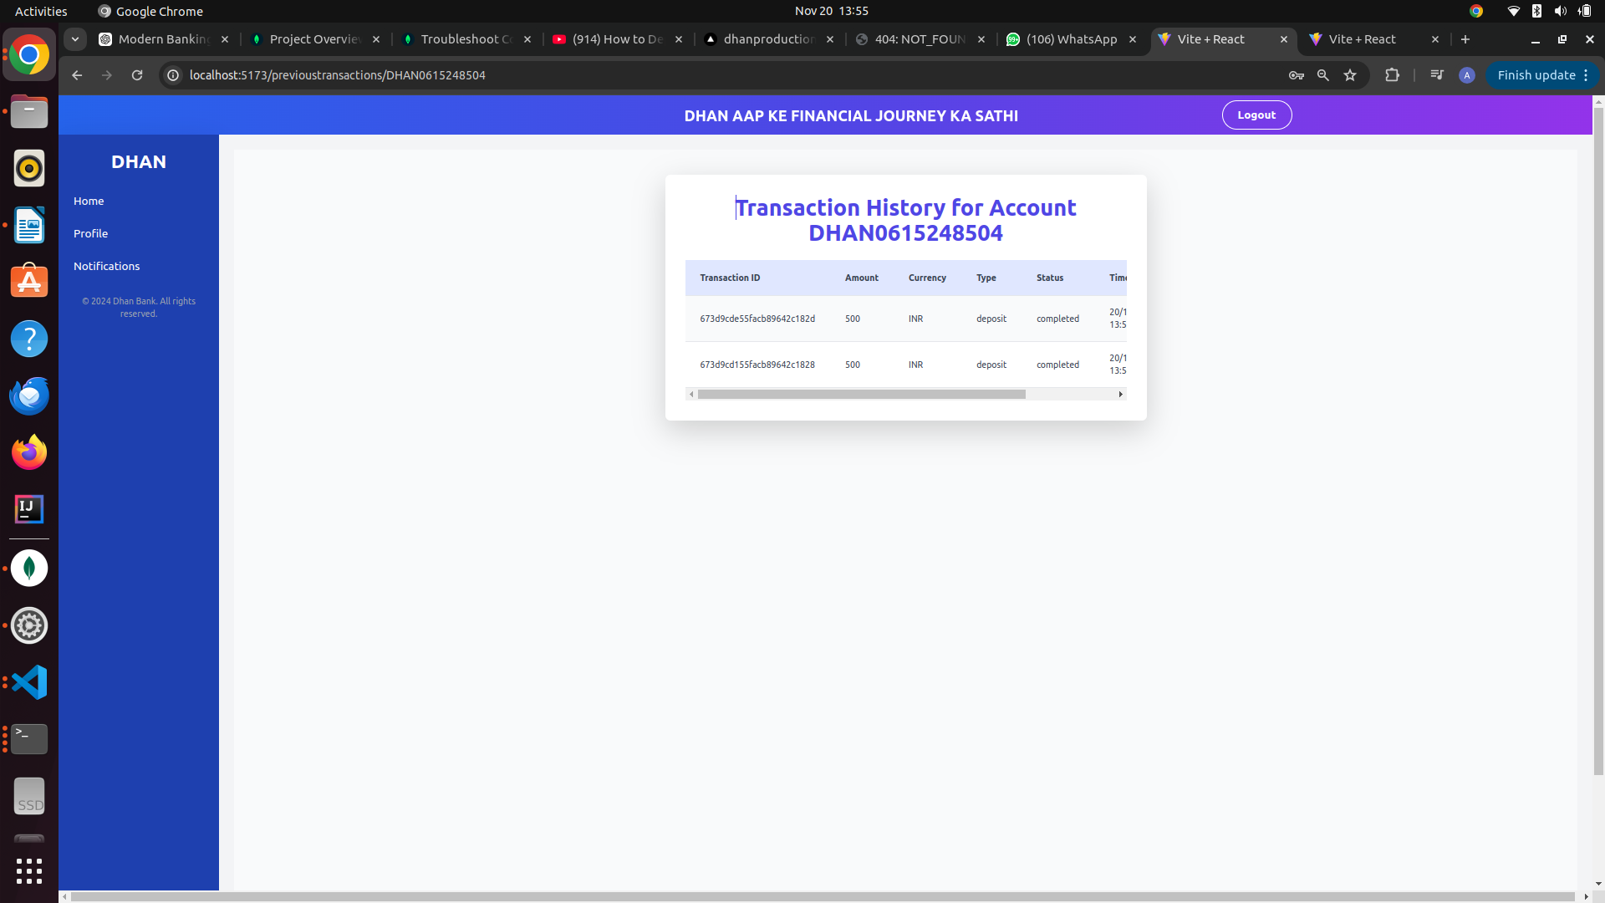

IMPLEMENTED BACKEND ENDPOINTS

1. User Authentication Endpoints (/api/Userauth)
These endpoints handle user registration, login, and logout:
- POST /api/Userauth/signup
  - Description: Register a new user
  - Controller: signup in auth.controller.js
- POST /api/Userauth/signin
  - Description: Log in a user
  - Controller: signin in auth.controller.js
- GET /api/Userauth/signout
  - Description: Log out a user
  - Controller: signout in auth.controller.js

2. User Account Endpoints (/api/UserAccount)
These endpoints manage user accounts, transactions, and profile details:
- POST /api/UserAccount/createbankaccount
  - Description: Create a new bank account (requires authentication via token)
  - Controller: createBankAccount in useraccountfunction.controller.js
- GET /api/UserAccount/previoustransactions/:id
  - Description: View the previous transactions for the user with a given ID (requires authentication)
  - Controller: transactionsHistory in useraccountfunction.controller.js
- POST /api/UserAccount/maketransaction
  - Description: Make a transaction (deposit or transfer)
  - Controller: Maketransaction in useraccountfunction.controller.js
- GET /api/UserAccount/viewaccountstatus
  - Description: View the status of the user’s account (requires authentication)
  - Controller: viewaccountstatus in useraccountfunction.controller.js
- GET /api/UserAccount/myaccounts
  - Description: List all approved accounts for the authenticated user
  - Controller: myapprovedaccounts in useraccountfunction.controller.js
- GET /api/UserAccount/myapprovedaccountsid
  - Description: Get the list of approved account IDs for the authenticated user
  - Controller: myapprovedaccountsid in useraccountfunction.controller.js
- GET /api/UserAccount/profile
  - Description: View the user’s profile (requires authentication)
  - Controller: profile in useraccountfunction.controller.js
- PUT /api/UserAccount/editprofile
  - Description: Edit the user’s profile (requires authentication)
  - Controller: editprofile in useraccountfunction.controller.js
- GET /api/UserAccount/getaccount/:id
  - Description: View the account details for a given account ID (requires authentication)
  - Controller: myapprovedaccountsaccountnumber in useraccountfunction.controller.js
- GET /api/UserAccount/transactionscompletion/:id
  - Description: View the completion status of a transaction (requires authentication)
  - Controller: transactionscompletion in useraccountfunction.controller.js

3. Admin Authentication Endpoints (/api/AdminAuth)
These endpoints handle admin registration, login, and logout:
- POST /api/AdminAuth/signup
  - Description: Register a new admin
  - Controller: signup in adminAuth.controller.js
- POST /api/AdminAuth/signin
  - Description: Log in an admin
  - Controller: signin in adminAuth.controller.js
- GET /api/AdminAuth/signout
  - Description: Log out an admin
  - Controller: signout in adminAuth.controller.js

4. Admin Account Management Endpoints (/api/AdminAccount)
These endpoints handle admin functions related to account approval, transaction verification, and other administrative actions:
- GET /api/AdminAccount/gettogetapprovalbankaccount
  - Description: Get a list of bank accounts that require admin approval
  - Controller: getToGetApprovalBankAccount in adminaccount.controller.js
- PUT /api/AdminAccount/updateaccountstatus/:id
  - Description: Approve or reject a bank account for a user (using account ID)
  - Controller: updateAccountStatus in adminaccount.controller.js
- GET /api/AdminAccount/pendingaccountdocument/document/:id
  - Description: Get the document details for a pending account approval (using account ID)
  - Controller: pendingaccountdetails in adminaccount.controller.js
- GET /api/AdminAccount/pendingdepositortransactions
  - Description: Get a list of pending transactions for check verification
  - Controller: togetapprovalchecktransactiondetails in adminaccount.controller.js
- PUT /api/AdminAccount/updateTransactionStatus/:id
  - Description: Approve or reject a transaction (using transaction ID)
  - Controller: updatetransactionStatus in adminaccount.controller.js

5. Transaction Endpoints (/api/Transaction)
These endpoints handle transactions like deposits and transfers:
- POST /api/Transaction/transfer
  - Description: Transfer funds from one account to another
  - Controller: transferFunds in transactions.controller.js
- POST /api/Transaction/deposit
  - Description: Deposit funds into a user’s account (either through cash or check)
  - Controller: depositFunds in transactions.controller.js

Summary of the API Structure:
- User Authentication Routes: /api/Userauth
- User Account Management Routes: /api/UserAccount
- Admin Authentication Routes: /api/AdminAuth
- Admin Account Management Routes: /api/AdminAccount
- Transaction Routes: /api/Transaction

Frontend Routes Overview(Frontend URLs & Pages)
- Main Layout Routes (Public Routes)
  - Home Page:
path: '/'
Component: <Home />
  - Tech Page:
path: '/tech/:techId'
Component: <TechPage />
(Dynamic route based on techId)
  - Login Page:
path: '/Login'
Component: <Login />
  - About Us Page:
path: '/AboutUs'
Component: <AboutUs />
- Post-login Layout Routes (User Dashboard and Account Management)
  - User Dashboard:
path: '/userdashboard/'
Component: <DashBoard />
  - Create Bank Account Page:
path: '/CreateAccount'
Component: <CreateBankAccountForm />
  - User Account Status:
path: '/useraccountstatus'
Component: <UserAccountStatus />
  - Account Details (Dynamic Route by Account ID):
path: '/account/:id'
Component: <AccountDetails />
  - Deposit Funds (Dynamic Route by Account ID):
path: '/deposit/:id'
Component: <DepositPage />
  - Payment Page (Dynamic Route by Account ID):
path: '/payment/:id'
Component: <PaymentForm />
  - Transaction History (Dynamic Route by User ID):
path: '/previoustransactions/:id'
Component: <TransactionHistory />
  - User Profile:
path: '/profile'
Component: <UserProfile />
  - Edit Profile:
path: '/editprofile'
Component: <EditProfile />
  - Successful Transaction Report (Dynamic Route by Transaction ID):
path: '/transactionreport/:id'
Component: <SuccessfulTransaction />
- Admin Layout Routes (Admin Dashboard)
  - Admin Login:
path: '/admin'
Component: <Adminlogin />
  - Admin Dashboard:
path: '/admindashboard'
Component: <AdminDashboard />

Link of the Source Code on GitHub or GitLab

https://github.com/honeychilli/dhan.git

ER Diagram:
Below is a description of the ER diagram structure:
- Entities:
  - Admin
  - User
  - VerifiedAccount
  - PendingAccount
  - Transaction
- Relationships:
  - Admin to PendingAccount: One Admin can handle many pending accounts (Admin → PendingAccount).
  - User to VerifiedAccount: One User can have many Verified Accounts (User → VerifiedAccount).
  - User to PendingAccount: One User can apply for many Pending Accounts (User → PendingAccount).
  - VerifiedAccount to Transaction: One Verified Account can have many Transactions (VerifiedAccount → Transaction).
  - Transaction: The from_account_id and to_account_id are references to VerifiedAccount for the transaction.

