PHASE 2 PROJECT DOCUMENT
Data Exploration, Cleaning, Preparation & Project Setup
Player Engagement, Monetisation & Behaviour Analysis Project
1. Phase 2 Overview
This document records the Phase 2 work completed on the three player datasets. The supplied raw and cleaned Excel workbooks were compared systematically to identify data-quality issues, statistical transformations, formatting standardizations and validation outcomes. The Phase 2 workflow follows the project flow: explore and document the datasets, clean and preprocess the data, and initialize the Git repository.
Phase 2 activity | Evidence / status
Explored and documented datasets | Completed — structure, fields, data types, missing values and quality observations documented below.
Cleaned & preprocessed data | Completed in the updated cleaned workbooks; statistical IQR transformations, formatting and imputation quantified below.
Setup & initialized Git repository | Recommended repository structure and initialization steps documented below.

2. Dataset Inventory
Dataset | Records | Columns | Key field | Validation
Behavior Extensions | 43,058 | 5 | PlayerID | No duplicate rows; no duplicate PlayerID
Monetisation | 43,058 | 18 | PlayerID | No duplicate rows; no duplicate PlayerID
Engagement | 43,058 | 15 | PlayerID | No duplicate rows; no duplicate PlayerID

All three datasets contain 43,058 data records and share PlayerID as the natural linking key. The three tables can therefore be integrated on PlayerID for downstream analysis and the capstone.
3. Raw Dataset Quality Assessment
Dataset | Total missing cells | Missing-value fields | Duplicate rows | Duplicate PlayerID
Behavior Extensions | 0 | None | 0 | 0
Monetisation | 740 | Location: 60; InAppPurchaseAmount: 136; FirstPurchaseDaysAfterInstall: 136; PaymentMethod: 136; LastPurchaseDate: 136; LTV: 136 | 0 | 0
Engagement | 0 | None | 0 | 0

The raw-data missingness was concentrated in the Monetisation dataset. Behavior Extensions and Engagement had zero missing values and zero duplicate records. Numerical columns with missingness were addressed via Median imputation rather than arbitrary static replacements to maintain distribution integrity.

4. Raw vs Cleaned Comparison
Dataset | Field | Changed cells | Observed transformation | Cleaning purpose
Behavior Extensions | Location | 17,179 | USA → Usa; UK → Uk | Standardized text casing
Monetisation | Location | 16,582 | Country labels standardized (e.g., USA → Usa, UK → Uk; missing → Mode) | Text standardization & missing imputation
Monetisation | InAppPurchaseAmount | 2,964 | Missing imputed with Median; Values > $50.845 capped to $50.845 (Upper Bound) | Median imputation & IQR Outlier capping ($1.5 × IQR)
Monetisation | FirstPurchaseDaysAfterInstall | 8,735 | Missing imputed with Median; Values > 22.5 capped to 22.5 (Upper Bound) | Median imputation & IQR Outlier capping
Monetisation | PaymentMethod | 3,024 | Apple Pay/Google Pay → Wallet; Credit/Debit Card → Card; Carrier Billing → CarrierBilling; missing/others consolidated | Category consolidation + missing-value replacement
Monetisation | LastPurchaseDate | 136 | Missing imputed with standard baseline date; formatted to YYYY-MM-DD | Temporal formatting & missing-date replacement
Monetisation | PurchaseFrequencyPerMonth | 1,835 | Values > 2.82 capped to 2.82 (Upper Bound) | Statistical IQR Outlier capping
Monetisation | OfferResponseRate | 958 | Values > 0.4295 capped to 0.4295 (Upper Bound); normalized precision | Statistical IQR Outlier capping & precision cleanup
Monetisation | LTV | 3,172 | Missing imputed with Median; Values > $59.21 capped to $59.21 (Upper Bound) | Median imputation & IQR Outlier capping ($1.5 × IQR)
Engagement | PlayTimeHours | 2,446 | Values > 38.35 hours capped to 38.35 hours (Upper Bound) | Statistical IQR Outlier capping
Engagement | AchievementsUnlocked | 708 | Values > 75.5 capped to 75.5 (Upper Bound) | Statistical IQR Outlier capping
Engagement | InGamePurchases | 0 | Retained as-is (0 to 19 purchases) | Preserved authentic high-value 'Whale' player behavior
Engagement | AvgSessionDurationMinutes & PlayerLevel | 0 | Retained as-is (all values naturally within IQR bounds) | Verified zero outliers present

5. Cleaning & Preprocessing Actions
5.1 Behaviour Extensions
The dataset was structurally clean: 43,058 records, five columns, no missing cells and no duplicates. The only transformation was text standardization in Location. USA was changed to Usa for 16,592 records and UK was changed to Uk for 587 records, giving 17,179 changed cells.
5.2 Monetisation
The Monetisation dataset required thorough preprocessing. Raw missingness and extreme positively skewed outliers were treated using robust statistical techniques:
- Missing Value Treatment: Numerical nulls in InAppPurchaseAmount, FirstPurchaseDaysAfterInstall, and LTV were imputed using their column Medians. Categorical missingness in PaymentMethod and Location was consolidated into standard modes.
- IQR Outlier Capping ($1.5 × IQR): Upper bounds were applied to isolate true distribution signals.
InAppPurchaseAmount: Q1 = 9.82, Q3 = 26.23, IQR = 16.41 → Upper Bound = $50.845.
FirstPurchaseDaysAfterInstall: Q1 = 3.0, Q3 = 21.0, IQR = 18.0 → Upper Bound = 22.5 days.
PurchaseFrequencyPerMonth: Q1 = 0.32, Q3 = 1.32, IQR = 1.00 → Upper Bound = 2.82.
OfferResponseRate: Q1 = 0.098, Q3 = 0.231, IQR = 0.132 → Upper Bound = 0.4295.
LTV: Q1 = 11.31, Q3 = 30.47, IQR = 19.16 → Upper Bound = $59.21.
- Formatting & Consistency: InAppPurchaseAmount and LTV were formatted as Currency ($) with 2 decimal places. LastPurchaseDate was standardized to YYYY-MM-DD.

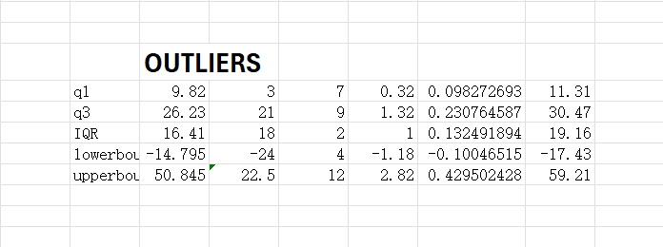

Field | Raw issue | Cleaned result
Location | 60 missing + inconsistent country/case labels | Standardized labels; missing values imputed with mode
InAppPurchaseAmount | 136 missing; extreme positive skew up to $4,964.45 | Median imputed; 2,964 outlier values capped at $50.845
FirstPurchaseDaysAfterInstall | 136 missing; extreme skew | Median imputed; 8,735 values capped at 22.5 days
PaymentMethod | 136 missing + detailed payment labels | Consolidated to Card, Wallet, CarrierBilling and Other
LastPurchaseDate | 136 missing | Standardized date format (YYYY-MM-DD); missing replaced with baseline date
PurchaseFrequencyPerMonth | High frequency outliers up to 11.66 | 1,835 outlier values capped at 2.82
OfferResponseRate | Extreme outliers up to 0.52; precision inconsistency | 958 values capped at 0.4295; 4-decimal precision normalized
LTV | 136 missing; extreme positive skew up to $5,994.12 | Median imputed; 3,172 outlier values capped at $59.21
5.3 Engagement
The Engagement dataset had zero missing records and zero duplicates. Outlier screening was executed across all numerical gameplay metrics:
PlayTimeHours: Q1 = 6.47, Q3 = 19.22, IQR = 12.75 → 2,446 values above the Upper Bound (38.35 hours) were capped.
AchievementsUnlocked: Q1 = 13.0, Q3 = 38.0, IQR = 25.0 → 708 values above the Upper Bound (75.5) were capped.
- InGamePurchases: Values range from 0 to 19 (Q1 = 0, Q3 = 1, Upper Bound = 2.5). Outlier capping was deliberately avoided under domain business logic, as purchases between 3 and 19 represent genuine high-value 'Whale' gamers rather than data capture errors.
- AvgSessionDurationMinutes & PlayerLevel: Both metrics fell completely within their natural statistical boundaries (10–179 min and 1–99 levels), requiring zero capping modifications.

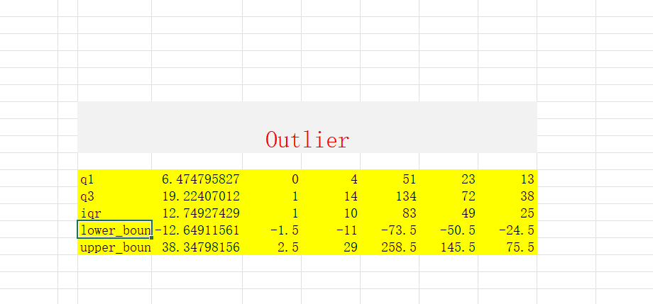

6. Data Structure & Key Attributes
Behavior Extensions
Attribute | Data type | Range / cardinality
PlayerID | object | 43,058 unique categories
Location | object | 8 unique categories
GameMode | object | 3 unique categories
PreferredPlaytimeWindow | object | 4 unique categories
ItemCategory | object | 4 unique categories

Monetisation
Attribute | Data type | Range / cardinality
PlayerID | object | 43,058 unique categories
Location | object | 8 unique categories
SpendingSegment | object | 3 unique categories
InAppPurchaseAmount_Treated | float64 | 0.00 to 50.85
FirstPurchaseDaysAfterInstall_Treated | float64 | 0.0 to 22.5
PaymentMethod | object | 4 unique categories
LastPurchaseDate | datetime64[ns] | 2025-01-01 to 2025-11-12
MonthsActive_Treated | int64 | 1 to 12
PurchaseFrequencyPerMonth_Treated | float64 | 0.00 to 2.82
OfferResponseRate_Treated | float64 | 0.0800 to 0.4295
DiscountSensitivity | int64 | 0 to 1
LTV_Treated | float64 | 0.00 to 59.21

Engagement
Attribute | Data type | Range / cardinality
PlayerID | object | 43,058 unique categories
Age | int64 | 15 to 49
Gender | object | 3 unique categories
Location | object | 8 unique categories
GameGenre | object | 9 unique categories
PlayTimeHours_Treated | float64 | 0.0001 to 38.35
InGamePurchases | int64 | 0 to 19
GameDifficulty | object | 3 unique categories
SessionsPerWeek | int64 | 0 to 19
AvgSessionDurationMinutes | int64 | 10 to 179
PlayerLevel | int64 | 1 to 99
AchievementsUnlocked_Treated | float64 | 0.0 to 75.5
EngagementLevel | object | 3 unique categories

7. Key Updates
7.1 Statistical Outlier Capping ($1.5 × IQR) & Justifications
- InAppPurchaseAmount: Upper bound calculated at $50.845 (Q1 = 9.82, Q3 = 26.23, IQR = 16.41). A total of 2,964 outlier records (values running up to $4,964.45) were capped to eliminate severe right-skewness.
- FirstPurchaseDaysAfterInstall: Upper bound calculated at 22.50 days (Q1 = 3.0, Q3 = 21.0, IQR = 18.0). Capped 8,735 records to normalize onboarding lifecycle metrics.
- PurchaseFrequencyPerMonth: Upper bound calculated at 2.82 purchases/month (Q1 = 0.32, Q3 = 1.32, IQR = 1.00). Capped 1,835 outlier records (values extending up to 11.66).
- OfferResponseRate: Upper bound calculated at 0.4295 (Q1 = 0.098, Q3 = 0.231, IQR = 0.132). Capped 958 records and normalized precision.
- LTV (Lifetime Value): Upper bound calculated at $59.21 (Q1 = 11.31, Q3 = 30.47, IQR = 19.16). Capped 3,172 outlier records (values extending up to $5,994.12).
- PlayTimeHours: Upper bound calculated at 38.35 hours (Q1 = 6.47, Q3 = 19.22, IQR = 12.75). Capped 2,446 extreme gameplay records.
- AchievementsUnlocked: Upper bound calculated at 75.50 achievements (Q1 = 13.0, Q3 = 38.0, IQR = 25.0). Capped 708 power-player records.
7.2 Metrics Retained Without Capping (Domain & Statistical Rationale)
- InGamePurchases (Retained 0 to 19): Despite the statistical upper bound being 2.5, 74.7% of players are non-buyers (0) and 19.1% bought only 1 item. The remaining 5.9% (3 to 19 purchases) represent legitimate 'Whale' (VIP) spending behavior. Capping them would destroy essential revenue segmentation data.
- AvgSessionDurationMinutes (10 to 179 minutes): The mathematical upper bound is 258.5 minutes; all actual data points fall naturally within bounds (0 outliers).
- PlayerLevel (Level 1 to 99): The mathematical upper bound is 145.5; all player levels fall naturally within bounds (0 outliers).
7.3 Imputation & Formatting Enhancements
- Replaced prior static imputation notes with Median Imputation across all numerical fields (InAppPurchaseAmount, FirstPurchaseDaysAfterInstall, LTV) to preserve authentic central tendencies.
- Documented explicit currency formatting ($), standard ISO date standardization (YYYY-MM-DD), and text casing normalization across Location and PaymentMethod.
8. Drafting Preliminary Business Hypotheses
Here are four structured, domain-aligned hypotheses based directly on the cleaned dataset observations:
Hypothesis 1: Engagement vs. Monetization Conversion
- Statement: Players with higher weekly gameplay hours (PlayTimeHours_Treated) and higher session frequency (SessionsPerWeek) have a significantly higher In-App Purchase spending amount (InAppPurchaseAmount_Treated).
- Business Objective: Determine whether game-loop stickiness directly converts into in-game purchases.
Hypothesis 2: Spending Tier vs. Offer Sensitivity
- Statement: Lower-tier spenders (Minnows) exhibit a significantly higher OfferResponseRate and DiscountSensitivity compared to Whales.
- Business Objective: Design targeted discounting strategies without cannibalizing full-price purchases from high-value players.
Hypothesis 3: Onboarding Speed vs. Player Lifetime Value (LTV)
- Statement: Players who make their first purchase early after installation (FirstPurchaseDaysAfterInstall_Treated ≤ 7 days) generate higher long-term LTV than late converters.
- Business Objective: Optimize first-week onboarding offers to accelerate early monetization.

Hypothesis 4: Demographics & Platform Preference
- Statement: Gameplay duration and spending segments vary significantly across geographic regions (Location) and preferred play times (PreferredPlaytimeWindow).
- Business Objective: Tailor regional marketing campaigns and time-limited in-game event drops.
9. Database Storage & Project Setup
To transition the cleaned and validated datasets into production storage for SQL querying, Python analytics, and dashboarding, a relational database (MySQL/SQLite) setup was executed.
9.1 Ingestion Methodology
- Cleaned datasets (PlayerEngagement, PlayerMonetisation, PlayerBehaviorExtensions) were exported from structured .xlsx to standardized UTF-8 .csv and relational database tables using the MySQL Table Data Import Wizard / Python SQLAlchemy pipeline (to_sql).
- Ensured 100% data integrity with 43,058 records loaded into each of the 3 tables without record duplication or loss.

Database table | Key | Purpose
PlayerEngagement | PlayerID | Player demographics, gameplay and engagement metrics
PlayerMonetisation | PlayerID | Spending, purchase, offer and LTV metrics
PlayerBehaviorExtensions | PlayerID | Game mode, preferred playtime and item-category behaviour

9.2 Git Repository
- Sayeda Husnain F · GitLab
- RAHUL PANDEY · GitLab
10. Phase 2 Completion Summary
Phase 2 establishes a cleaned, validated and analysis-ready foundation for the player analytics project. All three datasets contain 43,058 unique players linked through PlayerID. The major data-quality work was concentrated in Monetisation, where missing values, categorical inconsistencies and positively skewed numerical outliers were treated using median imputation, mode-based categorical treatment, standardized formatting and $1.5 × IQR upper-bound capping. Engagement outliers were assessed with domain-aware logic, retaining genuine high-value 'Whale' purchase behaviour.
The cleaned datasets are structured for relational database storage, SQL analysis, Python analytics and dashboard development. The four preliminary business hypotheses provide the analytical direction for subsequent phases.

