Frontend: Lab Assignment 2

Name : Abhinav Pandey
Section : NA
Roll No : 22515000006

Q1. Create webpage to display student's marksheet using table tag.
Code:
<!DOCTYPE html>
<html lang="en">
<head>
<meta charset="UTF-8">
<title>Student Marksheet</title>
<style>
body { font-family: Arial, Helvetica, sans-serif; background: #f2f2f2; padding: 30px; }
.marksheet { max-width: 650px; margin: auto; background: #fff; border: 2px solid #1f4e79; padding: 20px 30px; }
h1 { text-align: center; color: #1f4e79; margin-bottom: 5px; }
.sub { text-align: center; margin-bottom: 20px; color: #555; }
table { width: 100%; border-collapse: collapse; margin-top: 10px; }
th, td { border: 1px solid #1f4e79; padding: 8px 10px; text-align: center; }
th { background: #1f4e79; color: #fff; }
tr:nth-child(even) { background: #eef3f8; }
.info p { margin: 4px 0; font-size: 15px; }
.result { text-align: right; font-weight: bold; margin-top: 12px; color: #1f4e79; }
</style>
</head>
<body>
<div class="marksheet">
<h1>Student Marksheet</h1>
<p class="sub">Academic Year 2025 - 2026</p>

<div class="info">
<p><strong>Name:</strong> Abhinav Pandey</p>
<p><strong>Roll No:</strong> 22515000006</p>
<p><strong>Class:</strong> B.Tech - III Semester</p>
</div>

<table>
<tr>
<th>S.No</th>
<th>Subject</th>
<th>Max Marks</th>
<th>Marks Obtained</th>
<th>Grade</th>
</tr>
<tr>
<td>1</td>
<td>HTML &amp; CSS</td>
<td>100</td>
<td>92</td>
<td>A+</td>
</tr>
<tr>
<td>2</td>
<td>JavaScript</td>
<td>100</td>
<td>85</td>
<td>A</td>
</tr>
<tr>
<td>3</td>
<td>Bootstrap</td>
<td>100</td>
<td>88</td>
<td>A</td>
</tr>
<tr>
<td>4</td>
<td>Data Structures</td>
<td>100</td>
<td>78</td>
<td>B+</td>
</tr>
<tr>
<td>5</td>
<td>DBMS</td>
<td>100</td>
<td>81</td>
<td>A</td>
</tr>
<tr>
<th colspan="2">Total</th>
<th>500</th>
<th>424</th>
<th>A</th>
</tr>
</table>

<p class="result">Result: PASS &nbsp;|&nbsp; Percentage: 84.8%</p>
</div>
</body>
</html>

Output:
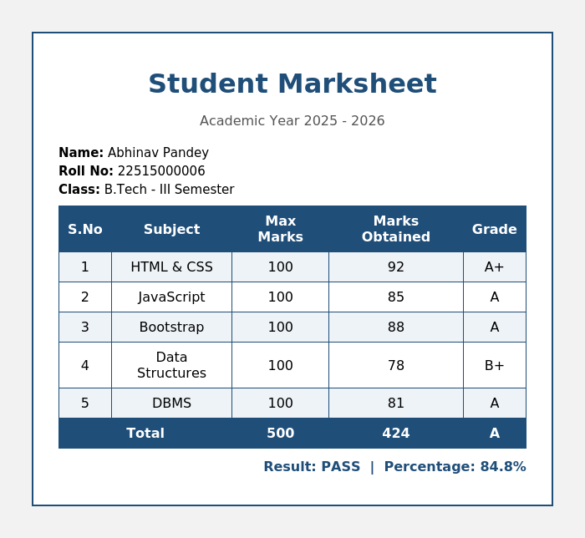
Q2. Create a web page in which display a resume.
Code:
<!DOCTYPE html>
<html lang="en">
<head>
<meta charset="UTF-8">
<title>Resume - Abhinav Pandey</title>
<style>
body { font-family: 'Segoe UI', Arial, sans-serif; background: #f7f7f7; padding: 25px; }
.resume { max-width: 700px; margin: auto; background: #fff; display: flex; box-shadow: 0 0 8px rgba(0,0,0,0.15); }
.sidebar { background: #1f4e79; color: #fff; width: 35%; padding: 25px 18px; }
.sidebar h2 { font-size: 16px; border-bottom: 1px solid #ffffff66; padding-bottom: 4px; margin-top: 22px; }
.sidebar p, .sidebar li { font-size: 13px; line-height: 1.5; }
.sidebar ul { padding-left: 18px; margin: 4px 0; }
.main { padding: 25px 22px; width: 65%; }
.main h1 { color: #1f4e79; margin-bottom: 0; }
.main .title { color: #555; margin-top: 2px; margin-bottom: 15px; }
.main h2 { color: #1f4e79; border-bottom: 2px solid #1f4e79; padding-bottom: 3px; font-size: 16px; margin-top: 18px; }
.main p, .main li { font-size: 13.5px; line-height: 1.5; }
.entry { margin-bottom: 10px; }
.entry .role { font-weight: bold; }
.entry .period { float: right; color: #777; font-size: 12px; }
</style>
</head>
<body>
<div class="resume">
<div class="sidebar">
<h2>Contact</h2>
<p><strong>Phone:</strong> +91-98XXXXXXXX</p>
<p><strong>Email:</strong> abhinav.pandey@example.com</p>
<p><strong>Location:</strong> Faridabad, Haryana, India</p>

<h2>Skills</h2>
<ul>
<li>HTML5 &amp; CSS3</li>
<li>JavaScript</li>
<li>Bootstrap</li>
<li>C / C++</li>
<li>MySQL</li>
</ul>

<h2>Languages</h2>
<ul>
<li>English</li>
<li>Hindi</li>
</ul>
</div>

<div class="main">
<h1>Abhinav Pandey</h1>
<p class="title">Frontend Web Development Student</p>

<h2>Objective</h2>
<p>Motivated computer science student seeking to apply strong front-end development skills to build responsive and user-friendly web applications.</p>

<h2>Education</h2>
<div class="entry">
<span class="role">Bachelor of Technology (B.Tech)</span>
<span class="period">2024 - 2027</span>
<p>Currently pursuing, Semester III</p>
</div>
<div class="entry">
<span class="role">Senior Secondary (XII)</span>
<span class="period">2024</span>
<p>Science Stream</p>
</div>

<h2>Projects</h2>
<div class="entry">
<span class="role">Student Marksheet Web Page</span>
<p>Built using HTML table tags to display academic results.</p>
</div>
<div class="entry">
<span class="role">Restaurant Menu Page</span>
<p>Designed a styled menu listing using HTML lists and CSS.</p>
</div>

<h2>Interests</h2>
<p>Web Development, UI Design, Reading Tech Blogs</p>
</div>
</div>
</body>
</html>

Output:
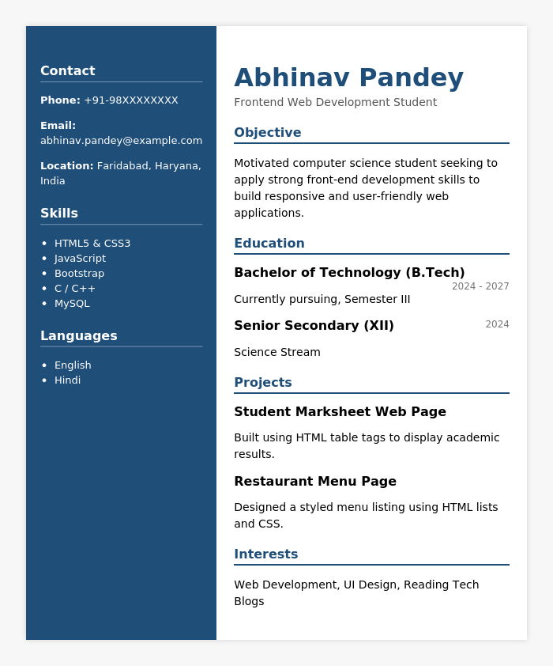
Q3. Create a menu of a restaurant using list.
Code:
<!DOCTYPE html>
<html lang="en">
<head>
<meta charset="UTF-8">
<title>Restaurant Menu</title>
<style>
body { font-family: Georgia, 'Times New Roman', serif; background: #fdf6ec; padding: 30px; }
.menu { max-width: 620px; margin: auto; background: #fffaf1; border: 3px double #8a5a2b; padding: 25px 35px; }
h1 { text-align: center; color: #8a5a2b; margin-bottom: 0; letter-spacing: 2px; }
.tagline { text-align: center; color: #a97b4f; margin-top: 4px; margin-bottom: 25px; font-style: italic; }
h2 { color: #8a5a2b; border-bottom: 1px solid #cba874; padding-bottom: 4px; margin-top: 22px; }
ul { list-style: none; padding: 0; }
ul li { display: flex; justify-content: space-between; padding: 6px 0; font-size: 15px; border-bottom: 1px dotted #d8c3a5; }
.item-name { color: #333; }
.price { color: #8a5a2b; font-weight: bold; }
.sub { display: block; font-size: 12px; color: #888; font-style: italic; }
</style>
</head>
<body>
<div class="menu">
<h1>The Green Fork</h1>
<p class="tagline">— Multi-Cuisine Restaurant —</p>

<h2>Starters</h2>
<ul>
<li><span class="item-name">Veg Spring Rolls</span><span class="price">₹150</span></li>
<li><span class="item-name">Paneer Tikka</span><span class="price">₹220</span></li>
<li><span class="item-name">Chicken Wings</span><span class="price">₹280</span></li>
</ul>

<h2>Main Course</h2>
<ul>
<li><span class="item-name">Butter Chicken<span class="sub">Served with naan/rice</span></span><span class="price">₹320</span></li>
<li><span class="item-name">Paneer Butter Masala</span><span class="price">₹260</span></li>
<li><span class="item-name">Veg Biryani</span><span class="price">₹240</span></li>
<li><span class="item-name">Dal Makhani</span><span class="price">₹200</span></li>
</ul>

<h2>Beverages</h2>
<ul>
<li><span class="item-name">Fresh Lime Soda</span><span class="price">₹90</span></li>
<li><span class="item-name">Cold Coffee</span><span class="price">₹120</span></li>
<li><span class="item-name">Masala Chai</span><span class="price">₹60</span></li>
</ul>

<h2>Desserts</h2>
<ul>
<li><span class="item-name">Gulab Jamun (2 pcs)</span><span class="price">₹100</span></li>
<li><span class="item-name">Chocolate Brownie</span><span class="price">₹150</span></li>
</ul>
</div>
</body>
</html>

Output:
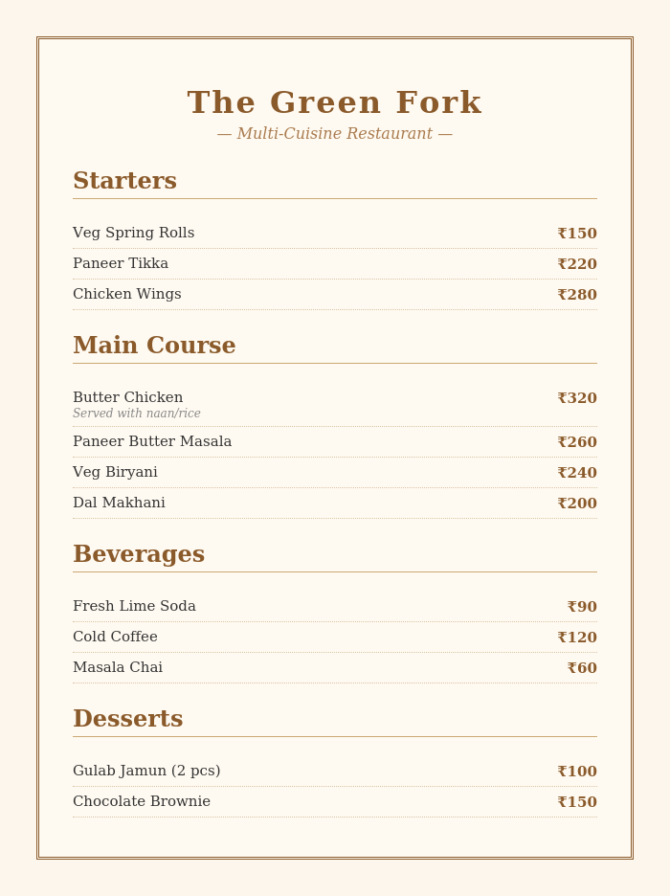
Q4. Create a registration form with text, email, password, radio buttons, checkboxes, a dropdown, and a submit button — using proper <label> and for attributes.
Code:
<!DOCTYPE html>
<html lang="en">
<head>
<meta charset="UTF-8">
<title>Registration Form</title>
<style>
body { font-family: Arial, Helvetica, sans-serif; background: #eef3f8; padding: 25px; }
.form-box { max-width: 480px; margin: auto; background: #fff; border-radius: 8px; padding: 25px 30px; box-shadow: 0 0 8px rgba(0,0,0,0.15); }
h1 { text-align: center; color: #1f4e79; font-size: 22px; margin-bottom: 20px; }
.field { margin-bottom: 14px; }
label { display: block; font-weight: bold; font-size: 14px; margin-bottom: 4px; color: #333; }
input[type="text"], input[type="email"], input[type="password"], select {
width: 100%; padding: 8px 10px; border: 1px solid #bbb; border-radius: 4px; font-size: 14px; box-sizing: border-box;
}
.inline-group label { display: inline-block; font-weight: normal; margin-right: 15px; }
.inline-group input { margin-right: 4px; }
.checkbox-group label { display: inline-block; font-weight: normal; margin-right: 15px; }
.checkbox-group input { margin-right: 4px; }
button { width: 100%; padding: 10px; background: #1f4e79; color: #fff; border: none; border-radius: 4px; font-size: 15px; margin-top: 10px; cursor: pointer; }
</style>
</head>
<body>
<div class="form-box">
<h1>Registration Form</h1>
<form action="#" method="post">

<div class="field">
<label for="fullname">Full Name</label>
<input type="text" id="fullname" name="fullname" placeholder="Enter your full name" required>
</div>

<div class="field">
<label for="email">Email Address</label>
<input type="email" id="email" name="email" placeholder="example@mail.com" required>
</div>

<div class="field">
<label for="password">Password</label>
<input type="password" id="password" name="password" placeholder="Enter password" required>
</div>

<div class="field">
<label>Gender</label>
<div class="inline-group">
<label for="male"><input type="radio" id="male" name="gender" value="male" checked>Male</label>
<label for="female"><input type="radio" id="female" name="gender" value="female">Female</label>
<label for="other"><input type="radio" id="other" name="gender" value="other">Other</label>
</div>
</div>

<div class="field">
<label>Hobbies</label>
<div class="checkbox-group">
<label for="reading"><input type="checkbox" id="reading" name="hobbies" value="reading">Reading</label>
<label for="sports"><input type="checkbox" id="sports" name="hobbies" value="sports" checked>Sports</label>
<label for="music"><input type="checkbox" id="music" name="hobbies" value="music">Music</label>
</div>
</div>

<div class="field">
<label for="country">Country</label>
<select id="country" name="country">
<option value="india">India</option>
<option value="usa">USA</option>
<option value="uk">UK</option>
<option value="canada">Canada</option>
</select>
</div>

<button type="submit">Register</button>
</form>
</div>
</body>
</html>

Output:
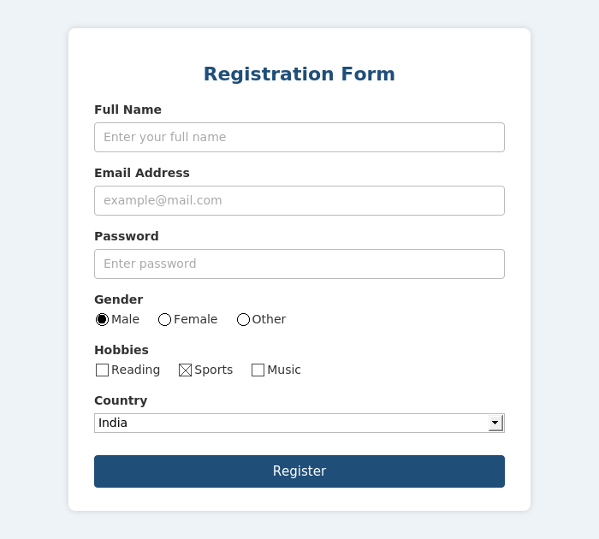
Q5. Create a login page
Code:
<!DOCTYPE html>
<html lang="en">
<head>
<meta charset="UTF-8">
<title>Login Page</title>
<style>
body {
font-family: Arial, Helvetica, sans-serif;
background: linear-gradient(135deg, #1f4e79, #4a90c2);
padding: 60px 25px;
margin: 0;
}
.login-box {
max-width: 340px; margin: auto; background: #fff; border-radius: 10px;
padding: 30px 28px; box-shadow: 0 4px 15px rgba(0,0,0,0.25); text-align: center;
}
.login-box h1 { color: #1f4e79; margin-bottom: 5px; font-size: 22px; }
.login-box p.sub { color: #777; margin-top: 0; margin-bottom: 20px; font-size: 13px; }
.field { margin-bottom: 14px; text-align: left; }
label { display: block; font-weight: bold; font-size: 13px; margin-bottom: 4px; color: #333; }
input[type="text"], input[type="password"] {
width: 100%; padding: 9px 10px; border: 1px solid #ccc; border-radius: 5px; font-size: 14px; box-sizing: border-box;
}
.options { display: flex; justify-content: space-between; font-size: 12px; margin-bottom: 15px; }
.options a { color: #1f4e79; text-decoration: none; }
button {
width: 100%; padding: 10px; background: #1f4e79; color: #fff; border: none;
border-radius: 5px; font-size: 15px; cursor: pointer;
}
.signup { margin-top: 15px; font-size: 13px; color: #555; }
.signup a { color: #1f4e79; font-weight: bold; text-decoration: none; }
</style>
</head>
<body>
<div class="login-box">
<h1>Welcome Back</h1>
<p class="sub">Login to your account</p>
<form action="#" method="post">
<div class="field">
<label for="username">Username</label>
<input type="text" id="username" name="username" placeholder="Enter username" required>
</div>
<div class="field">
<label for="password">Password</label>
<input type="password" id="password" name="password" placeholder="Enter password" required>
</div>
<div class="options">
<label for="remember"><input type="checkbox" id="remember" name="remember"> Remember me</label>
<a href="#">Forgot password?</a>
</div>
<button type="submit">Login</button>
</form>
<p class="signup">Don't have an account? <a href="#">Sign up</a></p>
</div>
</body>
</html>

Output:
