**Manual Testing (Alberta Science Park)**

**Testing Of Urls** — To check whether each URL is correctly mapped to its corresponding view. We discover that all urls function correctly. And following the testing, I used Django coverage to assess the overall accuracy for the urls.py file. Django Coverage is a library that gives us the overall percentage of testing accuracy. Additionally, the overall accuracy is 100%.

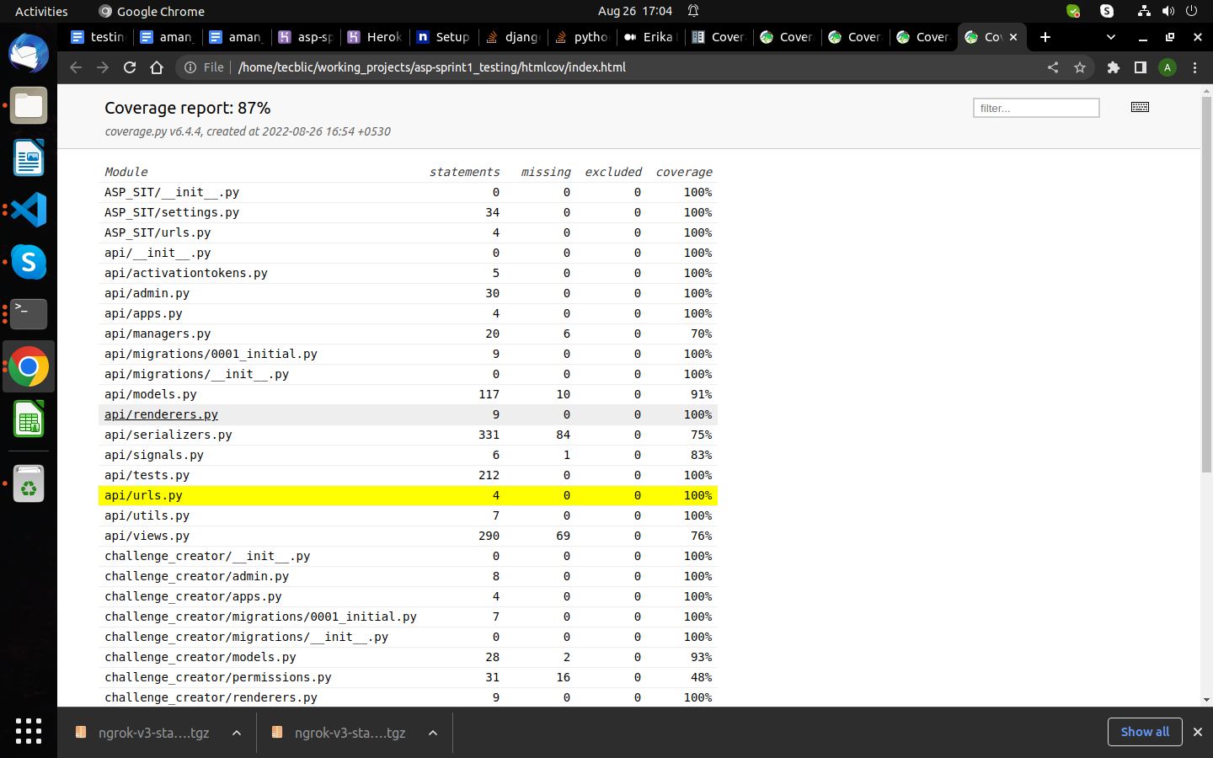

**Testing of challenge creator Urls** — To check whether each URL is correctly mapped to its corresponding view. We discover that all urls function correctly. And following the testing, I used Django coverage to assess the overall accuracy for the urls.py file. Django Coverage is a library that gives us the overall percentage of testing accuracy. Additionally, the overall accuracy is 100%.

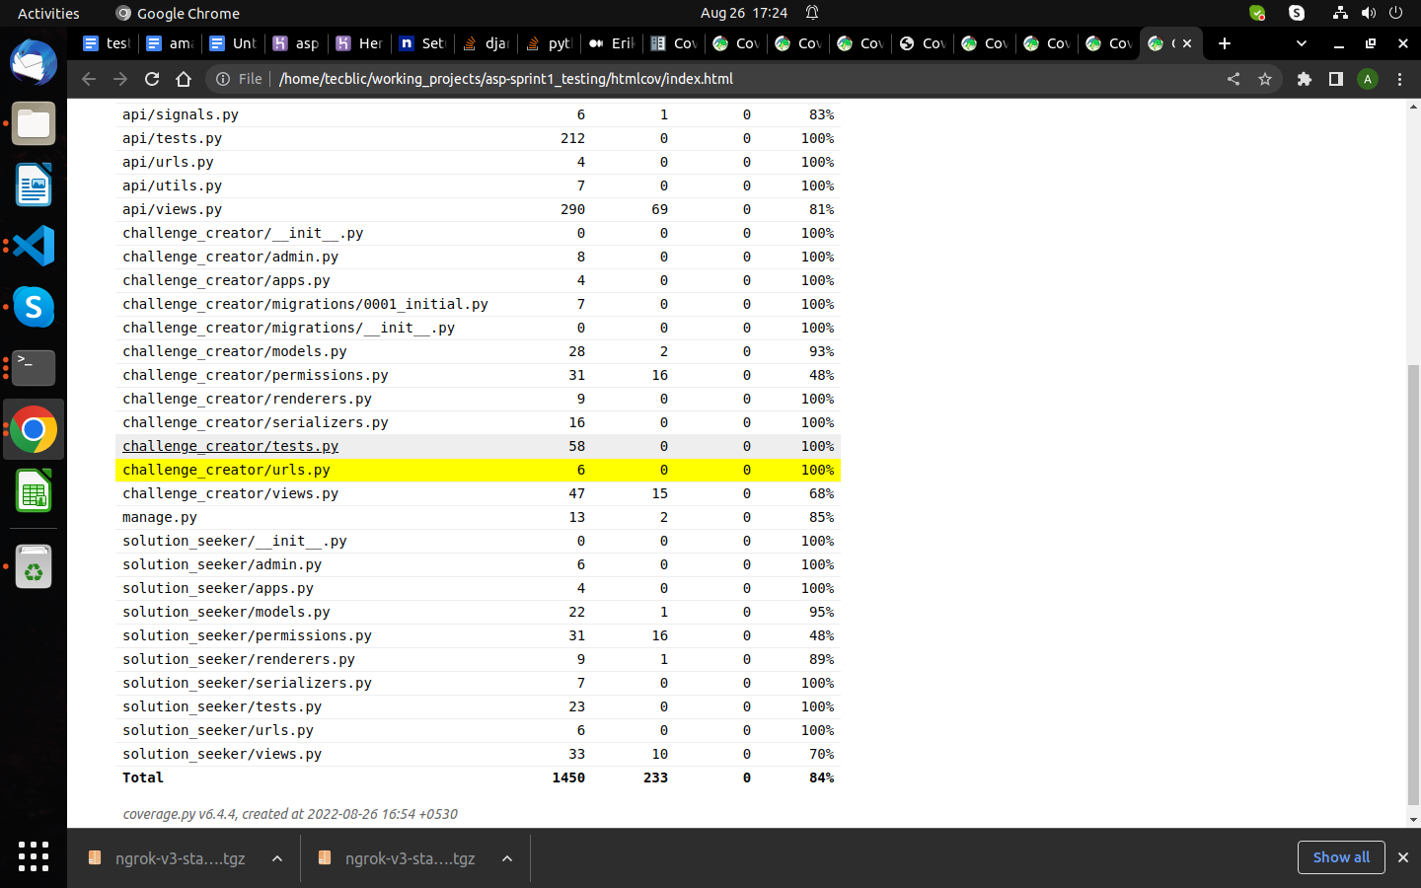

**Testing of solution seeker Urls** — To check whether each URL is correctly mapped to its corresponding view. We discover that all urls function correctly. And following the testing, I used Django coverage to assess the overall accuracy for the urls.py file. Django Coverage is a library that gives us the overall percentage of testing accuracy. Additionally, the overall accuracy is 100%.

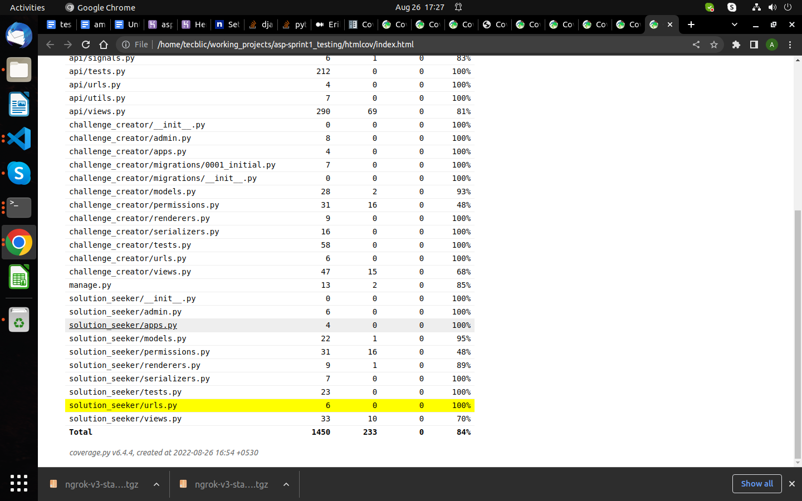

**Testing of Views** – To confirm that each view is functioning properly. Every view stores data in the database and retrieves data from the database. The coverage report for the views.py file is 80%.

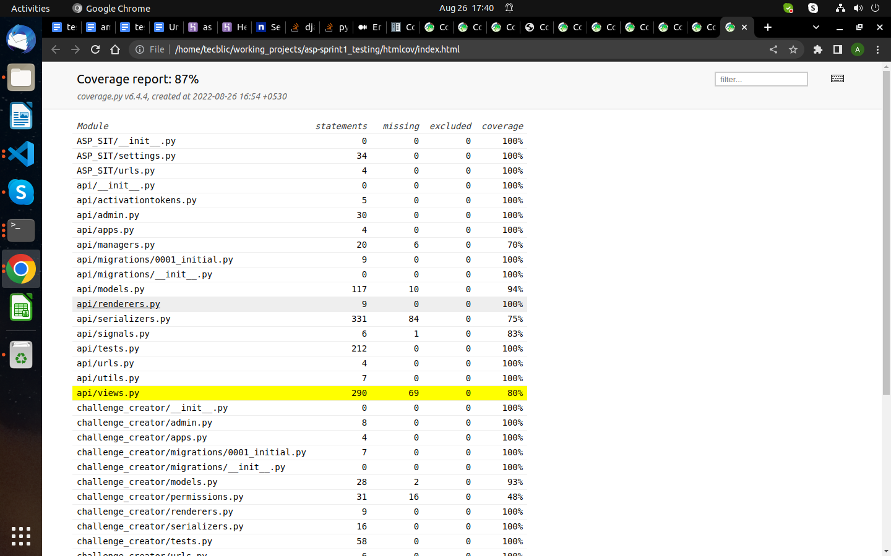

**Testing of challenge creator Views** – To confirm that each view is functioning properly. Every view stores data in the database and retrieves data from the database. The coverage report for the views.py file is 84%.

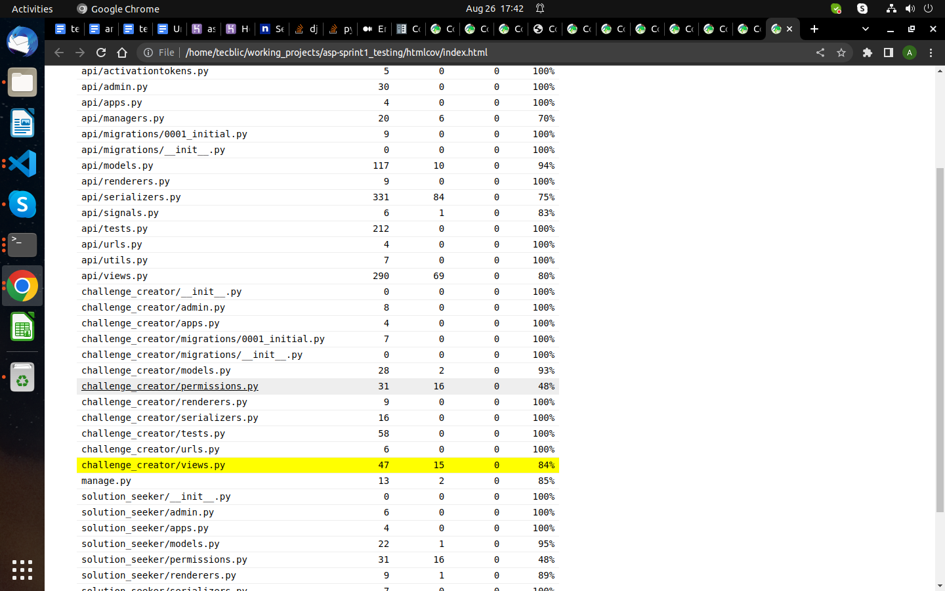

**Testing of solution seeker Views** – To confirm that each view is functioning properly. Every view stores data in the database and retrieves data from the database. The coverage report for the views.py file is 79%.

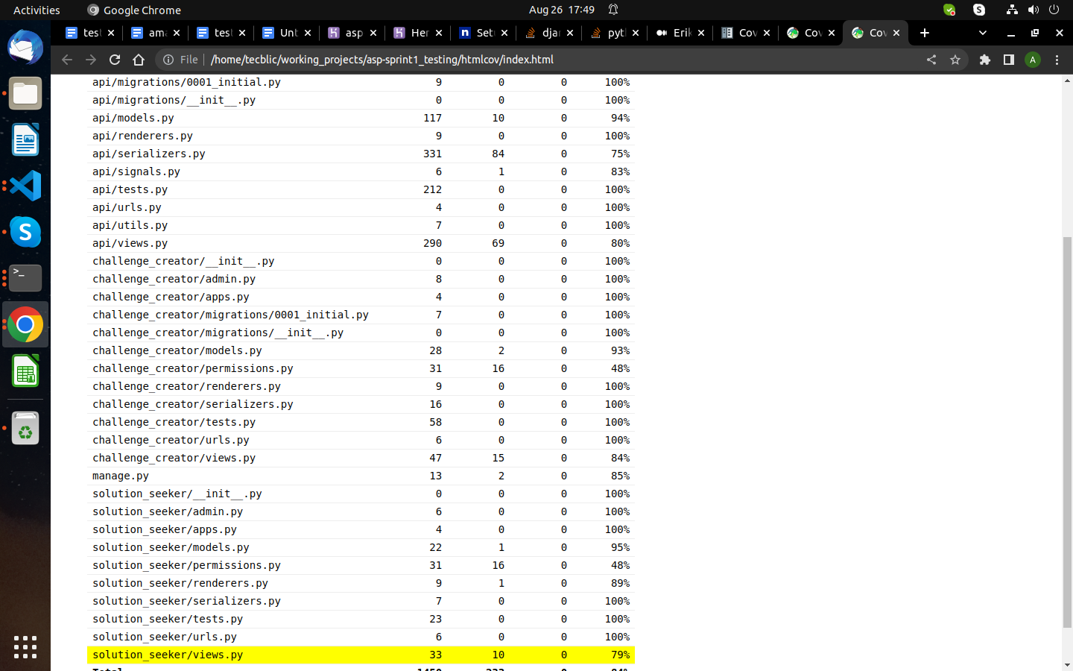

**Testing of Model –** To verify that all models for building databases and tables are functioning properly.coverage report for models.py file is 93%

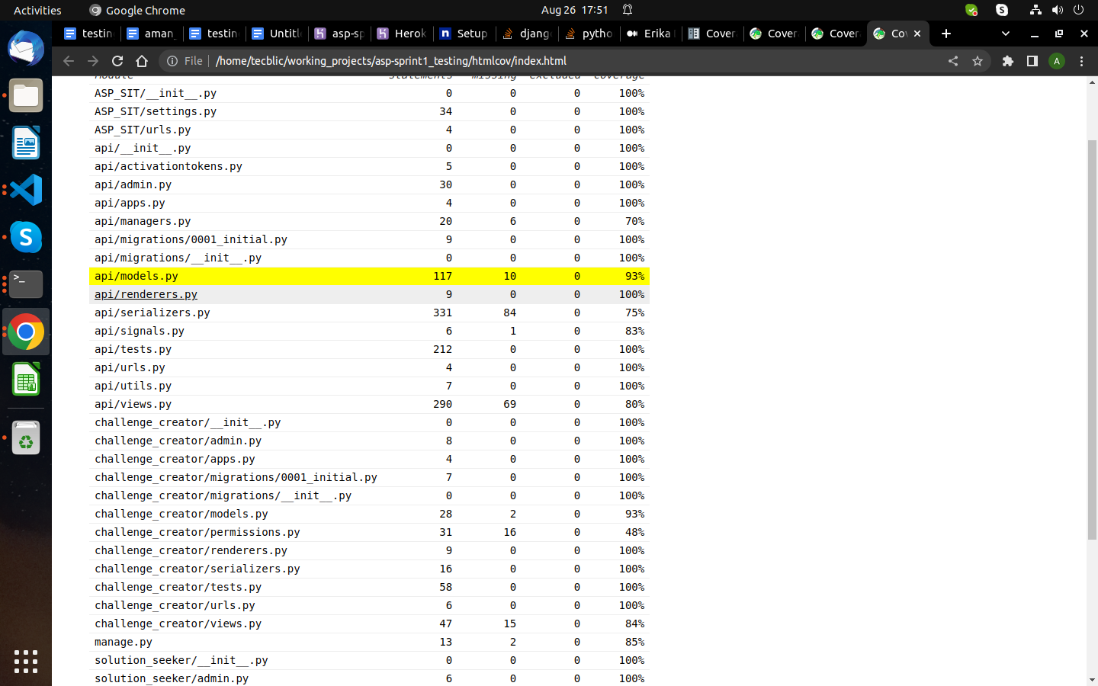

**Testing of challenge creator Model –** To verify that all models for building databases and tables are functioning properly.coverage report for models.py file is 95%.

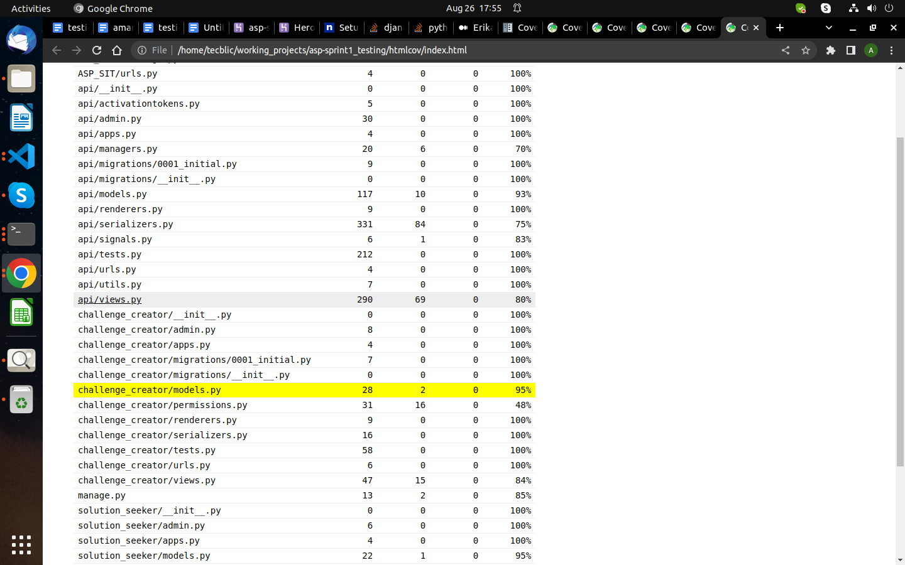

**Testing of solution seeker Model –** To verify that all models for building databases and tables are functioning properly.coverage report for models.py file is 91%.

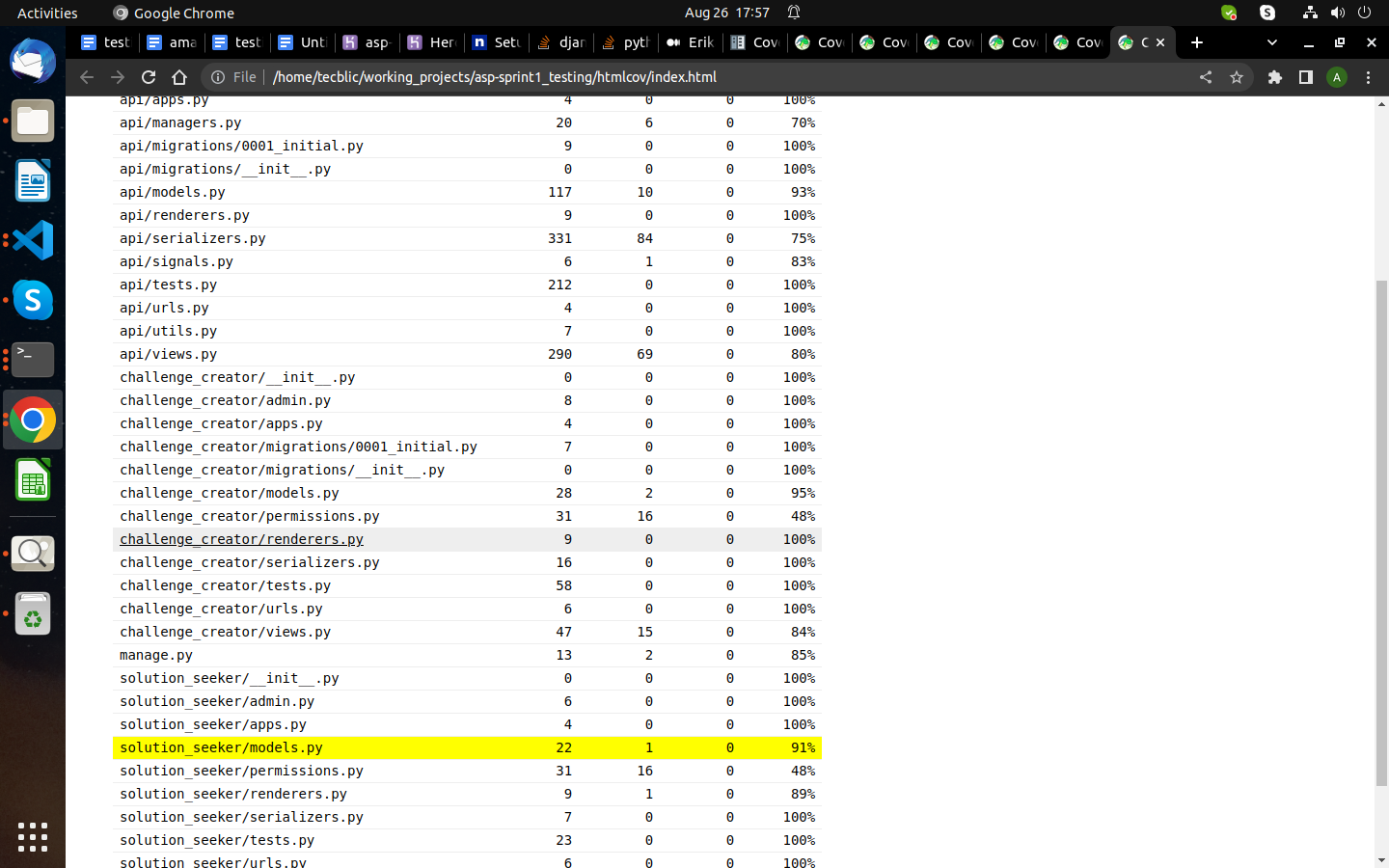

**Final Report For Sprint 4**

Final coverage report for sprint 4 is 86%.