**Manual Testing (Alberta Science Park)**

**Testing Of Urls** — To check whether each URL is correctly mapped to its corresponding view. We discover that all urls function correctly. And following the testing, I used Django coverage to assess the overall accuracy for the urls.py file. Django Coverage is a library that gives us the overall percentage of testing accuracy. Additionally, the overall accuracy is 100%.

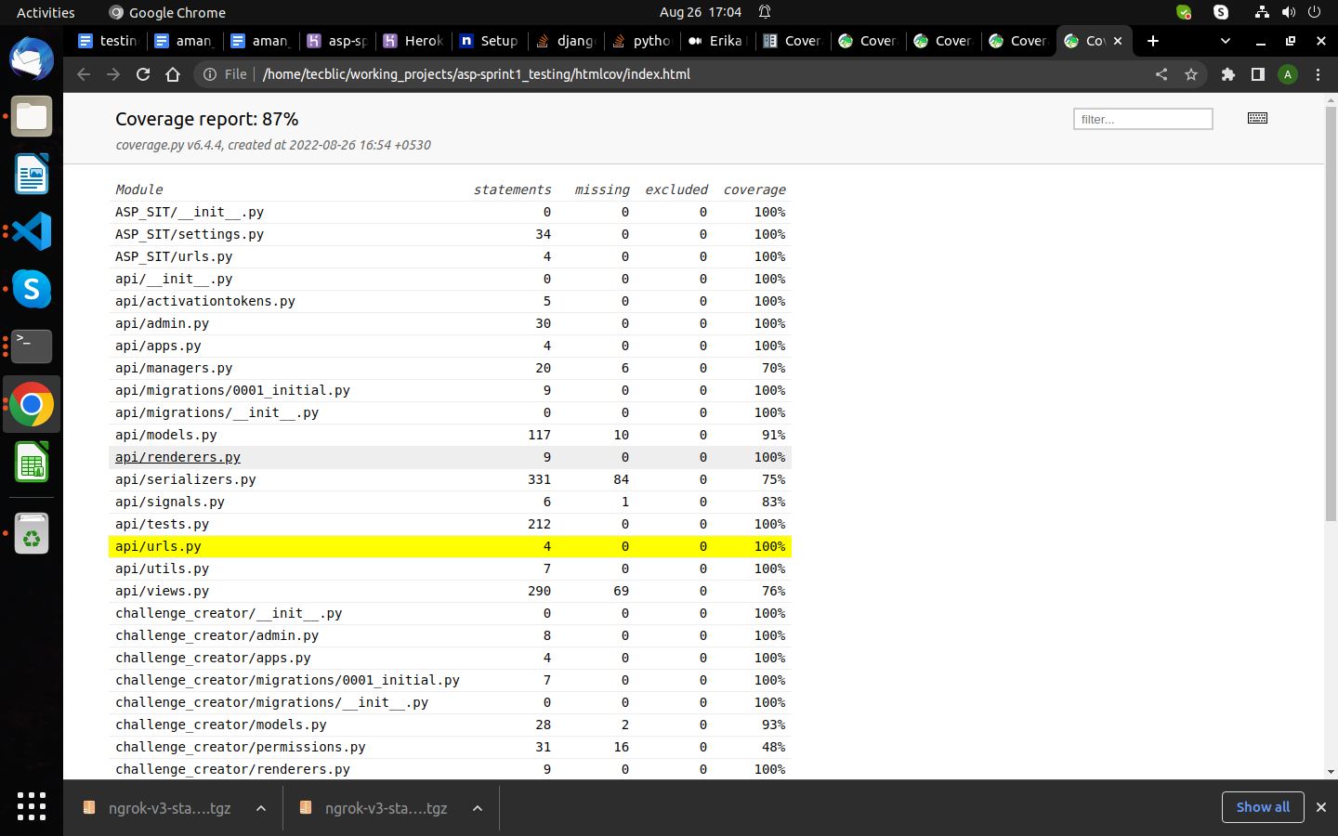

**Testing of Views** – To confirm that each view is functioning properly. Every view stores data in the database and retrieves data from the database. The coverage report for the views.py file is 81%.

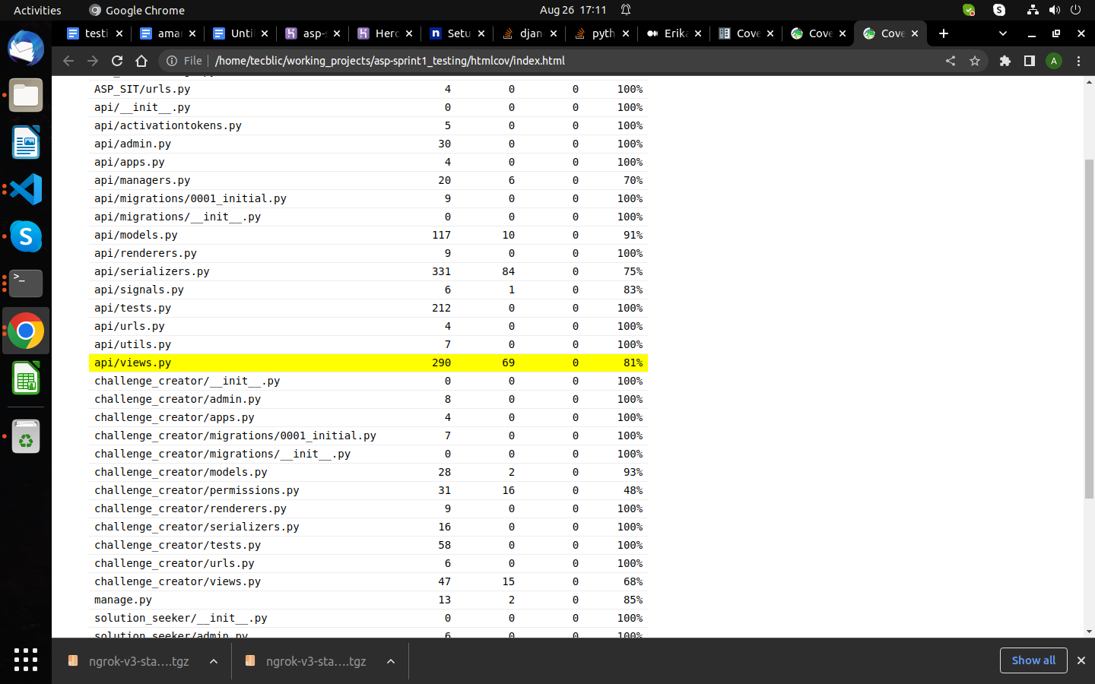

**Testing of Model –** To verify that all models for building databases and tables are functioning properly.coverage report for models.py file is 94%

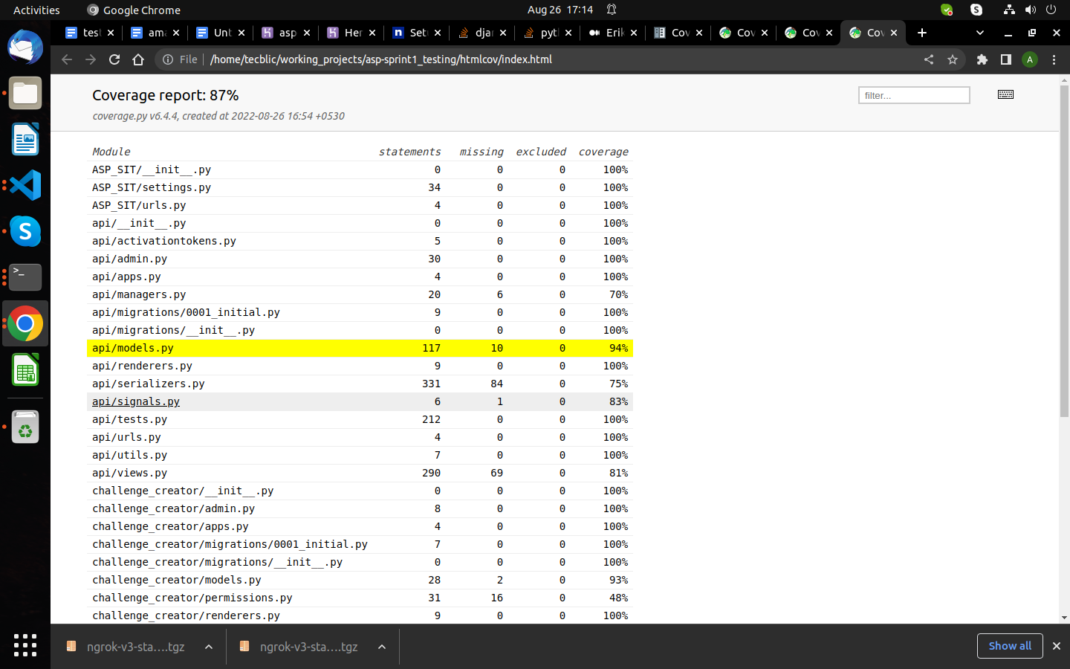

**Final Report For Sprint 3**

Final coverage report for sprint 3 is 87%.