**Nagarjuna College Of Information Technology**

**HariharBhawan,Lalitpur**

**Lab On DBA**

**LAB 2**

**Submitted By: -**

**Daniel Tamang**

**Roll No: - 07**

**BSc. CSIT 7th**

Daniel Tamang

**Multiplexing**

It is the process of maintaining more than one copy of file. The process of maintaining more than one member in each redolog groups is called multiplexing of redolog. Multiplexing of redolog files are usually done in mount mode.

The process of copying control file in different location and specifying the path in parameter file is called multiplexing of control file. Oracle allows at most 8 multiplex of control files. The database has to be in nomount mode when multiplexing control file.

Multiplexing helps in preventing loss of single copy of files.

**1. Monitor log file**

View group,member,sequence and status from log file

SQL> select group#,members,sequence#,status from V$log;

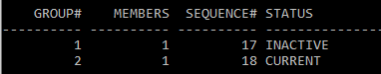

View group and member from log file

SQL> select group#,member from v$logfile;

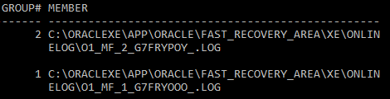

**2. Add group**

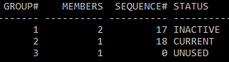

**3. Add member to group**

SQL> alter database add logfile member 'C:\oraclexe\app\oracle\oradata\XE\onlinelog\redo01.log' to group 1;

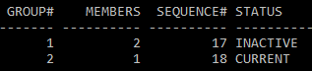

**4. Rename member in the group**

SQL> alter database rename file 'C:\oraclexe\app\oracle\oradata\XE\onlinelog\redo03.log' to 'C:\oraclexe\app\oracle\oradata\XE\onlinelog\redo03_b.redo';

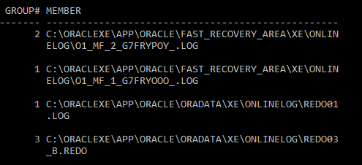

**5. Drop group**

SQL> alter database drop logfile group 3;

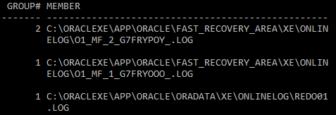

**6. Drop member**

SQL> alter database drop logfile member 'C:\oraclexe\app\oracle\oradata\XE\onlinelog\redo01.log';

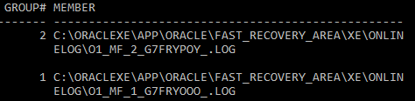

**7. Observe the status and sequence of the log file**

SQL> select group#,members,sequence#,status from V$log;

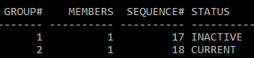

**8. Switch the log file for altering the status**

SQL> alter system switch logfile;

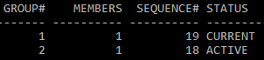

**9. View control file**

SQL> show parameter control;

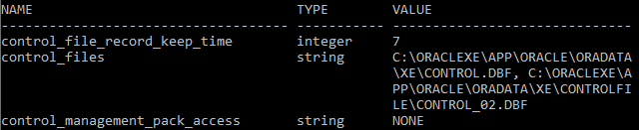

**6. Create new control file**

SQL> alter system set control_files='C:\oraclexe\app\oracle\oradata\XE\control.dbf','C:\oraclexe\app\oracle\oradata\XE\controlfile\control_02.dbf','C:\oraclexe\app\oracle\oradata\XE\controlfile\control_03.dbf' scope=spfile;

