Table Of Contents

1 Problem Definition 1

2 Objectives 2

3 Scope 2

4 Literature review 3

5 Requirement analysis 5

5.1 Functional Requirement 5

5.2 Feasibility Study 6

5.2.1 Economic Feasibility 6

5.2.2 Operational Feasibility 6

5.2.3 Technical Feasibility 6

6.3 Timeline / Estimated Time Schedule 7

6.4 Structuring System Requirements 7

6.4.1 Data Modeling 8

7 System Design 9

7.1 Database Schema Design 9

7.2 Interface Design 9

7.3 Flow Chart 11

8 Implementation 13

8.1.1 HTML, CSS, BOOTSTRAP 13

8.1.2 Python, Django and VSCode 13

8.1.3 SQLite and SciPy 13

8.1.4 Edraw Max 13

8.2 Algorithm Implementation 14

9 Expected Outcome: 16

References 17

Recommendation System keeps growing in popularity in the world of machine learning and predictive modeling. Recommendation Engine is our USP. This platform helps trekkers get to know about the unexplored, must visit trekking destinations and providing a platform to decide where to go for a trek in Nepal. It is the system where the recommendation is based on location service with the help of google map latitude and longitude. The system uses the current geolocation of the user and grabs the necessary information. The recommendation is the main task performed in this system, which takes input from users and does recommendations. Recommendation of travelling destination is based on current geolocation, users desire trekking days, trekking type, destination type, accommodation type, temperature, security, and level of difficulty.

The other business areas which have adopted the Recommendation System approach include social networking sites (Facebook, Instagram etc.), search engines, restaurants, insurance companies, online dating among countless others.

# Problem Definition

People obtained suggestions for their personal tourism from their friends or travel agencies. Such traditional sources are user-friendly; however, they have serious limitations. First, the suggestions from friends are limited to those places they have visited before. Second, the information from travel agencies is sometime biased since agents tend to recommend businesses they are associated with. Even worse, when users plan their travel by themselves. In the country like Nepal, the situation is even worse and there is an immediate need to introduce IT as the Tourism industry is the major backbone for the country’s economy. To give a user an efficient and fast recommender alongside a proper website with information about the popular destination as well as yet to be discovered destination. This system well addresses the problem of the need to boost IT development in tourism, give a proper and efficient recommendation.

# Objectives

Basically, the Recommender system as software tools and techniques provide users with suggestions for things a user may wish to utilize. And the basic theme of GO TRAVELLERS is to function as a recommender system. With this objective of the project can be inferred as:

* To develop a Tourism Recommendation System based on their interests and past records
* To reduce the time and cost of the travelling,
* To make clients more confident about the trip, and
* To guide the clients during their trip.

# Scope

Web-based applications, informative sites etc. in tourism have been a source for visitors to travel across countries and places. Platform with information and recommendation both embedded to one will be preferable. Especially in the country blessed with beauty like Nepal, but with very few information on the web, this system can appear as a boon of people eager to know about Nepal and travel here to get hypnotized in its beauty. And what can be more rejoiceful when the system comes with such a recommendation for a place to be visited based on interests along with a digital guide?

With all these features place into one, and with the feasibility of rating the places visited, what can a Tourist ask for more than being his travel agent on his own?

# Literature review

This work aims to build a system to suggest tourist destinations based on visual matching and minimal user input. A user can provide either a photo of the desired scenary or a keyword describing the place of interest, and the system will look into its database for places that share the visual characteristics. To that end, we first cluster a large-scale geotagged web photo collection into groups by location and then find the representative images for each group. Tourist destination recommendations are produced by comparing the query against the representative tags or representative images under the premise of "if you like that place, you may also like these places". [1].

In the era of the Web, the problem of information overload is continuously expanding. A common scenario is when people get too much irrelevant information alongside relevant ones as a response to queries posed on the Internet. This paper introduces “TODERES” which is a web based prototype recommendation system that allows tourists to discover interesting Greek travel destinations that fit with their preferences combining information such as personal interests, accommodation and travel mode. The proposed system is created by employing various tourism-related photographs of places and activities taking place at Greece and by using Case-based Reasoning algorithm. [2].

The development of and adoption rate of mobile technologies are increasing rapidly on a global scale. M-learning (mobile learning) is consequently an emerging concept as educationists are starting to explore more and more with mobile technologies in teaching and learning environments. Already, there are numerous applications for mobile technologies in education – from the ability to wirelessly transmit learning modules and administrative data, to enabling learners to communicate with lecturers and peers. The success and impact of m- learning does not, however, solely depend on the technological developments and the possibilities they provide. The ability of educationists to design and develop didactical sound m-learning opportunities and environments that enhances learning is imperative. It is therefore not only important to understand contemporary learning theory, but also to identify those applications of mobile technologies that contribute to the optimising of teaching and learning in the new learning environments. [3]

The Indian tourism and hospitality industry has emerged as one of the key drivers of growth among the services sector in India. Hospitality is the relationship between a guest and a host. Hospitality is the act or practice of being hospitable. Tourism and hospitality industry are related to each other. Hospitality is the act of welcoming, receiving, hosting or entertaining the guest. It involves ward and generous welcome of the tourist. This study is framed to analyze the usage of online platforms to book hotels online spread across South of India. It is an attempt to draw out results from the online hotel booking users, awareness on online hotel booking, and their satisfaction levels and to measure their priorities while booking a hotel online. With the introduction of peer to peer hospitality services which will bring a potential dynamic dimension to the hospitality industry, this study aims to find out whether the online users will prefer this community based hospitality services or not. [4]

The goal of this research is to design and implement an intelligent platform that will aid tourists in Nepal to have access to information on travelling destinations thus help fasten their decision-making process.

So “GO TRAVELLERS” is not an invented concept but with lot more innovation to existing ones but with support and suggestions taken from them.

# Requirement analysis

While developing a system and before implementing it, it is necessary to analyze the whole system requirements. It is categorized into mainly two parts, namely: functional and non- functional requirements.

## Functional Requirement

A functional requirement describes what software should do when it is given input. Some of the functional requirements are:

* The system will do the recommendation.
* The system will allow a user to choose parameters.

Use case diagram for this system is given below;

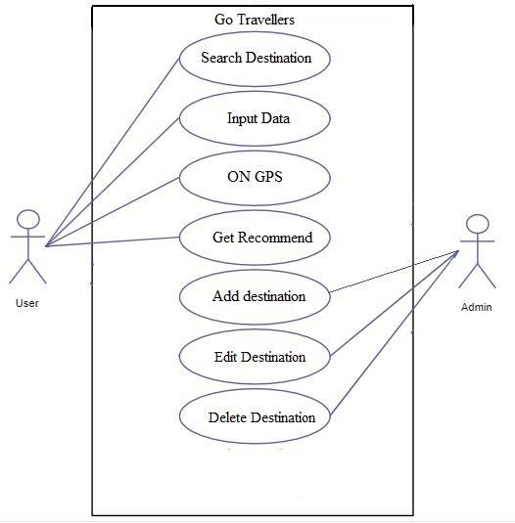

Fig 6.1 : - Use case diagram of the proposed system

# Feasibility Study

Feasibility analysis is a part of system analysis carried to confirm that the system is developing is actually feasible or not. This is the phase where any system designers are able to know whether to start the project or not.

We performed some study and analyzed the system and get to know that it is feasible to make the system. Mainly four types of feasibility studies were done with this system analysis, namely: Economic feasibility, Operational feasibility, Technical feasibility, and Schedule Feasibility.

## Economic Feasibility

Developing and deploying this system will have a very little economical cost. All the resources required to develop this system are computers and some hotel information.

For development, PCs that support any Operating System with some applications is sufficient. For deployment, a smart phone or PC with internet is required. During data collection too, not much cost was spent and same with time as well. Further, it does not cost much to develop and access this system and hence, we can say it is economically feasible to develop the system.

## Operational Feasibility

The proposed project is beneficial only if they are feasible into the real world implemented system, which will meet the user requirements. This system provides a simple user interface, which can be easily used by any type of users having a basic idea of using smartphones and PCs. This system will provide correct results according to the way the system needs to do. Hence, this system is operationally feasible too.

## Technical Feasibility

We can say that the current web application we are building is technically feasible. This system is built using simple programming language and design, which can be used by any users and can get a better place, which contains information regarding different services. It will run on all the existing web browsers with the latest version and even in smartphones.

# Timeline / Estimated Time Schedule

A system is said to be scheduled feasible if it is implemented within the planned scheduled. We carried out the study on how much it will take to complete the task after studying the requirements and proposed plan.

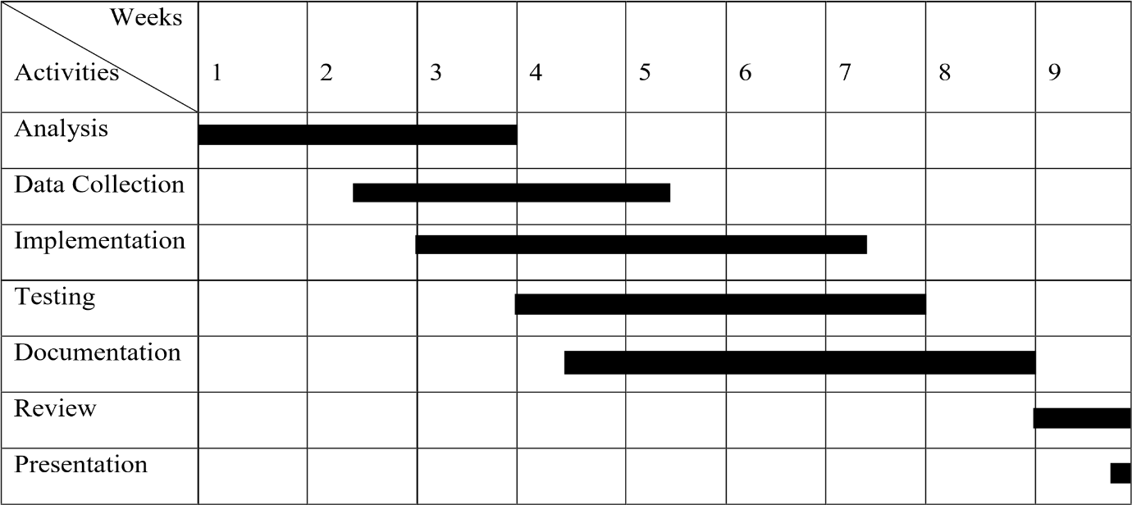

Figure: 6.3 Gantt chart for proposed system

We have proposed a rough timeline so that it would help us perform our different project activities. Following Gantt chart shows the proposed schedule to perform the project.

# Structuring System Requirements

Giving structure to system requirements will help to get a better idea about the system process and to know how the system actually works. Different models can be designed to represent the system and show the flow of data in different part of the system.

In this project, there will be no more than one table, so entity relation is not possible. In order to describe the workflow of our system, a simple block diagram is made.

## 6.4.1 Data Modeling

The block diagram would contain different parts of the system and their workflow. The following figures shows the block diagram.

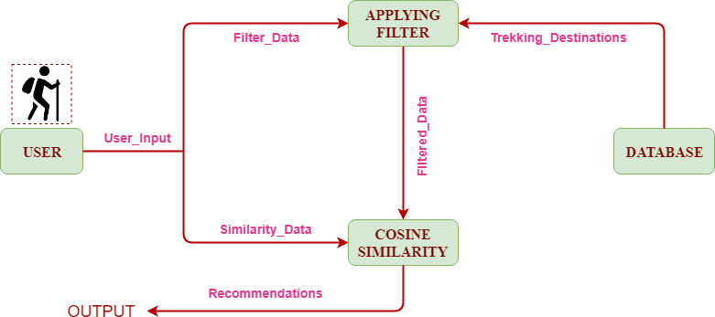

Figure 6.4.1 Block Diagram of the system

# System Design

This phase contains diagrams and designs that help to know about the overall process in the system. Some of the designs are described below.

## Database Schema Design

Database Schema Design is the overall representation of database tables in a way that represent all the co-relations between them.

**Table 7.1**: Destination table

|  |  |
| --- | --- |
| **Attributes** | **Data Types** |
| Title | CharField( ) |
| Slug | CharField( ) |
| Image | FileField( ) |
| Content | HTMLField( ) |
| Temperature | FloatField ( ) |
| Altitude | FloatField ( ) |
| Difficulty | FloatField ( ) |
| Security | FloatField ( ) |
| TravellingType | CharField( ) |

Fig 7.1 : - Table of Destination

## Interface Design

This is the way of representing how the system looks and how the data flow in the system along with the reference of the screen being displayed. There will be three parts in the design. Top part

represents the current screen number, the middle one represents the screen title or description and the bottom one represents the location of screen, which references the current screen. Here, after opening the system, the tasks that are done in the system are represented below:

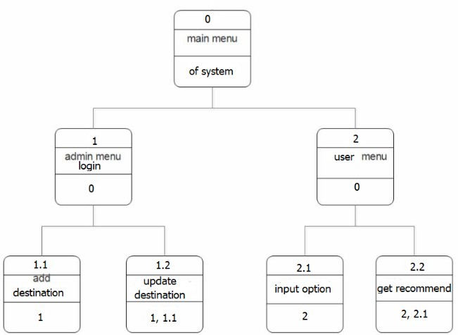

Fig 7.2: - Different interfaces of the system

# Flow Chart

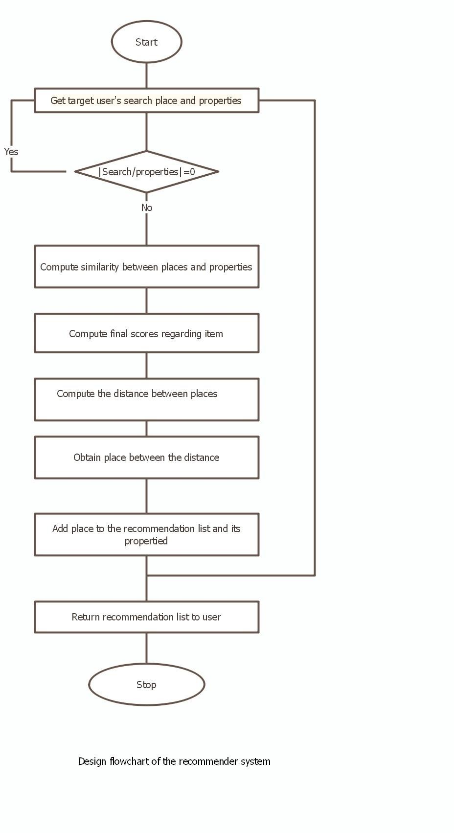

In this application, following steps are going to be followed to create our recommendation system.

STEP 1: In the first step, user searches the destination according to their desired trip types. If search box is empty then it will do nothing.

STEP 2: After searching place, comparison between the places and its property is done.

STEP 3: Latitude and longitude of entered place and places that are stored in our dataset are compared. The place closer to the user's current location is suggested.

STEP 4: Once destination place is analyzed, the system will fetch point of interest of that place. To fetch point of interest, the system will use Google places API.

RESULT: Destination and list of point of interest will be suggested to the user.

# Implementation

* 1. **Implementation Tools**

## HTML, CSS, BOOTSTRAP

In the system, HTML will be used to display the data in the web browser. Interactive forms will be created using HTML codes. Many pages include HTML codes that also links other pages and codes. In the header section of HTML tag, designing link are places so that it is accessed in every page.

CSS, will be used as a designing tool, helps the interface look much better. Bootstrap, so- called the framework of CSS, contains various classes for designing the interface. It will provide a better shape to CSS and makes the page more interactive and good looking. Bootstrap classes will be used to make a nice frame of design.

## Python, Django and VSCode

Python are going to be used, as a server-side scripting language, to build this project using the well- known python framework called Django. Django is a high-level Python Web framework that encourages rapid development and clean, pragmatic design. It uses model queries to interact with a database in our system.

For designing and coding, we will use a popular IDE called VSCode which makes easier to do tasks, have a better interface and easy to communicates with the different subfolders and pages.

## SQLite and SciPy

SQLite as a database language will be used for storing and communicating information with the database. Altogether one table will be created by us. The table will be created is the destination table. In this system, SciPy as a Numpy library will be used by us to enhance fast coding of cosine similarity.

## Edraw Max

In the system structuring part of the report organization, Block Diagram, and Use case diagrams would be drawn with the help of the case tool called Edraw Max. It is an easy tool for constructing such diagrams providing necessary images, shapes etc. It also provides some standards that are available in designing.

# Algorithm Implementation

Cosine Similarity algorithm are supposed to used by us for processing information and produce output. Cosine similarity method measures the similarity between two objects based on an angle formed by two objects in vector space. The cosine similarity ranges between 0 and 1 if the values in vectors are positive. A cosine similarity of 1 represents complete similarity between two objects and that of 0 represents complete dissimilarity. The user input contains travelling type, temperature, security, difficulty etc.

The formula for calculation is: Cos (a, b) = (a.b)/ (||a||×||b||) where,

||a|| and ||b|| are the Euclidean norms of vectors a and b, respectively, and a. b is dot product between vectors a and b.

The following steps are followed to implement this algorithm:

* + 1. First system takes the latitude and longitude of the user’s current location.
    2. In second step, System creates an empty array as radiofilterplace = [ ], where the title of filtered destination appends one after another if they matched with the input value from user’s input.
    3. In third step, System creates an empty array data = [ ], where the title of title of destination append one after another if it is within the range of user’s input duration value. This scenario uses a haversine formula to calculate a distance between two points as below;

dlon = lon2 - lon1 dlat = lat2 - lat1

a = sin(dlat / 2)**2 + cos(lat1) * cos(lat2) * sin(dlon / 2)**2 c = 2 * atan2(sqrt(a), sqrt(1 - a))

distance = R * c

dlat is latitude ,dlon in longitude, R is earth’s radius(mean radius = 6,371 km and a and c are variables.

* + 1. In step three, System check data length, If it is empty:

it do execute a function ApplyCosineSimi(cosine_para, places) and save data to finaldestination as below;

|  |  |  |
| --- | --- | --- |
| def FilterPlacesRadioInput(send): |  | |
| places = Destination.objects.filter( |
| Q(travelling_type contains | = | send['travelling']), |
| Q(destinaton_type contains | = | send['destination']), |

Q(accomodation_type contains = send['accomodation'])

)

radiofilterplace = [] for p in places:

radiofilterplace.append(p.title) print(radiofilterplace)

return radiofilterplace

finaldestination = Destination.objects.filter(title in = filteredplaces)

Else:

System do intersect the data within a distance length and filtered data as per users input and apply cosine similarity as below;

common = set(data).intersection(set(filteredplaces))

cosine_data= ApplyCosineSimi(data_for_cosine, common) finaldestination=Destination.objects.filter(title in= common)

* + 1. And next step is to pass data through dictionary to a desired page as below; gogo = {'places': finaldestination, 'cosine': cosine_data}
    2. The recommendation will be displayed in result page.

# Expected Outcome:

The main aim of this project is to develop a model-based Destination Recommendation System(DRS) System web application to assist tourists before they travel, or during their travel, to Choose the best destination for their vacation. Where travellers can choose a destination according to their current geolocation, users desire travelling days, travelling type, destination type, accommodation type, temperature, security, and level of difficulty.

# References

1. Liangliang Cao 2010 IEEE International Conference on Acoustics, Speech and Signal Processing
2. Anastasia A., Panagiota D. & Georgios M. (2012). A Web-based Prototype System For Personalized Tourism Destination Discovery And Management. Technological Educational Institute of Athens, Athens.
3. T. H. Brown (2003) "The role of m-learning in the future of e-learning in Africa?", presentation at the 21st ICDE World Conference.
4. S Akhila, C Manikandan “A study on growing trends of online hotel booking”