**Web development on Elibrary and Library Management System**

**At**

**SoftTechPark Pvt. Ltd.**

**[CSC-452]**

A final year internship project submitted in partial fulfillment of the requirement

for the degree of Bachelor of Science in Computer Science and Information Technology awarded by Tribhuvan University

**Submitted by**

Bivek Pandey (T.U. Exam Roll No.7682/072)

**Submitted to**

**Nagarjuna college of information technology**

Department of Computer Science

Affiliated to Tribhuvan University

November 2019

**CERTIFICATE OF APPROVAL**

The undersigned certify that they have read and recommended to the Department of Computer Science for acceptance, internship project report entitled **“Web development on Elibrary and Library Management System at Softtechpark.”** submitted by **Bivek Pandey(T.U. Exam Roll No. 7682/072)** in partial fulfillment for the degree of Bachelor of Science in Computer Science & Information Technology.

…………………………..

Mr. Ramesh Singh Saud

Supervisor

Department of Computer Science and Information Technology,

Nagarjuna College of Information Technology,

Pulchowk-Lalitpur

……………………………..

External Examiner

Tribhuvan University

**ACKNOWLEDGEMENT**

I would like to express my sincere gratitude to our supervisor **Mr. Ramesh Singh Saud**, Co-ordinator of Bsc.CSIT faculty in Nagarjuna college of IT for his incredible support and guidelines during the entire internship project execution period.

I would also like to thank **Mr. Jayamangal Gupta**, Director of Nagarjuna college of IT for his constant suggestions and guidance. His painstaking encouragements boosted morale for the completion of this project.

I would also like to appreciate **Er. Nishar Ali**, CTO of the softtechpark and **Er. Kiran Kandel** CMO of the softtechpark ,for their valuable guidance and providing the different learning resources required for project completion throughout the internship period.

I am also grateful to our lecturers Mr. Yagyaraj Joshi, Mr. Bipin Timsina, for their constant support and guidance.

Lastly, I offer my best regards and gratitude to all our colleagues, fellow workers and others who supported us in any respect during the completion of the project.

Thanking You,

Bivek Pandey (T.U. Exam Roll No. 7682/072)

# ABSTRACT

This report contains the details of the different activities carried out during the internship conducted for the three months internship duration.

The main focus of this report is Web Based Online Ebook and Library Management System.The online “Slibrary” is a Web based intended for Student and Librarian. The main objective of this website is to make it interactive and its ease of use. It is role-based, multi-user ebook and library management system. It would make searching, viewing detail, checking availability of books and sends email and SMS based notification. Student can view the complete detail of each books send notify on available request if currently unvailable. The website provides a features to a Librarian to add a books and ebooks, update and delete them. The main emphasis lies in providing a user-friendly advance library management system’s feature.

# Table of Contents

ABSTRACT iii

Table Of Contents iv

LIST OF TABLES vi

LIST OF ABBREVIATIONS vii

CHAPTER 1 1

INTRODUCTION 1

1.1 Introduction to Internship 1

1.2 Statement of Problem 4

1.3 Objective 4

1.4 Roles and Responsibility 5

1.5 Motivation 7

1.6 Report Organization 7

CHAPTER 2 8

SYSTEM ANALYSIS 8

2.1 Requirement Analysis 9

2.2 Feasibility Analysis 10

2.3 Dataflow Diagram 11

2.4 Flow Chart 12

2.5 Technical Requirements 13

CHAPTER 3 14

SYSTEM DESIGN 14

3.1 Architectural Design 14

3.2 Database Design 14

3.3 Interface Design 16

CHAPTER 4 17

IMPLEMENTATION AND TESTING 17

4.1 Implementation 17

4.2 Testing 19

CHAPTER 5 21

CONCLUSION 21

5.1 Conclusion 21

5.2 Lessons Learnt 21

# LIST OF TABLES

TABLE 1: CONTACT DETAILS OF ORGANIZATION.......................................................... 3

TABLE 2: INTERNSHIP DURATION ....................................................................................... 4

TABLE 3: TASK SCHEDULE DURING INTERNSHIP ............................................................ 6

TABLE 4: VALIDATION OF EMPTY FORM.......................................................................... 20

TABLE 5: VALIDATION OF EMAIL ....................................................................................... 21

TABLE 6: VALIDATION OF AGE IN NUMERIC FORMAT.................................................. 22

TABLE 7: INTEGRATION TESTING ....................................................................................... 24

# LIST OF ABBREVIATIONS

BSc. CSIT Bachelors in Science in Computer Science and Information Technology

UI User Interface

IDE Integrated Development Environment

QA Quality Assurance

DFD Data Flow Diagram

USB Universal Serial Bus

JS Java Script

GUI Graphical User Interface

MVT Model View Template

ER Entity Relation

# CHAPTER 1

## INTRODUCTION

### 1.1 Introduction to Internship

The internship is six credit (minimum ten weeks/180 hour long) as a part of the course requirement included in ‘Bachelors in Science in Computer Science and Information Technology’ a course affiliated by Tribhuvan University. The internship experience expect to enable the students to assist in the resolution of complex problem. Main goal is to assist students in focusing their interests, thus aiding in their professional carrier. It gives students the opportunity to re-examine their career objectives and explore the variety of opportunities in the field of Computer Science and Information Technology. The broad objectives of internship are as follows:

• To test the interest in particular field before permanent commitment are made.

• To develop skills in the application of theory to practical work situations.

• To test the aptitude for a particular career.

• To know the value of time management and interpersonal skills.

• To develop skills and techniques directly applicable to the careers.

• To acquire in depth knowledge of the formal functional activities of a participating organization.

During my internship period, I was introduced to the organizational structure and the professional world. Being the student of BSc. CSIT, I was interested in web-based application development. Therefore, to enhance knowledge in the web-based application development my joined Softparktech as an intern. After joining the company I was assigned for a Elibrary backend development as a junior/trainee developer. During internship period I was involved in the research for backend development and its integration with a front end.

#### 1.1.1 Introduction to Project

Slibrary is a role-based, multiuser, hardware-integrated (USB barcode scanner), online ebook and library management system .The main focus of Slibrary is to provide all the facility that could be provided from advance library to student such as borrowing a books, read a online books, search books, check availability of a books, email and SMS based notifications and information of fines as well as for librarian such as issuing a books to student by scanning a books barcode and student id’s barcode, check student activities by scanning a barcode on a individual student id card and print out the fine bills .

#### 1.1.2 Scope and Limitation of Project

This project has a great scope in every aspect it can be used to handle an ebook management and student activities within the library. It contains all the advanced feature that is required to maintain entire library of an educational institution. A software solution is never 100% perfect and error free. Like other software systems, this system is also not perfect. After the deploy of product we can’t add the new features which can only be modified from the source code. Since the project is developed from Django framework of Python as a script language which is not familiar for many developers. The project is currently developed only for web based platform.

#### 1.1.3 Brief Introduction of Organization

Softtechpark is a IT based outsourcing company, providing a broad range of services and solutions in strategy, consulting, digital and technology since 2018. It is situated in Tinkune, Kathmandu. Softtechpark believe in empowering with information, building relationships and taking social responsibilities. To make software easier for people to use and operate, it performs a huge level of testing and debugging through qualified professionals and native users. The main strategy is to discover and analyze the project to find the best possible solution for a product that contains all the possible current technologies and methodologies and test them in developer and user level.

Softechpark mission is to provide a digital solution for database management, data analyzation and visualization, website and application development. For each of the solution Softtechpark focuses on making it efficient, user friendly as well as cost effective. Softtechpark works with languages and technologies like PHP with Laravel, Java with spring boot, C# with .NET, React JS, React-Native, WordPress and databases like MYSQL or Postgress and some other development tools.

Softtechpark follows industry standards of software development approach to deliver the highest level of satisfaction to the client. The team keep themselves updated with new tools and technologies available in the market and implement these technology whenever necessary.

Following are the contact details of the Softtechpark.

Table 1: Contact Details of Organization

|  |  |
| --- | --- |
| Address | Tinkune, Kathmandu, Nepal |
| Phone Number | 01-4111992 |
| Email | info@softtechpark.com |
| Website | www.softechpark.com |

#### 1.1.4 Internship Duration

As per the requirement of the curriculum of B. Sc. CSIT. 8th Semester, the minimum requirement of internship period is 10 weeks/180 hours. It consists of different phase of training or tasks performed with a specific objective for each phase. Each phase shows the progress of intern in internship. It also consists of information about how and when interns will accomplish objectives of each task.

Table 2: InterTable nternship Duration

|  |  |
| --- | --- |
| Office Hour | 9:00 am – 5:00 pm |
| Working Hour | 8 Hours per day |
| Working Days | 6 days a week |
| Position | Junior Python Developer |
| Total Duration | 3 months |
| Mentor | Er. Nishar Ali |

### 1.2 Statement of Problem

### 1.3 Objective

The internship program was done to fulfill the academic requirement of B. Sc. CSIT 8th Semester. An internship provides a variety of benefits for the young workers who want to broaden their chances for landing in a job and jump-starting their careers. The main objectives of the internship project were to understand how the application works in real time.

The following are the internship objectives that were to be achieved:

#### 1.3.1 Objectives of Internship

The objectives of internship are as follows:

• To assist students in focusing their interests, thus aiding in their professional career.

• To give students the opportunity to re-examine their career objectives and explore the variety of opportunities in the field of computer networking.

• To be technically and organizationally eligible to work in the future after the completion of academic degree.

• To be able to work in team, maintain good public relation and develop strategic problem-solving skills.

#### 1.3.2 Objectives of Project

The objectives of project are as follows:

• To develop the web application that helps the daily activities performed within library of an educational institution.

• To provide a student an online resources such as online books to read.

• To develop the provide a user-friendly GUI to a user.

• To provide a role-based dynamic content to a user

### 1.4 Roles and Responsibility

The 3 month internship at Softtechpark involved various activities and tasks as per the requirement of both the organization and the project. Various responsibilities had been assigned such as CRUD operations in Librarian and Student dashboard, applying clients requirement in application and small bug fixing. All these tasks were done using Python with Django framework. The responsibilities of individual were not specified only to complete project, along with phases of software development life cycle, the responsibilities were varied. I worked as a Python Developer and was assigned to create the backend of project and also integrate with a frontend generated by frontend developer.

Table 3: Task schedule during internship

|  |  |
| --- | --- |
| Week 1 | Understanding about the company’s environment and researching about usage of Django for the development |
| Week 2 | Create CRUD operation to add some required features in our web applications. |
| Week 3 | Developing features for Elibrary rendering ebooks in application abd preventing to render in browser |
| Week 4 | USB barcode integration. |
| Week 5 | Integration with the front-end developed by front end developer |
| Week 6 | Dynamic data-vizualization for users according to their interest |
| Week 7 | Apply additional feature of client after client testing |
| Week 8 | Bug fixing after testing |
| Week 9 | Testing and validation of final project |

### 1.5 Motivation

#### 1.5.1 Motivation for choosing Softtechpark.

Softtechpark is a group of young, motivated, and skilled people whose main goal is to provide their clients with an innovative solution regarding web development and software development. Whether it’s a mobile application, a content-rich responsive website, its work is built for scale, performance and longevity.

As per the requirement of the Tribhuvan University (TU), the final year students of B.Sc. CSIT are required to complete a six credit (minimum ten weeks/180 hours long) internship as a part of the course requirement. Internship is one of medium that helps to break down the bars between the professional and the student life. Since, an internship is the course curriculum of TU, every student perusing BSc.CSIT need to do the internship in any area of their interest. So, the first motivation for choosing Softtechpark was to fulfill my academic requirements. Besides this, working as an intern in the organization I also got the opportunity to work in real-time projects which motivated me to work more towards my area of interest.

#### 1.5.2 Motivation for choosing Python

Python is a object oriented programming language with lots of package that can help in analyze and visualize of the data and perform various scientific operations some of the package of python that are widely used are tensorflow, numpy, pandas etc.Python can be used for various purpose such as AI, machine-learning, deep-learning, NLP, data science ,web development and desktop app development. Many IT company in current world are switching towards an AI so it can be useful for various aspect so I got motivated to choose python.

### 1.6 Report Organization

Chapter 1: Introduction puts emphasis on Overview, Problem Statement, Objectives, Scope and Limitation of the project.

Chapter 2: Requirement and Feasibility Analysis the important sections such as, Requirement Analysis and Feasibility Analysis. Requirement Analysis explains Functional and Non-functional requirements of the project, and Feasibility Analysis explains why/how the project is practical to be implemented.

Chapter 3: System Design gives the design of the system developed so that it can be used during the project implementation.

Chapter 4: Implementation provides an indication of how the system is implemented, what tools / platforms have been used.

Testing clarifies the system workflow.

Chapter 5: Conclusion marks an end to the document by summing up the entire project and also opening the door further for research in improving the developed system. The lesson learnt is also included in this chapter.

# CHAPTER 2

## SYSTEM ANALYSIS

Generally, System development comprises of two major phases: System Analysis and System Design. In System Analysis, the details of the existing system or proposed one is understood and decided whether proposed system is desirable or not and decided whether the existing system needs improvements. System analysis helps to understand the proposed system architecture, working and goals. Thus, System Analysis can be summarized as the process of investigating a system, identifying problems and using the gathered information to improve existing system or develop the proposed one.

By interacting with client of Slibrary, studying the documents provided by the client, discussing with the senior developers and studying the existing system we analyze the requirements of the system to be developed for the clear view of how the system should be and how it should be working so as to fulfill user requirements.

### 2.1 Requirement Analysis

This section presents complete set of functional and nonfunctional requirements. Functional requirements are listed first according to their relationship to the overall system. The non-functional requirements are listed after functional requirements. The functional requirements have been specified using natural language description using UML analysis model.

#### Functional Requirements

Functional Requirements defines what the system must do. It defines the behaviors or functions of a system, flows, business rules and other requirements of a system along with its output. The functional requirements are discussed below:

* **Add/Remove/Edit book:** To add, remove or modify a book or book item.
* **Search catalog:** To search books by title, author, subject or publication date.
* **Register new account/cancel membership:** To add a new member or cancel the membership of an existing member.
* **Check-out book:** To borrow a book from the library.
* **Reserve book:** To reserve a book which is not currently available.
* **Renew a book:** To reborrow an already checked-out book.
* **Return a book:** To return a book to the library which was issued to a member.
* **Notification:** Email and SMS based notification when reserved book is available
* **Billing:** Provide billing system of a fine amount
* **Ebooks:** Different ebooks are allowed to read a members
* **Hardware integrated:** Books can be issued or returned using a barcode on a library card

##### **2.1.1.1 Use Case Diagram**

Use case diagram is representation of user’s actions or interaction with system which can perform in collaboration with one users of the system. In this application, there are 3 types of student, librarian and admin/superuser, librarian can perform issue books, return books and allow ebook request only after registration and login whereas the student can user their functionality only after registration and login whereas admin can access the dashboard which consist of list of data and modification functionality according to client’s requirement.

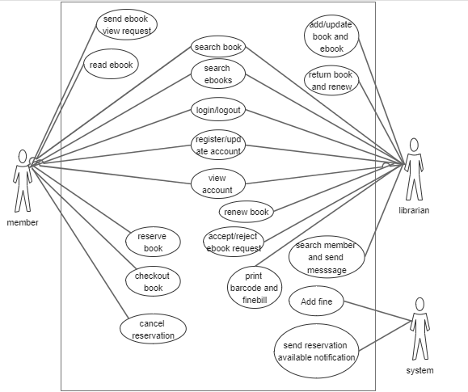

Figure 1: Use Case Diagram of the Project

##### **2.1.1.2 Non-Functional Requirements**

Non-functional requirements define how the system should be. It covers all the remaining requirements which are not covered by functional requirements. Slibrary system is easy to use and trust worthy to place orders. It follows some of the properties like secure, reliability, user-friendly, maintainability and usability.

### 2.2 Feasibility Analysis

Feasibility Study is used to determine the viability of an idea. It is often used before the actual implementation of the project. The objective of such a study is to ensure a project is legally and technically feasible and economically justifiable. It tells us whether a project is worth the investment.

#### 2.2.1 Technical Feasibility

Technical feasibility involves evaluation of the hardware and the software requirements of the proposed system. This application was developed using Django framework, Postgress for database and the hardware required was USB barcode scanner. Google Chrome and Firefox were used to run the application for facilitating user interface. So, this system was technically feasible. All the necessary hardware and software required for developing and installing the system were available.

#### 2.2.2 Operational Feasibility

Operational feasibility is dependent on human resources available for the project and involves projecting whether the system will be used if it is developed and implemented. Our system makes the maximum use of available resources including people, time and flow of forms. Our system provides reliable services to the client and the user should be familiar about the product they are using. This will enhance reduction in cost and increase in benefits for the business.

#### 2.2.3 Economic Feasibility

Economic feasibility is the cost and logistical outlook for a business project or endeavor. We considered various factors affecting the systems economic value and performance and implemented the best one. The application is a digital library based system and so it is economically feasible which means we can make the use of it at feasible cost and get much more benefit from it. It requires not many resources except what we already have along with our knowledge.

#### 2.2.4 Legal Feasibility

Legal Feasibility analyzes and deals with various legal issues, contracts, policies, laws and violations that staffs are usually unknown about. It ensures if the application is legal to operate or not. Some systems may require license to operate. In such cases legal feasibility needs to be checked. This was done by going through all the legal requirements of the government of Nepal.

### 2.3 Dataflow Diagram

A data flow diagram (DFD) is a graphical representation of the "flow" of data through an information system, modeling its process aspects. A DFD is often used as a preliminary step to create an overview of the system, which can later be elaborated.

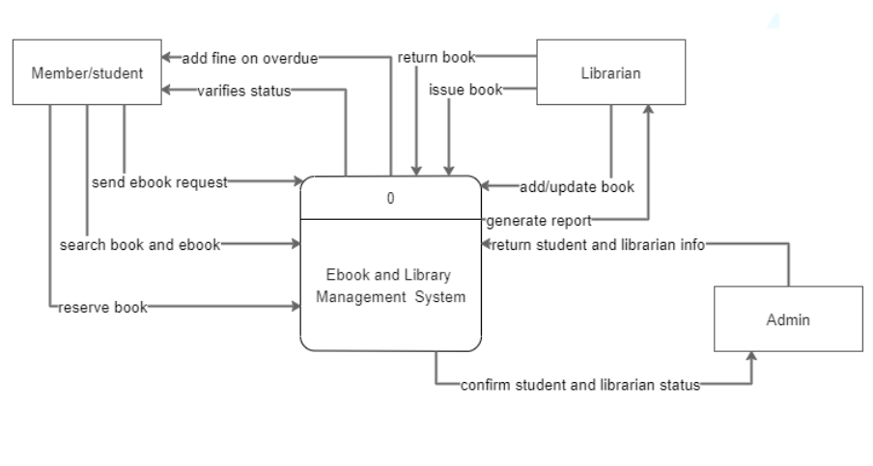

Figure 2: Context Diagram of System

Figure 3: Level-1 DFD of System

### 2.4 ER Diagram

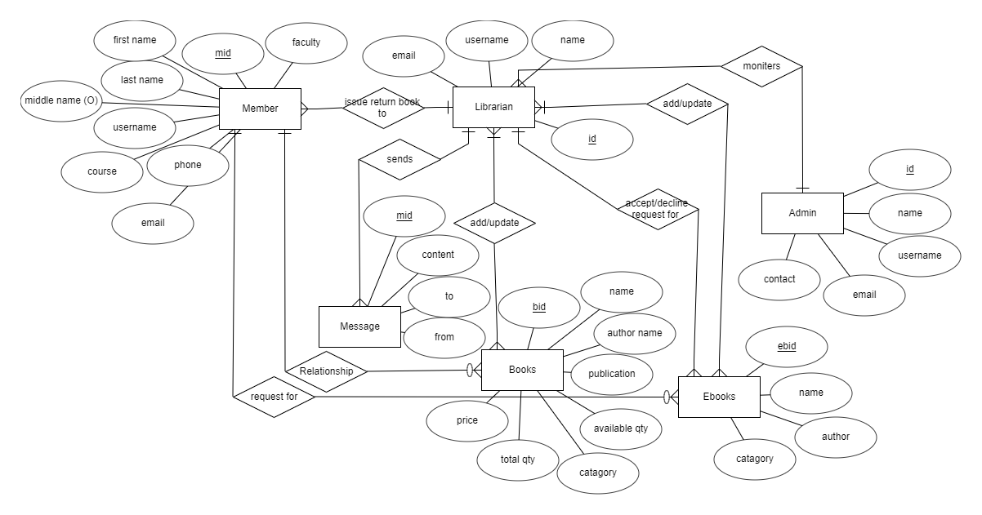

Figure 4: ER Diagram of the Project

### 2.5 Flow Chart

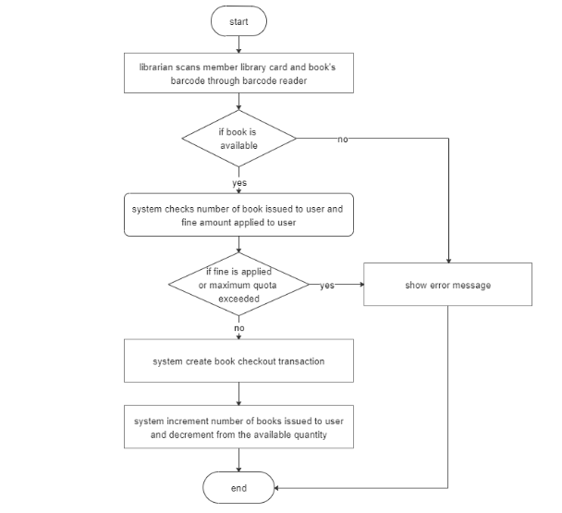

Figure 5: Flowchart to issue book in project

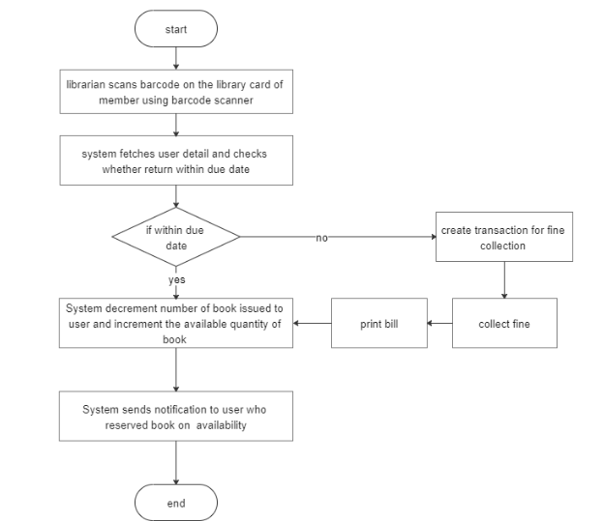

Figure 6: Flowchart to return book in project

### 2.6 Technical Requirements

#### 2.6.1 Hardware Requirements

The standard input devices like keyboard and mouse and USB barcode scanner were used to get input. The outputs are generated and displayed on the screen.

#### 2.6.2 Software Requirements

• Platform: Windows

• Programming Language: Python, JS

• Front End: HTML, CSS, AJAX and JS/Jquery

• Back End: Python with Django framework

•Database: Postgress

# CHAPTER 3

## SYSTEM DESIGN

Systems design is the process of defining elements of a system like modules, architecture, components and their interfaces and data for a system based on the specified requirements.

### 3.1 Architectural Design

The system architectural design is shown below:

Figure 4: Architectural Design

The architectural design of the system as shown above describes the view, models, behavior, and structure of the overall system. The system follows a 3-tier architecture which is composed of presentation tier, logical tier and data tier and for this, we have used MVT(model view and template) pattern.

### 3.2 Database Design

Database design is the part of system development. Since the data is stored in Postgress database, the database takes the form of single tabular format. The table is multiple so there is relationship among other table.

Time

Full Name

Email

Phone Number

Gender

Age

Quality of Service

Process of getting problem resolved

Quality of customer service representative

Knowledge of customer service representative

Wait time for my question to be answered

Possibility Satisfy with the product features

Property Management Usage

Communication Usage

Online Payments Usage

Management of Tenant lease Usage Additional products you think should be added in the product

Able to find information you were looking for

Able to find information you were looking for (Other)

Satisfy with the literature to describe our products and services

Easy to navigate our website

Satisfy with the delivery of products or services

Rate the comfortableness of using the product

Satisfy with the level of customer support we provide

Satisfy with our company's efforts to meet your communication needs

Interacting with Phone

Interacting with Email

Interacting with Social Media

Interacting with VOIP Application

Figure 5: Table Format of the system

### 3.3 Interface Design

Interface Design includes all Librarian and Student interface design.

#### 3.3.1 Student Interface Design

Figure 6:Buyer Interface Design

Buyer end design is the interface seen as home page which appears when the buyer is browsing the website. The buyer can choose products and place order, donates and send gifts.

#### 3.3.2 Seller Interface Design

Figure 6:Seller Interface Design

Seller end design is the interface seen as home page and seller dashboard which appears when the seller login in the website. The seller can not choose products and place order, donates and send gifts but can add products to sell with perfectgiving2u’s resources.

#### 3.3.3 Admin Panel Design

Figure 7:Admin Panel Design

Admin Panel is the interface where administrations and other site officials with appropriate privileges can access the Perfectgiving2u’s dashboard.

The admin can

• Add ,update, delete products

• Add ,update, delete members and blogs

• Access the website’s all previlages.

# CHAPTER 4

## IMPLEMENTATION AND TESTING

### 4.1 Implementation

Implementation phase is one of the important phases of project development. In this phase we implement our conceptual design into the working program by using various tools. The successful implementation of project was nearer steps towards the project completion. Project implementation was not an easy step to us as we encountered various issues related to the programming logic as challenges.

#### 4.1.2 Tools Used

Front end

* Html CSS and Javascript/Jquery was used to build website design.
* Django was used to make interactive and connect with database.

Back end:

* Postgress was used for creating and managing the database.
* Django for the development of the design and users dashboard.

Documentation Tools:

* Edraw max was used for designing of:
  + Data flow diagram
  + Use Case diagram
  + Architectural design
  + Interface design diagram
  + ER diagram
* MS Word was used as a text editor for documentation process.
* Sublime Text 3 was used as IDE for coding.

#### 4.1.3 Development Methodology

Waterfall model was followed for developing the system. The different phases that are required in this development methodology are requirement analysis, system design, implementation, testing, development and maintenance. The Project Manager and QA analyze all the functional and non-functional requirement of the system that needs to be developed. Knowing the requirements for the system we get a clear understanding and view about what the system is supposed to be.

After knowing the requirements for the system, now we define the overall architecture of the system through designs like, ER diagram, DFD, Database schemas, etc. Python language was used for the implementation of the system. For the data storage Postgress was used. while Python Anywhere a cloud based server is decided for deployment.

### 4.2 Testing

The testing phase can be carried out manually or by using automated testing tools to ensure each component works fine. After the project is ready, we tested its various components in terms of quality, performance to make it error free and remove any sort of technical jargons. The testing phase can be carried out manually or by using automated testing tools to ensure each component works fine.

#### 4.2.1 Unit Testing

#### Unit testing emphasizes the verification effort on the smallest unit of software design i.e.; a software component or module. Unit testing is a dynamic method for verification, where program is actually compiled and executed. Unit testing is performed in parallel with the coding phase. Unit testing tests units or modules not the whole software.

#### Author has tested each view/module of the application individually. As the modules were built up testing was carried out simultaneously, tracking out each and every kind of input and checking the corresponding output until module is working correctly.

#### 4.2.2 Integration Testing

#### 4.2.3 System Testing

System testing has done after integrating testing in order to ensure that the whole systems functions properly. After the integration testing the whole system working process was checked. The output was as per the system specifications and hence the system was found to work properly.

**4.2.4 Test Case**

|  |  |  |  |  |  |
| --- | --- | --- | --- | --- | --- |
| SN | Test Case Name | Test Procedure | Precondition | Expected Result | Outcome |
| 1 | Registration form test1 | Create Account | Registration page | Empty fields must generate error | Success |
| 2 | Registration form tesr2 | Email confirmation sent | Registration page | Activation link received through email | Success |
| 3 | Login form test | Login with unregistered account | Login Page | Must show error message | Success |
| 4 | Database Connection | Connect to database | Database connected | Connection successful | Success |
| 5 | Add book and ebook | Add book and ebook to database | Add book and ebook | Data should be added to database | Success |
| 6 | Update book and ebook | Update book and ebook in database | Update page | Update records | Success |
| 7 | Delete book and ebook | Delete from database | Delete page | Data should be deleted from database | Success |

# CHAPTER 5

## CONCLUSION

### 5.1 Conclusion

In current context, the increasing information Technology has built up the software development trend. To follow the trend internship provides a bridge for the industrial environment for the undergraduate to learn and experience the real world. Internship has helped in adapting well to working under pressure. Working with multiple features in a single week-long sprint and handling immediate and urgent bugs have assisted in enhancing professionalism to meet deadlines. The technical tasks that were undertaken during the internship period have helped the intern in improving software development and debugging skills. It has helped in gaining knowledge about various technical tools and frameworks used in software development and the process that should be followed for proper development completion. Working as an intern in one of the popular IT companies of Nepal, has boosted the confidence and has polished the professional as well as soft skills of the intern in the IT sector. As whole, this report includes project and the internship experiences, findings, knowledge and the technical skills.

### 5.2 Lessons Learnt

Through the internship from Softtechpark pvt. ltd., the lessons learnt were:

• Importance of time management and working with multiple features under pressure to meet deadlines.

• Immediate handling of urgent bugs and fixing them.

• Understanding the differences between theoretical and practical knowledge.

• Working in team with coordination and cooperation to make quality decisions.

• Working as Python\Django Developer can be considered as a potential career.

References

Appendix: Screenshots

1. Web Widget

Figure 13:Web Widget

30

2. Google Sheet as Database

Figure 14:Google Sheet as Database

3. BI Dashboard

Figure 15: BI Dashboard

31

4. BI Dashboard with visualization

Figure 16:BI Dashboard with visualization