**NAGARJUNA COLLEGE OF INFORMATION TECHNOLOGY**

**TRIBHUVAN UNIVERSITY**

**INSTITUTE OF SCIENCE AND TECHNOLOGY**

**An Internship Report**

**on**

**“Ebooks and Library Management System”**

**at**

**Softtechpark Pvt. Ltd.**

**Submitted To:**

Department of Computer Science and Information Technology

Nagarjuna College of Information Technology

***In partial fulfillment of the Bachelor’s Degree in Computer Science and Information Technology***

**Submitted By:**

Bivek Pandey (7682/072)

February 28, 2020

***SUPERVISOR’S RECOMMENDATION***

I hereby recommend that the internship report prepared under my supervision by **Bivek Pandey** entitled “**EBooks and Library Management System** ” in partial fulfillment of the requirements for the degree of Bachelor of Science in Computer Science and Information Technology to be processed for the evaluation.

…………………………..

**Mr. Ramesh Singh Saud**

**SUPERVISOR**

Academic Director and Lecture,

Department of Computer Science and Information Technology,

Nagarjuna College of Information Technology,

Pulchowk, Lalitpur, Nepal

***CERTIFICATE OF APPROVAL***

The undersigned certify that they have read and recommended to the Department of Computer Science for acceptance, internship project report entitled **“Web development on EBooks and Library Management System at Softtechpark Pvt. Ltd.”** submitted by **Bivek Pandey(T.U. Exam Roll No. 7682/072)** in partial fulfillment for the degree of Bachelor of Science in Computer Science & Information Technology.

…………………………..

Mr. Ramesh Singh Saud

Supervisor

Department of Computer Science and Information Technology,

Nagarjuna College of Information Technology,

Pulchowk-Lalitpur

……………………………..

External Examiner

Tribhuvan University

# *ACKNOWLEDGEMENT*

This intern report is prepared in the partial fulfillment of the requirements for the degree of Bachelor in Computer Science and Information Technology. This report would not have been completed successfully without the guidance and support of my seniors, who helped me throughout the process of report completion. I would like to express my sincere gratitude to our supervisor Mr. Ramesh Singh Saud, Co-Ordinator of Bsc.CSIT faculty in Nagarjuna college of IT for his incredible support and guidelines during the entire internship project execution period.

I would also like to thank **Mr. Jayamangal Gupta**, Director of Nagarjuna college of IT for his constant suggestions and guidance. His painstaking encouragements boosted morale for the completion of this project.

I would also like to appreciate **Er. Nishar Ali**, CTO and **Er. Kiran Kandel** CMO and senior developer of the Softtechpark Pvt. Ltd. ,for their valuable guidance and providing the different learning resources required for project completion throughout the internship period.

I am also grateful to our lecturers **Mr. Yagyaraj Joshi**, **Mr.Uttam Karki**, for their constant support and guidance.

Lastly, I offer my best regards and gratitude to all our colleagues, fellow workers and others who supported us in any respect during the completion of the project.

Thanking You,

Bivek Pandey (T.U. Exam Roll No. 7682/072)

# *ABSTRACT*

This report contains the details of the different activities carried out during the internship conducted for the three months internship duration.

The main focus of this report is Web Based Online Ebook and Library Management System.The “Slibrary” is a Web based application intended for Student and Librarian. The main objective of this website is to make it interactive and its ease of use. It is role-based, multi-user ebook and library management system. It would make searching, viewing detail, checking availability of books and sends email and SMS based notification. Student can view the complete detail of each books send notify on available request if currently unvailable. The website provides a features to a Librarian to add a books and ebooks, update and delete them. The main emphasis lies in providing a user-friendly advance library management system’s feature. This is a system which maintains the information about the books present in the library, their authors, the members of library to whom books are issued, library staff and all.

***TABLE OF CONTENTS***

*ACKNOWLEDGEMENT* i

*ABSTRACT* ii

*TABLE OF CONTENTS* iii

*LIST OF FIGURES* v

*LIST OF TABLES* vi

*LIST OF ABBREVIATIONS* vii

CHAPTER 1: INTRODUCTION 1

1.1 Introduction of Project 1

1.2 Problem Statement 1

1.3 Objectives of Study 2

1.4 Scope and Limitation 2

1.5 Brief Introduction of Organization 2

1.5.1 Services Offered by Organization 3

1.5.2 Organization Selection 4

1.5.3 Placement 4

1.5.4 Internship Duration 4

1.5.5 Responsibility Assigned 5

1.5.6 Contact Detail 5

CHAPTER 2: SYSTEM ANALYSIS 7

2.1 System Analysis 7

2.2 Requirement Analysis 7

2.2.1 Functional Requirements 7

2.2.2 Non-Functional Requirements 9

2.2.3 Technical Requirements 9

2.3 Feasibility Analysis 9

2.3.1 Technical Feasibility 9

2.3.2 Operational Feasibility 10

2.3.3 Schedule Feasibility 10

2.3.5 Legal Feasibility 11

2.4 ER Diagram 11

2.5 Flow Chart 12

2.6 Sequence Diagram 14

CHAPTER 3: SYSTEM DESIGN 15

3.1 Architectural Design 15

3.2 Database Design 15

3.2 Interface Design 16

3.2.1 Student Interface Design 16

3.2.2 Librarian Interface Design 17

3.2.3 Admin Interface Design 17

CHAPTER 4:IMPLEMENTATION AND TESTING 18

4.1 Implementation 18

4.1.2 Tools Used 18

4.1.3 Development Methodology 18

4.2 Testing 19

4.2.1 Unit Testing 19

4.2.2 Integration Testing 19

4.2.3 System Testing 20

4.2.4 Test Case 20

CHAPTER 5: CONCLUSION 21

5.1 Conclusion 21

5.2 Future Scope 21

5.3 Lessons Learnt 21

REFRENCES 23

APPENDIX-I:SCREENSHOTS 24

# *LIST OF FIGURES*

Figure 1: Use Case Diagram of the System................................................................................ ....8

Figure 2: Grantt Chart for project Scheduling.............................................................................. 10

Figure 3: ER Diagram of the System....................................................................................... .....11

Figure 4: Flowchart to Issue Book of System.............................................................................. .12

Figure 5: Flowchart to Return Book of System............................................................................ 13

Figure 6:Sequence Diagram of System .... ................................................................................... 14

Figure 7: Architectural Design of the System................................................................................15

Figure 8: Table Format of the System...........................................................................................16

# *LIST OF TABLES*

Table 1: Internship Duration .......................................................................................................... 4

Table 2: Responsibility Assigned……………………… ............................................................ ..5

Table 3:Contact Details of Organization………………............................................................. ..5

Table 4:Test Cases ………………............................................................................................... 20

# *LIST OF ABBREVIATIONS*

BSc. CSIT Bachelors in Science in Computer Science and Information Technology

UI User Interface

IDE Integrated Development Environment

QA Quality Assurance

DFD Data Flow Diagram

USB Universal Serial Bus

AJAX Asynchronous Javascript and XML(Extensible Markup Language)

JS Javascript

MVT Model View Template

ER Entity Relation

# CHAPTER 1: INTRODUCTION

## 1.1 Introduction of Project

EBooks and Library Management System is a role-based, multiuser, hardware-integrated (USB barcode scanner), online ebook and library management system .The main focus of the system is to provide all the facility that could be provided from advance library to student such as borrowing a books, read a online books, search books, check availability of a books, email and SMS based notifications and information of fines as well as for librarian such as issuing a books to student by scanning a books barcode and student id’s barcode, check student activities by scanning a barcode on a individual student id card and print out the fine bills . The system has been designed to computerize and automate the operations performed over the information about the members, book issues and returns and all other operations. The system has been designed to computerize and automate the operations performed over the information about the members, book issues and returns and all other operations.

When talking about this web application, it contains mainly three different types of users Admin and Librarian and Student. Admin is the one who accounts and has full control over the system. Librarian is the one who can access the Library management platform and upload/update their books , ebooks. Student are the normal users who can track their own library activities through site such as issued books, fine implemented etc.

## 1.2 Problem Statement

Manual process of keeping student records, book records, account details, managing employees is very difficult task. There are various problems also faced by student in library such as finding any particular books, information whether a book is available or not , when will be the particular book may become available. Sometimes due to some human error there may be a loss or damage of different files that contains the record of the day to day activities of the library which may affect the proper functioning of library. To eliminate this manual system ebooks and library management system has been developed. It will handle all the current issue faced by the student and admin personnel and helps in efficiently functioning of day to day activities of the library system.

## 1.3 Objectives of Study

The objectives of project are as follows:

* To develop the web application that helps the daily activities performed within library of an educational institution.
* To provide a student an online resources such as online books to read.
* To develop the provide a user-friendly UI to a user.
* To provide a role-based dynamic content to a user
* A search column to search availability of books
* Librarian is able to search record by using few clicks of mouse and few search keywords thus saving his valuable time.
* Have a facility to upload lectures notes in a pdf file having size not more than 10mb

## 1.4 Scope and Limitation

This project has a great scope in every aspect it can be used to handle an ebook management and student activities within the library. It contains all the advanced feature that is required to maintain entire library of an educational institution. A software solution is never 100% perfect and error free. Like other software systems, this system is also not perfect. After the deploy of product we can’t add the new features which can only be modified from the source code. Since the project is developed from Django framework of Python as a script language which is not familiar for many developers. The project is currently developed only for web based platform.

## 1.5 Brief Introduction of Organization

Softtechpark Pvt. Ltd. is a IT based outsourcing company, providing a broad range of services and solutions in strategy, consulting, digital and technology since 2018. It is situated in Tinkune, Kathmandu. Softtechpark Pvt. Ltd. believe in empowering with information, building relationships and taking social responsibilities. To make software easier for people to use and operate, it performs a huge level of testing and debugging through qualified professionals and native users. The main strategy is to discover and analyze the project to find the best possible solution for a product that contains all the possible current technologies and methodologies and test them in developer and user level.

Softtechpark Pvt. Ltd. mission is to provide a digital solution for database management, data analysis and visualization, website and application development. For each of the solution Softtechpark Pvt. Ltd. focuses on making it efficient, user friendly as well as cost effective. Softtechpark Pvt. Ltd. works with languages and technologies like PHP with Laravel, Java with spring boot, C# with .NET, React JS, React-Native, WordPress and databases like MYSQL or Postgress and some other development tools.

Softtechpark Pvt. Ltd. follows industry standards of software development approach to deliver the highest level of satisfaction to the client. The team keep themselves updated with new tools and technologies available in the market and implement these technology whenever necessary.

### 1.5.1 Services Offered by Organization

Softtechpark Pvt. Ltd. Has been associated to the clients in and out of the country. This company has proven to provide good quality product to it’s client. Company makes use of latest technology to design and build software and app for better user experience.

The different service provided by this organization are mentioned below:

#### 1.5.1.1 Website and Web Application Development:

This company provides services of web design and development for organizations and companies. They make use of modern design and technology to make flexible and attractive web applications. They have been providing web development services to many organizations all over and outside of Nepal since the establishment of company.

#### 1.5.1.2 Mobile Application Development:

This company also provides android and IOS app development. They develop mobile apps for their ERP software as well as for organizations all over the country. The company consists of skilled Android . IOS and Native mobile application developers for developing efficient mobile applications.

#### 1.5.1.3 Desktop Application Development:

This company provides services of desktop application development for organizations and companies. The company consists of skilled Java developers for developing different desktop based applications.

### 1.5.2 Organization Selection

As per the requirement of the Tribhuvan University (TU), the final year students of B.Sc. CSIT are required to complete a six credit (minimum ten weeks/180 hours long) internship as a part of the course requirement. Internship is one of medium that helps to break down the bars between the professional and the student life. Since, an internship is the course curriculum of TU, every student per using BSc.CSIT need to do the internship in any area of their interest. So, the first motivation for choosing Softtechpark Pvt. Ltd. was to fulfill my academic requirements. Besides this, working as an intern in the organization I also got the opportunity to work in real-time projects which motivated me to work more towards my area of interest

### 1.5.3 Placement

The 3 month internship at Softtechpark Pvt. Ltd. involved various activities and tasks as per the requirement of both the organization and the project. Various responsibilities had been assigned such as CRUD operations in Librarian and Student dashboard, applying clients requirement in application and small bug fixing. All these tasks were done using Python with Django framework. The responsibilities of individual were not specified only to complete project, along with phases of software development life cycle. . I worked as a Python Developer and was assigned to create the backend of project and also integrate with a frontend generated by frontend developer.

### 1.5.4 Internship Duration

|  |  |
| --- | --- |
| Office Hour | 9:00 am – 5:00 pm |
| Working Hour | 8 Hours per day |
| Working Days | 6 days a week |
| Position | Trainee Python Developer |
| Total Duration | 3 months |
| Mentor | Er. Nishar Ali |

Table1:Internship Duration

### 1.5.5 Responsibility Assigned

|  |  |
| --- | --- |
| Week 1 | Understanding about the company’s environment and researching about usage of Django for the development |
| Week 2 | Planning and research about the project. |
| Week 3 | Database Development for a project according to the user requirement and collaborating with mentor. |
| Week 4 | Create CRUD operation to add some required features in our web applications. |
| Week 5 | Developing features for Elibrary rendering ebooks in application and preventing to render in browser |
| Week 6 | Integration with the front-end developed by front end developer |
| Week 7 | USB barcode integration. |
| Week 8 | Dashboard and dynamic data-vizualization for users according to their interest |
| Week 9 | Apply additional feature of client after testing |
| Week 10 | Fixing bug of a project |
| Week 11 | Testing and validation of final project |
| Week 12 | Making documentation ready and presentation. |

Table 2:Responsibility Assigned

### 1.5.6 Contact Detail

|  |  |
| --- | --- |
| Address | Tinkune, Kathmandu, Nepal |
| Phone Number | 01-4111992 |
| Email | info@softtechpark.com |
| Website | www.softechpark.com |

Table 3:Contact Detail

# CHAPTER 2: SYSTEM ANALYSIS

## 2.1 System Analysis

Generally, System development comprises of two major phases: System Analysis and System Design. In System Analysis, the details of the existing system or proposed one is understood and decided whether proposed system is desirable or not and decided whether the existing system needs improvements. System analysis helps to understand the proposed system architecture, working and goals. Thus, System Analysis can be summarized as the process of investigating a system, identifying problems and using the gathered information to improve existing system or develop the proposed one.

By interacting with client of Slibrary, studying the documents provided by the client, discussing with the senior developers and studying the existing system we analyze the requirements of the system to be developed for the clear view of how the system should be and how it should be working so as to fulfill user requirements.

## 2.2 Requirement Analysis

This section presents complete set of functional and nonfunctional requirements. Functional requirements are listed first according to their relationship to the overall system. The non-functional requirements are listed after functional requirements. The functional requirements have been specified using natural language description using UML analysis model.

### 2.2.1 Functional Requirements

Functional Requirements defines what the system must do. It defines the behaviors or functions of a system, flows, business rules and other requirements of a system along with its output. The functional requirements are discussed below:

* **Add/Remove/Edit book:** To add, remove or modify a book or book item.
* **Search catalog:** To search books by title, author, subject or publication date.
* **Register new account/cancel membership:** To add a new member or cancel the membership of an existing member.
* **Check-out book:** To borrow a book from the library.
* **Reserve book:** To reserve a book which is not currently available.
* **Renew a book:** To reborrow an already checked-out book.
* **Return a book:** To return a book to the library which was issued to a member.
* **Notification:** Email and SMS based notification when reserved book is available
* **Invoice:** Provide billing system of a fine amount
* **Ebooks:** Different ebooks are allowed to read a members
* **Hardware integrated:** Books can be issued or returned using a barcode on a library card

#### 2.2.1.1 Use Case Diagram

Use case diagram is representation of user’s actions or interaction with system which can perform in collaboration with one users of the system. In this application, there are 3 types of student, librarian and admin/superuser, librarian can perform issue books, return books and allow ebook request only after registration and login whereas the student can user their functionality only after registration and login whereas admin can access the dashboard which consist of list of data and modification functionality according to client’s requirement.

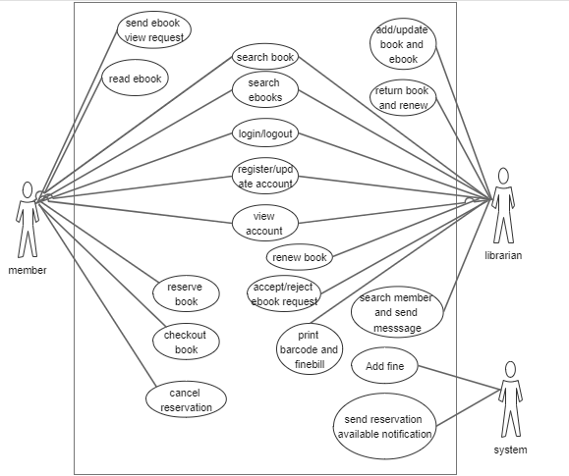

Figure 1: Use Case Diagram of the System

### 2.2.2 Non-Functional Requirements

Non-functional requirements define how the system should be. It covers all the remaining requirements which are not covered by functional requirements. Slibrary system is easy to use and trust worthy to place orders. It follows some of the properties like secure, reliability, user-friendly, maintainability and usability.

### 2.2.3 Technical Requirements

#### 2.2.3.1 Hardware Requirements

The standard input devices like keyboard and mouse and USB barcode scanner were used to get input. The outputs are generated and displayed on the screen.

#### 2.2.3.2 Software Requirements

* Platform: Windows
* Programming Language: Python, JS
* Front End: HTML, CSS, AJAX and JS/Jquery
* Back End: Python with Django framework
* Database: Postgress

## 2.3 Feasibility Analysis

Feasibility Study is used to determine the viability of an idea. It is often used before the actual implementation of the project. The objective of such a study is to ensure a project is legally and technically feasible and economically justifiable. It tells us whether a project is worth the investment.

### 2.3.1 Technical Feasibility

Technical feasibility involves evaluation of the hardware and the software requirements of the proposed system. This application was developed using Django framework, Postgress for database and the hardware required was USB barcode scanner. Google Chrome and Firefox were used to run the application for facilitating user interface. So, this system was technically feasible. All the necessary hardware and software required for developing and installing the system were available.

### 2.3.2 Operational Feasibility

Operational feasibility is dependent on human resources available for the project and involves projecting whether the system will be used if it is developed and implemented. Our system makes the maximum use of available resources including people, time and flow of forms. Our system provides reliable services to the client and the user should be familiar about the product they are using. This will enhance reduction in cost and increase in benefits for the business.

### 2.3.3 Schedule Feasibility

A system is said to be scheduled feasible if it is implemented within the planned scheduled. We carried out the study on how much it will take to complete the task after studying the requirements and proposed plan.

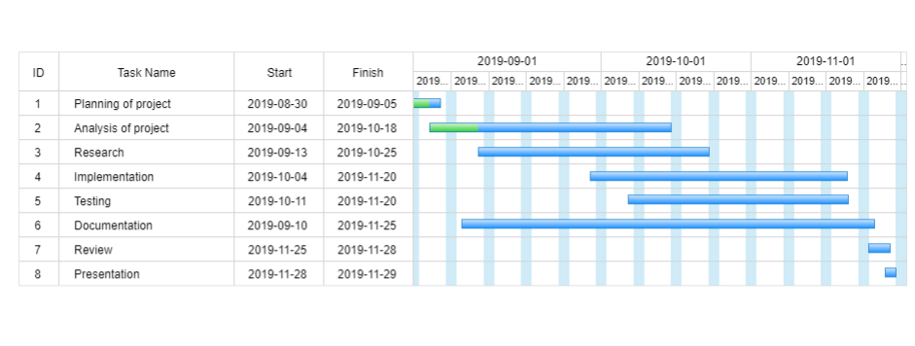

Figure 2: Grantt Chart for Project Scheduling

#### 2.3.4 Economic Feasibility

Economic feasibility is the cost and logistical outlook for a business project or endeavor. We considered various factors affecting the systems economic value and performance and implemented the best one. The application is a digital library based system and so it is economically feasible which means we can make the use of it at feasible cost and get much more benefit from it. It requires not many resources except what we already have along with our knowledge.

### 2.3.5 Legal Feasibility

Legal Feasibility analyzes and deals with various legal issues, contracts, policies, laws and violations that staffs are usually unknown about. It ensures if the application is legal to operate or not. Some systems may require license to operate. In such cases legal feasibility needs to be checked. This was done by going through all the legal requirements of the government of Nepal.

## 2.4 ER Diagram

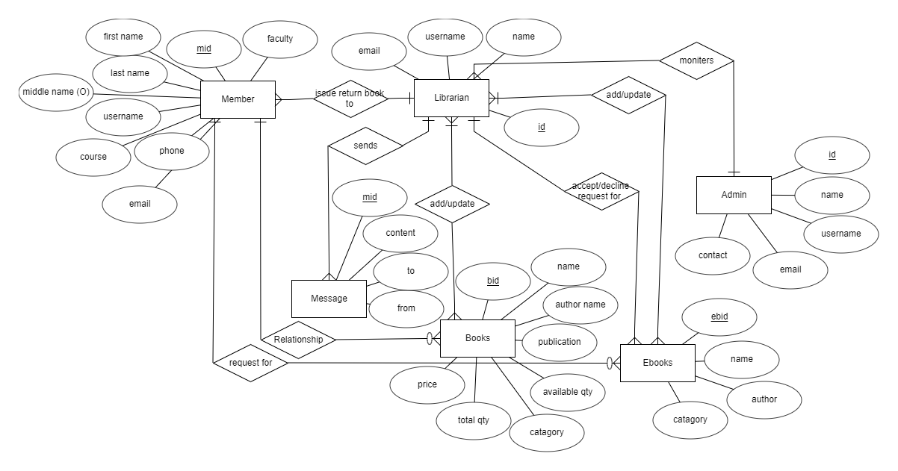

Figure 3: ER Diagram of System

## 2.5 Flow Chart

Figure 4: Flowchart To Issue Book of System

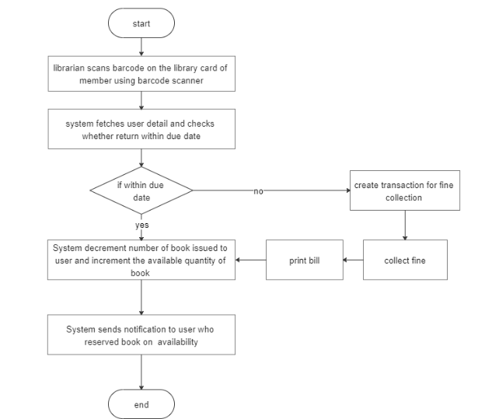

Figure 5: Flowchart To Return Book of System

## 2.6 Sequence Diagram

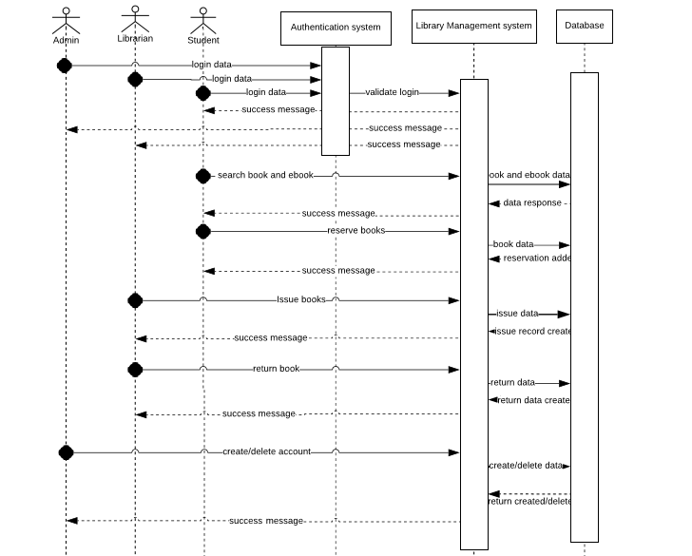

Figure 6: Sequence Diagram of System

# CHAPTER 3: SYSTEM DESIGN

Systems design is the process of defining elements of a system like modules, architecture, components and their interfaces and data for a system based on the specified requirements

## 3.1 Architectural Design

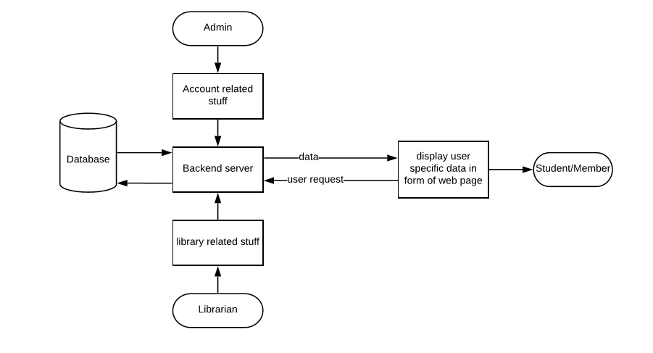

Figure 7: Architectural Design of System

## 3.2 **Database Design**

Database design is the part of system development. Since the data is stored in Postgress database, the database takes the data from multiple forms. The table is multiple so there is relationship among other table.

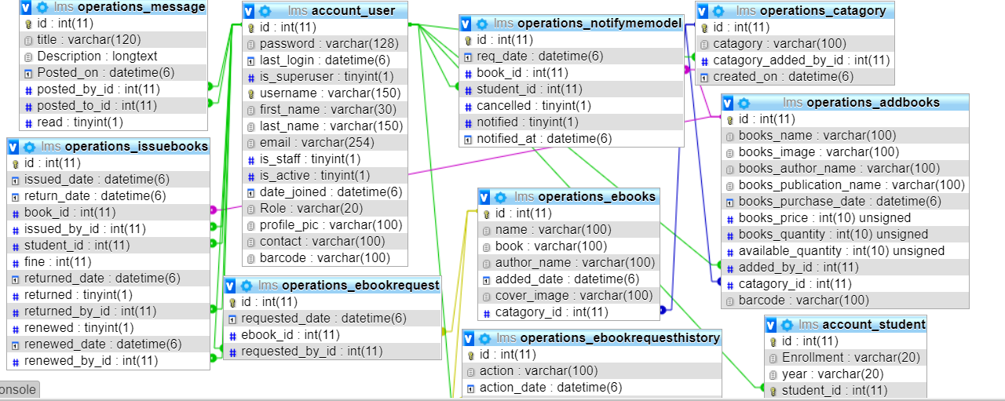

Figure 8: Table Format of System

## 3.2 Interface Design

This is the way of representing how the system looks and how the data flow in the system along with the reference of the screen being displayed. There are three parts in the design. Top part represents the current screen number, the middle one represents the screen title or description and the bottom one represents the location of screen, which references the current screen. Here, after opening the system, the tasks that are done in the system are represented below:

### 3.2.1 Student Interface Design

Student Interface is the interface where student can access and view the permitted data and perform permitted actions.

The Student can

* View their issued books
* Search Books and Ebooks
* Check availability of books
* Reserve unavailable books
* Cancel their reservations
* View whether fine is implemented or not.
* Send request for ebooks

### 3.2.2 Librarian Interface Design

Librarian Interface is the interface where librarian can access and view the permitted data and perform permitted actions.

The Librarian can

* Create, Edit, Delete books and ebooks.
* Activate/Deactivate student account.
* Change their profile and passwords
* Allow/Deny the request of ebooks
* Issue/return books

### 3.2.3 Admin Interface Design

Admin Interface is the interface where Admin can access and view the content, Admin has the full privilege over a system

The Admin Can

* Can Edit/Delete student and librarian Account
* Create, Edit, Delete Category, Faculty and Courses list
* View day to day activities records

# CHAPTER 4:IMPLEMENTATION AND TESTING

## 4.1 Implementation

Implementation phase is one of the important phases of project development. In this phase we implement our conceptual design into the working program by using various tools. The successful implementation of project was nearer steps towards the project completion. Project implementation was not an easy step to us as we encountered various issues related to the programming logic as challenges.

### 4.1.2 Tools Used

Front end

* Html CSS and Javascript/Jquery was used to build website design.
* Django was used to make interactive and connect with database.

Back end:

* Postgress was used for creating and managing the database.
* Django for the development of the design and users dashboard.

Documentation Tools:

* Edraw max was used for designing of:
  + Data flow diagram
  + Use Case diagram
  + Interface design diagram
  + ER diagram
  + Flow Chart
* MS Word was used as a text editor for documentation process.
* Sublime Text 3 was used as IDE for coding.

### 4.1.3 Development Methodology

Waterfall model was followed for developing the system. The different phases that are required in this development methodology are requirement analysis, system design, implementation, testing, development and maintenance. The Project Manager and QA analyze all the functional and non-functional requirement of the system that needs to be developed. Knowing the requirements for the system we get a clear understanding and view about what the system is supposed to be.

After knowing the requirements for the system, now we define the overall architecture of the system through designs like, ER diagram, DFD, Database schemas, etc. Python language was used for the implementation of the system. For the data storage Postgress was used. while Python Anywhere a cloud based server is decided for deployment.

## 4.2 Testing

The testing phase can be carried out manually or by using automated testing tools to ensure each component works fine. After the project is ready, we tested its various components in terms of quality, performance to make it error free and remove any sort of technical jargons. The testing phase can be carried out manually or by using automated testing tools to ensure each component works fine.

### 4.2.1 Unit Testing

Unit testing emphasizes the verification effort on the smallest unit of software design i.e.; a software component or module. Unit testing is a dynamic method for verification, where program is actually compiled and executed. Unit testing is performed in parallel with the coding phase. Unit testing tests units or modules not the whole software.

Author has tested each view/module of the application individually. As the modules were built up testing was carried out simultaneously, tracking out each and every kind of input and checking the corresponding output until module is working correctly.

### 4.2.2 Integration Testing

In this type of testing we test various integration of the project module by providing the input .The primary objective is to test the module interfaces in order to ensure that no errors are occurring when one module invokes the other module.

### 4.2.3 System Testing

System testing has done after integrating testing in order to ensure that the whole systems functions properly. After the integration testing the whole system working process was checked. The output was as per the system specifications and hence the system was found to work properly.

### 4.2.4 Test Case

|  |  |  |  |  |  |
| --- | --- | --- | --- | --- | --- |
| SN | Test Case Name | Test Procedure | Precondition | Expected Result | Outcome |
| 1 | Registration form test1 | Create Account | Registration page | Empty fields must generate error | Success |
| 2 | Login form test | Login with unregistered account | Login Page | Must show error message | Success |
| 3 | Database Connection | Connect to database | Database connected | Connection successful | Success |
| 4 | Add book and ebook | Add book and ebook to database | Add book and ebook | Data should be added to database | Success |
| 5 | Update book and ebook | Update book and ebook in database | Update page | Update records | Success |
| 6 | Delete book and ebook | Delete from database | Delete page | Data should be deleted from database | Success |

Table 4:Test Cases

# CHAPTER 5: CONCLUSION

## 5.1 Conclusion

In current context, the increasing information Technology has built up the software development trend. To follow the trend internship provides a bridge for the industrial environment for the undergraduate to learn and experience the real world. Internship has helped in adapting well to working under pressure. Working with multiple features in a single week-long sprint and handling immediate and urgent bugs have assisted in enhancing professionalism to meet deadlines. The technical tasks that were undertaken during the internship period have helped the intern in improving software development and debugging skills. It has helped in gaining knowledge about various technical tools and frameworks used in software development and the process that should be followed for proper development completion. Working as an intern in one of the popular IT companies of Nepal, has boosted the confidence and has polished the professional as well as soft skills of the intern in the IT sector. As whole, this report includes project and the internship experiences, findings, knowledge and the technical skills.

## 5.2 Future Scope

There is a future scope of this facility that many more features such as online lectures video tutorials can be added by teachers as well as online assignments submission facility , a feature Of group chat where students can discuss various issues of engineering can be added to this project thus making it more interactive more user friendly and project which fulfills each users need in the best way possible.

## 5.3 Lessons Learnt

Through the internship from Softtechpark pvt. ltd., the lessons learnt were:

* Importance of time management and working with multiple features under pressure to meet deadlines.
* Immediate handling of urgent bugs and fixing them.
* Understanding the differences between theoretical and practical knowledge.
* Working in team with coordination and cooperation to make quality decisions.
* Working as Python\Django Developer can be considered as a potential career.

# REFRENCES

[1] D. a. J. G. Craig, Internship for Duminie, Center Garland Hall, January, 2010,, pp. 1-2 page.

[2] "Benjamin S. Blanchard & Wolt Fabrycky (2010). Systems Engineering & Analysis . 5th edition".

[3] “Library Management” [Online Document], March. 2011 [2011 March 23] <http://www.mobileread.com/forums/attachment.php?attachmentid=46713&d=1267348578>

[4] Henke, H., 2001. Electronic books and epublishing. A practical guide for authors. London: Springer-Verlag

[5] “Watchdox: online library system” [Online Document], May. 2011, [2011 May 10] https://www.watchdox.com/

[6] Jaiswal, Sanjeev; Kumar, Ratan (22 June 2015), Learning Django Web Development (1st ed.), Packt, p. 405, ISBN 1783984406

[7] "How Barcodes Work". Stuff You Should Know. 4 June 2019. Retrieved 5 June 2019.

[8] Automating Management Information Systems: Barcode Engineering and Implementation – Harry E. Burke, Thomson Learning, ISBN 0-442-20712-3

[9] Sommerville, Ian (2007) Software Engineering (8th edition). Harlow, England: Pearson Education. ISBN 0-321-31379-8.

[10] "Young, G. I. M. (1970). Feasibility studies. Appraisal Journal 38 (3) 376383."

# APPENDIX-I:SCREENSHOTS

1 Login Page

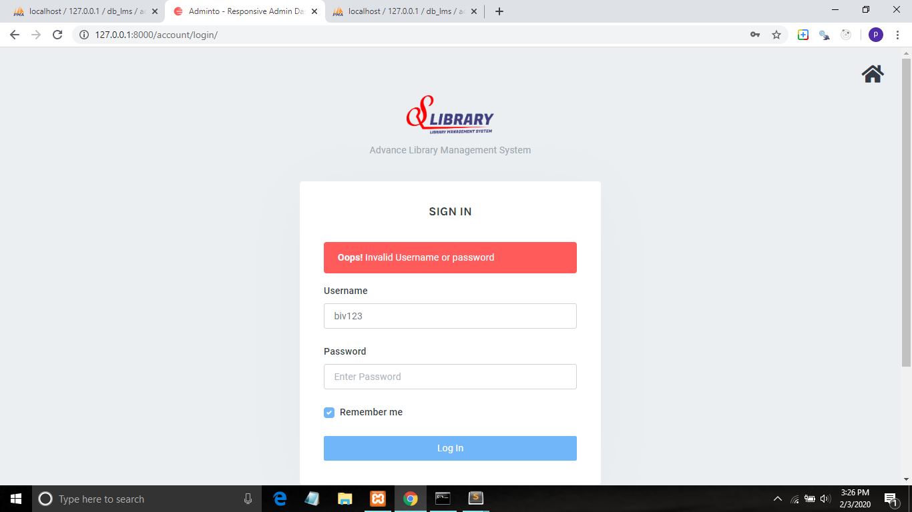

2 Student Dashboard

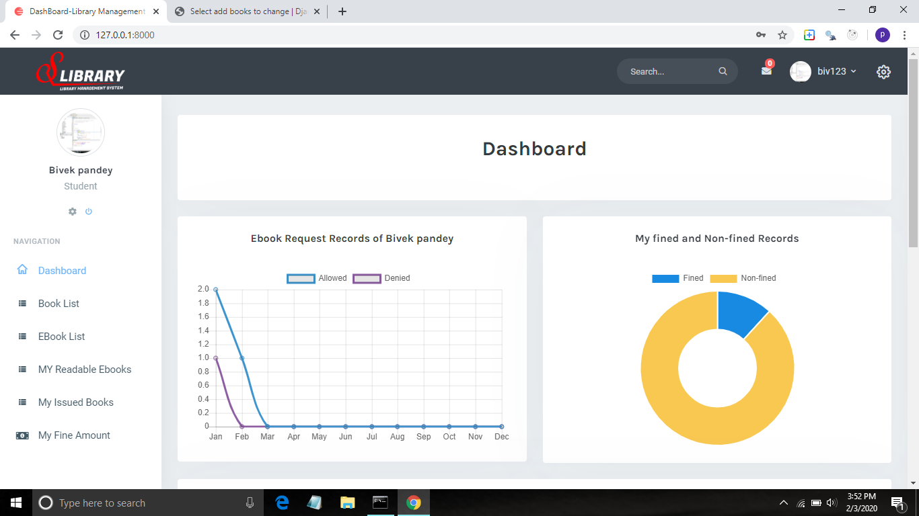

3 Book Reserving

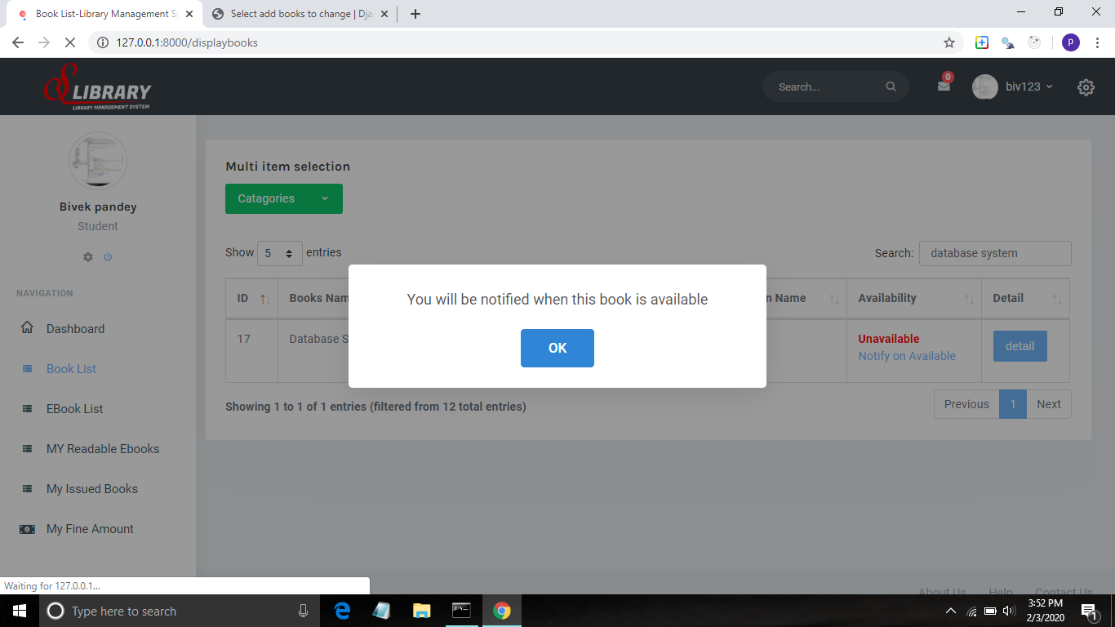

4 Rendering Ebooks

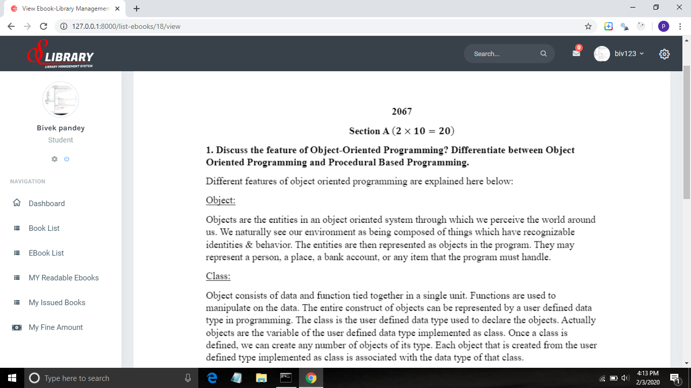

5 Librarian Dashboard

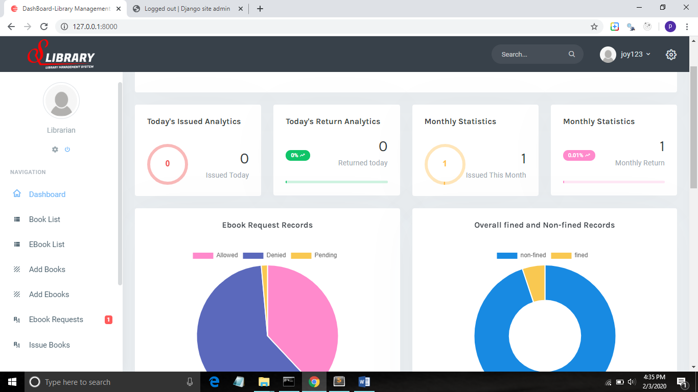

6 Librarian HomePage

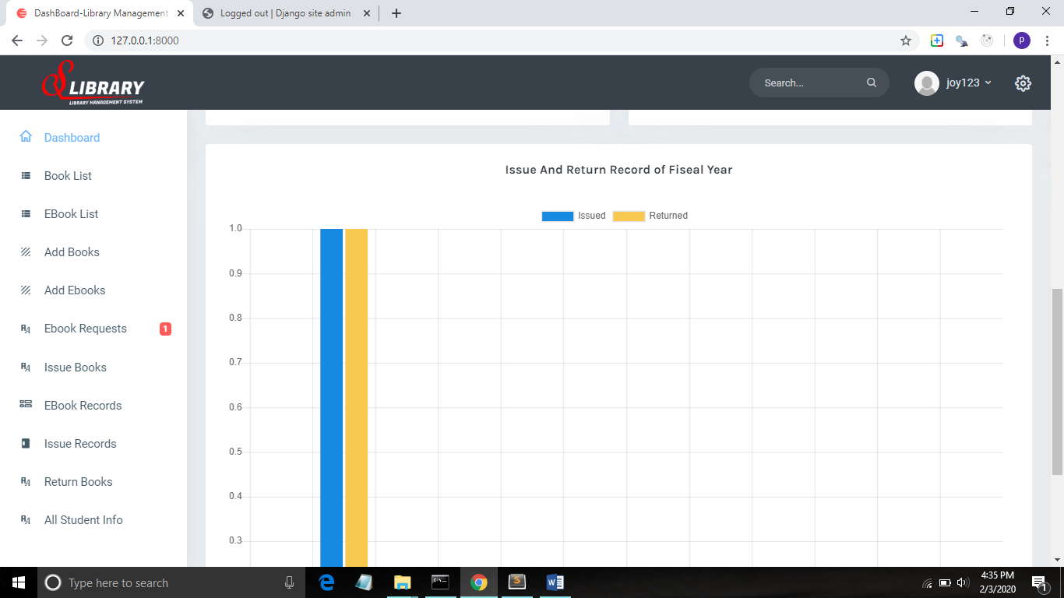

7 Student List

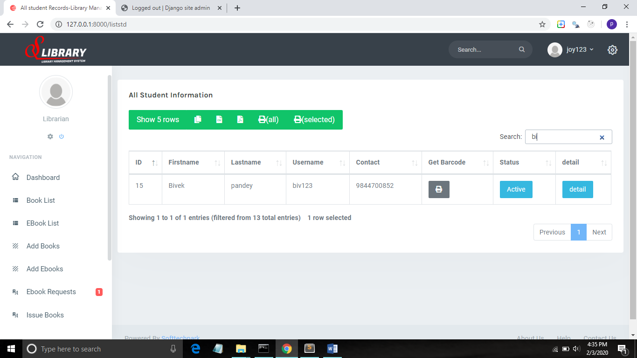

8 Book List

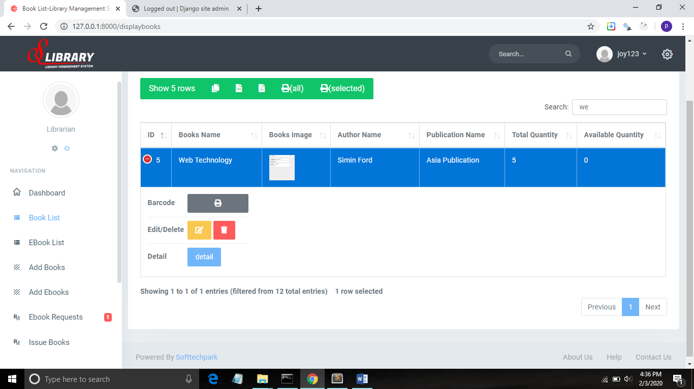

9 Add Ebooks Page

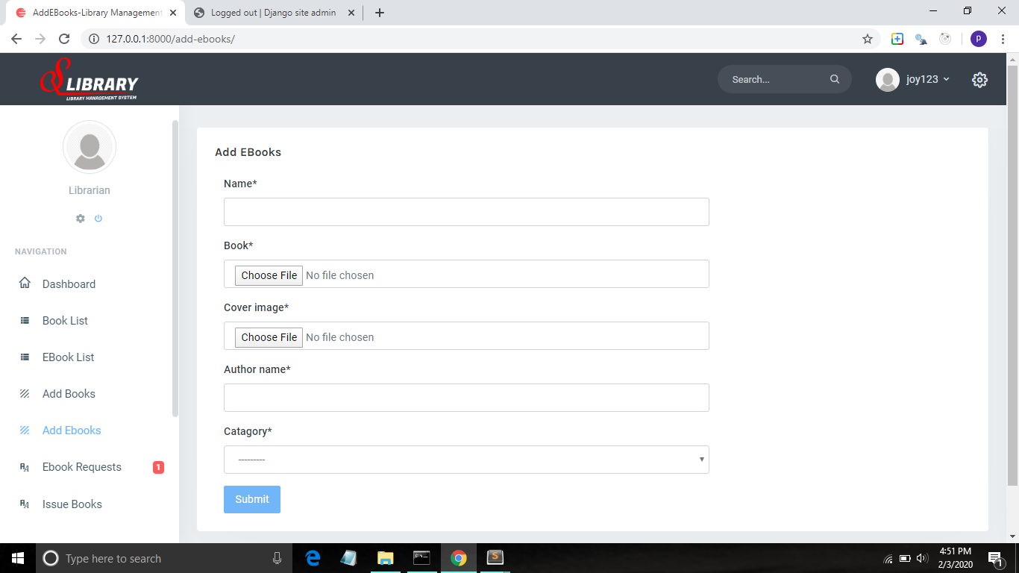

10 Add Books Page

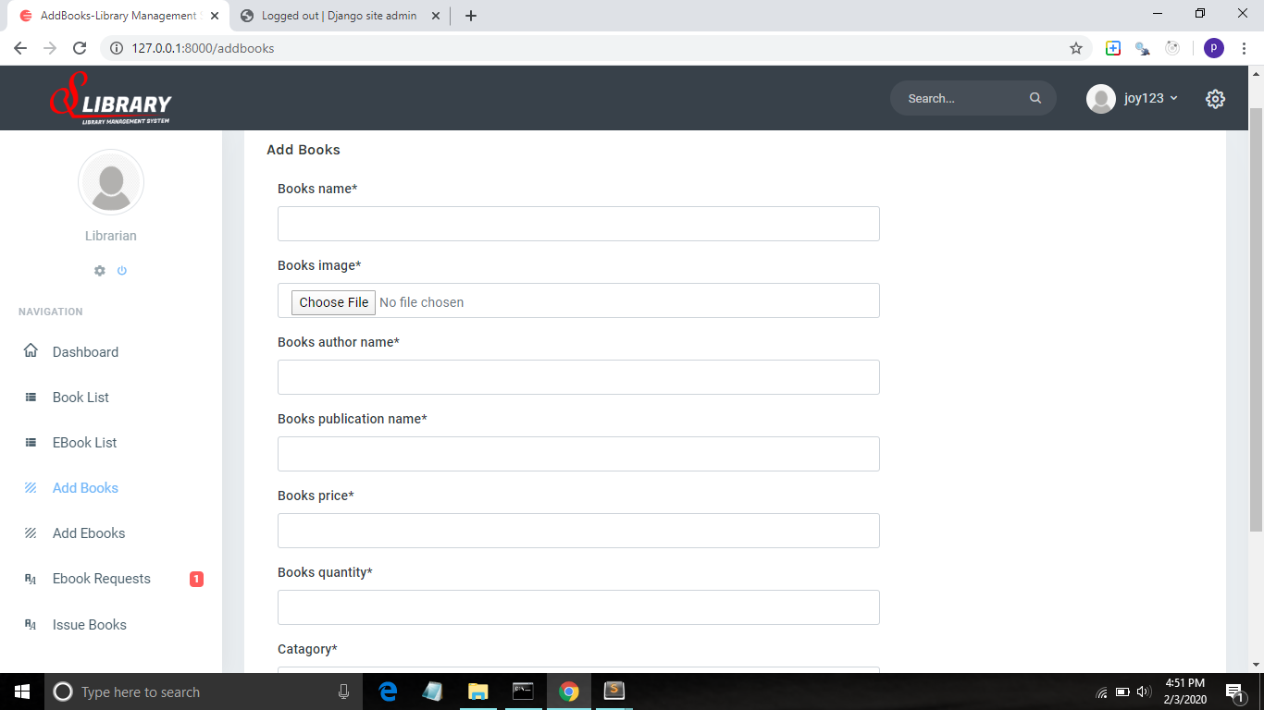

11 Change user password page

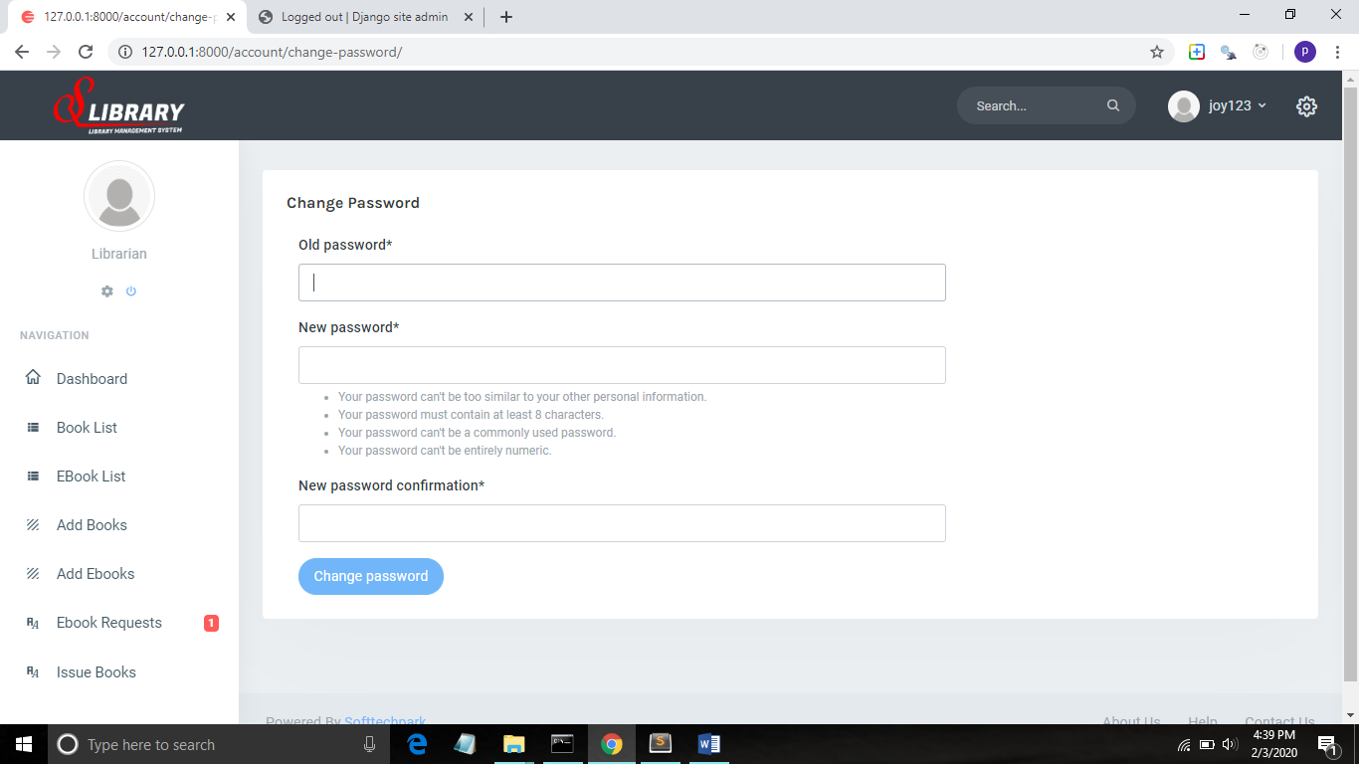

12 Admin Dashboard

