**Name: Hemant Pandey Roll No.: 46**

**Class: MSc CS-I Subject: Algorithms**

**Academic Year: 2020-2021**

|  |  |  |  |
| --- | --- | --- | --- |
| **Sr. No.** | **Practical** | **Page No** | **Signature** |
| **1.** | **Program for Randomized Selection Algorithm** | **2** |  |
| **2.** | **Python program for implementation of heap Sort Algorithm** | **4** |  |
| **3.** | **Python program for implementation of Radix Sort Algorithm** | **6** |  |
| **4.** | **Write a Program to Perform Bucket Sort Algorithm** | **9** |  |
| **5.** | **Write a Program to Perform Folyd-Warshall algorithm** | **11** |  |
| **6.** | **Write a Program for Counting Sort Algorithm in python** | **14** |  |
| **7.** | **Write a Program to find a family of subsets that covers the universal set** | **16** |  |
| **8.** | **Write a Program to returns true if there is a subset of set[] with sum equal to given sum** | **18** |  |

**Practical 1**

**Aim: Program for Randomized Selection Algorithm.**

**Code:**

**from random import randrange**

**def partition(x,pivot_index=0):**

**i=0**

**if pivot_index!=0:**

**x[0],x[pivot_index]=x[pivot_index],x[0]**

**for j in range(len(x)-1):**

**if x[j+1]<x[0]:**

**x[j+1],x[i+1]=x[i+1],x[j+1]**

**i+=1**

**x[0],x[i]=x[i],x[0]**

**return x,i**

**def RSelect(x,k):**

**if len(x)==1:**

**return x[0]**

**else:**

**xpart=partition(x,randrange(len(x)))**

**x=xpart[0]**

**j=xpart[1]**

**if j==k:**

**return x[j]**

**elif j>k:**

**return RSelect(x[:j],k)**

**else:**

**k=k-j-1**

**return RSelect(x[(j+1):],k)**

**x = [3,1,8,4,7,9]**

**for i in range(len(x)):**

**print(RSelect(x,i))**

**Output:**

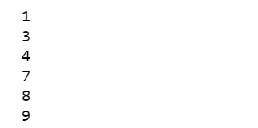

**Practical 2**

**Aim: Python program for implementation of heap Sort Algorithm.**

**Code:**

**# To heapify subtree rooted at index i.**

**# n is size of heap**

**def heapify(arr,n,i):**

**largest = i # Initialize largest as root**

**l=2*i+1**

**r=2*i+2**

**# See if left child of root exists and is**

**# greater than root**

**if l<n and arr[i]<arr[l]:**

**largest=l**

**# See if right child of root exists and is**

**# greater than root**

**if r<n and arr[largest]<arr[r]:**

**largest=r**

**# Change root, if needed**

**if largest!=i:**

**arr[i],arr[largest]=arr[largest],arr[i]**

**# Heapify the root.**

**heapify(arr,n,largest)**

**# The main function to sort an array of given size**

**def heapSort(arr):**

**n=len(arr)**

**# Build a maxheap.**

**for i in range(n,-1,-1):**

**heapify(arr,n,i)**

**# One by one extract elements**

**for i in range(n-1,0,-1):**

**arr[i],arr[0]=arr[0],arr[i]**

**heapify(arr,i,0)**

**# Driver code to test above**

**arr = [ 12, 11, 13, 5, 6, 7]**

**heapSort(arr)**

**n = len(arr)**

**print ("Sorted array is--> ")**

**for i in range(n):**

**print('%d',arr[i])**

**Output:**

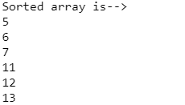

**Practical 3**

**Aim: Python program for implementation of Radix Sort Algorithm.**

**Code:**

**# A function to do counting sort of arr[] according to**

**# the digit represented by exp.**

**def countingSort(arr,expl):**

**n=len(arr)**

**# The output array elements that will have sorted arr**

**output=[0]*n**

**count=[0]*10 # initialize count array as 0**

**for i in range(0,n): # Store count of occurrences in count[]**

**index=int(arr[i]/expl)**

**count[index%10] +=1**

**# Change count[i] so that count[i] now contains actual**

**# position of this digit in output array**

**for i in range(1,10):**

**count[i]+=count[i-1]**

**# Build the output array**

**i=n-1**

**while i>=0:**

**index=int(arr[i]/expl)**

**output[count[index%10]-1]=arr[i]**

**count[index%10] -=1**

**i=i-1**

**# Copying the output array to arr[],**

**# so that arr now contains sorted numbers**

**i=0**

**for i in range(0,len(arr)):**

**arr[i]=output[i]**

**# Method to do Radix Sort**

**def radixSort(arr):**

**# Find the maximum number to know number of digits**

**max1=max(arr)**

**# Do counting sort for every digit. Note that instead**

**# of passing digit number, exp is passed. exp is 10^i**

**# where i is current digit number**

**exp=1**

**while max1/exp>0:**

**countingSort(arr,exp)**

**exp *=10**

**# Driver code to test above**

**arr = [ 170, 45, 75, 90, 802, 24, 2, 66]**

**radixSort(arr)**

**for i in range(len(arr)):**

**print(arr[i])**

**Output:**

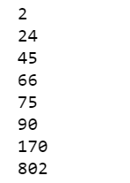

**Practical 4**

**Aim: Write a Program to Perform Bucket Sort Algorithm.**

**Code:**

**# Python3 program to sort an array**

**# using bucket sort**

**def insertationSort(b):**

**for i in range(1,len(b)):**

**up=b[i]**

**j=i-1**

**while j>=0 and b[j]>up:**

**b[j+1]=b[j]**

**j -=1**

**b[j+1]=up**

**return(b)**

**def bucketSort(x):**

**arr=[]**

**slot_num=10**

**# 10 means 10 slots, each**

**# slot's size is 0.1**

**for i in range(slot_num):**

**arr.append([])**

**# Put array elements in different buckets**

**for j in x:**

**index_b = int(slot_num * j)**

**arr[index_b].append(j)**

**# Sort individual buckets**

**for i in range(slot_num):**

**arr[i]=insertationSort(arr[i])**

**# concatenate the result**

**k=0**

**for i in range(slot_num):**

**for j in range(len(arr[i])):**

**x[k] = arr[i][j]**

**k += 1**

**return x**

**# Driver Code**

**x = [0.897, 0.565, 0.656,**

**0.1234, 0.665, 0.3434]**

**print("Sorted Array is--> ")**

**print(bucketSort(x))**

**Output:**



**Practical 5**

**Aim: Write a Program to Perform Folyd-Warshall algorithm.**

**Code:**

**# Python Program for Floyd Warshall Algorithm Number of vertices in the graph**

**v=4**

**# Define infinity as the large enough value. This value will be used for vertices not connected to each other**

**inf=99999**

**# Solves all pair shortest path via Floyd Warshall Algorithm**

**def floydWarshall(graph):**

**""" dist[][] will be the output matrix that will finally**

**have the shortest distances between every pair of vertices**

**initializing the solution matrix same as input graph matrix**

**OR we can say that the initial values of shortest distances**

**are based on shortest paths considering no**

**intermediate vertices """**

**dist=list(map(lambda i:list(map(lambda j:j,i)),graph))**

**""" Add all vertices one by one to the set of intermediate**

**vertices.**

**---> Before start of an iteration, we have shortest distances**

**between all pairs of vertices such that the shortest**

**distances consider only the vertices in the set**

**{0, 1, 2, .. k-1} as intermediate vertices.**

**----> After the end of a iteration, vertex no. k is**

**added to the set of intermediate vertices and the**

**set becomes {0, 1, 2, .. k}**

**"""**

**for k in range(v):**

**for i in range(v):** # pick all vertices as source one by one

**for j in range(v):** # Pick all vertices as destination for the above picked source

**dist[i][j] = min(dist[i][j],dist[i][k]+dist[k][j])**

**printSolution(dist)**

**# A utility function to print the solution**

**def printSolution(dist):**

**print('Following matrix shows the shortest Distance between every pair of vertices---> ')**

**for i in range(v):**

**for j in range(v):**

**if (dist[i][j] == inf):**

**print("%7s"%"inf")**

**else:**

**print("%7d\t" %(dist[i][j]))**

**if j ==v-1:**

**print('')**

**""" Driver program to test the above program**

**Let us create the following weighted graph**

**10**

**(0)------->(3)**

**| /|\**

**5 | |**

**| | 1**

**\|/ |**

**(1)------->(2)**

**3 """**

**graph = [[0,5,inf,10],**

**[inf,0,3,inf],**

**[inf, inf, 0, 1],**

**[inf, inf, inf, 0] ]**

**# Print the solution**

**floydWarshall(graph)**

**Output:**

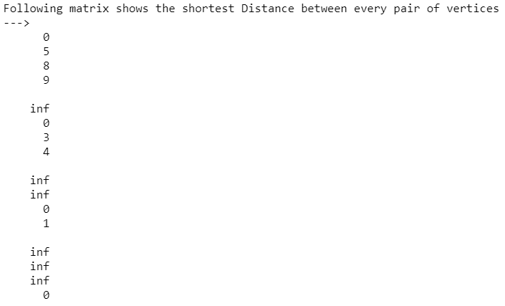

**Practical 6**

**Aim: Write a Program for Counting Sort Algorithm in python.**

**Code:**

**# The main function that sort the given string arr[] in alphabetical order**

**def countSort(arr):**

**# The output character array that will have sorted arr**

**output=[0 for i in range(256)]**

**# Create a count array to store count of inidividul characters and initialize count array as 0**

**count=[0 for i in range(256)]**

**# For storing the resulting answer since the string is immutable**

**ans = ["" for _ in arr]**

**# Store count of each character**

**for i in arr:**

**count[ord(i)] +=1**

**# Change count[i] so that count[i] now contains actual position of this character in output array**

**for i in range(256):**

**count[i] += count[i-1]**

**# Build the output character array**

**for i in range(len(arr)):**

**output[count[ord(arr[i])]-1] = arr[i]**

**count[ord(arr[i])] -= 1**

**# Copy the output array to arr, so that arr now contains sorted characters**

**for i in range(len(arr)):**

**ans[i] = output[i]**

**return ans**

**# Driver program to test above function**

**arr = "geeksforgeeks"**

**ans = countSort(arr)**

**print("Sorted character array is %s" % ("".join(ans)))**

**Output:**



**Practical 7**

**Aim: Write a Program to find a family of subsets that covers the universal set.**

**Code:**

**def set_cover(universe, subsets):**

**"""Find a family of subsets that covers the universal set"""**

**elements = set(e for s in subsets for e in s)**

**# Check the subsets cover the universe**

**if elements != universe:**

**return None**

**covered = set()**

**cover = []**

**# Greedily add the subsets with the most uncovered points**

**while covered != elements:**

**subset = max(subsets, key=lambda s: len(s - covered))**

**cover.append(subset)**

**covered |= subset**

**return cover**

**def main():**

**universe = set(range(1, 11))**

**subsets = [set([1, 2, 3, 8, 9, 10]),**

**set([1, 2, 3, 4, 5]),**

**set([4, 5, 7]),**

**set([5, 6, 7]),**

**set([6, 7, 8, 9, 10])]**

**cover = set_cover(universe, subsets)**

**print(cover)**

**if __name__ == '__main__':**

**main()**

**Output:**



**Practical 8**

**Aim: Write a Program to returns true if there is a subset of set[] with sum equal to given sum.**

**Code:**

**def isSubsetSum(set,n, sum) :**

**# Base Cases**

**if (sum == 0) :**

**return True**

**if (n == 0 and sum != 0) :**

**return False**

**# If last element is greater than**

**# sum, then ignore it**

**if (set[n - 1] > sum) :**

**return isSubsetSum(set, n - 1, sum);**

**# else, check if sum can be obtained**

**# by any of the following**

**# (a) including the last element**

**# (b) excluding the last element**

**return isSubsetSum(set, n-1, sum) or isSubsetSum(set, n-1, sum-set[n-1])**

**# Driver program to test above function**

**set = [3, 34, 4, 12, 5, 2]**

**sum = 9**

**n = len(set)**

**if (isSubsetSum(set, n, sum) == True) :**

**print("Found a subset with given sum")**

**else :**

**print("No subset with given sum")**

**Output:**

