**Name:Hemant Pandey Sem: I**

**Subject: Data Warehousing & Data Mining (BI) Class: MSC I**

**Academic Year: 2020-21 Roll No: 46**

**INDEX**

|  |  |  |  |
| --- | --- | --- | --- |
| **S.NO** | **Topic** | **Page No** | **Sign** |
| **1** | **Creation of Dimensions and Fact tables.** |  |  |
| **2** | **Create Data Source using SSAS (SQL Server Analysis Services.)** |  |  |
| **3** | **Create Data Source View using SSAS (SQL Server Analysis Services.)** |  |  |
| **4** | **Create cube using SSAS (SQL Server Analysis Services.) and process the cube.** |  |  |
| **5** | **View cube data in multidimensional Format. (Excel Pivot Chart.)** |  |  |
| **6** | **Working with measures in the cube.** |  |  |
| **7** | **Creating an Excel Pivot Table and Pivot Chart by using the OLAP cube data.** |  |  |
| **8** | **Firing Queries on Tables.** |  |  |

**Practical No 1**

**Aim: Creation of Dimensions and Fact tables.**

**Solution:**

**Open Application -> Microsoft SQL Server 2008 R2 -> SQL Server Management Studio**

1. **Select Connect Tab -> Database Engine -> Select Server Name(local)**
2. **Right Click the Database -> New Database**
3. **Types “SalesInformation” as the database name, click on OK to close the dialog box and to create the database.**

**Create a Database Diagrams**

**Expand the “SalesInformation” database folder.**

1. **Click on Database Diagrams to expand it**

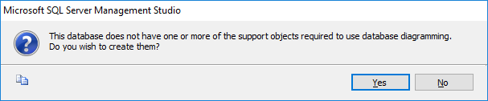

**On click of it, above Dialog box appears, click on Yes to close it.**

1. **Right Click on Database Diagrams -> New Database Diagrams**
2. **Create fact and Dimension Tables. (Right click on surface, choose New Table to add tables n Database Diagrams.)**

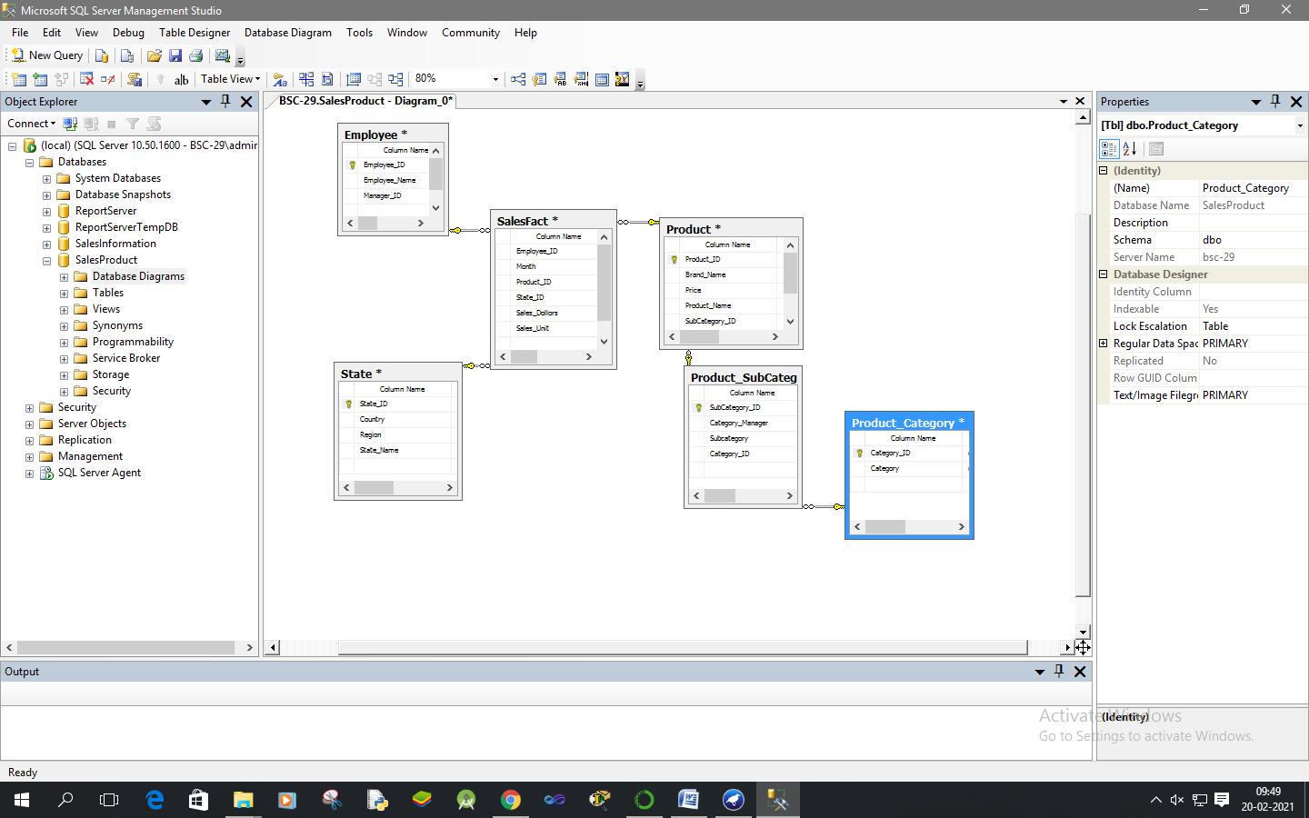

1. **Establish relationship between fact and dimension tables.**
2. **Save Database Diagrams with name as “SalesInfo”. (After saving Database Diagrams fact and dimension tables are automatically placed in Table tab.)**

**Practical No 2**

**Aim: Create Data Source using SSAS(SQL Server Analysis Services.)**

**Solution:**

**Open Application -> Microsoft SQL Server 2008 R2 -> SQL Server Business Intelligence Development Studio**

1. **Select File -> New Project -> Choose Analysis Service Project -> Name it as “SalesInfo_BIPrj” and click on OK.**
2. **Right Click on Data Sources -> New Data Source**

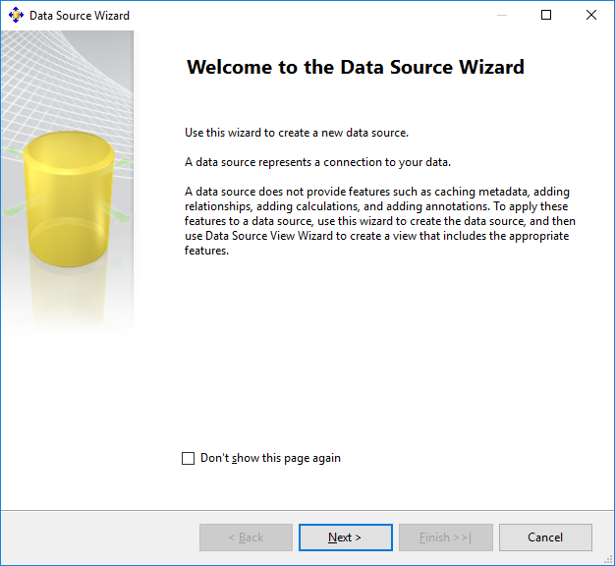

**Click on Next.**

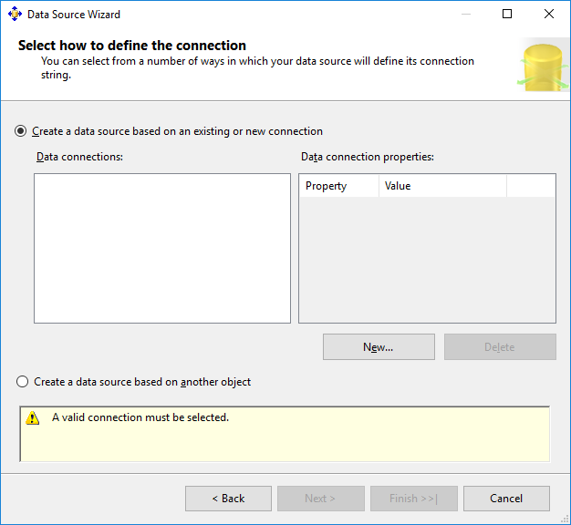

**Click on New.**

1. **Choose Provider as “Microsoft OLEDB Provider for SQL Server” , Server Name as “.”, Select database name as “SalesInformation”.(Created in SQL Server Management studio).**

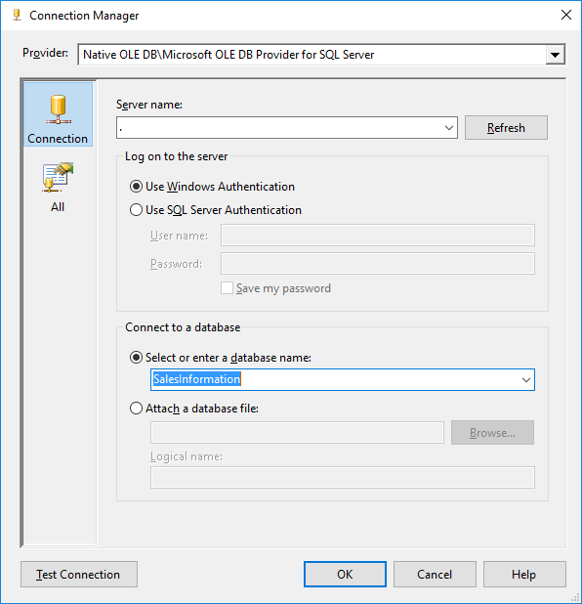

1. **Click on Test Connection.**

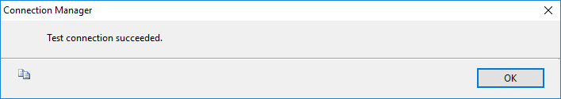

**Click on OK.**

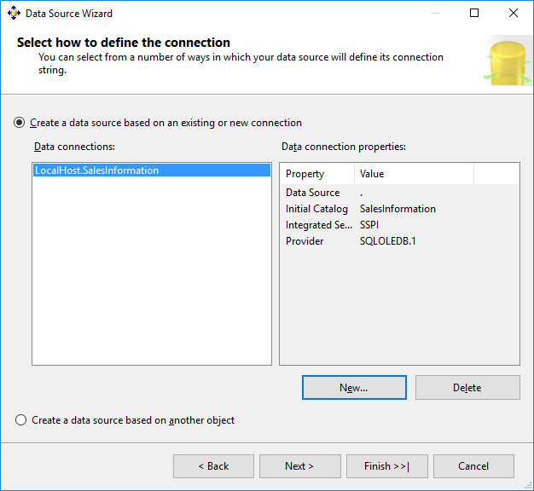

**Click on Next**

1. **Choose “Inherit” option.**

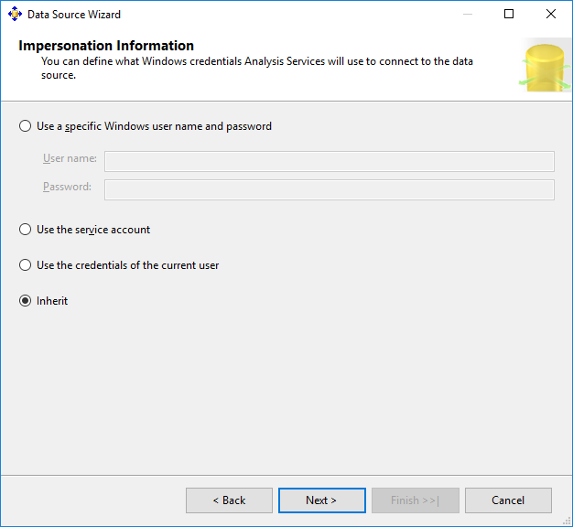

**Click on Next.**

1. **Click on Finish.**

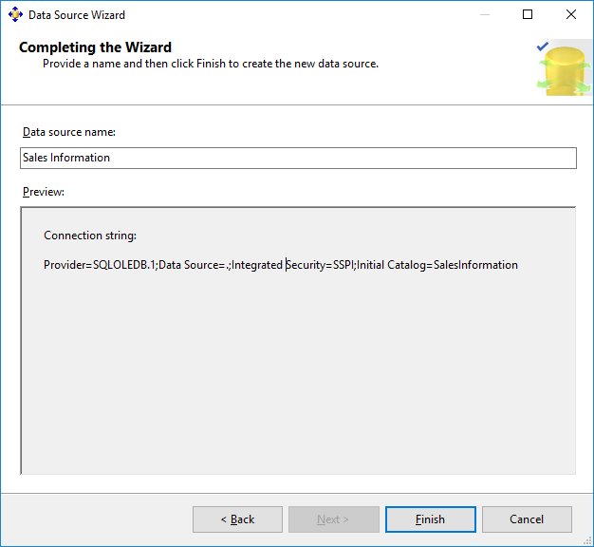

**Name Data Source as “Sales Information”.**

**Practical No 3**

**Aim: Create Data Source View using SSAS (SQL Server Analysis Services.)**

**Solution:**

1. **Right click on Data Source View -> New Data Source View**

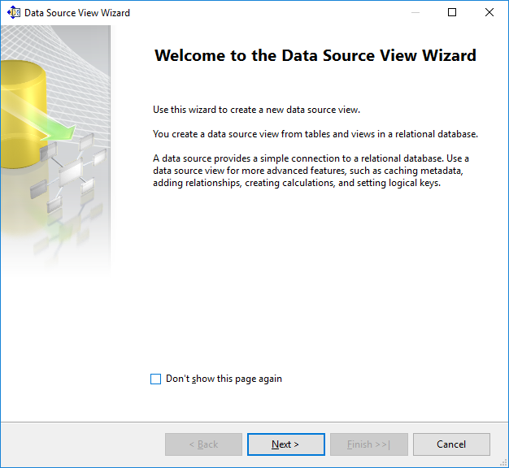

**Click on Next.**

1. **Click on Next.**

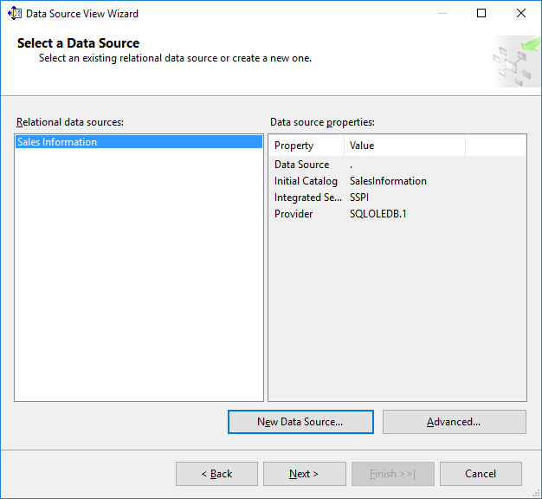

1. **Select Tables and Views.**

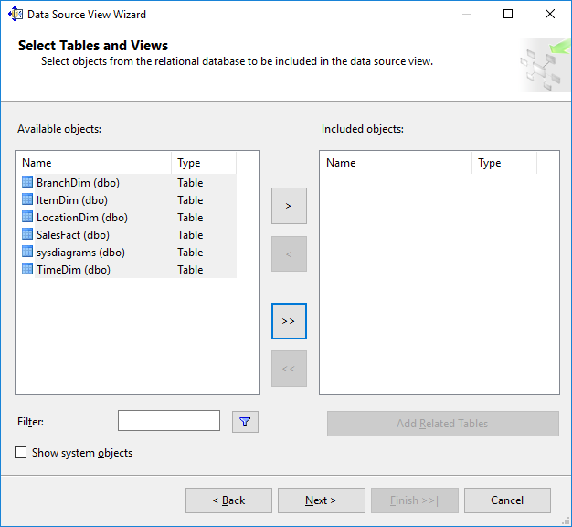

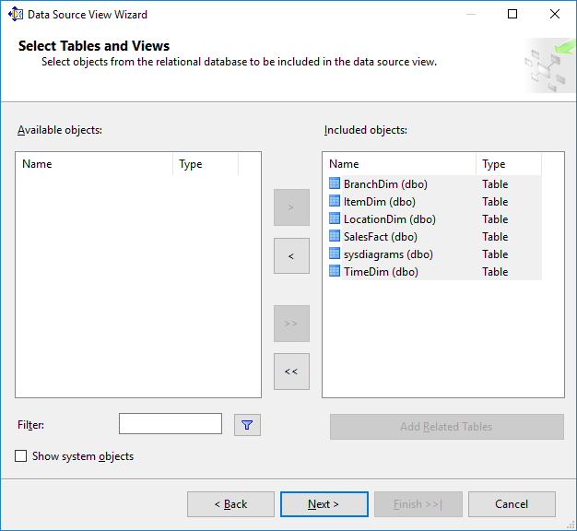

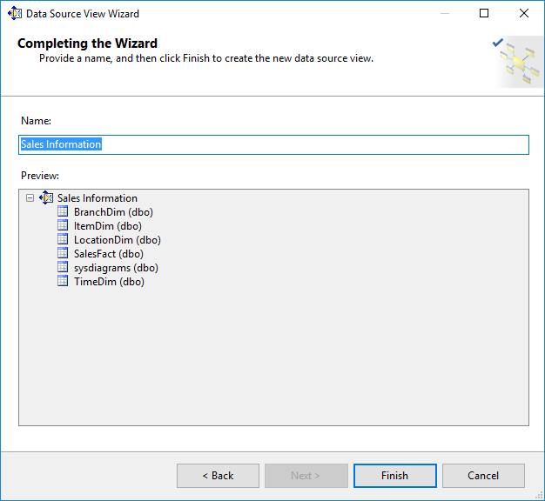

**Click on Finish.**

1. **Finally, we will get the Data Source View like :**

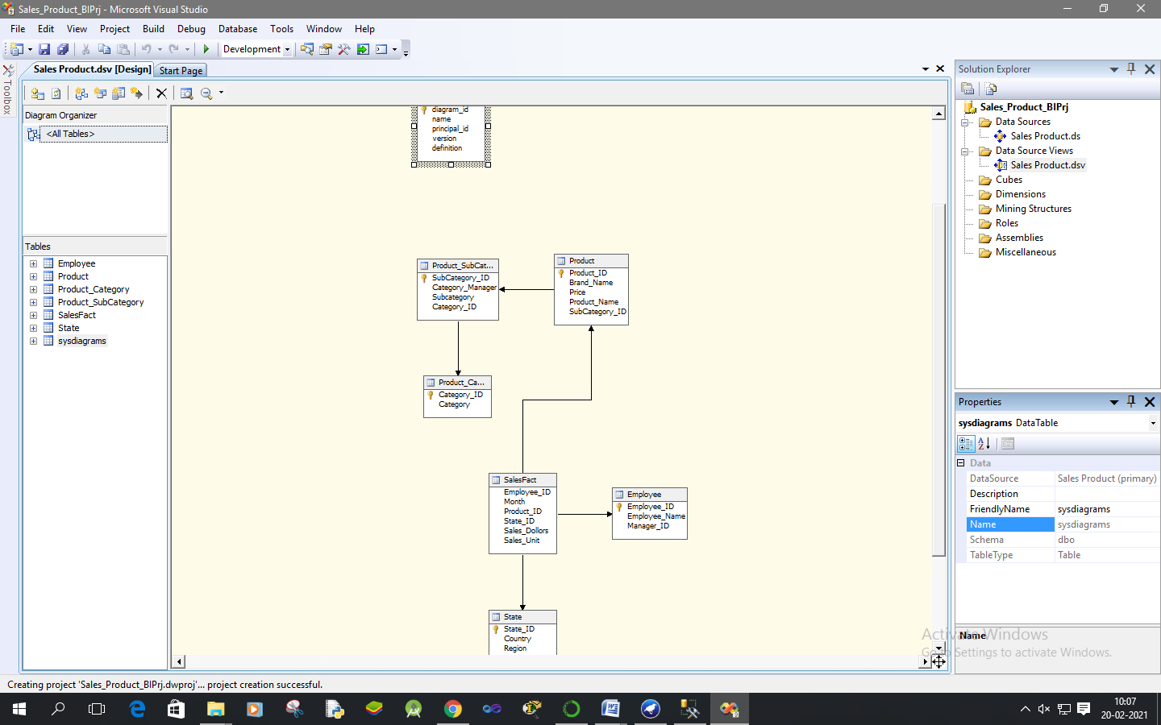

**Practical No 4**

**Aim: Create cube using SSAS (SQL Server Analysis Services.) and process the cube.**

**Solution:**

1. **Right click on Cubes -> New Cube.**

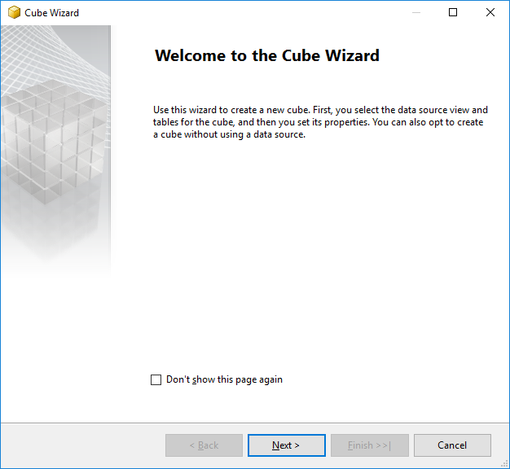

**Click on Next.**

1. **Select First option “Use existing tables”. Click on Next.**

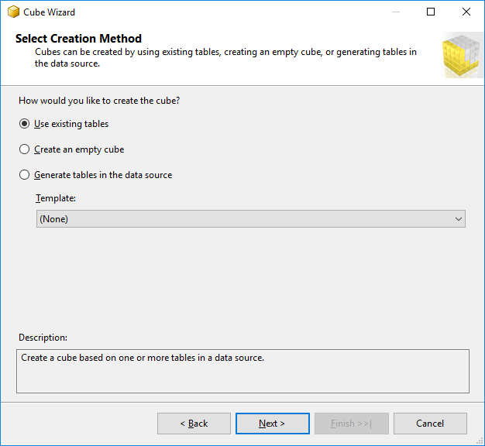

1. **Select Data Source View as “Sales Information” and Select all the tables.**

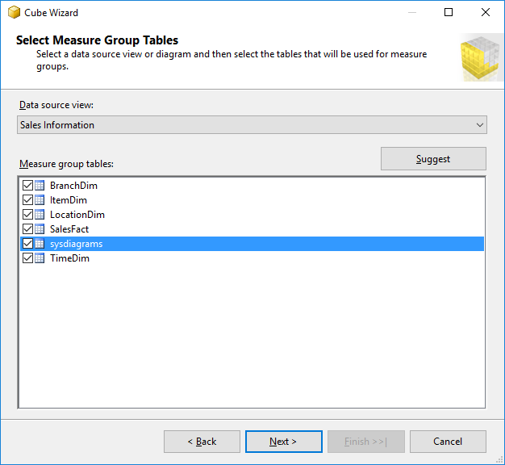

**Click on Next.**

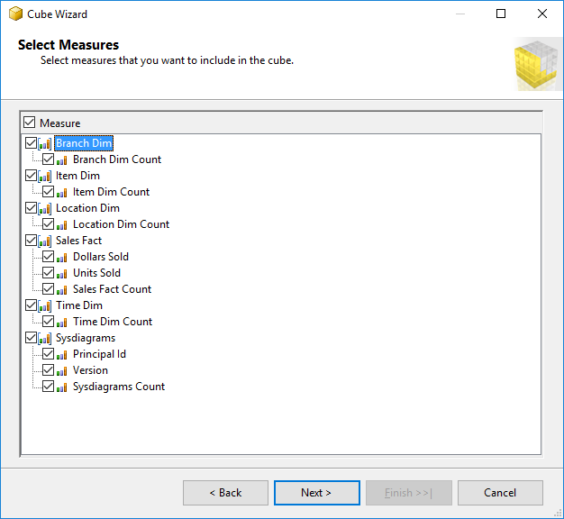

**Click on Next.**

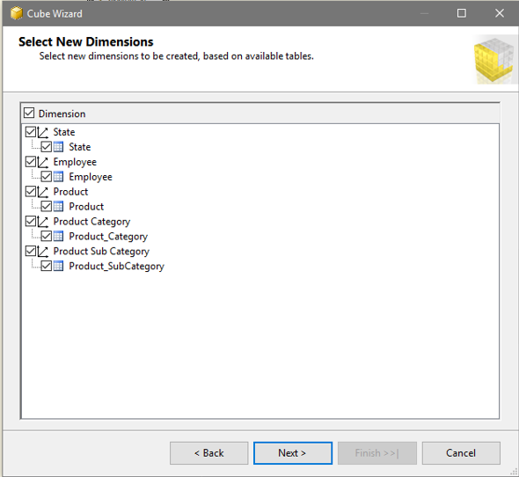

**Click on Next.**

1. **Name Cube as “SalesProduct”.**

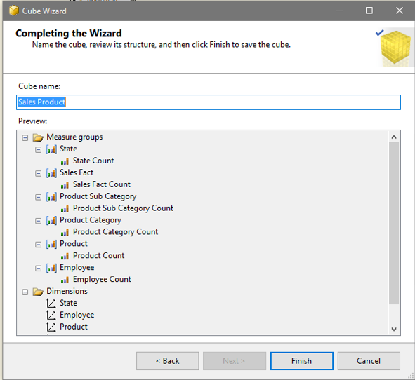

**Click on Finish.**

1. **Finally, we will get the Cube View as well Dimensions View like :**

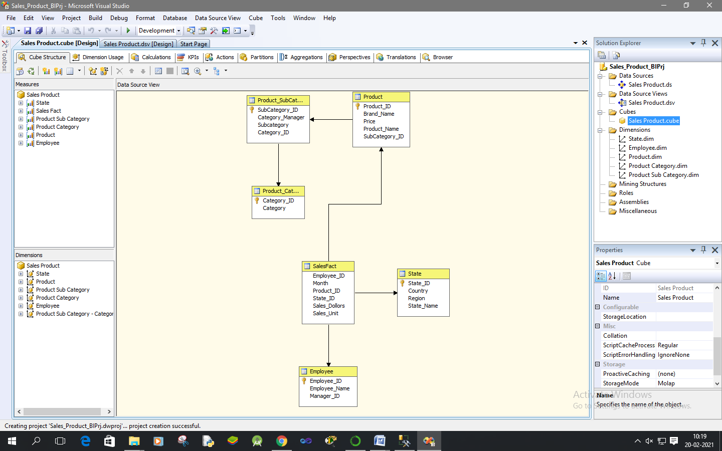

1. **Finally, Process cube by Right click on SalesProduct -> Process.**

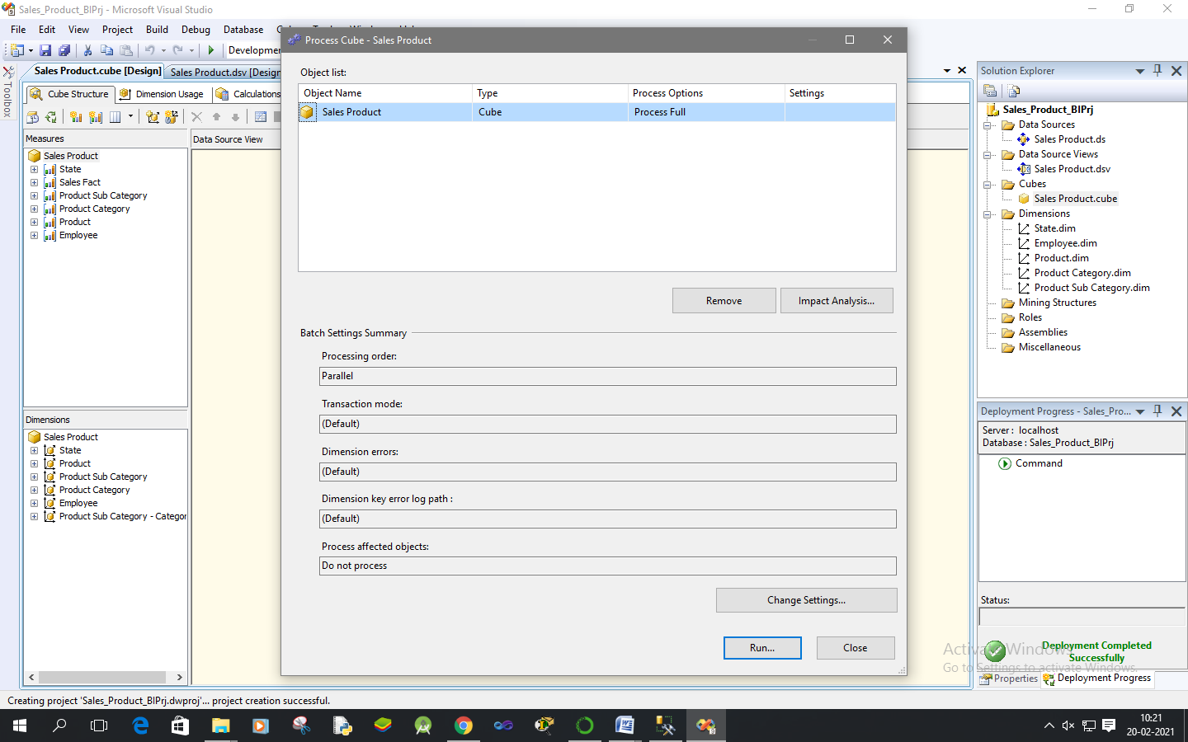

1. **Click on Run.**

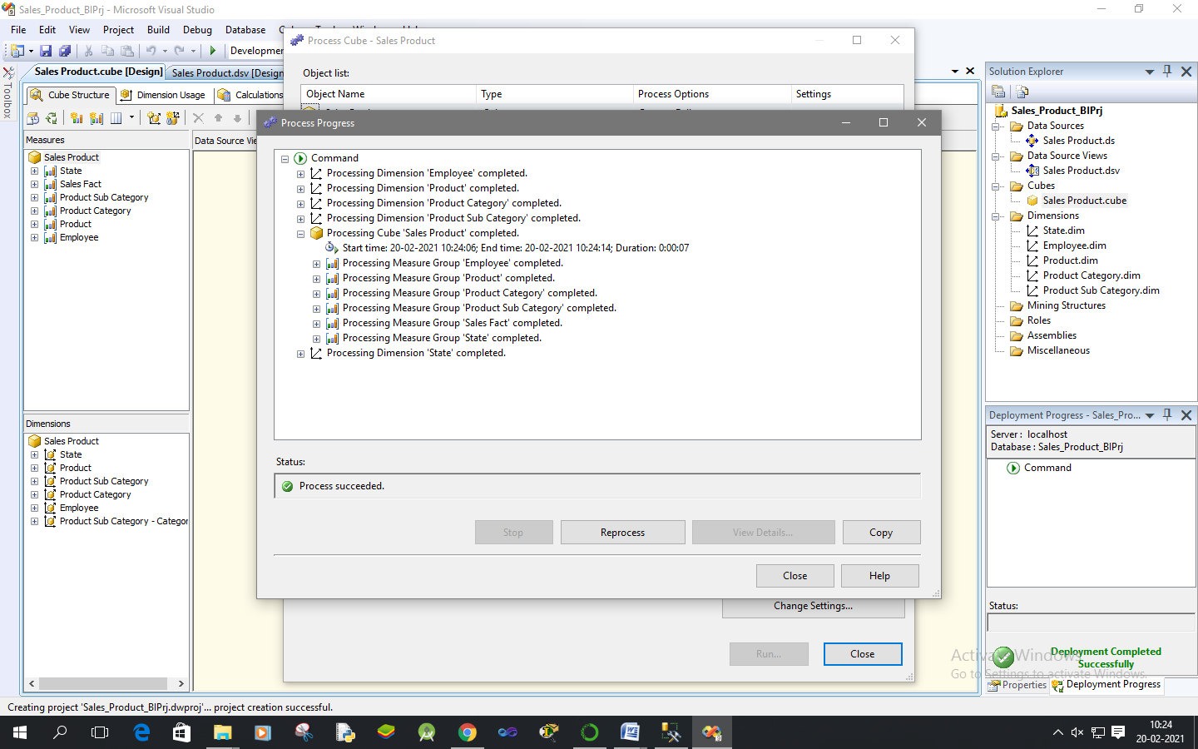

**Practical No 5**

**Aim: View cube data in multidimensional Format.**

**Solution:**

1. **Double Click on “SalesProduct”. Go to the “Browser” Tab.**

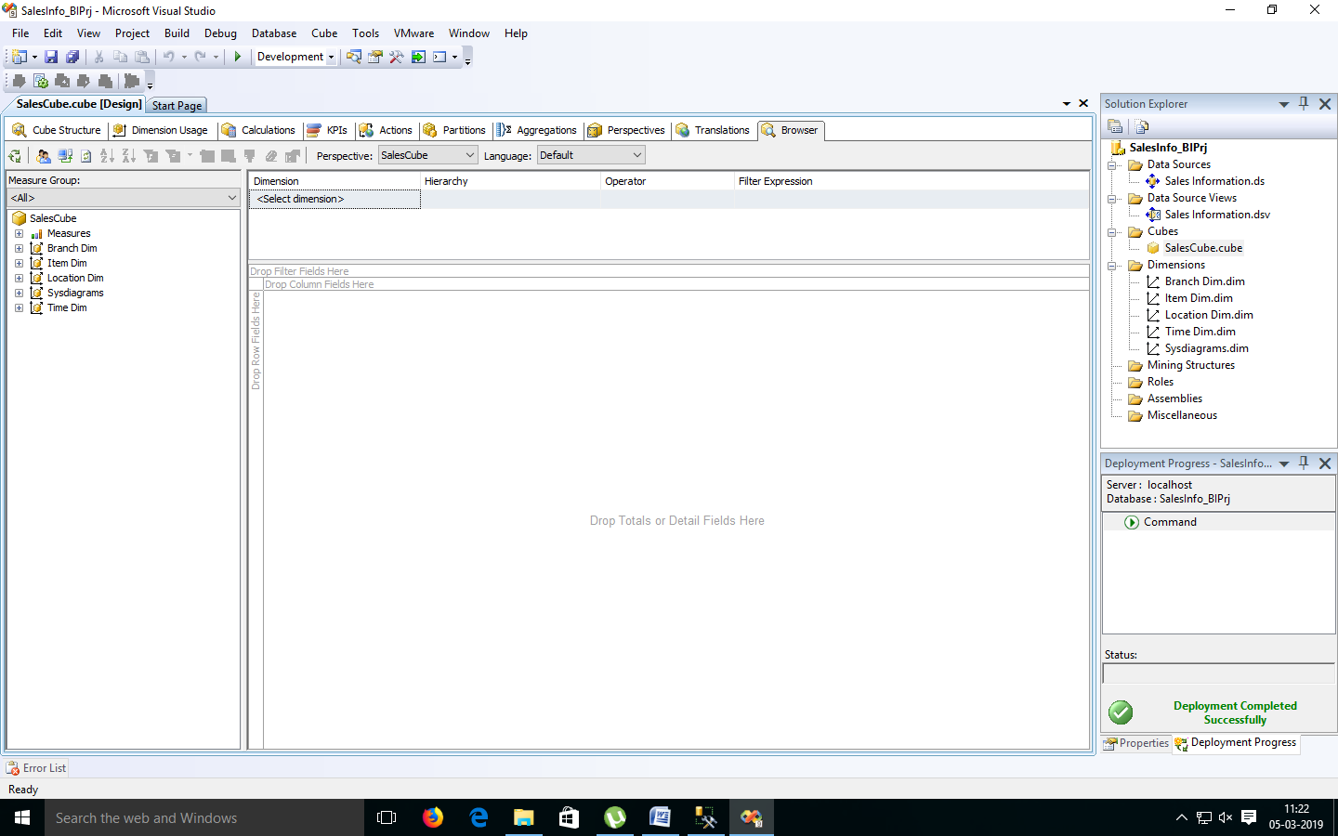

1. **Go to the “Item Dimension”. Right Click on ‘Item Key’ -> Add to Row Area.**

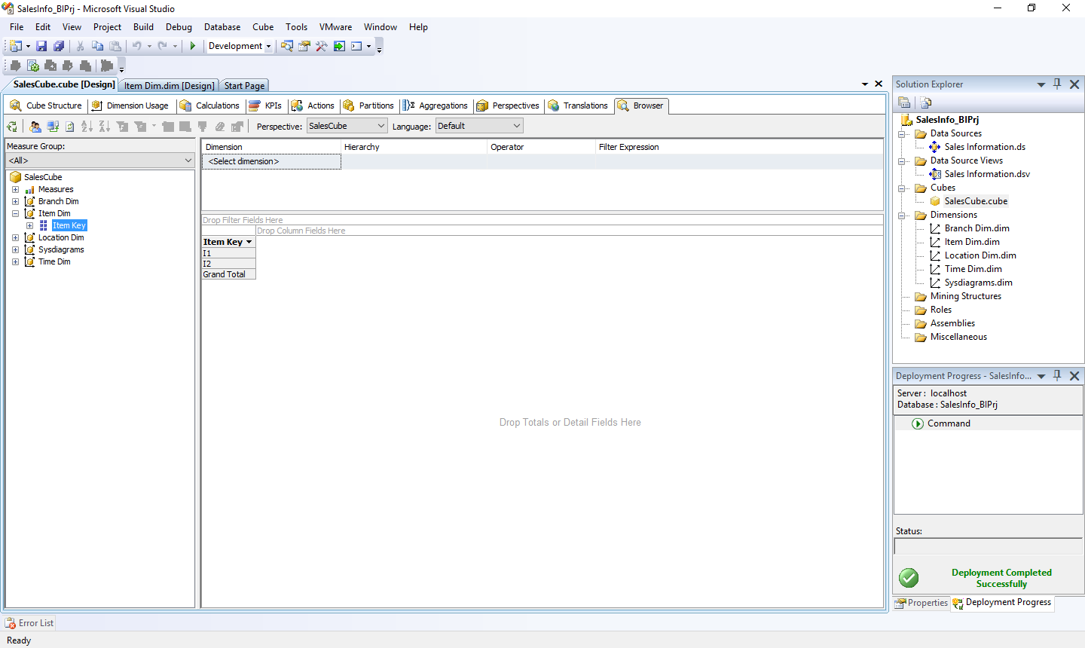

1. **Go to the “Location Dimension”. Right Click on ‘Location Key’ -> Add to Column Area.**

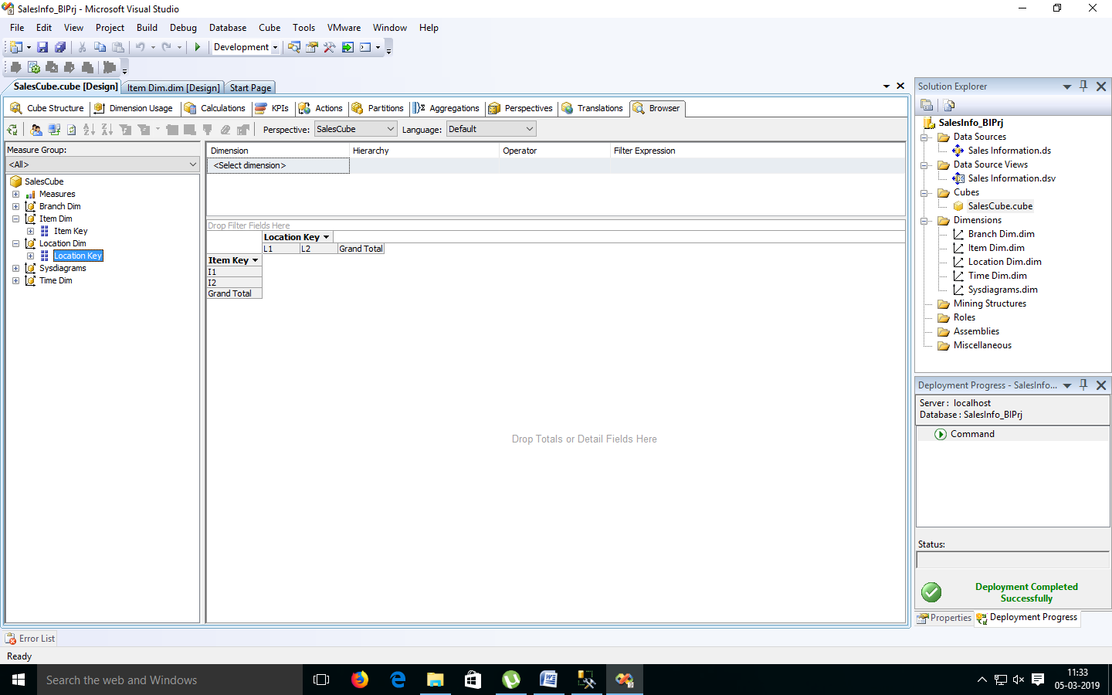

1. **Go to ‘Measures’. Select ‘SalesFact’ -> Right Click on “Dollars Sold” -> Add to Data area.**

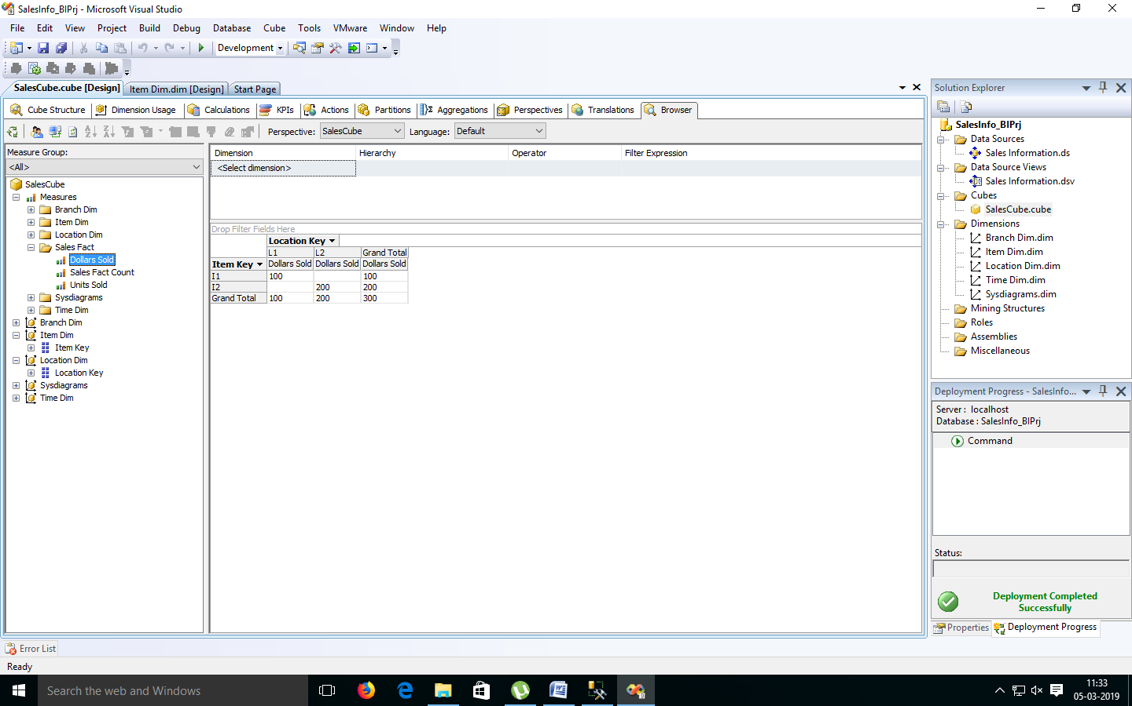

1. **Go to the “Branch Dimension”. Right Click on ‘Branch Key’ -> Add to Row Area.**

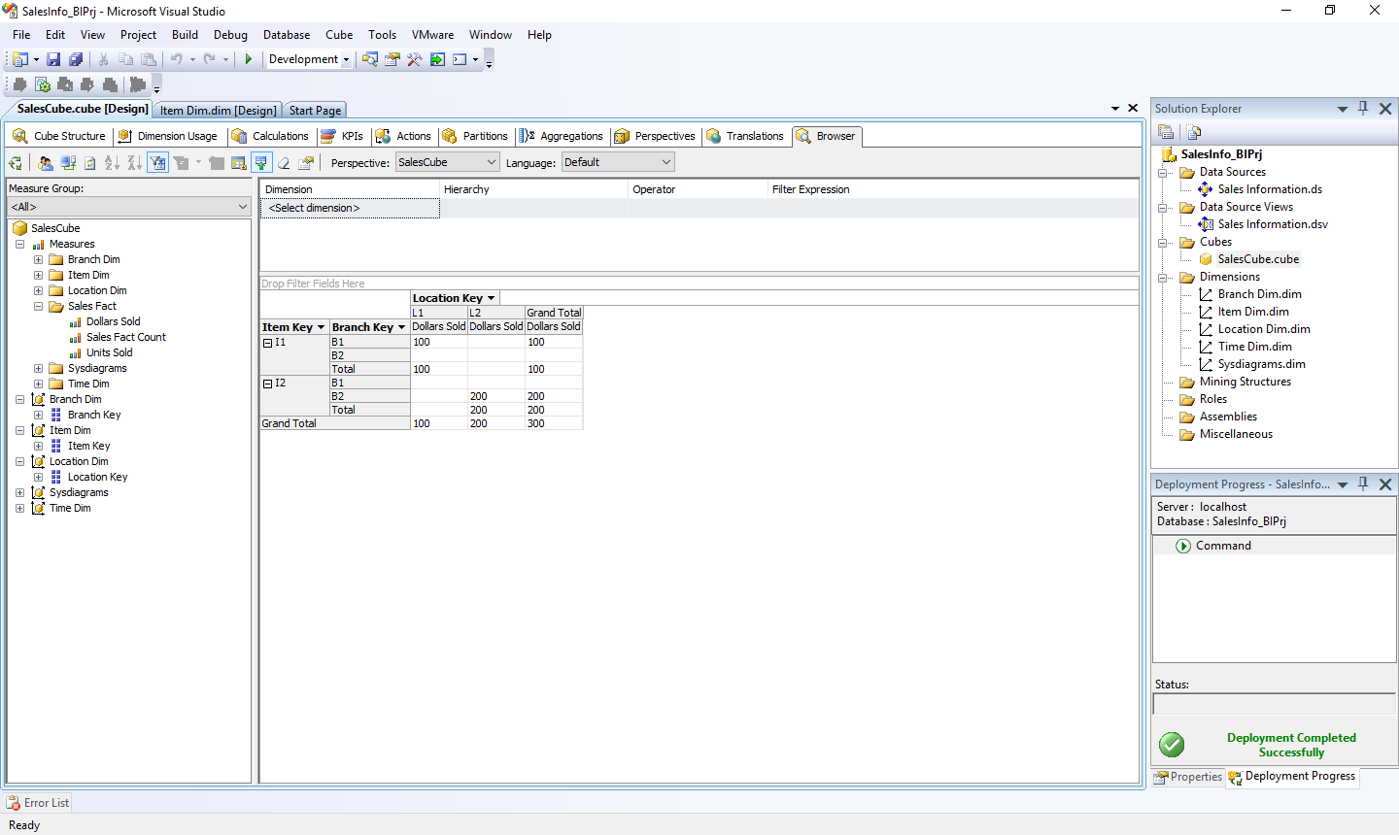

**Practical No 6**

**Aim: Working with measures in the cube.**

**Solution:**

1. **Double click on ‘SalesCube’. Go to cube structure.**

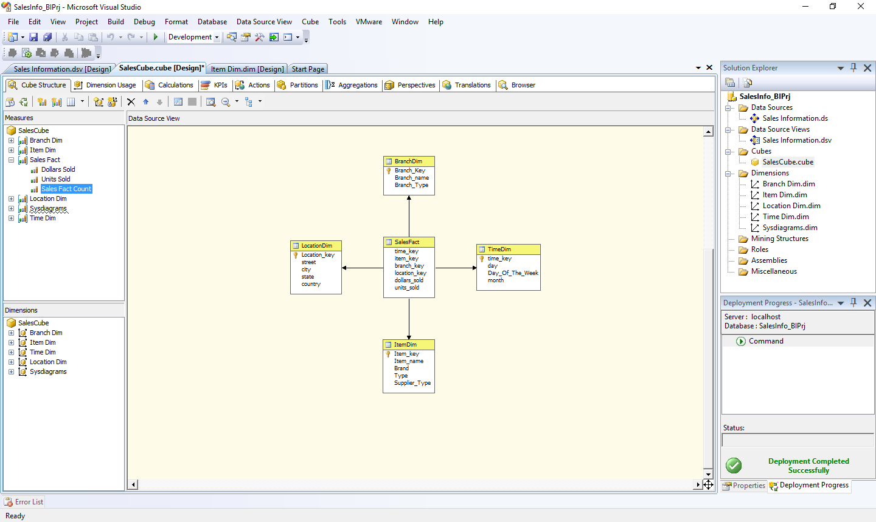

1. **Right click on SalesCube -> New Measure.**

**Select Usage = “Sum”, Source table = “SalesFact” and Source Column = “dollars_sold”.**

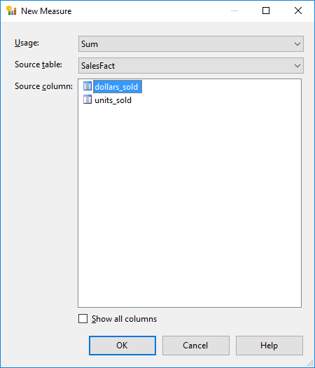

**Click on OK.**

1. **Rename Measure as “Sum Dollars sold”.**

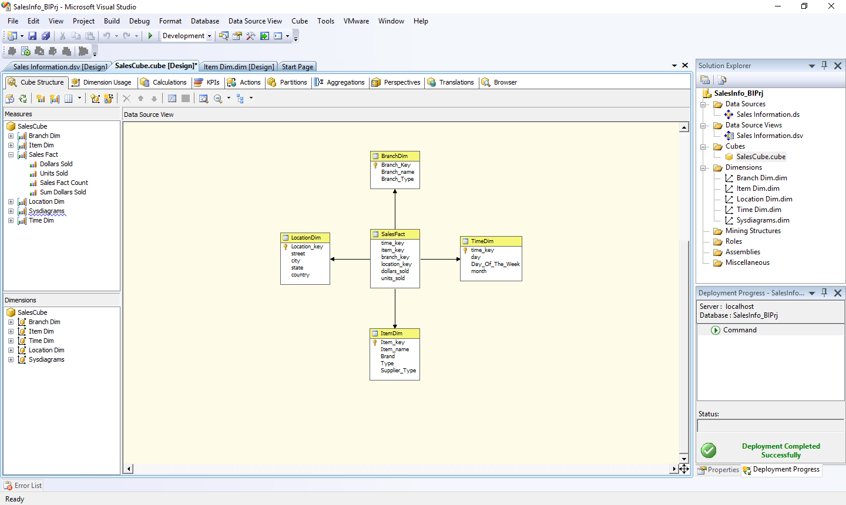

1. **Process Cube and Go to Browser and Reconnect it. Right Click on “Sum Dollars Sold” -> Add to Data Area.**

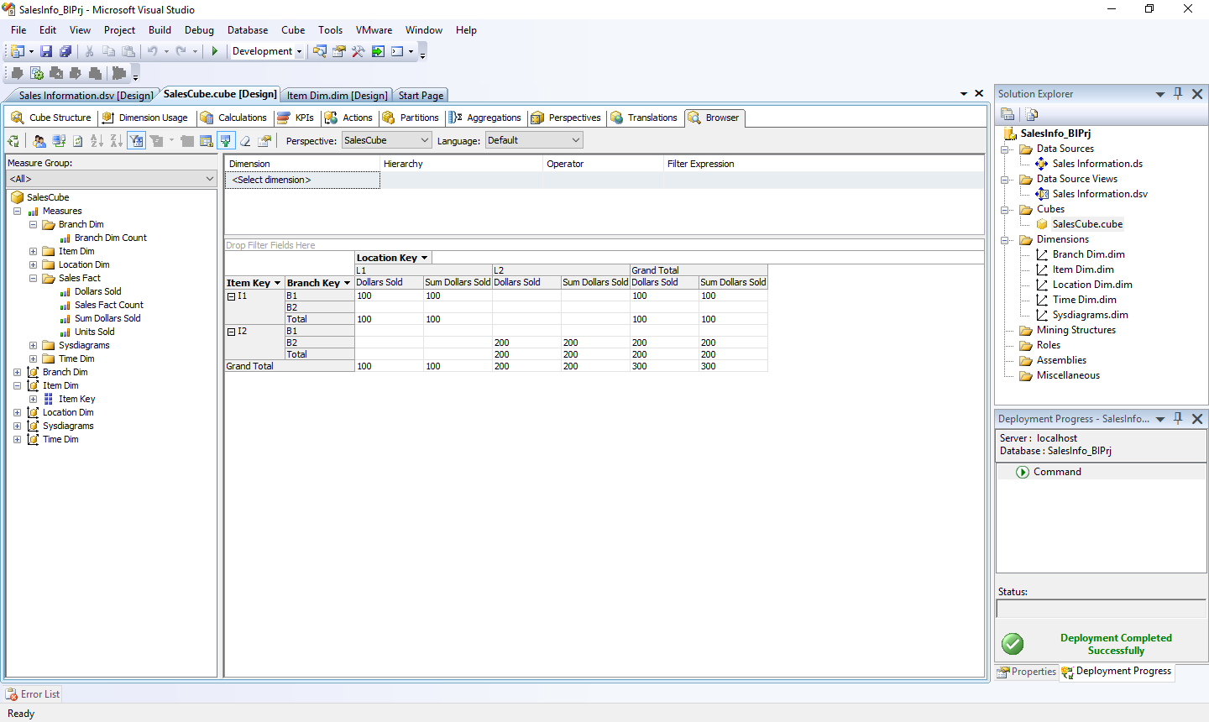

**Practical No 7**

**Aim: Creating an Excel Pivot Table and Pivot Chart by using the OLAP cube data.**

**Solution:**

1. **Open MS-Excel. Click on Data Menu.**
2. **Go to From Other Sources.**
   1. **From SQL Server -> Type Server name as “.”**

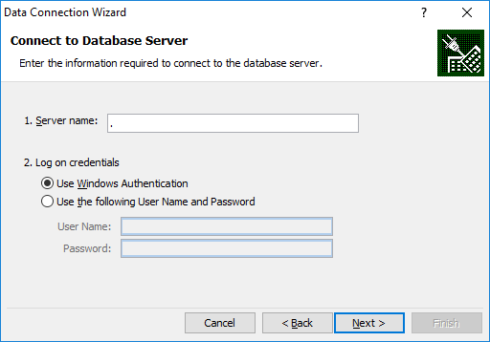

**Click on Next.**

**Choose SQL Database -> “SalesInformation”**

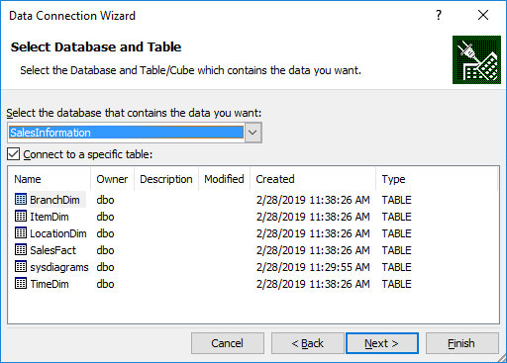

* 1. **From Analysis Services -> Type Server name as “.”**



**Click on Next.**

**Choose Analysis Database as “SalesInfo_BIPrj”. Click on Next.**

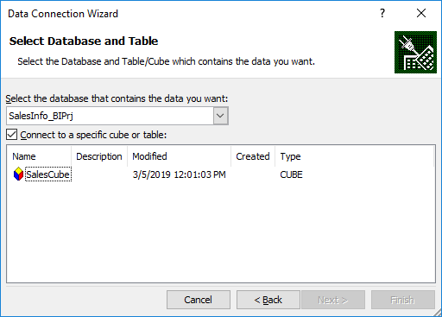

**Click on OK**

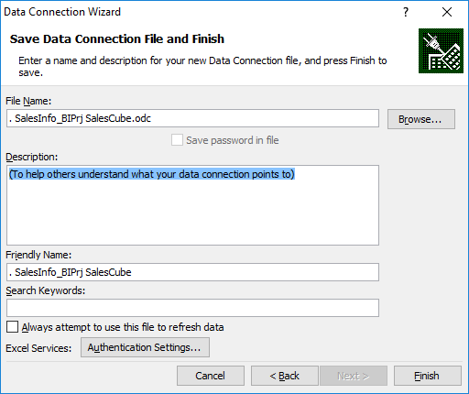

**Click on Finish.**

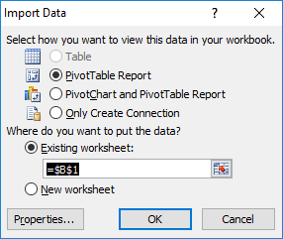

**Click on OK.**

1. **Select Item Key, Location Key and Measures as Dollars Sold, Units Sold and Sum Dollars Sold**

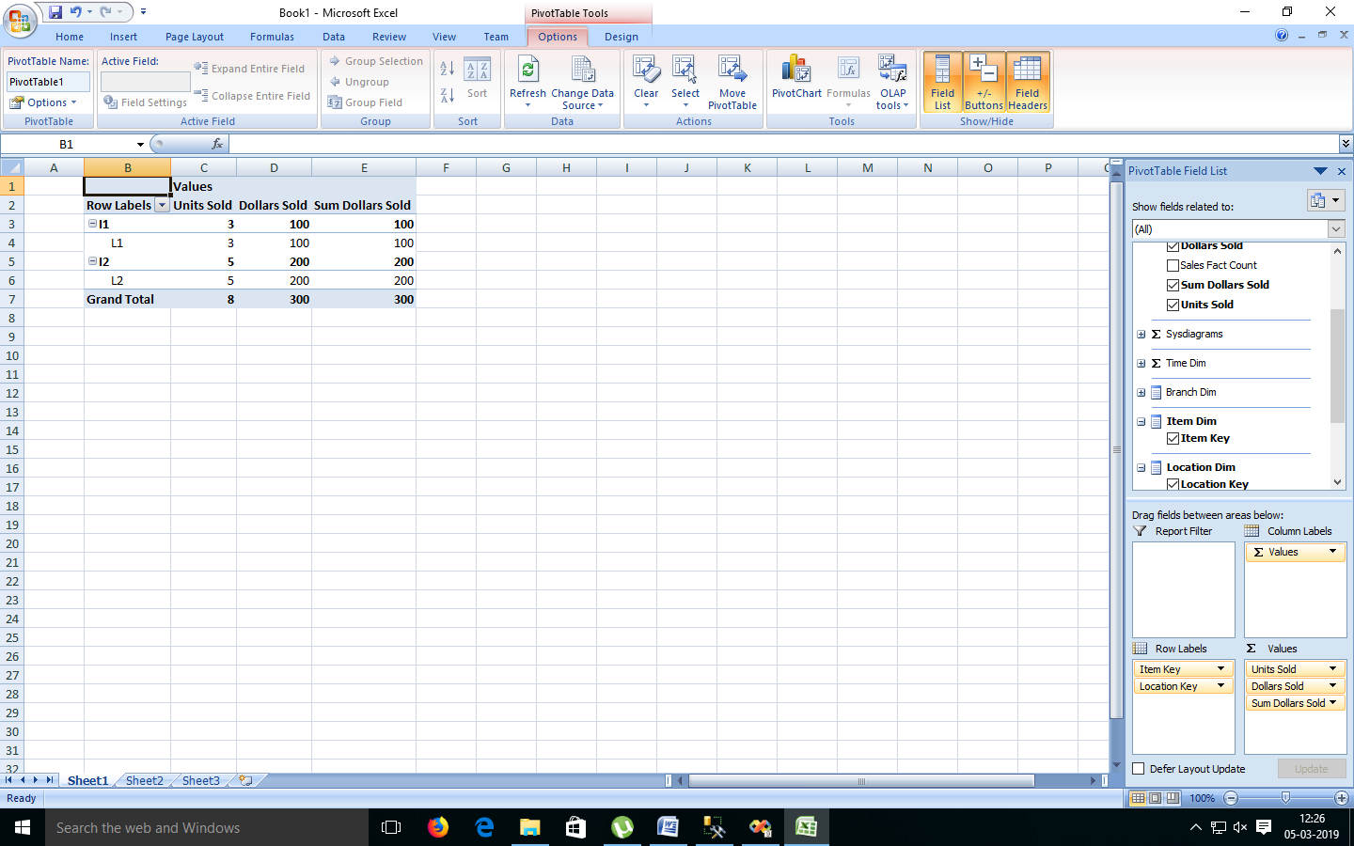

1. **Select Result Area. Go to Insert Menu. Select Pie Chart option.**

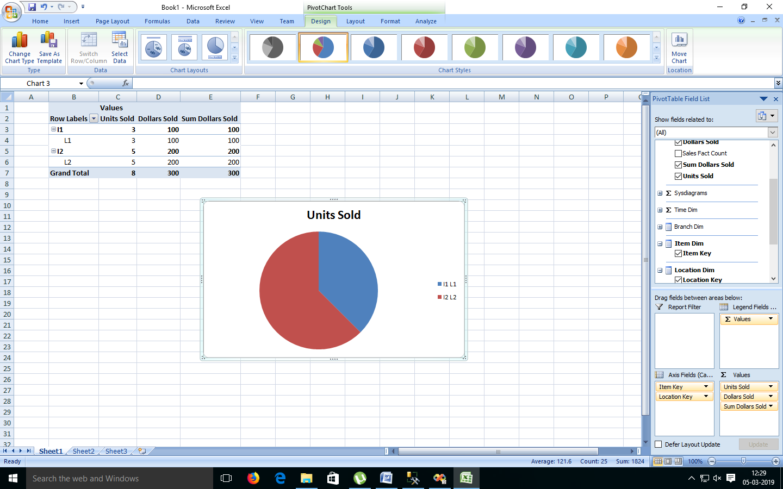

1. **Select Result Area. Go to Insert Menu. Select Column option.**

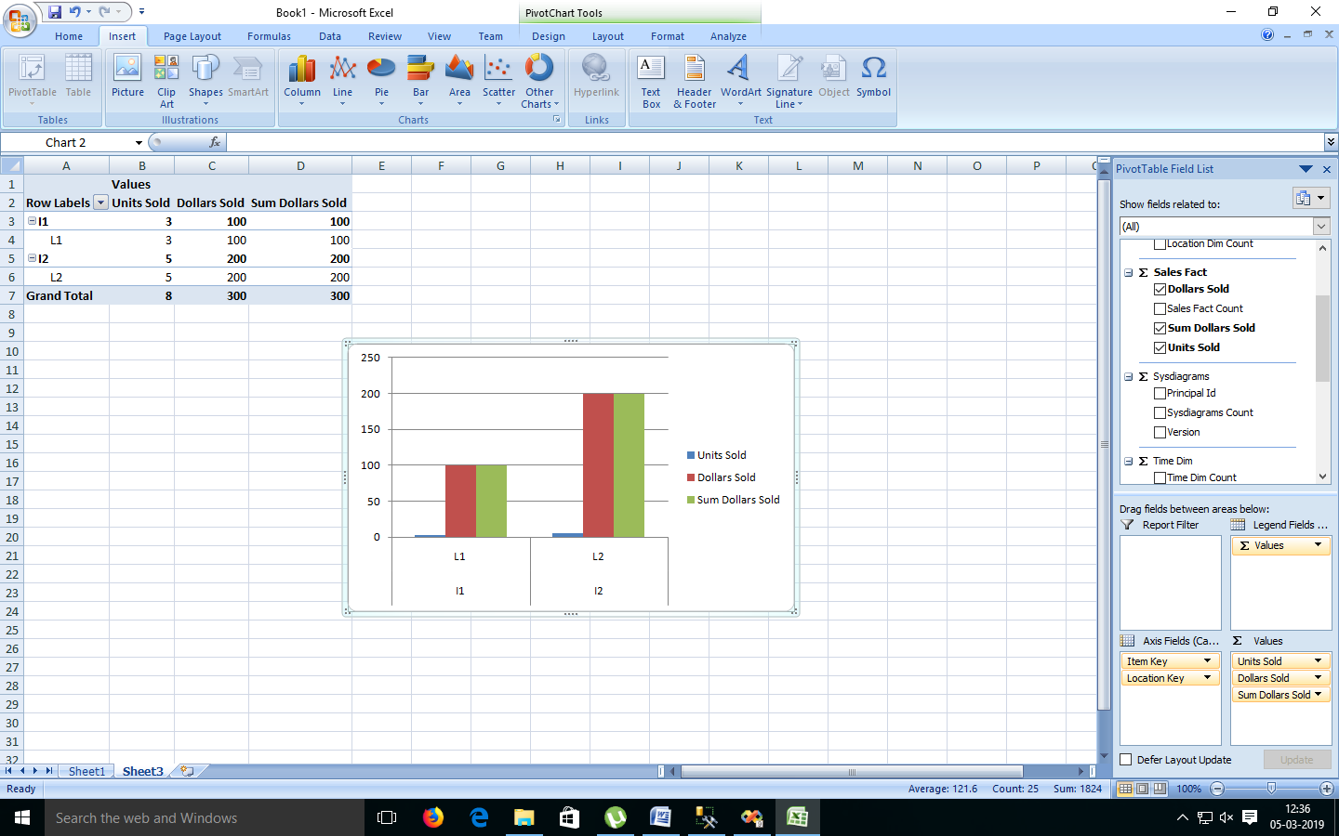

**Practical No 8**

**Aim: Firing Queries on Tables.**

**Solution:**

**Open Application -> Microsoft SQL Server 2008 R2 -> SQL Server Management Studio**

1. **Select Connect Tab -> Database Engine -> Select Server Name(local)**
2. **Expand ‘Database’ -> Expand ‘SalesInformation’ -> Expand Tables.**
3. **Fire following queries :**

**3.1.** SELECT [Branch_Key],[Branch_name],[Branch_Type]

FROM [SalesInformation].[dbo].[BranchDim]

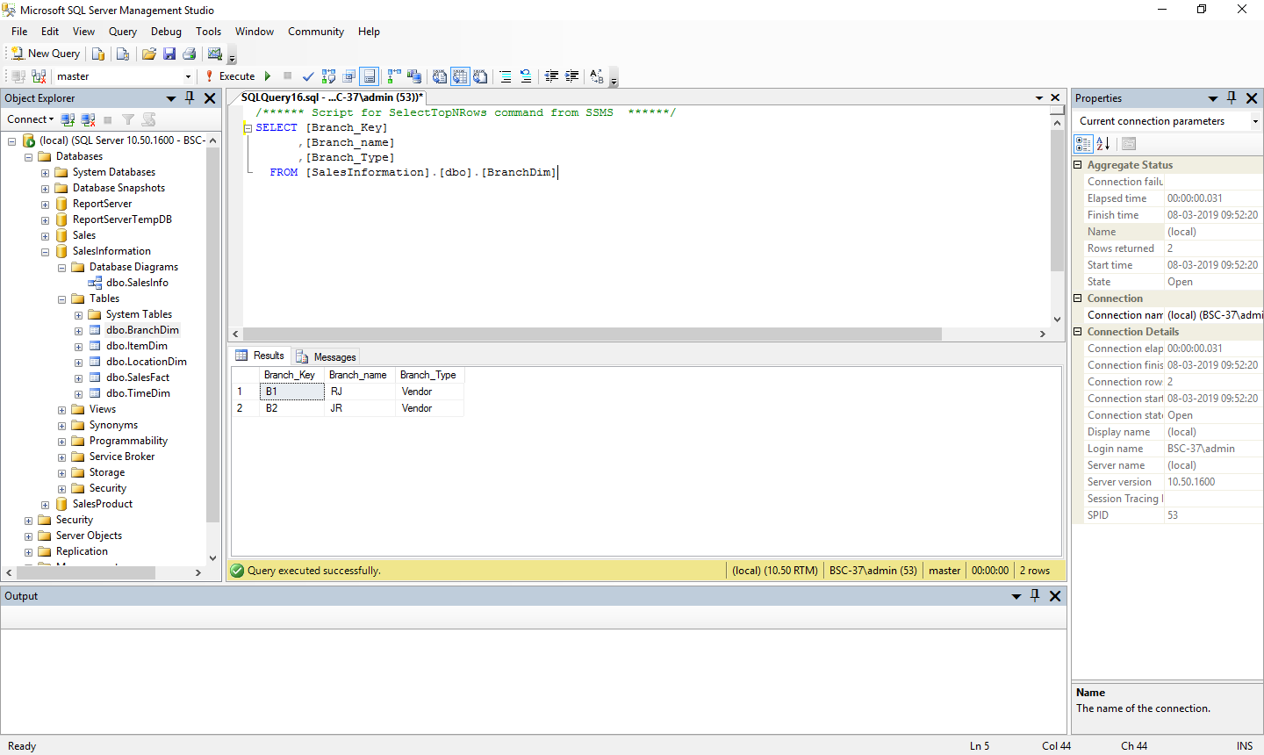

**3.2.** SELECT [Item_key],[Item_name],[Brand],[Type],[Supplier_Type]

FROM[SalesInformation].[dbo].[ItemDim]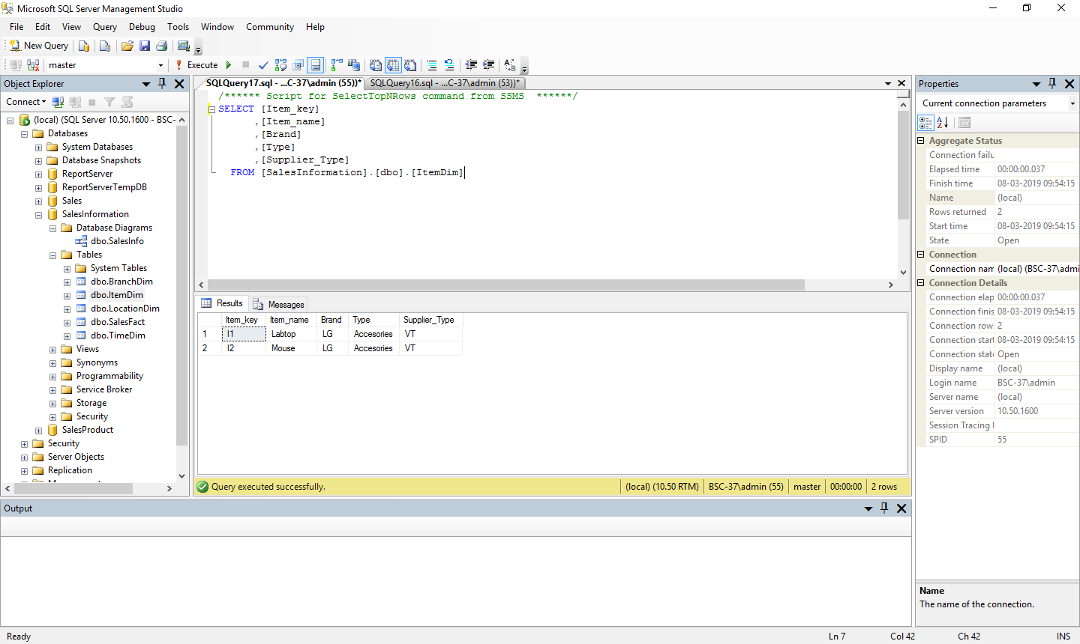

**3.3.** SELECT [Location_key],[street],[city],[state],[country]

FROM [SalesInformation].[dbo].[LocationDim]

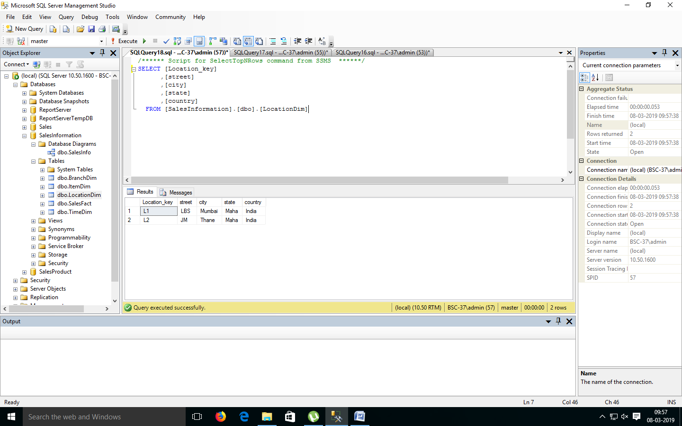

**3.4.** SELECT [time_key],[item_key],[branch_key],[location_key]

,[dollars_sold],[units_sold]

FROM [SalesInformation].[dbo].[SalesFact]

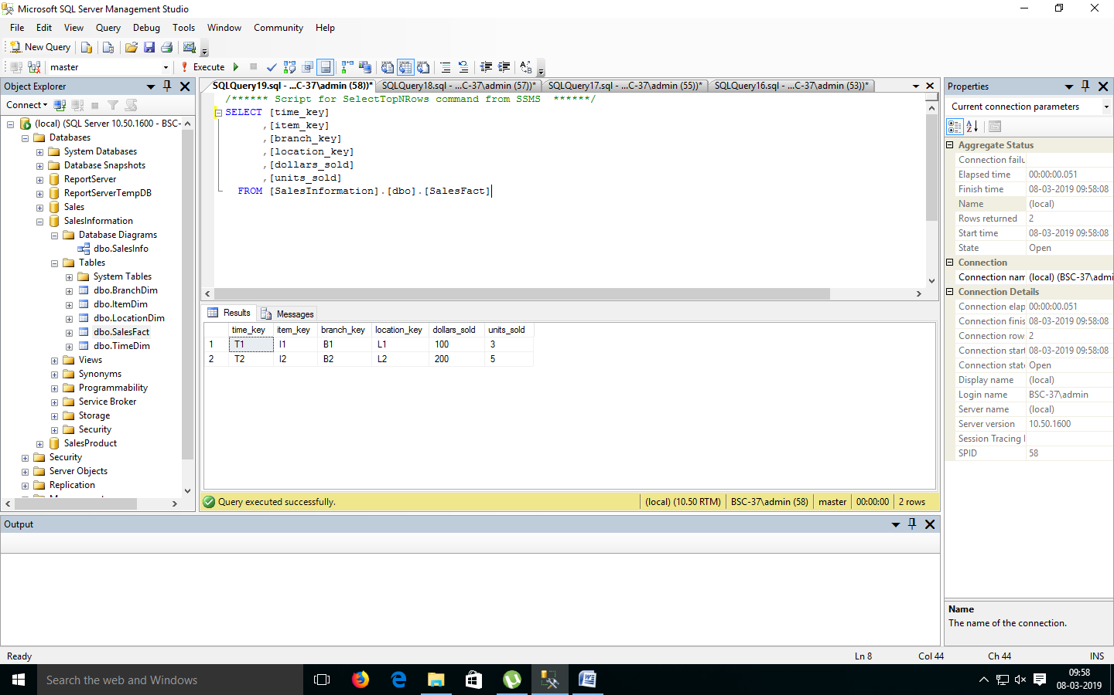

**3.5.** SELECT [time_key],[day],[Day_Of_The_Week],[month]

FROM [SalesInformation].[dbo].[TimeDim]

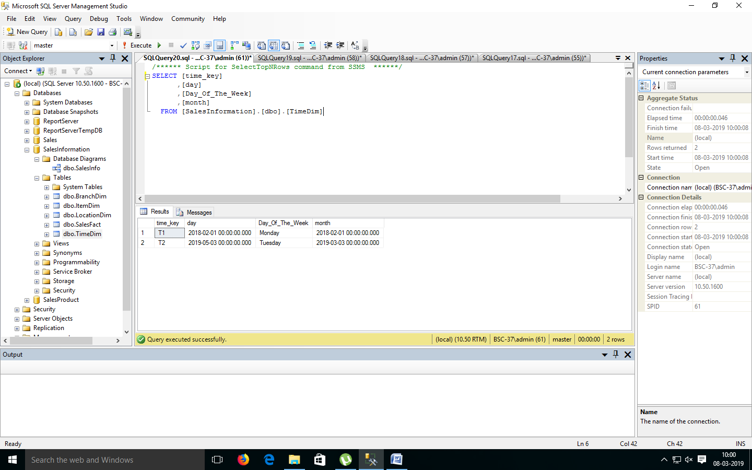

**3.6.** SELECT [SalesInformation].[dbo].[BranchDim].[Branch_Key],

[Branch_name],[dollars_sold],[units_sold]

FROM [SalesInformation].[dbo].[BranchDim],

[SalesInformation].[dbo].[SalesFact]

where [SalesInformation].[dbo].[BranchDim].[Branch_Key]=

[SalesInformation].[dbo].[SalesFact].[Branch_Key];

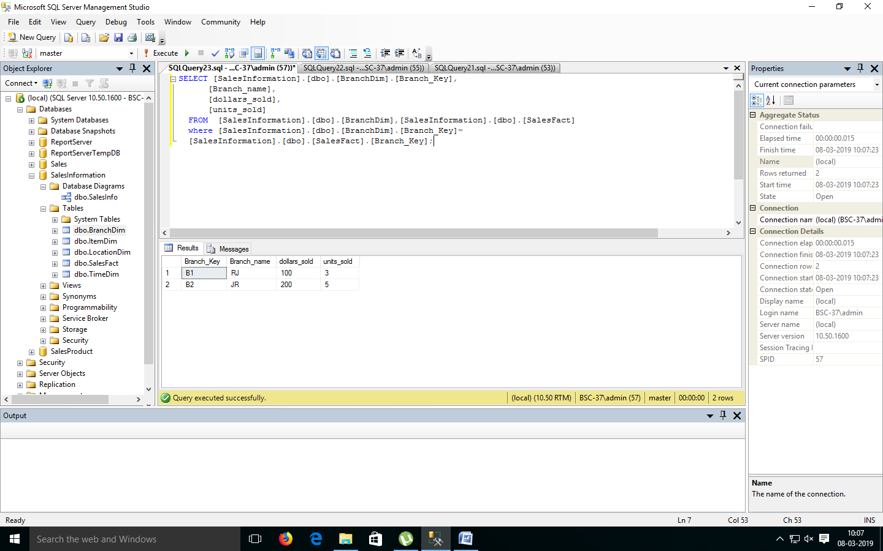

**3.7.** SELECT [SalesInformation].[dbo].[ItemDim].[Item_Key],[item_Name]

,[Type],[dollars_sold],[units_sold]

FROM [SalesInformation].[dbo].[ItemDim],

[SalesInformation].[dbo].[SalesFact]

Where [SalesInformation].[dbo].[ItemDim].[Item_key]=

[SalesInformation].[dbo].[SalesFact].[item_key];

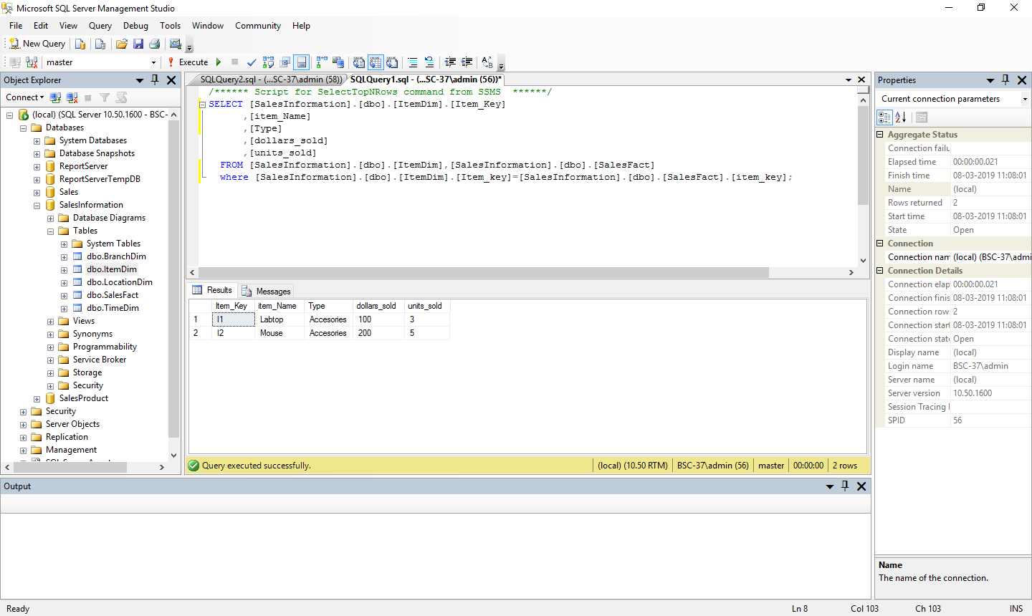

**3.8.** SELECT [SalesInformation].[dbo].[LocationDim].[Location_key]

,[city],[item_Key],[dollars_sold],[units_sold]

FROM [SalesInformation].[dbo].[LocationDim],

[SalesInformation].[dbo].[SalesFact]

where [SalesInformation].[dbo].[LocationDim].[Location_key]=

[SalesInformation].[dbo].[SalesFact].[location_key];

