**Assignment Part I: Prediction and Trading System**

Abstract

The report is about the implementation of BP Neural network and how it can be helpful in generating the graph that could possibly predict about the future result perceiving the recent data. The price for the year 2013 to 2018 from Nordpool site is taken into consideration to generate the price for the next day and the price for next week and for the two weeks. Similarly, the weather data were also considered in order in the same graph to predict about the snowfall, overcast using the Neural Network. Also, the ensemble technique was used in order to improve the performance of the BP Neural Network method. Regression tree approach was in the project to load the same data and generate the result considering the recent data for the comparison with BP Neural Network. NordPool is the site that runs the leading power market in Europe offering both day-ahead and intraday markets to its customers. But in this project, we have only considered the data from different areas within Norway. We have taken the Elspot prices for the year from 2013 to 2018 in areas that are Oslo, Kristainsand, Bergen, Molde, Trondheim and Tromso. The site provides the hourly, daily, weekly and yearly report for elspot price.

Similarly, Yr.no is the weather site that provides the prediction of weather in different places within Norway and outside of Norway. It predicts the result for the current day and also predict for the two days further. It gives hour to hour result of the weather. The fact that two sites is considered is to check the effect of weather change on elspot price of the Nordpool site.Visual Studio .net framework was implemented in order to interpret the future result and c# programming language was used as it provide better platform and different library that can easily be added on the project.

**Problem Description**

The main objective of the project is to implement the idea of time series graph from different sets of data on excel file for different years. Huge data sets for different years and make the analysis based on the current and past result for the enterprise to operate successfully.

In the project the two sites data were taken for the observation and prediction that is Nordpool and yr.no.The problem is to first load the past data and current data from excel file to the project environment and implement it to show the data through the graph for the daily price. After that the next problem is to apply the neural network that could read the current data and predict the result for another week. For the comparison Regression method is also to be applied to check the accuracy.

The next step was to use the weather data on the same grid to produce the result and predict the graph for weather one day ahead. Finally, the last one was to implement Ensemble equation for the graph that is the boosting technique for data that is one day ahead and one week ahead.

The predicted data should be nearly equivalent to the data on Nordpool of sys column.

Tools:

FANNCSharp

Microsoft Excel Interop

Microsoft Visual Studio(Framework)

**Method of Approach**

The method of approach applied is Back propagation neural network and Ensemble technique as the boosting technique. Back propagation neural network is a multi-layered feedforward network that implement supervised learning method. It utilizes the method of mean square error and gradient descent to realize the modification to the connection weight of the network. In my project there are 7 input layer, 5 hidden layer and one output layer for the prediction of price data and for the weather there is 8 input layer, 5 hidden layer and one output layer. Similarly, for ensemble there are 7 input layer 5 hidden layer and 1 output layer. The input signal is propagated from input layer to hidden layer and to the output layer. During the operation, the weight value and offset value of the network are maintained constant. The continuous modification of weight value and offset value is applied to make real output of the network closer to expected one. The goal is to train a multi-layered neural network such that it can learn any appropriate internal representation to allow it to learn any arbritary mapping of input to the output. The neural network is trained for each graph prediction for price, for weather and for ensemble algorithm. For each prediction there are training data form excel loader where the network is trained for 10000 number cycles with corresponding 1000 feedback and error rate of 0.0003.

Ensemble prediction takes data from first 6 month of the year to predicate the remaining part of the year. First of all, the prediction is done for one day ahead and one week ahead to train the network. This is similar for both the price data and for the weather data.

There are methods for loading excel files, price prediction, weather prediction and ensemble prediction for the weather and price data. Different button is connected to data for easy user interface. Excel loader takes the used range of sheet for 6 different places. Make the object of array of all the cells in graph. And the neural network is applied on the data for further prediction. To distinguish to output of the graph various colour index are used.

**Ensemble technique**

Ensemble is a learning algorithm that uses multiple learning algorithm to obtain more accurate result. It is also the supervised learning technique which has been applied on the project to predict the price and weather graph for one and one week ahead.

**Project Flowchart**

**Discussion**

Program is being developed in c# using windows form application that has a form interface which reads out the events pressed by user, it is the most easy and interactive way to build any application. After that the built-in event handler handles the event and the desired event switches according to the particular zone of price and weather data loading and processing them using the FANNCSHARP neural network to predict the values for the next day. The data from the excel files are loaded and the graph is plotted on the data grid. The processed data is predicted using Artificial Engine.

Output of the project:

Original Price graph:

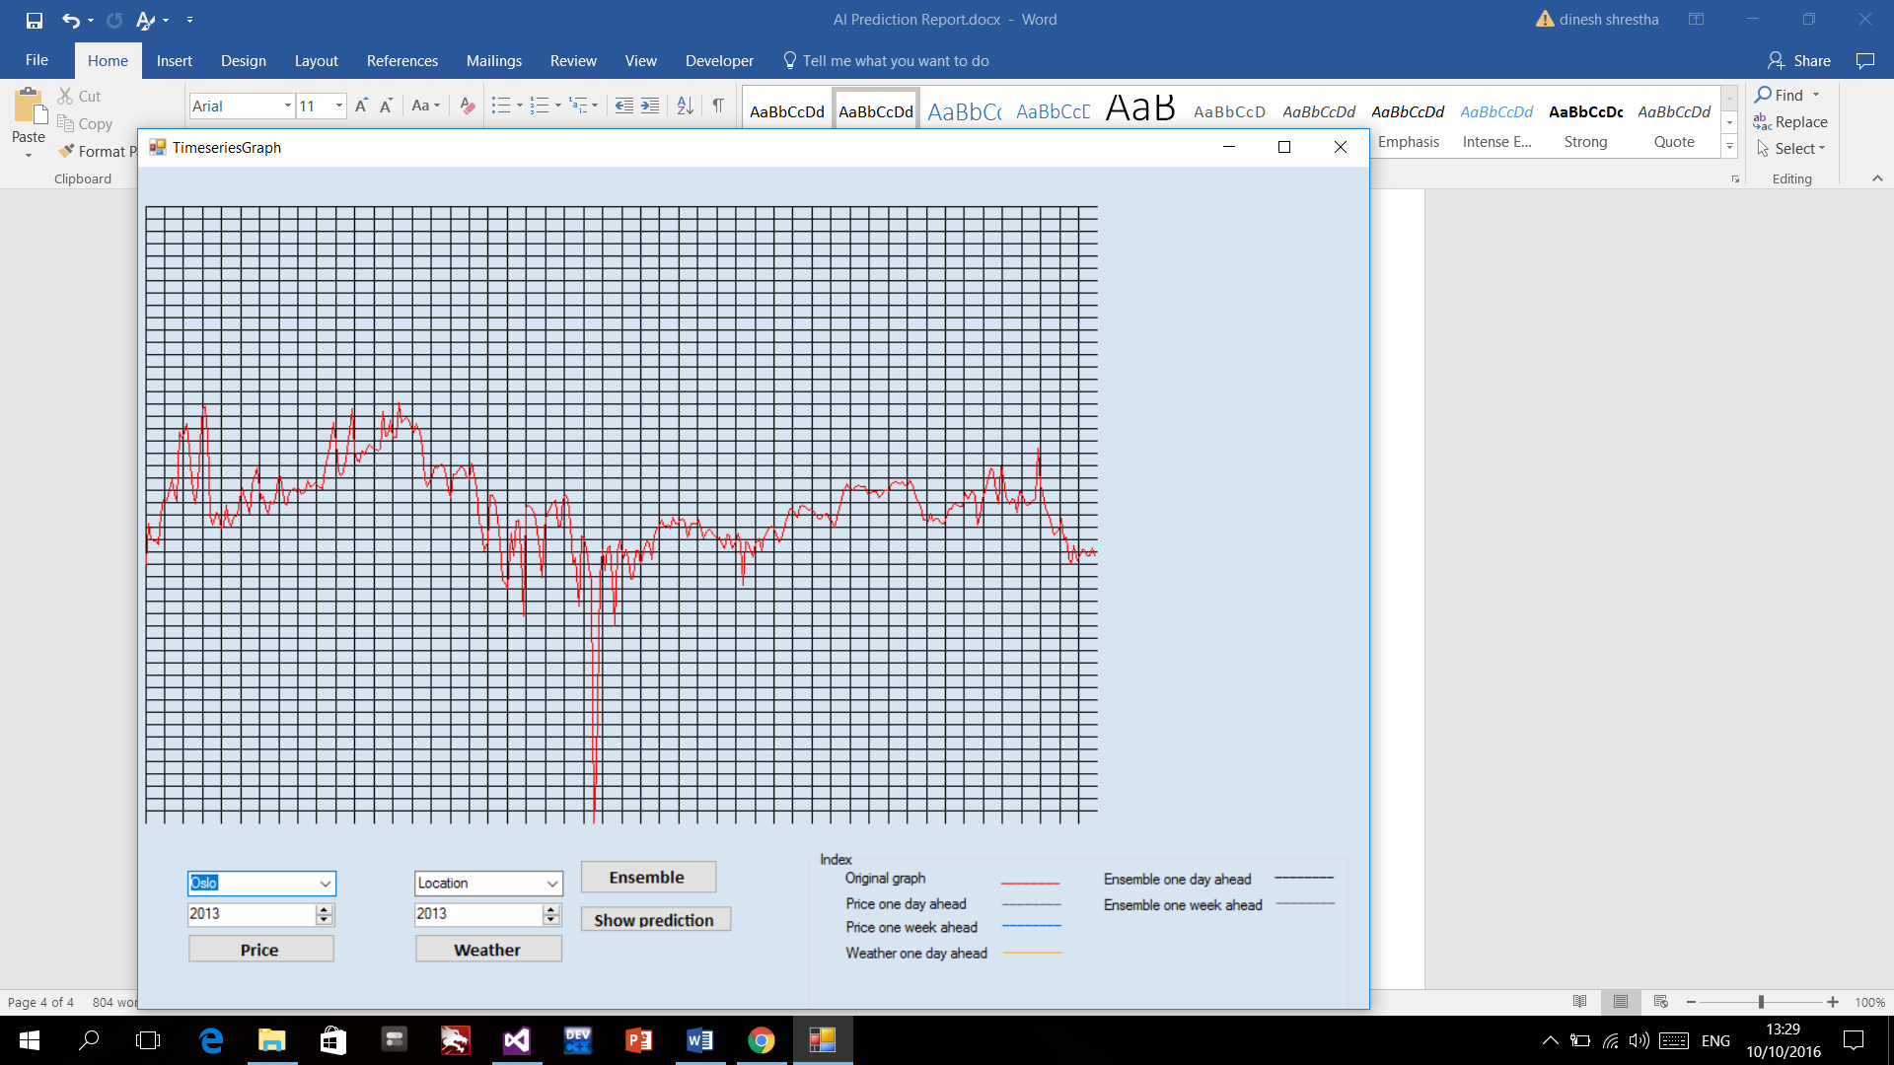

Price one day ahead and One week ahead

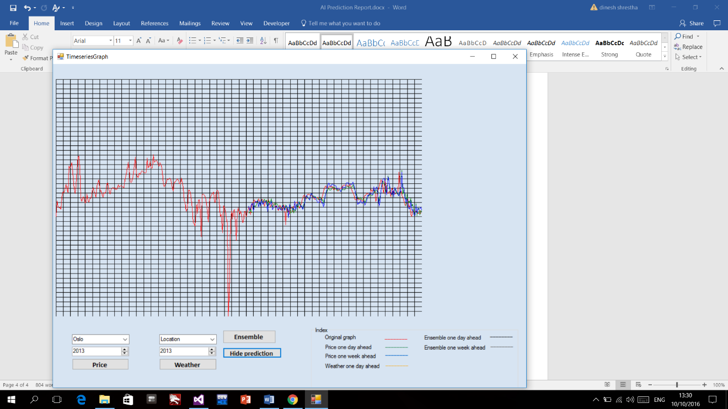

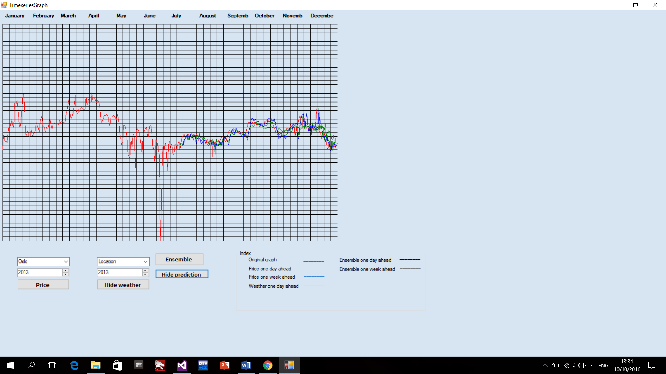

Weather Graph (One day ahead and one week ahead)

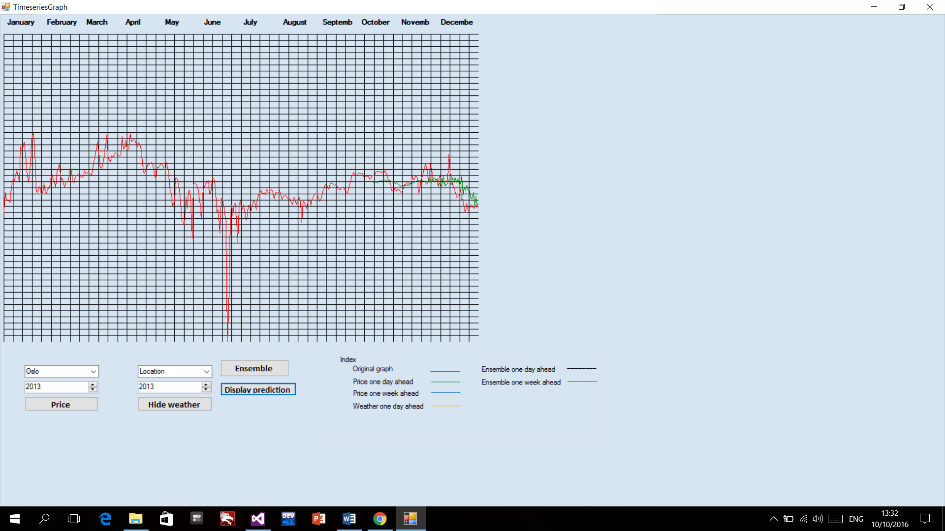

Ensemble Graph

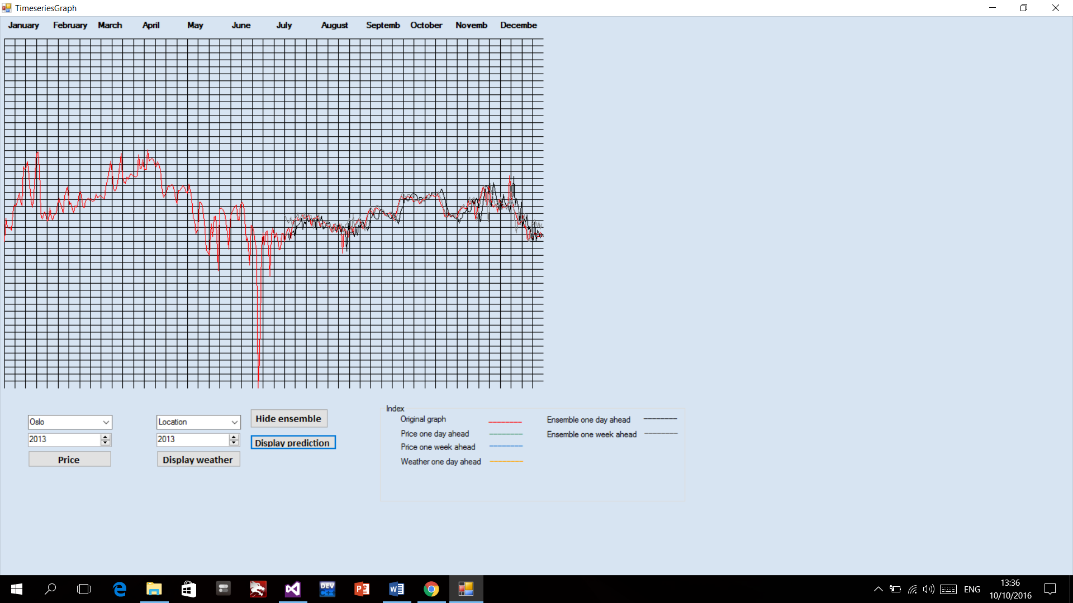

**Conclusion**

From this project I came to know more about BP neural network on data and how the prediction is made for the future outcome. I was more interacted to c# programming language and how it can be handy to implement different neural network libraries and different excel loaders.

The data predicted is still not accurate but I have given my full effort to implement all the thing that is needed within the project. Regression tree is not implemented on the project.

References:

https://en.wikipedia.org/wiki/Ensemble_learning

https://en.wikipedia.org/wiki/Backpropagation

https://source.uit.no

www.hin.no

www.nordpool.no

www.Yr.no