1. hdfs dfs -cat quest1c/part\*

Using option –cat we can print the contents for the file on hadoop file system

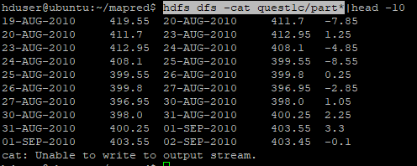

1. hdfs dfs -tail quest1c/part-00000

This command will output last 1KB of data from file. Using -f will keep displaying the update 1KB data.

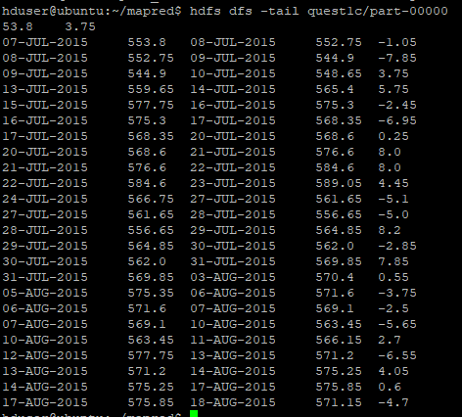

1. hdfs dfs -rmr quest1c

This command will delete the directory recursively.

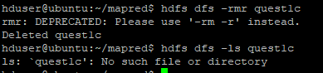

1. hdfs dfs -appendToFile - quest2/part-00000

This command will append data to end of the file.

Syntax: hdfs dfs -appendToFile <source> <destination>

If source is – then it will read the input from stdin.

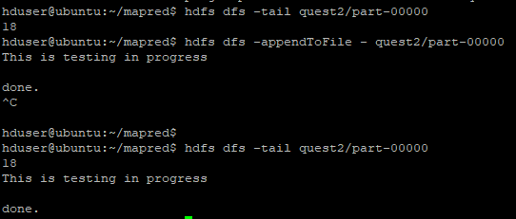

1. hdfs dfs -count -v quest2/

This command will give the number of directories files and there size on specified directory.

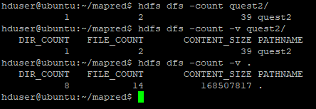

1. hdfs dfs -find -iname quest\*

This command is used to find directories and files on hadoop file system.

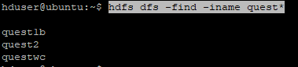

1. hdfs dfs -getmerge quest1b quest2 mapout/part-000001

This command concatenates files in src into the destination local file.

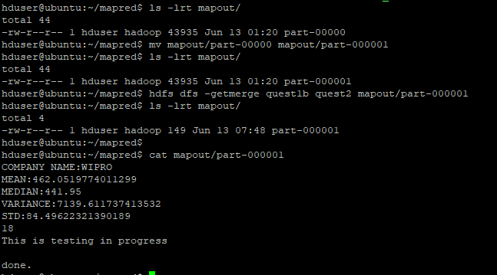

1. hadoop fs -touchz questwc/xcv

This Command will create empty file

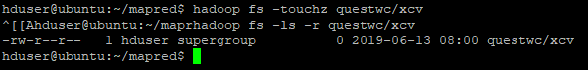

1. hadoop fs -truncate -w 127 output/part-00000

This command wwill truncate the file to specified size

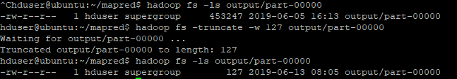

1. hadoop fs –usage will show the help for the command

