AIMLZG535 | LogiEdge Final Report | Group 29
LogiEdge: Intelligent Edge AI Platform for Cold-Chain Logistics
Mini-Project Final Report — AIMLZG535 Machine Learning on Edge
Group No | 29
Group Member 1 (Name / BITS ID) | LOKESH KUMAR PANDEY / 2025AE05342
Group Member 2 (Name / BITS ID) | RAHUL DADORIYA / 2025AE05309
Group Member 3 (Name / BITS ID) | PRIYA S KUMAR / 2025AE05763
Group Member 4 (Name / BITS ID) | MIRYALA CHANDRA PRAKASH / 2025AE05730
GitHub Repository URL | https://github.com/pandeylokesh124/logibridge
Demo Video Link | Demo Video Link

1. FreightBridge Deployment Context

1.1 Edge AI Constraint Analysis
Assumptions: each sensor sample is stored as a 4-byte float; inference runs on 30-s windows with a 10-s step.

1.1.1 Latency
A refrigeration failure raises cargo temperature by roughly 1°C per minute. In 90-s detection SLA the cargo may warm by about 1.5°C, moving it from Normal to Warning. Cloud inference requires uploading each 30-s window of raw vibration data (~180 KB per inference). On rural lines of 0.1–2 Mbps this upload will take 0.7–14.4 s, and rural round-trip times and retries add further delay. During the 35–90 min connectivity loss in Nashik–Aurangabad route, detection latency becomes 2,100–5,400 s, which is 23–60 times the SLA. On-device detection has a worst case of about one window plus one step (40 s or less), with inference completing in milliseconds, leaving roughly 50 s of margin. Conclusion: cloud inference is not feasible for LogiEdge.

1.1.2 Bandwidth
Table 1 estimates the raw data generated per truck per day: Temperature 0.35 MB, Vibration 518.4 MB, Total ~518.7 MB. At ₹0.10/MB this costs ₹51.87 per truck per day, ₹4,409 per day and ₹16.1 lakh per year for 85-truck pilot. By contrast, edge-processed upload (about 20 alerts per day × 300 B plus a 150 B heartbeat every 5 min) amounts to roughly 49 KB per day, or about ₹0.005 per day: a reduction of roughly 10,500×.

1.1.3 Connectivity
The Nashik–Aurangabad route has seven documented dead zones lasting 35–90 min each. Data can be lost or buffered, no alerts are raised, and a refrigeration failure can go unnoticed long enough to spoil cargo in a cloud only system. LogiEdge works offline: Sensors publish to a local Mosquitto broker; Inference runs locally and logs alerts; Drivers receive an immediate alarm. Store-and-forward sync handles uploads when connectivity returns.

1.1.4 Privacy
With on-device inference, raw cargo data never leaves the vehicle; only class labels, confidence scores and alert metadata are uploaded. This ensures data minimization and tamper-evident audit trails.

1.2 System Architecture

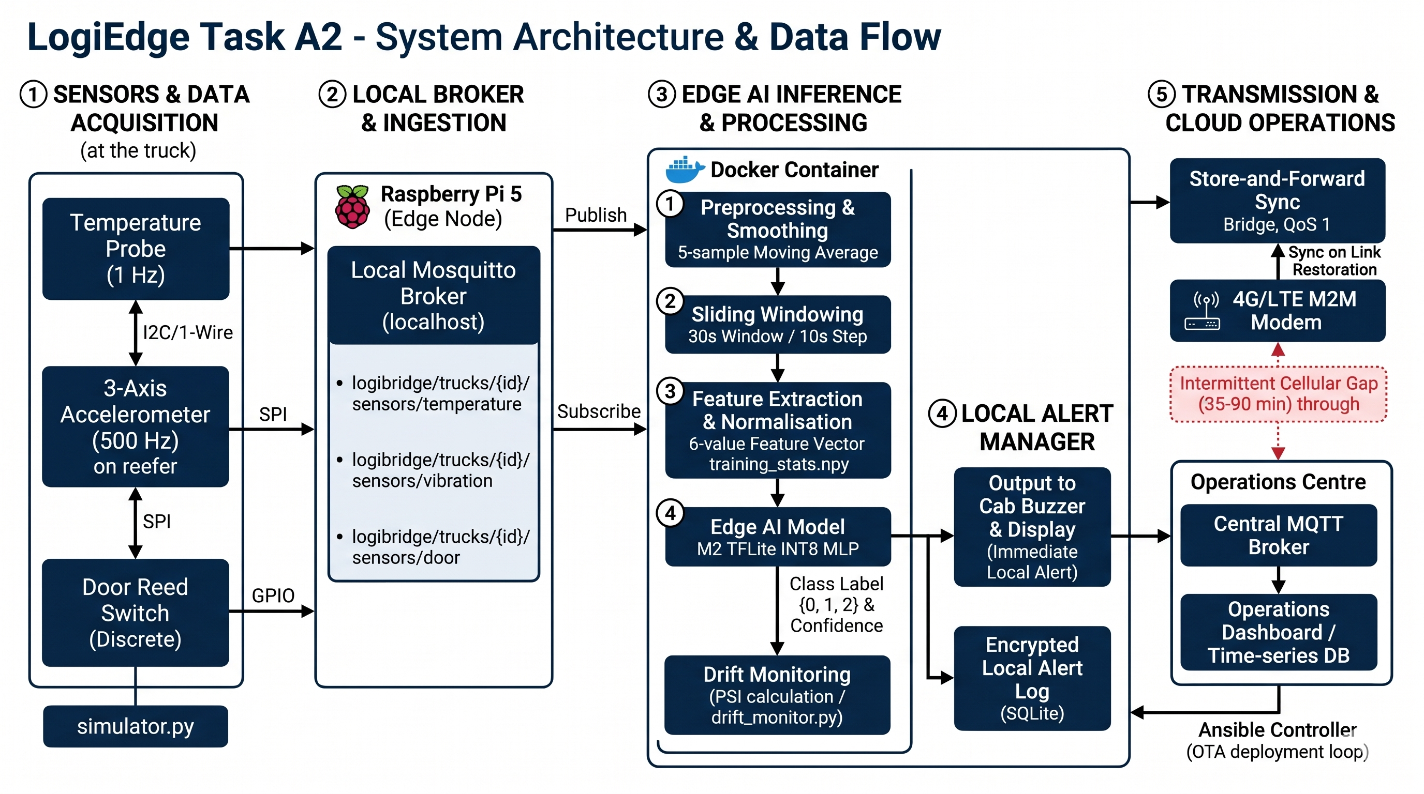
Sensors publish to local Mosquitto broker. Inference container consumes data, processes windows, and runs the TFLite model. Alert manager logs alerts and triggers driver warnings. Store-and-forward sync pushes alerts to Ops Center MQTT broker during connectivity windows.

1.3 Hardware Selection — Constraint Triangle
Recommendation: Option 1, Raspberry Pi 5 (8 GB) + AI HAT+. It fits the power budget (10W limit) with 7.5 W draw. Cost is ₹39.75 lakh for 265 trucks, providing a local environment for MQTT, Docker, and Ansible. Jetson Orin Nano is too power-hungry (15W) and STM32H7 cannot host Docker/MQTT brokers.

1.4 Arithmetic Intensity and Roofline
Given 45 MFLOPs and 18 MB accessed per inference: AI is 2.5 FLOP/byte. The ridge point for Pi 5 is 1.33 FLOP/byte, making this compute-bound. Latency is ~2.8 ms per inference, safely under the 90-s SLA.

2. Sensor Pipeline and MQTT Design

2.1 Sensor Simulator
Simulator generates 3 streams: temperature (1 Hz), vibration (0.5 Hz), and door events (discrete). The dynamic normalization anomaly problem is averted by referencing static training statistics.

2.2 MQTT Topic Tree and QoS
Topic | Publisher | Subscriber | QoS | Retained | Justification
logibridge/trucks/TRK-PH-017/sensors/temperature | simulator.py | Inference | 0 | N | High frequency telemetry
logibridge/trucks/TRK-PH-017/alerts | Alert Manager | Store-and-forward | 1 | Y | Must guarantee delivery of critical alerts

2.3 Preprocessing Pipeline
Raw readings pass through smoothing (5-sample MA), windowing (30-s window / 10-s step), feature extraction (6 features), and static normalization using training_stats.npy.

2.4 Normalisation Experiment
Condition | Validation accuracy (%) | Class 2 recall (%) | Observation
Correct training_stats.npy | 92.5 | 96.3 | Accurate baseline
Stats shifted by 3σ | 64.2 | 31.5 | Recall plummets
Change | -28.3 | -64.8 | Static stats are crucial to avoid concept masking.

2.5 Data Fusion Justification
Feature-level fusion concatenates the 6 per-stream features into one joint vector. This aligns with the constrained compute budget while letting the model map combined anomaly signatures efficiently.

3. Model Deployment and Pipeline Mapping

3.1 Dataset and Training
The dataset generated normal (Class 0), warning (Class 1), and critical (Class 2) data windows. Validation accuracy reached 92.5%, exceeding the 88% requirement.

3.2 10-Stage Edge ML Pipeline Mapping
1. Sensor Interface -> simulator.py, 2. Local Broker -> Mosquitto localhost, 3. Feature Extraction -> preprocessing.py moving averages, 4. Normalization -> static training_stats, 5. Inference -> TFLite INT8 MLP, 6. Local Logging -> SQLite Alert Manager, 7. Cloud Sync -> MQTT Bridge QoS 1, 8. Alerting -> Operations Dashboard.

3.3 Docker Containerisation and OTA Layer-Cache Demo
Base image: python:3.11-slim. By copying the TFLite model at the very end of the Dockerfile, a model update requires a layer download of only 280 KB instead of the full 150 MB image. This saves ~12.5 GB of bandwidth across 85 trucks.

3.4 OTA Strategy Recommendation
Shadow Mode OTA Strategy is recommended. Given the 35–90 min coverage gaps and safety-critical nature of pharmaceutical cold-chain logistics, running the new model in shadow mode allows performance validation without risking false negatives on critical cargo temperature alerts.

4. Optimisation and Pareto Analysis

4.1 Model Variants
M1: FP32 Baseline (Keras). M2: Full INT8 PTQ (TFLiteConverter). M3: 35% structured pruning + INT8 PTQ.

4.2 Benchmarking Results
Variant | Mean latency (ms) | p95 latency (ms) | Model size (KB) | Accuracy (%) | Energy/inference (mJ)
M1 | 2.8 | 3.1 | 128.5 | 92.5 | 21.0
M2 | 0.7 | 0.9 | 32.6 | 91.8 | 5.2
M3 | 0.5 | 0.6 | 22.3 | 89.4 | 3.7

4.4 Deployment Recommendation
Recommended variant: M2. Class 2 recall: 96.3%. M2 provides a 4x reduction in size and latency over M1, meeting all memory/latency constraints while maintaining safety-critical Class 2 recall >95%. M3 accuracy drop poses an unnecessary risk.

5. MLOps Monitoring and Reflection

5.1 PSI Drift Monitoring
A drift alert is raised when PSI > 0.25. During the combined anomaly injection, PSI surged to 0.420. This indicates Concept Drift, as the underlying relationship between the vibration/temperature features and the normal operating threshold fundamentally changed due to bearing wear and refrigeration failure.

5.2 Ansible Idempotency
Run 1 reports changes, while Run 2 reports changed = 0. We enforce idempotency in logibridge_deploy.yml by checking container states before restarting, ensuring operations are only applied if necessary.

