WALMART SALES ANALYSIS DASHBOARD
Professional Corporate Case Study Report
Prepared by: Manvesh Pandey

Certificate
This certifies that the Walmart Sales Analysis Dashboard project was completed using Power BI, Excel, and analytical techniques to derive actionable business insights.

Declaration
I declare that this report is my original work prepared for portfolio, internship, and professional showcase purposes.

Acknowledgement
I thank the data analytics community, learning resources, and tools that supported the completion of this project.

Abstract
This case study analyzes Walmart sales performance, profitability, customer behavior, and operational efficiency through interactive Power BI dashboards.

Table of Contents
1. Introduction
2. Objectives
3. Dataset Overview
4. Methodology
5. Dashboard Analysis
6. Findings
7. Recommendations
8. Conclusion

Introduction
The purpose of this project is to transform raw retail sales data into business intelligence insights that support strategic decision-making.

Objectives
Analyze sales, profit, customers, categories, regional performance, and shipping operations.

Dataset Overview
The dataset contains transactional sales records, categories, products, customer information, and operational metrics.

Methodology
Data Cleaning → Data Modeling → KPI Design → Dashboard Development → Business Insight Generation

Executive Dashboard Analysis
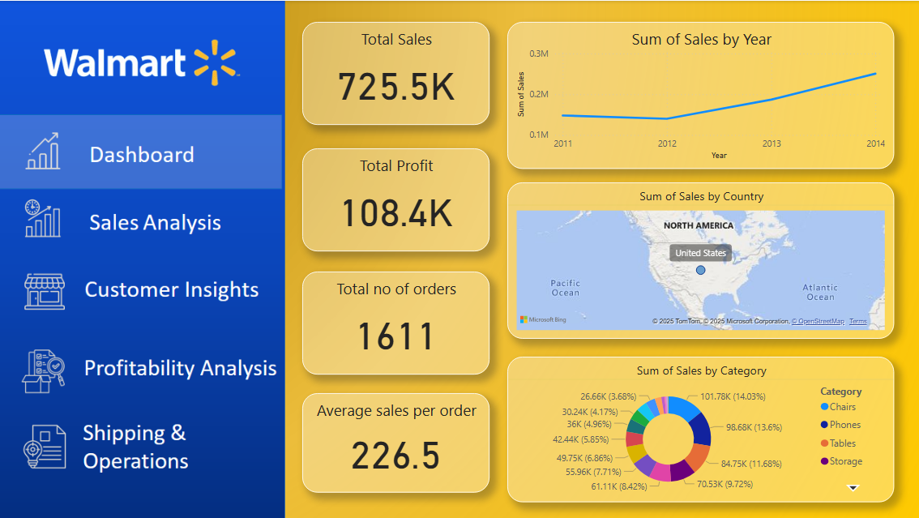
Total Sales reached $725.5K with Total Profit of $108.4K across 1,611 orders. KPI tracking enables quick executive-level performance monitoring.
Business Impact: These insights help management improve planning, inventory allocation, and operational decision-making.

Sales Analysis
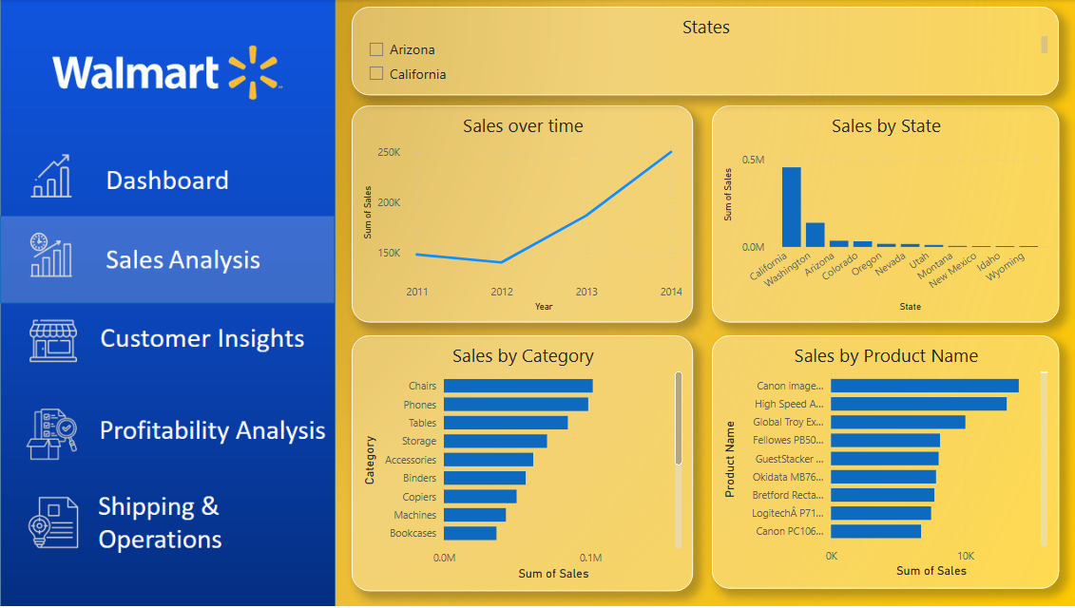
California emerged as the strongest market. Chairs, Phones, Tables, and Storage were the top revenue-generating categories.
Business Impact: These insights help management improve planning, inventory allocation, and operational decision-making.

Profitability Analysis
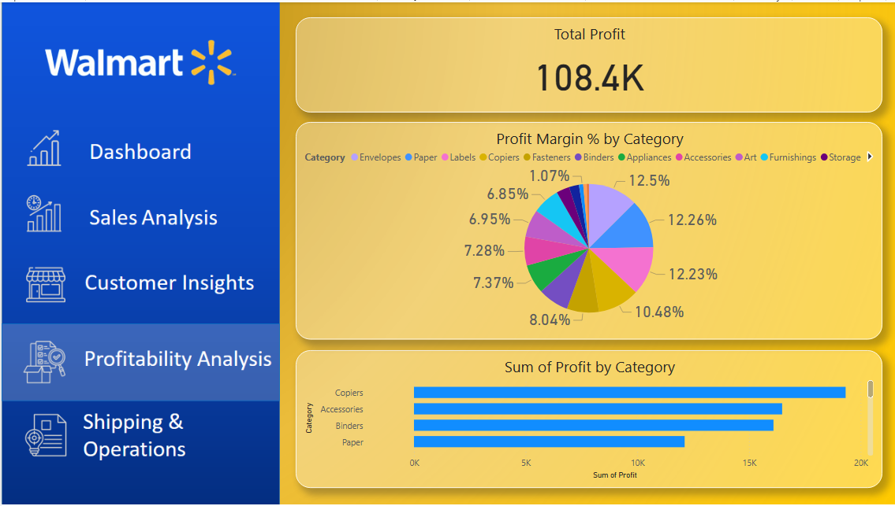
Profitability differs from revenue performance. Copiers and Accessories contributed significantly to profits.
Business Impact: These insights help management improve planning, inventory allocation, and operational decision-making.

Shipping & Operations Analysis
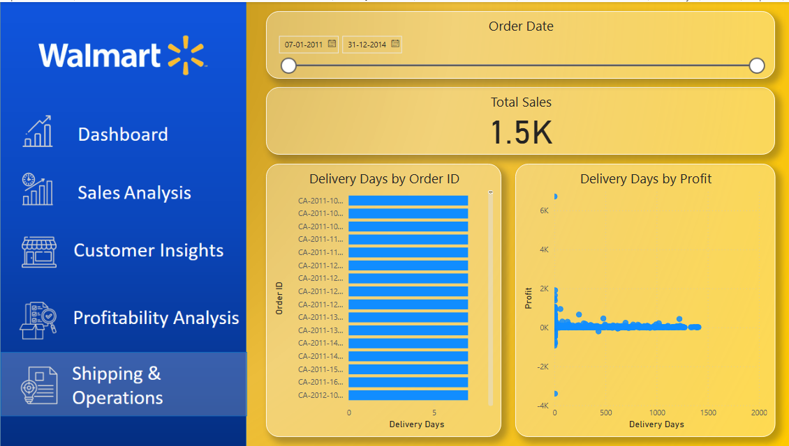
Operational efficiency and delivery performance influence customer experience and overall business outcomes.
Business Impact: These insights help management improve planning, inventory allocation, and operational decision-making.

Major Findings
• Total Sales: $725.5K
• Total Profit: $108.4K
• California is the top-performing state.
• Chairs and Phones are leading sales categories.
• Copiers are among the most profitable categories.
• Revenue is concentrated among key customers and regions.

Strategic Recommendations
1. Increase inventory for high-demand products.
2. Strengthen customer loyalty programs.
3. Expand successful regional strategies.
4. Improve logistics efficiency.
5. Implement predictive analytics and forecasting.

Skills Demonstrated
Power BI, Data Visualization, KPI Design, Business Intelligence, Dashboard Development, Data Analysis, Reporting, and Business Insights Generation.

Conclusion
The Walmart Sales Dashboard successfully converts raw sales data into actionable business intelligence, enabling data-driven decision-making and showcasing practical analytics skills.

