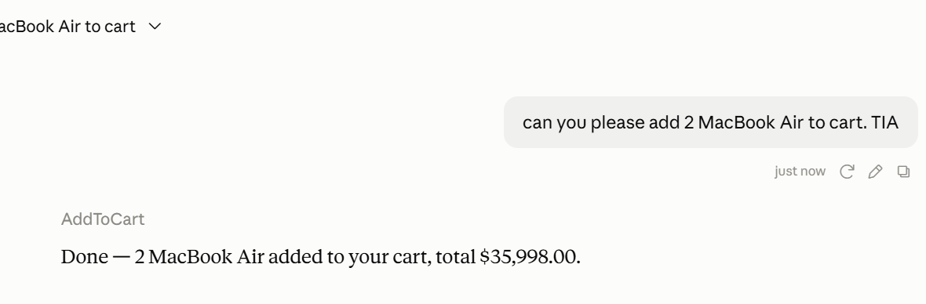
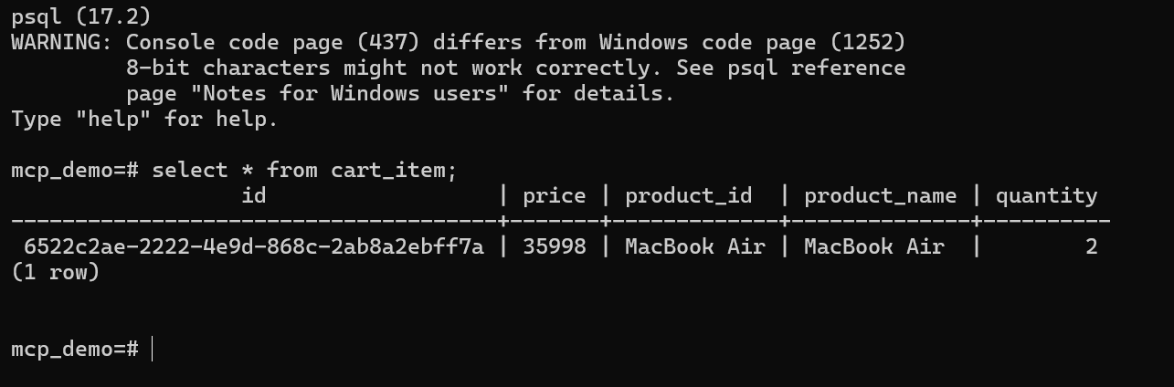
please add 2 Boat Airphones also .TIA

how many items are there in cart
GetCarts
Your cart has 2 distinct products, totaling 5 items:
- Boat Airphones — qty 2
- MacBook Air — qty 3
- ===============================
- remove all product from cart
- Used shopping-cart-mcp integration
- Done — both items removed. Your cart is now empty.
- 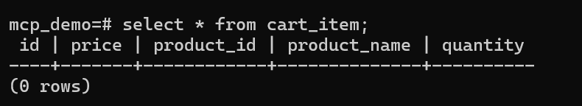

please add 3 Boat Airphones and calculate the total.TIA
AddToCart
Added 3 Boat Airphones to your cart — total price: ₹5,997.00

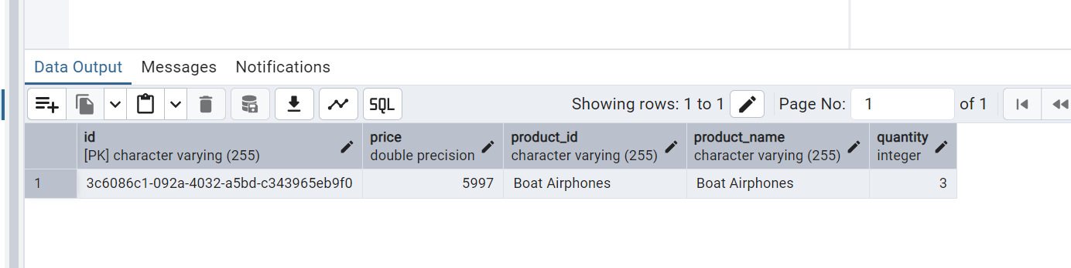
remove 1 Boat Airphones give me the update
Used shopping-cart-mcp integration
1 removed — you now have 2x Boat Airphones in your cart, total: ₹3998.
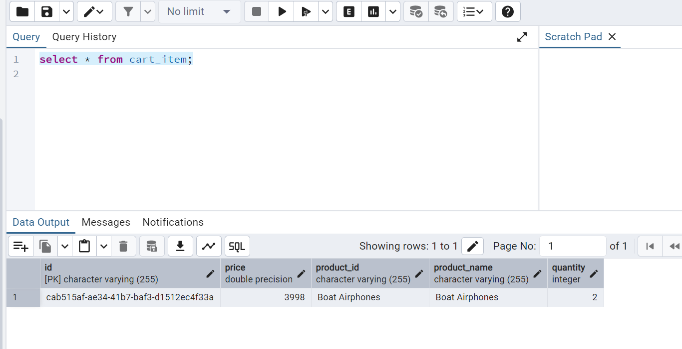

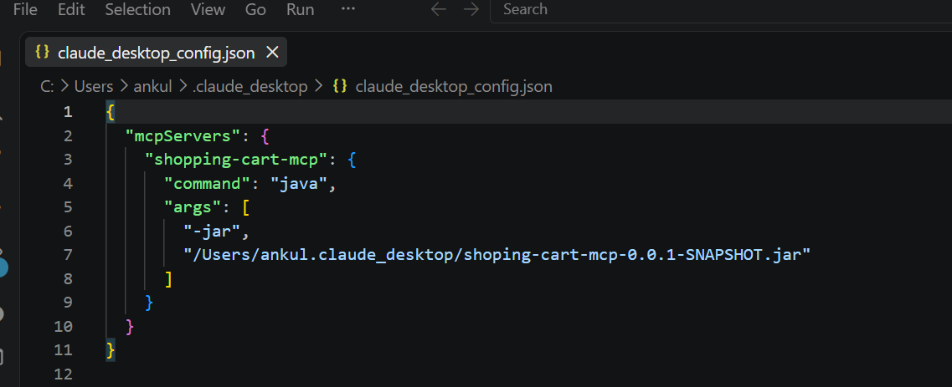New-Item -ItemType Directory -Force -Path "$env:USERPROFILE\.claude_desktop"
@'
{
"mcpServers": {
"shopping-cart-mcp": {
"command": "java",
"args": [
"-jar",
"C:\\stock-viewer\\shoping-cart-mcp\\target\\shoping-cart-mcp-0.0.1-SNAPSHOT.jar"
],
"env": {
"SPRING_PROFILES_ACTIVE": "dev"
},
"transport": {
"type": "stdio"
}
}
}
}
'@ | Set-Content "$env:USERPROFILE\.claude_desktop\claude_desktop_config.json"

