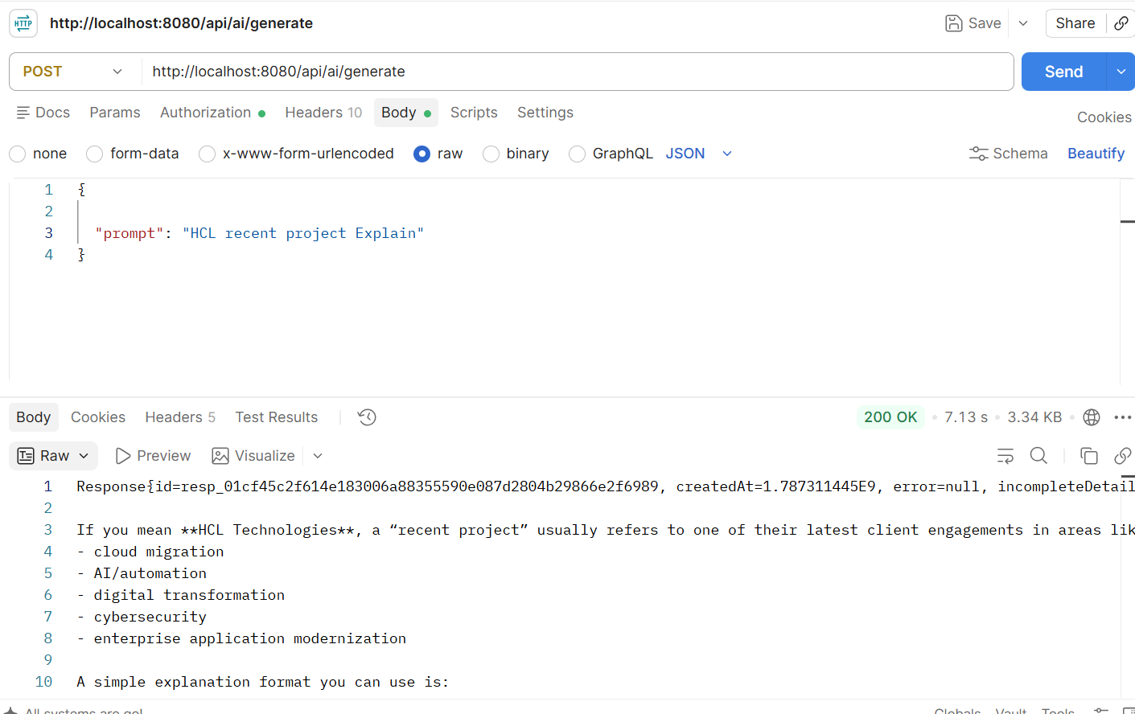

//http://localhost:8080/api/ai/generate
{

"prompt": "HCL recent project Explain"
}

