**OpenStack**

Open source software to build public and private clouds. OpenStack is a Cloud operating System, that takes resources such as compute, storage, network, virtualization technologies and controls those resources at a data center level.

OpenStack lets users deploy virtual machines and other instances which handle different tasks for managing a cloud environment on the fly. It makes horizontal scaling easy, which means that tasks which benefit from running concurrently can easily serve more or less users on the fly by just spinning up more instances. For example, a mobile application which needs to communicate with a remote server might be able to divide the work of communicating with each user across many different instances, all communicating with one another but scaling quickly and easily as the application gains more users.

It was originally developed by NASA and Rackspace, and the first release was in 2010. Their intention from the beginning was to make it an open source project that anyone could use or contribute to. OpenStack is under the Apache License 2.0, and since that first release it has grown into a large community supported by over 9,000 contributors in nearly 90 countries, and more than 150 companies including Red Hat, Canonical, IBM, AT&T, Cisco, Intel, PayPal, Comcast, and a host of other names

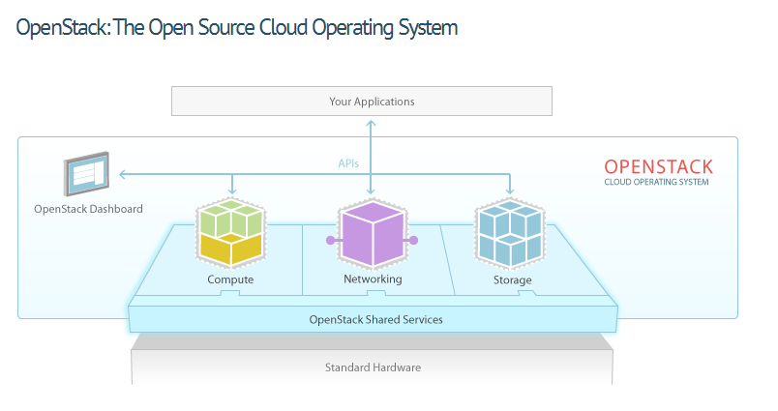

Image Reference: http://www.openstack.org/software/

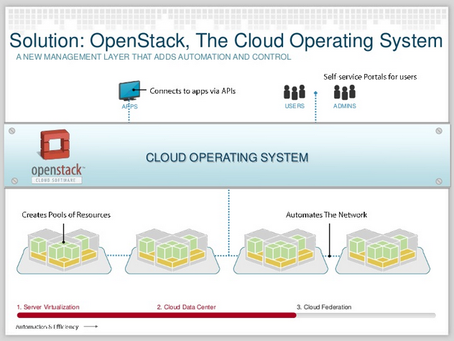

Image reference: <http://www.slideshare.net/openstackcommgr/openstack-technology-overview>, Slide no: 8

To summarize, Cloud computing enables organisations to

1) Control and automate pools of resources

2) Efficiently allocate resources

3) Empower admins and users via self service portals

4) allows developers to make apps cloud-aware via APIs

Components of OpenStack:

OpenStack is made up of many different moving parts. Because of its open nature, anyone can add additional components to OpenStack to help it to meet their needs. But the OpenStack community has collaboratively identified nine key components that are a part of the "core" of OpenStack, which are distributed as a part of any OpenStack system and officially maintained by the OpenStack community.

Advantages of Openstack:

1) Control and flexibility

2) Industry Standard

3) Proven Software

4) Compatible and Connected

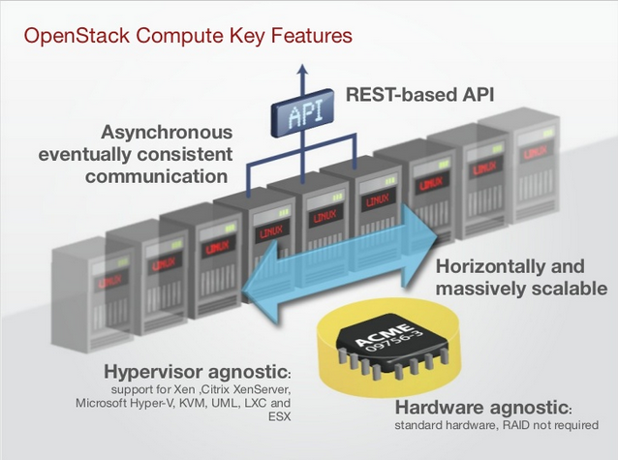

Image Reference: <http://www.slideshare.net/flatburger/openstack-overview>; slide 10

References

Overview of Apache links

<http://www.slideshare.net/openstackindia/openstack-introduction-14761434>

<http://www.slideshare.net/flatburger/openstack-overview>

<http://www.slideshare.net/openstackcommgr/openstack-technology-overview>

http://www.openstack.org/software/