DEEPFAKE DETECTION
Architecture Diagram
System Architecture with Component Explanations

────────────────────────────────────────

Major Prabhat Pandey | April 2026 | MLOps Project

1. System Architecture Overview
The Deepfake Detection system is a full-stack MLOps platform composed of five distinct architectural layers. Each layer is independent and communicates through well-defined interfaces, ensuring loose coupling and high cohesion.

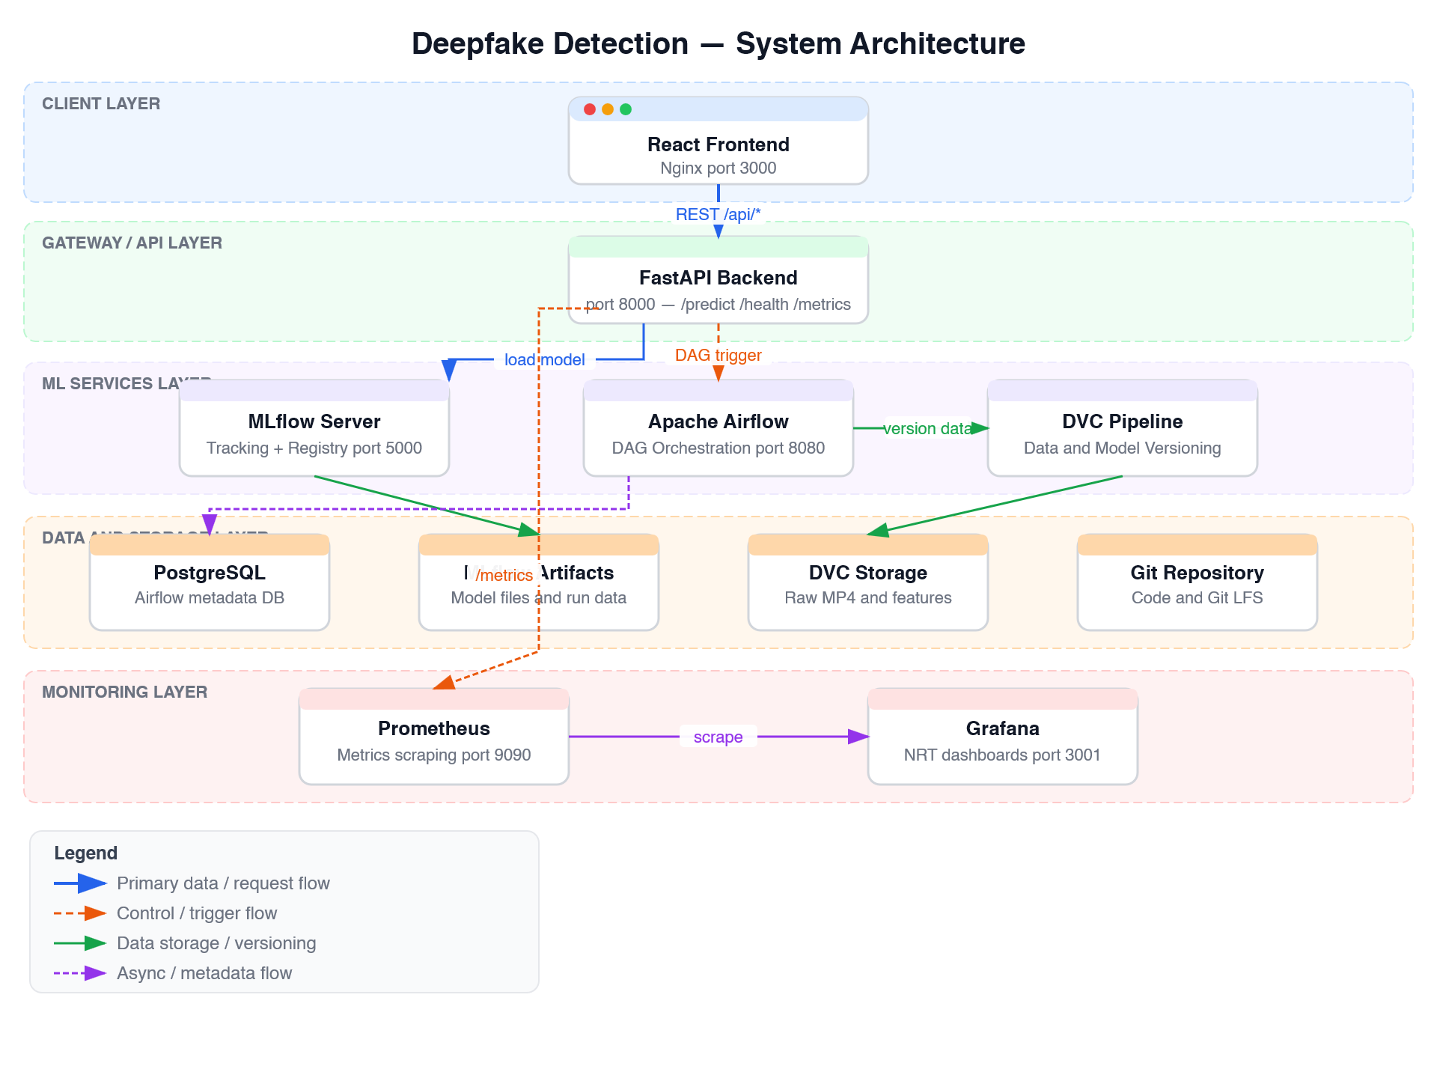
Figure 1: System Architecture — Five-Layer View

1.1 Architecture Layers
The system is organized into five horizontal layers, each with a distinct responsibility:

Layer 1 — Client Layer
The React frontend (served by Nginx on port 3000) is the only user-facing component. It accepts MP4 video uploads via drag-and-drop and presents prediction results including confidence scores and Grad-CAM heatmaps. Nginx proxies all /api/* requests to the backend.

Layer 2 — Gateway / API Layer
FastAPI (port 8000) is the sole entry point for all backend operations. It enforces strict input validation, orchestrates preprocessing, calls the ML model, generates explainability overlays, and exposes Prometheus metrics. The frontend and backend are connected exclusively via REST API — no shared state or direct imports.

Layer 3 — ML Services Layer
Three services power the ML lifecycle:
- MLflow Server (port 5000): Tracks experiments, manages the model registry, and stores training artifacts. The backend loads the production model via mlflow.pyfunc at startup.
- Apache Airflow (port 8080): Orchestrates the data ingestion pipeline (daily) and model retraining pipeline (weekly) using a LocalExecutor — no separate worker container required.
- DVC Pipeline: Manages reproducible data versioning across five stages: extract_frames → detect_faces → compute_features → train → evaluate.

Layer 4 — Data and Storage Layer
Persistent storage is split by concern:
Store | Purpose | Technology
PostgreSQL (port 5432) | Airflow metadata, task state, DAG history | PostgreSQL 15
MLflow Artifacts | Model weights, confusion matrices, ROC curves | Local filesystem / MLflow store
DVC Storage | Raw MP4s, extracted frames, face crops, feature tensors | DVC + Git LFS
Git Repository | Source code, config, dvc.lock, dvc.yaml | Git + Git LFS

Layer 5 — Monitoring Layer
Prometheus (port 9090) scrapes metrics from all four services every 15 seconds. Grafana (port 3001) visualises these in three dashboards: inference performance, model drift, and pipeline health. Alert rules fire when error rate exceeds 5%, p95 latency exceeds 200ms, or drift score exceeds 3.0.

1.2 Loose Coupling Guarantee
The architecture strictly enforces loose coupling at every boundary:
Boundary | Communication Method | Configurable Via
Frontend ↔ Backend | REST API only (/api/* proxy) | VITE_API_URL env var
Backend ↔ ML Model | mlflow.pyfunc.load_model() URI | MODEL_NAME / MODEL_STAGE env vars
Backend ↔ Airflow | HTTP (Airflow REST API) | AIRFLOW_URL env var
Backend ↔ MLflow | HTTP (MLflow Tracking API) | MLFLOW_TRACKING_URI env var
All services ↔ Secrets | .env file (never committed) | .env.example template

1.3 Docker Compose Services
Service | Port | Purpose
frontend | 3000 | React app + Nginx proxy
backend | 8000 | FastAPI inference + monitoring
mlflow-server | 5000 | Experiment tracking + model registry
airflow-webserver | 8080 | DAG management UI
airflow-scheduler | — | LocalExecutor task runner
postgres | 5432 | Airflow metadata database
prometheus | 9090 | Metrics collection
grafana | 3001 | Dashboards and alerting
node-exporter | 9100 | Host system metrics

