DEEPFAKE DETECTION
High-Level Design
Design Choices, Rationale, and MLOps Pipeline

────────────────────────────────────────

Major Prabhat Pandey | April 2026 | MLOps Project

1. System Overview
The Deepfake Detection System is an end-to-end ML platform that classifies MP4 videos as real or fake using a deep learning model served through a production-grade MLOps pipeline. The system is designed for local deployment using Docker Compose.
Key design goals:
- End-to-end deepfake classification with ≥ 90% accuracy and ≥ 0.90 F1-score
- Full MLOps lifecycle: data versioning, experiment tracking, model registry, automated retraining
- Sub-200ms inference latency at p95
- Reproducibility: every experiment tied to a Git commit hash and MLflow run ID
- Monitoring, alerting, and drift detection on all components

2. MLOps Pipeline
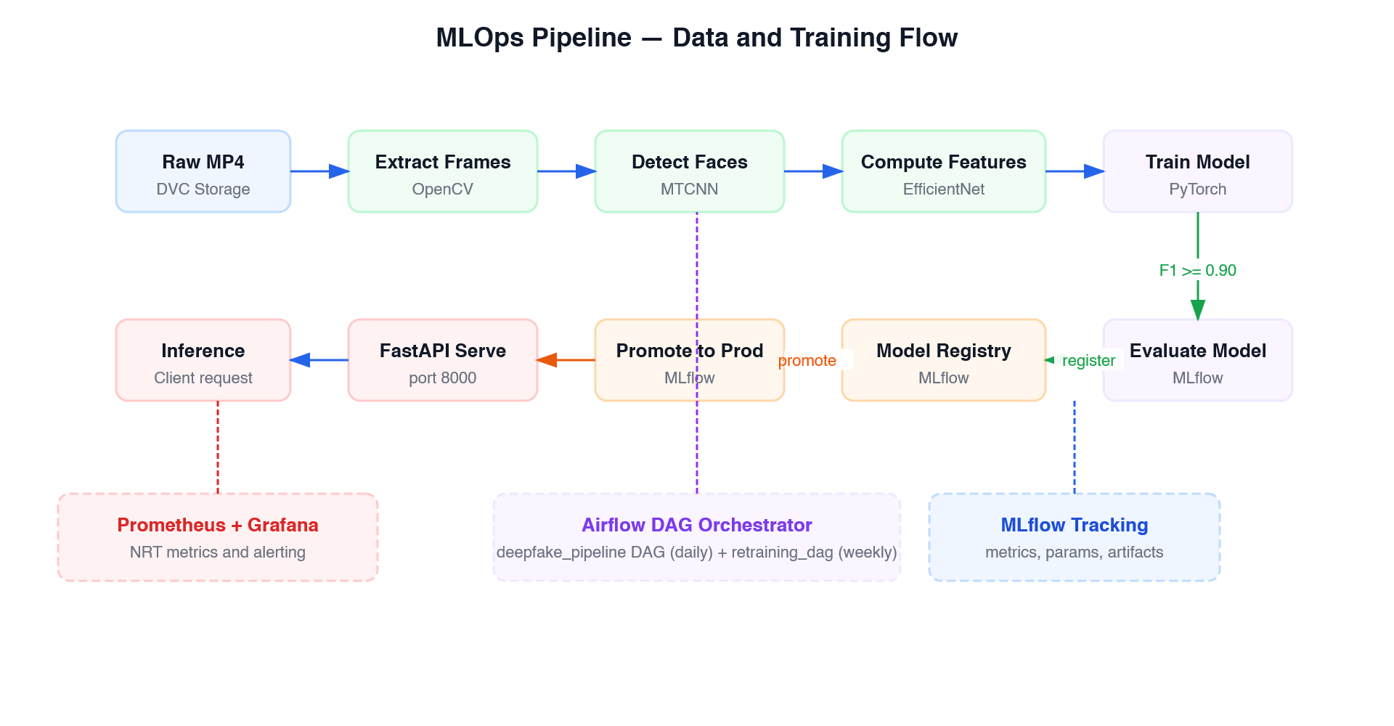
Figure 2: MLOps Data and Training Pipeline
The pipeline flows in two paths: a data processing path (top row) that feeds raw MP4 videos through frame extraction, face detection, and feature computation, and a model lifecycle path (bottom row) that handles training, evaluation, registry, and promotion.

2.1 Data Engineering Pipeline (Airflow — Daily)
The deepfake_pipeline DAG runs daily and executes these stages in sequence:
Stage | Tool | Input | Output
ingest_videos | Airflow PythonOperator | data/landing/*.mp4 | data/raw/*.mp4
extract_frames | OpenCV | data/raw/ | data/frames/ (30 JPGs/video)
detect_faces | MTCNN | data/frames/ | data/faces/ (cropped 224×224)
compute_features | EfficientNet-B0 | data/faces/ | data/features/*.pt
validate_schema | Custom validator | data/features/ | validation report
record_baseline_stats | NumPy | data/features/ | ml/feature_baseline.json
version_with_dvc | DVC | all data/ | dvc.lock committed to Git

2.2 DVC CI Pipeline
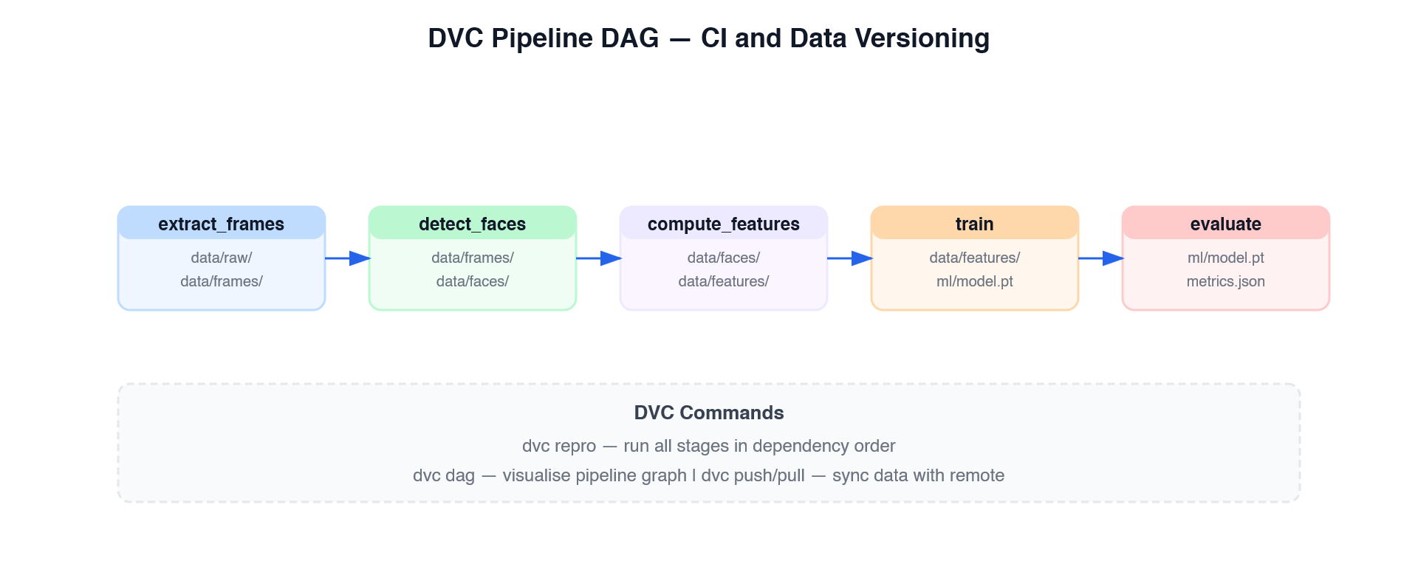
Figure 3: DVC Pipeline DAG — Five Reproducible Stages
DVC defines a five-stage pipeline in dvc.yaml with explicit dependency declarations. Running dvc repro re-executes only stages whose inputs have changed, making the pipeline fully reproducible and auditable. The dvc.lock file is committed to Git, ensuring any team member can recreate the exact pipeline state.

2.3 Automated Retraining (Airflow — Weekly)
The retraining_dag uses a BranchPythonOperator to decide whether retraining is needed based on feature drift. If drift score exceeds 3.0, the full retraining pipeline executes:
- fetch_new_data: pulls newly labelled data from data/landing/
- run_mlproject: executes ml/MLproject with params from ml/params.yaml
- evaluate_model: computes F1, accuracy, PR-AUC, per-class precision/recall
- register_if_better: registers model to MLflow registry if F1 ≥ 0.90
- promote_to_production: transitions Staging → Production, archives current Production

3. Model Architecture
The model is a CNN + LSTM architecture using EfficientNet-B0 as a temporal feature extractor:
Input: (batch, 30, 3, 224, 224) — 30 face-cropped frames
EfficientNet-B0 (pretrained ImageNet) — spatial features per frame
2-layer LSTM (hidden=256) — temporal dependencies across frames
Linear(256→128) → ReLU → Dropout(0.3) → Linear(128→1) → Sigmoid
Output: (batch, 1) — probability (>= 0.5 = fake)
Decision | Choice | Rationale
Feature extractor | EfficientNet-B0 | Best accuracy/efficiency trade-off; pretrained ImageNet weights reduce training time
Temporal model | 2-layer LSTM | Captures inter-frame temporal dependencies; simpler than transformers for 30-frame sequences
Face detection | MTCNN | High accuracy, handles pose variation; lightweight at inference
Experiment tracking | MLflow | Rich model registry with stage transitions; pyfunc serving eliminates extra container
Data pipeline | Airflow + DVC | Airflow for orchestration and scheduling; DVC for reproducible data versioning
Model serving | mlflow.pyfunc (in-process) | Backend loads model directly — no extra container, lower latency, fewer failure points
Monitoring | Prometheus + Grafana | Industry standard; no external dependencies; full metrics lifecycle
Frontend | React + Vite + TypeScript | Fast build; type safety; component-based architecture

4. Experiment Tracking
MLflow tracking is fully manual — no autolog — to give precise control over what is recorded:
What is Tracked | How | Purpose
All hyperparameters | mlflow.log_params(params) | Single source of truth from ml/params.yaml
Per-epoch metrics | mlflow.log_metrics({...}, step=epoch) | train_loss, val_loss, train_f1, val_f1, val_accuracy, learning_rate
Git commit SHA | mlflow.set_tag("git_commit", ...) | Links every run to the exact code state
Device used | mlflow.set_tag("device", ...) | CPU vs CUDA affects reproducibility
Best model artifact | mlflow.pytorch.log_model() | Registered to Model Registry as 'deepfake'
Confusion matrix | mlflow.log_artifact() | Visual evaluation artifact
ROC curve | mlflow.log_artifact() | AUC-ROC visual artifact
Extended eval metrics | mlflow.log_metrics() | PR-AUC, per-class precision/recall, optimal threshold

5. Monitoring Architecture
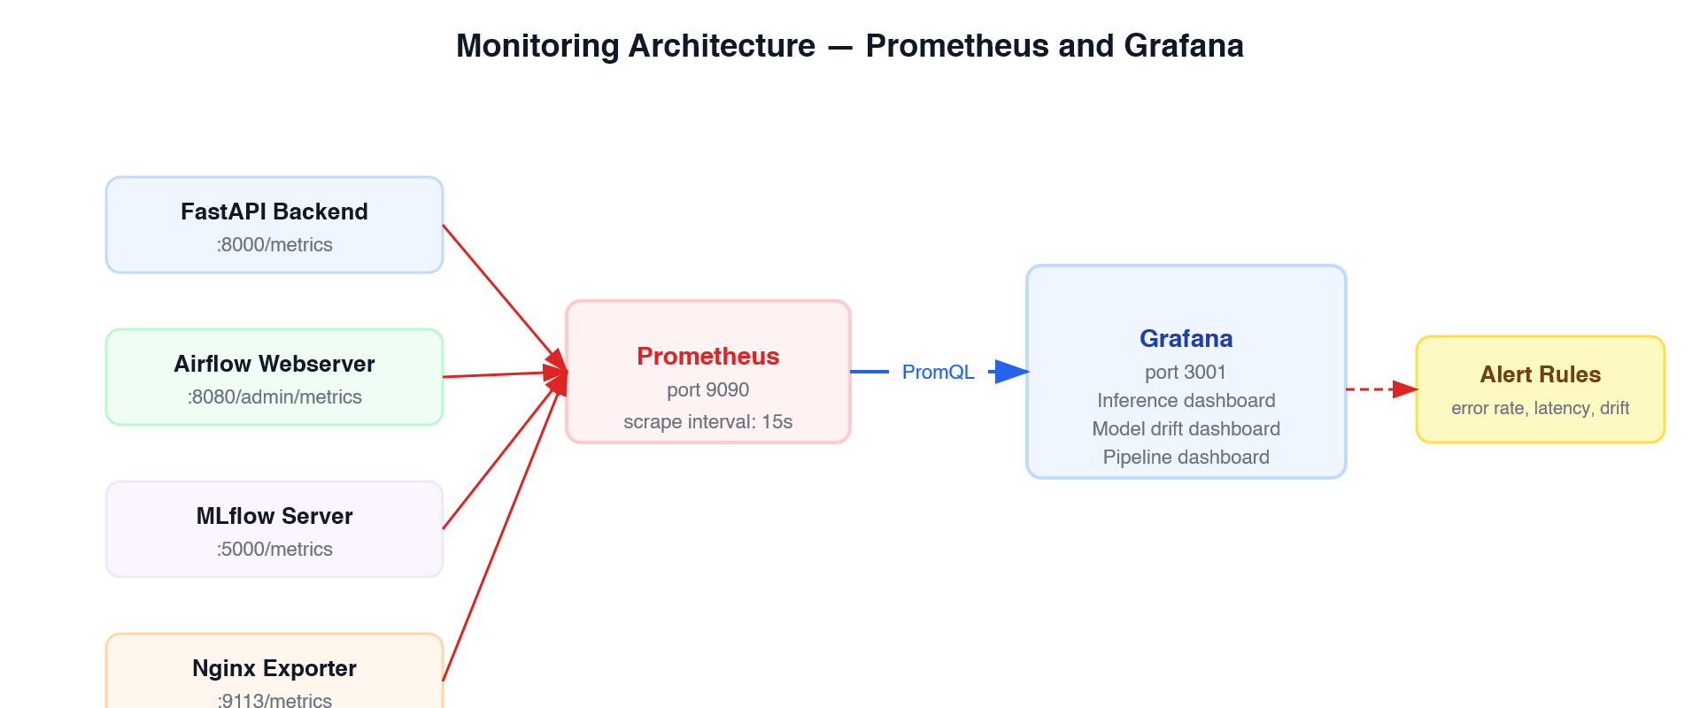
Figure 4: Prometheus and Grafana Monitoring Architecture
All components expose Prometheus metrics endpoints. Prometheus scrapes every 15 seconds. Grafana visualises three dashboards in near-real-time:
- Inference Dashboard: request rate, latency histogram, error rate, drift score gauge
- Model Drift Dashboard: z-score time series with threshold markers at 3.0
- Pipeline Dashboard: Airflow task durations, DVC pipeline throughput, data volume
Alert rules fire when:
Condition | Threshold | Response
Error rate | > 5% for 3 minutes | Grafana alert + investigate logs
p95 Latency | > 200ms | Grafana alert + profile backend
Drift score | > 3.0 | Triggers retraining_dag BranchPythonOperator
Pipeline validation failure | Any failure | Grafana alert + check Airflow logs

6. Software Design Paradigm
The codebase uses a mixed OO + functional paradigm, chosen per layer:
Layer | Paradigm | Rationale
ML model (ml/model.py) | Object-Oriented — DeepfakeDetector(nn.Module) | PyTorch Module system requires OO; encapsulates CNN + LSTM as a single composable unit
Backend API (routers/) | Functional — FastAPI route functions | Stateless request handlers are naturally functional; easier to test in isolation
Model loader | Module-level singleton | Holds shared mutable state (loaded model) without a class; standard Python pattern for process-wide singletons
Airflow DAGs | Functional — plain Python callables | Airflow PythonOperator expects callables; pure functions are easier to test
Preprocessing | Functional with lazy singleton | Stateless transforms; MTCNN cached via module-level variable to avoid reloading per request

7. Security
- All secrets stored in .env (never committed to Git; .env.example provided)
- HTTPS via Nginx TLS termination in production
- Prometheus and Grafana behind basic auth
- No cloud usage — all data stays local (GDPR-safe for video PII)
- Encryption at rest: Docker volumes mounted on OS-level encrypted filesystem (BitLocker/LUKS)
- Admin endpoint (POST /admin/reload-model) not exposed through Nginx to public users

