DEEPFAKE DETECTION
Low-Level Design
API Endpoint Definitions and I/O Specifications

────────────────────────────────────────

Major Prabhat Pandey | April 2026 | MLOps Project

1. API Endpoint Overview
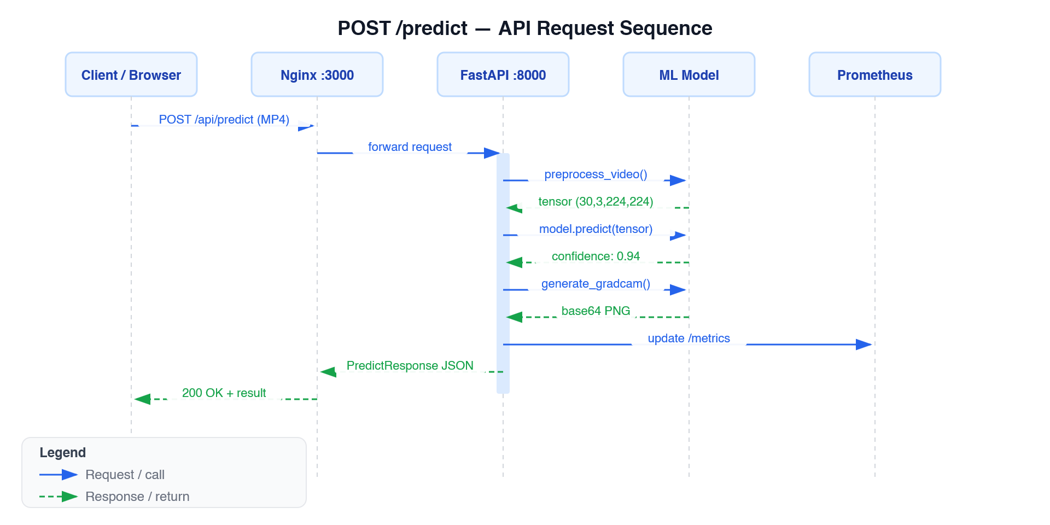
Figure 5: POST /predict — API Request Sequence Diagram
The FastAPI backend exposes a RESTful API. All endpoints accept and return JSON (except /predict which accepts multipart/form-data and /metrics which returns Prometheus text format).

Endpoint | Method | Auth | Purpose
/predict | POST | None | Video deepfake classification
/predict/batch | POST | None | Batch classification (max 10 videos)
/health | GET | None | Liveness probe
/ready | GET | None | Readiness probe (model loaded check)
/metrics | GET | None | Prometheus metrics export
/feedback | POST | None | Submit ground-truth label
/admin/reload-model | POST | Internal only | Force model reload
/admin/rollback | POST | Internal only | Roll back to specific model version
/admin/model-info | GET | Internal only | Current model metadata
/pipeline/mlflow-runs | GET | None | Recent MLflow experiment runs
/pipeline/airflow-runs | GET | None | Recent Airflow DAG runs
/pipeline/throughput | GET | None | Pipeline throughput metric
/support/tickets | POST/GET | X-Username header | Support ticket management
/support/chat | POST | None | Rule-based chatbot

2. Endpoint Specifications

2.1 POST /predict
Classifies a single MP4 video as real or fake.

Request
Content-Type: multipart/form-data
field: file (MP4, max 100MB)

Success Response — HTTP 200
{
"prediction": "fake",
"confidence": 0.94,
"inference_latency_ms": 143.2,
"gradcam_image": "<base64 PNG string>",
"mlflow_run_id": "uuid-string",
"frames_analyzed": 30
}

Error Responses
HTTP Code | Condition | Response Body
400 | File is not .mp4 extension | {"detail": "Only MP4 files are accepted"}
500 | Model inference failure | {"detail": "<error message>"}

Processing Pipeline
1. Save upload to temp file (tempfile.NamedTemporaryFile)
2. preprocess_video(tmp_path) → tensor (30, 3, 224, 224)
3. model.predict(tensor.unsqueeze(0).numpy()) → confidence float
4. prediction = 'fake' if confidence >= 0.5 else 'real'
5. Feature drift check: compute_drift_score(features, baseline)
6. generate_gradcam(model, frames_tensor) → base64 PNG (best-effort)
7. Update Prometheus metrics (request count, latency, confidence, drift)

2.2 POST /predict/batch
Classifies up to 10 MP4 videos in a single request.

Request
Content-Type: multipart/form-data
field: files (list of MP4, max 10)

Success Response — HTTP 200
{
"results": [
{"filename": "v1.mp4", "prediction": "fake", "confidence": 0.87, "inference_latency_ms": 132.1, "error": null},
{"filename": "v2.mp4", "prediction": null, "confidence": null, "error": "Only MP4 files are accepted"}
],
"total": 2, "succeeded": 1, "failed": 1
}

2.3 GET /health
{"status": "ok", "model_loaded": true}

2.4 GET /ready
{"status": "ready", "model_version": "deepfake/Production/3"}
Returns HTTP 503 with {"detail": "Model not loaded"} when model is unavailable.

2.5 GET /metrics
Returns Prometheus text exposition format. Metrics exposed:
Metric Name | Type | Labels | Description
deepfake_requests_total | Counter | method, endpoint, status | Total prediction requests
deepfake_request_latency_seconds | Histogram | endpoint | End-to-end request latency
deepfake_inference_latency_ms | Histogram | — | Model inference time only
deepfake_confidence_score | Histogram | — | Confidence distribution
deepfake_predictions_total | Counter | label (real/fake) | Predictions by class
deepfake_drift_score | Gauge | — | Current feature drift z-score
deepfake_drift_detected_total | Counter | — | Requests with drift detected
pipeline_validation_failures_total | Counter | — | Schema validation failures

2.6 POST /feedback

Request
{
"request_id": "uuid-string",
"predicted": "fake",
"ground_truth": "real"
}
Validation: predicted and ground_truth must be "real" or "fake" — returns HTTP 422 otherwise.

Response — HTTP 200
{"status": "logged", "request_id": "uuid-string"}

2.7 POST /admin/rollback
Request: {"version": "2"}
Response: {"status": "reloaded", "model_version": "models:/deepfake/2"}

2.8 GET /admin/model-info
{"model_version": "models:/deepfake/Production", "run_id": "abc123def456", "model_loaded": true}

2.9 Support Endpoints
Endpoint | Method | Headers | Key Behaviour
/support/tickets | POST | X-Username | Create ticket; 201 with TicketResponse
/support/tickets | GET | X-Role, X-Username | Admin sees all; user sees own tickets
/support/tickets/{id}/resolve | PATCH | X-Role: admin | Set status=resolved; 403 if not admin
/support/chat | POST | — | Rule-based keyword reply; no LLM

3. Module Reference

3.1 backend/app/preprocessing.py
Function | Signature | Description
get_mtcnn() | () → MTCNN | Lazy singleton; device=cpu
extract_frames() | (path, num_frames=30) → list[np.ndarray] | Sample frames evenly via np.linspace; raises ValueError if unreadable
detect_faces() | (frames) → list[np.ndarray] | MTCNN detection; fallback to resized full frame on miss
preprocess_video() | (path, num_frames=30) → torch.Tensor | Full pipeline; pads by repeating last frame if needed; shape (30,3,224,224)

3.2 backend/app/model_loader.py
Symbol | Type | Description
_model | module-level var | Singleton loaded model; None until load_model() called
_current_version | module-level var | Current model URI string
load_model() | () → None | Reads MODEL_NAME/MODEL_STAGE env vars; calls mlflow.pyfunc.load_model
reload_model() | () → None | Force-reloads for rollback support

3.3 backend/app/drift_detector.py
Function | Description
compute_drift_score(features, baseline) | Mean absolute z-score; zero-std guard via np.where(std==0, 1e-8, std)
is_drifted(score, threshold=3.0) | Returns True if score exceeds threshold
load_baseline() | Returns None if ml/feature_baseline.json not found

4. Airflow DAG Reference

4.1 deepfake_pipeline (daily)
ingest_videos → extract_frames → detect_faces → compute_features
→ validate_schema → record_baseline_stats → version_with_dvc

4.2 retraining_dag (weekly)
check_drift (BranchPythonOperator)
├── [drift detected]
│ fetch_new_data → run_mlproject → evaluate_model
│ → register_if_better → promote_to_production
└── [no drift]
skip_retraining (DummyOperator)

5. MLflow Model Registry Lifecycle
None → Staging → Production → Archived
Stage | Trigger | Action
None | Training run completes | Model version created automatically
Staging | register_if_better() — F1 ≥ 0.90 | Version transitioned to Staging
Production | promote_to_production() | Staging → Production; current Production → Archived
Archived | Rollback or new promotion | Retained indefinitely for rollback

