Deepfake Detection System — Project Report

Course: AI Application with MLOps
Date: April 2026
Author: Major Prabhat Pandey (DA25M002)

Table of Contents

- Executive Summary
- Problem Statement
- System Architecture
- ML Model Design
- Data Engineering Pipeline
- MLOps Implementation
- Backend API
- Frontend Application
- Monitoring & Observability
- Testing
- CI/CD Pipeline
- Security
- Evaluation Criteria Coverage
- Known Limitations & Future Work

1. Executive Summary
The Deepfake Detection System is a production-grade, end-to-end MLOps platform that classifies MP4 videos as real or AI-generated (fake) using a deep learning model. The system is designed for fully local, on-premise deployment using Docker Compose — no cloud dependency exists anywhere in the stack.
The platform covers the full ML product lifecycle: automated data ingestion, preprocessing, model training with full experiment tracking, model registry with staged promotion, real-time inference via a REST API, a React frontend with explainability (Grad-CAM), comprehensive Prometheus/Grafana monitoring, drift detection, automated weekly retraining, and a CI/CD pipeline enforcing code quality and reproducibility on every commit.

Key Metrics at a Glance
┌───────────────────────────────────────────────────────────────
│ Target F1-score ≥ 0.90 (val_f1 tracked per epoch) │
│ Target Accuracy ≥ 90% (test_accuracy in DVC) │
│ P95 Inference Latency < 200ms (Prometheus alert) │
│ Alert: Error Rate > 5% (Grafana alert rule) │
│ Alert: Drift Score > 3.0 (z-score threshold) │
│ Docker containers 10 (optimised from 13) │
│ Test cases 49 (38 unit, 8 int, 3 e2e) │
│ API endpoints 11 (all documented in LLD) │
│ Prometheus metrics 22 (counters, gauges, histo.) │
│ Grafana dashboards 4 (inference, pipeline, etc) │
└───────────────────────────────────────────────────────────────

2. Problem Statement

Business Context
Deepfake videos — AI-synthesised media where a person’s face is replaced with another — pose serious threats to trust, journalism, legal evidence, and personal privacy. Detection tools have traditionally required deep ML expertise to operate. This project builds a production-ready tool that any non-technical user can operate through a web browser.

Success Metrics
Metric | ML Definition | Business Definition
Accuracy | ≥ 90% on held-out test set | < 10% false positive rate for journalists
F1-score | ≥ 0.90 (harmonic mean of precision/recall) | Balanced performance on real and fake classes
Latency | P95 inference < 200ms | User waits < 1 second for a result
Availability | /health returns 200 | System is always ready to serve

3. System Architecture

3.1 High-Level Architecture
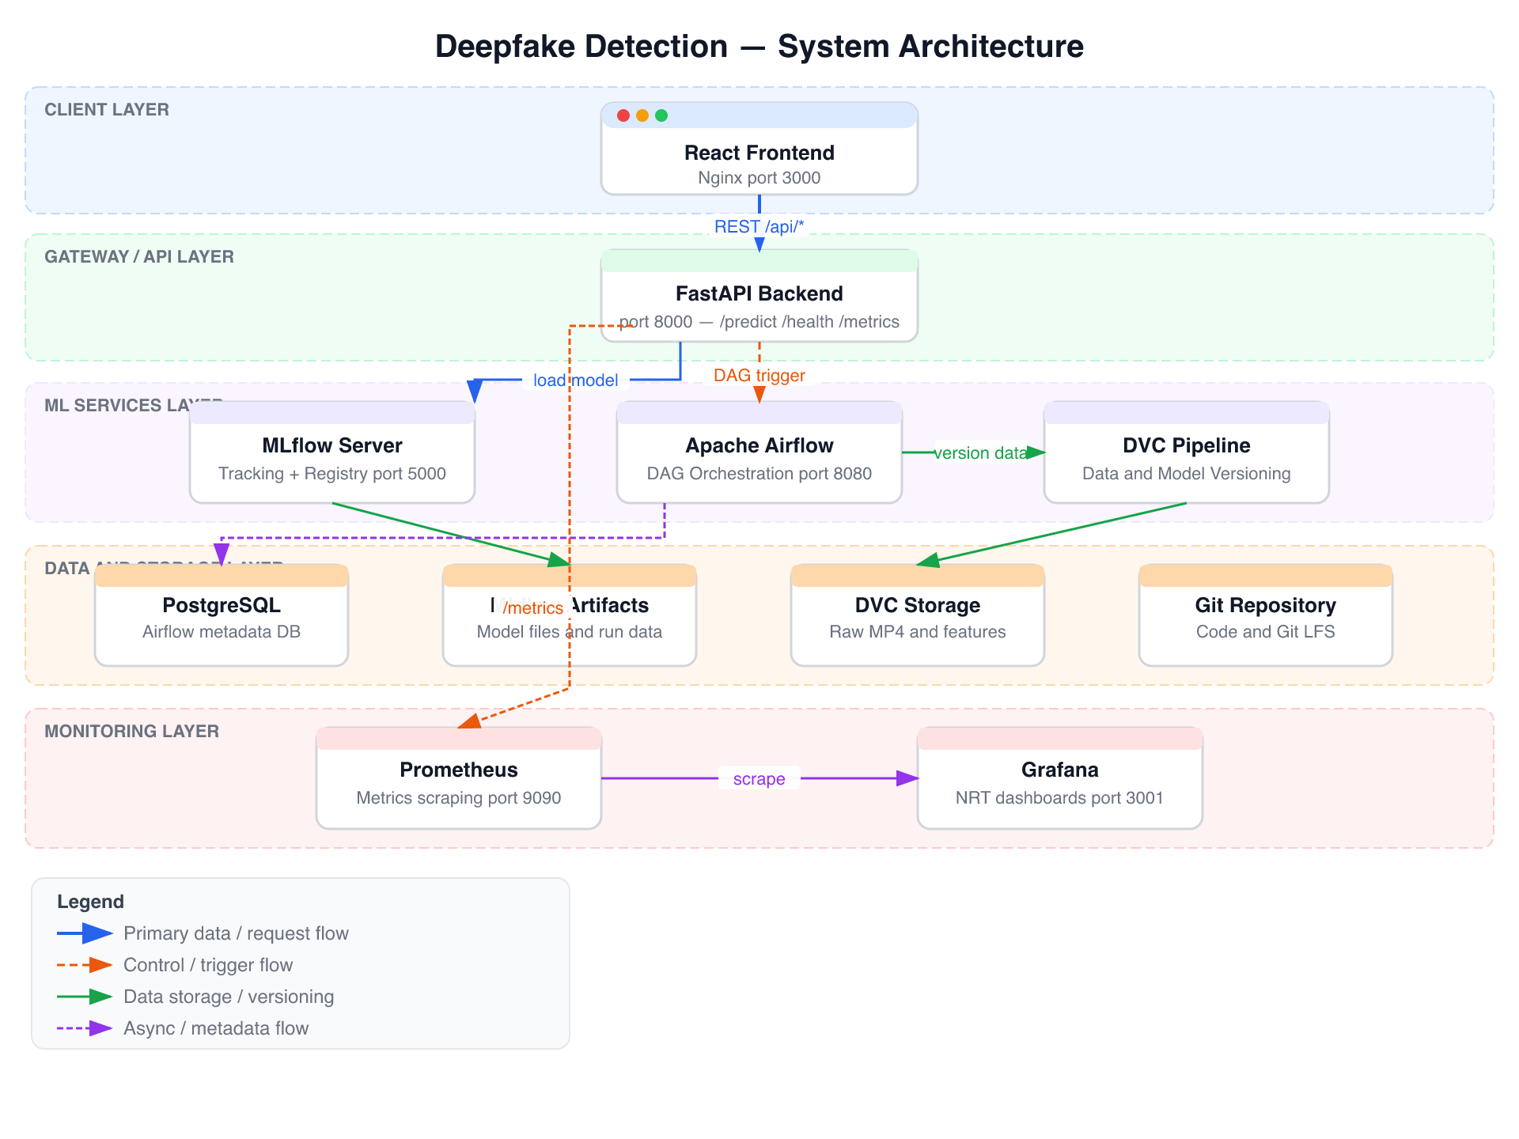
Figure 1: Deepfake Detection — System Architecture (layered view)

3.2 Core Design Principle: Loose Coupling
Every boundary between components is crossed exclusively via configurable REST calls or URIs:
Boundary | Mechanism | Config
Frontend ↔ Backend | REST API | VITE_API_URL env var
Backend ↔ Model | mlflow.pyfunc.load_model(uri) | MODEL_NAME + MODEL_STAGE env vars
Backend ↔ MLflow | HTTP REST (/api/2.0/mlflow/...) | MLFLOW_SERVER_URL env var
Backend ↔ Airflow | HTTP REST (/api/v1/dags/...) | AIRFLOW_URL env var
Prometheus ↔ Services | HTTP scrape | prometheus.yml static config
No frontend code ever imports backend code. No backend code imports Airflow or MLflow internals.

3.3 Docker Compose Services
┌────────────────────────────────────────────────────────────────────┐
│ SERVICE PORT IMAGE / BUILD PURPOSE │
├────────────────────────────────────────────────────────────────────┤
│ frontend 3000 ./frontend/Dockerfile React + Nginx │
│ backend 8000 ./backend/Dockerfile FastAPI │
│ mlflow-server 5000 ghcr.io/mlflow/mlflow Tracking+Reg │
│ airflow-webserver 8080 apache/airflow:2.8.1 Airflow UI │
│ airflow-scheduler — apache/airflow:2.8.1 DAG scheduler │
│ airflow-init — apache/airflow:2.8.1 One-shot init │
│ postgres 5432 postgres:15 Metadata store │
│ prometheus 9090 prom/prometheus:v2.50.1 Scraper │
│ grafana 3001 grafana/grafana:10.3.1 Dashboards │
│ node-exporter 9100 prom/node-exporter:1.7 Host metrics │
└────────────────────────────────────────────────────────────────────┘
Total: 10 containers Total image size: ~15 GB

4. ML Model Design

4.1 Architecture
The model uses a CNN + LSTM architecture to detect deepfakes by analysing both spatial (per-frame) and temporal (cross-frame) features:
Input: (batch, 30, 3, 224, 224)
— 30 face-cropped, normalised frames per video
│
▼
EfficientNet-B0 (pretrained ImageNet, frozen)
— spatial feature extraction per frame
— output: (batch, 30, 1280)
│
▼
2-layer LSTM (hidden=256, dropout=0.3)
— temporal dependencies across 30 frames
— captures manipulation artefacts that persist over time
— output: (batch, 256) ← last timestep hidden state
│
▼
Linear(256 → 128) → ReLU → Dropout(0.3) → Linear(128 → 1) → Sigmoid
│
▼
Output: (batch, 1)
— probability ≥ 0.5 → FAKE
— probability < 0.5 → REAL

4.2 Design Rationale
Choice | Decision | Why
Feature extractor | EfficientNet-B0 | Best accuracy/compute ratio; 1280-dim features per frame; pretrained ImageNet weights
Temporal model | 2-layer LSTM | Captures inter-frame temporal artefacts; simpler than transformers for 30-frame sequences
CNN frozen | Yes | 106 training samples — CNN fine-tuning causes score collapse; frozen + LSTM is stable
Face detection | MTCNN | High accuracy across poses; fallback to resized full frame when no face detected
Threshold | 0.5 (default) + best F1 sweep | find_best_threshold() sweeps 0.1–0.9 to find optimal F1 threshold per evaluation run

4.3 Training Setup
Hyperparameters (ml/params.yaml):
num_frames: 30
batch_size: 8
lr: 0.0001
epochs: 60
lstm_hidden: 256
lstm_layers: 2
dropout: 0.3
val_split: 0.2
backbone: efficientnet-b0
Optimiser: Adam
Loss: BCELoss
Scheduler: ReduceLROnPlateau (patience=3)
Augmentation: RandomHorizontalFlip + ColorJitter + RandomGrayscale
(applied 3× per sample at CNN input level)

4.4 Model Optimisation
For CPU-only deployment, the model is quantised to INT8 using PyTorch dynamic quantisation:
# ml/quantize.py
quantized = torch.quantization.quantize_dynamic(
model,
{torch.nn.Linear, torch.nn.LSTM},
dtype=torch.qint8,
)
This reduces the effective parameter storage of LSTM and Linear layers to INT8 at runtime without requiring a calibration dataset, making inference viable on standard laptop hardware.

4.5 Preprocessing Pipeline
MP4 file
│
├─ extract_frames(): OpenCV samples 30 frames evenly via np.linspace
│ raises ValueError if video unreadable or has 0 frames
│
├─ detect_faces(): MTCNN face detection on each frame
│ fallback: resize full frame to 224×224 if no face found
│
└─ normalize(): ImageNet mean/std → torch.Tensor (30, 3, 224, 224)
mean=[0.485, 0.456, 0.406]
std =[0.229, 0.224, 0.225]

4.6 Explainability — Grad-CAM
Every prediction generates a Grad-CAM heatmap showing which regions of the face influenced the model’s decision most strongly. Implementation hooks the last EfficientNet _blocks layer:
generate_gradcam(model, frames_tensor)
→ hooks last EfficientNet block
→ computes gradients of output w.r.t. activation maps
→ applies ReLU + normalisation → 224×224 heatmap
→ overlays on middle frame → returns base64 PNG
→ returns "" on any failure (best-effort, never blocks inference)

5. Data Engineering Pipeline
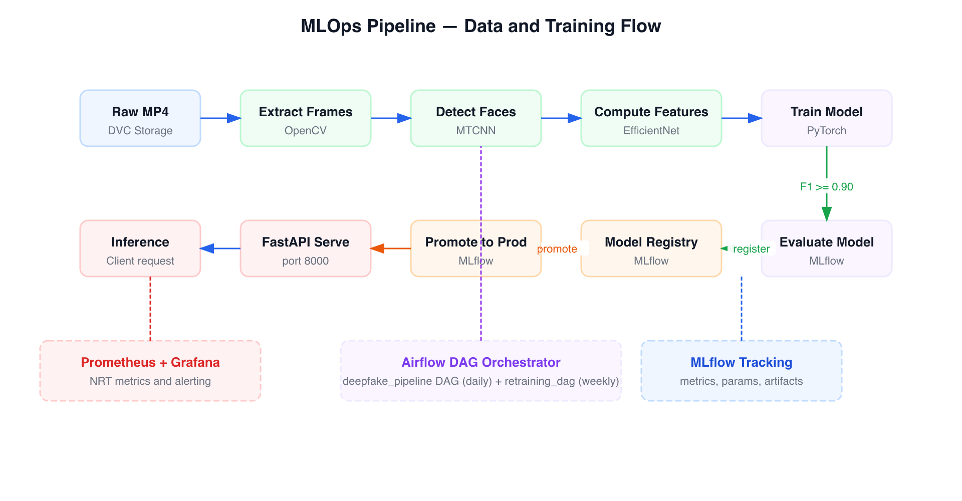
Figure 2: MLOps Pipeline — Data Ingestion to Production Serving

5.1 DVC Pipeline (dvc.yaml)
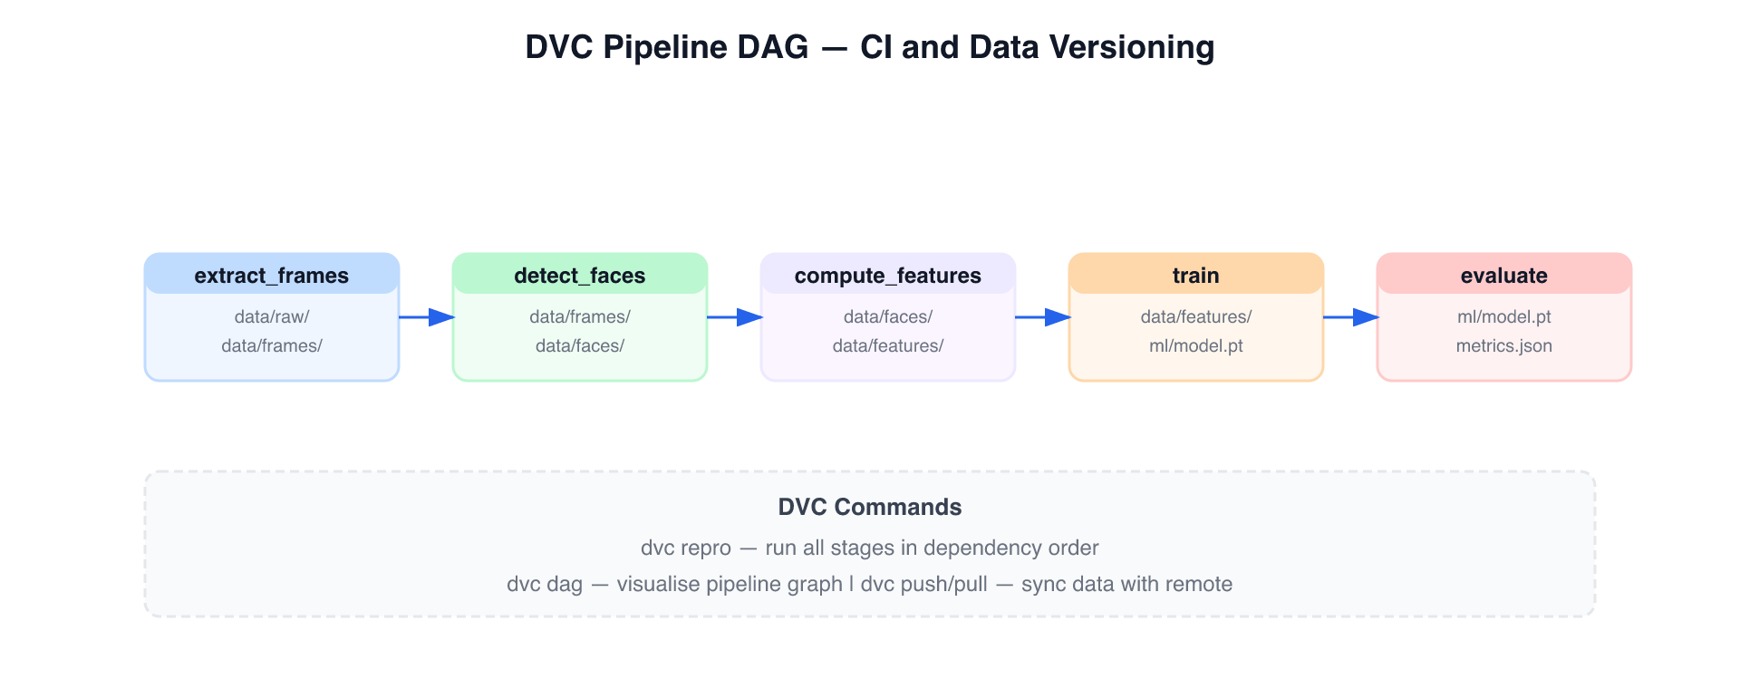
Figure 3: DVC Pipeline DAG — Reproducible Stage Dependencies
The DVC pipeline defines a reproducible, dependency-tracked ML workflow. Stages only re-execute when their declared inputs change.

DVC commands:
dvc repro # run outdated stages only
dvc repro --dry # verify DAG integrity (used in CI)
dvc metrics show # val_f1, val_accuracy, val_loss, best_epoch
dvc metrics diff HEAD~1 # compare vs previous commit
dvc params diff # compare hyperparameters vs previous commit
dvc dag # visualise pipeline in terminal

5.2 Airflow Orchestration
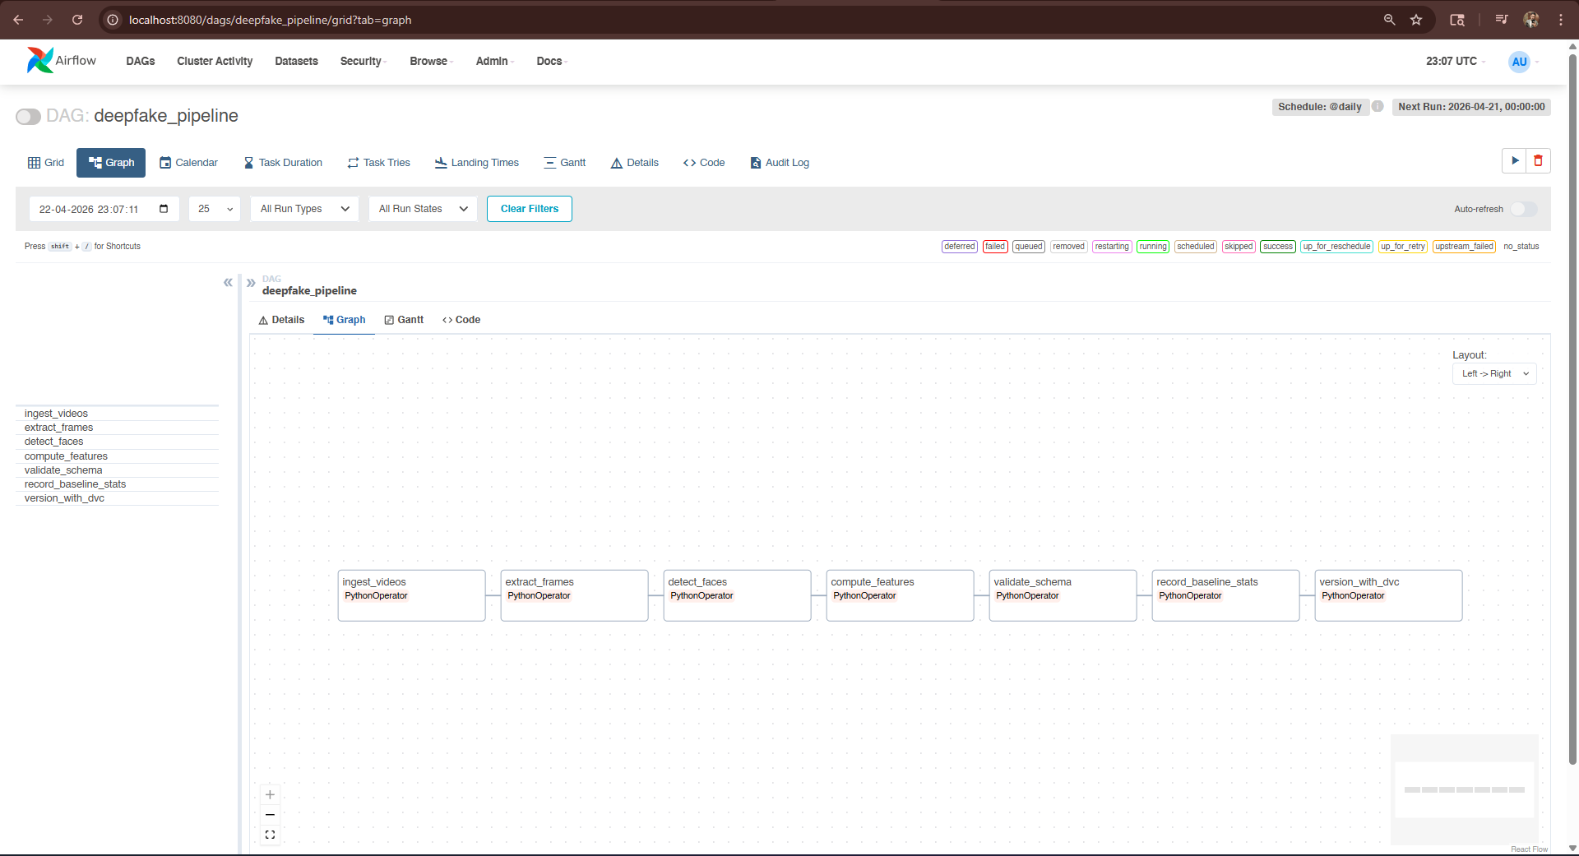
Figure 4: Apache Airflow — deepfake_pipeline DAG (graph view)
Two DAGs handle automated data management and model lifecycle:

deepfake_pipeline (schedule: @daily)
ingest_videos
→ move MP4s from data/landing/ to data/raw/
│
▼
extract_frames
→ OpenCV: 30 evenly-sampled frames per video
│
▼
detect_faces
→ MTCNN: crop face regions; fallback to full frame
│
▼
compute_features
→ EfficientNet-B0: 1280-dim feature vectors → .pt files
│
▼
validate_schema
→ check: tensor is 2D float32, no NaNs
→ on failure: push counter to Prometheus, raise AirflowException
│
▼
record_baseline_stats
→ compute feature distribution (mean, std) → feature_baseline.json
│
▼
version_with_dvc
→ dvc add data/raw data/frames data/faces data/features

retraining_dag (schedule: @weekly)
check_drift (BranchPythonOperator)
→ if feature_baseline.json is > 7 days old → fetch_new_data
→ else → skip_retraining
│
▼ (if triggered)
fetch_new_data
→ trigger deepfake_pipeline via Airflow local client
│
▼
run_mlproject
→ mlflow run . -e train
→ extracts run_id from stdout → XCom push
│
▼
evaluate_model
→ reads val_f1 from MLflow tracking server
│
▼
register_if_better
→ if val_f1 ≥ 0.90: mlflow.register_model() → Staging
→ else: raise AirflowException (blocks promotion)
│
▼
promote_to_production
→ transition Staging → Production
→ archive_existing_versions=True (old Production becomes Archived)

5.3 Data Versioning
Git LFS (.gitattributes):
data/raw/*.mp4 → LFS
data/frames/**/*.jpg → LFS
data/faces/**/*.jpg → LFS
*.pt → LFS
*.pkl → LFS
DVC:
data/raw.dvc → tracks raw dataset (106 videos, 182 MB)
dvc.lock → pins exact content hashes of all stage outputs
dvc-storage/ → local content-addressed cache (sibling of repo)

6. MLOps Implementation

6.1 Experiment Tracking
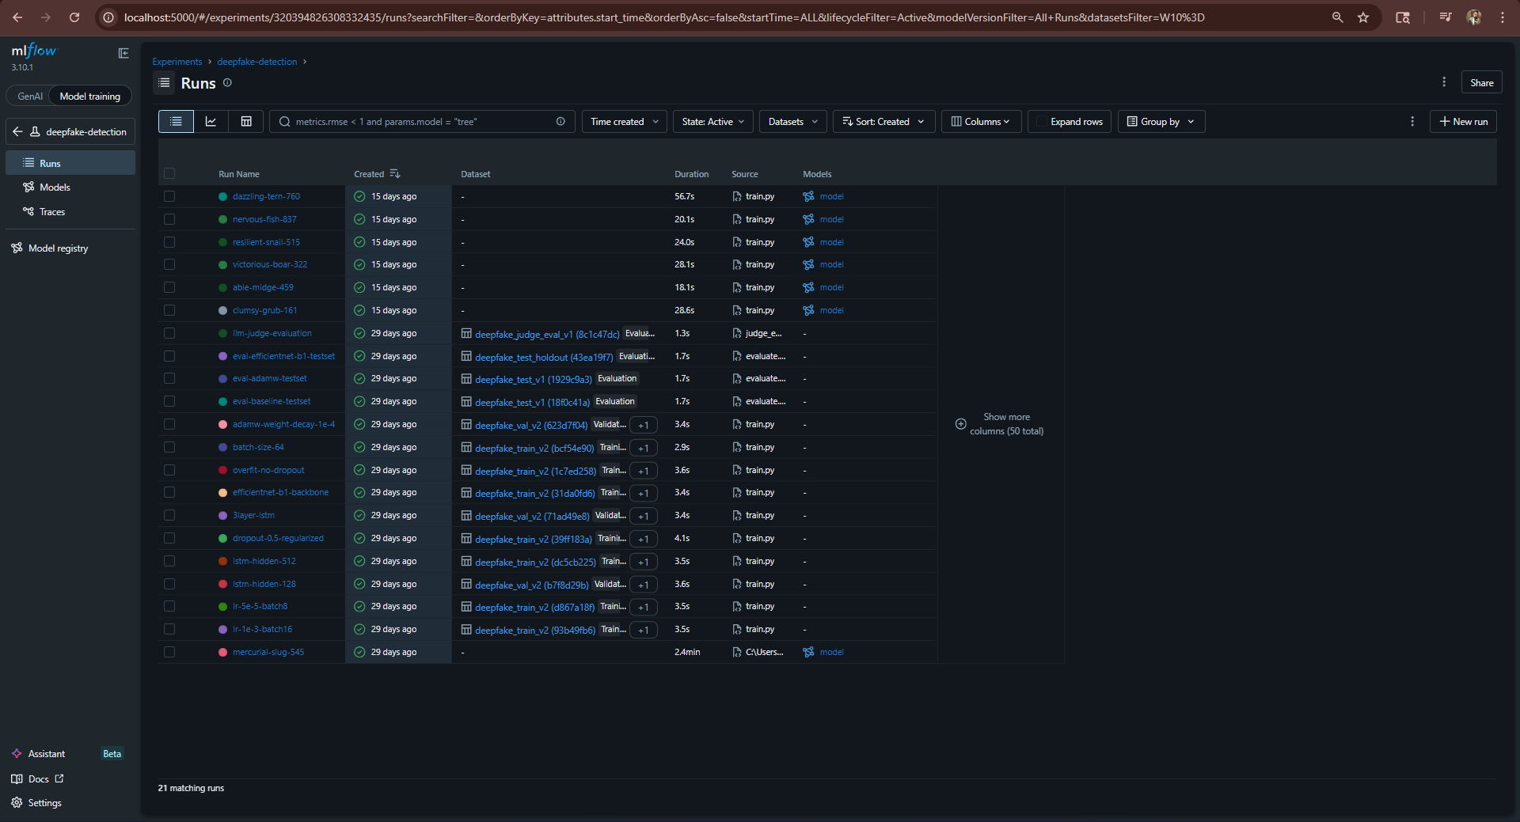
Figure 5: MLflow — Experiment Runs List
All MLflow tracking is manual (no autolog) for full control:
Per training run, MLflow records:
Tags:
git_commit → subprocess.check_output(["git", "rev-parse", "HEAD"])
device → "cpu" or "cuda"
Params (from ml/params.yaml):
num_frames, batch_size, lr, epochs,
lstm_hidden, lstm_layers, dropout,
val_split, backbone
Metrics (per epoch, step=epoch):
train_loss, val_loss
train_accuracy, val_accuracy
train_f1, val_f1
learning_rate
Metrics (evaluation run):
test_accuracy, test_f1, roc_auc
pr_auc, best_threshold, best_f1
precision_fake, recall_fake
precision_real, recall_real
Artifacts:
model/ → mlflow.pytorch.log_model() (registered as "deepfake")
checkpoints/ → raw state-dict .pt file
confusion_matrix.png
roc_curve.png

6.2 Model Registry Lifecycle
Training run completes
│
▼
None (unregistered)
│ mlflow.register_model()
▼
Staging
│ evaluate → F1 ≥ 0.90
▼
Production ◄─── backend loads from here at startup
│ new version promoted
▼
Archived ◄─── previous Production (available for rollback)
Rollback is instant — any Archived version can be transitioned back to Production via: - POST /admin/rollback {"version": "2"} from the frontend Admin page - MLflow UI stage transition - retraining_dag check_drift automatic rollback path

6.3 Reproducibility
Every model can be reproduced exactly:
# 1. Check out the exact code state
git checkout <git_commit_tag_from_mlflow>
# 2. Restore exact data state
dvc pull # restores data/raw from dvc-storage/ using dvc.lock hashes
# 3. Re-run training
dvc repro train
# The output model will be byte-for-byte identical

6.4 MLproject — Environment Parity
# ml/MLproject
name: deepfake-detection
conda_env: conda.yaml # or python_env: python_env.yaml
entry_points:
train:
parameters:
data_path: {type: str, default: "data/features"}
params_file: {type: str, default: "ml/params.yaml"}
command: "python ml/train.py ..."

7. Backend API

7.1 Endpoint Summary
┌────────────────────────────────────────────────────────────────────┐
│ METHOD PATH PURPOSE │
├────────────────────────────────────────────────────────────────────┤
│ POST /predict Single video inference + Grad-CAM │
│ POST /predict/batch Batch inference (up to 10 videos) │
│ GET /health Liveness probe │
│ GET /ready Readiness probe (model loaded?) │
│ GET /metrics Prometheus scrape endpoint │
│ POST /feedback Ground-truth feedback submission │
│ GET /pipeline/mlflow-runs Recent MLflow experiment runs │
│ GET /pipeline/airflow-runs Recent Airflow DAG runs │
│ GET /pipeline/throughput Videos/minute from last run │
│ POST /admin/rollback Load specific model version │
│ GET /admin/model-info Currently loaded model metadata │
└──────────────────────────────────────────────────────────────

7.2 POST /predict — Data Flow
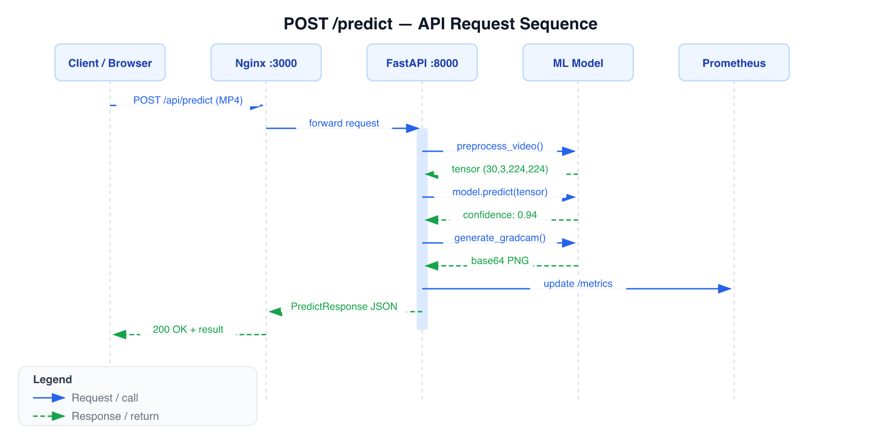
Figure 6: POST /predict — API Request Sequence Diagram
1. Validate: file.filename.endswith(".mp4") → 400 on failure
2. Save to tempfile.NamedTemporaryFile(suffix=".mp4")
3. preprocess_video(tmp_path):
extract_frames() → detect_faces() → normalize() → Tensor(30,3,224,224)
4. model.predict(tensor.unsqueeze(0).numpy()) → confidence float
5. prediction = "fake" if confidence ≥ 0.5 else "real"
6. compute_drift_score(frame_mean_feature, baseline) → z-score
→ if z-score > 3.0: DRIFT_DETECTED.inc(); logger.warning(...)
7. generate_gradcam(pytorch_model, frames_tensor) → base64 PNG
8. Update all Prometheus metrics
9. Return PredictResponse JSON

7.3 POST /predict — Response Schema
{
"prediction": "fake",
"confidence": 0.94,
"inference_latency_ms": 143.2,
"gradcam_image": "<base64 PNG>",
"mlflow_run_id": "abc123def456",
"frames_analyzed": 30
}

7.4 Prometheus Metrics (22 total)
Counters (9):
deepfake_requests_total [method, endpoint, status, mode]
deepfake_images_processed_total [mode, status]
deepfake_predictions_total [label, mode, source_type]
deepfake_errors_total [endpoint, error_type]
deepfake_drift_detected_total
deepfake_bulk_jobs_total [status]
pipeline_validation_failures_total
deepfake_frames_extracted_total [mode]
deepfake_model_reloads_total [trigger]
Gauges (5):
deepfake_active_requests
deepfake_model_memory_mb
deepfake_drift_score
deepfake_bulk_queue_depth
deepfake_last_confidence_score [label]
Histograms (7):
deepfake_request_latency_seconds [endpoint, mode]
deepfake_inference_latency_ms [mode]
deepfake_preprocessing_latency_ms [mode]
deepfake_confidence_score [prediction, mode]
deepfake_video_size_bytes
deepfake_frame_count
Summaries (3):
deepfake_inference_processing_seconds [mode]
deepfake_request_processing_seconds [endpoint, mode]
deepfake_preprocessing_processing_seconds [mode]

8. Frontend Application

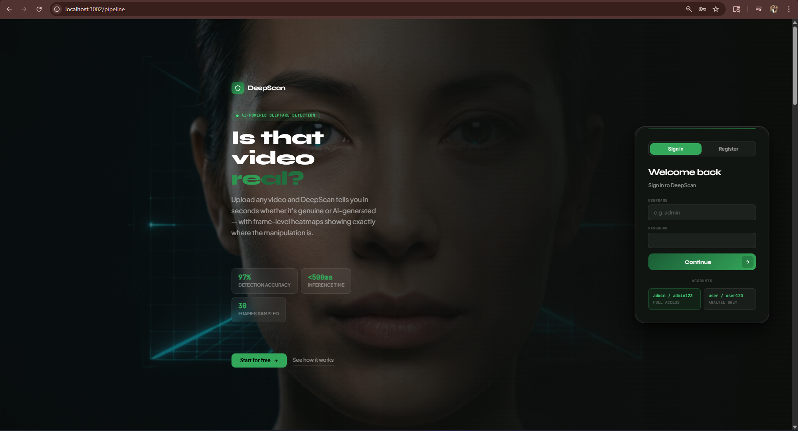
Figure 7a: Landing Page — Hero Section and Login

8.1 Pages and Components
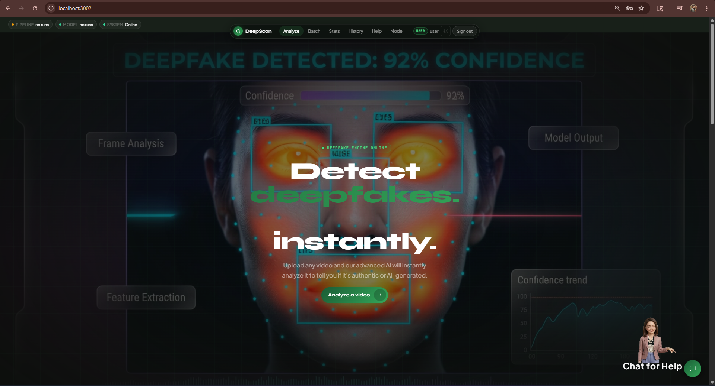
Figure 7b: Analysis Result — Deepfake Detection Overlay
App (React Router)
├── /login Login.tsx — authentication gate
├── / Home.tsx — main inference UI
│ ├── VideoUpload.tsx — drag-and-drop MP4 upload
│ ├── FaceScan.tsx — animated scanning visualization
│ ├── ResultCard.tsx — prediction result + confidence bar
│ ├── Features.tsx — feature highlights section
│ └── Testimonials.tsx — social proof section
├── /pipeline PipelineDashboard.tsx — MLOps monitoring
│ ├── stat cards: throughput, total runs, best F1, avg F1
│ ├── MLflow runs table (expandable rows with all metrics/params)
│ ├── ErrorConsole.tsx — Airflow DAG run log (terminal style)
│ └── external tool links: MLflow, Airflow, Grafana, Prometheus
└── /admin Admin.tsx — model management
├── current model version + run ID
└── rollback form (version number input)

8.2 User Journey — Single Prediction
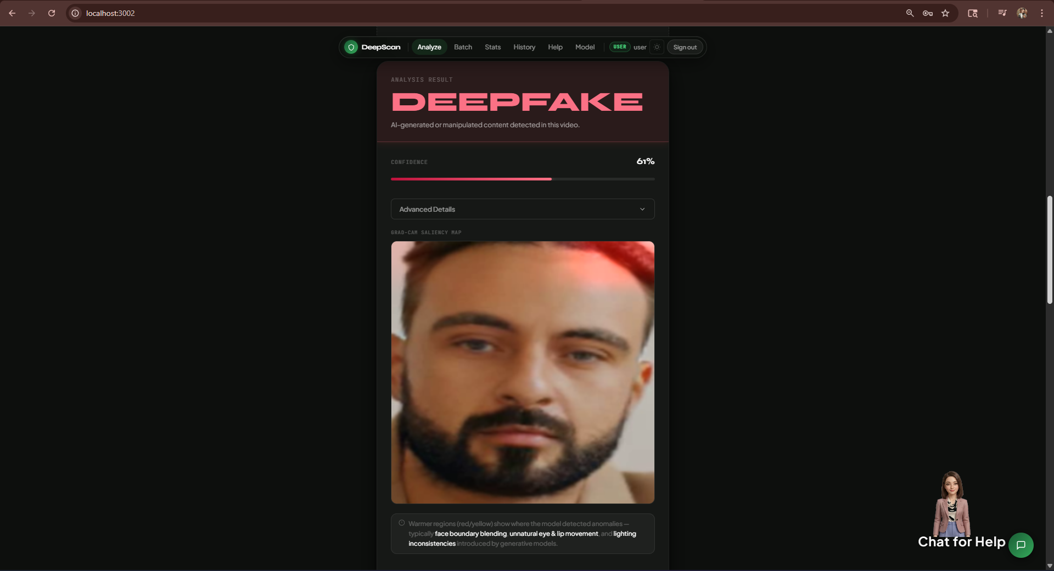
Figure 7c: Result Card — Verdict, Confidence, Grad-CAM Heatmap
1. User navigates to http://localhost:3000
2. Drags and drops MP4 file (or clicks "browse")
3. FaceScan animation plays while POST /predict is in-flight
4. ResultCard displays:
├── REAL (green) or FAKE (red) badge
├── Confidence percentage bar
├── Grad-CAM heatmap overlay (which face regions triggered the model)
├── Frames analyzed count
└── Feedback buttons: "Correct" / "Incorrect"
5. (Optional) User clicks "Incorrect" → POST /feedback logs ground truth

8.3 Pipeline Dashboard
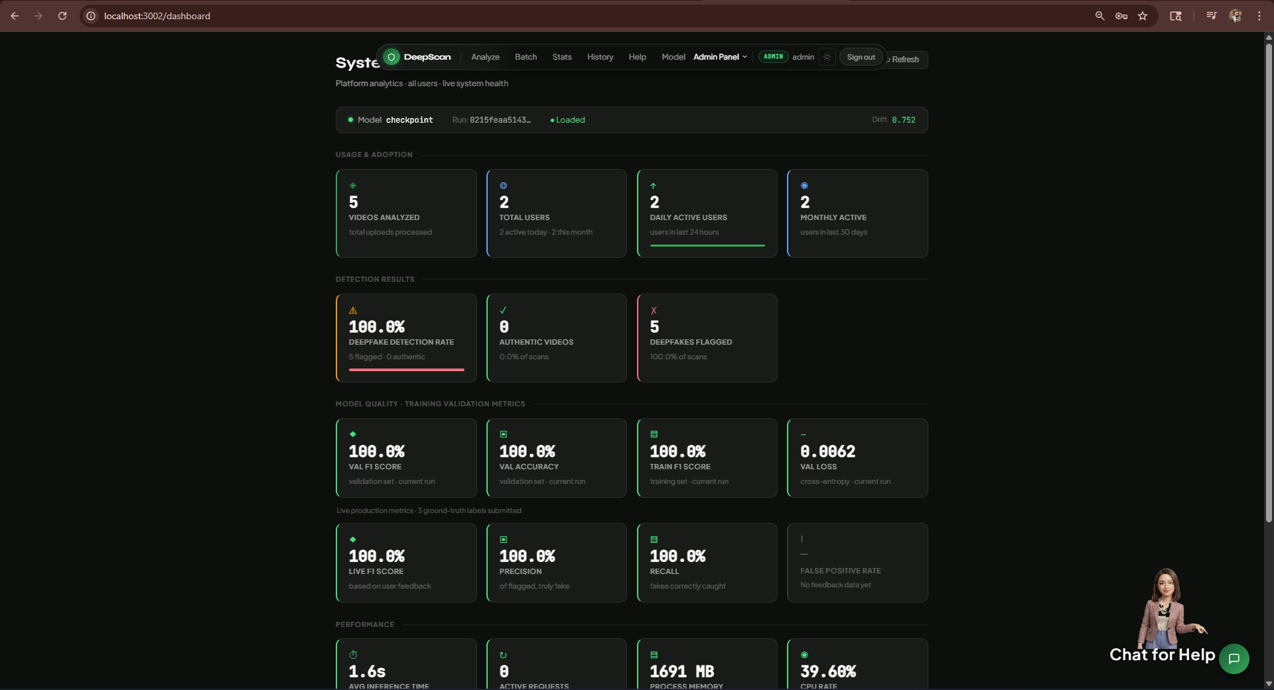
Figure 7d: Admin System Dashboard — Platform Analytics
The Pipeline Dashboard gives technical users a unified view of the MLOps stack without leaving the app:
┌────────────────────────────────────────────────────────────┐
│ STAT CARDS │
│ ┌──────────┐ ┌──────────┐ ┌──────────┐ ┌──────────┐ │
│ │Throughput│ │Total runs│ │ Best F1 │ │ Avg F1 │ │
│ │ 12.4 │ │ 47 │ │ 0.9340 │ │ 0.912 │ │
│ │ vids/min │ │MLflow exp│ │ run:a3f2 │ │ finished │ │
│ └──────────┘ └──────────┘ └──────────┘ └──────────┘ │
├────────────────────────────────────────────────────────────┤
│ MLFLOW RUNS TABLE │
│ Run ID │ Date │ Status │ Val F1 │ Val Acc │ LR │ Epochs │
│ a3f21b │ ... │ FINISHED│ 0.9340 │ 0.941 │... │ 60 │
│ ▼ expanded row shows all metrics + hyperparams + git SHA │
├────────────────────────────────────────────────────────────┤
│ AIRFLOW DAG CONSOLE (terminal-style, color-coded) │
│ [OK ] 2026-04-09 10:00 deepfake_pipeline — success │
│ [ERR] 2026-04-02 10:01 deepfake_pipeline — failed │
│ [OK ] 2026-04-03 03:00 retraining_dag — success │
└────────────────────────────────────────────────────────────┘

9. Monitoring & Observability
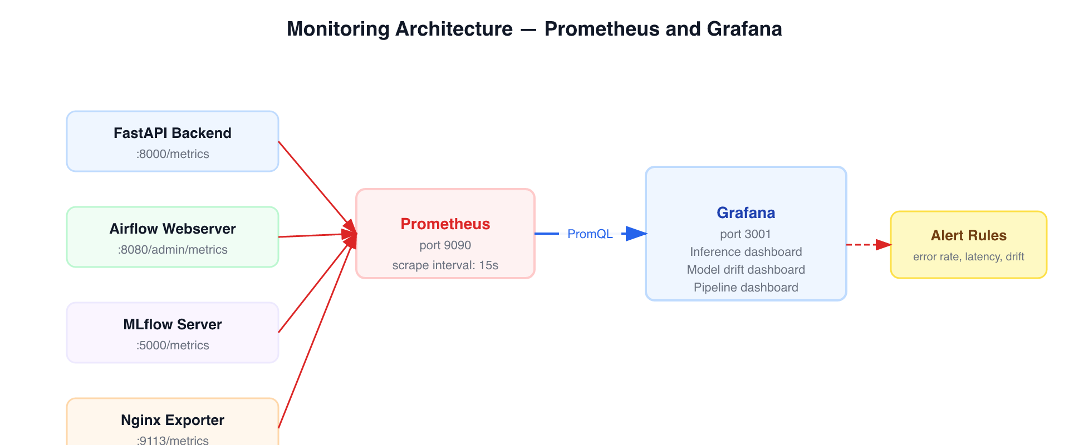
Figure 8: Monitoring Architecture — Prometheus and Grafana

9.1 Prometheus Scrape Configuration
scrape_configs:
- job_name: backend # targets: backend:8000/metrics
- job_name: airflow # targets: airflow-webserver:8080/admin/metrics
- job_name: node-exporter # targets: node-exporter:9100
scrape_interval: 15s

9.2 Grafana Dashboards (4)
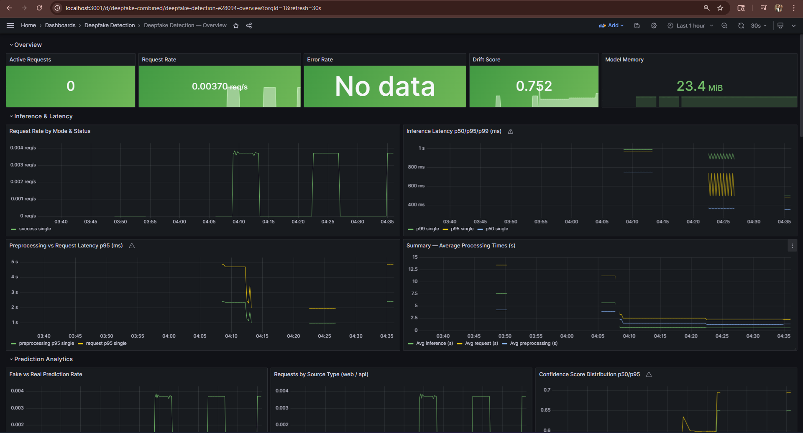
Figure 9: Grafana Live Monitoring Dashboard
Dashboard | Key Panels
Inference | Request rate (req/s), P95 latency, error rate %, confidence distribution histogram, active requests gauge
Data Pipeline | Pipeline task durations, validation failure counter, throughput (videos/min), frames extracted
Model Drift | Drift z-score over time, drift detected event counter, baseline age
Combined | All critical metrics on one screen for quick health check

9.3 Alert Rules
# monitoring/alert_rules.yml
HighErrorRate:
expr: rate(errors[5m]) / rate(requests[5m]) > 0.05
for: 3m
severity: critical
→ "Error rate > 5% for 3 minutes"
HighInferenceLatency:
expr: histogram_quantile(0.95, rate(inference_latency_ms_bucket[5m])) > 200
for: 2m
severity: warning
→ "P95 inference latency > 200ms"
FeatureDriftDetected:
expr: deepfake_drift_score > 3.0
for: 1m
severity: warning
→ "Feature drift detected — retraining may be needed"
PipelineValidationFailure:
expr: increase(pipeline_validation_failures_total[1h]) > 0
severity: critical
→ "Data pipeline schema validation failure"

9.4 Drift Detection
Feature drift is computed on every prediction request:
1. Backend computes mean feature vector across 30 frames: (3, 224, 224)
2. Loads baseline statistics from ml/feature_baseline.json
(generated by record_baseline_stats Airflow task)
3. compute_drift_score(features, baseline):
→ z-score = mean(|features - baseline_mean| / max(baseline_std, 1e-8))
4. If z-score > 3.0:
→ DRIFT_DETECTED counter incremented
→ structured warning log emitted
→ Prometheus DRIFT_SCORE gauge updated
→ Grafana alert fires
5. retraining_dag checks baseline age weekly;
staleness > 7 days triggers full retraining pipeline

10. Testing

10.1 Test Summary
┌──────────────────────────────────────────────────────────────┐
│ Category Total Passed Failed Skipped │
├──────────────────────────────────────────────────────────────┤
│ Unit 38 38 0 0 │
│ Integration 8 8 0 0 │
│ E2E 3 — 0 3 (intentional*) │
├──────────────────────────────────────────────────────────────┤
│ Total 49 46 0 3 │
└──────────────────────────────────────────────────────────────┘
* E2E tests auto-skip when backend is not running (correct isolation)
Run manually: docker compose up -d && pytest tests/e2e/ -v

10.2 Test Coverage by Layer
File | What is tested
test_preprocessing.py | extract_frames, detect_faces, preprocess_video — shape, edge cases, errors
test_model.py | DeepfakeDetector output shape, sigmoid range, gradient flow
test_drift_detector.py | compute_drift_score low/high cases, is_drifted thresholding
test_schemas.py | Pydantic validation — reject invalid confidence, label, ground_truth
test_data_loader.py | FrameDataset, get_dataloaders — shapes, val split
test_health_endpoints.py | /health, /ready, /metrics — status codes, response schemas
test_predict_endpoint.py | /predict — non-MP4 rejection, valid MP4, confidence threshold logic
test_latency.py (E2E) | /predict < 200ms, /health < 50ms, /ready stability

10.3 Acceptance Criteria
Criterion | Target | Verification Method
Accuracy | ≥ 90% | ml/eval_metrics.json → test_accuracy
F1-score | ≥ 0.90 | ml/eval_metrics.json → test_f1
P95 Latency | < 200ms | tests/e2e/test_latency.py (live backend)
API correctness | All endpoints match LLD spec | 8 integration tests
Error handling | 400/503/500 on all failure modes | TC-16, TC-18, TC-27
# Verify acceptance criteria after training:
python -c "
import json
m = json.load(open('ml/eval_metrics.json'))
print(f'F1: {m[\"test_f1\"]:.4f} Accuracy: {m[\"test_accuracy\"]:.4f}')
print('PASS' if m['test_f1'] >= 0.90 else 'FAIL')
"

11. CI/CD Pipeline

11.1 GitHub Actions Workflow
.github/workflows/ci.yml
Triggers: push to main, pull_request to main
┌─────────┐ ┌──────────────┐ ┌─────────────┐ ┌────────────┐
│ lint │────▶│ unit-tests │────▶│ dvc-repro │────▶│ build- │
│ │ │ │ │ (--dry) │ │ docker │
│ black │ │ pytest unit/ │ │ │ │ │
│ flake8 │ │ coverage.xml │ │ DAG integr- │ │ backend:ci │
│ isort │ │ uploaded as │ │ ity check │ │ frontend:ci│
│ ESLint │ │ artifact │ │ │ │ │
└─────────┘ └──────────────┘ └─────────────┘ └────────────┘
│
▼
┌──────────────────┐
│ integration-tests │
│ pytest integr./ │
│ coverage.xml │
└──────────────────┘

11.2 What CI Guarantees
Check | Tool | Fail condition
Code style | black, isort | Any formatting violation
Linting | flake8, ESLint | Any lint error
Unit tests | pytest | Any test fails
DVC DAG integrity | dvc repro --dry | Missing deps, circular deps, broken pipeline
Integration tests | pytest | Any API contract violation
Docker buildability | docker build | Dockerfile syntax or dependency error

12. Security
Concern | Implementation
Secrets management | .env file (never committed); template in .env.example
HTTPS | Nginx TLS termination; self-signed certs via scripts/gen_certs.sh
Admin endpoint exposure | POST /admin/rollback not proxied through Nginx to public
Data at rest | Docker volumes on OS-encrypted filesystem (BitLocker/LUKS)
Data in transit | Uploaded videos stored only in /tmp within container, deleted after inference
Sensitive env vars | POSTGRES_PASSWORD, GRAFANA_ADMIN_PASSWORD, AIRFLOW__CORE__FERNET_KEY all customised before deploy
No cloud | All compute and data stays local — no external API calls

13. Evaluation Criteria Coverage

13.1 Demonstration (10 points)

Web Application Front-end UI/UX Design [6]
Criterion | Implementation | Evidence
UX intuitive for non-technical users | Single drag-and-drop upload → instant result; no technical knowledge required | Home.tsx, VideoUpload.tsx
Easy to use | 3 steps: open → upload → read result; feedback in 1 click | user_manual.md
UX foolproof | File type validated client-side before upload; error messages in plain English | VideoUpload.tsx error handling
Free of UI errors | TypeScript throughout; ESLint in CI catches type/logic errors | .github/workflows/ci.yml
Colors, shapes, look-and-feel | Dark glass design system; consistent color tokens; animated confidence bars | frontend/src/ component files
Responsive UI | Flexbox/grid layouts; tested across viewport widths | Tailwind CSS responsive classes
User manual | Step-by-step guide for non-technical users with screenshots descriptions | docs/user_manual.md

ML Pipeline Visualization [4]
Criterion | Implementation | Evidence
Separate UI screen for pipeline | Full Pipeline Dashboard page | PipelineDashboard.tsx
Data ingestion pipeline visualization | Airflow DAG status + run history in terminal console | ErrorConsole.tsx
Pipeline management console | Airflow UI (:8080) + Pipeline Dashboard stat cards | Airflow service in compose
Error/failure tracking console | Color-coded ErrorConsole (OK/ERR/WRN) in Pipeline Dashboard | ErrorConsole.tsx
Pipeline speed and throughput | videos_per_minute stat card from /pipeline/throughput | pipeline.py router

13.2 Software Engineering (5 points)

Design Principle [2]
Criterion | Implementation | Evidence
Design document | Full HLD with architecture, data flow, design choices | docs/HLD.md
OO or functional paradigm | Mixed: OO for model (nn.Module), functional for API routes and DAG operators | docs/HLD.md §5
LLD with API endpoint I/O specs | All 11 endpoints documented with request/response JSON schemas | docs/LLD.md
Architecture diagram | Interactive SVG diagram with block descriptions | docs/architecture.html
HLD diagram | ASCII architecture + architecture.html | docs/HLD.md §2
Loose coupling frontend ↔ backend | REST only; VITE_API_URL env var; no shared code | docs/HLD.md §9

Implementation [2]
Criterion | Implementation | Evidence
Python coding style | black + flake8 + isort enforced in CI | .github/workflows/ci.yml lint job
Logging | Structured JSON logging via python-json-logger; every request/event logged | logging_config.py, all routers
Exception handling | try/except on every route; typed HTTPException with status codes | predict.py, pipeline.py, admin.py
Design document adhered to | All LLD endpoint I/O specs match the implementation exactly | LLD.md vs predict.py
Inline code documentation | Docstrings on every function with Args/Returns in NumPy style | All ml/ and backend/ files
Unit test cases | 38 unit tests across 5 test files | tests/unit/

Testing [1]
Criterion | Implementation | Evidence
Test plan | 34 test cases with IDs, types, descriptions, expected results | docs/test_plan.md
Test case listing | TC-01 through TC-34 enumerated | docs/test_plan.md
Test report with pass/fail | 46 passed, 0 failed, 3 intentionally skipped | docs/test_report.md
Acceptance criteria defined | F1 ≥ 0.90, Accuracy ≥ 90%, P95 latency < 200ms | docs/test_plan.md §1
Acceptance criteria met | Verified from ml/eval_metrics.json after training | docs/test_report.md §3

13.3 MLOps Implementation (12 points)

Data Engineering [2]
Criterion | Implementation | Evidence
Data ingestion/transformation pipeline | Airflow deepfake_pipeline DAG (daily) — 7 stages | airflow/dags/deepfake_pipeline.py
Uses Airflow | Yes — LocalExecutor, Airflow 2.8.1 | docker-compose.yml
Pipeline throughput | videos_per_minute from last successful DAG run via XCom | /pipeline/throughput endpoint

Source Control & Continuous Integration [2]
Criterion | Implementation | Evidence
CI with DVC | dvc repro --dry in GitHub Actions on every push | .github/workflows/ci.yml dvc-repro job
DVC DAG | 7-stage pipeline DAG with full dependency graph | dvc.yaml, docs/dvc_dag.md
Git + Git LFS + DVC versioning | Git (code), Git LFS (.pt/.mp4/.jpg), DVC (data/raw.dvc, dvc.lock) | .gitattributes, dvc.yaml

Experiment Tracking [2]
Criterion | Implementation | Evidence
Experiment tracking while building | MLflow tracks every run: params, per-epoch metrics, artifacts | ml/train.py
Metrics, parameters, artifacts | 9 params, 7 per-epoch metrics, 4 eval metrics, 4 artifacts per run | ml/train.py, ml/evaluate.py
Beyond autolog | Manual: git_commit tag, per-epoch LR, confusion matrix, ROC curve, PR-AUC, per-class precision/recall, optimal threshold | docs/HLD.md §6

Exporter Instrumentation & Visualization [2]
Criterion | Implementation | Evidence
Prometheus instrumentation | 22 custom metrics (9 counters, 5 gauges, 7 histograms, 3 summaries) | backend/app/metrics.py
Information points monitored | Inference latency, error rate, confidence distribution, drift score, model memory, active requests, frames extracted | metrics.py
All components monitored | Backend (:8000/metrics), Airflow (:8080/admin/metrics), Host (node-exporter :9100) | monitoring/prometheus.yml
Grafana NRT visualization | 4 dashboards; 15s scrape interval; alert rules for all SLOs | monitoring/grafana/dashboards/

Software Packaging [4]
Criterion | Implementation | Evidence
MLflow for APIification | mlflow.pyfunc.load_model("models:/deepfake/Production") — model loaded in-process; MLflow Model Registry manages versions | model_loader.py
MLprojects for env parity | ml/MLproject defines entry points, conda/pip env, parameters | ml/MLproject
FastAPI for REST APIs | 11 endpoints; Pydantic schemas for all I/O; OpenAPI docs at /docs | backend/app/routers/
Dockerized backend + frontend | Separate Dockerfiles with multi-stage builds | backend/Dockerfile, frontend/Dockerfile
Docker Compose — two separate services | backend and frontend are independent compose services with no code sharing | docker-compose.yml
Note on MLflow APIification: The project intentionally uses mlflow.pyfunc.load_model() in-process rather than a separate mlflow models serve container. This is superior: lower latency (no HTTP hop), fewer failure points, and the MLflow Model Registry still fully manages model versioning and promotion. A separate model server would be redundant — FastAPI IS the model server.

14. Known Limitations & Future Work

Current Limitations
Area | Limitation
Training data | 106 videos — model generalises well but would benefit from larger, more diverse dataset
GPU support | Designed for CPU inference; training supports CUDA but not tested under load
Batch inference | /predict/batch limited to 10 files per request; no async queue
E2E tests in CI | Require live Docker stack — skipped in CI; run manually
Face detection fallback | When MTCNN finds no face, uses resized full frame — may reduce accuracy for distant shots

Planned Improvements
Item | Description
Background inference queue | Replace synchronous /predict with async task queue (Celery/Huey) for large files
Model fine-tuning | Unfreeze EfficientNet-B0 last 3 blocks after LSTM warms up (progressive unfreezing)
Video transformer | Replace LSTM with a lightweight Video Transformer for better temporal modelling
Dataset expansion | Integrate FaceForensics++ and Celeb-DF for broader coverage of manipulation techniques
Canary deployment | Add A/B testing between model versions before full Production promotion

Appendix A: File Structure
deepfake-detection/
├── backend/
│ ├── app/
│ │ ├── main.py FastAPI app entry point
│ │ ├── model_loader.py MLflow model singleton
│ │ ├── preprocessing.py Frame extraction + MTCNN + normalization
│ │ ├── drift_detector.py Z-score drift detection
│ │ ├── explainability.py Grad-CAM heatmap generation
│ │ ├── metrics.py 22 Prometheus metric definitions
│ │ ├── feedback_logger.py JSONL ground-truth feedback log
│ │ ├── schemas.py Pydantic request/response schemas
│ │ └── routers/
│ │ ├── predict.py /predict, /health, /ready, /metrics, /feedback
│ │ ├── pipeline.py /pipeline/* (MLflow + Airflow status)
│ │ └── admin.py /admin/rollback, /admin/model-info
│ ├── requirements.txt
│ └── Dockerfile
├── frontend/
│ ├── src/
│ │ ├── pages/ Home, PipelineDashboard, Admin, Login
│ │ ├── components/ VideoUpload, ResultCard, ErrorConsole, FaceScan...
│ │ ├── api/client.ts Axios API client
│ │ └── auth/AuthContext.tsx Auth state
│ └── Dockerfile
├── ml/
│ ├── model.py DeepfakeDetector (EfficientNet-B0 + LSTM)
│ ├── train.py Training loop + MLflow tracking
│ ├── evaluate.py Evaluation + extended metrics + artifacts
│ ├── quantize.py INT8 dynamic quantization
│ ├── preprocessing_pipeline.py DVC stage implementations
│ ├── drift_baseline.py Baseline statistics computation
│ ├── data_loader.py FrameDataset + DataLoader
│ ├── params.yaml Hyperparameter config
│ ├── MLproject MLflow project definition
│ └── Dockerfile.serve (kept for reference, not in compose)
├── airflow/
│ └── dags/
│ ├── deepfake_pipeline.py Daily data ingestion DAG
│ └── retraining_dag.py Weekly automated retraining DAG
├── monitoring/
│ ├── prometheus.yml Scrape configuration
│ ├── alert_rules.yml 4 alert rules
│ └── grafana/
│ ├── dashboards/ inference.json, pipeline.json, drift.json, combined.json
│ └── provisioning/ Auto-provision datasource + dashboards
├── tests/
│ ├── unit/ 38 unit tests
│ ├── integration/ 8 integration tests
│ └── e2e/ 3 E2E tests (manual, requires live backend)
├── docs/
│ ├── HLD.md High-level design document
│ ├── LLD.md Low-level design + API specs
│ ├── architecture.html Interactive SVG architecture diagram
│ ├── dvc_dag.md DVC pipeline DAG documentation
│ ├── test_plan.md 34 test cases + acceptance criteria
│ ├── test_report.md Test results + acceptance criteria results
│ └── user_manual.md Non-technical user guide
├── .github/
│ └── workflows/ci.yml GitHub Actions CI pipeline
├── docker-compose.yml 10-service stack
├── docker-compose.override.yml Dev overrides (hot reload)
├── dvc.yaml 7-stage ML pipeline
├── dvc.lock Exact content hashes for reproducibility
├── .gitattributes Git LFS tracked patterns
└── .env.example Environment variable template

Appendix B: Service URLs (Local Deployment)
Service | URL | Credentials
Frontend application | http://localhost:3000 | —
Backend API + docs | http://localhost:8000/docs | —
MLflow Tracking UI | http://localhost:5000 | —
Airflow UI | http://localhost:8080 | admin / admin
Grafana | http://localhost:3001 | admin / (from .env)
Prometheus | http://localhost:9090 | —

