Which Sensors Bring a Drone Home?
GPS-Loss Path Retrace: Real Logs, Perfect Worlds, Live SITL
MTech Capstone Project, GPS-Denied Drone Navigation, IIT Madras
September 2026, branch optimal-retracement

Abstract
When a drone loses GPS, it must navigate home on sensors its flight controller logged before the outage. This paper measures which sensors matter. Six cumulative sensor sets (C1: gyro plus accelerometer, up to C6: adding compass, barometer, thrust, battery and zero-velocity updates) are tested three ways: replaying two real ArduPilot logs under 10/30/60 s simulated outages, ablating factors in a perfect analytic world, and flying a square live in PX4 SITL with raw and with perfect sensors. Gyro plus accelerometer alone retrace 801 m to 0.21 m when sensors are exact. On real logs the thrust-based drag model is the biggest win (30 s error 119 to 8.8 m). SITL repeats the ranking and proves the 50x scale gap is measured sensor dirt, not bad math: same square retraces to 6 mm with exact sensors.

1. The question in plain terms
Picture a quadcopter 500 m out when GPS dies. Two ways home exist. Dead reckoning: integrate gyro and accel from the last known fix and fly the resulting home arrow (Exp1). Breadcrumb reversal: re-fly the logged trail backwards, steering each step toward the next crumb (Exp2). Exp1 tests how fast position error grows. Exp2 tests whether pursuit converges despite that error. Both run without any GPS after the cutoff.
Jargon used below, defined once. Strapdown: attitude kept by integrating gyro in software, no gimbal. Tilt-compensated compass: yaw from magnetometer after removing roll/pitch tilt. ZUPT: zero-velocity update, trusting that near-zero speed means stopped. HDop: GPS geometry quality, lower is better. EKF: the onboard estimation filter fusing all sensors. OFFBOARD: PX4 mode following external setpoints. ATE: average trajectory error against truth. VRE: vibration-rectification bias, a DC shift shaking imprints on MEMS sensors.

2. Combos, gates, pass bars
Combos are cumulative: each adds one aid to the previous set. Gates pick clean GPS truth windows (HDop under 1.0, 10+ satellites, speed under 0.3 m/s for calibration). A 30 s run passes Exp1 under 2 percent drift (about 5 m on these legs); Exp2 passes under 5 m home miss.
Combo | Adds | Why it should help
C1 | gyro + accel (core) | minimum for any inertial navigation
C2 | + compass yaw | stops yaw random walk
C3 | + barometer | vertical channel otherwise drifts freely
C4 | + thrust drag model | rotor drag caps velocity error instead of double-integrating it
C5 | + battery current | thrust scaling when PWM saturates
C6 | + ZUPT | kills drift during genuine hover

3. Data and signals
Two ArduPilot DataFlash logs: Flight A (00000061.BIN, 48 MB) and Flight B (June 2026, 79 MB). Both carry IMU, magnetometer with hard-iron offsets, baro, GPS, attitude, motor PWM, throttle, vibration and battery at native rates. GPS is truth only; outages are simulated by withholding it. Flights differ in IMU quality, so results stay per flight. Two traps: attitude logs in degrees while everything else is radians, and the flights need separate reporting or pooling hides the mechanism.

4. Method

4.1 One core, three testbeds
A single quaternion strapdown core runs in all three testbeds, so differences in results come from data, not code. Static windows set gyro/accel biases, hover throttle and one compass offset, then the filter integrates attitude, rotates specific force, adds gravity and integrates velocity and position. Aids (compass 0.1 gain, baro 0.1 blend, drag damping, ZUPT) toggle by combo. Figure 1 shows the flow.
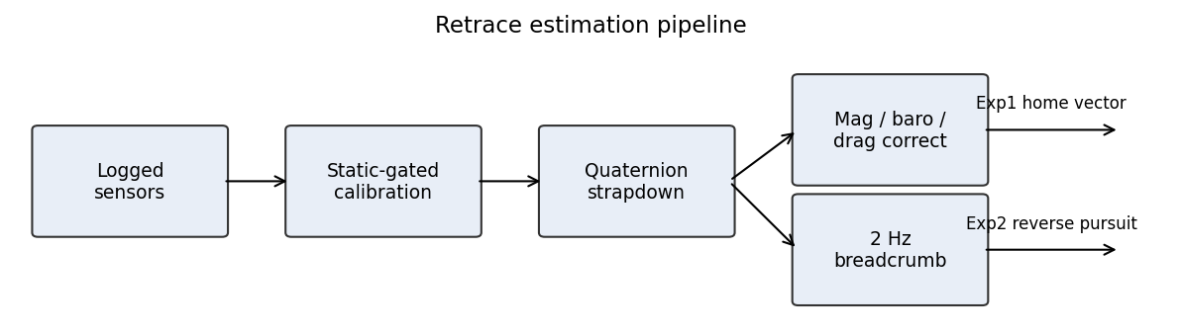
Figure 1. Retrace pipeline: calibration, propagation, per-combo aids, Exp1 forward vector and Exp2 reverse pursuit.

4.2 Offline replay (real logs)
For each log, clean GPS windows seed 60 s GPS-denied runs per combo, scored at 10/30/60 s horizons against gated GPS truth (72 rows total: 6 combos x 3 horizons x 2 flights x 2 experiments). Exp2 flies the stored 2 Hz trail backwards with combo-derived heading noise. Script: run_matrix.py.

4.3 Analytic optimal world (perfect sensors)
A 120 s scripted profile (hover, 8 m/s legs, banked 90 degree turns, climb, hover; 801 m) generates exact 100 Hz gyro, accel, mag, baro and thrust. Removal runs F1-F6 delete one factor each, so leftover error is pure information loss. Script: optimal_world.py.

4.4 Live SITL square (raw sensors)
PX4 SITL plus Gazebo Garden (taif_test4 world) plus MAVROS, flown as a 20 m square at 5 m (114.5 m; PX4 home miss 0.36 m). A commander node streams setpoints, engages OFFBOARD, arms and lands through MAVROS services. Takeoff is ramped because a step climb shook the sim IMU into a 10 s storm. The estimator node ports the core with three measured adaptations: FLU/ENU to FRD/NED conversion with full-attitude init, tilt-aware accel bias, and spike skipping over 25 m/s2 or 3 rad/s. One recorded bag replays per combo against odom truth with timestamp interpolation. Scripts: commander.py, retrace_node.py, replay_all.sh, RUN_SITL_LOOP.ps1.

4.5 SITL optimal control (perfect sensors, flown geometry)
Same square as 4.4, but sensors are machine-exact 100 Hz signals differentiated from the commanded profile (yaw fixed, cosine blends), not from noisy odometry. Same combos, same scorer. Any gap to 4.4 is sensor dirt by construction. Script: sitl_optimal.py.

5. Results

5.1 Perfect world: core pair suffices
Run | Missing | ATE (m) | Yaw err (rad) | Reading
F1 full | nothing | 0.21 | 0.00004 | baseline over 801 m
F4/F6 | compass / baro | 0.22 | 0.00000 | no loss
F2/F3 | gyro / accel | 232 / frozen | 0.075 / exact | each core sensor necessary
F5 | thrust proxy | 365 | exact | velocity aid matters even here

With exact sensors, gyro plus accel do everything and compass plus baro add nothing. Each core sensor is individually necessary. This is the information-content ceiling everything else is judged against.
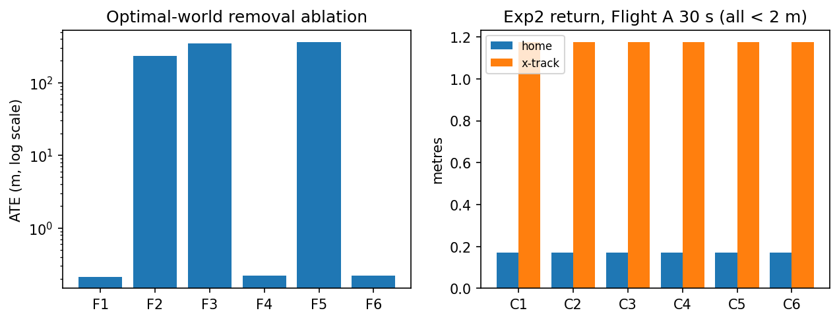
Figure 2. Optimal-world ablation, log scale (left); Exp2 return on Flight A 30 s leg (right).

5.2 Real logs: drag wins
Log/combo | ATE 10 s | ATE 30 s | ATE 60 s
A C1 (IMU) | 11.9 | 120.7 | 460.8
A C3 (+mag+baro) | 12.9 | 119.0 | 433.4
A C4 (+drag) | 4.3 | 8.8 | 14.8
A C6 (+ZUPT) | 3.9 | 4.9 | 7.3
B C1 (IMU) | 2.4 | 30.3 | 223.2
B C4 (+drag) | 1.7 | 11.4 | 43.1
B C6 (+ZUPT) | 0.3 | 0.6 | 7.4

Why drag wins: without it, velocity error integrates twice into position; with it, velocity error is capped, so position grows linearly instead of quadratically. Hence 13x on A at 30 s. Battery adds nothing anywhere. ZUPT needs real hover: 19x on B, nil on A. Two B runs pass the 5 m bar.
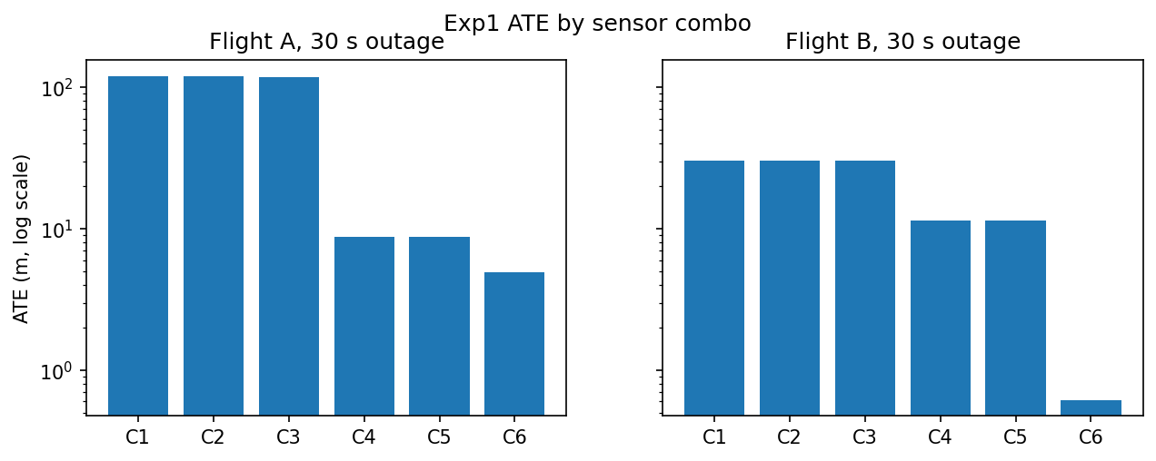
Figure 3. Exp1 ATE by combo, 30 s outage, log scale.
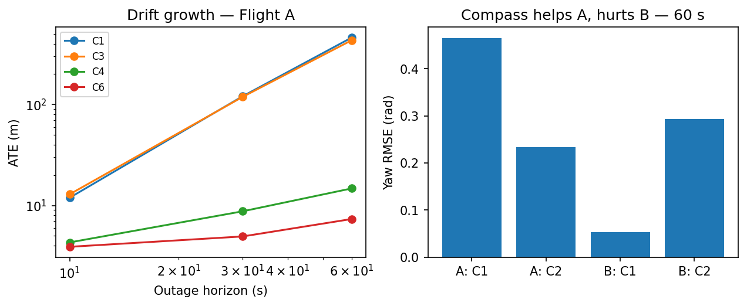
Figure 4. Drift growth with outage length (left); yaw error at 60 s (right).

5.3 Compass can hurt
Mechanism: compass corrects yaw drift but injects its own bias. On A (drifty gyro) the trade wins (yaw 0.47 to 0.23 rad). On B (superb gyro, 0.00 to 0.05 rad) an uncalibrated 0.3 rad mag bias loses (0.00 to 0.30 rad). Calibrate in the field or leave it out.

5.4 Breadcrumb always lands
Why: pursuit re-aims every step, so position error never compounds; only heading error matters. Home miss under 2 m and cross-track within 1.2 m for every combo on both flights (optimal: 0.02 m).

5.5 Raw SITL repeats the ranking at 50x scale
SITL combo (114 m) | ATE 3D (m) | Horiz (m) | Vert (m)
C1 (IMU) | 2690 | 2690 | 23.9
C2 (+mag) | 2677 | 2677 | 24.6
C3 (+baro) | 2665 | 2665 | 0.3
C4 (+drag) | 423 | 423 | 0.3

Same order as real logs: compass nil, baro fixes vertical only (24 to 0.3 m), drag cuts horizontal 6.3x. Scale differs for measured reasons: +0.46 m/s2 cruise rectification bias, aliasing spikes to 1137 m/s2 and 37 rad/s at 49 Hz, and EKF height wobble in truth. C5/C6 omitted deliberately (nil offline, no hover here). Do not quote SITL magnitudes as performance; quote the ranking.

5.6 Perfect SITL: 6 mm, case closed
Control combo (80 m) | ATE (m) | Home (m)
C1 (IMU) | 0.006 | 0.00
C3 (+baro) | 0.005 | 0.00
C4 (+drag) | 4.97 | 0.21
C6 (+ZUPT) | 4.99 | 0.00

Same geometry, exact sensors: 6 mm. Drag costs 5 m here only because the truth has no drag physics and stop-and-go corners keep it transient (long-cruise F1 costs 0.2 m). Raw-vs-perfect on identical geometry is 2690 m against 0.006 m. The gap is sensor dirt, and now it is a measured quantity rather than a suspicion.

6. Bugs found while testing
Five, each with a number attached. Degrees consumed as radians (57x; fix collapsed errors 10 to 20x). World-frame quaternion delta used as body rate (yaw 1.54 to 0.001 rad). Unwrapped yaw RMSE near 35 rad, fixed circularly. A tautological Exp2 scorer rebuilt as pursuit. SITL accel bias assumed level rest against 4 to 6 degrees of tilt, leaking about 1 m/s2 after the first turn; the fix rotates gravity by init attitude.
Limits: blind dead reckoning (8 to 43 m at 30 to 60 s) is still too poor to fly home on; breadcrumbs plus a velocity aid (flow or VIO) is the operational answer. Drag gain is untuned per airframe. Mag was not re-tested in SITL.

7. Conclusion
Log gyro and accel fast; they are necessary and sufficient when clean. Log motor commands; the drag model on them is the biggest real-world win here. Calibrate the compass or drop it. Keep baro and a 2 Hz breadcrumb trail. Analytic truth, two real logs and a live square all vote the same way.

References
- [1] ArduPilot, Dead Reckoning Failsafe, Copter documentation, ardupilot.org.
- [2] D. Titterton and J. Weston, Strapdown Inertial Navigation Technology, 2nd ed., IET, 2004.
- [3] P. Groves, Principles of GNSS, Inertial, and Multisensor Integrated Navigation Systems, 2nd ed., Artech House, 2013.
- [4] RIOTU Lab, gps_denied_navigation_sim: PX4 SITL and Gazebo GPS-denied benchmark, github.com/riotu-lab.

