GPS-Loss Path Retrace:
Which Sensors Bring a Drone Home?
September 2026, branch optimal-retracement

1. Objective
Find out which onboard sensors a quadcopter needs to get home after GPS fails. Two return strategies were tested.
Exp1 (dead reckoning): integrate gyro and accelerometer from the last known fix and fly the home arrow.
Exp2 (breadcrumb reversal): re-fly the logged 2 Hz trail backwards, steering toward each point in turn.
Six sensor sets ran through both, from IMU-only (C1) up to IMU plus compass, barometer, thrust, battery and zero-velocity updates (C6).
Set | Contains | Expected benefit
C1 | gyro + accel | baseline; minimum for inertial navigation
C2 | + compass yaw | stops yaw random walk
C3 | + barometer | holds the vertical channel
C4 | + thrust drag model | caps velocity error instead of double-integrating it
C5 | + battery current | thrust scaling at saturation (no effect found)
C6 | + ZUPT | kills drift while hovering

2. Setup
Same estimator core in all three testbeds, so result differences come from data, not code: a quaternion strapdown integrator with static-window calibration (biases, hover throttle, one compass offset), compass yaw blending, baro blending, rotor-drag damping and ZUPT.
Testbed 1: two ArduPilot logs (Flight A 48 MB, Flight B 79 MB) replayed under simulated 10/30/60 s outages against gated GPS truth (HDop < 1.0, 10+ sats), 72 runs total.
Testbed 2: a 120 s scripted profile (hover, 8 m/s legs, banked turns, climb; 801 m) with machine-exact 100 Hz sensors, deleting one factor at a time (F1-F6).
Testbed 3: a 20 m square at 5 m flown live in PX4 SITL (Gazebo taif_test4 + MAVROS, 114.5 m, PX4 home miss 0.36 m), replayed per combo through a ROS estimator node, plus a perfect-sensor rerun of the same square.
Scripts: run_matrix.py, optimal_world.py, sitl_optimal.py, commander.py, retrace_node.py, replay_all.sh, RUN_SITL_LOOP.ps1.
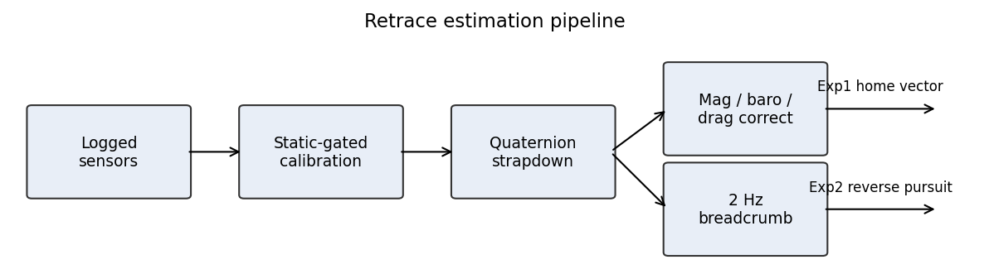
Figure 1. Signal flow: calibration, propagation, per-set aids, Exp1 vector and Exp2 pursuit.

3. Results

3.1 Perfect world (801 m, exact sensors)
Run | Removed | ATE (m) | Yaw err (rad) | Outcome
F1 full | nothing | 0.21 | 0.00004 | baseline
F4 / F6 | compass / baro | 0.22 | 0.00000 | no loss
F2 / F3 | gyro / accel | 232 / frozen | 0.075 / exact | each core sensor necessary
F5 | thrust proxy | 365 | exact | velocity aid matters even here

Takeaway: with exact sensors the core pair does everything. Each is individually necessary.
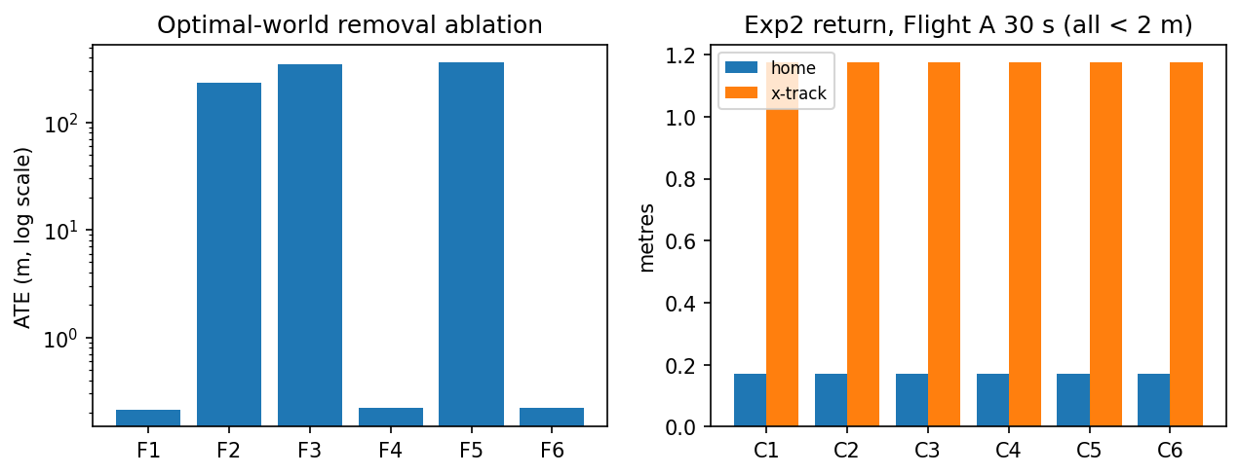
Figure 2. Removal ablation, log scale (left); Exp2 return on Flight A 30 s leg (right).

3.2 Real logs (ATE in metres)
Log/set | 10 s | 30 s | 60 s
A C1 (IMU) | 11.9 | 120.7 | 460.8
A C3 (+mag+baro) | 12.9 | 119.0 | 433.4
A C4 (+drag) | 4.3 | 8.8 | 14.8
A C6 (+ZUPT) | 3.9 | 4.9 | 7.3
B C1 (IMU) | 2.4 | 30.3 | 223.2
B C4 (+drag) | 1.7 | 11.4 | 43.1
B C6 (+ZUPT) | 0.3 | 0.6 | 7.4

Takeaways: drag is the biggest win (13x on A at 30 s) because capped velocity error grows position linearly instead of quadratically. Battery adds nothing. ZUPT needs real hover (19x on B, nil on A). Compass halves yaw error on A (0.47 to 0.23 rad) but an uncalibrated 0.3 rad bias hurts B (0.00 to 0.30 rad): calibrate or drop it. Breadcrumb return lands under 2 m for every set on both flights (optimal: 0.02 m) since pursuit re-aims each step.
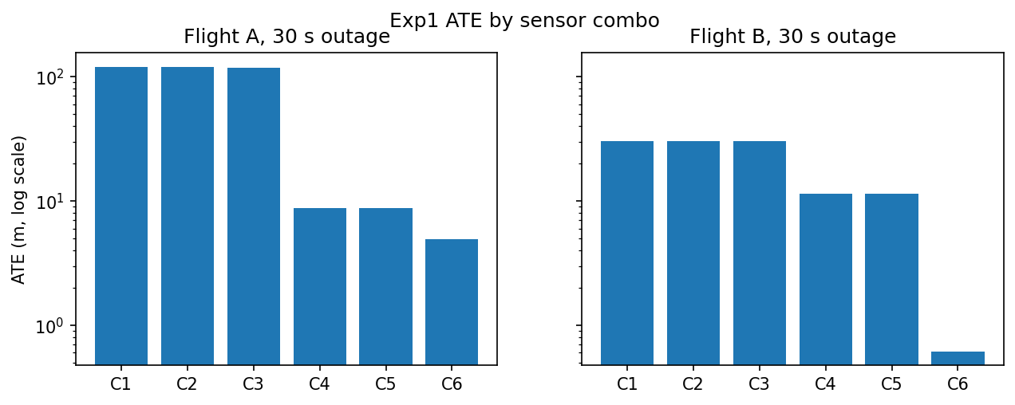
Figure 3. Exp1 ATE by set, 30 s outage, log scale.
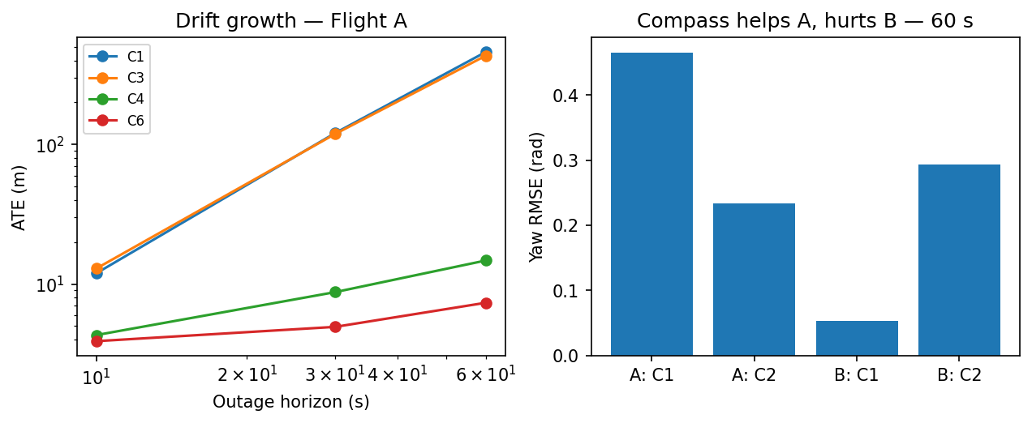
Figure 4. Drift growth with outage length (left); yaw error at 60 s (right).

3.3 Live SITL square, raw sensors (114 m)
Set | ATE 3D (m) | Horiz (m) | Vert (m)
C1 (IMU) | 2690 | 2690 | 23.9
C2 (+mag) | 2677 | 2677 | 24.6
C3 (+baro) | 2665 | 2665 | 0.3
C4 (+drag) | 423 | 423 | 0.3

Takeaway: identical ranking as real logs (compass nil, baro vertical-only 24 to 0.3 m, drag 6.3x), roughly 50x scale from measured sensor dirt: +0.46 m/s2 cruise rectification bias, spikes to 1137 m/s2 / 37 rad/s at 49 Hz, EKF height wobble. Quote the ranking, not the magnitudes. C5/C6 omitted (nil offline, no hover in square).

3.4 Same square, perfect sensors (80 m profile)
Set | ATE (m) | Home (m)
C1 (IMU) | 0.006 | 0.00
C3 (+baro) | 0.005 | 0.00
C4 (+drag) | 4.97 | 0.21
C6 (+ZUPT) | 4.99 | 0.00

Takeaway: 6 mm out of the same estimator on the same geometry. Raw-vs-perfect is 2690 m vs 0.006 m, so the gap is sensor dirt, measured. Drag costs 5 m here only because stop-and-go corners keep it transient against drag-free truth.

4. Issues faced and fixes
Issue | Symptom | Fix
ATT logged in degrees, read as radians | errors 10-20x too big | convert on load (57x factor)
World-frame delta used as body rate | yaw RMSE 1.54 rad | body-frame quaternion update (0.001 rad)
Yaw RMSE unwrapped | ~35 rad reported | circular RMSE
Tautological Exp2 scorer | perfect scores always | rebuilt as pursuit with heading noise
Arming checks set to -1 | PX4 never arms (always-fails compare) | lenient 10.0 + save
MAVROS transmit to dead port | services unusable | fcu_url to onboard listener 14580
Pymavlink direct TX dead | takeoff never happens | MAVROS-native commander, service calls
Instant 0-5 m takeoff step | 10 s IMU storm, 92% gyro saturation | ramped 0.5 m climb
FLU/ENU vs FRD/NED mix | live estimate 1097 m off | boundary conversion + full-attitude init
Level-rest bias vs 4-6 deg tilt | ~1 m/s2 leak after first turn | rotate gravity by init attitude
Sim-time replay pitfalls | teleporting tracks, skipped cal | wall clock, -r 1, MAVROS dead, one publisher, topic-filtered play

SITL also degrades on the ground: EKF GPS drift re-fails preflight after about ten minutes, so reboot PX4 and fly fast. MAVROS IMU at 49 Hz carries the vibration of the sim motors; the estimator skips samples over 25 m/s2 or 3 rad/s with time carried forward.

5. Conclusion and next steps
- Log gyro and accel fast; they are necessary and sufficient when clean.
- Log motor commands; the drag model on them is the biggest real-world win measured here (13x).
- Calibrate the compass or drop it.
- Keep baro and a 2 Hz breadcrumb trail.
- Analytic truth, two real logs and a live square all agree.

