**NoSQL DATABASE FOR IMPLEMENTING E-COMMERCE APPLICATION**

*Submitted by*

***Rohit Pandey***

***Reg. No. 21352046***

***M.C.A (3rd Semester)***

*Project phase – Design Phase review*

**CSCA513 - Mini Project**

*Under the guidance of*

**Dr. Pothula Sujatha**

**Associate Professor**



**DEPARTMENT OF COMPUTER SCIENCE**

**SCHOOL OF ENGINEERING AND TECHNOLOGY**

**PONDICHERRY UNIVERSITY**

**PUDUCHERRY- 605014**

**SEPTEMBER 2022**

* **Abstract**

E-Commerce (Electronic Commerce) is process of doing business through computer networks. A person sitting on his chair in front of a computer can access all the facilities of the Internet to buy or sell the products. Unlike traditional commerce that is carried out physically with effort of a person to go and get products, e-commerce has made it easier for human to reduce physical work and to save time.    E-Commerce which was started in early 1990’s has taken a great leap in the world of computers, but the fact that has hindered the growth of e-commerce is security. Security is the challenge facing e-commerce today & there is still a lot of advancement made in the field of security.

The project objective is to deliver the online shopping application. This project is an attempt to provide the advantages of online shopping to customers of a real shop. It helps buying the products in the shop anywhere through internet by using a web site. Thus the customer will get the service of online shopping and home delivery from this shop. This system can be implemented to Sai Supermarket in the locality. If shops are providing an online portal where their customers can enjoy easy shopping from anywhere, the shops won’t be losing any more customers to the trending online shops such as flipkart or eBay. Since the application is available in the given site it is easily accessible and always available.

* **Introduction**

**What is e-commerce -** E-commerce is a term for any type of business, or commercial transaction that involves the transfer of information across the Internet. It covers a range of different types of businesses, from consumer based retail sites, through auction or music sites, to business exchanges trading goods and services between corporations. It is currently one of the most important aspects of the Internet to emerge. There are six types of E-commerce website.

**Business-to-consumer (B2C):** Probably the most familiar to the average person, a B2C site enables an exchange of goods or services between a business and a consumer, such as buying a T-shirt from your favourite online shop.

**Business-to-business (B2B):** A B2B platform facilitates electronic transactions between two businesses. If you own a company that sells T-shirts, for example, you might buy those shirts from an online wholesaler.

**Business-to-administration (B2A):** A B2A site facilitates electronic exchanges between an organization and a public institution, like the website of a company that designed your city’s web portal, for instance.

**Consumer-to-consumer (C2C):** A C2C site, often known as a marketplace, hosts an exchange of goods between 2 or more consumers. Examples include websites like Etsy and eBay.

**Consumer-to-business (C2B):** On a C2B site, individuals offer goods or services to businesses. This could be a freelance SEO expert who works with companies in a certain industry or an influencer paid to promote a company’s products.

**Consumer-to-administration (C2A):** Similar to B2A, this type of site allows a consumer to provide information, goods, or services to public administration and governmental organizations—think paying a parking ticket on your city’s web portal.

**How e-commerce works -** The consumer moves through the internet to the merchant's web site. From there, he decides that he wants to purchase something, so he is moved to the online transaction server, where all of the information he gives is encrypted. Once he has placed his order, the information moves through a private gateway to a Processing Network, where the issuing and acquiring banks complete or deny the transaction. This generally takes place in no more than 5-7seconds.There are many different payment systems available to accommodate the varied processing needs of merchants.

* **Analysis**

Nowadays, E-commerce is really the name of the game. If we don't have an e-commerce website or online store to sell your products, we should create one right now.

Not only is this a great way to sell to a larger audience, but we are also able to gain valuable data about which products interest them, which ad was the more successful, which search engine they used, and way more information about your audience's interests and behaviour.

And to track our e-commerce site's metrics (like conversion rate, customer retention, checkout data, etc...) we need an all-in-one analytics report like the ones Dash this got for us!

* **Proof and Customer Reviews**

One of the most important elements of any online store is proof that your product or service is really good. And one of the strongest things that can confirm this is customer reviews. According to Graham Charlton, 61 percent of customers read online reviews before making a purchasing decision. Consumers are more likely to buy things from websites that have reviews and ratings. These sites have real value for people. That’s why online retailers should encourage their customers to leave feedback and share comments.

* **Context and Good Visualization**

Several of our chat participants noticed that the website clearly describes the products it sells. It uses images of dogs that are nice-looking and that attract people, especially their target audience.

* **A Clear CTA**

Even if your online store looks great and your pages load quickly, visitors still might not add products to their carts. Maybe the problem is that they simply don’t know what to click on. But a call-to-action button tells users where to go, where to click and what to do.

* **Delivery Information**

Another important factor is your delivery information and options. These details play a major role in many customers’ decision to purchase something on the internet. It’s great when an online store provides next-day or expresses delivery and flexible delivery slots.

The cost of delivery is also a crucial factor; online retailers should ensure that their shipping rates charges are easy for users to find.

Also, it’s better to provide a return option, as most people who buy things in online stores expect this.

* **A Handy Menu With Images**

Some of our chat participants also mentioned Waggle’s handy menu, which includes pictures. It’s segmented by categories, such as “dog apparel,” “safety gear,” “toys,” “accessories” and others. Waggle’s menu is easy to find, and it has a clear structure that includes categories and subcategories. There’s also a “quick view” button on every item. When you click it, a window with product details pops up.

* **Models of the system**
* **Menu**
* **Login**
* **Registration**
* **Category**
* **Category List**
* **Product List**
* **Category Management**
* **Product Browsing**
* **Shopping Cart**
* **Checkout**
* **Auto Generated Bill**
* **Payment**
* **Order shipping detail**
* **System requirements**
* **Languages**
* **NodeJs**
* **ExpressJs**
* **JavaScript**
* **HTML**
* **CSS**
* **Tools**
* **Ui_Material**
* **CryptoJS**
* **VScode**
* **Backend**
* **MongoDB**

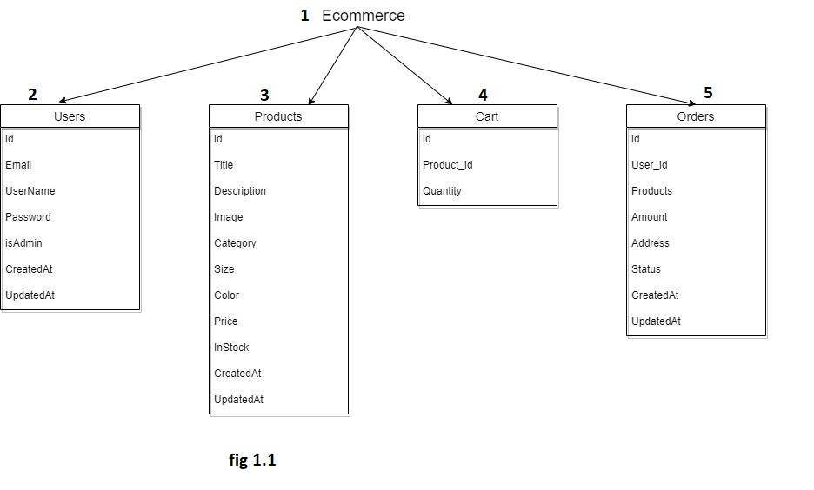

* **In figure 1.1 the actors and artefacts are described as follows**

1. There is Ecommerce Database, which having four rows to store all the data of our website
2. There is User table for store our customer and Admin details, it has seven rows to store all the details of particular person.
3. There is Products table to store all products details, it has eleven rows to carry all the details of a particular product.
4. There is cart table which will store cart details, it has three rows to store all details of a cart.
5. There is Orders table to store all details of an order, it has eight rows to store all the details of any particular order.

* **UML diagram**

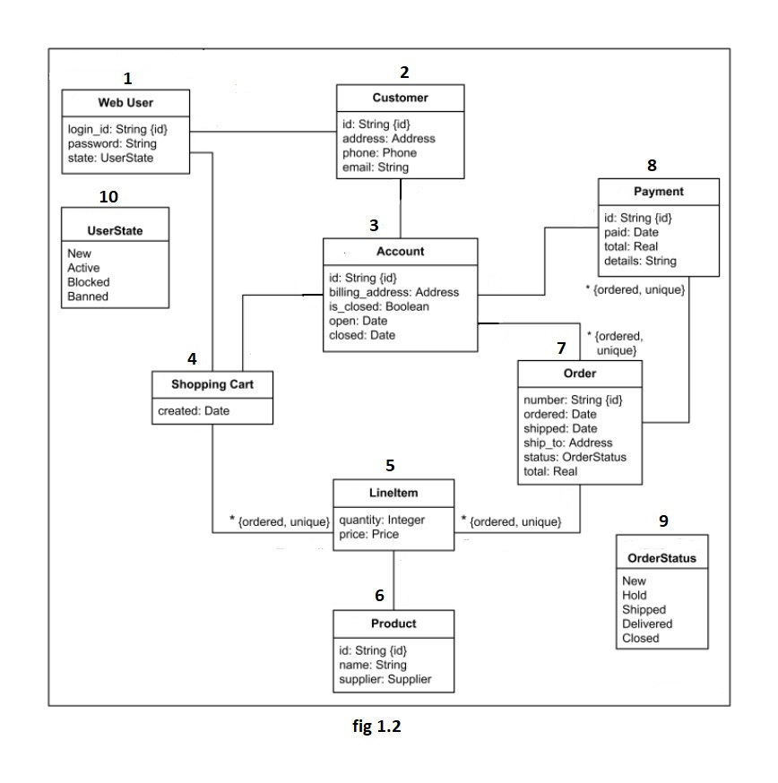

* **In figure 1.2 the actors and artefacts are described as follows**

1. **Web User –** There is web for Admin, it has three attributes Login id, Password and status. Status to know whether admin is active or not.
2. **Customer –** thereis customer, it has four attributes Login id, Email id, phone no and address**.**
3. **Account –** There is account, every customer having their own account in that there is four attributes id, billing address, open_date and close_date.
4. **Shopping cart –** there is shopping card for storing the product whatever customer will add in cart it has only one attribute cart created date.
5. **LineItem –** There is LineItem for storing the product details whichever customer has added in cart it has two attributes quantity and price
6. **Product –** There is product for storing the particular product details there is three attributes product id, product name and seller name.
7. **Order –** There is order for storing the order details it has six attributes order id, order date, shipping date, shipping address, order status, total price.
8. **Payment –** There is payment for storing the details of all payments it has four attributes payment id, paid date, total paid amount and details.
9. **Other status –** There is other status for storing other details it has five attributes new, hold, shipped, delivered, closed.
10. **User State –** There is user state for knowing the user is active or not it has four attributes new, active, blocked and banned.

___________________

Mentor In-Charge

**Dr. Pothula Sujatha**

Associate Professor

Department of Computer Science,

School of Engineering & Technology,

Pondicherry University