PROJECT
Of
Web Technology Lab (22CSH-282)
Subject Code: 22CSH-282

Digital Quote Generator

Submitted By:  [Student Name]  [Roll Number]  [Section] | Submitted To:  [Professor Name]  Department of CSE

University Institute of Computing
Chandigarh University, Gharuan, Mohali

INDEX
S.No. | Topic | Page No.
1 | Abstract | 3
2 | Code of the Project | 4
3 | Output / Screenshots | 7

1. Abstract
Project Title: Digital Quote Generator

The "Digital Quote Generator" is a lightweight web-based mini project designed to provide users with random inspirational or motivational quotes at the click of a button. The application is built using core front-end technologies: HTML for structure, CSS for styling and responsive layout, and JavaScript for dynamic content generation and interaction logic.
The user interface displays a quote along with its author. A "New Quote" button fetches a new random quote from a pre-defined list. This project demonstrates fundamental concepts of DOM manipulation, event handling, and basic array data storage. It can be easily extended to fetch quotes from an external API or database.
The project is visually clean, mobile-responsive, and serves as a practical example of integrating HTML, CSS, and JavaScript to create a functional and interactive tool.

2. Code of the Project
Filename: quote_generator.html

<!DOCTYPE html>
<html lang="en">
<head>
<meta charset="UTF-8">
<meta name="viewport" content="width=device-width, initial-scale=1.0">
<title>Digital Quote Generator</title>
<style>
* { margin: 0; padding: 0; box-sizing: border-box; }
body {
font-family: 'Segoe UI', Tahoma, Geneva, Verdana, sans-serif;
background: linear-gradient(135deg, #667eea 0%, #764ba2 100%);
min-height: 100vh;
display: flex; justify-content: center; align-items: center;
padding: 20px;
}
.quote-container {
background-color: white; border-radius: 20px; padding: 40px 30px;
max-width: 700px; width: 100%;
box-shadow: 0 20px 40px rgba(0, 0, 0, 0.2);
text-align: center; transition: transform 0.3s ease;
}
.quote-container:hover { transform: scale(1.02); }
h1 { color: #764ba2; margin-bottom: 25px; font-size: 2rem; }
.quote-text { font-size: 1.6rem; line-height: 1.4; color: #333;
margin-bottom: 20px; font-style: italic; min-height: 120px;
display: flex; align-items: center; justify-content: center; }
.quote-author { font-size: 1.2rem; color: #764ba2; font-weight: 600; margin-bottom: 30px; }
.btn { background: linear-gradient(135deg, #667eea 0%, #764ba2 100%);
color: white; border: none; padding: 12px 28px; font-size: 1rem;
border-radius: 50px; cursor: pointer; transition: all 0.3s ease; }
.btn:hover { transform: translateY(-3px); }
footer { margin-top: 30px; font-size: 0.75rem; color: #aaa; }
</style>
</head>
<body>
<div class="quote-container">
<h1>✨ Quote Generator ✨</h1>
<div class="quote-text" id="quoteDisplay">
"The only limit is your mind."
</div>
<div class="quote-author" id="authorDisplay">— Anonymous</div>
<button class="btn" id="newQuoteBtn">New Quote</button>
<footer>Click the button for daily inspiration</footer>
</div>
<script>
const quotes = [
{ text: "The only way to do great work is to love what you do.", author: "Steve Jobs" },
{ text: "Life is what happens when you're busy making other plans.", author: "John Lennon" },
{ text: "In the middle of difficulty lies opportunity.", author: "Albert Einstein" },
{ text: "Believe you can and you're halfway there.", author: "Theodore Roosevelt" },
{ text: "The future belongs to those who believe in the beauty of their dreams.",
author: "Eleanor Roosevelt" },
{ text: "It does not matter how slowly you go as long as you do not stop.",
author: "Confucius" },
{ text: "Happiness is not something ready made. It comes from your own actions.",
author: "Dalai Lama" }
];
function getRandomQuote() {
return quotes[Math.floor(Math.random() * quotes.length)];
}
function displayNewQuote() {
const q = getRandomQuote();
document.getElementById("quoteDisplay").innerHTML = '"' + q.text + '"';
document.getElementById("authorDisplay").innerHTML = '— ' + q.author;
}
document.getElementById("newQuoteBtn").addEventListener("click", displayNewQuote);
window.addEventListener("DOMContentLoaded", displayNewQuote);
</script>
</body>
</html>

3. Output (Screenshots/Results)
The following screenshots demonstrate the working output of the Digital Quote Generator. The application loads with a random quote on startup and displays a new quote each time the "New Quote" button is clicked.

Screenshot 1 – Quote Display (John Lennon)
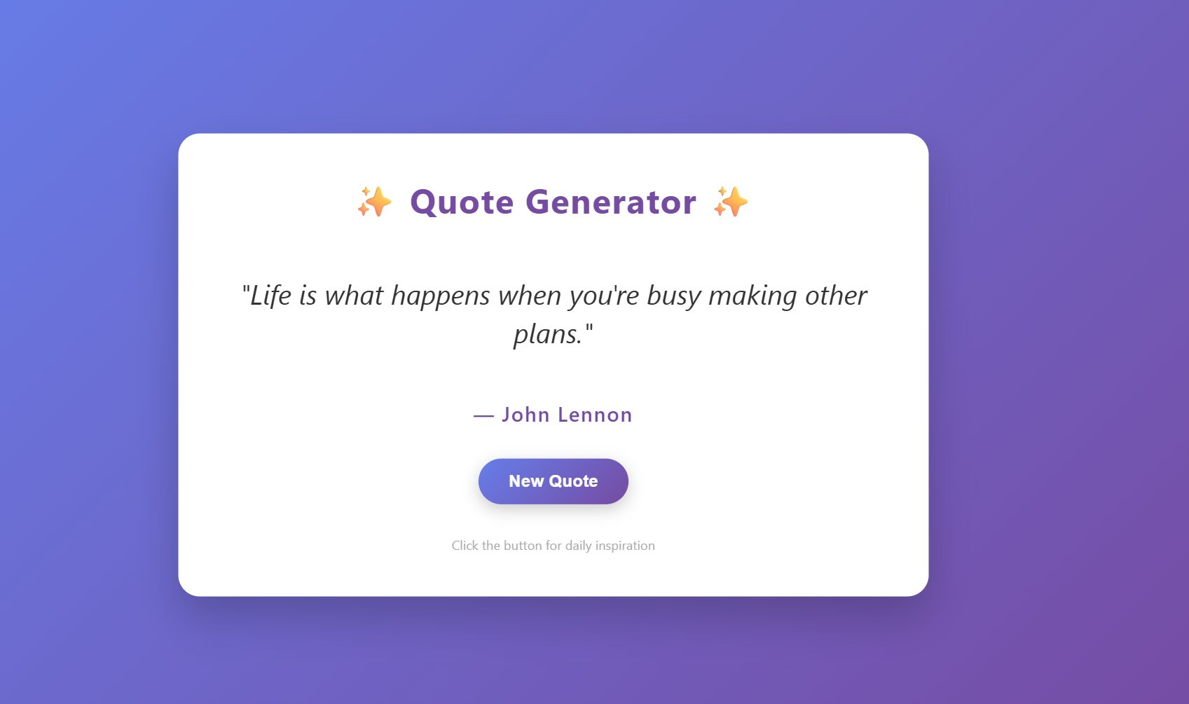
Fig 1: Quote Generator displaying a quote by John Lennon

Screenshot 2 – Quote Display in Browser (William James)
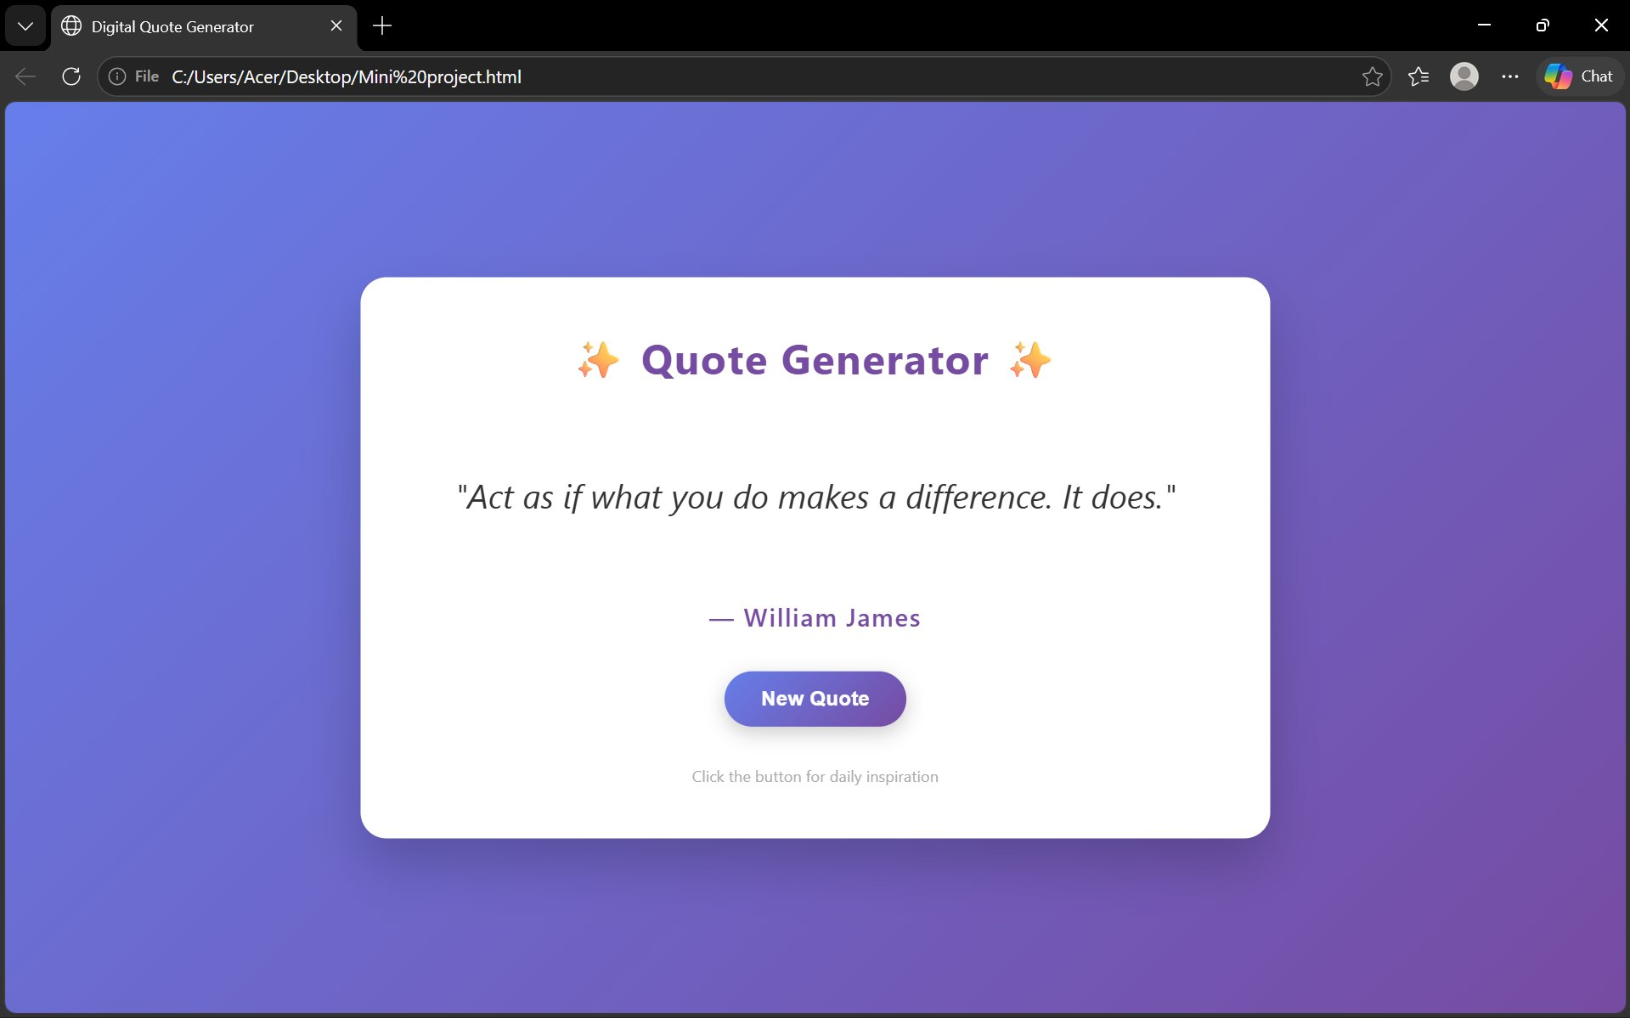
Fig 2: Quote Generator running in Microsoft Edge browser showing a William James quote

