CHAPTER 1
INTRODUCTION

Chapter 1
INTRODUCTION
1.1. Problem Definition
Secret Message Transmitter for Defence Outposts will be a system completely dedicated to the soldiers of our country. In today’s world of enmity between the neighbouring countries, it’s very evident to protect our international borders. When the soldiers guarding the outposts, need to communicate, they communicate over the radio signals over the walkie-talkies, which are prone to be intruded with. In view of that, this system is designed to be hack efficient, and to provide them with a transmitter which does the work secretly. The person sitting on the other end of the border will think it as an electricity fluctuation and thereby transmitting the message secretly over the air using just the lights.

1.2. Purpose and Scope
In this system, we can input the message and send it to the processor board which will in-turn send it to the person sitting at the other outpost. The main purpose of this project is to provide security to the soldiers while sending crucial, mission-critical messages to their peers. The system is designed to be hack proof, because we are implementing Wi-Fi to send the data to the processor, and if anyone wants to hack the wifi signal, they’ve to come in the radius of 10m which is nearly impossible with our brave hearted soldiers. The scope of this project will surround the defence outposts of B.S.F or the Indian Army and help them with their day-to-day operations for vigilance.

1.3. Definitions and Acronyms
The Raspberry is the central controlling board which helps in overall functioning. The different definitions related to our project are:
1.3.1.- Light Source : A laser is a device that emits light through a process of optical amplification based on the stimulated emission of electromagnetic radiation. We are going to implement the light to send the message. The light source we are going to use would be a laser light. We can even use LED bulb to do the same.
1.3.2.- Photo-resistor/Camera : A photo-resistor is a small device to capture the intensity of Lux present in the light source. Same like a camera, it will be used to get the coded message from the sender’s side.

1.3.3.- WiFi : Wi-Fi is technology for radio wireless local area networking of devices based on the IEEE 802.11 standards. Devices that can use Wi-Fi technologies include desktops and laptops, video game consoles, smartphones and tablets, smart TVs, digital audio players, cars, and modern printers. Wi-Fi compatible devices can connect to the Internet via a WLAN and a wireless access point.
1.3.4.- LiFi : Li-Fi is a technology for wireless communication between devices using light to transmit data and position. In its present state only LED lamps can be used for the transmission of visible light. The term was first introduced by Harald Haas during a 2011 TEDGlobal talk in Edinburgh. In technical terms, Li-Fi is a visible light communications system that is capable of transmitting data at high speeds over the visible light spectrum, ultraviolet and infrared radiation.

1.4. Advantages
Our system has several advantages
- User friendly interface
- Encoded message, hard to understand
- Hack Proof
- Android Application
- Bravely fools anyone who thinks of intruding
All the difficulties faced during the transmission of a message securely, is overcome by the implementation of our system, hence it’s very future-worthy too.

1.5. History
1.5.1.- Morse Codes : Morse Code Alphabet was invented by Samuel F. B. Morse as a way of communicating over a telegraph. Each character in the Military Morse Code is represented by a series of dots (“.”) and dashes (“-“). The invention of wireless telegraphy enabled Morse’s system of dots and dashes to play a key role in 20th- century ship-to-shore communication. Morse code was extensively used for early radio communication beginning in the 1890s. In the early part of the twentieth century, the majority of high-speed international communication was conducted in Morse code, using telegraph lines, undersea cables, and radio circuits. In 1999 the last four stations that communicated with ships by Morse code signed off the air.

1.5.2.- Morse Code Transmission : Morse code can be transmitted in a number of ways: originally as electrical pulses along a telegraph wire, but also as an audio tone, a radio signal with short and long tones, or as a mechanical, audible, or visual signal (e.g. a flashing light) using devices like an Aldis lamp or a heliograph, a common flashlight, or even a car horn. Some mine rescues have used pulling on a rope - a short pull for a dot and a long pull for a dash. Morse code is transmitted using just two states (on and off). Historians have called it the first digital code. Morse code may be represented as a binary code, and that is what telegraph operators do when transmitting messages. Morse messages are generally transmitted by a hand-operated device such as a telegraph key, so there are variations introduced by the skill of the sender and receiver — more experienced operators can send and receive at faster speeds.

1.5.3.- Telegraph Key : A telegraph key is a specialized electrical switch used by a trained operator to transmit text messages in telegraph systems, usually in Morse code. Keys are used in all forms of electrical telegraph systems, such as landline or "wire" electrical telegraphy, and "wireless", or radio telegraphy. An operator taps on the switch, connecting and disconnecting the electrical circuit, creating electrical pulses of two different lengths called "dots" and "dashes", to spell out text messages in code.
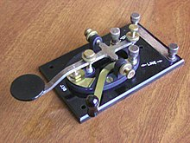

Fig.1.1.- A straight key style of telegraph key – model J38

1.6. Future of Morse Codes
Morse Codes are getting continuous technological advancements. From being sent over wire to being sent over light, it is getting improved over decades. Morse Codes are of great importance for military and secret communications. The future of this is very bright even after being a very old technology to send messages. We and also the people in today’s world, are finding different ways to send the messages secretly over a distance by introducing limits of privacy. It is and has to be of major importance for secret messaging.

Chapter 2
LITERATURE SURVEY

Chapter 2
LITERATURE SURVEY
2.1. Base Paper
2.1.1. Design and Implementation of Line Follower Robot
Generally, the line follower robot is one of the self- operating mobile machines that follows a line drawn on the floor. The path can be a visible black line on a white surface (reverse). The basic operations of the line follower are as follows:
1. Capturing the line position with optical sensors mounted at the front end of the robot. Most are using several numbers of photo-reflectors, and some leading contestants using an image sensor for image processing. Therefore, the line sensing process requires high resolution and high robustness.
2. Steering the robot to track the line with any steering mechanism. This is just a servo operation; actually, any phase compensation will be required to stabilize tracking motion by applying digital PID filter or any other servo algorithm.
3. Controlling the speed according to the lane condition. The speed is limited during passing a curve due to the friction of the tire and the floor. Better mechanisms, therefore, can improve the power of manoeuvre. The speed of the robot, hence, can be increased. Consequently, the robot's performance can be increased, too This kind of robot can be used for military purposes, delivery services, transportation systems, blind assistive applications. On the there hand, there are many annual line follower robots competitions organized by universities or industries around the world. They usually ask robotic teams for building a small robot with specific dimensions and weight according to the competition rules. Actually, the line follower robots are a perennial favourite of the small robot builder but definitely the tricky part is to make the line follower fast and smooth in its response.

2.1.2. Obstacle Avoidance Robot
Obstacle avoidance is a primary requirement of any autonomous mobile robot. Obstacle avoidance Robot is design to allow robot to navigate in unknown environment by avoiding collisions. Obstacle avoiding robot senses obstacles in the path,avoid it and resumes its running.
There are some very famous methods for robot navigation like wall-following, edge detection, line following. One of the commercial systems uses wall- following method on a floor cleaning robot for long hallways. A more general and commonly employed method for obstacle avoidance is based on edge detection. A disadvantage with obstacle avoidance based on edge detecting is the need of the robot to stop in front of an obstacle in order to provide a more accurate measurement. All mobile robots feature some kind of collision avoidance, ranging from primitive algorithms that detect an obstacle and stop the robot in order to avoid a collision, using some sophisticated algorithms, that enable the robot to detour obstacles. The latter algorithms are more complex, since they involve detection of an obstacle as well as some kind of quantitative measurements concerning the obstacle's dimensions. Once these have been determined, the
obstacle avoidance algorithm needs to steer the robot around the obstacle and resume motion toward the original target. In this paper the steering algorithm ensures that the robot does not have to stop in front of an obstacle during its navigation.Hence the robots may overcome some of the problems during navigation, which are discussed above and it can navigate smoothly during its operation avoiding the collisions. We have presented a basic algorithm and design which can be further improved depending upon the required applications. The project proposes a autonomous robotic vehicle, In which no remote is used for controlling the robotic actions. It intelligently detects obstacles present on its path through the sensors, avoid it and take decision on the basis of internal code that we set for it. The detail information is given in the following subtopics which will help you to understand the whole system and its design.

2.2 Reference paper
2.2.1 Improved BCM Obstacle Avoidance Algorithm
Security patrol robot running on the road in senior residential areas, warehouses, factories and other high safety requirements environment, mainly fulfill the tasks of the mobile monitoring and intelligent anomaly detection. Autonomous patrol is the basis to accomplish these tasks and local obstacle avoidance is the reactive behavior as a guarantee of complete autonomous patrol. This paper mainly studies the problem of local obstacle avoidance for outdoor security patrol robot using low cost ultrasonic ranging sensor. At present, in the normal mobile robot obstacle avoidance system, mainly based on the target plane cataract ranging the obstacle distribution information in the 2D plane acquired from ranging sensors and robot running direction, the angular velocity and linear velocity are calculated to drive the robot. The artificial potential field method proposed by Khatib, is effective for processing obstacle avoidance in global path planning, but easy to fall into local optimum and make the robot in the trap. Borenstein et al proposed a vector field method (VFH) , by controlling the speed and direction, which has good effective of obstacle avoidance, but this method requires high detection precision and is not very easy to apply in practice. Velocity space method which takes the dynamic model of the robot into account , chooses the suitable linear velocity and angular velocity . The curvature velocity method (CVM) describes the local obstacle avoidance problem as a constrained optimization problem in the velocity space, and selects optimized speed command to satisfy all the constraints by the objective function, which makes robot to avoid obstacles successfully, and run more smoothly and faster. Based on CVM, presents a roadway curvature method (LCM) . In this method the environment is divided into a plurality of road way, according to the distribution of obstacles and a wide channel is chose that provides more secure direction for CVM. The problem of LCM is difficult to detect the pathway that is represented as a sudden rotation in the experiment. Therefore, Fernandez proposed a beam curvature method (BCM). BCM adopts a double-layer structure in which the environment is divided into several sectors and the linear and angular velocities are calculated by CVM according to the corresponding optimal sector. Compared with LCM, BCM can discover the new channel more easily while the disadvantage is the high computational complexity and the low real-time performance. However, these algorithms are based on obstacle distribution detected in the twodimensional plane, so that they can not deal with the hanging obstacles.

2.2.2 High-Performance Line Following Robot
Basically, line following robot achieves the objective of following the line through feedback. Sensors, placed over the line, send different signals, to the microcontroller, depending upon their position over the line. Sensors consist of sender and receiver. The sender can be infrared LED (Light Emitting Diode), LED, LASER (Light Amplification by Stimulated Emission of Radiation) diode, etc. while the receiver can be photodiode, phototransistor, LDR (Light Dependent Resistor), etc. The sender sends a signal which gets reflected from the surface of the path to be followed and then incidents at the receiver. Now, different
color has different absorptivity for the incident signal from the sender so the signal going towards the receiver, after the reflection, will have a different intensity. In this way sensors for line following robot work.
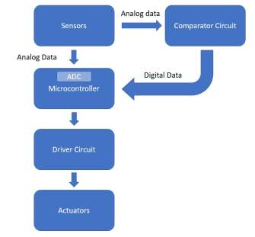

Fig 2.1 Schematic Block Diagram of Basic Line Following Robot

Microcontroller compares this signal to the ideal value, the value which sensors give when the robot is at the desired place on the line. Depending upon the difference between ideal value and actual value, the microcontroller generates a signal which is applied to the driver circuit. the performance of line following
robot heavily depends upon sensors as they generate an input signal for microcontroller depending upon their position over the line to be followed.

2.4. Domains
2.4.1.Arduino Uno
Arduino is an open-source computer hardware and software company, project and user community that
designs and manufactures micro controller-based kits for building digital devices and interactive objects
that can sense and control objects in the physical world. The heart of Arduino is the micro controller. For
Arduino Uno ATmega328 is used.It has specification of 8 bit CPU, 16 MHZ clock speed, 2 KB SRAM
32 KB flash Memory, 1 KB EEPROM .
Features :-
• 14 digital input output pins ( 3,5,6,9,10 and 11 pins are able to generate PWM).
• 6 analog input pins
• Voltage input from the 7 – 12 V
The Arduino Uno is a micro controller board based on the ATmega328 (datasheet). It has 14 digital input/output pins (of which 6 can be used as PWM outputs), 6 analog inputs, a 16 MHz crystal oscillator, a USB connection, a power jack, an ICSP header, and a reset button. It contains everything needed to support the micro controller; simply connect it to a computer with a USB cable or power it with a AC-to DC adapter or battery to get started.


Fig.2.4.- Raspberry PI Logo
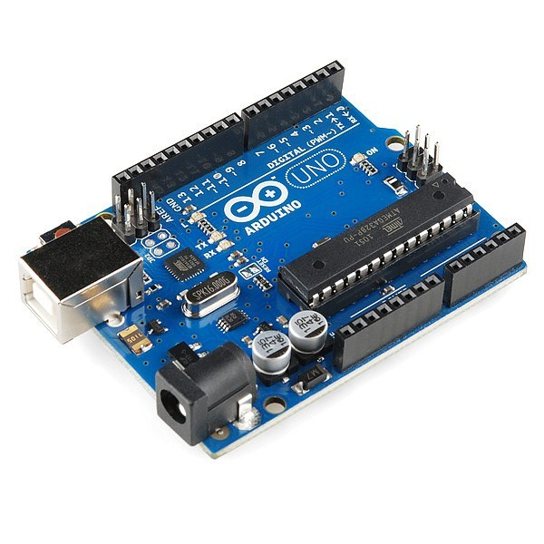

Fig.2.5.- The Arduino Uno

2.4.2. IOT- Internet of Things
The Internet of things (IoT) is the network of physical devices, vehicles, home appliances, and other items embedded with electronics, software, sensors, actuators, and connectivity which enables these things to connect, collect and exchange data.
IoT involves extending Internet connectivity beyond standard devices, such as desktops, laptops, smartphones and tablets, to any range of traditionally dumb or non-internet-enabled physical devices and everyday objects. Embedded with technology, these devices can communicate and interact over the Internet, and they can be remotely monitored and controlled. Defining the Internet of things as "simply the point in time when more 'things or objects' were connected to the Internet than people", Cisco Systems estimated that IoT was "born" between 2008 and 2009, with the things/people ratio growing from 0.08 in 2003 to 1.84 in 2010.
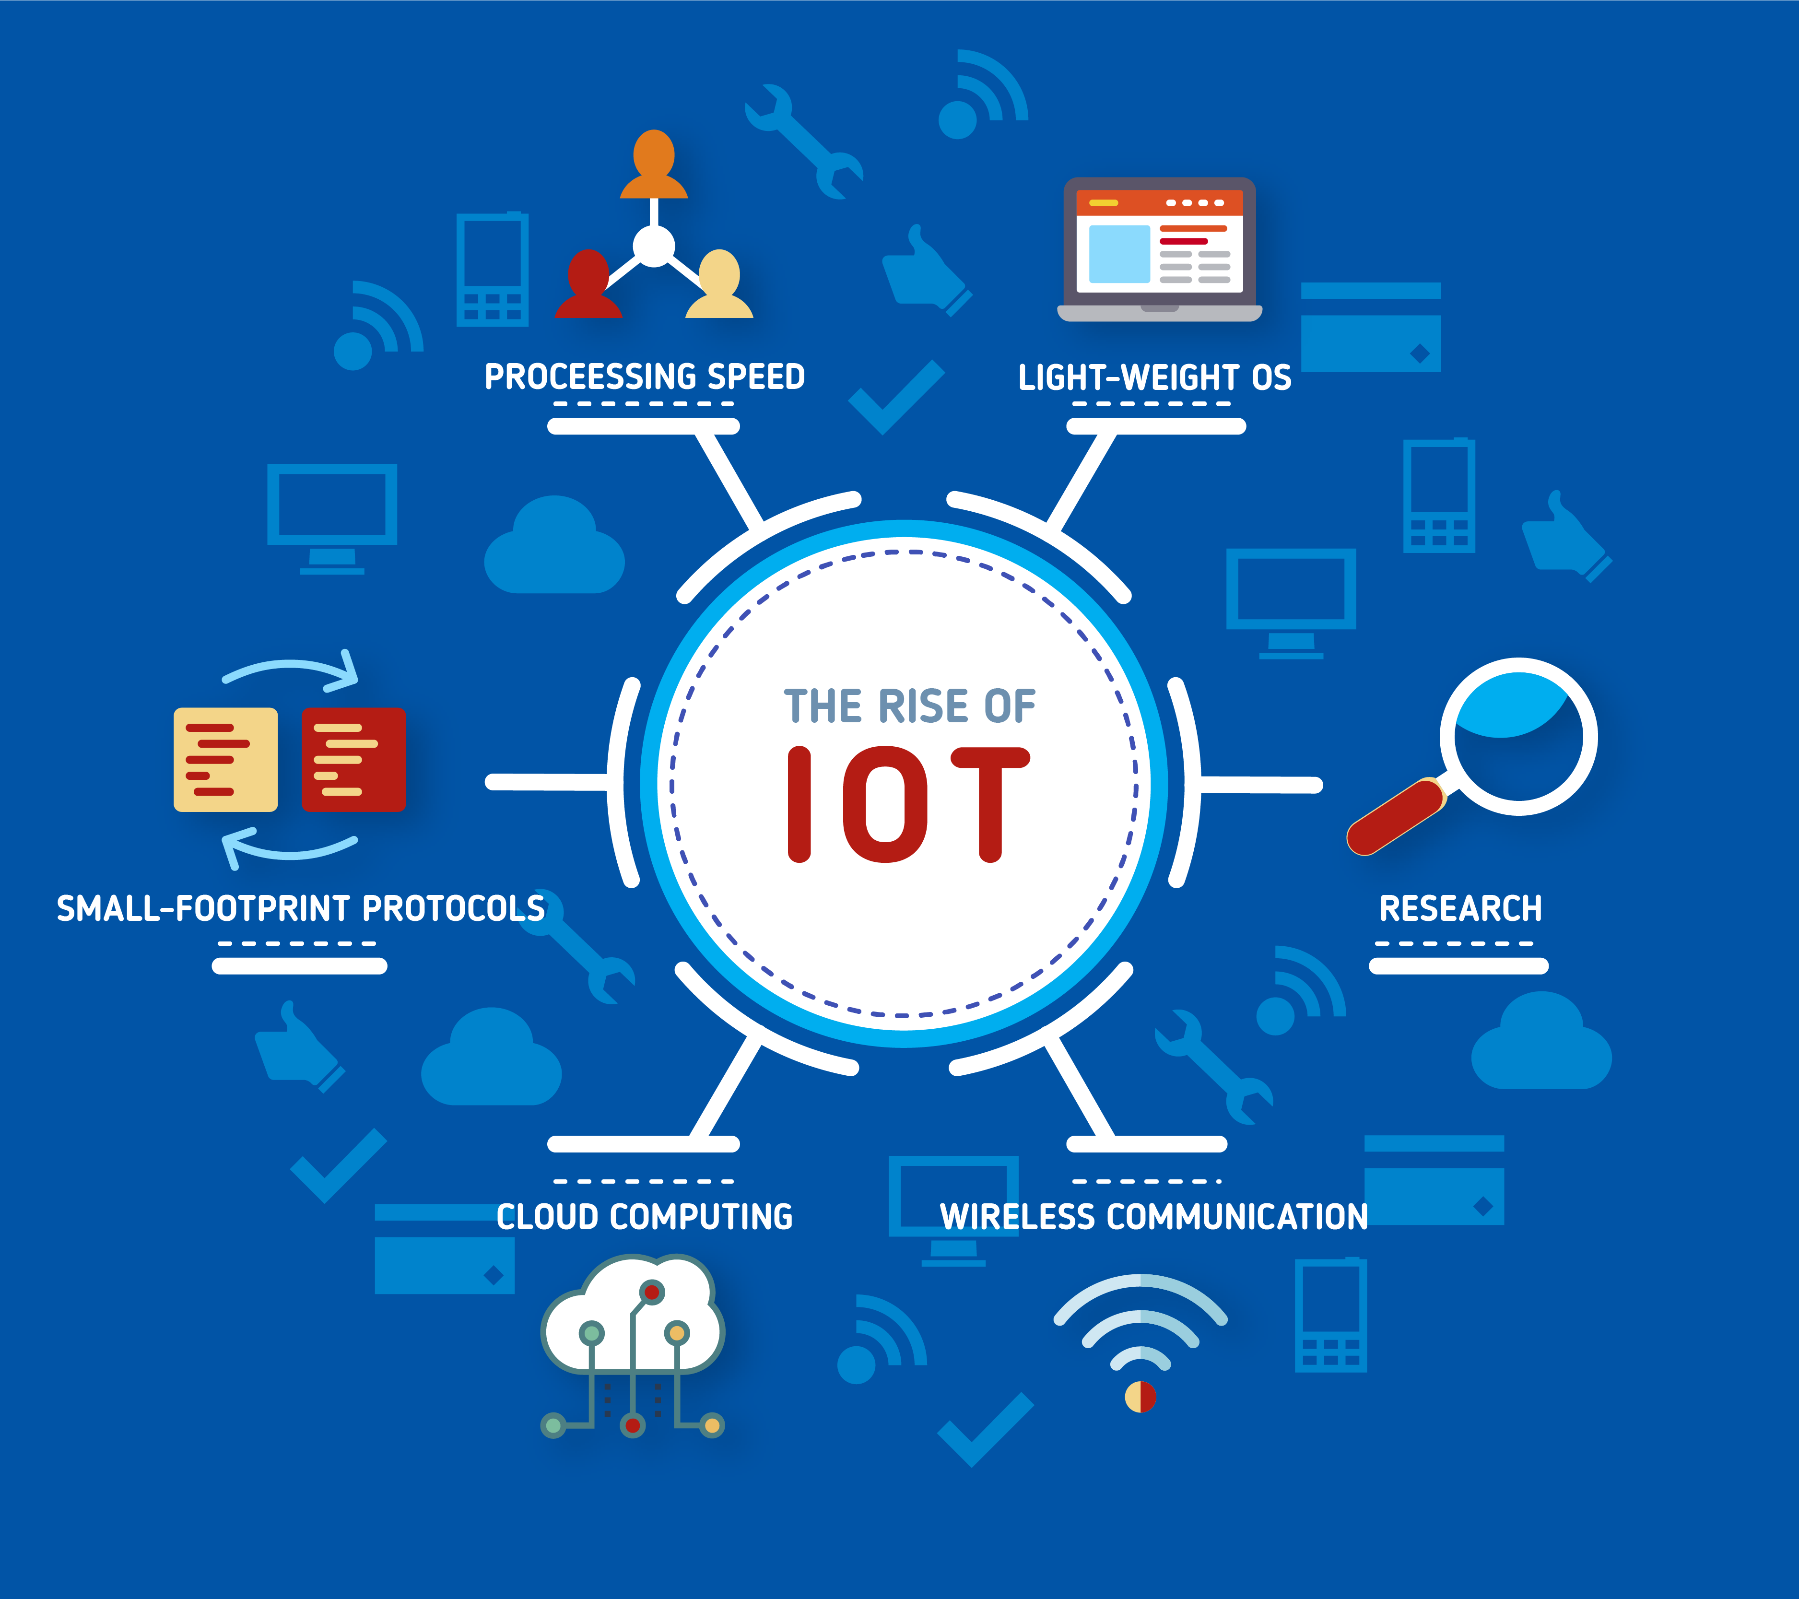
Fig.2.6- Internet of Things
2.5. Programming Languages
2.5.1. C
C is a general-purpose, imperative computer programming language, supporting structured programming, lexical variable scope and recursion, while a static type system prevents many unintended operations. By design, C provides constructs that map efficiently to typical machine instructions, and it has therefore found lasting use in applications that were previously coded in assembly language. Such applications include operating systems, as well as various application software for computers ranging from supercomputers to embedded systems.
C was originally developed at Bell Labs by Dennis Ritchie, between 1972 and 1973. It was created to make utilities running on Unix. Later, it was applied to re-implementing the kernel of the Unix operating system. During the 1980s, C gradually gained popularity. Nowadays, it is one of the most widely used programming languages, with C compilers from various vendors available for the majority of existing computer architectures and operating systems. C has been standardized by the American National Standards Institute (ANSI) since 1989 (see ANSI C) and subsequently by the International Organization for Standardization (ISO). C is an imperative procedural language. It was designed to be compiled using a relatively straightforward compiler, to provide low-level access to memory, to provide language constructs that map efficiently to machine instructions, and to require minimal runtime support. Despite its low-level capabilities, the language was designed to encourage cross-platform programming. A standards-compliant C program that is written with portability in mind can be compiled for a wide variety of computer platforms and operating systems with few changes to its source code; the language has become available on various platforms, from embedded microcontrollers to supercomputers.


Fig.2.7.- The C programming language

2.5.2. C++
C++ is one of the most popular languages primarily utilized with system/application software, drivers, client-server applications and embedded firmware.
The main highlight of C++ is a collection of predefined classes, which are data types that can be instantiated multiple times. The language also facilitates declaration of user-defined classes. Classes can further accommodate member functions to implement specific functionality. Multiple objects of a particular class can be defined to implement the functions within the class. Objects can be defined as instances created at run time. These classes can also be inherited by other new classes which take in the public and protected functionalities by default.
C++ includes several operators such as comparison, arithmetic, bit manipulation and logical operators. One of the most attractive features of C++ is that it enables the overloading of certain operators such as addition.

A few of the essential concepts within the C++ programming language include polymorphism, virtual and friend functions, templates, namespaces and pointers.



Fig.2.8.- C++ programming language

CHAPTER 3
SYSTEM REQUIREMENTS SPECIFICATION

CHAPTER 3
SYSTEM REQUIREMENTS SPECIFICATION
In this chapter we discuss the hardware and software requirements for the system. The feasibility has also been discussed in the chapter, which indicates the feasibility of this project in the market.
3.1. Software Requirements
- Operating System
- C++ programming language.
- Arduino Uno IDE

3.2. Hardware Requirements
These are the requirements to be fulfilled in order to run the model and to successfully send the message as defined.
- Processor : Intel core i3
- CPU : 2.10GHz
- RAM : 4GB
- Micro-controller : Arduino Uno
- Sensors : Infra-red and Ultra-sonic
- Relay
- Motors: DC
- Switch
- Pump
- Motor regulater

3.3. Feasibility Study
The feasibility of the project is analyzed in this phase and business proposal is put forth with a very general plan for the project and some cost estimates. During system analysis the feasibility study of the proposed system is to be carried out. This is to ensure that the proposed system is not a burden to the company. For feasibility analysis, some understanding of the major requirements for the system is essential.
Three key considerations involved in the feasibility analysis are-
• Economic Feasibility
• Technical Feasibility
• Social Feasibility

3.3.1. Economic Feasibility
This study is carried out to check the economic impact that the system will have on the organization. The amount of fund that the company can pour into the research and development of the system is limited. The expenditures must be justified. Thus the developed system as well within the budget and this was achieved because most of the technologies used are freely available. Only the customized products had to be purchased.

3.3.2. Technical Feasibility
This study is carried out to check the technical feasibility, that is, the technical requirements of the system. Any system developed must not have a high demand on the available technical resources. This will lead to high demands on the available technical resources. This will lead to high demands being placed on the client. The developed system must have a modest requirement, as only minimal or null changes are required for implementing this system.

3.3.3. Social Feasibility
The aspect of study is to check the level of acceptance of the system by the user. This includes the process of training the user to use the system efficiently. The user must not feel threatened by the system, instead must accept it as a necessity.
The level of acceptance by the users solely depends on the methods that are employed to educate the user about the system and to make him familiar with it. His level of confidence must be raised so that he is also able to make some constructive criticism, which is welcomed, as he is the final user of the system.

CHAPTER 4
DESIGN AND IMPLEMENTATION

CHAPTER 4
DESIGN AND IMPLEMENTATION
This section consists of the structural diagram and description of the system, that is, the overall connection being used in this system.
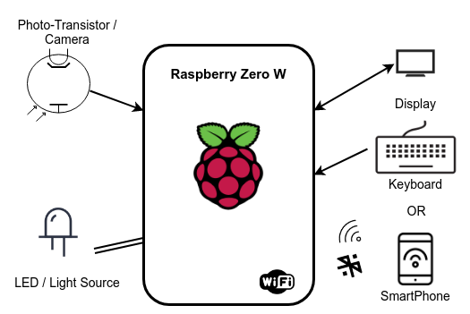
Fig:- 4.1- Structural Diagram for the System
Above is the structural diagram of our system. It contains the Raspberry microcontroller, connected over wire with the Camera and the LED Bulb and wirelessly to a smartphone. The smartphone is also Wi-Fi enabled and sends the data to the raspberry using the Wi-Fi module on the controller. It consists of this simple architecture, and helps in such a complex message transmission using the visual light. Raspberry has the Wi-Fi module installed on it, and also the ports to connect the LED and the Camera. It also contains USB port, using which we can connect any USB device as well.

4.1. General Structure
The system contains the components mentioned in the architecture diagram. The different components interact with each other to give us a proper functioning system to achieve our desired goals. The different entity in our system are :
4.1.1. Raspberry Zero W - This is our main board which will be doing the core functionalities. It will interact with other components through wired and wireless connection. With wire to the laser module and the photoreceptor and wirelessly with the mobile or sender medium.

4.1.2. Smartphone/ Keyboard - This will be our sender medium, and will be used to send the messages to the raspberry, where it’ll be converted to coded message and sent over the light medium.

4.1.3. Laser and Photoreceptor module - These are the message transferrers for our system. They will be used to send and receive the messages through light medium respectively.
4.2. Procedural Approach
Our designed system will follow the procedural approach and there are different modules which will be used to provide different functionalities. We will be calling these modules as and when required depending upon the process calls by different functions. The different modules which will be present in the system are listed below.

4.2.1. Lasercontrol - This module written in python will be the one, responsible to analyze the codes received from the raspberry board, and then use the same to blink the laser/led. This blink would represent the message we want to send.

4.2.2. Receiver - This module will be responsible to take the captured data from the photoreceptor and process it to get the signal data based on the lux change value. After this the next, signal_processor module will be called to do the further functions.

4.2.3. Signal_processor - This module is responsible to get the signal chart from the Receiver and then convert it back to the required text. This will be called after the signal has been processed by the previous Receiver module.
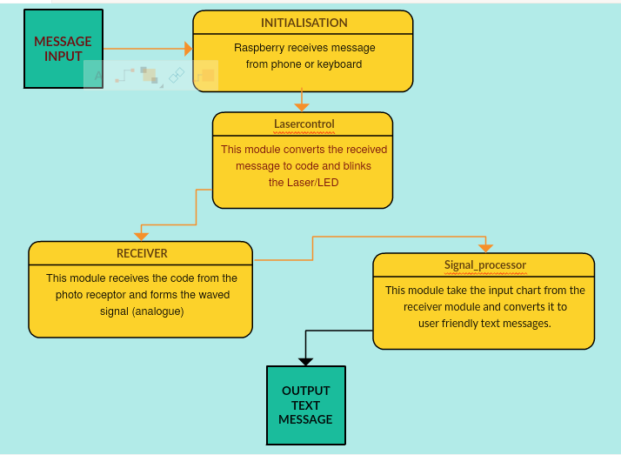
Fig.-4.2. Data Flow Diagram of the proposed system
The data flow diagram depicts how the process is flowing in our system, mentioned in the boxes are the different modules through which our main input text will pass through. Finally form the input message we had sent in the start, we’ll get the same text message at the end, that is, the Output text message.
4.3. Object Oriented Approach
Object-oriented design is the process of planning a system of interacting objects for the purpose of solving a software problem. It is one approach to software design. In our system, we are mainly using the Python programming language which is of course and object oriented programming language. Hence we’ve followed the OOD approach in our codes too. Total code is divided into different modules which perform the different functionalities as mentioned in the previous section. The modules have different classes present in them which work in accordance with the OOD concepts.

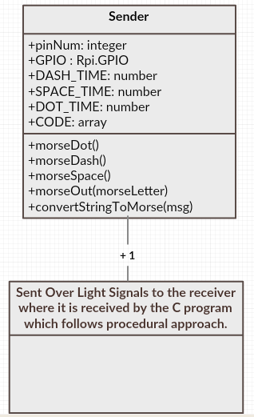
Fig.-4.3. Class Diagram pertaining to our Model
Above is the class diagram being implemented in our model. The different classes present under it are:
4.3.1. Laser Controller Class - This is the class responsible for the conversion of given code into pointer to on and off light sources. The different functions defined in the class are used at different point of time to perform the desired works.
4.3.2. Open - This is not a class, but the functions defined in the diagram above, below Open, are the ones which are not contained in any class but are of major importance for our model to work.
4.3.3. Receiver - This is the class which functions to receive the input from the photo-resistor. It converts them to Analog signal.
4.3.4. ADC - This is the class which is responsible to convert analog signal to digital, 0s and 1s. This will help in easing the decoding process.
4.3.5. Processor - This is the class having methods which will take the output from the ADC class and convert them into user readable text format. So this is the class to give the final output message to the user.

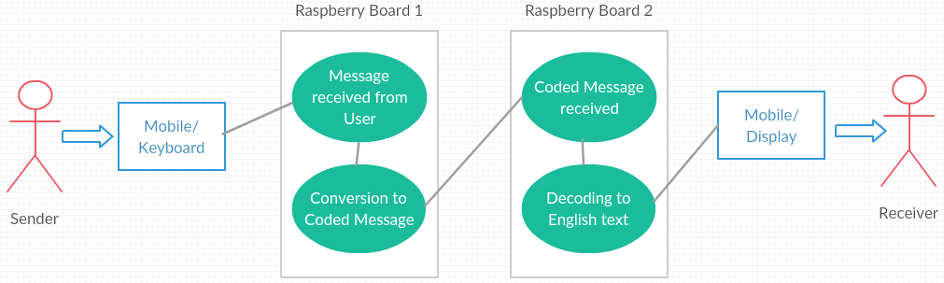
Fig.- 4.4. Use Case Diagram
Above is the use case diagram for our proposed project. The sender is the first user and the receiver is the second. The main transferer and processor of our model are the Raspberry Boards.

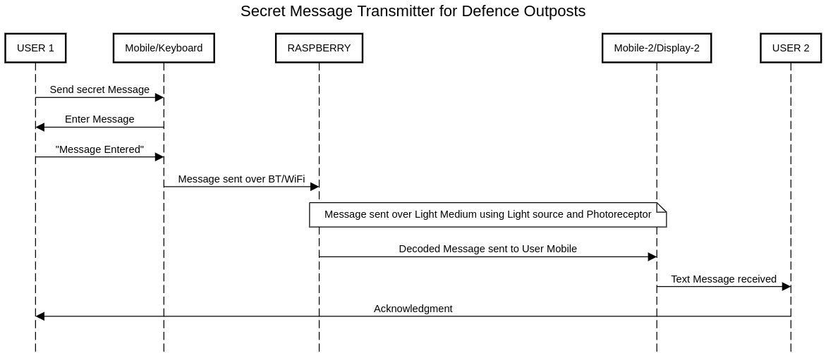
Fig.- 4.5. Sequence Diagram
Above is the sequence diagram for our model. The sequence diagram represents how the overall control will flow in the system. User 1 is the sender and User 2 is the receiver, while the mediator is the Raspberry Board.

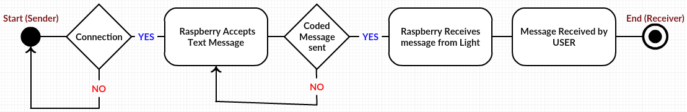
Fig.- 4.6. State Chart Diagram
Above is the state chart diagram for our system, which tells how our system’s transition is taking place. Start is the point from where the sender is starting the overall flow and after passing through all the intermediates, it reaches the end who is the receiver of the message.
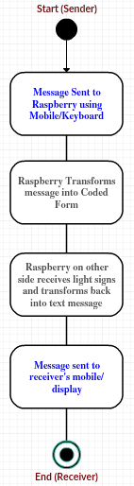
Fig. 4.7. Activity Chart Diagram
Above is the diagram, which shows the activity flow of our system. The activities done by sender and the system to get the message to the receiver are depicted in the chart above.

4.4. Library / APIs used
This section describes the different Libraries which we will be using to complete out project and get the work done. We are using Python as our main coding language and hence the libraries belong to the Python programming language. The following are the libraries being used in our model:

4.4.1. Broadcom BCM 2835 - This is a C library for Raspberry Pi (RPi). It provides access to GPIO and other IO functions on the Broadcom BCM 2835 chip, as used in the RaspberryPi, allowing access to the GPIO pins on the 40 pin IDE plug on the RPi board so you can control and interface with various external devices. It is C++ compatible, and installs as a header file and non-shared library on any Linux-based distro (but clearly is no use except on Raspberry Pi or another board with BCM 2835).
Tested on debian6-19-04-2012, 2012-07-15-wheezy-raspbian, 2013-07-26-wheezy-raspbian and Occidentalisv01, 2016-02-09 Raspbian Jessie. CAUTION: it has been observed that when detect enables such as bcm2835_gpio_len() are used and the pin is pulled LOW it can cause temporary hangs on 2012-07-15-wheezy-raspbian, 2013-07-26-wheezy-raspbian and Occidentalisv01. Reason for this is not yet determined, but we suspect that an interrupt handler is hitting a hard loop on those OSs. If you must use bcm2835_gpio_len() and friends, make sure you disable the pins with bcm2835_gpio_clr_len() and friends after use.
Installation
This library consists of a single non-shared library and header file, which will be installed in the usual places by make install
# download the latest version of the library, say bcm2835-1.xx.tar.gz, then:
-----
tar zxvf bcm2835-1.xx.tar.gz
cd bcm2835-1.xx
./configure
make
sudo make check
sudo make install
-----

The functions bcm2835_peri_read(), bcm2835_peri_write() and bcm2835_peri_set_bits() are low level peripheral register access functions. They are designed to use physical addresses as described in section 1.2.3 ARM physical addresses of the BCM2835 ARM Peripherals manual. Physical addresses range from 0x20000000 to 0x20FFFFFF for peripherals. The bus addresses for peripherals are set up to map onto the peripheral bus address range starting at 0x7E000000. Thus a peripheral advertised in the manual at bus address 0x7Ennnnnn is available at physical address 0x20nnnnnn.
On RPI 2, the peripheral addresses are different and the bcm2835 library gets them from reading “/proc/device-tree/soc/ranges”. This is only availble with recent versions of the kernel on RPI 2.
After initialisation, the base address of the various peripheral registers are available with the following externals: ‘bcm2835_gpio bcm2835_pwm bcm2835_clk bcm2835_pads bcm2835_spio0 bcm2835_st bcm2835_bsc0 bcm2835_bsc1 bcm2835_aux bcm2835_spi1’.
Raspberry Zero W (RPI-Z)
For this library to work correctly on RPI2, you MUST have the device tree support enabled in the kernel. You should also ensure you are using the latest version of Linux. The library has been tested on RPI2 with 2015-02-16-raspbian-wheezy and ArchLinuxARM-rpi-2 as of 2015-03-29.
When device tree suport is enabled, the file “/proc/device-tree/soc/ranges” will appear in the file system, and the bcm2835 module relies on its presence to correctly run on RPI2 (it is optional for RPI1). Without device tree support enabled and the presence of this file, it will not work on RPI2.
To enable device tree support:
-----
sudo raspi-config
under Advanced Options - enable Device Tree
Reboot.
-----
Pin Numbering
The GPIO pin numbering as used by RPi is different to and inconsistent with the underlying BCM 2835 chip pin numbering. “http://elinux.org/RPi_BCM2835_GPIOs”
RPi has a 26 pin IDE header that provides access to some of the GPIO pins on the BCM 2835, as well as power and ground pins. Not all GPIO pins on the BCM 2835 are available on the IDE header.
RPi Version 2 also has a P5 connector with 4 GPIO pins, 5V, 3.3V and Gnd.

The functions in this library are designed to be passed the BCM 2835 GPIO pin number and not the RPi pin number. There are symbolic definitions for each of the available pins that you should use for convenience.
SPI Pins
The bcm2835_spi_* functions allow you to control the BCM 2835 SPI0 interface, allowing you to send and received data by SPI (Serial Peripheral Interface).
When ‘bcm2835_spi_begin()’ is called it changes the bahaviour of the SPI interface pins from their default GPIO behaviour in order to support SPI. While SPI is in use, you will not be able to control the state of the SPI pins through the usual bcm2835_spi_gpio_write(). When bcm2835_spi_end() is called, the SPI pins will all revert to inputs, and can then be configured and controled with the usual bcm2835_gpio_* calls.
The Raspberry Pi GPIO pins used for SPI are:
- P1-19 (MOSI)
- P1-21 (MISO)
- P1-23 (CLK)
- P1-24 (CE0)
- P1-26 (CE1)
Although it is possible to select high speeds for the SPI interface, up to 125MHz (see bcm2835_spi_setClockDivider()) you should not expect to actually achieve those sorts of speeds with the RPi wiring. Our tests on RPi 2 show that the SPI CLK line when unloaded has a resonant frequency of about 40MHz, and when loaded, the MOSI and MISO lines ring at an even lower frequency. Measurements show that SPI waveforms are very poor and unusable at 62 and 125MHz. Dont expect any speed faster than 31MHz to work reliably.
The bcm2835_aux_spi_* functions allow you to control the BCM 2835 SPI1 interface, allowing you to send and received data by SPI (Serial Peripheral Interface).
The Raspberry Pi GPIO pins used for AUX SPI (SPI1) are:
- P1-38 (MOSI)
- P1-35 (MISO)
- P1-40 (CLK)
- P1-36 (CE2)

4.4.2. SpiDev for python - This project contains a python module for interfacing with SPI devices from user space via the spidev linux kernel driver. All code is MIT licensed unless explicitly stated otherwise.
Usage
-----
```python
import spidev
spi = spidev.SpiDev()
spi.open(bus, device)
to_send = [0x01, 0x02, 0x03]
spi.xfer(to_send)
```
Settings:
--------
```python
import spidev
spi = spidev.SpiDev()
spi.open(bus, device)
# Settings (for example)
spi.max_speed_hz = 5000
spi.mode = 0b01
* `bits_per_word`
* `cshigh`
* `loop` - Set the "SPI_LOOP" flag to enable loopback mode
* `no_cs` - Set the "SPI_NO_CS" flag to disable use of the chip select (although the driver may still own the CS pin)
* `lsbfirst`
* `max_speed_hz`
* `mode` - SPI mode as two bit pattern of clock polarity and phase [CPOL|CPHA], min: 0b00 = 0, max: 0b11 = 3
* `threewire` - SI/SO signals shared

Methods:
-------
open(bus, device)
Connects to the specified SPI device, opening `/dev/spidev<bus>.<device>`

readbytes(n)
Read n bytes from SPI device.

writebytes(list of values)
Writes a list of values to SPI device.

writebytes2(list of values)
Similar to `writebytes` but accepts arbitrary large lists.

If list size exceeds buffer size (which is read from `/sys/module/spidev/parameters/bufsiz`),
data will be split into smaller chunks and sent in multiple operations. Also, `writebytes2` understands so it can accept numpy byte arrays for example without need to convert them with `tolist()` first. This offers much better performance where you need to transfer frames to SPI-connected displays for instance.

xfer(list of values[, speed_hz, delay_usec, bits_per_word])
Performs an SPI transaction. Chip-select should be released and reactivated between blocks.
Delay specifies the delay in usec between blocks.

xfer2(list of values[, speed_hz, delay_usec, bits_per_word])
Performs an SPI transaction. Chip-select should be held active between blocks.

xfer3(list of values[, speed_hz, delay_usec, bits_per_word])
Similar to `xfer2` but accepts arbitrary large lists.
If list size exceeds buffer size (which is read from `/sys/module/spidev/parameters/bufsiz`),
data will be split into smaller chunks and sent in multiple operations.

close()
Disconnects from the SPI device.

4.4.3. sys/time.h library for C (time types) - The <sys/time.h> header defines the timeval structure that includes at least the following members:
- time_t tv_sec → seconds
- suseconds_t tv_usec → microseconds
The <sys/time.h> header defines the itimerval structure that includes at least the following members:
- struct timeval it_interval timer interval
- struct timeval it_value current value
The time_t and suseconds_t types are defined as described in <sys/types.h>. The <sys/time.h> header defines the fd_set type as a structure that includes at least the following member:
- long fds_bits[] bit mask for open file descriptions
The <sys/time.h> header defines the following values for the which argument of getitimer() and setitimer():
- ITIMER_REAL
Decrements in real time.
- ITIMER_VIRTUAL
Decrements in process virtual time.
- ITIMER_PROF
Decrements both in process virtual time and when the system is running on behalf of the process.
Each of the following may be declared as a function, or defined as a macro, or both:
- void FD_CLR(int fd, fd_set *fdset)
Clears the bit for the file descriptor fd in the file descriptor set fdset.
- int FD_ISSET(int fd, fd_set *fdset)
Returns a non-zero value if the bit for the file descriptor fd is set in the file descriptor set by fdset, and 0 otherwise.
- void FD_SET(int fd, fd_set *fdset)
Sets the bit for the file descriptor fd in the file descriptor set fdset.
- void FD_ZERO(fd_set *fdset)
Initialises the file descriptor set fdset to have zero bits for all file descriptors.

- FD_SETSIZE
Maximum number of file descriptors in an fd_set structure.
If implemented as macros, these may evaluate their arguments more than once, so that arguments must never be expressions with side effects.
The following are declared as functions and may also be defined as macros. Function prototypes must be provided for use with an ISO C compiler.
- int getitimer(int, struct itimerval *);
- int setitimer(int, const struct itimerval *, struct itimerval *);
- int gettimeofday(struct timeval *, void *);
- int select(int, fd_set *, fd_set *, fd_set *, struct timeval *);
- int utimes(const char *, const struct timeval [2]);

4.4.4. time for python – It is an inbuilt package provided by the python to help the developers in time related activities and values. Time can be used to pause a running thread for sleep and the values can also be adjusted accordingly. Time is also responsible for effectively managing the Threads on the basis of the values provided by the user. Time also plays major role in customized job scheduling, in which the developer can set the time limits for different threads or functions. In our project too, we are using the threads, and hence we are also using the time package to simplify our work of scheduling the threads and managing them effectively to get the messages sent and received effectively.
To use functions defined in the module, we need to import the module first. Here's how:
- import time
Here are commonly used time-related functions:
- Python time.time()
The time() function returns the number of seconds passed since epoch. For Unix system, January 1, 1970, 00:00:00 at UTC is epoch (the point where time begins).
Example-
-----
import time
seconds = time.time()
print("Seconds since epoch =", seconds)
-----

- Python time.ctime()
The time.ctime() function takes seconds passed since epoch as an argument and returns a string representing local time.
Example-
-----
import time
# seconds passed since epoch
seconds = 1545925769.9618232
local_time = time.ctime(seconds)
print("Local time:", local_time)
----
If you run the program, the output will be something like:
‘Local time: Thu Dec 27 15:49:29 2018’

- Python time.sleep()
The sleep() function suspends (delays) execution of the current thread for the given number of seconds.
Example-
-----
import time
print("This is printed immediately.")
time.sleep(2.4)
print("This is printed after 2.4 seconds.")
-----

- Python time.localtime()
The localtime() function takes the number of seconds passed since epoch as an argument and returns struct_time in local time.
Example-
-----
import time
result = time.localtime(1545925769)
print("result:", result)
print("\nyear:", result.tm_year)
print("tm_hour:", result.tm_hour)
-----
When you run the program, the output will be something like:
“result: time.struct_time(tm_year=2018, tm_mon=12, tm_mday=27, tm_hour=15, tm_min=49, tm_sec=29, tm_wday=3, tm_yday=361, tm_isdst=0)
year: 2018
tm_hour: 15”

4.4.5. General Purpose Input/ Output for Raspberry - A powerful feature of the Raspberry Pi is the row of GPIO (general-purpose input/output) pins along the top edge of the board. A 40-pin GPIO header is found on all current Raspberry Pi boards (unpopulated on Pi Zero and Pi Zero W). Prior to the Pi 1 Model B+ (2014), boards comprised a shorter 26-pin header. Any of the GPIO pins can be designated (in software) as an input or output pin and used for a wide range of purposes.
- Voltages- Two 5V pins and two 3V3 pins are present on the board, as well as a number of ground pins (0V), which are unconfigurable. The remaining pins are all general purpose 3V3 pins, meaning outputs are set to 3V3 and inputs are 3V3-tolerant.
- Outputs- A GPIO pin designated as an output pin can be set to high (3V3) or low (0V).
- Inputs- A GPIO pin designated as an input pin can be read as high (3V3) or low (0V). This is made easier with the use of internal pull-up or pull-down resistors. Pins GPIO2 and GPIO3 have fixed pull-up resistors, but for other pins this can be configured in software.
As well as simple input and output devices, the GPIO pins can be used with a variety of alternative functions, some are available on all pins, others on specific pins.
- PWM (pulse-width modulation)
  - Software PWM available on all pins
  - Hardware PWM available on GPIO12, GPIO13, GPIO18, GPIO19
- SPI
  - SPI0: MOSI (GPIO10); MISO (GPIO9); SCLK (GPIO11); CE0 (GPIO8), CE1 (GPIO7)
  - SPI1: MOSI (GPIO20); MISO (GPIO19); SCLK (GPIO21); CE0 (GPIO18); CE1 (GPIO17); CE2 (GPIO16)

- I2C
  - Data: (GPIO2); Clock (GPIO3)
  - EEPROM Data: (GPIO0); EEPROM Clock (GPIO1)
- Serial
  - TX (GPIO14); RX (GPIO15)

4.5. Codes and Libraries
This section tells about the libraries being used in our model with examples and explanations. The different libraries mentioned in the previous section are all being used for our model and are responsible for the efficient functioning of our system. Going through this section will get you the knowledge of the whole system and the proper functioning of the system.
4.5.1. GPIO Usage:
We are using GPIO for all our system needs because this is the one which activates or deactivates the input or output pins and help us get or send the data from these ports respectively. We can use it with Python as it is provided as inbuilt library in the Raspbian OS. The following are the ways where we have used the GPIO in our system:
-----
import RPi.GPIO as GPIO
timeMultiplier = 5
pinNum = 18
GPIO.setmode(GPIO.BCM) #numbering scheme that corresponds to breakout board and pin layout
GPIO.setup(pinNum, GPIO.OUT) #replace pinNum with whatever pin you used, this sets up that pin as an output

def morseDot():
GPIO.output(pinNum, GPIO.HIGH)
time.sleep(DOT_TIME)
GPIO.output(pinNum, GPIO.LOW)

def morseDash():
GPIO.output(pinNum, GPIO.HIGH)
time.sleep(DASH_TIME)
GPIO.output(pinNum, GPIO.LOW)

def morseSpace():
time.sleep(SPACE_TIME)
-----
In the above code snippet, you can notice the uses of the GPIO in our codes. The first task is to import the GPIO package which is already provided in the OS for the raspberry, so we are using the import keyword to get this task done.
After that we are using the ‘setmode’ to set the initial values to be used by the board io pins. Then the ‘setup’ is used to tell the board the input and output ports we will be using for our project for sending and receiving the data over the IO ports being provided and connected in the Raspberry processor board.
‘cleanup’ is the command to flush and make the ports free of any cached process too. This is of utmost importance after the execution of the whole code is done and hence should be used regularly and executed after every small methods are done with execution. The ports should be free after the execution is over and so this command is very useful in the proper functioning of the raspberry processor board.

4.5.2. BCM2835 library for C Usage:
This is a C library for Raspberry Pi (RPi). It provides access to GPIO and other IO functions on the Broadcom BCM 2835 chip, as used in the RaspberryPi, allowing access to the GPIO pins on the 26 pin IDE plug on the RPi board so you can control and interface with various external devices. It is C++ compatible, and installs as a header file and non-shared library on any Linux-based distro (but clearly is no use except on Raspberry Pi or another board with BCM 2835). The following part gives the example of the code where we are using this library:
-----
#include <bcm2835.h>
int main(int argc, char**argv) {
if(!bcm2835_init()) {
return 1;
}
bcm2835_gpio_fsel(PIN, BCM2835_GPIO_FSEL_INPT);
bcm2835_gpio_set_pud(PIN, BCM2835_GPIO_PUD_DOWN);

while(1) {
if(bcm2835_gpio_lev(PIN) == HIGH) {
}
}
}
-----
Here we are using this C package to control the input output pins of our raspberry board which is helping us to detect when a certain pin is set to high or low. This library is specifically built for the Raspberry board so that the work of the programmers becomes more easier and faster to obtain. This is helping us to detect the high when there is a signal of light and using the time value for how much it was kept on we are decoding it to get the secret message which was sent over the light medium. Hence we are able to achieve this main functionality with the help of this particular library.

4.5.4. sys/time.h library for C (time types) Usage - The <sys/time.h> header defines the timeval structure. This package is helping us to achieve the calculation of the time in very minute details because we need that data to differentiate between the dots and dash message. These are only our coding and decoding source. The perfect time calculations is being done with the help of this package as it can even give us details of time in micro seconds that is the 6th part of a second and being so precise helps us to achieve the accurate message being sent from the sender side as well as helps in decoding the message at the receiver’s side. The following lines defines such usages:
-----
#include <sys/time.h>
struct timeval tv;
gettimeofday(&tv, NULL);
secs = tv.tv_sec;
tics = tv.tv_usec;
litStartTime = (secs * 1000000) + tics;
if(litEndTime) {
pauseDuration = litStartTime - litEndTime;
if(pauseDuration > 900000) {
decode(msgBuf);
idx = 0; // reset
} else if(pauseDuration > 400000) {
msgBuf[idx++] = ' '; // new word
} else if(pauseDuration > 100000) {
msgBuf[idx++] = '#'; // new letter
}
}
while(bcm2835_gpio_lev(PIN) == HIGH);
gettimeofday(&tv, NULL);
secs = tv.tv_sec;
tics = tv.tv_usec;
litEndTime = (secs * 1000000) + tics;
litDuration = litEndTime - litStartTime;
if(litDuration > 100000) {
msgBuf[idx++] = '-';
} else {
msgBuf[idx++] = '.';
}
-----
In the above code, we can see that this time package is only giving us the major functionality. From the definition of the variable as object of the time package we are initiating the usage of this library. At further stages, we have used this package to get the tim evalues in seconds and even micro-seconds which is of utmost efficiency. At all the conditional statements and looping constructs, the variable being used is being formulated with the help of this time package itself. The time_t and suseconds_t types are defined as described in <sys/types.h>. Including this header with the C code helps us to use the functionalities defined in it so that the overall time calculations can be facilitated by the C code which is also a native and powerful programming language that is still being used.

4.5.5. time package for python Usage: The time as defined, is used to do the time related tasks, and so we are using for the same purpose in our model too, the following lines describes the codes where we are using it:
-----
def morseDot():
GPIO.output(pinNum, GPIO.HIGH)
time.sleep(DOT_TIME)
GPIO.output(pinNum, GPIO.LOW)

def morseDash():
GPIO.output(pinNum, GPIO.HIGH)
time.sleep(DASH_TIME)
GPIO.output(pinNum, GPIO.LOW)

def morseSpace():
time.sleep(SPACE_TIME)

def morseOut(morseLetter):
for letter in morseLetter:
if letter == '.':
morseDot()
elif letter == '-':
morseDash()
elif letter == ' ':
morseSpace()
else:
print('error')
time.sleep(DOT_TIME)

def convertStringToMorse(msg):
for letter in msg:
morseLetter = CODE[letter.upper()]
morseOut(morseLetter)
time.sleep(PAUSE_TIME)
-----

Here, we are using the time to set the current time to the variable ‘start’ and also to check the conditions because we want to run the code for 30 seconds and hence time is the package used for this. More of ‘time.sleep’ is being used to create the pause rate, so that we can send and receive the messages with a valid time frame. The last mention function of this time package in python is the one responsible for sending of message alone because it is this fellow who is creating right gaps to get the light source glowing and hence the messages being sent through it.

CHAPTER 5
OBJECTIVES AND METHODOLOGIES

CHAPTER 5
OBJECTIVES AND METHODOLOGIES
5.1. Objectives
The objectives of our project is as follows:
- Transmitting message securely over the visual medium
- Provide a channel to send message without having the fear of getting eavesdropped
- To provide a system with secret codes which would be very hard to guess and decode
- To portray the message being sent over visual medium, as nothing more than voltage fluctuation
- Become the backbone of our soldiers in secret messaging

5.2. Methodology
The methodology being followed in the development and functioning of our system is as follows:
- Taking reference of the International Morse Codes.
- After the codes are defined, we’ll be putting those onto our Raspberry Board so that it is ready to code or decode the same.
- The program working for the system is stored on the Raspberry too.
- This program is responsible for the conversion of text message to our defined codes and the conversion vice-versa.
- The program is also responsible in instructing the Raspberry Board to send visual signal using the Bulb attached to it, and also to send the decoded message over Wi-Fi to our Smartphone.
- When the whole system is ready, we can use our mobile phones to send the message using the app to Raspberry over Wi-Fi, which will convert the message to our secret code and use that code pattern to glow the LED on or off. On the receiver’s side, this flashing of LED, will be captured by the Web-Camera, which will send the set of images to the raspberry. The raspberry will decode the image using the defined secret code and send the final message to the user over Wi-Fi on his/her smart-phone in the form of English text.

CHAPTER 6
TESTING

CHAPTER 6
TESTING
This project has been tested under different circumstances, which includes different types such as Unit testing, Integration testing and System testing that are described below.

6.1 Unit Testing
Unit testing is a method by which individual units of source code, sets of one or more computer program modules together with associated control data, usage procedures and operating procedures, are tested to determine if they are fit for use. Intuitively, one can view a unit as the smallest testable part of an application. In object-oriented programming a unit is often an entire interface, such as a class, but could be an individual method.
For unit testing first we adopted the code testing strategy, which examined the logic of program. During the development process itself all the syntax errors etc. got rooted out. For this developed test case that result in executing every instruction in the program or module i.e. every path through program was tested. Test cases are data chosen at random to check every possible branch after all the loops.
Test Cases
Table: 6.1 Unit Test Cases for the Project
Steps | Test Action | Results
Step 1 | Type out the message | Laser is blinked to represent the Morse Code
Step 2 | Thread shifts to receive mode | Photo-resistor will take the values according to Lux
Step 3 | Plotting | The graph is plotted and the message is decoded and showed

6.1.1 Error Handling: In this system, we have tried to handle all the errors that occurred while running the application. The common errors we saw were reading a tuple with an attribute set to null and database connection getting lost. For Testing we used Top-Down design a decomposition process which focuses as the flow of control, at latter strategies concern itself with code production. The first step is to study the overall aspects of the tasks at hand and break it into a number of independent modules. The second step is to break one of these modules further into independent sub modules. One of the important features is that each level the details at lower levels are hidden. So unit testing was performed first and then system testing.
6.2 Integration Testing
Data can be lost across an interface, one module can have an adverse effect on the other sub function, when combined may not produce the desired functions. Integrated testing is the systematic testing to uncover the errors with an interface. This testing is done with simple data and developed system has run successfully with this simple data. The need for integration system is to find the overall system performance.
Steps to perform integration testing:
Step 1: Create a test plan.
Step 2: Create Test cases and test data.
Step 3: Once the components have been integrated execute the test cases.
Step 4: Fix the bugs if any and Re test the code.
Step 5: Repeat the test cycles until the components have been successfully integrated.

Table: 6.2 Test Cases for Integration Testing
Name of the Test | Integration testing
Test plan | To check whether the system works properly when all the modules are integrated.
Test Data | Sample company scrip code and longitude/latitude of a sample city

6.3 System Testing
Ultimately, software is included with other system components and the set of system validation and integration tests are performed. System testing is a series of different tests whose main aim is to fully exercise the computer-based system. Although each test has a different role all work should verify that all system elements are properly integrated and formed allocated functions.
Table: 6.3 Test cases for Input-Output
Name of the Test | System Testing
Item being tested | Over all functioning of GUI with all functions properly linked.
Sample Input | Sample company scrip code and longitude/latitude of a sample city
Expected Output | All the modules like data pull, merge, statistics, and background task
Actual Output | Application reacts to user inputs in expected manner.
Remarks | Successful

6.3.1 Validation Testing
At the culmination of black box testing, software is completely assembled is as a package. Interfacing errors have been uncovered and the correct and final series of tests, i.e., validation tests begin. Validation test is defined with a simple definition that validation succeeds when the software function in a manner that can be reasonably accepted by the customer.

6.3.2 Output Testing
After performing validation testing, the next step is output testing of the proposed system. Since the system cannot be useful if it does not produce the required output. Asking the user about the format in which the system is required tests the output displayed or generated by the system is required tests the output displayed or generated by the system under consideration. The output format is considered in two ways, one is on screen format and the other is printed format. The output format on the screen is found to be corrected as the format was designated in the system has according to the user needs. As for the hard copy the output comes according to the specification requested by the user. The output testing does not result in any correction of the system.
6.3.3 Test Data and Output:
Taking various kind soft data plays a vital role in system testing. After preparing the test data system under study is tested using the test data. While testing, errors are again uncovered and corrected by using the above steps and corrections are also noted for future use.

6.3.4 User acceptance Testing:
User acceptance testing of the system is the key factor for the success of the system. A system under consideration is tested for user acceptance by constantly keeping in touch with the prospective system at the time of development and making change whenever required. This is done Regard to input screen design and output screen design.

CONCLUSION AND FUTURE ENHANCEMENTS
Henceforth to conclude, we’ve developed this system to do the above tasks. It is dedicated to our soldiers. This system is of great help for them in transmitting critical data. It is also useful in case of emergencies and any unwanted attack. As the message transmission is safe and secure, it’ll provide them with a secret medium to help them informing their peers about any enemy intruder, if they notice. And for the efficient working of the existing methodologies, we’ll provide this system to further simplify the lives of soldiers.
Future Enhancements: -
- If we get a chance, we would like to make it on a larger scale and implement it into actual scenarios.
- We can even further make it private and secured by implementing Log-in IDs on the android app.
- We can give away this software for more number of people and organizations to conduct a Beta Testing and based upon the results we can just make those changes and be assured of the application developed.
- We can implement the Solar Power lightning, for our help in case, the electricity from the grid source is unavailable.

REFERENCES
- www.google.co.in/
- https://en.wikipedia.org/wiki/Morse_code
- IEEE Std 830-1998: IEEE Recommended Practice for Software Requirements Specifications.
- IEEE Paper- Morse code Generator Using Micro-controller with Alphanumeric Keypad published in: 2016 International Conference on Electrical, Electronics, and Optimization Techniques (ICEEOT).
- Headquarters, Department of the Army, TM 11-459, International Morse Code (Instructions), Washington, D.C.: U.S.G.P.O., 1968, pp. 6-7
- Google Android Studio Developer’s Guide

APPENDIX-‘A’
SCREENSHOTS

APPENDIX-A
SCREENSHOTS
This section contains different snapshots of the project, indicating the various stages of its working.
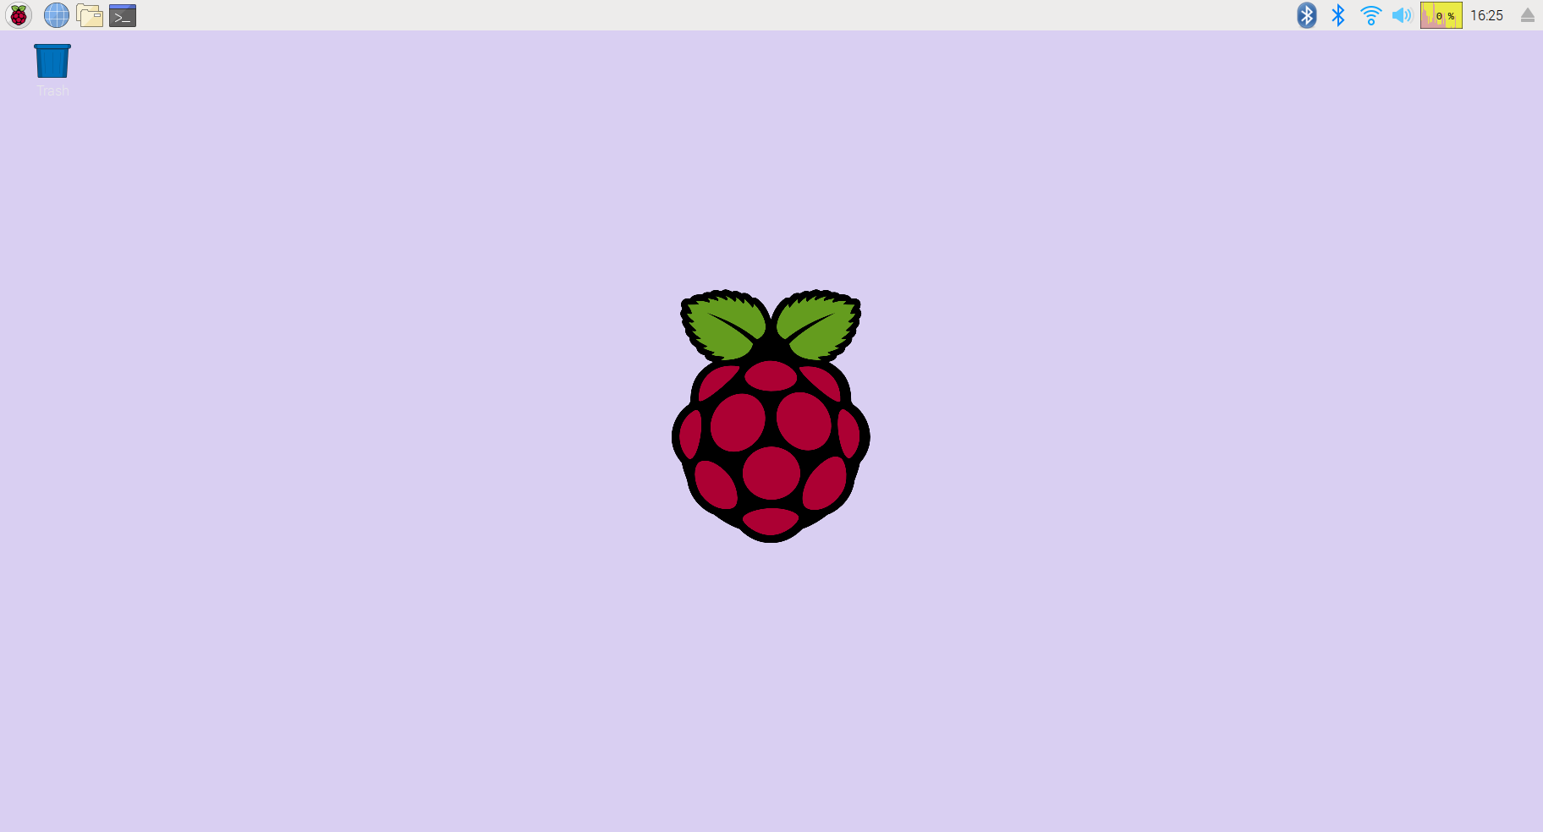
Fig.A.1.- Raspbian OS
Raspbian is a Debian-based computer operating system for Raspberry Pi. There are several versions of Raspbian including Raspbian Stretch and Raspbian Jessie. Since 2015 it has been officially provided by the Raspberry Pi Foundation as the primary operating system for the family of Raspberry Pi single-board computers. Raspbian was created by Mike Thompson and Peter Green as an independent project. The initial build was completed in June 2012. The operating system is still under active development. Raspbian is highly optimized for the Raspberry Pi line's low-performance ARM CPUs.
Raspbian uses PIXEL, Pi Improved X-Window Environment, Lightweight as its main desktop environment as of the latest update. It is composed of a modified LXDE desktop environment and the Openbox stacking window manager with a new theme and few other changes. The distribution is shipped with a copy of computer algebra program Mathematica and a version of Minecraft called Minecraft Pi as well as a lightweight version of Chromium as of the latest version.

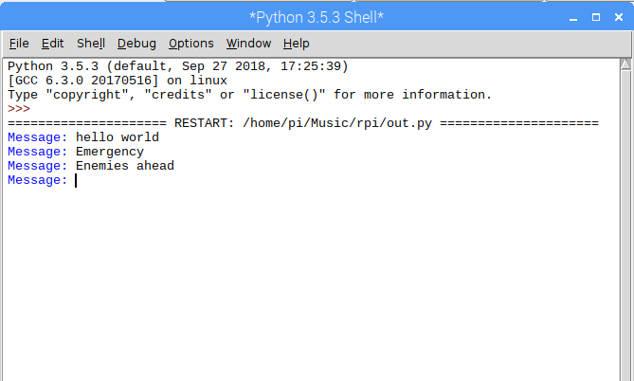
Fig.A.2.- Sending the message
IDLE (short for integrated development environment or integrated development and learning environment) is an integrated development environment for Python, which has been bundled with the default implementation of the language since 1.5.2b1. It is packaged as an optional part of the Python packaging with many Linux distributions. It is completely written in Python and the Tkinter GUI toolkit. We are using this screen to send the message which in turn blinks the LED accordingly to get the process started.

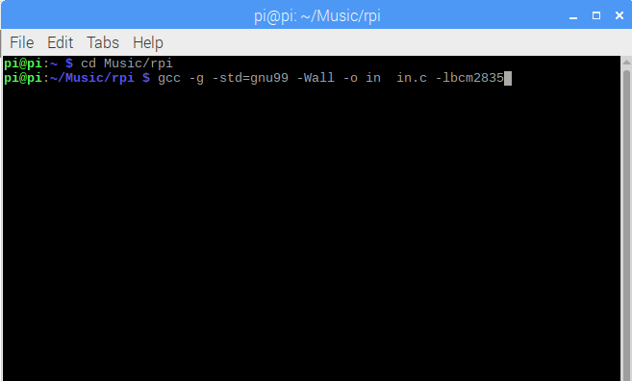
Fig.A.3.- Receiving End (Terminal)
This is the terminal of raspbian, in which we are compiling the C code, and further we are using the compiled code to execute the C code which we have supplied to the raspberry. This, after executing will wait for the light source to blink and then receive the same using the GPIOs inputs and hence converting it to the message which was actually sent from the sender.

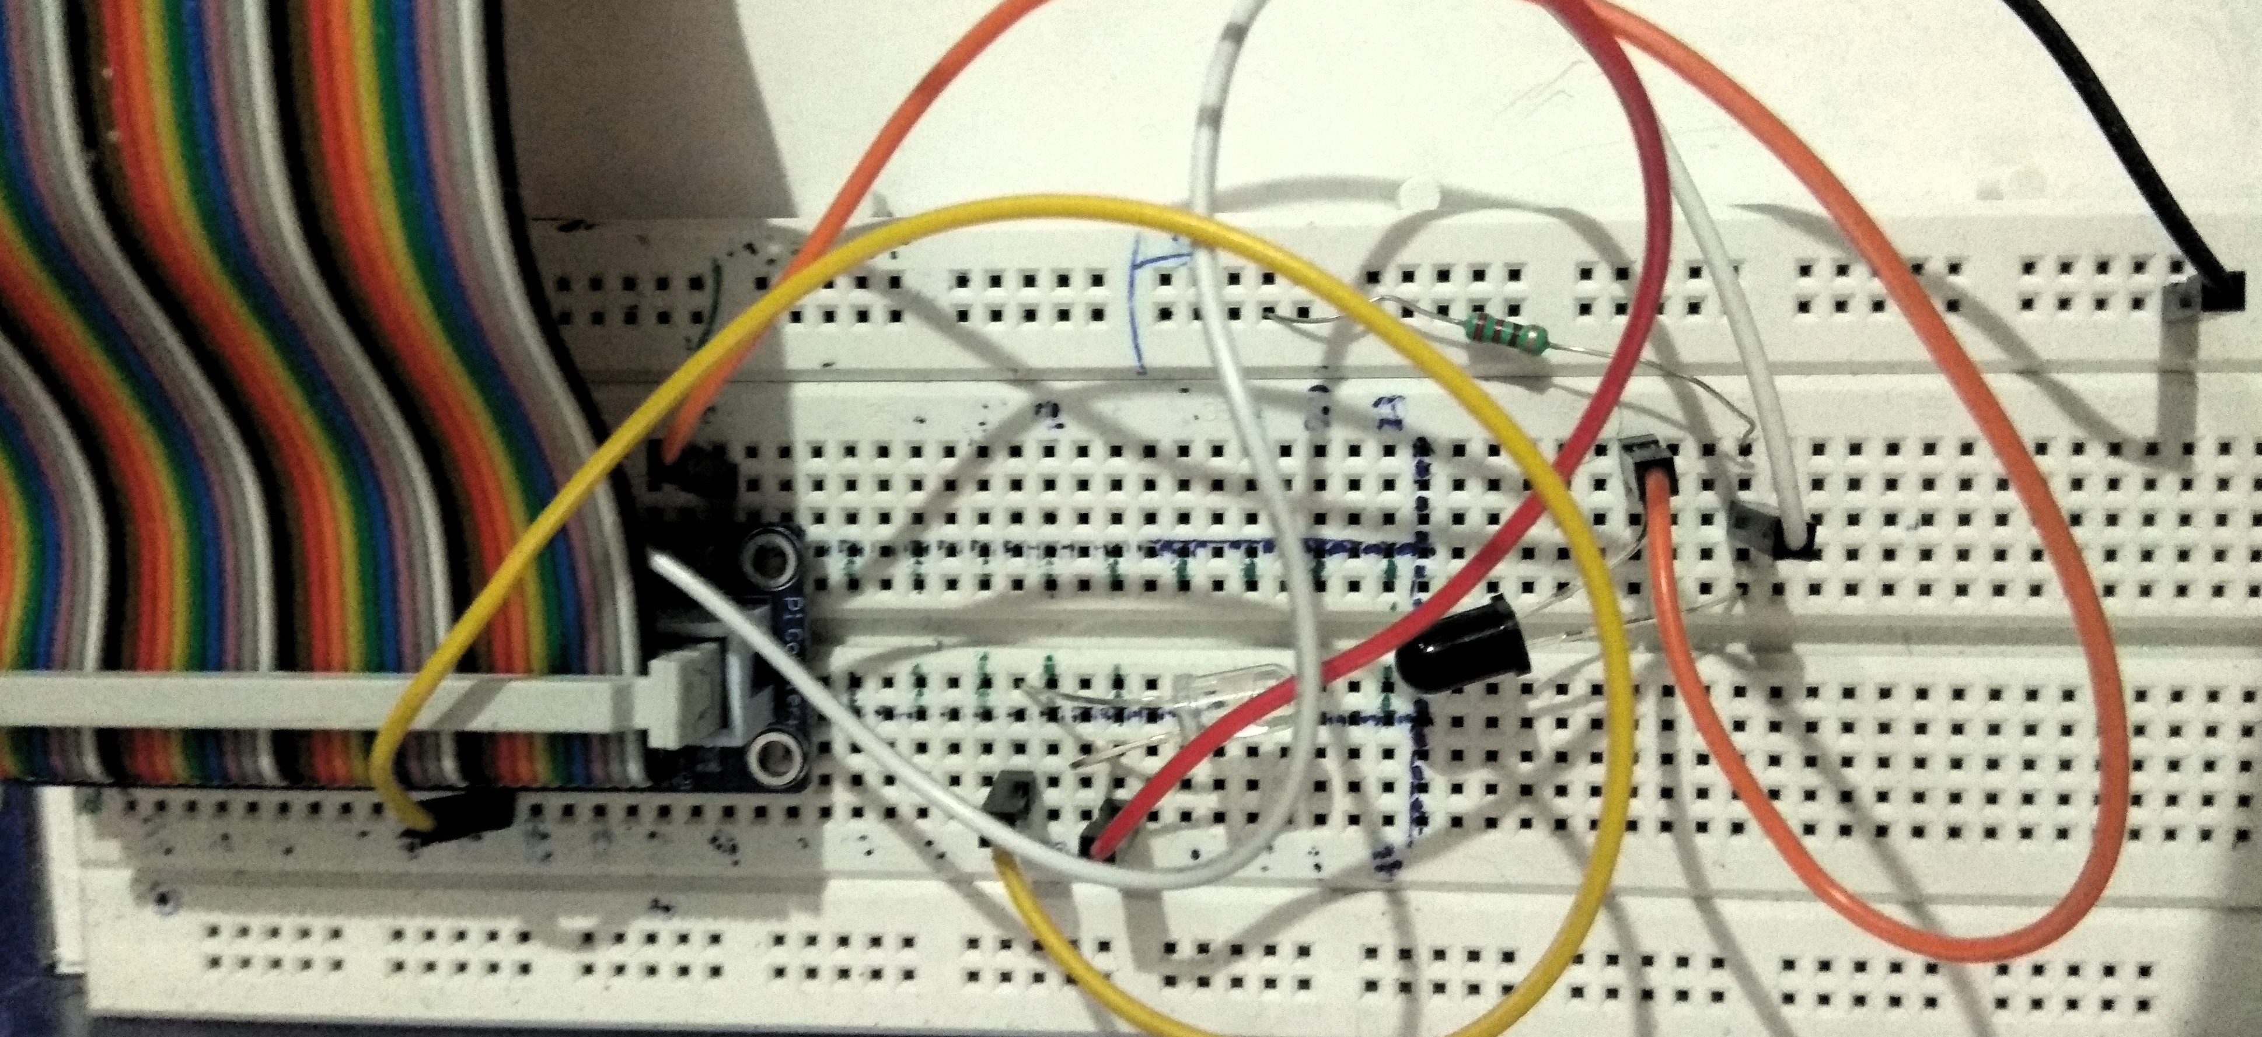
Fig.A.4.- Original Setup of Model
Here you can see the dark colour LED is the photo-transistor which is responsible for the receiving end. To the left of it, we have the sender IR LED, which is sending message by blinking itself. These are connected with Resistors of 220 ohm each, and then using the breadboard and jumper cables, these are connected to the GPIO pins. With the help of the GPIO pins we are accessing the input and outputs of the respective IOT peripherals. The left-most bunch of cables is called the T-Cobbler wire which is used for easy connectivity of the 40 pins of the raspberry to the breadboard and other components. It reduces human effort by consolidating all the data.

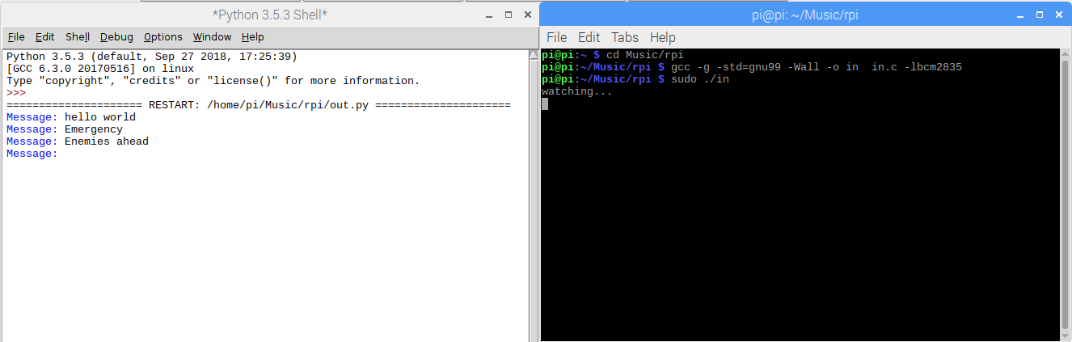
Fig.A.5.- Full Fledged working
In the above diagram we can see the full fledged working of our model, software side. Here on the left we have the sending part and on the right we have the receiving part. When the message is being sent, the terminal on the right waits at ‘watch’ mode, as soon as it detects a signal of light trace, it starts decoding received values. The code takes the length of light signals, and hence uses it to convert it back to the text message which was originally sent from the sender’s side. Currently we are doing this operation on the same raspberry but it can be done using two different raspberry boards too, hence making simplex connection also. Currently we are working in full-duplex operation mode, using different pins of the raspberry.

APPENDIX-‘B’
CODE SNIPPETS ( PSEUDO CODE)

APPENDIX-B
CODE SNIPPET (PSEUDO CODE)
This section describes the codes used in our system. We will be briefing about the codes hereafter.
B.1. out.py
-----
import RPi.GPIO as GPIO
import time

timeMultiplier = 5
pinNum = 18

DOT_TIME = 0.01 * timeMultiplier
DASH_TIME = DOT_TIME * 3
SPACE_TIME = DASH_TIME * 2
PAUSE_TIME = DASH_TIME

GPIO.setmode(GPIO.BCM) #numbering scheme that corresponds to breakout board and pin layout
GPIO.setup(pinNum, GPIO.OUT) #replace pinNum with whatever pin you used, this sets up that pin as an output
CODE = {' ': ' ', "'": '.----.',
'(': '-.--.-', ')': '-.--.-', ',': '--..--', '-': '-....-',
'.': '.-.-.-', '/': '-..-.', '0': '-----', '1': '.----',
'2': '..---', '3': '...--', '4': '....-', '5': '.....',
'6': '-....', '7': '--...', '8': '---..', '9': '----.',
':': '---...', ';': '-.-.-.', '?': '..--..', 'A': '.-',
'B': '-...', 'C': '-.-.', 'D': '-..', 'E': '.',
'F': '..-.', 'G': '--.', 'H': '....', 'I': '..',
'J': '.---', 'K': '-.-', 'L': '.-..', 'M': '--',
'N': '-.', 'O': '---', 'P': '.--.', 'Q': '--.-',
'R': '.-.', 'S': '...', 'T': '-', 'U': '..-',
'V': '...-', 'W': '.--', 'X': '-..-', 'Y': '-.--',
'Z': '--..', '_': '..--.-'}

def morseDot():
GPIO.output(pinNum, GPIO.HIGH)
time.sleep(DOT_TIME)
GPIO.output(pinNum, GPIO.LOW)

def morseDash():
GPIO.output(pinNum, GPIO.HIGH)
time.sleep(DASH_TIME)
GPIO.output(pinNum, GPIO.LOW)

def morseSpace():
time.sleep(SPACE_TIME)

def morseOut(morseLetter):
for letter in morseLetter:
if letter == '.':
morseDot()
elif letter == '-':
morseDash()
elif letter == ' ':
morseSpace()
else:
print('error')
time.sleep(DOT_TIME)

def convertStringToMorse(msg):
for letter in msg:
morseLetter = CODE[letter.upper()]
morseOut(morseLetter)
time.sleep(PAUSE_TIME)
-----
B.2. in.c
-----
#include <bcm2835.h>
#include <stdio.h>
#include <sys/time.h>
#include <string.h>
#define PIN RPI_GPIO_P1_11 /*GPIO 17 = real pin position 11*/
void decodeLetter(char *letter) {
if(strcmp(letter, ".----.") == 0) {
printf("'");
} else if(strcmp(letter, "-.--.-") == 0) {
printf("(");
} else if(strcmp(letter, "-.--.-") == 0) {
printf(")");
} else if(strcmp(letter, "--..--") == 0) {
printf(",");
} else if(strcmp(letter, "-....-") == 0) {
printf("-");
} else if(strcmp(letter, ".-.-.-") == 0) {
printf(".");
} else if(strcmp(letter, "-..-.") == 0) {
printf("/");
} else if(strcmp(letter, "---...") == 0) {
printf(":");
} else if(strcmp(letter, "-.-.-.") == 0) {
printf(";");
} else if(strcmp(letter, "..--..") == 0) {
printf("?");
} else if(strcmp(letter, "..--.-") == 0) {
printf("_");
} else if(strcmp(letter, "-----") == 0) {
printf("0");
} else if(strcmp(letter, ".----") == 0) {
printf("1");
} else if(strcmp(letter, "..---") == 0) {
printf("2");
} else if(strcmp(letter, "...--") == 0) {
printf("3");
} else if(strcmp(letter, "....-") == 0) {
printf("4");
} else if(strcmp(letter, ".....") == 0) {
printf("5");
} else if(strcmp(letter, "-....") == 0) {
printf("6");
} else if(strcmp(letter, "--...") == 0) {
printf("7");
} else if(strcmp(letter, "---..") == 0) {
printf("8");
} else if(strcmp(letter, "----.") == 0) {
printf("9");
} else if(strcmp(letter, ".-") == 0) {
printf("A");
} else if(strcmp(letter, "-...") == 0) {
printf("B");
} else if(strcmp(letter, "-.-.") == 0) {
printf("C");
} else if(strcmp(letter, "-..") == 0) {
printf("D");
} else if(strcmp(letter, ".") == 0) {
printf("E");
} else if(strcmp(letter, "..-.") == 0) {
printf("F");
} else if(strcmp(letter, "--.") == 0) {
printf("G");
} else if(strcmp(letter, "....") == 0) {
printf("H");
} else if(strcmp(letter, "..") == 0) {
printf("I");
} else if(strcmp(letter, ".---") == 0) {
printf("J");
} else if(strcmp(letter, "-.-") == 0) {
printf("K");
} else if(strcmp(letter, ".-..") == 0) {
printf("L");
} else if(strcmp(letter, "--") == 0) {
printf("M");
} else if(strcmp(letter, "-.") == 0) {
printf("N");
} else if(strcmp(letter, "---") == 0) {
printf("O");
} else if(strcmp(letter, ".--.") == 0) {
printf("P");
} else if(strcmp(letter, "--.-") == 0) {
printf("Q");
} else if(strcmp(letter, ".-.") == 0) {
printf("R");
} else if(strcmp(letter, "...") == 0) {
printf("S");
} else if(strcmp(letter, "-") == 0) {
printf("T");
} else if(strcmp(letter, "..-") == 0) {
printf("U");
} else if(strcmp(letter, "...-") == 0) {
printf("V");
} else if(strcmp(letter, ".--") == 0) {
printf("W");
} else if(strcmp(letter, "-..-") == 0) {
printf("X");
} else if(strcmp(letter, "-.--") == 0) {
printf("Y");
} else if(strcmp(letter, "--..") == 0) {
printf("Z");
}
}

void decodeWord(char word[]) {
char cpy[1024];
strcpy(cpy, word);

// printf("word '%s' (%i)\n", cpy, strlen(cpy));
char delims[] = "#";
char *letter = NULL;
letter = strtok(cpy, delims);
while(letter != NULL) {
decodeLetter(letter);
letter = strtok(NULL, delims);
}
printf(" ");
}
void decode(char msg[]) {
char cpy[1024];
strcpy(cpy, msg);
// printf("msg: '%s' (%i)\n", cpy, strlen(cpy));

char delims[] = " ";
char *word = NULL;
char *end_str;

word = strtok_r(cpy, delims, &end_str);
while(word != NULL) {
decodeWord(word);
word = strtok_r(NULL, delims, &end_str);
}
printf("\n");
}

int main(int argc, char**argv) {

struct timeval tv;
long secs;
long tics;
long litStartTime;
long litEndTime;
char msgBuf[100];
int idx = 0;
long litDuration;
long pauseDuration;

msgBuf[99] = '\0';

if(!bcm2835_init()) {
return 1;
}
bcm2835_gpio_fsel(PIN, BCM2835_GPIO_FSEL_INPT);
bcm2835_gpio_set_pud(PIN, BCM2835_GPIO_PUD_DOWN);
printf("watching...\n");
while(1) {
if(bcm2835_gpio_lev(PIN) == HIGH) {
gettimeofday(&tv, NULL);
secs = tv.tv_sec;
tics = tv.tv_usec;
litStartTime = (secs * 1000000) + tics;
if(litEndTime) {
pauseDuration = litStartTime - litEndTime;
//printf("pause between lights: %ld\n", pauseDuration);

if(pauseDuration > 900000) {
decode(msgBuf);
idx = 0; // reset
} else if(pauseDuration > 400000) {
msgBuf[idx++] = ' '; // new word
} else if(pauseDuration > 100000) {
msgBuf[idx++] = '#'; // new letter
}
}
while(bcm2835_gpio_lev(PIN) == HIGH);
gettimeofday(&tv, NULL);
secs = tv.tv_sec;
tics = tv.tv_usec;
litEndTime = (secs * 1000000) + tics;
litDuration = litEndTime - litStartTime;
//printf("Lit duration: %ld usec\n", litDuration );
if(litDuration > 100000) {
msgBuf[idx++] = '-';
} else {
msgBuf[idx++] = '.';
}
msgBuf[idx] = '\0';
}
delay(1);
}
-----

