Hydro Power System

# Background

In hydropower production, potential and/or kinetic energy in flowing water is used to rotate a turbine, which in turn provides mechanical energy to drive an electric generator. A hydro power plant includes components such as the waterway, the aggregate (hydro turbine/generator) and the electric grid.

Firstly, the main study will be within the waterway part the hydro power system, which is schematically shown in the figure below.

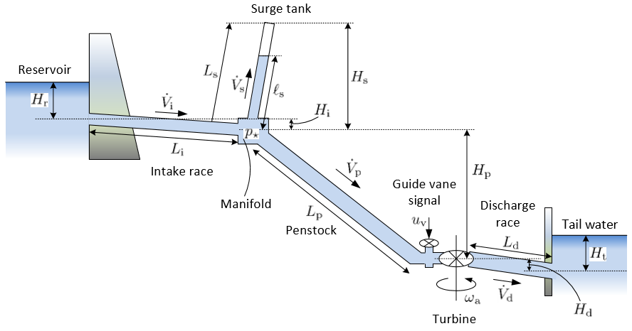

For high pressure hydro power production, the waterway consists of a long, almost horizontal intake race (also known as conduit) for transporting water to the vicinity of the turbine, followed by a steep penstock (pressure shaft) with a considerable pressure build-up which is then used to drive the turbine. The turbine power can be manipulated by changing the turbine valve/vane signal. Quick changes in the vane signal may lead to large pressure variations (“water hammer”), which in the worst case can destroy equipment. In order to smooth out such pressure variations, a surge tank is often installed between the intake race and the penstock.

Downstream from the turbine, a discharge race leads water out to the tail water. The length of the discharge race often depends on the quality of the rock in the mountain: a sufficient strength in the rock above the penstock is required to handle the high pressures in the penstock.

Because the water mass in the penstock moves in tandem with the water in the discharge race, a long discharge race implies added inertia to the moving mass trough the turbine. One way to reduce this problem, is to install another surge tank in the discharge race – close to the turbine. Such a surge tank will effectively decouple the penstock mass from the discharge mass.

Two problems are relevant for large variations in the pressures of the system: (i) a high pressure may destroy pipes/equipment, while (ii) too low a pressure may cause the water to evaporate, and thus lead to cavitation. Because of this, the guide vane signal is often filtered/smoothed so that changes are gradual. In addition to provide sufficient power to the electric grid by manipulating the guide vane signal, it is also important to keep the angular velocity of the aggregate at a fixed value. This is so since the angular velocity of the aggregate is proportional to the frequency of the electric grid – in Europe, the grid frequency should be held at/close to 50Hz.

# Waterway modelling

## Reservoir/tail water

For simplification, it is assumed that the level of reservoir is kept constant and the area of the reservoir is closed to infinity. Then the reservoir can be presented just as an equation for pressure in the inlet/outlet of reservoir.

…

## Intake race/discharge race

The schematic of the Intake race/discharge race can be described as a simple pipe and presented as below:

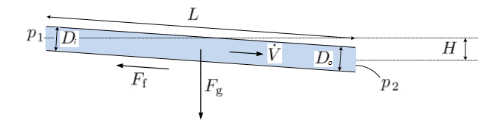

Assuming that the water is incompressible and inelastic walls of the pipe due to small pressures (<10 bar). The mass of water in the conduit/discharge race is constant, which leads to equality of inlet and outlet mass flow rates as also is seen from the mass balance:

where, ;

, .

Assuming that the diameter of the pipe is gradually change from the inlet to the outlet, the average cross section area can be define as follows:

where, .

The momentum balance then leads to:

Velocities in this equation can define from volumetric flow rate:

Here – forces due to pressure drop, gravity and friction respectively and can be define as follows:

Respectively to average cross section area, the average diameter can be define as:

The slope of the pipe can be determine as follows:

Finely, the momentum equation can be written like follows:

…

## Surge shaft/tank

The surge shaft/tank will be presented here as a vertical open pipe with constant diameter together with manifold, which connecting conduit, surge volume and penstock. Surge volume (vertical open pipe) can be presented as below:

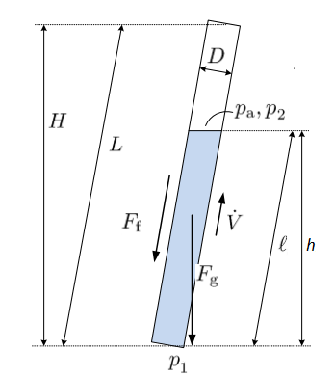

The model for the surge volume can be described by mass and momentum balances as follows:

Here, ;

;

;

;

.

The manifold is described by the preservation of mass in steady state; the volumetric flow rate in the intake race equals the sum of volumetric flow rates from surge volume and penstock:

Also the manifold pressure is equal for all three connections.

…

## Penstock

The schematic of the penstock can be presented as below:

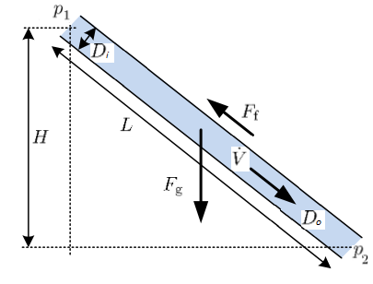

In simple cases, the model of the penstock can be described as a simple pipe model that was presented above. But for more detailed studies, the water compressibility and elasticity of the penstock walls should also be taken into account due to the big pressure difference in the penstock, which supposed by the big height difference. To make this, some compressibility coefficients, which shows the relationship between pressure, water density and pipe inner radios, are introduced:

This equation can be rewritten in way that is convenient to calculate fluid density at different pressures:

The same equations can be written for the pipe inner surface using the equivalent compressibility due to the pipe shell elasticity:

Where sum of these compressibility coefficients define the total compressibility due to water compressibility and pipe shell elasticity:

And the last one can be define through the speed of sound in water inside the pipe:

And also is used for define the product ():

Also all these three pressure depended equations can be simplify for linear form:

Using these formulas for the momentum and mass balances for the pipe, the partial differential equations are defined:

where:

These PDE can be discretize with Staggard grid (like in Behzad’s thesis []) or KP07 schemes. Here then comes the comparison of these two method together with simple pipe model without compressibility and elasticity.

From Behzad’s thesis, using the simple Staggered grid for discretization, the discretized differential equations for the penstock with elastic wall and compressible water are as follows:

where:

In case of using the KP07 scheme, firstly the common form of PDE will be presented:

Combined and in a state vector, the next PDE can be written:

where:

In reference to [], solution for this PDE is as follows:

Where is the central upwind numerical fluxes and given as:

With being the one-side local speeds of propagation and can be defined as the smallest and the largest eigen values of the Jacobian of the system. That is why; the Jacobian should be defined, which is shown next:

From this Jacobian matrix, it can be easily defined the eigenvalues.

Detailed description of this scheme is shown below in the relative Section.

…

## Open Channel

For simplification the rectangular open channel will be used and it looks like below:

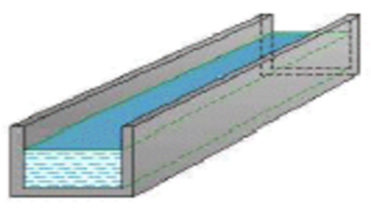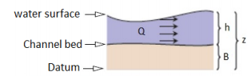

Detailed description of the model where done before [], but should be noticed here that model based on Saint Venant equation (PDE) and KP07 is used for discretization. Model looks as follows:

where:

with:

Here, – water depth in the channel, – the channel bed elevation, – discharge pre unit width of the open channel.

The KP07 scheme is describe before, but here some additional specific details for open channels should be added.

Firstly, the eigen values for this model are defined as follows:

where, – the cross section average water velocity.

…

# Mechanical part modelling

## Turbine

In simple case, the turbine can be divided into the hydraulic part and the rotor-shaft-aggregate part, with transfer of generated shaft power from the hydraulic volume to the rotor shaft. It can be seen in figure below:

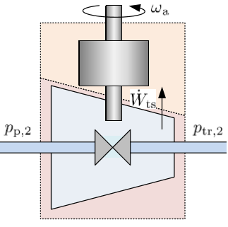

The pressure drop from the penstock exit, over the hydraulic part of the turbine to the turbine rotor exit is . In a simplified description, the turbine shaft power can be expressed from energy balance as:

where gives the hydraulic loss through the turbine (friction, shock loss, whirl dissipation, etc.) while is the volumetric flow rate through the penstock and the turbine. The term represents the kinetic energy flow rate.

For simplicity, the hydraulic part can be described as a valve (orifice) and vs. relation then can be presented as following expression:

where is some guide vane “valve capacity”; is the guide vane signal, with value in the range [0,1].

…

## Francis Turbine

It is the radial flow turbine, where the guide vane opening controls the amount of water flowing through the turbine.

The shaft power which is produced in the turbine and transferred to generator can be defined as follows:

where, is the losses in the turbine due to shock, whirl effects and friction. is the difference in a work rate through the turbine and can be defined from the Euler’s turbine equation:

Here, using figure below reference velocity , tangential velocity and radial velocity can be defined as follows:

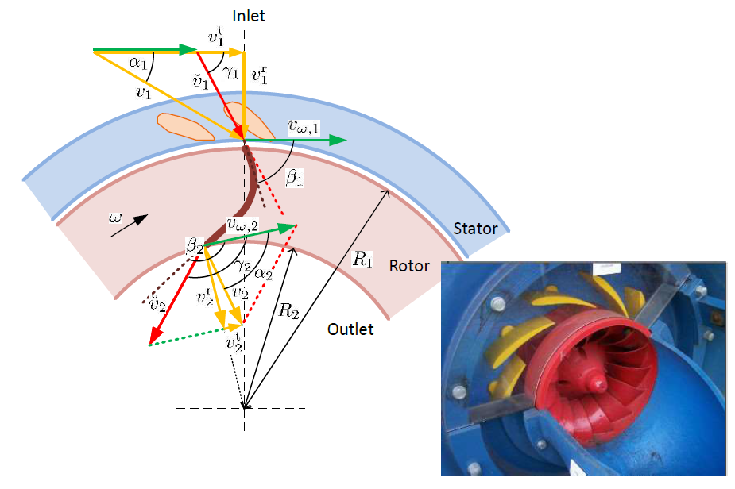

,

,

,

,

.

Hence:

Here should be mentioned that is an angel of guide vane and is an input for the model. is the turbine outlet blade’s angel and is a design variable (common values 160°÷170°).

The losses term consists of the three following parts:

1. Friction shock loss which is incurred when the turbine is working with not nominal conditions. Due to no-shock condition the inlet blade’s angel is designed, such that for nominal operating and then in other case:

Then the shock friction loss can be expressed as follows:

1. Whirl and hydraulic friction loss is also accrued due to the not nominal operating conditions. No-whirl effluent condition assumed that and it can be used for design the outlet cross section area . Here:

And the whirl and hydraulic friction loss can be expressed as follows:

1. Wall friction loss which is standard friction loss. Can be defined as follows:

Then:

There is also pressure drop through the guide vanes, which can be easily expressed from the energy balance. The formula for this pressure drop will look as follows:

Here, is a cross section area opening through the guide vanes and can be defined as: . is a cross section area of the entrance to the turbine.

…

Algorithm for the turbine design, with given nominal net head and volumetric flow rate through the turbine :

1. Choose the outlet blade angel and reference velocity . These values are usually in the interval[1]:

Here outlet angel and reference velocity take higher values for higher heads. In reference to the same author[2] these interval can be varies a bit ( and ) .

1. Define outlet the outlet cross section area (diameter ) and adjusting it with reference velocity to the normal synchronous speed.

Firstly, from the vector diagram the radial velocity can be define as:

then outlet diameter can be define from outlet cross section area*:

From other hand, it can be formulated from no-whirl effluent condition:

Then the turbine speed can be calculated:

After this the turbine speed should be reduced to the nearest synchronous speed (depends on pole pairs in the generator, frequency is constant 50 Hz) and then the outlet diameter with the reference velocity should be recalculated in backward.

*\* the outlet cross section area can be defined as or . According to Brekke 2001 the first formula is used. Second formula leads to more complex calculating due to two unknowns and .*

1. Choosing the inlet dimension, inlet cross section area (diameter and width ).

The inlet diameter can be defined from the reference velocity as follows:

Here, the reference velocity can chosen from the range for reduced value (0.6÷0.9[3]), which is dimensionless and expressed as:

From Brekke 2001, it is normal to use .

The tangential velocity can be also defined from reduced value.

Another way to define the reference velocity can be from assumption that approximately 50% of the energy in front of the runner is converted to kinetic energy (Brekke 2001), which then make a possibility to calculate the absolute velocity as follows:

And then it is possible to define the tangential velocity from the velocity diagram[4]:

Assuming the hydraulic efficiency , the reference velocity can be calculated as follows:

Commonly, an acceleration of the flow through the runner is desirable, in order to avoid back flow in the runner. That is why the inlet radial velocity can be chosen approximately ten percent lower than outlet.

According to the constant volumetric flow rate the inlet area can be define from:

Then the inlet width can be calculated as follows:

Or:

Here should be noted that the blade thickness can also be include for the calculation of the inlet cross section area, e.g. 10% of the perimeter (Brekke 2001).

It is also possible to find the inlet blade angel from the vector diagram:

1. Diameter of the guide vane suspension circle can be define from known inlet runner diameter and speed number[5],[6]:

…

## Aggregate

The aggregate is the combined turbine rotor and electric generator rotor. The aggregate angular velocity mainly depends on its inertia, internal friction and available power. The kinetic energy stored in the rotating aggregate is , where is the angular velocity of the aggregate and is its moment of inertia. Schematic of the aggregate loaded with power is shown below:

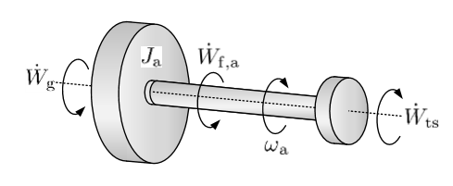

The kinetic energy is changed by power terms operating on the aggregate axis, e.g., the turbine shaft power produced by the turbine, friction power , and power taken up by the generator, . And from energy balance, can be expressed as follows:

is the frictional power loss in the aggregate. This frictional power loss is mainly due to losses in the shaft supporting bearings, losses in the transmission gearboxes and losses in the windage (air gap). For simplicity, it is assumed that the bearing term is dominating, and express as

where is the bearing friction factor.

The power taken up by the generator, is transmitted to the grid with electric efficiency , thus the electric power available on the grid is

…

# Friction force

The friction force is directed in the opposite direction of the velocity of the fluid. Expression for friction force in fluid pipe using the Darcy friction factor is the following:

where – length of the pipe, – diameter of the pipe.

The Darcy friction factor is defined in respect to Reynold’s number and depends on which different formulas can be used. The Reynold’s number is calculated as follows:

where – dynamic viscosity of water and – water density.

Depends on the Reynold’s number, the flow can be:

* Turbulent (), which is a flow regime where the velocity across the pipe has a stochastic nature, and where the velocity is more or less uniform across the pipe. In this case the Darcy friction factor can be defined as follows:
* Laminar (), which is a flow regime with a regular velocity which varies as a parabola with radius of the pipe, with zero velocity at the pipe wall and maximal velocity at the center of the pipe. Can be calculated in the following way:
* Transitional zone between the laminar and turbulent regions ()m which can be defined by the interpolation expression, in this case the cubic fitting with the same slope as laminar friction at and turbulent friction at will be used. To achieve global differentiability, with , thus:

which gives the solution for 4 unknowns: .

…

# Modelling of the fittings

Due to different constrictions in the pipes, it is of interest to define losses in these fittings. This can be done based on friction pressure drop which can be calculated as:

where the dimensionless factor is for a long, straight pipe. Here, will be the generalized friction factor. In this case then, it is possible to write pressure drop for different constrictions.

Some cases of different fittings are presented below:

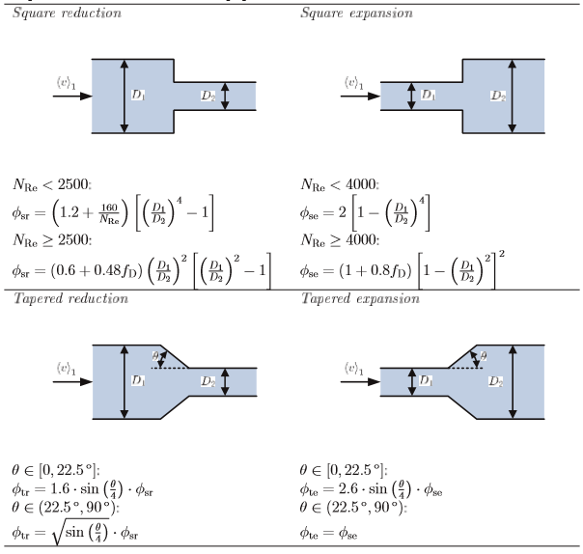

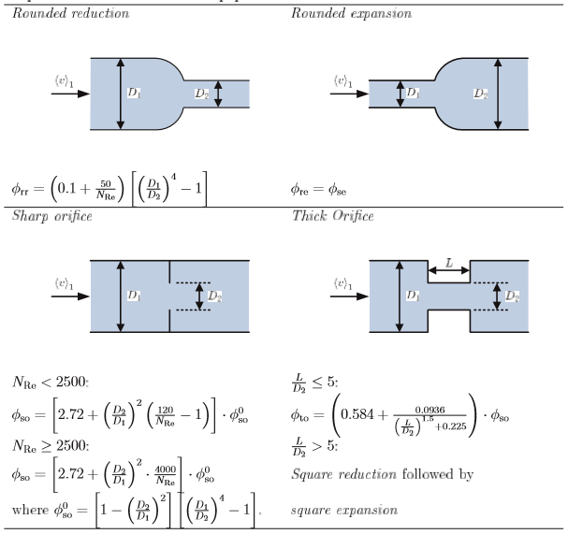

…

# Kurganov-Petrova scheme

This is a well-balanced second order scheme, which is a Reimann problem solver free scheme (central scheme) while at the same time it takes the advantage of the upwind scheme by utilizing the local, one side speed of propagation (given by the Eigen values of the Jacobian matrix) during the calculation of the flux at the cell interfaces.

The central-upwind numerical scheme is presented for one dimensional case.

with e.g.:

The semi-discrete (time dependent ODEs) central-upwind scheme can be then written in the following from:

where the central upwind numerical fluxes at the cell interfaces are given by:

with being the one-sided local speeds of propagation.

For calculating the numerical fluxes , the values of are needed. These can be calculated as the end points of a piecewise linearly reconstructed function:

The slope of the reconstructed function in each cell is computed using a limiter function to obtain a non-oscillatory nature of the reconstruction. The KP07 scheme utilizes the generalized minmod limiter as:

It can be observed that for a given *i­th* cell, information from the neighboring cells *i*-1 and *i*-2 (to the left) and *i*+1 and *i*+2 (to the right) are required for calculating the flux integrals. This will pose difficulties at the cells on the left and right boundaries. While evaluating the flux integrals near the left boundary cells (*i*=1 and *i*=2) and near the right boundary cells (*i*=*N*-1 and *i*=*N*; *N* being the number of cells in the grid), imaginary cells that lie outside the physical boundary should be taken into consideration.

These imaginary cells denoted by *i*=0 and *i*=-1 on the left, and *i*=*N*+1 and *i*=*N*+2 on the right are called ghost cells. The average value of the conserved variables at the center of these ghost cells depend on the nature of the physical boundary taken into account. These ghosts cells can be defined in the following way:

The one-sided local speed of propagations can be estimated as the largest and the smallest eigenvalues of the Jacobian of the system as:

The last, the source term has to be appropriately discretized to ensure that the method is well-balanced. This can be written as:

…

# Simulation

## Validation

Models validation against model from Modelon Hydro Power library is shown in figure below.

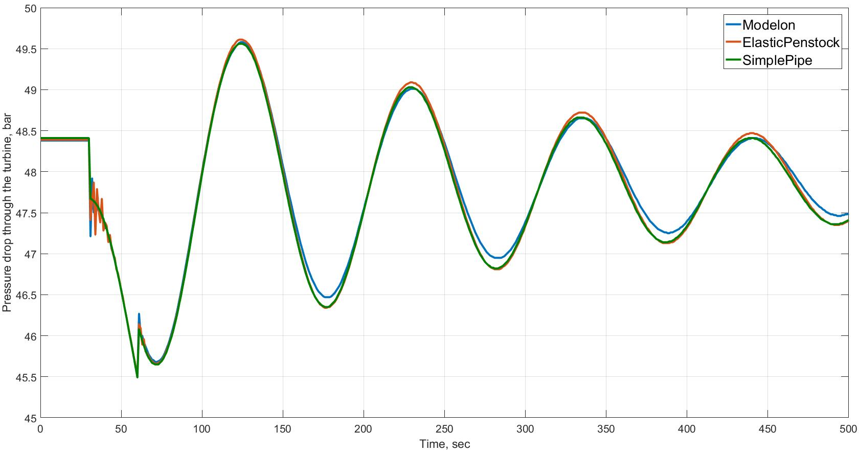

## Method comparison

Firstly, the method that were used in Behzad’s thesis is presented, where the penstock was divided into 20 compartments and the volumetric flow rate in the first, last and middle cells are shown in figure.

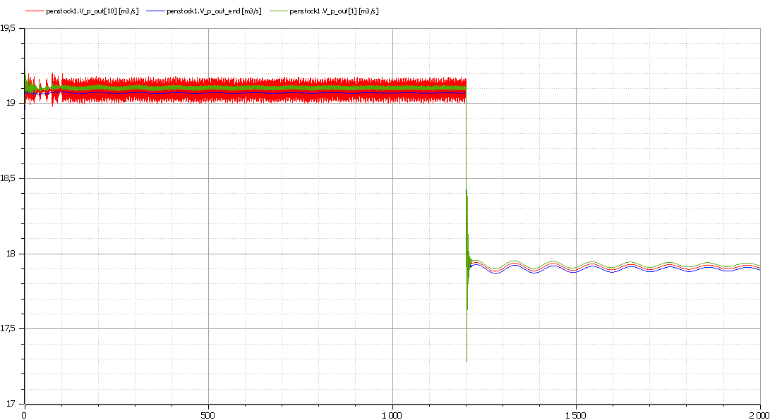

Here it is seen that this method shows some oscillatory results, especially the volumetric flow rate in the first and middle cells. It should be noticed that increasing the number of compartments affect to these oscillations, but still does not make results stable enough.

The results of using the KP07 scheme looks better and more stable. The penstock is also divided into 20 cells in this case. The volumetric flow rate in the first, last and middle cells are shown in figure. From this figure, the results are not oscillatory as much as from the previous one.

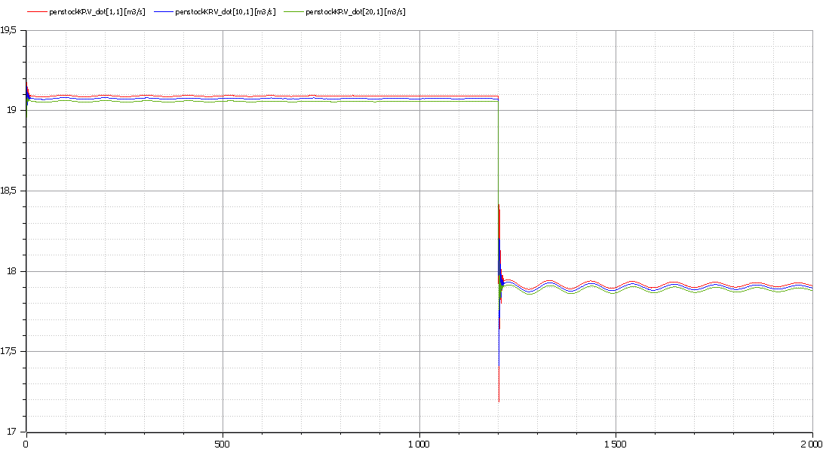

Now the comparison of results from these two methods together with results from simple pipe model will be done. For this, the volumetric flow rate through the turbine and the turbine pressure drop will be compared.

Firstly, the volumetric flow rates through the turbine form different penstock models are presented in the figure. Zoomed plot of these result is also added to make difference between methods more visible.

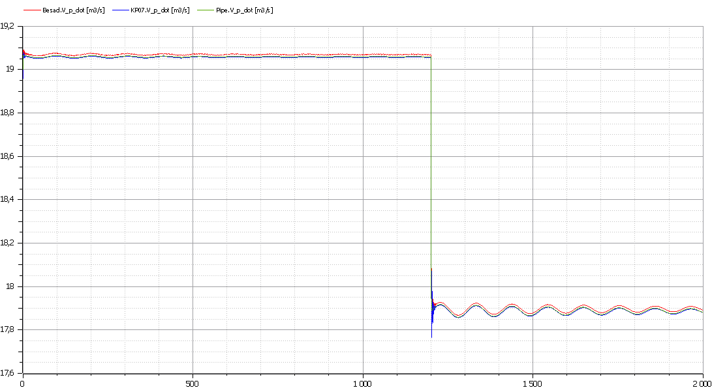

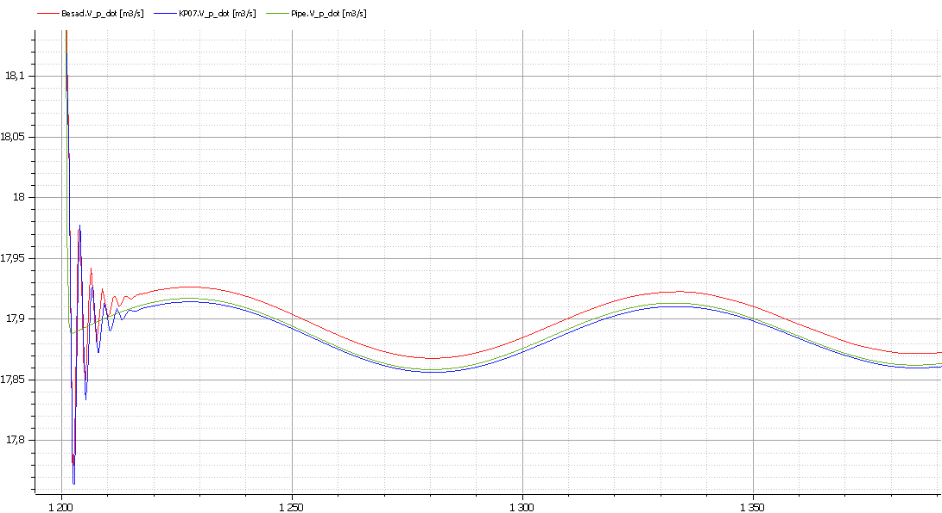

As it is seen from these figures, the results form different models are quite the same. There is just small difference in behavior of more complex models with compressible water and elastic walls, which is seen between 1200 and 1220 sec, where the result from simple pipe model is more smoothed and two other results show some oscillations.

After this the turbine pressure drop form different penstock models are presented in the figure. There is also added zoomed plot of these result.

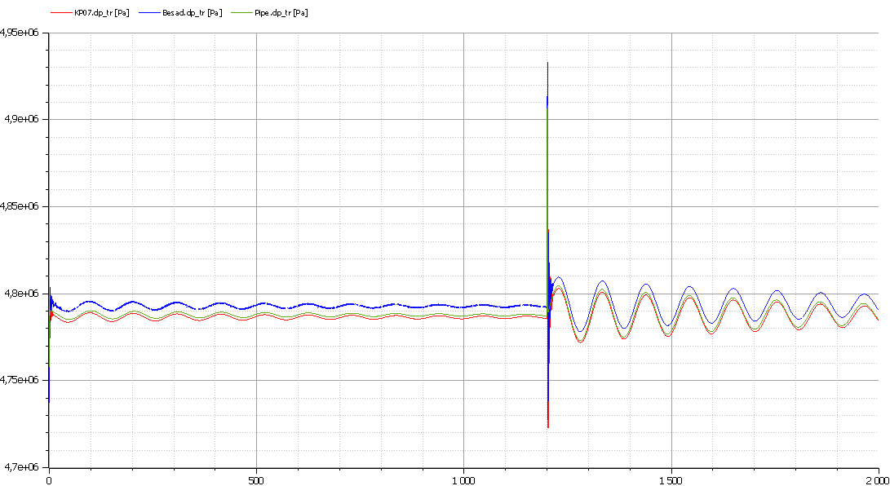

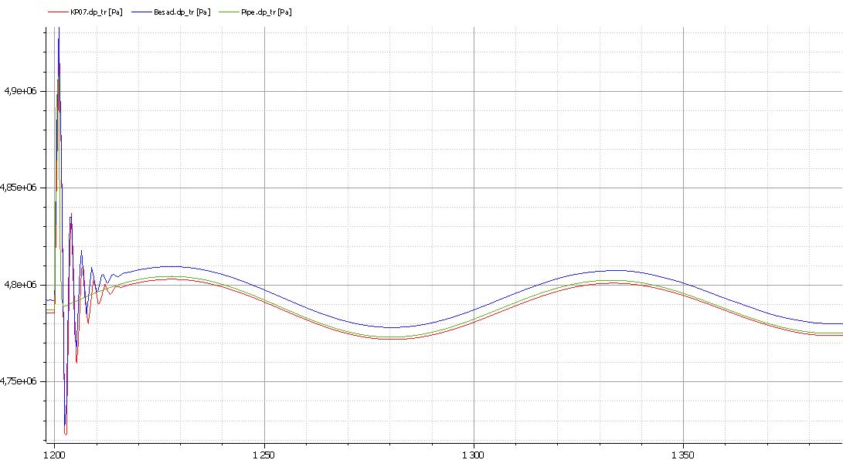

As in the figures with volumetric flow rates, the turbine pressure drop results look also quite the same and there is also some oscillations in the results form more complex models, which is not visible for simple pipe model. There is also some small difference in the pressure values for models discretized by KP07 scheme and other. This value difference were also visible from figures with volumetric flow rates and can be caused by the different values that are used for the output form penstock in these methods.

Also it is of interest to compare KP07 scheme (solving PDE) with simple pipe model for the penstock (ODE). This comparison is presented below, for the volumetric flow rate through the turbine:

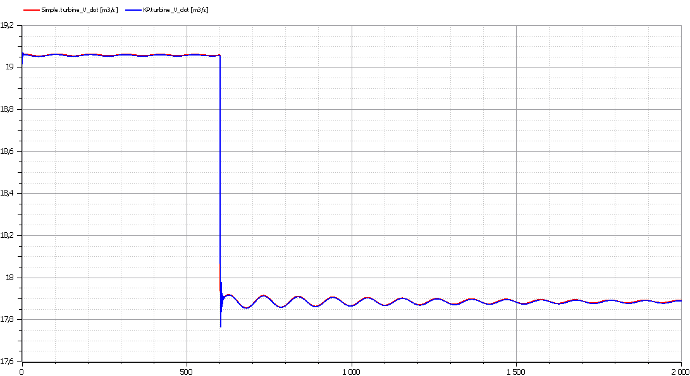

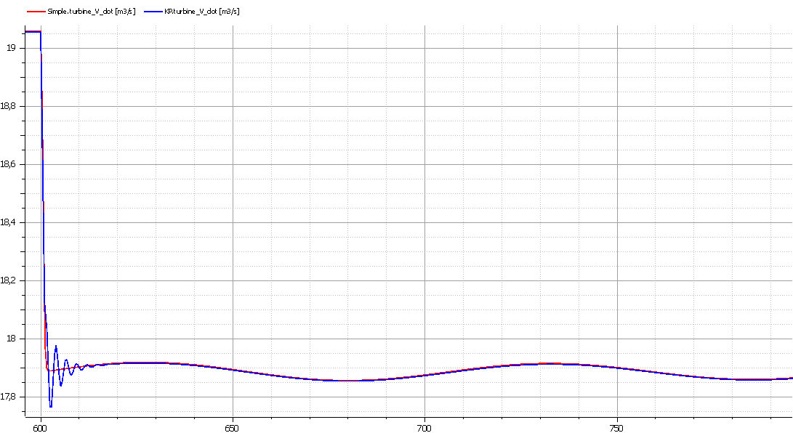

As it was seen also before, there is small difference, caused by the oscillations at time 600 - 620 sec. for the elastic penstock (PDE, KP07 scheme). Also it should be noticed that simulation time is varying:

* Penstock as simple pipe (ODE) – 0.88 sec (OpenModelica) – 0.16 sec (Dymola);
* Elastic penstock solved by KP (PDE) – 4.52 sec (OpenModelica) – 0.82 sec (Dymola).

## Surge tank studying

**Diameter reducing**

It is of interest to compare simulation results for the hydropower system with surge tank that has different diameter. For this, the models with different penstocks will be used (simple pipe model and model with compressible water and elastic walls discretized with KP07 scheme).

Firstly, the results from model with simple pipe as a penstock is considered, where the surge tank has two diameter values: 3.4 m as it was provided from before and half of previous diameter 1.7 m. The results of the pressure drop in the turbine are presented in figures.

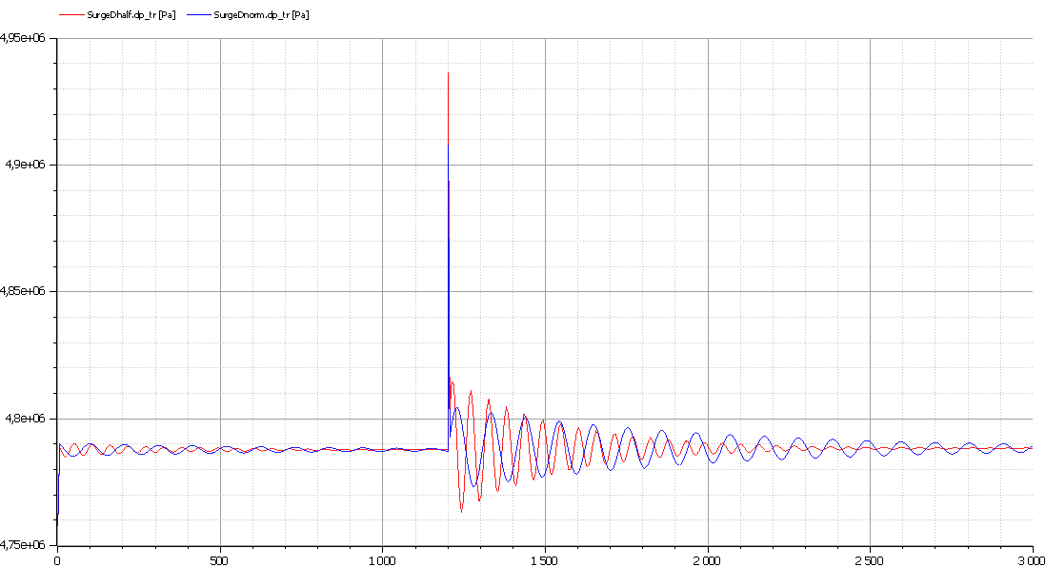

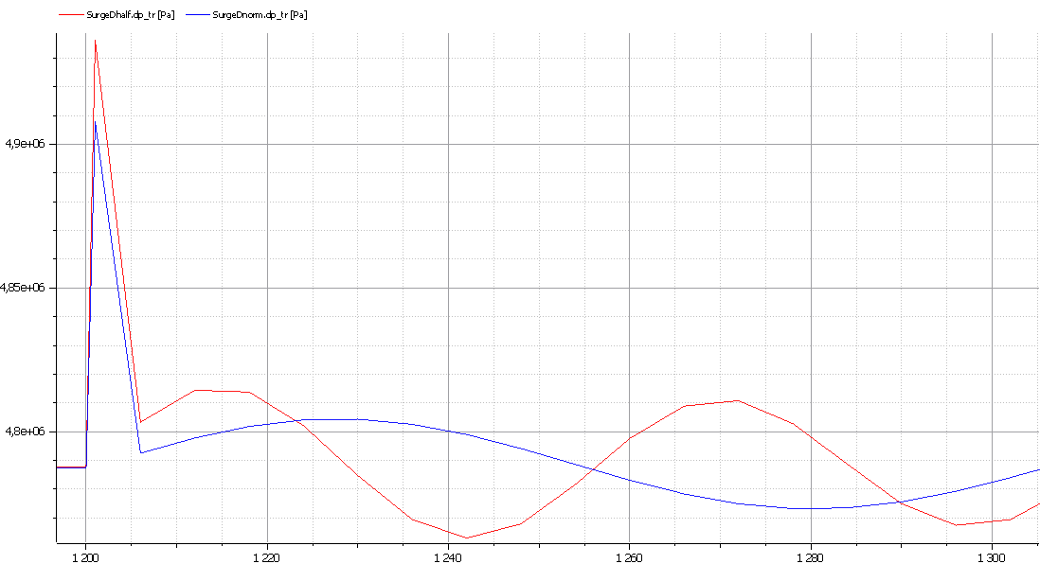

Here it is seen that reducing of the surge tank diameter leads to faster oscillations damping and from other side to increasing the amplitude of oscillations.

In a case with more complex model with elastic penstock and compressible water in it, the result of the pressure drop in the turbine are presented in following figures. The variation of the surge tank diameters is as previously.

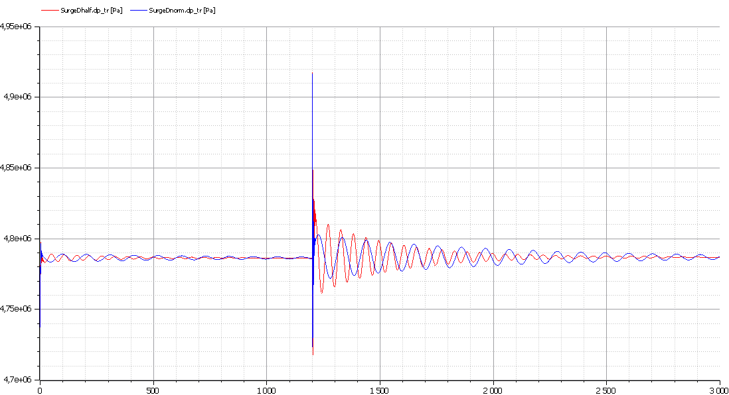

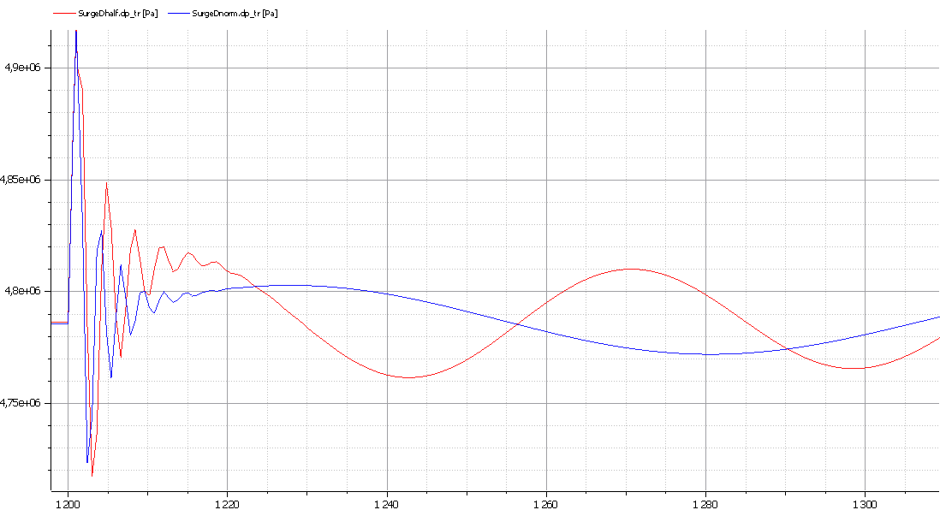

These figures shows that more detailed model of the penstock did change the damping behavior of the oscillations in the turbine pressure drop, but it affect to the amplitude of the oscillations, which looks smaller than for the previous case.

**Surge tank effect**

There is also of interest to see behavior of the hydropower system when the surge is removed. The model with elastic penstock and compressible water in it is going to be used. The turbine pressure drops are compared for this model with and without surge tank. The results are show in figures.

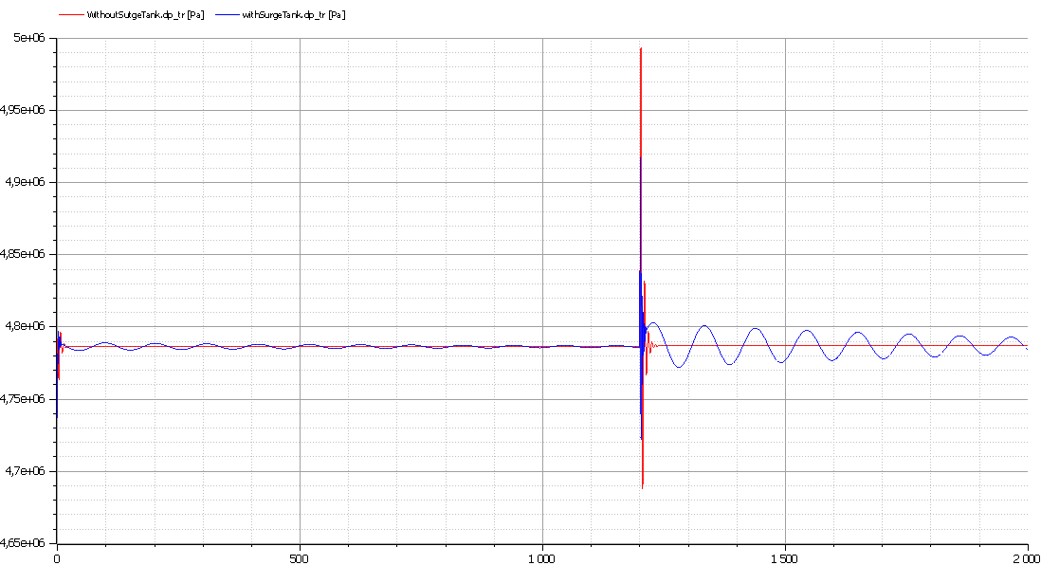

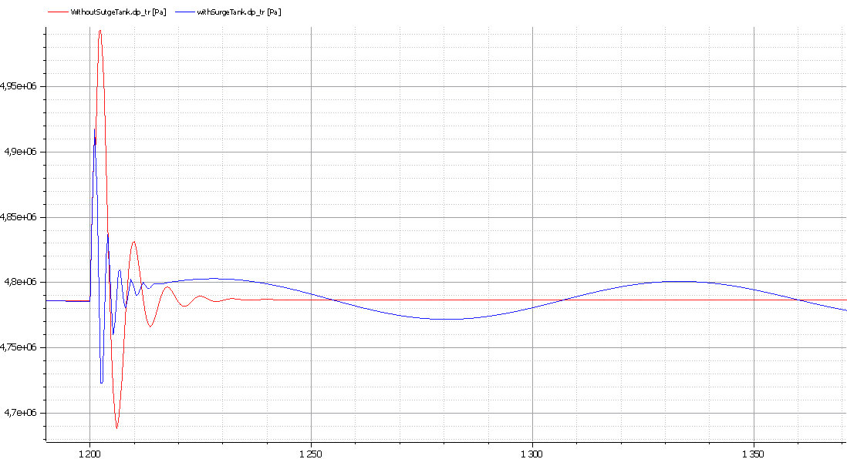

1. P. J. Gogstad. Hydraulic design of Francis turbine exposed to sediment erosion. Master thesis, NTNU. Appendix A. (referenced to the Hermod Brekke’s book on Norwegian) <http://www.diva-portal.org/smash/get/diva2:536445/FULLTEXT01.pdf>
2. Hermod Brekke, Hydraulic Turbines. Design, Erection and Operation. 2001: <https://www.ntnu.no/documents/381182060/1267681377/HYDRAULIC+TURBINES_Hermod+Brekke+-+2015.pdf>
3. <http://164.100.133.129:81/eCONTENT/Uploads/15-Hydraulic%20Turbines-new031211%20%5BCompatibility%20Mode%5D.pdf>
4. Khanal, K., and all. A methodology for designing Francis runner blade to find minimum sediment erosion using CFD. Renewable Energy, 2016. <http://www.sciencedirect.com/science/article/pii/S0960148115303761>
5. The speed number is a dimensionless expression for rotation speed at a given head at best efficiency point: , where: and .
6. <https://www.researchgate.net/publication/274721814_Guide_vanes_in_Francis_Turbine>