**U.S Agricultural Output**

Presenters: Aurelian F, Maria DP, Sudip P

**Vision**

Our aim is to help our audience visualize the U.S agricultural production over the year 2017. To achieve this, we will produce an interactive map that will contain various information about agricultural products across the country. The platform will help the viewer identify the diversity and intensity of the U.S agricultural output.

**Data sources**

USDA: <https://quickstats.nass.usda.gov/>

Agricultural News: <https://www.agriculture.com/news/crops>

Open Weather: <https://openweathermap.org/api>

Images: <https://world-crops.com>

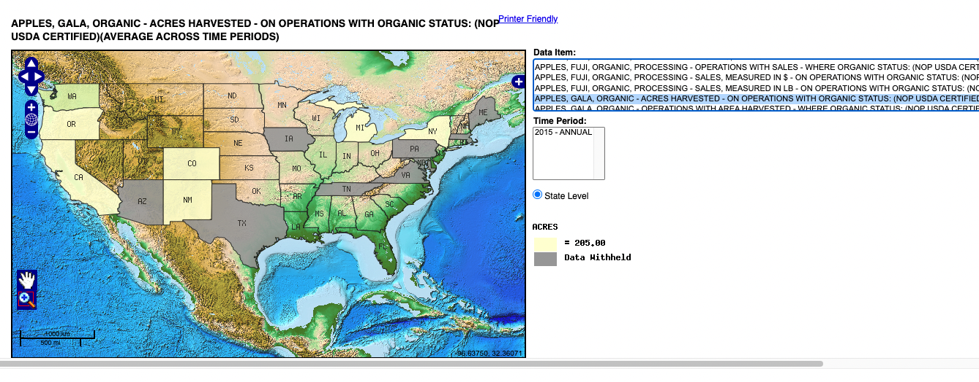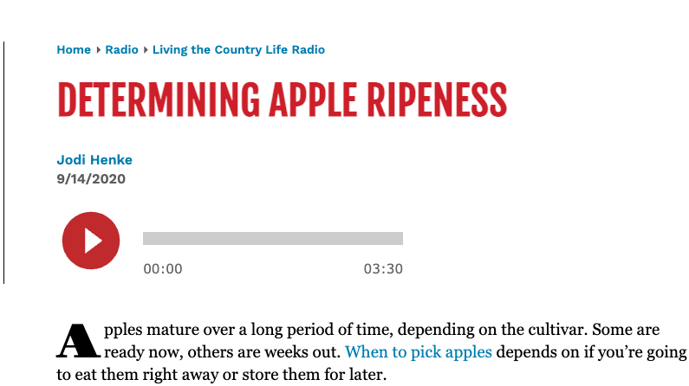

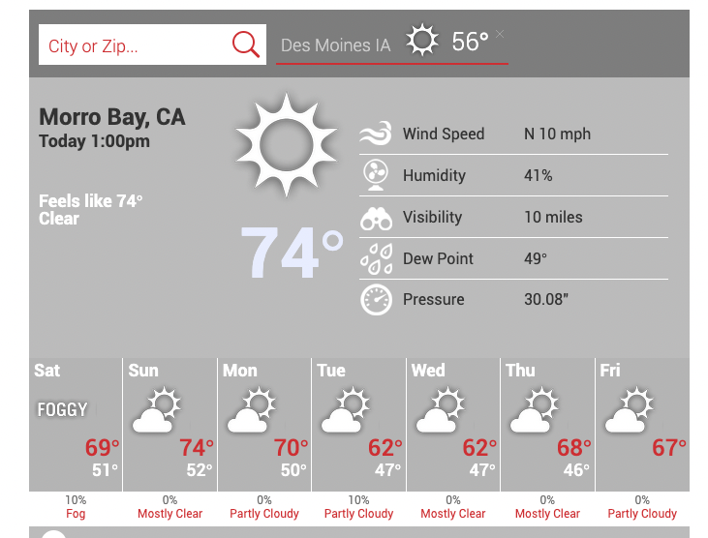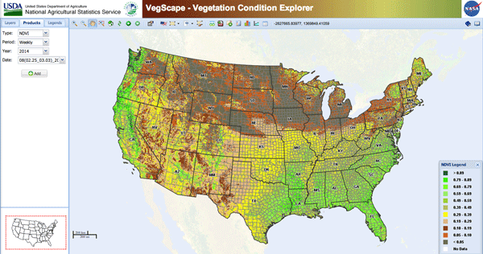

**Sketch**

The website will contain an overview description of the US agriculture, then an interactive map where the viewer will obtain information by clicking or hovering their mouse on the various counties. A comparison of sales of specific crops per county, by State will be provided with graphs. Peripheral info will be provided to the viewer, such as images of the specific crop, and local agricultural news concerning the specific crop. Weather info will also be provided to give the viewer an idea of the local climate and conditions for growth of the specific agricultural product.

The information will be displayed in the form of a marker. A link to a glossary will be provided and a legend applied to the map.

**GitHub**

<https://github.com/pandeysudip/us-agriculture.git>

Tasks:

Maria HTML/CSS

Aurelian Graphing the Data

Sudip: Database structure