MPLADS Risk Intelligence & Investigation Engine
Complete Locked Build Architecture, Data Strategy, Scoring Logic & Demo Flow
SIH 2026 — Problem Statement SIH26102
LOCKED SPEC — Do not expand core architecture during the 48-hour build.
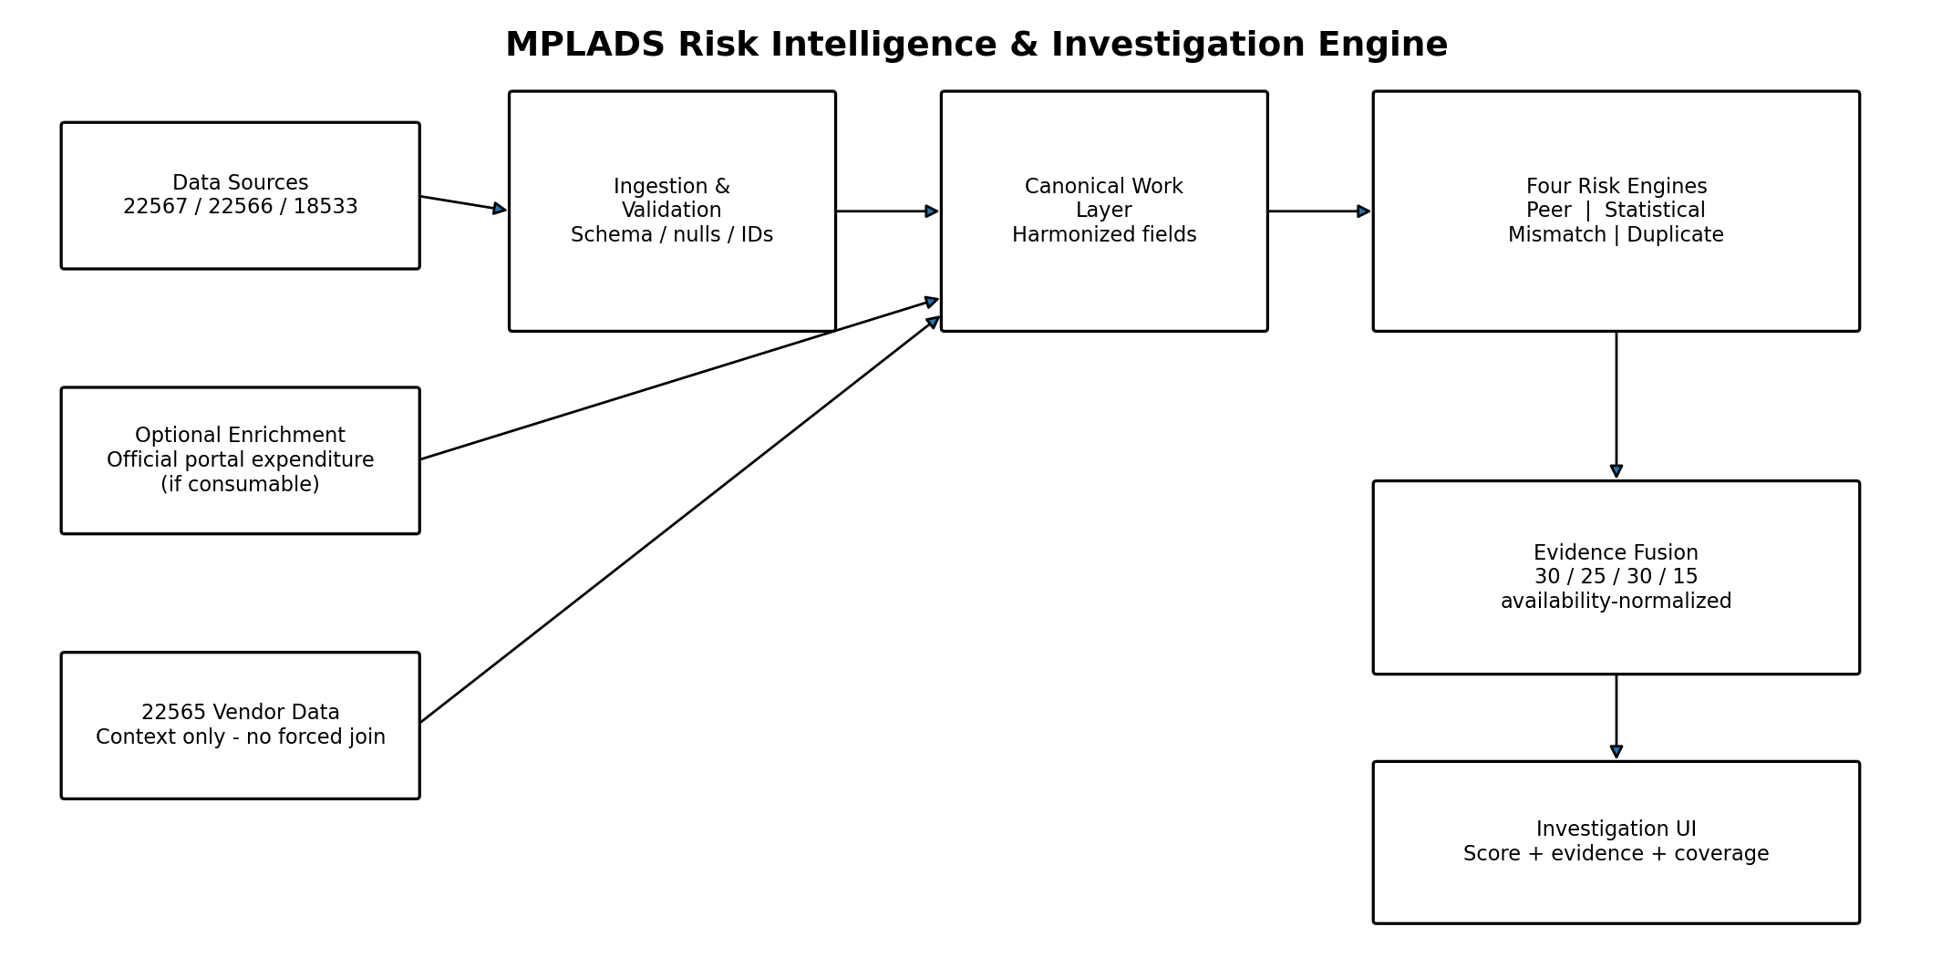

1. Executive Definition
The system is an explainable MPLADS risk-intelligence prototype that evaluates individual works using four independent evidence engines: Peer Benchmarking, Statistical Outlier Detection, Financial–Execution Mismatch, and Duplicate/Overlap Detection. Their outputs are combined by a simple availability-normalized evidence-fusion layer into a 0–100 risk score, with an investigator-facing explanation and data-coverage indicator.

What the system is not
- It is a risk-screening and investigation-support system, not a fraud verdict engine.
- It does not invent expenditure, physical progress, GPS coordinates, vendors, or other unavailable fields.
- It does not use SHAP, Isolation Forest, Benford’s Law, GPS matching, forecasting, or vendor-graph analysis as core components.
- It does not force joins between datasets whose granularity or keys cannot be validated.

2. Locked Architecture Principles
Principle | Implementation rule
Real-data first | Every live score must be traceable to fields that actually exist in the selected source data.
Four-core-only | The four risk engines remain the architecture. Cheap rule add-ons are optional and never replace a core engine.
Explainability by construction | Every engine returns the values, peer cohort, rule/threshold, and reason that produced its score.
Availability-aware | Missing fields reduce module availability; the final score is renormalized over available modules.
Conservative claims | An anomaly means “investigate”; it does not mean fraud is proven.
No black-box dependency | Primary scoring is deterministic statistics/rules, not an unvalidated ML detector.
Data granularity honesty | Project-level evidence is only used when the row-to-work relationship is validated.

3. Data Sources — Exact Selection
The prototype uses a layered data strategy. Raw datasets are cached locally so the demo is reproducible and does not depend on a live external download during presentation.
Dataset | Role | Key fields used | Do not use for
22567 — 18th Lok Sabha Recommended Works | Primary current-work layer; recommendations, category, description and organization context. | state, implementing_district, loksabha_constituency, MP, work_category, unique_work_number, work_name, work_description, date_of_recommendation, recommended_amount, image_status, implementing_agency_name | Treating NA work numbers as exact IDs; project-level expenditure.
22566 — 18th Lok Sabha Completed Works | Completion evidence and completed-work amount; source for completion date, category, description, images/status. | unique_work_number, work_name, work_category, implementing_district, constituency, implementing_agency_name, work_description, date_of_completion, amount, image_uploaded, image_status | Assuming every recommended work has a matching completed row.
18533 — 17th Lok Sabha Works | Historical benchmark/reference layer; long time span and explicit work status. | state, district, constituency, MP, sanction_amount, proposal date, admin approval date, work_name, unique_work_number, agency, work_status | Assuming all administrative approval dates or agency fields are complete; using NA IDs as real keys.
22565 — 18th Lok Sabha Vendor-level Expenditure | Context/enrichment only. Used only for descriptive vendor views or future enrichment where aggregation is honest. | state, district, constituency, MP, work_name, agency, vendor_name, expenditure_date, payment_status, expenditure_amount | Joining to an individual work and assigning vendor spend as that project’s exact expenditure.
Official MPLADS guidelines / portal | Rules, category eligibility, scheme thresholds, and optional portal-level context. | Guideline text; portal report fields when accessible | Creating a synthetic physical-progress percentage or assuming an undocumented threshold.

Verified current metadata: 22567 = 73,764 rows / 16 columns; 22566 = 11,077 rows / 17 columns; 22565 = 96,541 rows / 13 columns; 18533 = 73,305 rows / 17 columns. 22567 currently shows `unique_work_number` values including NA in the visible preview, so the full-field population test is mandatory before any exact join.

4. Data Ingestion & Canonical Work Layer

4.1 Acquire and cache
- Download or export the four Dataful datasets once into data/raw/. Store the original file unchanged.
- Prefer Parquet for the working copy for fast reads; retain CSV/XLSX only as source snapshots if needed.
- Keep a source manifest containing dataset ID, source URL, retrieval date, file checksum, row count, and column count.

4.2 Standardization
- Normalize column names to snake_case while preserving a source-column map.
- Convert empty strings, blank strings, textual NA variants (NA, N/A, null, None, -) to proper missing values.
- Parse all date columns with day-first-safe parsing and retain a parse-error flag.
- Parse monetary fields by stripping commas, currency symbols and whitespace; retain original raw field for audit.
- Normalize text for matching: lowercase, Unicode normalization, punctuation removal, whitespace collapse, common abbreviation normalization.
- Normalize categorical values for state, district, constituency, category, agency and status without destroying the original display value.
- Create a canonical work record with source_dataset, source_row_id and source_priority fields.

4.3 Canonical schema
Canonical field | Source mapping | Purpose
work_id | unique_work_number when valid | Exact identity key; only trusted when populated and collision-checked.
work_description | work_description / work_name | Text similarity, duplicate detection, investigator display.
work_category | work_category | Peer cohort + eligibility rules.
state | state | Peer cohort / filtering.
district | implementing_district or compatible district field | Peer cohort + blocked duplicate candidate pool.
constituency | loksabha_constituency / constituency | Peer cohort + locality context.
mp_name | loksabha_MP_name / mp_name | Context and investigator view.
agency_name | implementing_agency_name | Peer cohort + duplicate/entity signal.
amount_recommended | recommended_amount | Current financial scale.
amount_sanctioned | sanction_amount | Historical financial scale.
amount_completed | amount | Completed-work financial evidence when matched.
proposal_date | date_of_recommendation or proposal-date equivalent | Age/duration proxy.
approval_date | date_of_administrative_approval | Historical timing feature when present.
completion_date | date_of_completion | Completion-duration evidence when matched.
work_status | work_status when available | Mismatch hierarchy Level 1 status signal.
image_status | image_status/image_uploaded | Completion evidence context; not treated as physical-progress percentage.
source_as_of | data_as_on | Snapshot date and reproducibility.
source_dataset | dataset ID | Traceability.
source_row_id | generated stable row key | Audit/debugging.
match_method | exact / approximate / none | Join confidence and audit trail.
match_confidence | high / medium / low / none | Prevents accidental overclaiming.

5. Mandatory Join-Key Validation — FIRST DAY-ONE CHECK
This is now an explicit gate, not an assumption. Before implementing the Financial–Execution Mismatch join, compute the population and uniqueness of unique_work_number in 22567 and 22566.
Check | Pass condition | Action
Non-missing ID rate — 22567 | Measure, do not assume; report exact percentage. | Proceed with exact join only for valid IDs.
Non-missing ID rate — 22566 | High population expected; verify. | Use as completion-side identity source.
Uniqueness / duplication | No silent many-to-many joins. | Detect duplicates; dedupe only with a deterministic latest-record rule and conflict flag.
Exact match coverage | Record count and percentage of 22567 valid IDs found in 22566. | Show coverage in the UI.
Field consistency after match | Description/category/agency/locality should be sufficiently consistent. | Create conflict flags; do not hide them.
Low-match contingency | If exact coverage is weak, do not fabricate completion joins. | Use an explicit approximate candidate matcher only as lower-confidence fallback or leave unmatched.

5.1 Approximate matching fallback — only when needed
Fallback is not a replacement for the exact key. It is a constrained candidate-matching path for records with no valid exact key. A candidate must be blocked by locality/context first, then ranked by similarity.
- Blocking keys: same state; then same district where available; then same constituency; then compatible work category and implementing agency.
- Text similarity: sentence-transformers all-MiniLM-L6-v2 cosine similarity on normalized work descriptions.
- Entity similarity: RapidFuzz token-set/token-sort similarity on agency names and supporting fields.
- Amount consistency: compare recommended/sanctioned amount to completed amount where both exist; large unexplained divergence lowers match confidence rather than automatically rejecting.
- Date plausibility: recommendation/proposal date should fall before completion date by a sensible interval.
- Only return a match when the combined score exceeds a fixed threshold and the margin over the second-best candidate is sufficient.
- Label all such matches match_method=approximate and confidence=low/medium. They cannot be described as exact work-ID joins.

6. Engine 1 — Context-Aware Peer Benchmarking (30%)
Purpose: determine whether a work is unusual relative to the right comparison set, not the entire country blindly.

6.1 Peer cohort hierarchy
- Same district + same work category + compatible period/year bucket.
- If the cohort is too small, widen to same state + same category + compatible period.
- If still too small, widen to national + same category + compatible period.
- If still below the minimum peer count, mark the module unavailable rather than inventing a benchmark.
Minimum practical cohort target: 10 comparable works. Use the fallback ladder automatically so live demo selections never silently return an empty peer set.

6.2 Statistical comparisons
- Primary robust baseline: peer median.
- Robust spread: IQR = Q3 − Q1.
- Percentile position: percentile rank within cohort.
- IQR-based deviation for amount/other numeric features; avoid fragile mean/std-only logic when distributions are skewed.
- Feature-level outputs are converted to bounded 0–100 module scores and accompanied by raw peer counts and values.

6.3 Example evidence
“Recommended amount = ₹10.0 lakh; peer median = ₹5.5 lakh; percentile = 96th; cohort = 41 works; district/category fallback = same district + category.”

7. Engine 2 — Statistical Outlier Detection (25%)
Purpose: capture unusual numeric patterns using transparent robust statistics. This is not a black-box anomaly model.
Signal | Calculation | Output
Amount outlier | Robust IQR distance or percentile rank within the selected peer cohort. | signal_score + evidence text
Relative scale anomaly | Amount / peer median or equivalent relative ratio. | ratio + severity band
Timing anomaly | Elapsed time compared with peer timing distribution when dates exist. | days + percentile/IQR evidence
Data quality anomaly | Missing/contradictory fields that materially affect detection. | coverage/quality warning, not automatic fraud score

Primary method: deterministic IQR/Z-score-style robust rules. Isolation Forest is explicitly excluded from the core scoring path.

8. Engine 3 — Financial–Execution Mismatch (30%)
This engine follows a strict evidence hierarchy: Status → Time → Actual Physical Progress. Higher levels supersede lower-confidence proxy evidence when genuinely available.

8.1 Level 1 — Status / financial-exposure or expenditure mismatch
- Preferred observed signal: when a valid work-level expenditure value is available, compare financial spend/expenditure exposure to reported work status.
- Example: a work marked ongoing while a very high share of available financial amount has already been spent is a review signal.
- Where project-level expenditure is unavailable, use a clearly labeled proxy based on status + financial exposure (sanctioned/recommended amount) + project age. Never present this proxy as actual spending.
- No fabricated status-to-percentage mapping is allowed.

8.2 Level 2 — Time + money / abnormal slippage
- Compute elapsed days from the earliest reliable project-date field to the source snapshot date, or completion duration when completion exists.
- Compare elapsed time with comparable completed-work timing distributions.
- Use financial scale as context: a high-value work that remains ongoing far beyond comparable duration is more investigation-worthy than an otherwise similar low-value work.
- Level 2 is stronger than Level 1 because it is based on observed time rather than assumed progress percentages.

8.3 Level 3 — Actual physical-progress mismatch
- Activate only when a genuine physical-progress percentage is supplied by an authoritative source or user-provided operational data.
- Compute financial progress % versus physical progress % directly.
- Example: 80% financial progress versus 40% physical progress is a strong mismatch signal.
- If physical-progress data is absent, Level 3 is unavailable; do not simulate it.

8.4 Confidence display
Tier | Confidence label | Rule
Level 1 proxy | LOW | Uses status/financial exposure and/or heuristic evidence without direct project expenditure.
Level 1 observed financial | MEDIUM | Uses actual work-level expenditure when a validated source exists.
Level 2 time-based | HIGH | Uses observed dates/duration versus peer completion behavior.
Level 3 physical-progress | VERY HIGH | Uses direct physical-progress data from an authoritative source.

9. Engine 4 — Duplicate / Overlap Detection (15%)
Purpose: identify likely duplicate or overlapping works without assuming GPS data that is not present.

9.1 Candidate blocking
- Never run all-pairs similarity across the entire dataset.
- Candidate pool: same district where available, then same constituency; optionally same/near period and compatible work category.
- Keep candidate pool small before any embedding similarity is computed.

9.2 Matching signals
- Text: all-MiniLM-L6-v2 embeddings + cosine similarity on work descriptions.
- Entity/context: RapidFuzz similarity on implementing agency names and normalized locality/entity fields.
- Amount/context: compare recommended/sanctioned/completed amounts where available.
- Geographic context means district/constituency only. No GPS or coordinate distance is assumed.

9.3 Match classes
Class | Meaning | UI behavior
Likely duplicate | Very high text/context agreement and strong candidate evidence. | High-priority alert.
Possible overlap | Meaningful similarity but insufficient evidence for a duplicate claim. | Medium-priority investigation suggestion.
Unrelated | Candidate does not satisfy threshold. | No alert; optionally visible during investigation.

10. Evidence Fusion & Risk Score
The final risk score combines the four module outputs. The weights are fixed at first pass and are availability-normalized so missing data do not unfairly penalize or inflate a work.
Module | Base weight
Peer Benchmarking | 30%
Statistical Outliers | 25%
Financial–Execution Mismatch | 30%
Duplicate/Overlap | 15%

Formula: Risk Score = Σ(available module score × module weight) / Σ(available module weights). Clamp final score to 0–100.
Example: if only Peer, Statistical and Mismatch are available, divide by 30+25+30 = 85 rather than by 100.

10.1 First-pass severity bands
Risk score | Label | Meaning
0–29 | LOW | No strong multi-signal evidence.
30–59 | MEDIUM | One or more meaningful anomalies; review context.
60–79 | HIGH | Multiple or strong independent signals; prioritize investigation.
80–100 | CRITICAL | Strong convergence of evidence; urgent investigation candidate, not a fraud verdict.

10.2 Confidence is separate from risk
Risk measures how anomalous/suspicious the evidence is. Confidence measures how trustworthy the evidence source is. They must remain separate in the UI so a high-risk proxy does not look like a proven finding.

11. Investigation Evidence Object
Every selected work should produce a structured evidence payload that the UI can render directly.
Field | Example
work_id | WS/MP18002/2025-2026/219710
risk_score | 87
risk_label | HIGH
available_modules | Peer, Statistical, Mismatch, Duplicate
module_scores | Peer 91; Statistical 74; Mismatch 86; Duplicate 79
coverage | 4/4 modules available
peer_evidence | 2.1× peer median; 95th percentile; 41 peers
outlier_evidence | Amount and elapsed time in upper tail
mismatch_evidence | Level 2: elapsed time 1.8× peer median
duplicate_evidence | 0.91 text similarity with candidate X
confidence | High for time; Medium for exact completion linkage
match_method | exact / approximate / none
warnings | Any join conflict, missing date, or proxy caveat
recommendation | Review sanction, implementation timeline, completion evidence and supporting records

12. Data Coverage & Honesty Layer
Coverage reporting is a first-class feature, not a footnote. It tells the judge and investigator where the real data supports each engine.
Metric | Example display
Peer coverage | Peer Benchmarking available for 88% of records
Statistical coverage | Statistical Outlier engine available for 92%
Mismatch Level 1 | Observed financial data 14%; proxy evidence 61%; unavailable 25%
Mismatch Level 2 | Time evidence available for 74%
Level 3 | Physical progress available 0% in current public dataset — not simulated
Exact join coverage | 22567 → 22566 exact key match = X% after validation
Approximate match coverage | Used for Y% only when exact key absent; clearly labeled low/medium confidence

13. Optional Cheap Add-ons — Only After 4 Core Engines Work
Add-on | Placement | Rule
Threshold-splitting detector | Statistical / forensic rules | Flag clusters of recommendations/sanctions near a known approval threshold; only when the relevant threshold is documented.
Invalid work-category detector | Eligibility/rules layer | Compare work category/name against the official MPLADS permitted/barred category rules. Never label as fraud; label as eligibility review.
Reviewer feedback capture | UI only | Allow reviewer disposal label for future learning; do not build a trained feedback model in the 48-hour prototype.

Benford’s Law is explicitly not a core detector in this build because the confirmed data lacks the bill-level granularity required for a strong bill-value test.

14. Tech Stack — Locked and Deliberately Simple
Layer | Technology | Use
Language | Python 3.11+ | Entire data/scoring/application stack.
Data wrangling | pandas + NumPy | Cleaning, feature engineering, aggregation.
Storage | Parquet via PyArrow | Fast local analytics and reproducible cached datasets.
Statistics / utilities | SciPy / scikit-learn utilities as needed | Percentiles, distance helpers, deterministic statistical calculations.
Text embeddings | sentence-transformers — all-MiniLM-L6-v2 | Duplicate/overlap semantic similarity.
Fuzzy matching | RapidFuzz | Agency/entity normalization and approximate candidate matching.
Visualization | Plotly | Interactive distributions, peer comparisons, score explanations.
Application | Streamlit | Single-file-friendly rapid demo UI with filters and investigation view.
Packaging | requirements.txt + config.toml/.yaml | Pinned dependencies and thresholds/weights.
Testing | pytest | Small deterministic tests for formulas, joins, fallbacks and scoring.
Versioning | Git | Commit data schema, code and configuration changes; do not commit raw restricted files if policy forbids.

15. Project Structure
mplads-risk-engine/
|-- app.py
|-- requirements.txt
|-- README.md
|-- config/
| |-- scoring.yaml
| |-- thresholds.yaml
|-- data/
| |-- raw/
| |-- processed/
| |-- cache/
|-- src/
| |-- ingestion.py
| |-- validation.py
| |-- canonical.py
| |-- joins.py
| |-- peer_benchmark.py
| |-- statistical_outliers.py
| |-- mismatch.py
| |-- duplicate_overlap.py
| |-- fusion.py
| |-- evidence.py
| |-- coverage.py
| |-- rules.py
| |-- ui_helpers.py
|-- tests/
| |-- test_scoring.py
| |-- test_join_validation.py
| |-- test_peer_fallback.py
| |-- test_duplicate_blocking.py
|-- artifacts/
| |-- screenshots/
| |-- demo_outputs/

16. End-to-End Execution Flow
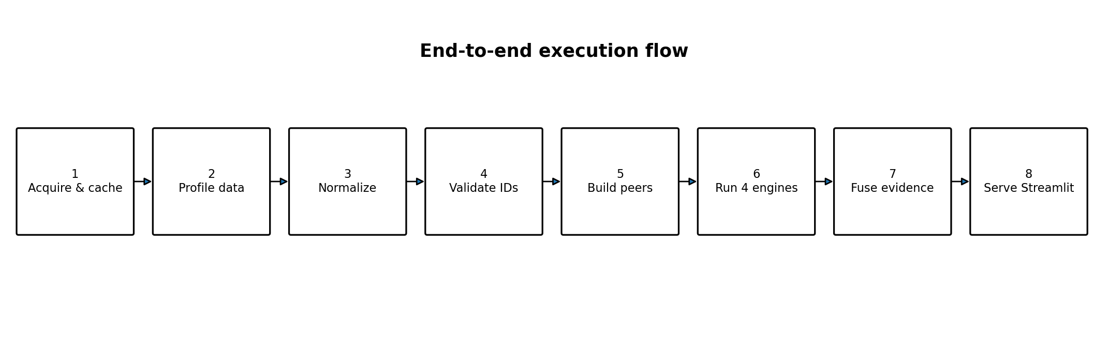
- Load raw files and source manifest.
- Profile row counts, null rates, unique counts and data types.
- Normalize fields and create canonical work layer.
- Validate unique_work_number population and exact-join coverage.
- Build peer cohorts with fallback ladder.
- Run Peer Benchmarking.
- Run Statistical Outlier Detection.
- Run Financial–Execution Mismatch hierarchy using only available evidence.
- Run blocked Duplicate/Overlap detection.
- Assemble evidence objects and coverage metrics.
- Fuse available module scores using 30/25/30/15 weights.
- Render investigation UI: score, evidence, comparisons, warnings, coverage and recommended next checks.

17. Streamlit Application — Exact Screens
Screen | Elements
A. Overview / Command Center | Total works; high/critical count; average risk; module coverage; filters by state/district/constituency/category/status.
B. Risk Queue | Sortable table with work ID, MP, district, category, risk score, severity, module flags, confidence, match method.
C. Work Investigation | Selected work summary; 0–100 score; module contribution cards; evidence text; peer cohort size; duplicate candidate list; mismatch level/confidence; coverage.
D. Peer Detail | Selected work vs peer median/IQR/percentile; cohort composition and fallback level.
E. Duplicate Detail | Candidate pairs with semantic similarity, entity similarity and locality context; class = likely duplicate / possible overlap / unrelated.
F. Data Quality / Coverage | ID population, exact join coverage, missing dates, module availability, approximate-match share, source snapshots.
G. Methodology | Short plain-language explanation of all four engines, weights, evidence hierarchy and caveats.

18. What a Judge Should See in the Main Demo
The demo should revolve around one real work and tell an investigation story rather than showing a generic dashboard.
- Select one real MPLADS work from the queue.
- Show the 0–100 risk score and severity.
- Show four module cards and the independent evidence each produced.
- Zoom into peer evidence: “2.1× peer median, 95th percentile, 41 comparable works.”
- Show mismatch evidence with the correct confidence label (proxy / observed / high-confidence time evidence).
- Show a duplicate/overlap candidate and its similarity evidence.
- Show coverage and join validation numbers so the data story is transparent.
- Finish with “Recommended investigation checks” rather than “Fraud detected.”

19. Testing & Validation Before Demo
Test | Must pass
Data schema test | Expected columns present after normalization.
Numeric parsing test | Monetary strings convert correctly and raw values are preserved.
Date parsing test | No silent date shifts; parse failures reported.
Unique ID test | NA / blank values never treated as real IDs.
Exact join test | No accidental many-to-many merge; match rate recorded.
Peer fallback test | District → state → national fallback never returns an empty cohort silently.
Statistical test | Known synthetic examples produce expected IQR/percentile severity.
Mismatch test | Level 1/2/3 are mutually understandable and confidence labels are correct.
Duplicate blocking test | All-pairs comparison is not used on the full dataset.
Fusion test | Weights renormalize correctly when modules are missing.
Explainability test | Every nonzero module score has a human-readable evidence string.
No-fabrication test | No GPS, physical-progress %, expenditure or vendor value is invented.

20. 48-Hour Build Order
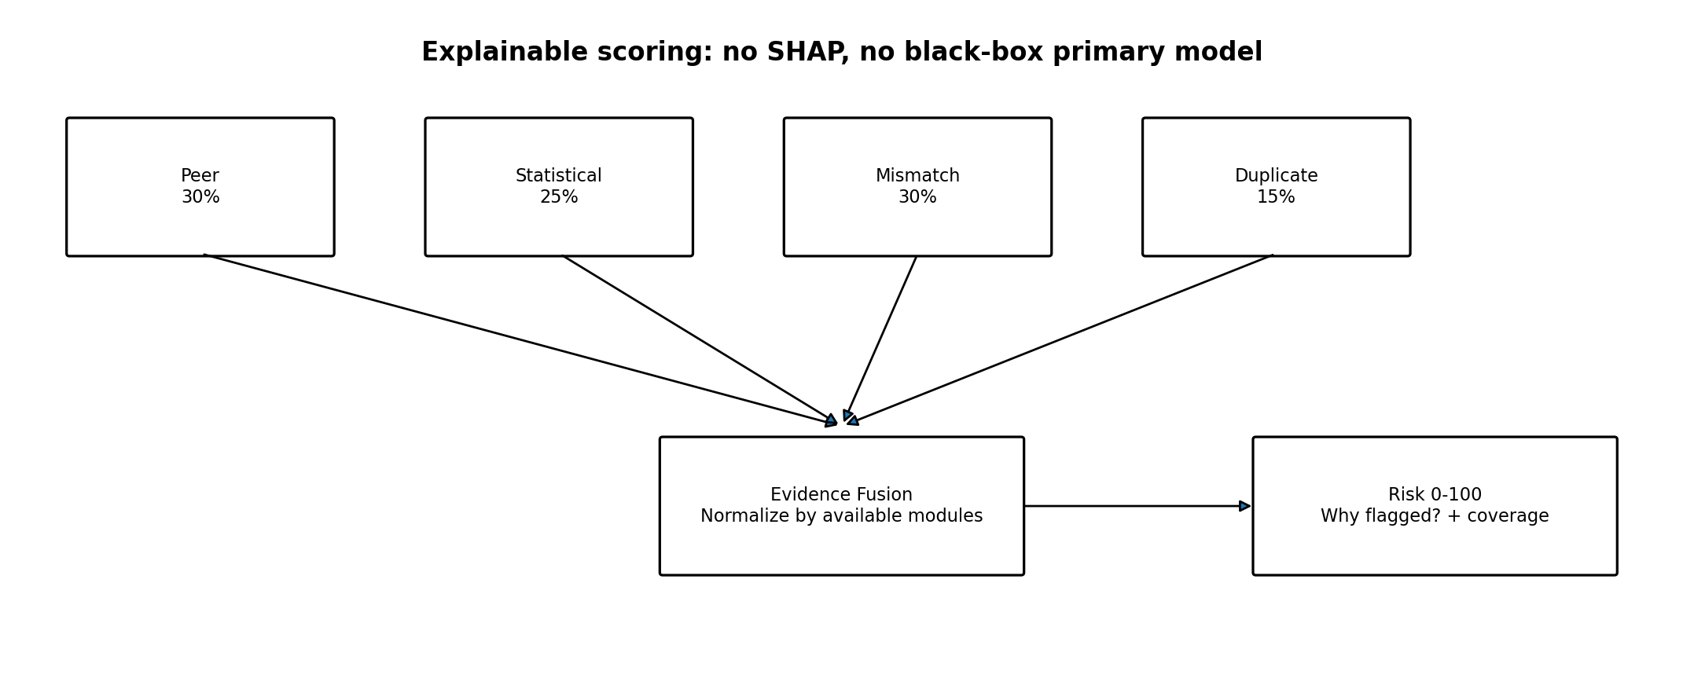
- Hour 0–3: acquire datasets, profile schemas, validate ID populations, create canonical schema.
- Hour 3–9: build Peer Benchmarking + cohort fallback and verify real outputs.
- Hour 9–14: build mismatch hierarchy using actual available dates/financial evidence; implement exact and guarded fallback matching.
- Hour 14–20: build blocked duplicate/overlap engine.
- Hour 20–25: build Statistical Outlier engine and module normalization.
- Hour 25–30: build fusion, evidence objects and coverage reporting.
- Hour 30–38: Streamlit command center, risk queue and work investigation view.
- Hour 38–43: methodology/data-quality pages, polish and judge-facing language.
- Hour 43–48: testing, demo path hardening, screenshots, backup data/cache, final rehearsal.

21. Locked Exclusions / Non-Negotiables
- No Isolation Forest as a primary detector.
- No SHAP layer; scoring logic is already transparent.
- No GPS/latitude/longitude matching.
- No vendor concentration detector as a core engine.
- No fiscal year-end payment burst detector.
- No survival/forecasting completion model.
- No Benford’s Law as a core detector.
- No synthetic physical-progress percentages.
- No fabricated project-level expenditure joins from dataset 22565.
- No architecture expansion before the four core engines work end-to-end.

22. Configuration Defaults — First-Pass Locked Values
Parameter | Default
Peer weight | 0.30
Statistical weight | 0.25
Mismatch weight | 0.30
Duplicate weight | 0.15
Minimum preferred peer cohort | 10
Risk bands | 0–29 Low; 30–59 Medium; 60–79 High; 80–100 Critical
Confidence — Level 1 proxy | LOW
Confidence — Level 1 observed financial | MEDIUM
Confidence — Level 2 time | HIGH
Confidence — Level 3 actual physical progress | VERY HIGH
Primary anomaly method | IQR / percentile / robust deterministic rules
Primary duplicate model | all-MiniLM-L6-v2 + RapidFuzz + blocking
Primary UI | Streamlit
Primary local storage | Parquet

All weight values are configuration-driven so tuning can happen without changing architecture. Tuning may change thresholds/weights after validation, but it must not introduce new core engines during the 48-hour build.

23. Source Verification Notes
The following external sources were checked during preparation of this architecture. URLs are provided for reproducibility and should be captured in README.md as well.
S1 — Dataful dataset 22567 — 18th Lok Sabha Recommended Works: https://dataful.in/datasets/22567/
S2 — Dataful dataset 22566 — 18th Lok Sabha Completed Works: https://dataful.in/datasets/22566/
S3 — Dataful dataset 22565 — 18th Lok Sabha Vendor-level Expenditure: https://dataful.in/datasets/22565/
S4 — Dataful dataset 18533 — 17th Lok Sabha MPLADS Works and Funds Sanctioned: https://dataful.in/datasets/18533/
S5 — Official MPLADS Guidelines index: https://www.mplads.gov.in/mplads/En/2010-mplads-guidelines.aspx
S6 — Official MPLADS portal / WMS reports: https://mplads.gov.in/mplads/En/2010-mplads-guidelines.aspx

24. Final Build Contract
This document is the working contract for the prototype. The team may tune thresholds and fix data-handling bugs, but the four core engines, evidence-fusion architecture, real-data rule, confidence hierarchy, 30/25/30/15 base weights, blocked duplicate strategy, and locked exclusions are not reopened during the build window.
REAL DATA → 4 EVIDENCE ENGINES → EXPLAINABLE RISK SCORE → INVESTIGATION

