**4E1: Management for Engineers**

**Reflective Essay**

**Submitted by-Yash Pandey**

**17317629**

**D-stream**

The three scenarios given in this assignment were extremely well designed and focused on various aspects of project management. All the scenarios created a different situational awareness and improved my thought process in developing innovative initiatives required to solve those problems and to find ways to streamline the process of solving problems. Each scenario is discussed briefly below.

**Scenario B**

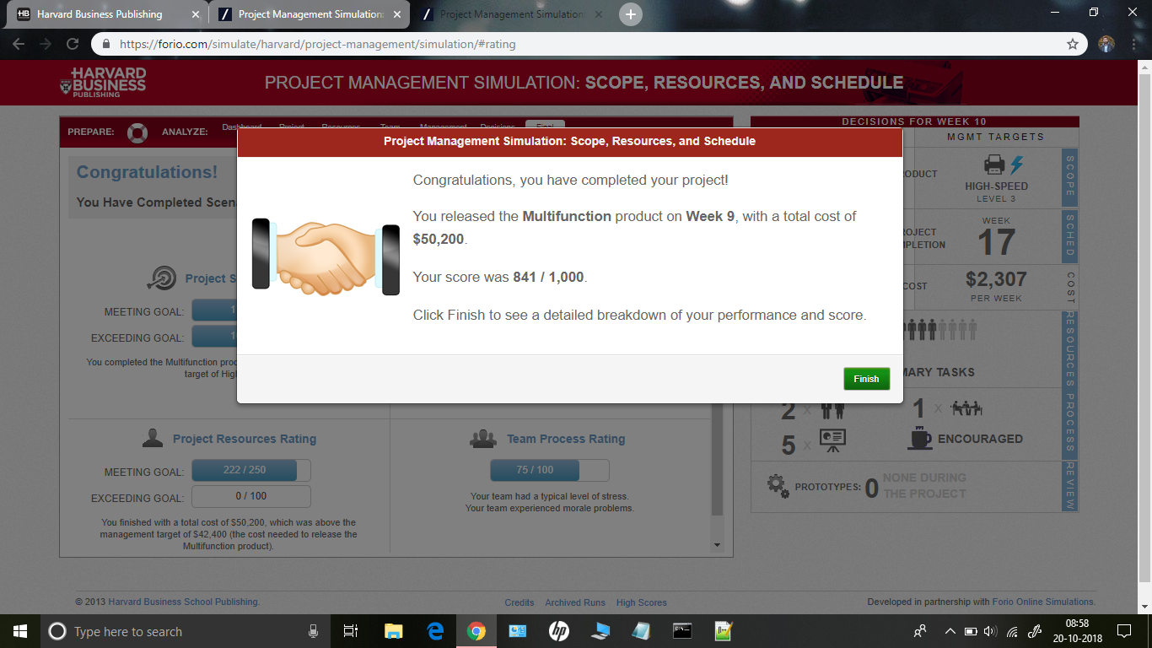

Scenario B mainly focused on the aspect of dealing with manpower during a project. Given the objective to make a level 3 printer in 17 weeks initially I started with a simple strategy of balancing cost, workforce and time, it went as planned till week 5, but due to the aggressive recruiting policy of our competitors some of my team members joined that company which was a setback for me as I lost manpower for 3 weeks due to which more workers were hired after week 8 to compensate for the delay which greatly increased the cost. Then onwards I planned for it in advanced and my workers did more tasks from week one to five due to which I had no problems for the manpower I lost for 3 weeks and the cost was also balanced, and I completed the project in time. I realised that I can exploit my resources even more and can complete the project in a more efficient way. I decided to decrease the deadline of the project to 15 weeks, with the cost that was saved from week 15 to17 man power was increased and project was completed in week 15 and I got higher score. But as I was reducing the deadline my cost was increasing so I had to balance time and cost somehow. Then I started to outsource, and it reduced the cost very much. After my deadline had come down wo week 13 I set target to level 4 printer which gave me extra budget at the same time increased my score. Initially I was not able to figure out a right combination to complete level four printer in 13 weeks, so I increased the deadline to week 15 and dived the cost accordingly. I was able to complete level 4 printer in 15 weeks and from there on iteratively I reduced the deadline to week 13 and from week 13 to week 11 at the same time maintaining the balance between everything. I observed that the variation in cost had less effect on my total score compared to time, so I decided to prioritize time and not cost. Then my strategy was to hire more workers and complete the project in such time in which my use to my resources are optimal. The increased number of workers completed more tasks than required from weeks one to five and due this even the team morale was good all the time which ultimately meant more efficient work, which in turn only led to one worker leaving the project after week 5 but since we were already ahead of the schedule the reduction in man power did not affect the project much at times workers were mildly stressed but new workers joining in after week boosted the morale of the team and hence I was able to complete the project in week 9, though it was slightly over budget but due to the well balance rest of the things I felt overall it was optimal.

**Scenario C**

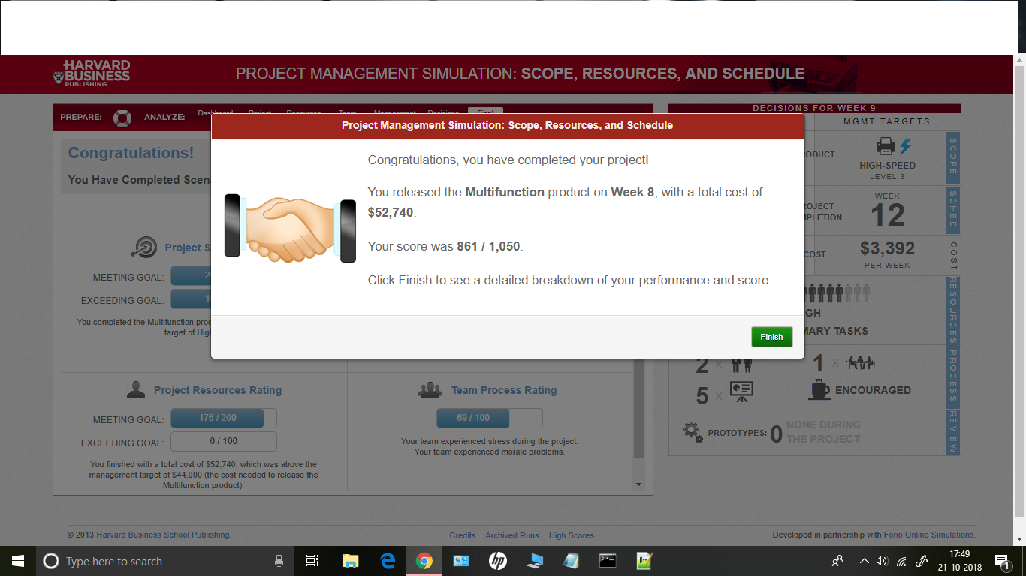

Scenario C focused in the aspect of dealing with changing deadlines due to the competitors change of plans. Given the objective to make a level 3 printer in 17 weeks initially I started with a simple strategy of balancing cost, workforce and time, it went as planned till week 5, but due to the change in plans of our competitors who reduced their deadline of launching the printer to compete with them we had to reduce our deadline to week 12 which literally shattered all my plans and not only I was not able to complete my project in time, I was over budget, team morale was low and I got a very low score. Then onwards I used the same strategy I used in the previous simulation to reduce the deadline to week 12 and hence with the very same strategy I was able to complete project in week 12 but I realised that I can be more efficient as I had no manpower limitation in this simulation as it was in simulation b, so I got more balance in manpower due to which I was more cost efficient as instead of using more manpower for few weeks less for few, it was distributed evenly which meant more work less cost in less time, also keeping the team in good spirits throughout the project. To get a higher score I decided to give preference to time and not cost again as a result of which I was able to complete the project in week 8 which was way before my competitors also the team morale was excellent through to the project, though it was a overbudget but due to the optimality overall I got a higher score.

**Scenario F:**

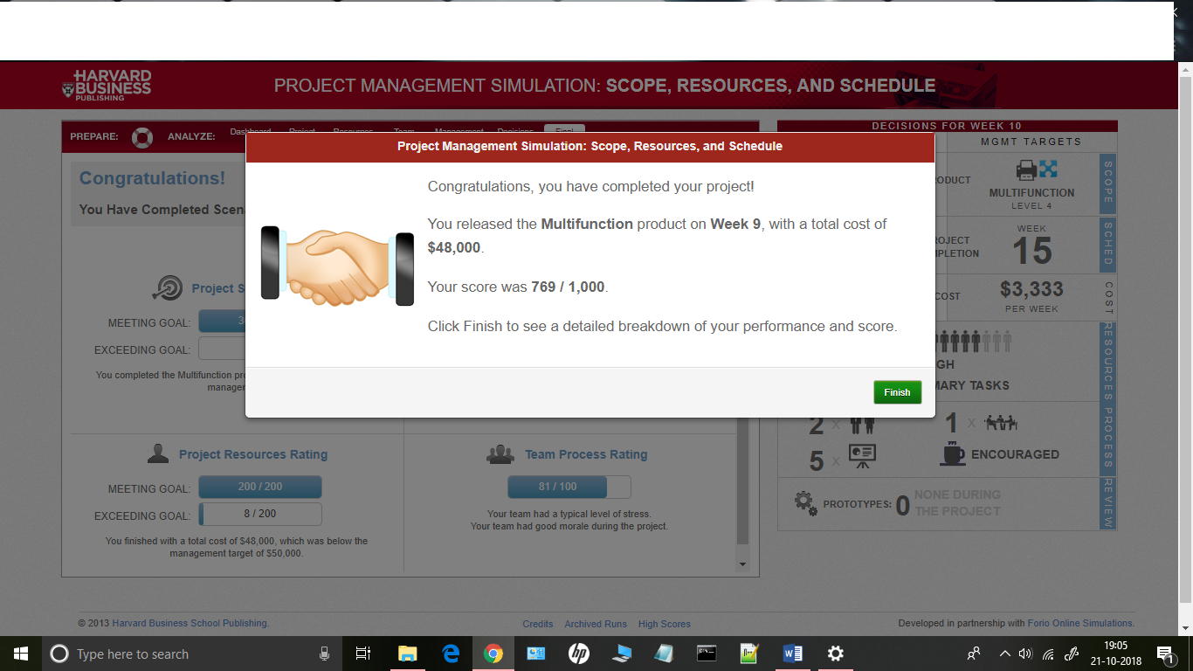

Scenario F was by far the most challenging of all the scenarios focused in the aspect of dealing with various unexpected situations. Given the objective to make a level 4 printer in 15 weeks initially I started with a simple strategy of balancing everything but as I proceeded I was faced with various challenges at different points of time these were, due to a car accident several team members were injured and new workers had to be hired which reduced the task rate, second was increase in the number of the tasks and final challenge was again in the increment if task. As I have already done in the previous scenarios I knew that I could completer the project in week 8 that would bypass the two of the challenges where the number of tasks were increased so I needed to only deal with one challenge that was the car accident as I started doing the project I realised I needed to change something in the previous strategy as the task rate was reduced due to new workers coming in. As the budget for this task was high, so as to compensate for the new workers I increased the man power in the start if the project as a result even when new workers came in I was left with less number of tasks to complete and hence I was able to get a higher score, maintaining the balance between time and cost at the same time keeping team sprits high.

**Conclusion**

1. Learned how to manage a project.
2. Learned various skills required to manage a project.
3. Learned how to deal with various unexpected situations
4. Learned how to find an optimal solution for a problem.