**15IT423E – DATA SCIENCE AND BIG DATA**

**ANALYTICS**

**SEMESTER - VI**

**Name :**

**Register No. :**

**Class : III B.Tech. IT**

**2017 - 2018**



**FACULTY OF ENGINEERING AND TECHNOLOGY**

**SRM INSTITUTE OF SCIENCE AND TECHNOLOGY**

**(Under Section 3 of UGC Act, 1956)**

**S.R.M. NAGAR, KATTANKULATHUR – 603 203**

**KANCHEEPURAM DISTRICT**

**PROJECT TITLE:**

**APPLICATION OF K MEANS CLUSTERING AND NAIVE BAYES CLUSTERING ON IRIS DATASET**

**K Means**

|  |
| --- |
| > Iris=read.csv("F:/iris.csv")  > Iris  Sepal.Length Sepal.Width Petal.Length Petal.Width Species  1 5.1 3.5 1.4 0.2 setosa  2 4.9 3.0 1.4 0.2 setosa  3 4.7 3.2 1.3 0.2 setosa  4 4.6 3.1 1.5 0.2 setosa  5 5.0 3.6 1.4 0.2 setosa  6 5.4 3.9 1.7 0.4 setosa  7 4.6 3.4 1.4 0.3 setosa  8 5.0 3.4 1.5 0.2 setosa  9 4.4 2.9 1.4 0.2 setosa  10 4.9 3.1 1.5 0.1 setosa  11 5.4 3.7 1.5 0.2 setosa  12 4.8 3.4 1.6 0.2 setosa  13 4.8 3.0 1.4 0.1 setosa  14 4.3 3.0 1.1 0.1 setosa  15 5.8 4.0 1.2 0.2 setosa  16 5.7 4.4 1.5 0.4 setosa  17 5.4 3.9 1.3 0.4 setosa  18 5.1 3.5 1.4 0.3 setosa  19 5.7 3.8 1.7 0.3 setosa  20 5.1 3.8 1.5 0.3 setosa  21 5.4 3.4 1.7 0.2 setosa  22 5.1 3.7 1.5 0.4 setosa  23 4.6 3.6 1.0 0.2 setosa  24 5.1 3.3 1.7 0.5 setosa  25 4.8 3.4 1.9 0.2 setosa  26 5.0 3.0 1.6 0.2 setosa  27 5.0 3.4 1.6 0.4 setosa  28 5.2 3.5 1.5 0.2 setosa  29 5.2 3.4 1.4 0.2 setosa  30 4.7 3.2 1.6 0.2 setosa  31 4.8 3.1 1.6 0.2 setosa  32 5.4 3.4 1.5 0.4 setosa  33 5.2 4.1 1.5 0.1 setosa  34 5.5 4.2 1.4 0.2 setosa  35 4.9 3.1 1.5 0.2 setosa  36 5.0 3.2 1.2 0.2 setosa  37 5.5 3.5 1.3 0.2 setosa  38 4.9 3.6 1.4 0.1 setosa  39 4.4 3.0 1.3 0.2 setosa  40 5.1 3.4 1.5 0.2 setosa  41 5.0 3.5 1.3 0.3 setosa  42 4.5 2.3 1.3 0.3 setosa  43 4.4 3.2 1.3 0.2 setosa  44 5.0 3.5 1.6 0.6 setosa  45 5.1 3.8 1.9 0.4 setosa  46 4.8 3.0 1.4 0.3 setosa  47 5.1 3.8 1.6 0.2 setosa  48 4.6 3.2 1.4 0.2 setosa  49 5.3 3.7 1.5 0.2 setosa  50 5.0 3.3 1.4 0.2 setosa  51 7.0 3.2 4.7 1.4 versicolor  52 6.4 3.2 4.5 1.5 versicolor  53 6.9 3.1 4.9 1.5 versicolor  54 5.5 2.3 4.0 1.3 versicolor  55 6.5 2.8 4.6 1.5 versicolor  56 5.7 2.8 4.5 1.3 versicolor  57 6.3 3.3 4.7 1.6 versicolor  58 4.9 2.4 3.3 1.0 versicolor  59 6.6 2.9 4.6 1.3 versicolor  60 5.2 2.7 3.9 1.4 versicolor  61 5.0 2.0 3.5 1.0 versicolor  62 5.9 3.0 4.2 1.5 versicolor  63 6.0 2.2 4.0 1.0 versicolor  64 6.1 2.9 4.7 1.4 versicolor  65 5.6 2.9 3.6 1.3 versicolor  66 6.7 3.1 4.4 1.4 versicolor  67 5.6 3.0 4.5 1.5 versicolor  68 5.8 2.7 4.1 1.0 versicolor  69 6.2 2.2 4.5 1.5 versicolor  70 5.6 2.5 3.9 1.1 versicolor  71 5.9 3.2 4.8 1.8 versicolor  72 6.1 2.8 4.0 1.3 versicolor  73 6.3 2.5 4.9 1.5 versicolor  74 6.1 2.8 4.7 1.2 versicolor  75 6.4 2.9 4.3 1.3 versicolor  76 6.6 3.0 4.4 1.4 versicolor  77 6.8 2.8 4.8 1.4 versicolor  78 6.7 3.0 5.0 1.7 versicolor  79 6.0 2.9 4.5 1.5 versicolor  80 5.7 2.6 3.5 1.0 versicolor  81 5.5 2.4 3.8 1.1 versicolor  82 5.5 2.4 3.7 1.0 versicolor  83 5.8 2.7 3.9 1.2 versicolor  84 6.0 2.7 5.1 1.6 versicolor  85 5.4 3.0 4.5 1.5 versicolor  86 6.0 3.4 4.5 1.6 versicolor  87 6.7 3.1 4.7 1.5 versicolor  88 6.3 2.3 4.4 1.3 versicolor  89 5.6 3.0 4.1 1.3 versicolor  90 5.5 2.5 4.0 1.3 versicolor  91 5.5 2.6 4.4 1.2 versicolor  92 6.1 3.0 4.6 1.4 versicolor  93 5.8 2.6 4.0 1.2 versicolor  94 5.0 2.3 3.3 1.0 versicolor  95 5.6 2.7 4.2 1.3 versicolor  96 5.7 3.0 4.2 1.2 versicolor  97 5.7 2.9 4.2 1.3 versicolor  98 6.2 2.9 4.3 1.3 versicolor  99 5.1 2.5 3.0 1.1 versicolor  100 5.7 2.8 4.1 1.3 versicolor  101 6.3 3.3 6.0 2.5 virginica  102 5.8 2.7 5.1 1.9 virginica  103 7.1 3.0 5.9 2.1 virginica  104 6.3 2.9 5.6 1.8 virginica  105 6.5 3.0 5.8 2.2 virginica  106 7.6 3.0 6.6 2.1 virginica  107 4.9 2.5 4.5 1.7 virginica  108 7.3 2.9 6.3 1.8 virginica  109 6.7 2.5 5.8 1.8 virginica  110 7.2 3.6 6.1 2.5 virginica  111 6.5 3.2 5.1 2.0 virginica  112 6.4 2.7 5.3 1.9 virginica  113 6.8 3.0 5.5 2.1 virginica  114 5.7 2.5 5.0 2.0 virginica  115 5.8 2.8 5.1 2.4 virginica  116 6.4 3.2 5.3 2.3 virginica  117 6.5 3.0 5.5 1.8 virginica  118 7.7 3.8 6.7 2.2 virginica  119 7.7 2.6 6.9 2.3 virginica  120 6.0 2.2 5.0 1.5 virginica  121 6.9 3.2 5.7 2.3 virginica  122 5.6 2.8 4.9 2.0 virginica  123 7.7 2.8 6.7 2.0 virginica  124 6.3 2.7 4.9 1.8 virginica  125 6.7 3.3 5.7 2.1 virginica  126 7.2 3.2 6.0 1.8 virginica  127 6.2 2.8 4.8 1.8 virginica  128 6.1 3.0 4.9 1.8 virginica  129 6.4 2.8 5.6 2.1 virginica  130 7.2 3.0 5.8 1.6 virginica  131 7.4 2.8 6.1 1.9 virginica  132 7.9 3.8 6.4 2.0 virginica  133 6.4 2.8 5.6 2.2 virginica  134 6.3 2.8 5.1 1.5 virginica  135 6.1 2.6 5.6 1.4 virginica  136 7.7 3.0 6.1 2.3 virginica  137 6.3 3.4 5.6 2.4 virginica  138 6.4 3.1 5.5 1.8 virginica  139 6.0 3.0 4.8 1.8 virginica  140 6.9 3.1 5.4 2.1 virginica  141 6.7 3.1 5.6 2.4 virginica  142 6.9 3.1 5.1 2.3 virginica  143 5.8 2.7 5.1 1.9 virginica  144 6.8 3.2 5.9 2.3 virginica  145 6.7 3.3 5.7 2.5 virginica  146 6.7 3.0 5.2 2.3 virginica  147 6.3 2.5 5.0 1.9 virginica  148 6.5 3.0 5.2 2.0 virginica  149 6.2 3.4 5.4 2.3 virginica  150 5.9 3.0 5.1 1.8 virginica  > View(Iris)  > Iris.features=Iris  > Iris.features$class <- NULL  > View(Iris.features)  C:\Users\hp\OneDrive\Pictures\Screenshots\2018-04-09 (16).png  > Iris=read.csv("F:/iris.csv")  > Iris.features=Iris  > Iris.features$Species <- NULL  > View(Iris.features)  > Results<- kmeans(Iris.features,3)  > Results  K-means clustering with 3 clusters of sizes 38, 50, 62  Cluster means:  Sepal.Length Sepal.Width Petal.Length Petal.Width  1 6.850000 3.073684 5.742105 2.071053  2 5.006000 3.428000 1.462000 0.246000  3 5.901613 2.748387 4.393548 1.433871  Clustering vector:  [1] 2 2 2 2 2 2 2 2 2 2 2 2 2 2 2 2 2 2 2 2 2 2 2 2 2 2 2 2 2 2 2 2 2 2 2 2 2 2 2 2 2 2  [43] 2 2 2 2 2 2 2 2 3 3 1 3 3 3 3 3 3 3 3 3 3 3 3 3 3 3 3 3 3 3 3 3 3 3 3 1 3 3 3 3 3 3  [85] 3 3 3 3 3 3 3 3 3 3 3 3 3 3 3 3 1 3 1 1 1 1 3 1 1 1 1 1 1 3 3 1 1 1 1 3 1 3 1 3 1 1  [127] 3 3 1 1 1 1 1 3 1 1 1 1 3 1 1 1 3 1 1 1 3 1 1 3  Within cluster sum of squares by cluster:  [1] 23.87947 15.15100 39.82097  (between_SS / total_SS = 88.4 %)  Available components:  [1] "cluster" "centers" "totss" "withinss" "tot.withinss"  [6] "betweenss" "size" "iter" "ifault"  > Results$size  [1] 38 50 62  > Results$cluster  [1] 2 2 2 2 2 2 2 2 2 2 2 2 2 2 2 2 2 2 2 2 2 2 2 2 2 2 2 2 2 2 2 2 2 2 2 2 2 2 2 2 2 2  [43] 2 2 2 2 2 2 2 2 3 3 1 3 3 3 3 3 3 3 3 3 3 3 3 3 3 3 3 3 3 3 3 3 3 3 3 1 3 3 3 3 3 3  [85] 3 3 3 3 3 3 3 3 3 3 3 3 3 3 3 3 1 3 1 1 1 1 3 1 1 1 1 1 1 3 3 1 1 1 1 3 1 3 1 3 1 1  [127] 3 3 1 1 1 1 1 3 1 1 1 1 3 1 1 1 3 1 1 1 3 1 1 3  > table(Iris$Species, Results$cluster)    1 2 3  setosa 0 50 0  versicolor 2 0 48  virginica 36 0 14  > plot(Iris[c("Petal.Length","Petal.Width")], col=Results$cluster) |
|  |
| |  | | --- | | > | |

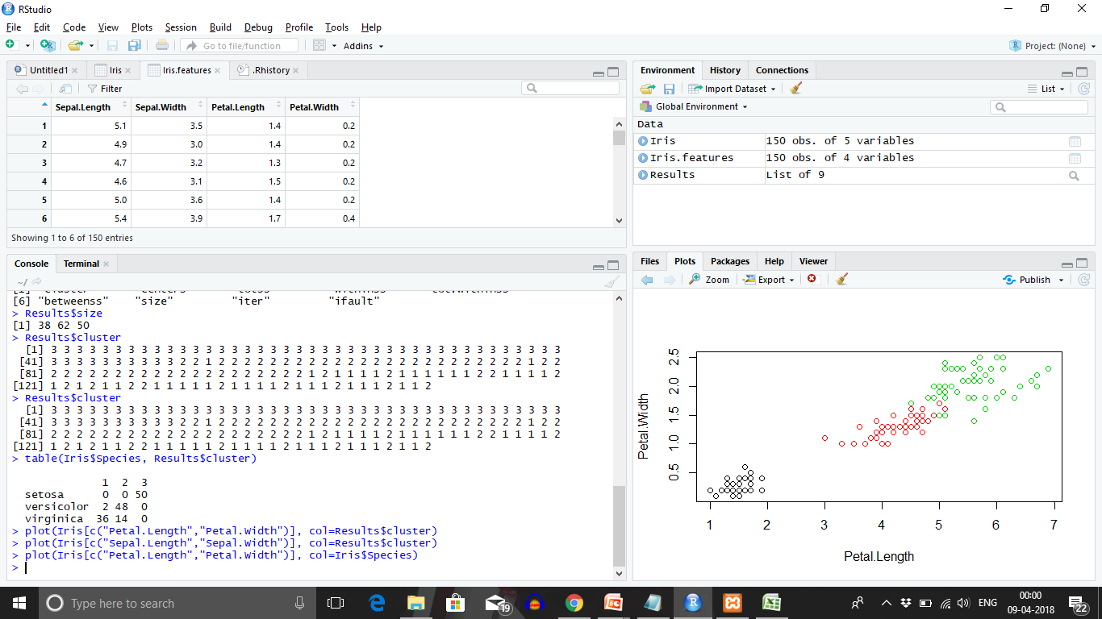> plot(Iris[c("Sepal.Length","Sepal.Width")], col=Results$cluster)

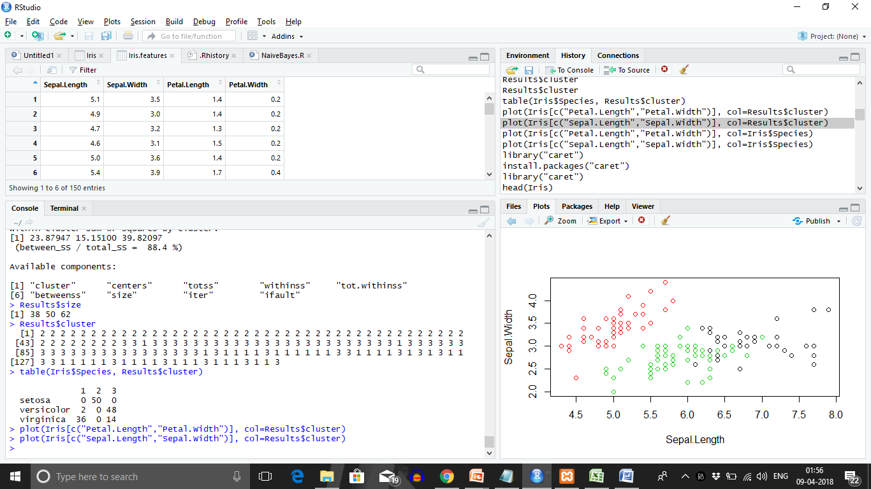

|  |
| --- |
| > plot(Iris[c("Petal.Length","Petal.Width")], col=Iris$Species) |
|  |
| |  | | --- | |  | |



|  |
| --- |
| > plot(Iris[c("Sepal.Length","Sepal.Width")], col=Iris$Species) |
|  |
| |  | | --- | |  | |

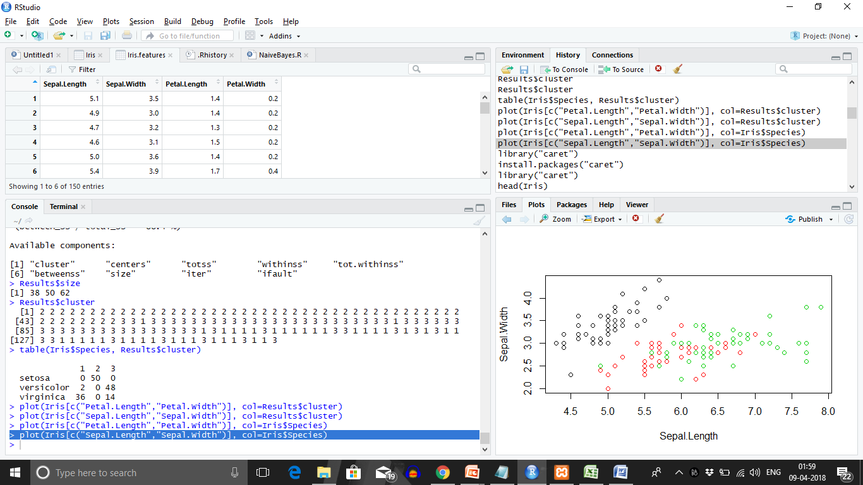

**NAIVE BAYES**

library("caret")

Loading required package: lattice

Loading required package: ggplot2

Warning messages:

1: package ‘caret’ was built under R version 3.4.4

2: package ‘ggplot2’ was built under R version 3.4.4

> head(Iris)

Sepal.Length Sepal.Width Petal.Length Petal.Width Species

1 5.1 3.5 1.4 0.2 setosa

2 4.9 3.0 1.4 0.2 setosa

3 4.7 3.2 1.3 0.2 setosa

4 4.6 3.1 1.5 0.2 setosa

5 5.0 3.6 1.4 0.2 setosa

6 5.4 3.9 1.7 0.4 setosa

> names(Iris)

[1] "Sepal.Length" "Sepal.Width" "Petal.Length" "Petal.Width" "Species"

> x=Iris[,-5]

> y=Iris$Species

> model=train(x,y,'nb',trControl = trainControl(method='cv', number = 10))

1 package is needed for this model and is not installed. (klaR). Would you like to try to install it now?

1: yes

2: no

model

Naive Bayes

150 samples

4 predictor

3 classes: 'setosa', 'versicolor', 'virginica'

No pre-processing

Resampling: Cross-Validated (10 fold)

Summary of sample sizes: 135, 135, 135, 135, 135, 135, ...

Resampling results across tuning parameters:

usekernel Accuracy Kappa

FALSE 0.9533333 0.93

TRUE 0.9600000 0.94

Tuning parameter 'fL' was held constant at a value of 0

Tuning parameter 'adjust'

was held constant at a value of 1

Accuracy was used to select the optimal model using the largest value.

The final values used for the model were fL = 0, usekernel = TRUE and adjust = 1.

> predict(model$finalModel,x)

$class

[1] setosa setosa setosa setosa setosa setosa setosa

[8] setosa setosa setosa setosa setosa setosa setosa

[15] setosa setosa setosa setosa setosa setosa setosa

[22] setosa setosa setosa setosa setosa setosa setosa

[29] setosa setosa setosa setosa setosa setosa setosa

[36] setosa setosa setosa setosa setosa setosa setosa

[43] setosa setosa setosa setosa setosa setosa setosa

[50] setosa versicolor versicolor versicolor versicolor versicolor versicolor

[57] versicolor versicolor versicolor versicolor versicolor versicolor versicolor

[64] versicolor versicolor versicolor versicolor versicolor pversicolor versicolor

[71] virginica versicolor versicolor versicolor versicolor versicolor versicolor

[78] virginica versicolor versicolor versicolor versicolor versicolor virginica

[85] versicolor versicolor versicolor versicolor versicolor versicolor versicolor

[92] versicolor versicolor versicolor versicolor versicolor versicolor versicolor

[99] versicolor versicolor virginica virginica virginica virginica virginica

[106] virginica versicolor virginica virginica virginica virginica virginica

[113] virginica virginica virginica virginica virginica virginica virginica

[120] versicolor virginica virginica virginica virginica virginica virginica

[127] virginica virginica virginica virginica virginica virginica virginica

[134] versicolor virginica virginica virginica virginica virginica virginica

[141] virginica virginica virginica virginica virginica virginica virginica

[148] virginica virginica virginica

Levels: setosa versicolor virginica

> table(predict(model$finalModel,x)$class,y)

y

setosa versicolor virginica

setosa 50 0 0

versicolor 0 47 3

virginica 0 3 47

Iris

Sepal.Length Sepal.Width Petal.Length Petal.Width Species

1 5.1 3.5 1.4 0.2 setosa

2 4.9 3.0 1.4 0.2 setosa

3 4.7 3.2 1.3 0.2 setosa

4 4.6 3.1 1.5 0.2 setosa

5 5.0 3.6 1.4 0.2 setosa

6 5.4 3.9 1.7 0.4 setosa

7 4.6 3.4 1.4 0.3 setosa

8 5.0 3.4 1.5 0.2 setosa

9 4.4 2.9 1.4 0.2 setosa

10 4.9 3.1 1.5 0.1 setosa

11 5.4 3.7 1.5 0.2 setosa

12 4.8 3.4 1.6 0.2 setosa

13 4.8 3.0 1.4 0.1 setosa

14 4.3 3.0 1.1 0.1 setosa

15 5.8 4.0 1.2 0.2 setosa

16 5.7 4.4 1.5 0.4 setosa

17 5.4 3.9 1.3 0.4 setosa

18 5.1 3.5 1.4 0.3 setosa

19 5.7 3.8 1.7 0.3 setosa

20 5.1 3.8 1.5 0.3 setosa

21 5.4 3.4 1.7 0.2 setosa

22 5.1 3.7 1.5 0.4 setosa

23 4.6 3.6 1.0 0.2 setosa

24 5.1 3.3 1.7 0.5 setosa

25 4.8 3.4 1.9 0.2 setosa

26 5.0 3.0 1.6 0.2 setosa

27 5.0 3.4 1.6 0.4 setosa

28 5.2 3.5 1.5 0.2 setosa

29 5.2 3.4 1.4 0.2 setosa

30 4.7 3.2 1.6 0.2 setosa

31 4.8 3.1 1.6 0.2 setosa

32 5.4 3.4 1.5 0.4 setosa

33 5.2 4.1 1.5 0.1 setosa

34 5.5 4.2 1.4 0.2 setosa

35 4.9 3.1 1.5 0.2 setosa

36 5.0 3.2 1.2 0.2 setosa

37 5.5 3.5 1.3 0.2 setosa

38 4.9 3.6 1.4 0.1 setosa

39 4.4 3.0 1.3 0.2 setosa

40 5.1 3.4 1.5 0.2 setosa

41 5.0 3.5 1.3 0.3 setosa

42 4.5 2.3 1.3 0.3 setosa

43 4.4 3.2 1.3 0.2 setosa

44 5.0 3.5 1.6 0.6 setosa

45 5.1 3.8 1.9 0.4 setosa

46 4.8 3.0 1.4 0.3 setosa

47 5.1 3.8 1.6 0.2 setosa

48 4.6 3.2 1.4 0.2 setosa

49 5.3 3.7 1.5 0.2 setosa

50 5.0 3.3 1.4 0.2 setosa

51 7.0 3.2 4.7 1.4 versicolor

52 6.4 3.2 4.5 1.5 versicolor

53 6.9 3.1 4.9 1.5 versicolor

54 5.5 2.3 4.0 1.3 versicolor

55 6.5 2.8 4.6 1.5 versicolor

56 5.7 2.8 4.5 1.3 versicolor

57 6.3 3.3 4.7 1.6 versicolor

58 4.9 2.4 3.3 1.0 versicolor

59 6.6 2.9 4.6 1.3 versicolor

60 5.2 2.7 3.9 1.4 versicolor

61 5.0 2.0 3.5 1.0 versicolor

62 5.9 3.0 4.2 1.5 versicolor

63 6.0 2.2 4.0 1.0 versicolor

64 6.1 2.9 4.7 1.4 versicolor

65 5.6 2.9 3.6 1.3 versicolor

66 6.7 3.1 4.4 1.4 versicolor

67 5.6 3.0 4.5 1.5 versicolor

68 5.8 2.7 4.1 1.0 versicolor

69 6.2 2.2 4.5 1.5 versicolor

70 5.6 2.5 3.9 1.1 versicolor

71 5.9 3.2 4.8 1.8 versicolor

72 6.1 2.8 4.0 1.3 versicolor

73 6.3 2.5 4.9 1.5 versicolor

74 6.1 2.8 4.7 1.2 versicolor

75 6.4 2.9 4.3 1.3 versicolor

76 6.6 3.0 4.4 1.4 versicolor

77 6.8 2.8 4.8 1.4 versicolor

78 6.7 3.0 5.0 1.7 versicolor

79 6.0 2.9 4.5 1.5 versicolor

80 5.7 2.6 3.5 1.0 versicolor

81 5.5 2.4 3.8 1.1 versicolor

82 5.5 2.4 3.7 1.0 versicolor

83 5.8 2.7 3.9 1.2 versicolor

84 6.0 2.7 5.1 1.6 versicolor

85 5.4 3.0 4.5 1.5 versicolor

86 6.0 3.4 4.5 1.6 versicolor

87 6.7 3.1 4.7 1.5 versicolor

88 6.3 2.3 4.4 1.3 versicolor

89 5.6 3.0 4.1 1.3 versicolor

90 5.5 2.5 4.0 1.3 versicolor

91 5.5 2.6 4.4 1.2 versicolor

92 6.1 3.0 4.6 1.4 versicolor

93 5.8 2.6 4.0 1.2 versicolor

94 5.0 2.3 3.3 1.0 versicolor

95 5.6 2.7 4.2 1.3 versicolor

96 5.7 3.0 4.2 1.2 versicolor

97 5.7 2.9 4.2 1.3 versicolor

98 6.2 2.9 4.3 1.3 versicolor

99 5.1 2.5 3.0 1.1 versicolor

100 5.7 2.8 4.1 1.3 versicolor

101 6.3 3.3 6.0 2.5 virginica

102 5.8 2.7 5.1 1.9 virginica

103 7.1 3.0 5.9 2.1 virginica

104 6.3 2.9 5.6 1.8 virginica

105 6.5 3.0 5.8 2.2 virginica

106 7.6 3.0 6.6 2.1 virginica

107 4.9 2.5 4.5 1.7 virginica

108 7.3 2.9 6.3 1.8 virginica

109 6.7 2.5 5.8 1.8 virginica

110 7.2 3.6 6.1 2.5 virginica

111 6.5 3.2 5.1 2.0 virginica

112 6.4 2.7 5.3 1.9 virginica

113 6.8 3.0 5.5 2.1 virginica

114 5.7 2.5 5.0 2.0 virginica

115 5.8 2.8 5.1 2.4 virginica

116 6.4 3.2 5.3 2.3 virginica

117 6.5 3.0 5.5 1.8 virginica

118 7.7 3.8 6.7 2.2 virginica

119 7.7 2.6 6.9 2.3 virginica

120 6.0 2.2 5.0 1.5 virginica

121 6.9 3.2 5.7 2.3 virginica

122 5.6 2.8 4.9 2.0 virginica

123 7.7 2.8 6.7 2.0 virginica

124 6.3 2.7 4.9 1.8 virginica

125 6.7 3.3 5.7 2.1 virginica

126 7.2 3.2 6.0 1.8 virginica

127 6.2 2.8 4.8 1.8 virginica

128 6.1 3.0 4.9 1.8 virginica

129 6.4 2.8 5.6 2.1 virginica

130 7.2 3.0 5.8 1.6 virginica

131 7.4 2.8 6.1 1.9 virginica

132 7.9 3.8 6.4 2.0 virginica

133 6.4 2.8 5.6 2.2 virginica

134 6.3 2.8 5.1 1.5 virginica

135 6.1 2.6 5.6 1.4 virginica

136 7.7 3.0 6.1 2.3 virginica

137 6.3 3.4 5.6 2.4 virginica

138 6.4 3.1 5.5 1.8 virginica

139 6.0 3.0 4.8 1.8 virginica

140 6.9 3.1 5.4 2.1 virginica

141 6.7 3.1 5.6 2.4 virginica

142 6.9 3.1 5.1 2.3 virginica

143 5.8 2.7 5.1 1.9 virginica

144 6.8 3.2 5.9 2.3 virginica

145 6.7 3.3 5.7 2.5 virginica

146 6.7 3.0 5.2 2.3 virginica

147 6.3 2.5 5.0 1.9 virginica

148 6.5 3.0 5.2 2.0 virginica

149 6.2 3.4 5.4 2.3 virginica

150 5.9 3.0 5.1 1.8 virginica

> y

[1] setosa setosa setosa setosa setosa setosa setosa

[8] setosa setosa setosa setosa setosa setosa setosa

[15] setosa setosa setosa setosa setosa setosa setosa

[22] setosa setosa setosa setosa setosa setosa setosa

[29] setosa setosa setosa setosa setosa setosa setosa

[36] setosa setosa setosa setosa setosa setosa setosa

[43] setosa setosa setosa setosa setosa setosa setosa

[50] setosa versicolor versicolor versicolor versicolor versicolor versicolor

[57] versicolor versicolor versicolor versicolor versicolor versicolor versicolor

[64] versicolor versicolor versicolor versicolor versicolor versicolor versicolor

[71] versicolor versicolor versicolor versicolor versicolor versicolor versicolor

[78] versicolor versicolor versicolor versicolor versicolor versicolor versicolor

[85] versicolor versicolor versicolor versicolor versicolor versicolor versicolor

[92] versicolor versicolor versicolor versicolor versicolor versicolor versicolor

[99] versicolor versicolor virginica virginica virginica virginica virginica

[106] virginica virginica virginica virginica virginica virginica virginica

[113] virginica virginica virginica virginica virginica virginica virginica

[120] virginica virginica virginica virginica virginica virginica virginica

[127] virginica virginica virginica virginica virginica virginica virginica

[134] virginica virginica virginica virginica virginica virginica virginica

[141] virginica virginica virginica virginica virginica virginica virginica

[148] virginica virginica virginica

Levels: setosa versicolor virginica

> data("iris")

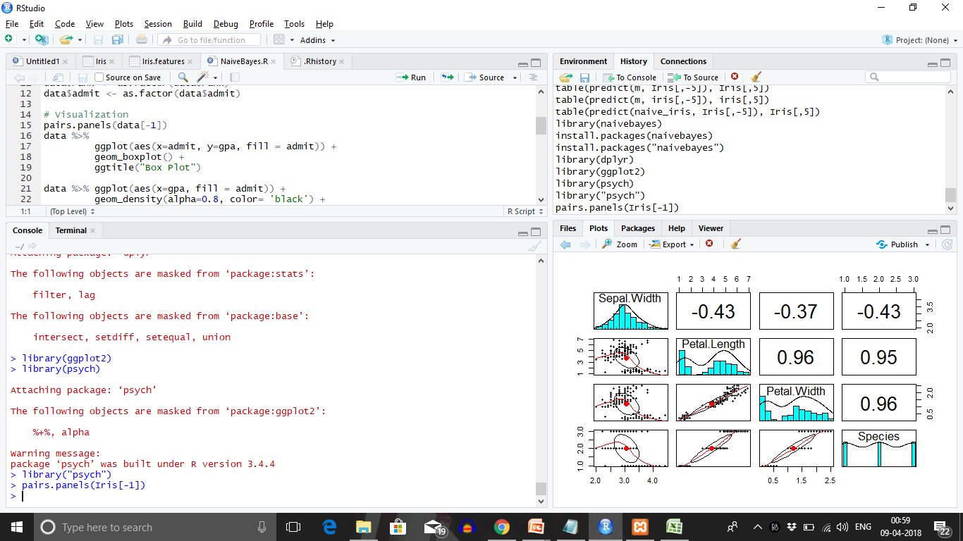

> naive_iris<- naiveBayes(Species ~ ., data = iris)

> naive_iris

Naive Bayes Classifier for Discrete Predictors

Call:

naiveBayes.default(x = X, y = Y, laplace = laplace)

A-priori probabilities:

Y

setosa versicolor virginica

0.3333333 0.3333333 0.3333333

Conditional probabilities:

Sepal.Length

Y [,1] [,2]

setosa 5.006 0.3524897

versicolor 5.936 0.5161711

virginica 6.588 0.6358796

Sepal.Width

Y [,1] [,2]

setosa 3.428 0.3790644

versicolor 2.770 0.3137983

virginica 2.974 0.3224966

Petal.Length

Y [,1] [,2]

setosa 1.462 0.1736640

versicolor 4.260 0.4699110

virginica 5.552 0.5518947

Petal.Width

Y [,1] [,2]

setosa 0.246 0.1053856

versicolor 1.326 0.1977527

virginica 2.026 0.2746501

table(predict(naive_iris, Iris[,-5]), Iris[,5])

setosa versicolor virginica

setosa 50 0 0

versicolor 0 47 3

virginica 0 3 47

library(dplyr)

Attaching package: ‘dplyr’

The following objects are masked from ‘package:stats’:

filter, lag

The following objects are masked from ‘package:base’:

intersect, setdiff, setequal, union

> library(ggplot2)

> library(psych)

Attaching package: ‘psych’

The following objects are masked from ‘package:ggplot2’:

%+%, alpha

Warning message:

package ‘psych’ was built under R version 3.4.4

> library("psych")

> pairs.panels(Iris[-1])

|  |
| --- |
| > Iris %>%  + ggplot(aes(x=Sepal.Width, fill=Iris$Species)) +  + geom_boxplot()+  +  C:\Users\hp\OneDrive\Pictures\Screenshots\2018-04-09 (8).png  > Iris %>%  + ggplot(aes(x=Sepal.Width, fill=Iris$Species)) +  + geom_density(alpha=0.8, color='black')+  + ggtitle("Density Plot")  C:\Users\hp\OneDrive\Pictures\Screenshots\2018-04-09 (9).png |
|  |
| |  | | --- | |  | |