PROJECT REPORT ON

GOVERNMENT ARTS AND SCIENCE COLLAGE

Submitted by

SATHYA

PANDIMITHA

SARANYA

SURYA

1.INTRODUCTION

Uber links passangers with drivers using the uber ap, generally the drivers owntheir own car.

The company does also offer rental or lease on cars through third party partners like hertz get around and fair.

2.PURPOSE

Uber is a transportation company with an app that allows passengers to hail a ride.

Uber mission is to reimagine the way th world moves for the better.

3.PROBLEM DEFINITION &DEFINITION DESIGN

Many of its users face the problem of cancellation by the driver or non-availability of car.

Long wait times and dissatisfication among drivers and customers due to low fares and high fuel prices.

4.EMPATHY MAP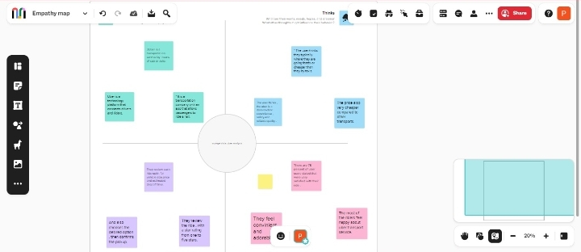

5.BRAINSTROMING MAP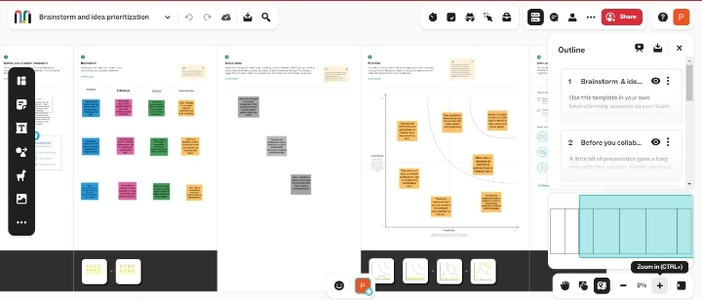

6.RESULT

Revenue grew 12 percentage you to 9.2 billion constsnt currency basis.

Income from operation was 326 million up 1.0 billion you and5 588 million

7.ADVANTAGES

Uber advantages include door to door convinence safety and reliable quality

Uber has become a prime example of the gog economy at work.

8.DISADVANTAGES

Ubers disadvantages include its surge pricing and the negative effects replacing steady jobs with gig work.

Uber uses automated system to incrse prices based on supply work.

9.APPLICATION

The uber app provides convenient and affordable transport in the city.

Communication between the passengers and drivers is done via the app.

10. CONCLUSION

It is headquatered in san fransico and operates in approximstely 70 countries.

Uber is one of the well know taxi companies around the whole globe.