AWS 3-Tier Architecture - Project 01
Screenshots collection
Prepared by: Pandi Selvam P

1. Overview and architecture
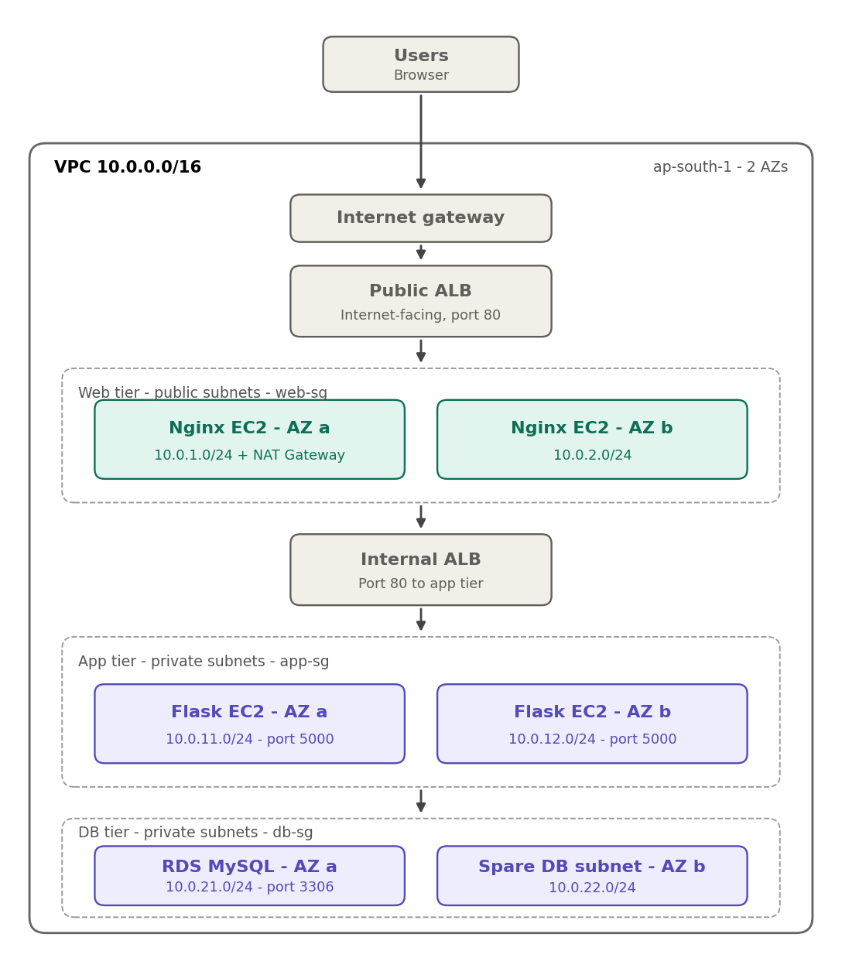
Figure 1

2. Task 1 - VPC and networking
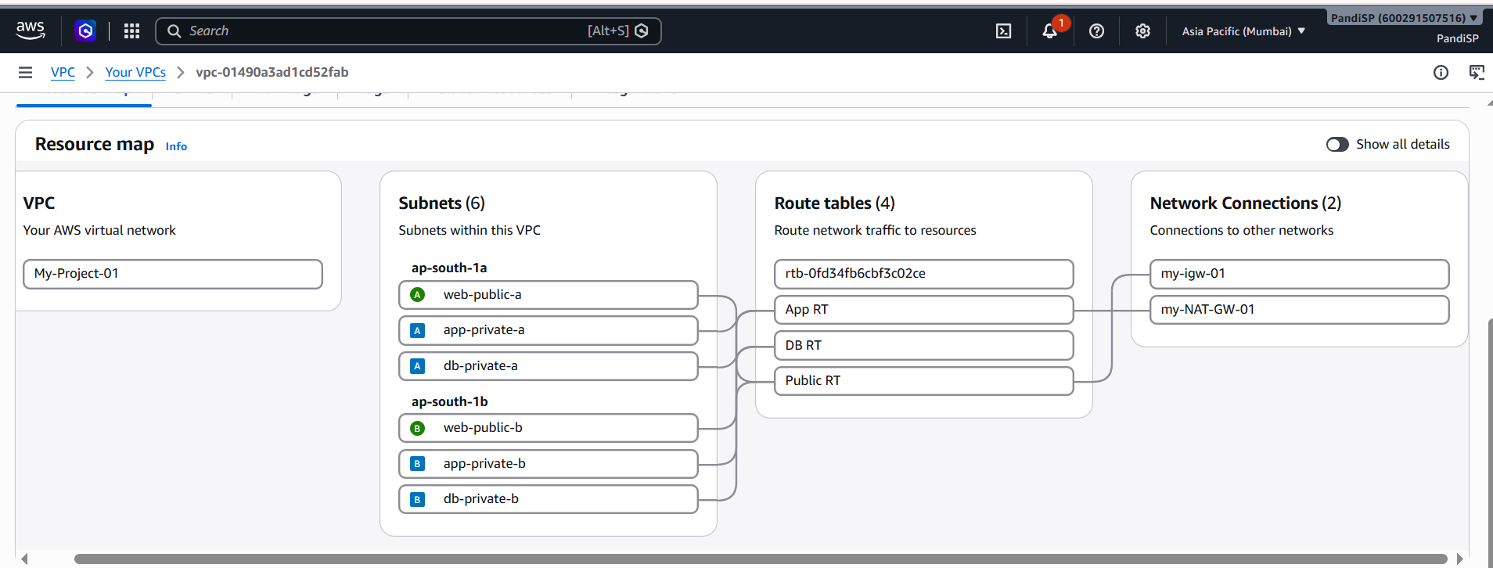
Figure 2
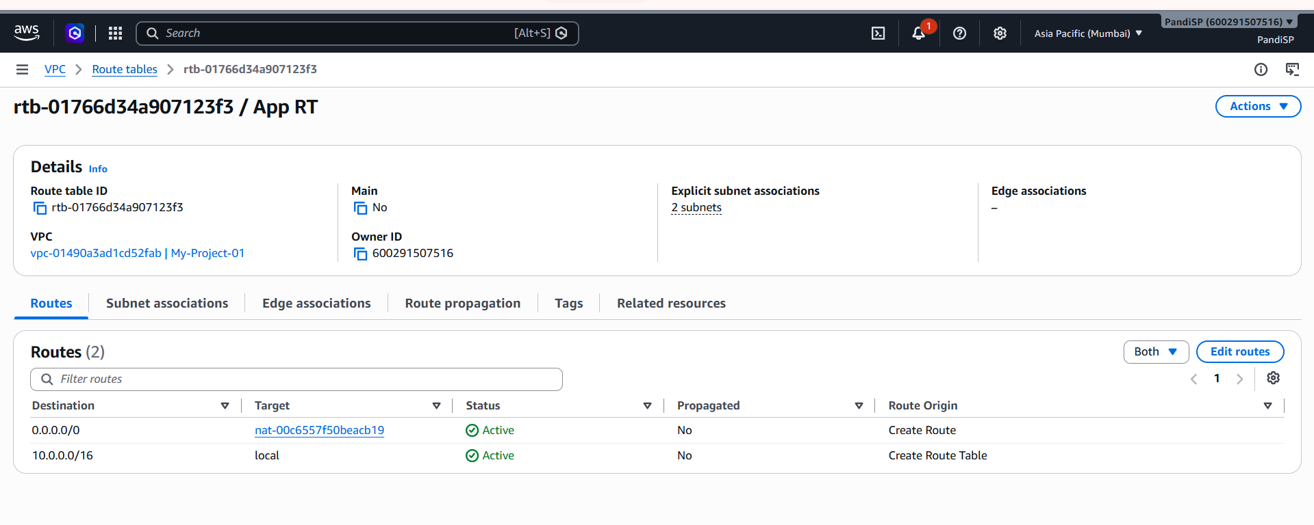
Figure 3
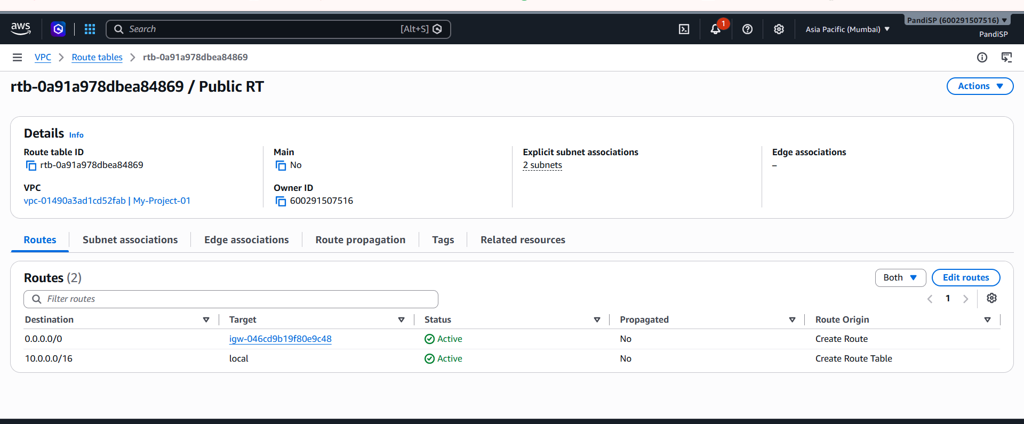
Figure 4
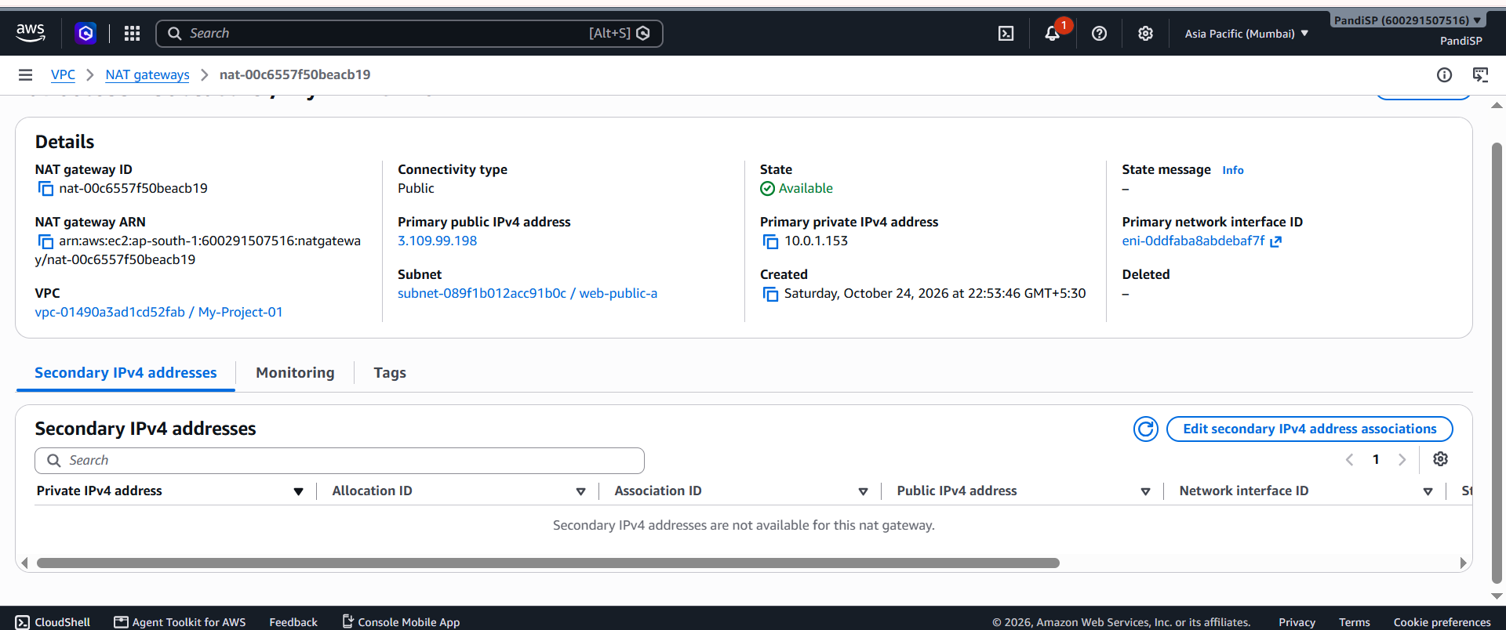
Figure 5

3. Task 2 - Web tier (Nginx on EC2)
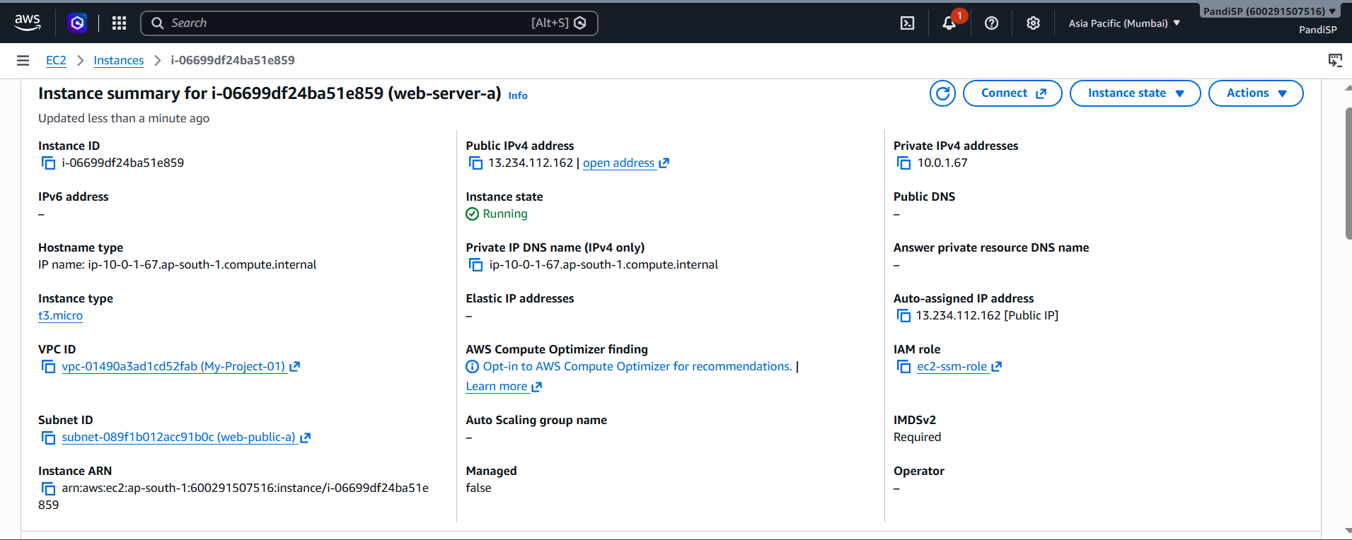
Figure 6
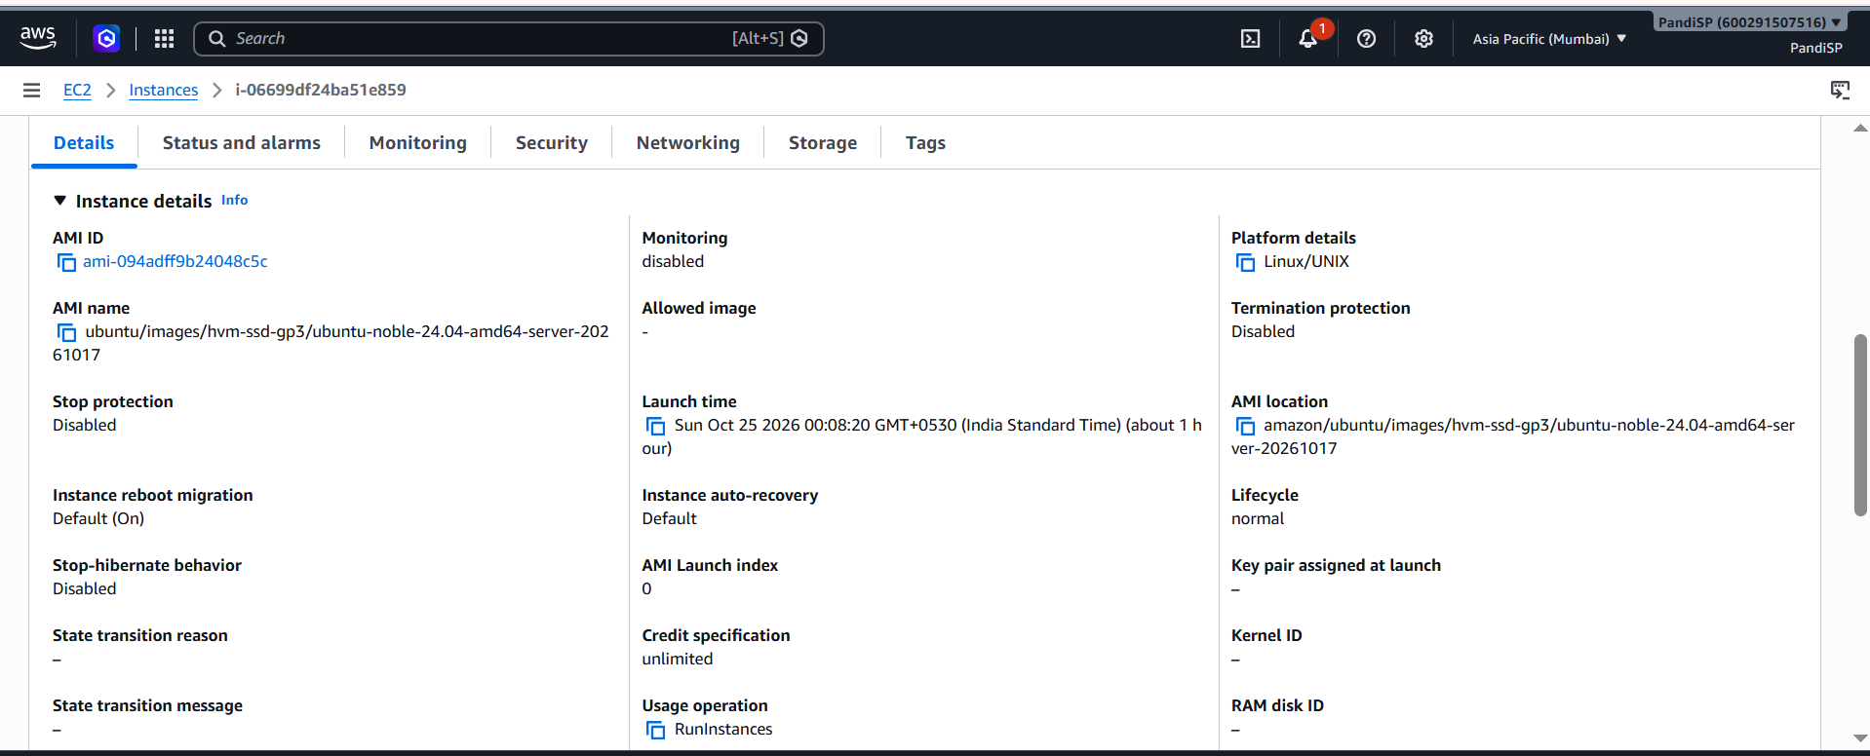
Figure 7
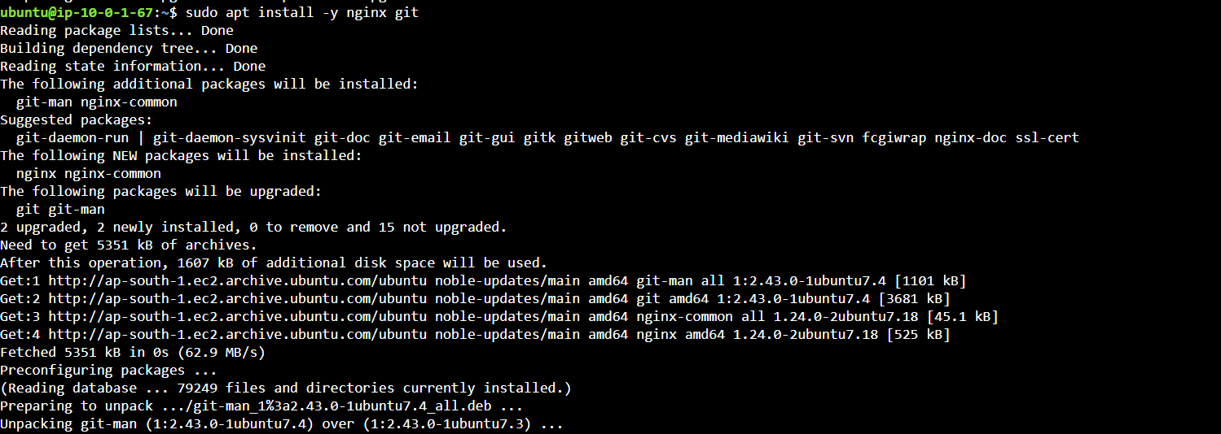
Figure 8
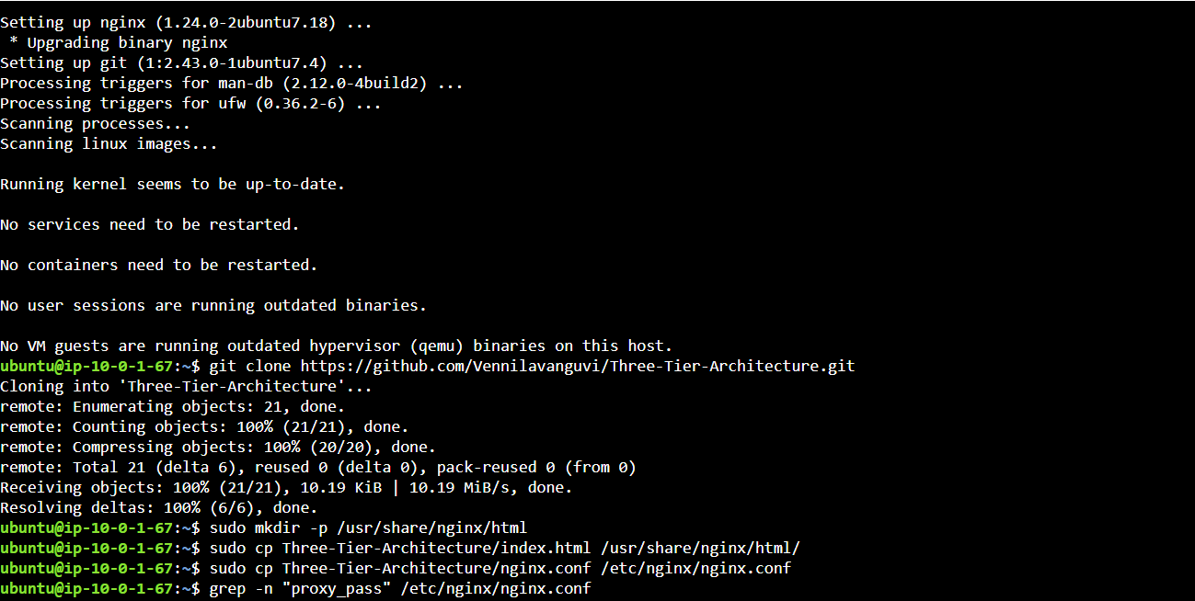
Figure 9

4. Task 3 - Application tier (Flask on EC2)
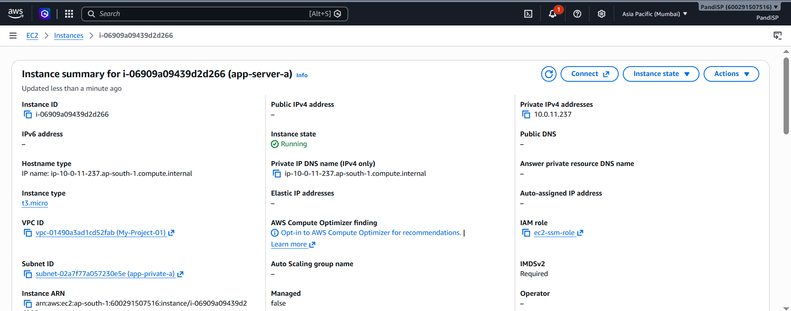
Figure 10
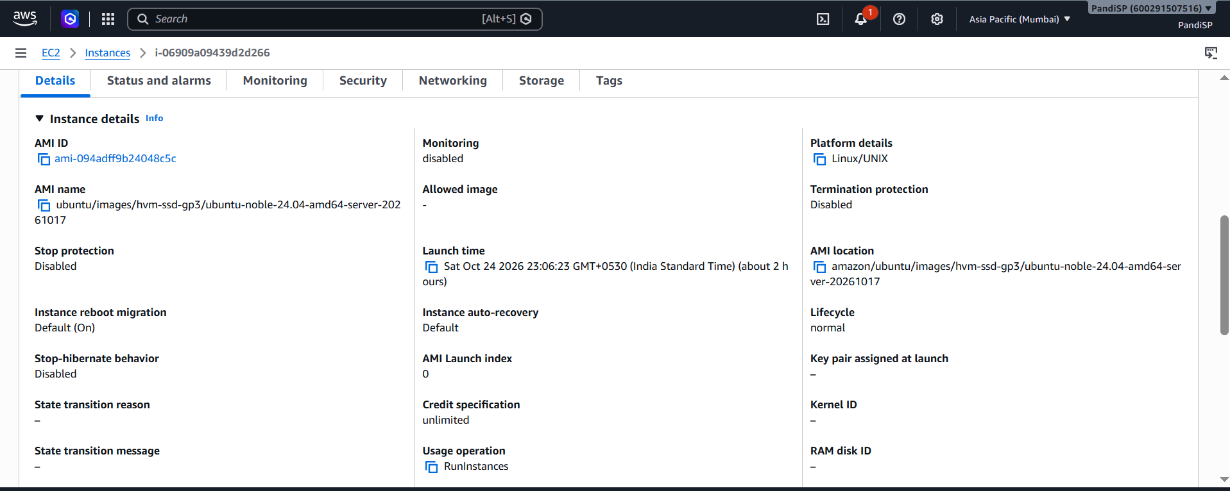
Figure 11
Figure 12

5. Task 4 - Database tier (RDS MySQL)
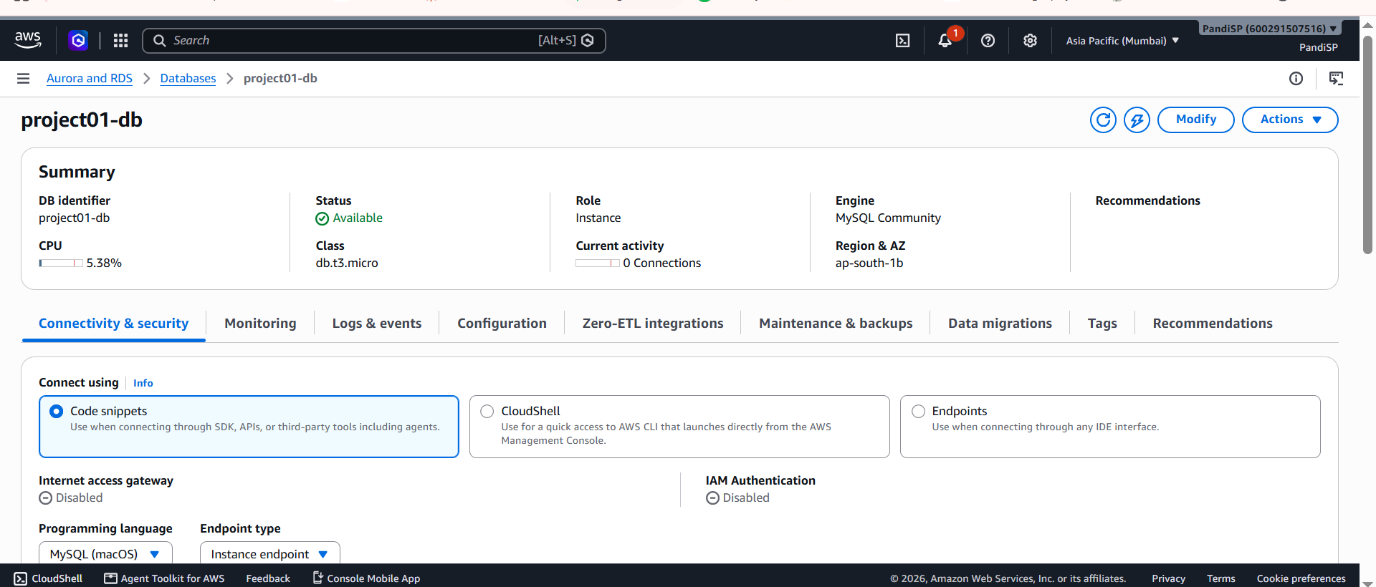
Figure 13
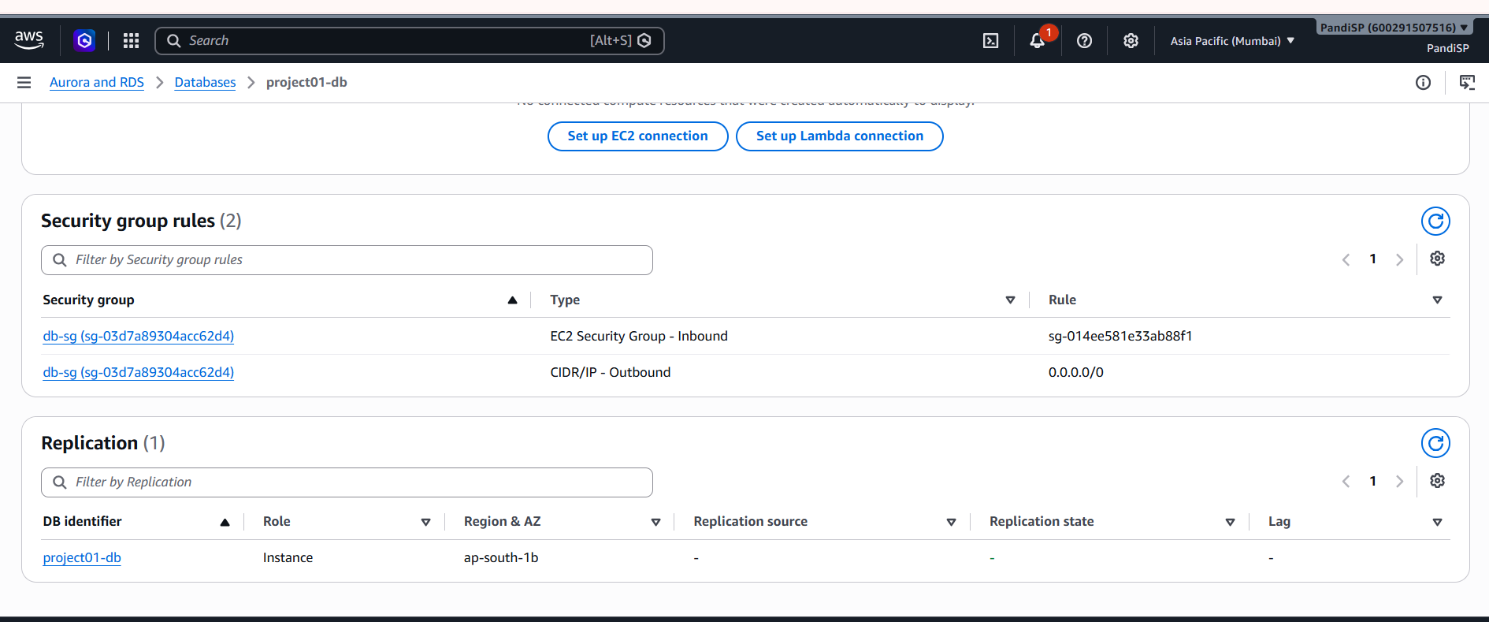
Figure 14
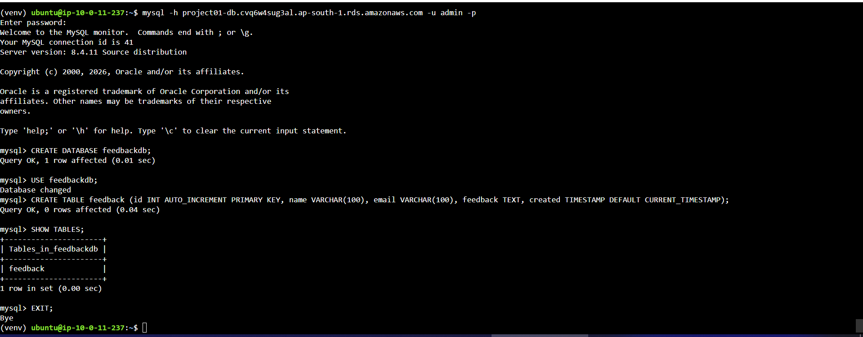
Figure 15

6. Task 5 - Security groups
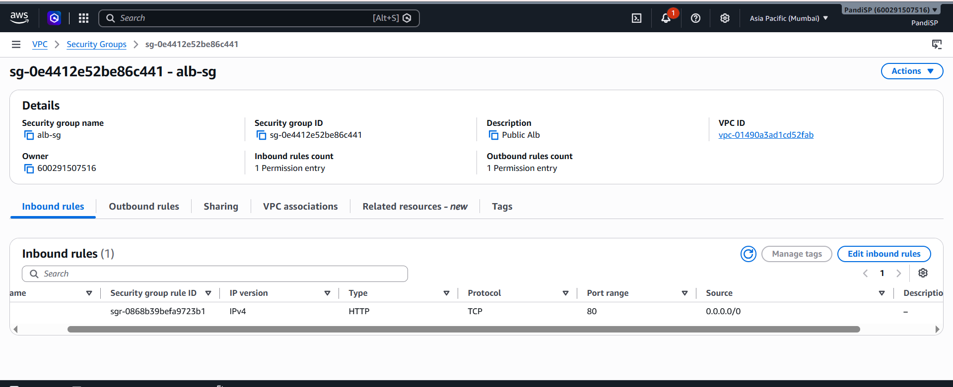
Figure 16
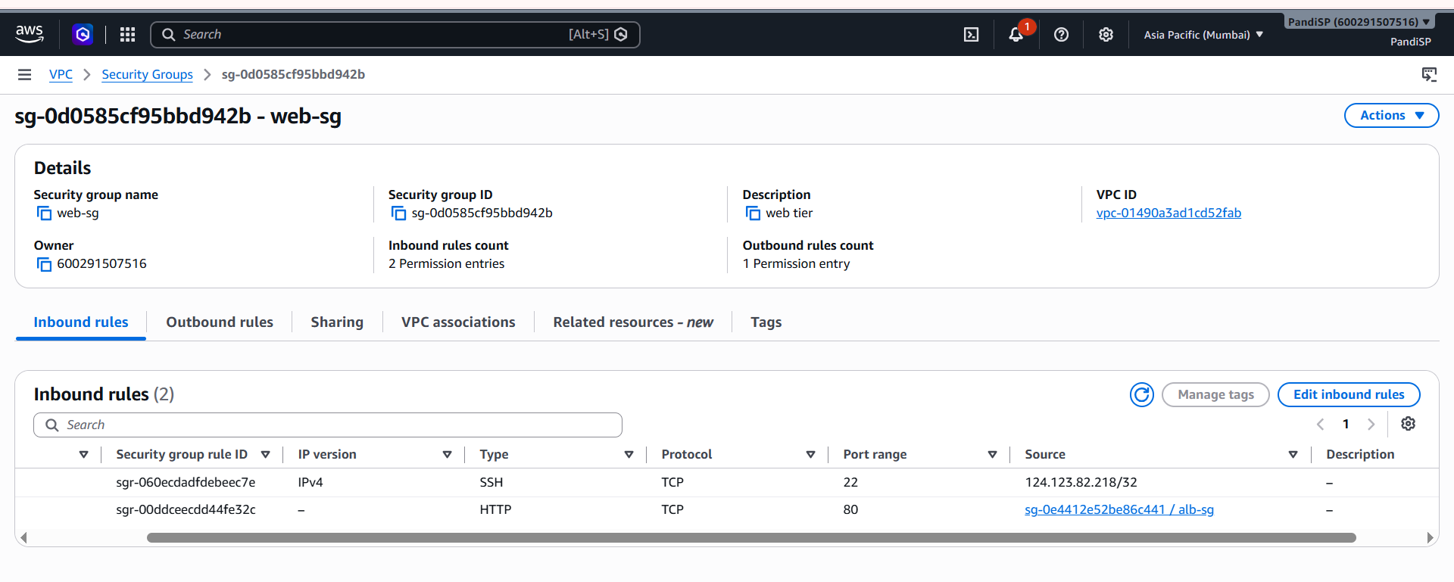
Figure 17
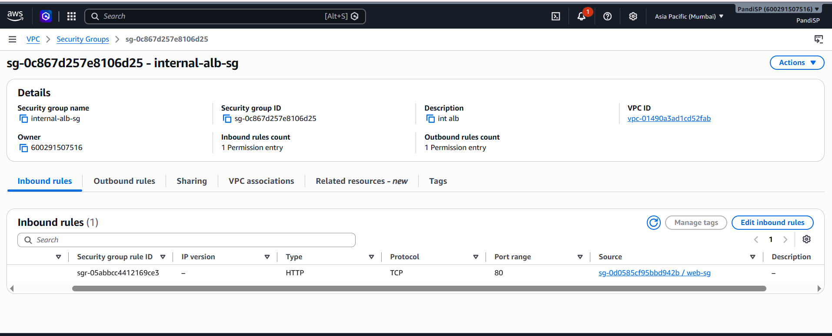
Figure 18
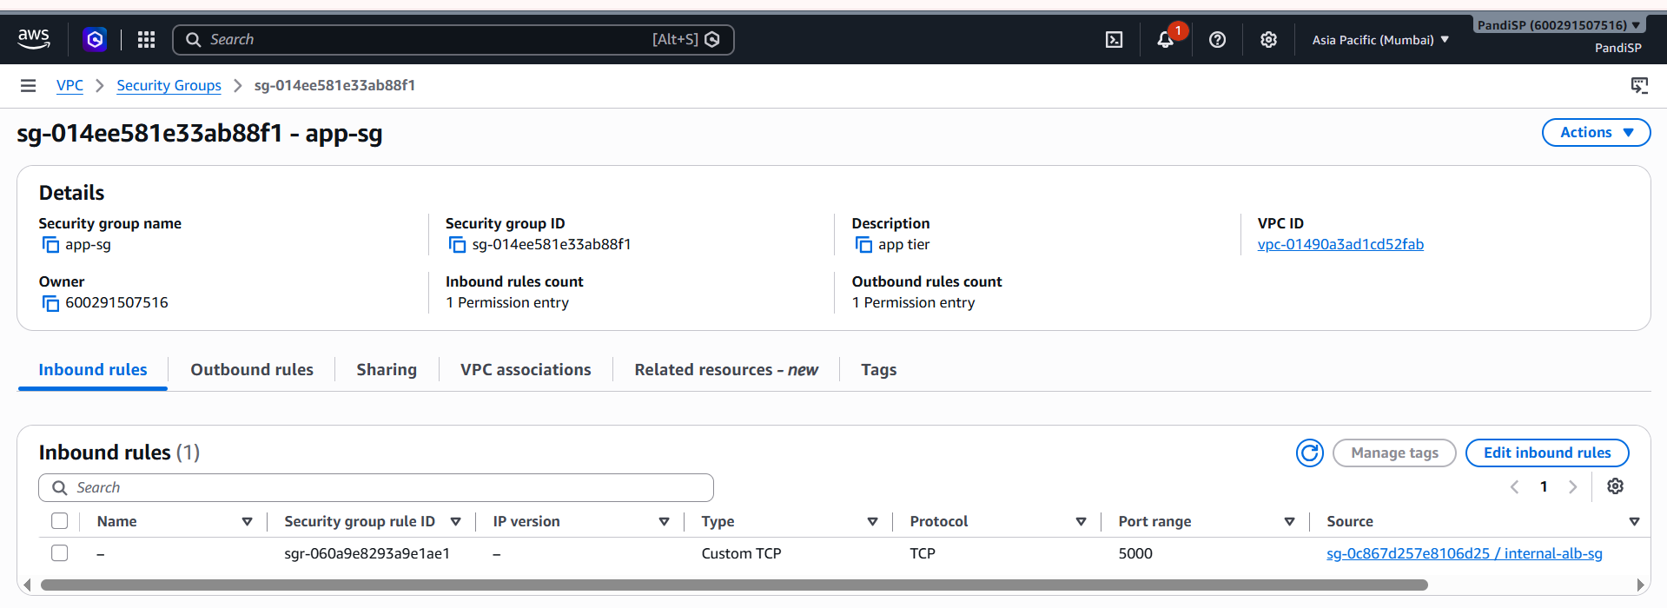
Figure 19
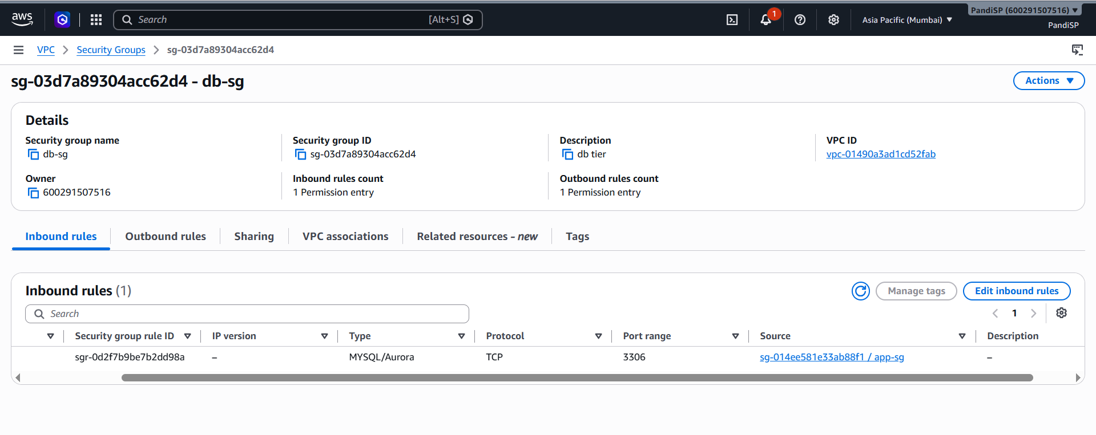
Figure 20

7. Task 6 - Public Application Load Balancer
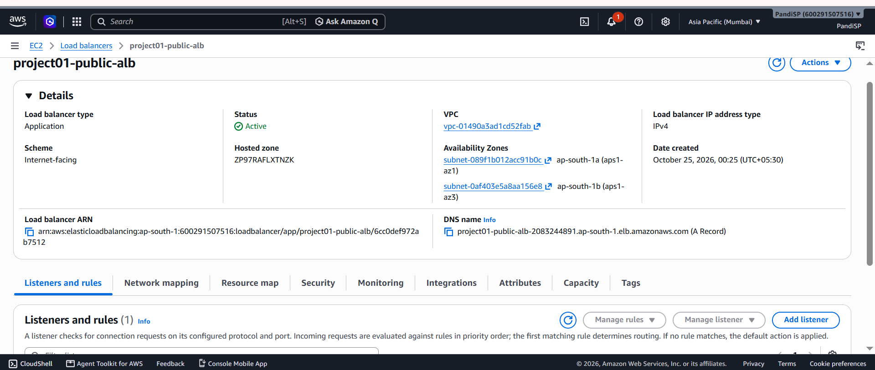
Figure 21
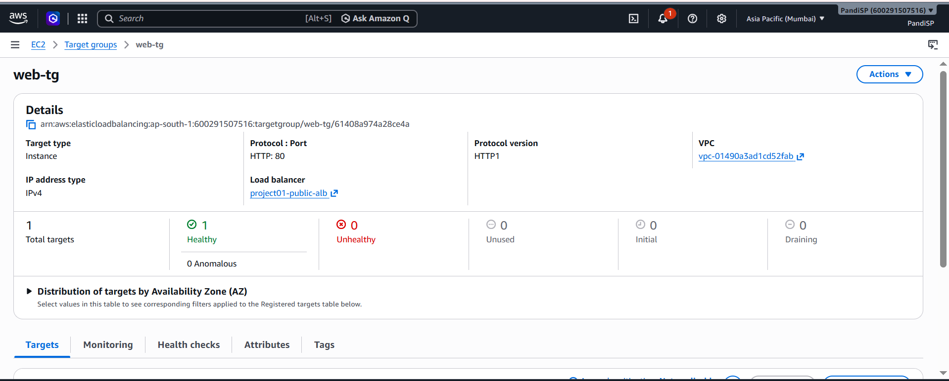
Figure 22

8. Task 7 - Internal Application Load Balancer
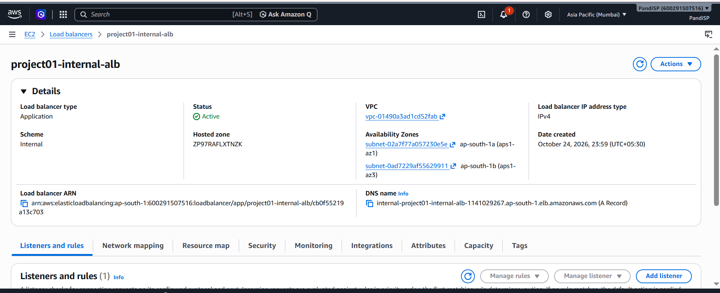
Figure 23
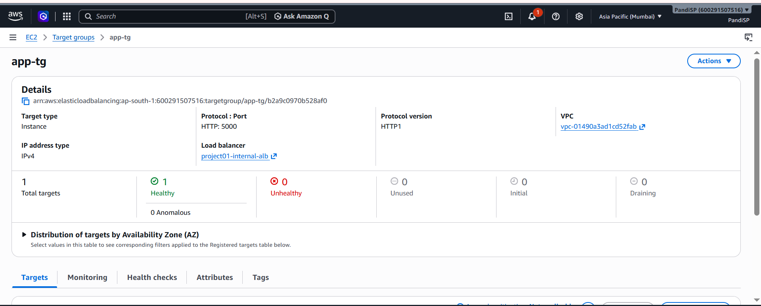
Figure 24

9. Task 8 - Nginx reverse proxy
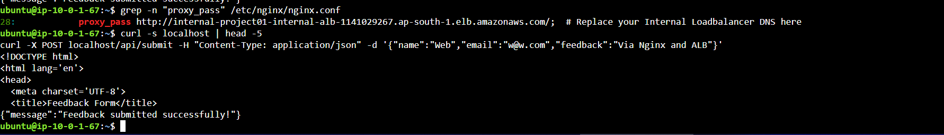
Figure 25

10. Task 9 - Connect Flask to RDS
Figure 26
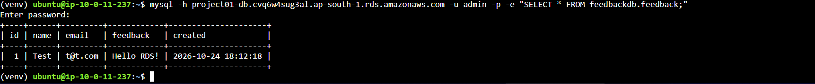
Figure 27

11. Task 10 - End-to-end validation
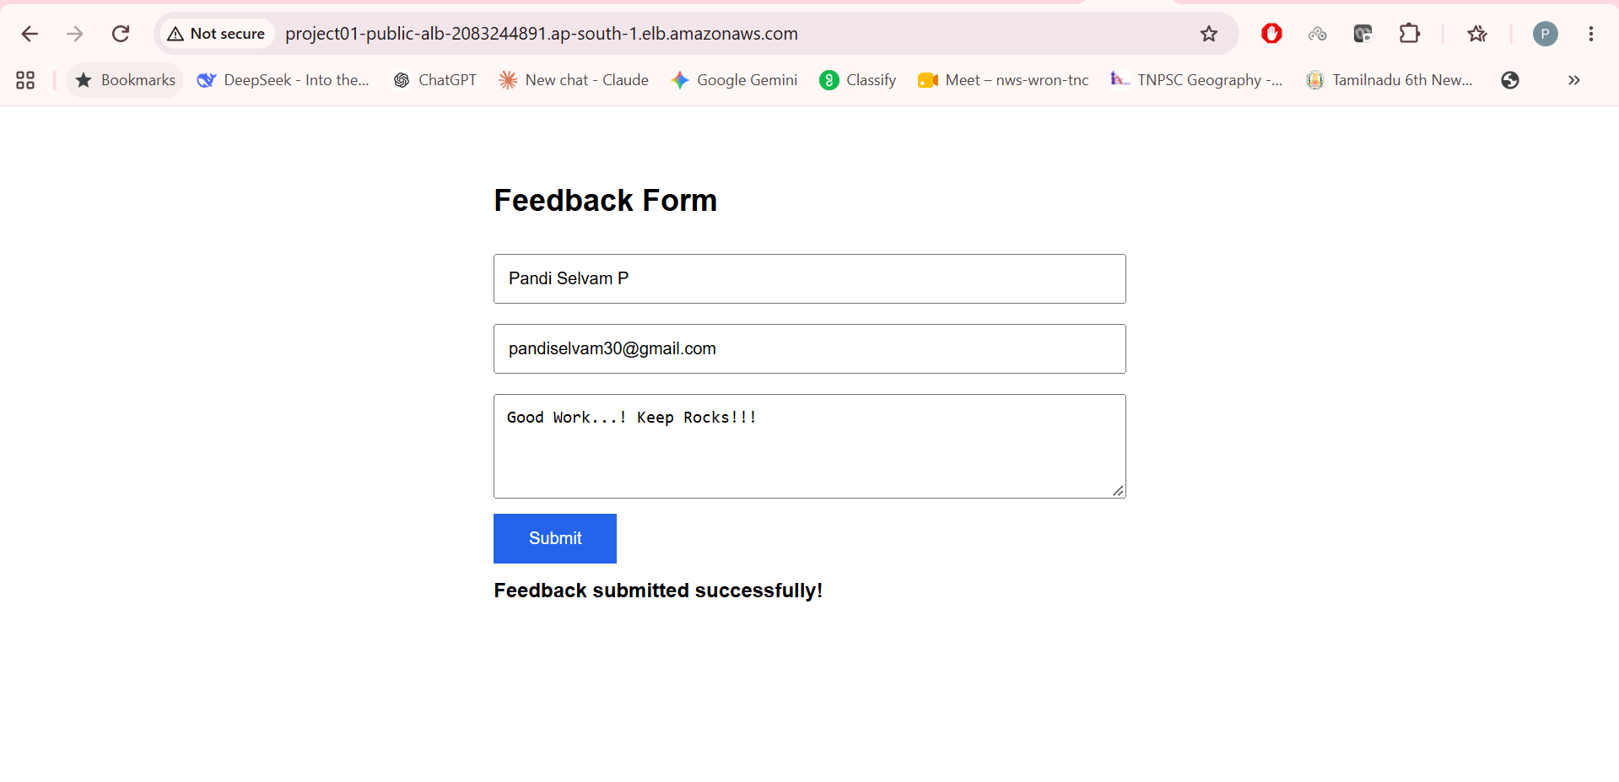
Figure 28
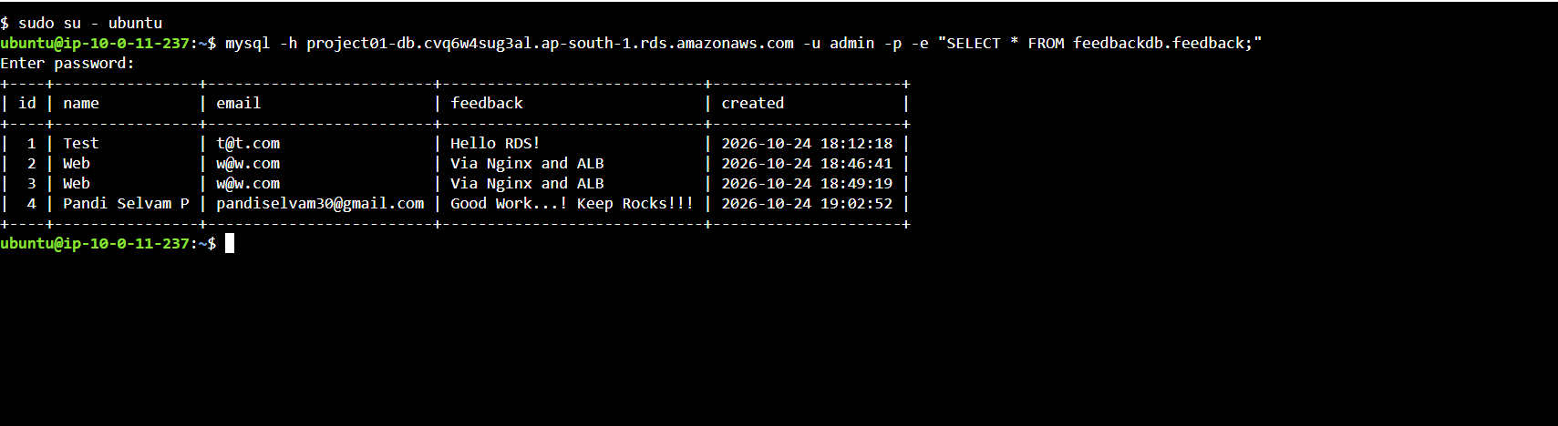
Figure 29

12. Bonus - Auto Scaling
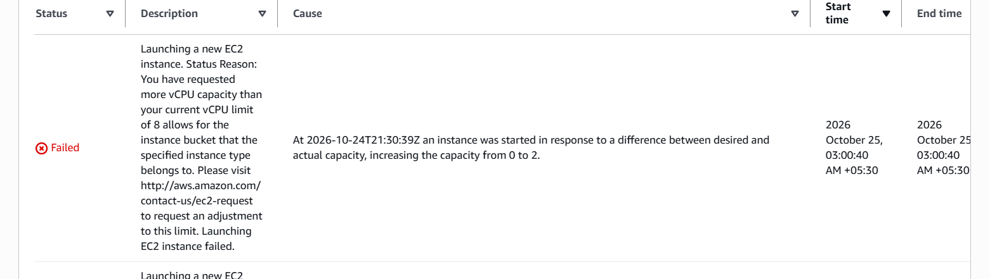
Figure 30

