What is NLP?
Natural Language Processing, or NLP, is an area of computer science that focuses on developing techniques to produce machine-driven analyses of text.

Why is Natural Language Processing Important?
NLP expands the sheer amount of data that can be used for insight. Since so much of the data we have available is in the form of text, this is extremely important to data science!
A specific common application of NLP is each time you use a language conversion tool. The techniques used to accurately convert text from one language to another very much falls under the umbrella of "natural language processing."
nltk: (Natural Language Toolkit) the python module we'll be using repeatedly; it has a lot of useful built-in NLP techniques.
Token: a string of contiguous characters between two spaces, or between a space and punctuation marks. A token can also be an integer, real, or a number with a colon.

What is Stemming?
Stemming is the process of converting the words of a sentence to its non-changing portions. In the example of amusing, amusement, and amused above, the stem would be amus.
“Stemming is process of reducing infected or derived words to their word stem, base or root form.”

Types of Stemmers
First, let's try the Lancaster Stemmer:
lancaster = nltk.LancasterStemmer()
stems = [lancaster.stem(i) for i in tokens]
Secondly, we try the Porter Stemmer:
porter = nltk.PorterStemmer()
stem = [porter.stem(i) for i in tokens]
Example:
intelligence
intelligent
intelligently
intelligen

What is Lemmatization?
Lemmatization is the process of converting the words of a sentence to its dictionary form. For example, given the words amusement, amusing, and amused, the lemma for each and all would be amuse.
“Some as stemming but intermediate representation/root form has a meaning”

WordNetLemmatizer
Once again, NLTK is awesome and has a built in lemmatizer for us to use:

from nltk import WordNetLemmatizer

lemma = nltk.WordNetLemmatizer()
text = "Women in technology are amazing at coding"
ex = [i.lower() for i in text.split()]

lemmas = [lemma.lemmatize(i) for i in ex]
Diffrence between Stemming and Lemmatization
Lemmatization | Stemming
-Word representation have meaning.  -Takes more time than stemming  -Use lemmatization when meaning of words is important for analysis.  Example: Question answering applicaton | -Word representation may not have meaning.  -Takes less time  -Use stemming when meaning of words is not important for analysis. Example:Spam detection

NLTK Parts of Speech Tagger
NLTK is a package in python that provides libraries for different text processing techniques, such as classification, tokenization, stemming, parsing, but important to this example, tagging.

WordNet
WordNet is an English lexical database with emphasis on synonymy - sort of like a thesaurus. Specifically, nouns, verbs, adjectives and adjectives are grouped into synonym sets.

Synsets
nltk has a built-in WordNet that we can use to find synonyms. We import it as such:
from nltk.corpus import wordnet as wn
If we feed a word to the synsets() method, the return value will be the class to which belongs. For example, if we call the method on motorcycle,
print(wn.synsets('motorcar'))

SentiWordNet
Based on WordNet synsets, SentiWordNet is a lexical resource for opinion mining, where each synset is assigned three sentiment scores: positivity, negativity, and objectivity.
from nltk.corpus import sentiwordnet as swn
cat = swn.senti_synset('cat.n.03')
cat.pos_score()
cat.neg_score()
cat.obj_score()

Stop Words
Stop words are extremely common words that would be of little value in our analysis are often excluded from the vocabulary entirely. Some common examples are determiners like the, a, an, another, but your list of stop words (or stop list) depends on the context of the problem you're working on.

What is Information Extraction?
With that said, information extraction is the means by which you acquire structured data from a given unstructured dataset. There are a number of ways in which this can be done, but generally, information extraction consists of searching for specific types of entities and relationships between those entities.

Chunking
Chunking is used for entity recognition and segments and labels multitoken sequences. This typically involves segmenting multi-token sequences and labeling them with entity types, such as 'person', 'organization', or 'time'.

Noun Phrase Chunking
Noun Phrase Chunking, or NP-Chunking, is where we search for chunks corresponding to individual noun phrases.

Named Entity Extraction
Named entities are noun phrases that refer to specific types of individuals, such as organizations, people, dates, etc. Therefore, the purpose of a named entity recognition (NER) system is to identify all textual mentions of the named entities.

Sentiment Analysis
Sentiment analysis refers to the use of text analysis and statistical learning to identify and extract subjective information in textual data.

Preparing the Data
To implement our bag-of-words linear classifier, we need our data in a format that allows us to feed it in to the classifer. Using sklearn.feature_extraction.text.CountVectorizer in the Python scikit learn module, we can convert the text documents to a matrix of token counts. So first, we import all the needed modules:
import re
import nltk
from sklearn.feature_extraction.text import CountVectorizer
from nltk.stem.porter import PorterStemmer
We need to remove punctuations, lowercase, remove stop words, and stem words. All these steps can be directly performed by CountVectorizer if we pass the right parameter values. We can do this as follows.
We first create a stemmer, using the Porter Stemmer implementation.
stemmer = PorterStemmer()
def stem_tokens(tokens, stemmer):
stemmed = [stemmer.stem(item) for item in tokens]
return(stemmed)

Bag of Words
The simplest approach to convert text into structured features is using the bag of words approach. Bag of words simply breaks apart the words in the review text into individual word count statistics.
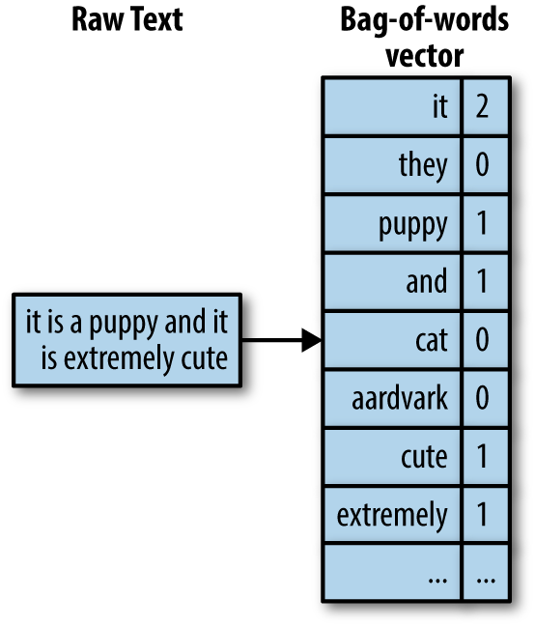

Word2Vec
Word2vec is an efficient predictive model for learning word embeddings from raw text. It comes in two models: the Continuous Bag-of-Words model (CBOW) and the Skip-Gram model. Algorithmically, these models are similar, except that CBOW predicts target words (e.g. 'mat') from source context words ('the cat sits on the'), while the skip-gram does the inverse and predicts source context-words from the target words.
The easiest way to think about word2vec is that it figures out how to place words on a graph in such a way that their location is determined by their meaning. In other words, words with similar meanings will be clustered together. More interestingly, though, is that the gaps and distances on the graph have meaning as well. So if you go to where “king” appears, and move the same distance and direction between “man” and “woman”, you end up where “queen” appears. And this is true of all kinds of semantic relationships!
Put more mathematically, you can think of this relationship as:
[king] - [man] + [woman] ~= [queen]

Skip-gram Model

Inputs
The input of the skip-gram model is a single word, wn. For example, in the following sentence:
I drove my car to school.
"car" could be the input, or "school".

Outputs
The output of a skip-gram model is the words in wn's context. Going along with the example from before, the output would be:
{"I","drove","my","to","school"}
This output is defined as {wO,1 , ... , wO,C }, where C is the word window size that you define.
Continuous Bag-of-Words model

Inputs
This input is defined as {wO,1 , ... , wO,C }, where C is the word window size that you define. For example, the input could be:
{"I","drove","my","to","school"}

Outputs
The output of the neural network will be wi. Hence you can think of the task as "predicting the word given its context". Note that the number of words we use depends on your setting for the window size.
I drove my car to school. "car" could be the output.

