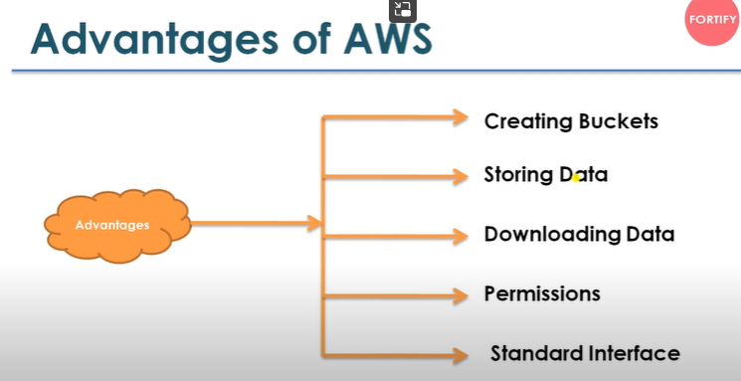

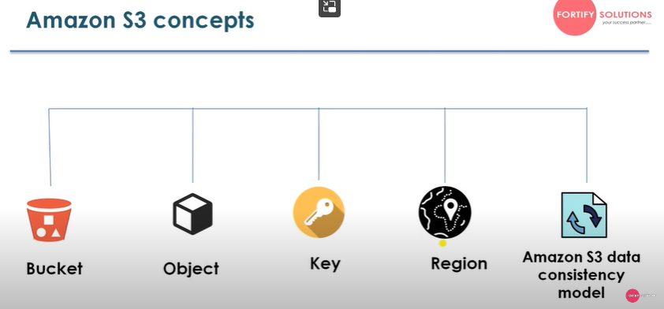

What is is Bucket?

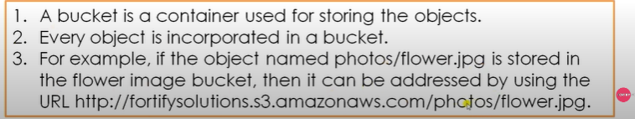

What is Object?

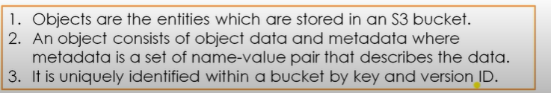

What is key?

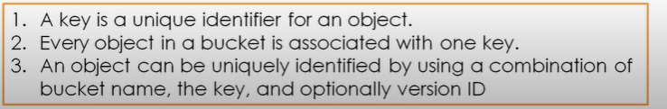

What is Region?

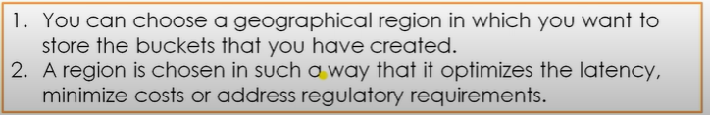

What is S3 data consistency model?

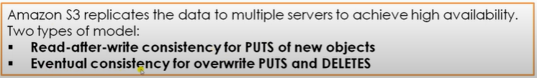

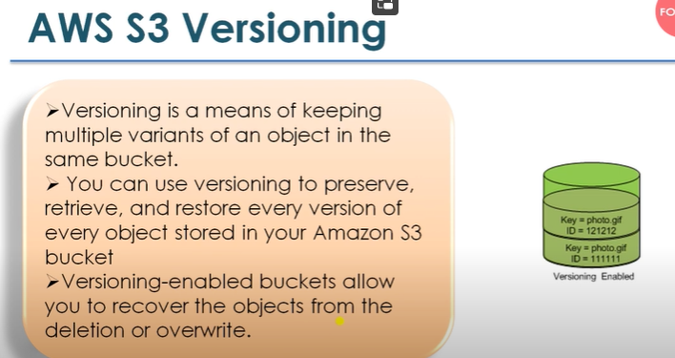

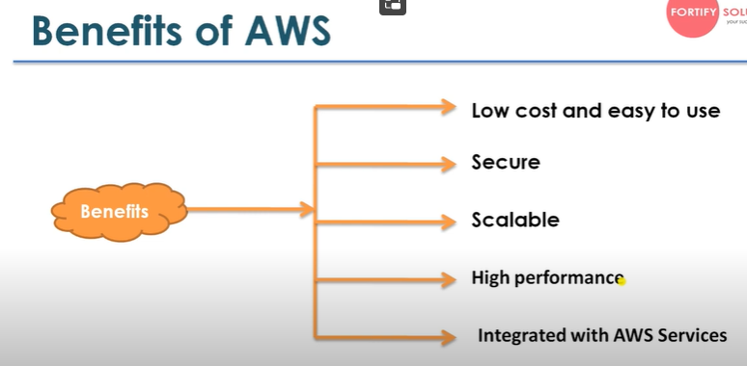

How to create s3 bucket?

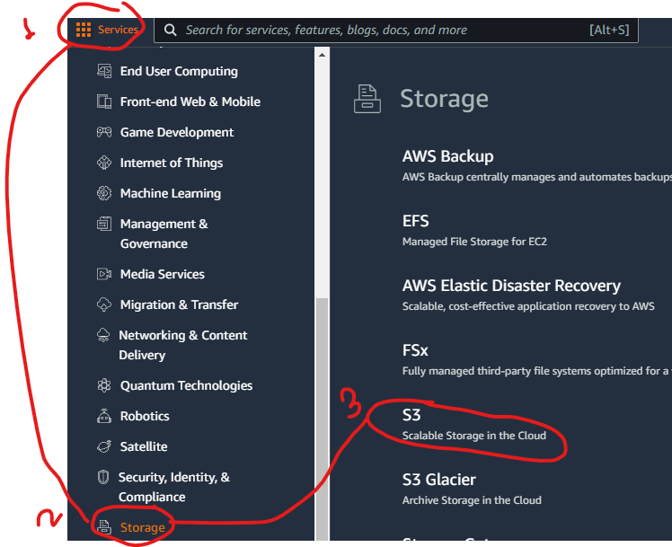

AWS EC2 Instances?

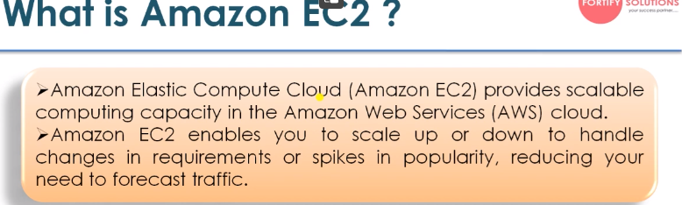

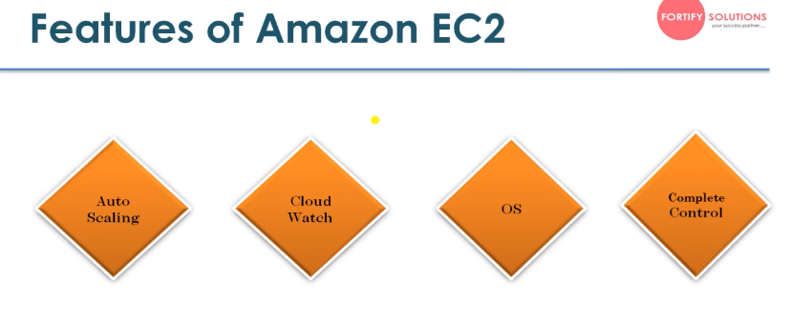

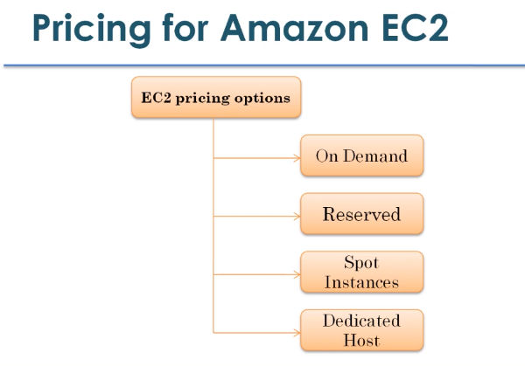

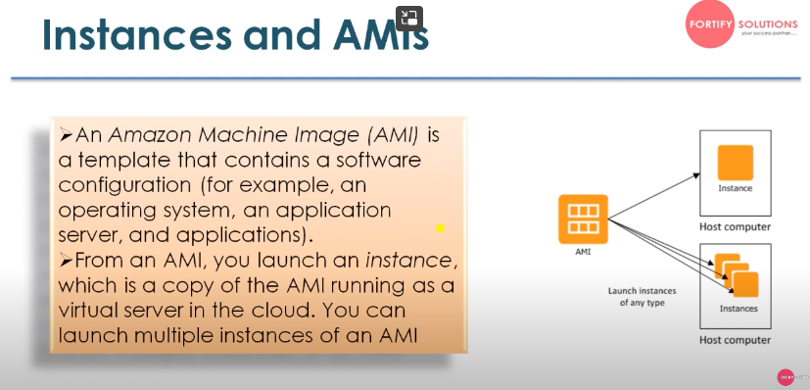

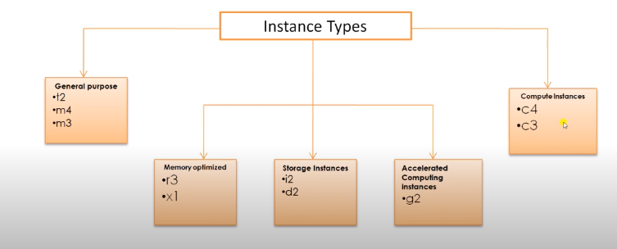

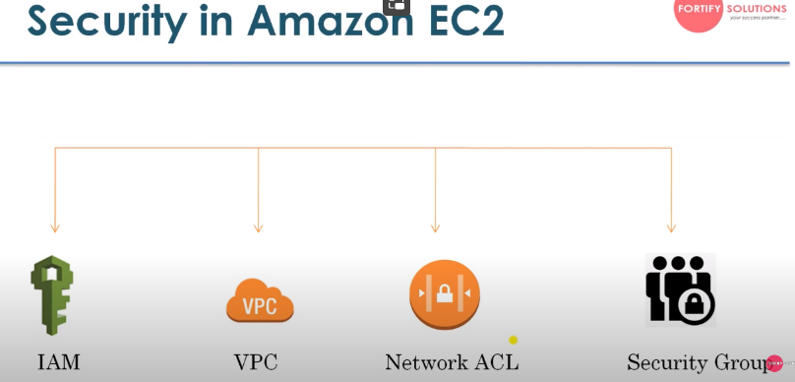

IAM –Identity access management

VPC- Virtual private cloud

Network ACL –Network Access Control List

Security Group –Virtual Firewell

**Launch and Create EC2 Instances?**

**Go to services ->EC2 ->Launch Instance**

**Create instance and generate key pair and save it**

**Open puttygen and load key pair and save as ppk file**

**Open putty and type**

**Ec2-user@ {**Public IPv4 DNS this is instance name}

 ec2-3-108-234-213.ap-south-1.compute.amazonaws.com

**and open it then accept it will show instance in putty**

**How to luunch windows instances?**

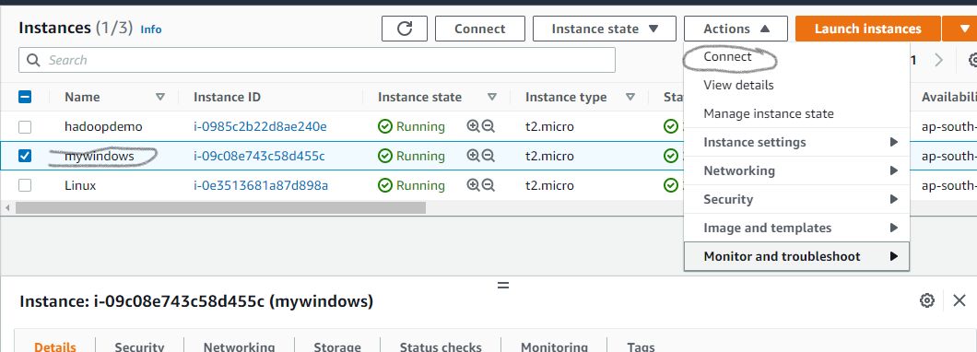

**Click connect and go to RDP client**

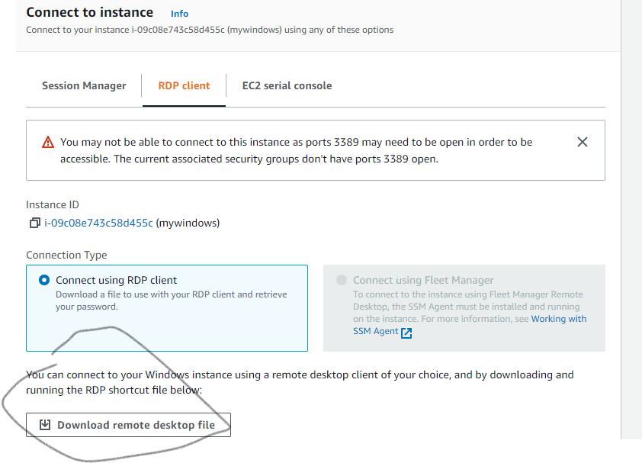

**Download remote desktop file and open it**

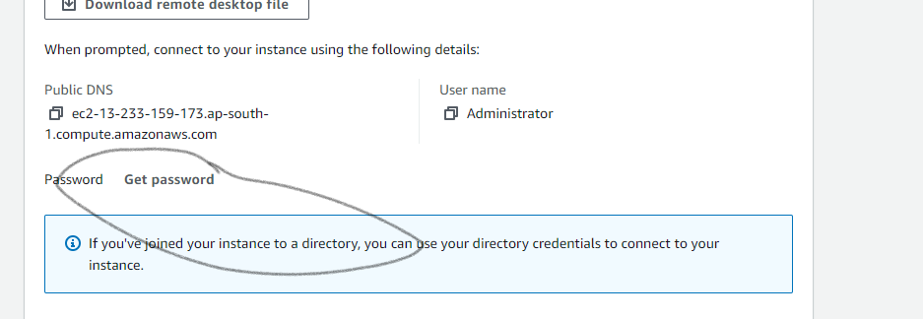**click get password and browse key-pair file and decrepit it and generated password enter in RDP.**

**HOW TO ATTACHED Extra Volume to windwos EC2 Instance?**

**How to Access Metadata in AWS EC2?**

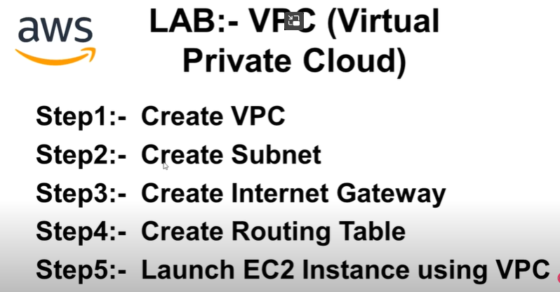

**AWS DATABASE SERVICES?**

