[AWS Step Function | AWS Lab | AWS Hands On | AWS By Doing - YouTube](https://www.youtube.com/watch?v=gl0T8MBQmfk&list=PLisYSIHvE9qNqE21etGZgzLdKMErFS1OJ&index=4)

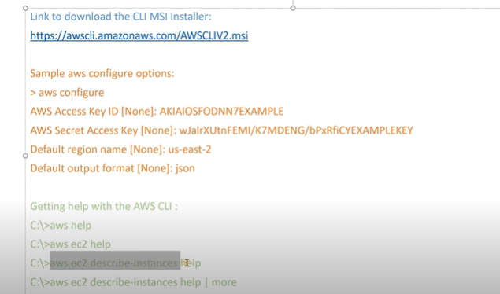

Step Functions:

State Machines

