Architecture
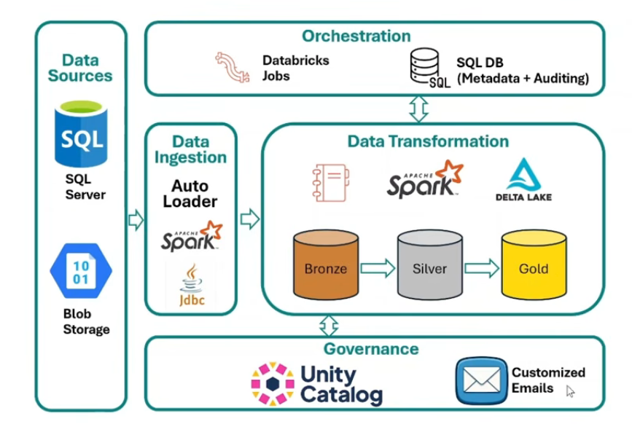
Understand our architecture how exactly we are going to build this project.
Source data from Redshift ARC Views, HRSA files, and reference tables is ingested directly into Azure Databricks using JDBC connections. The data is stored in Bronze Delta tables for raw persistence, processed through Silver cleansing and standardization layers, enriched using business matching and fuzzy matching logic, and classified using existing Contract Pharmacy eligibility rules. The curated outputs are stored in Gold Delta tables and exposed through Databricks SQL Views for Qlik Sense reporting. Databricks Jobs orchestrate the end-to-end workflow, while Unity Catalog and SQL metadata tables provide governance, auditing, and load management for both full and incremental processing.

For relational source:
Redshift Tables
↓
JDBC Connection
↓
Azure Databricks
``
For file-based sources:
Blob Storage
↓
Auto Loader
↓
Azure Databricks
Full Load
Source → Bronze Layer
Incremental Load
Used for:
- Daily processing
- New and updated records only
Source → Delta Merge → Bronze Layer

Bronze Layer (Raw Data)
Purpose
Stores source data exactly as received.
Silver Layer (Data Cleansing & Standardization)
This layer corresponds to the current:
Activities
- Data Cleansing
- Address Standardization
- Null Handling
- Data Quality Validation
- Deduplication
- Business Standardization

Orchestration Layer
- Databricks Jobs / Workflows
Responsible for:
Ingestion
↓
Cleansing
↓
Matching
↓
Fuzzy Matching
↓
Classification
↓
Publishing
Metadata & Auditing Database
Stores:
- Watermark Values
- Job Status
- Execution Logs
- Record Counts
- Audit Information
Supports both Full and Incremental processing.
Governance Layer
Unity Catalog
Provides:
- Centralized Data Governance
- Role-Based Access Control
- Data Lineage
- Schema Management
- Data Auditing
Notifications
Automated email alerts for:
- Success Notifications
- Failure Notifications
- SLA Monitoring
- Pipeline Health Checks

Reporting Layer
- Databricks SQL
Creates business-facing SQL views.
Gold Tables
↓
SQL Views
↓
Qlik Sense
Qlik Sense
Consumes curated datasets directly from Databricks SQL Warehouse to support:
- Operational Reporting
- Business Dashboards
- Executive Analytics

End to End Flow
Data Sources
↓
Data Ingestion
↓
Bronze Layer
(Raw Data)
↓
Silver Layer
(Cleansed Data)
↓
Matching Rules
↓
Fuzzy Matching
↓
Eligibility Classification
↓
Gold Layer
(Business Ready Data)
↓
Databricks SQL Views
↓
Qlik Sense
By directly ingesting data from Redshift and other source systems into Delta Lake. Data flows through Bronze, Silver, and Gold layers where cleansing, matching, fuzzy matching, and eligibility classification are performed. Databricks Workflows orchestrate the end-to-end pipeline, Unity Catalog provides governance and security, and Qlik Sense consumes curated business-ready datasets through Databricks SQL views. This approach improves scalability, performance, maintainability, and support for both full and incremental data processing.
Source is Redshift
Databricks can connect directly to Redshift.
jdbc_url = ( "jdbc:sqlserver://server.database.windows.net:1433;" "database=ARCDB")
df_844 = (
spark.read
.format("jdbc")
.option("url", redshift_url)
.option("dbtable", "arc_view_844")
.option("user", username)
.option("password", password)
.load()
)

df_844.write \
.format("delta") \
.mode("overwrite") \
.saveAsTable("bronze.arc_844")

Intestion
arc_844 -> bronze.arc_844
arc_867 -> bronze.arc_867
silver(cleansing)
gold(hrsa_matches)

In Azure Databricks, Data is collected from source systems means redshift tables.
Data quality and cleansing rules are applied.
Matching and validation rules are executed.
Fuzzy matching identifies the best possible matches.
Business classification logic determines eligibility categories.
Final datasets are prepared for reporting and analytics.
Qlik Sense consumes the finalized data.
Source Views/Tables
|
v
Databricks Ingestion
(JDBC / Connector)
|
v
Bronze Delta Tables
|
v
844 Cleansing
867 Cleansing
|
v
Silver Delta Tables
|
v
Matching Rules
|
v
Fuzzy Matching
(Pandas UDF)
|
v
Business Classification
|
v
Gold Delta Tables
|
v
Databricks SQL Views
|
v
Qlik Sense
2. Incremental Load
Incremental load processes only new or changed records.

Processing Workflow
1. Read Source Data
|
v
2. Load Raw Data to Bronze
|
v
3. Execute 844 Cleansing
|
v
4. Execute 867 Cleansing
|
v
5. Apply Business Matching Rules
|
v
6. Execute Fuzzy Matching
|
v
7. Apply Eligibility Classification
|
v
8. Publish Gold Tables
|
v
9. Create SQL Views
|
v
10. Qlik Sense Consumption
Incremental Load Design
Source Tables
|
v
Read New/Changed Records
|
v
Delta MERGE
|
v
Bronze Tables
|
v
Downstream Processing
In our project, data is read directly from Redshift tables into Azure Databricks using a Lakehouse architecture, eliminating the need for intermediate unload processes and file-based data movement.

The ingested data is stored in Bronze Delta tables as the raw data layer. It is then processed through Silver Delta tables, where data cleansing, standardization, and business matching rules are applied. The data is further enriched using fuzzy matching algorithms and eligibility classification logic to identify and categorize Contract Pharmacy relationships.

The final business-ready datasets are published to the Gold layer, providing curated and trusted data for reporting and analytics. Databricks Workflows orchestrate the end-to-end pipeline, including ingestion, cleansing, matching, classification, and publishing processes. Finally, Qlik Sense consumes the data directly from Databricks SQL views, enabling efficient and scalable reporting.

Full Load Logic

Used for:

Initial migration
Historical reload
Backfill
Reconciliation
Read Entire Source

df_844 = (
spark.read
.format("jdbc")
.option("url", jdbc_url)
.option("dbtable", "ARC_VIEW_844")
.option("user", username)
.option("password", password)
.load()
)

df_867 = (
spark.read
.format("jdbc")
.option("url", jdbc_url)
.option("dbtable", "ARC_VIEW_867")
.option("user", username)
.option("password", password)
.load()
)

######Load to Bronze

df_844.write \
.format("delta") \
.mode("overwrite") \
.saveAsTable("bronze.arc_844")

df_867.write \
.format("delta") \
.mode("overwrite") \
.saveAsTable("bronze.arc_867")

######################Flow########################
ARC_VIEW_844
|
v
Read Entire Table
|
v
Overwrite Bronze Table

ARC_VIEW_867
|
v
Read Entire Table
|
v
Overwrite Bronze Table

#####################################
Incremental Load Logic

Used for:

Daily execution
New records
Updated records
Step 1: Create Metadata Table
##########################################
CREATE TABLE metadata.job_control
(
job_name STRING,
last_processed_timestamp TIMESTAMP
);
`

##########step2 Read last_processed_timestamp from watermark
watermark = spark.sql("""
SELECT last_processed_timestamp
FROM metadata.job_control
WHERE job_name='arc_844_load'
""").collect()[0][0]

###########Step3 Read only changed records
incremental_query = f"""
(
SELECT *
FROM ARC_VIEW_844
WHERE LAST_UPDATED > '{watermark}'
) src
"""

##Only new/updated rows are loaded.
incremental_df = (
spark.read
.format("jdbc")
.option("url", jdbc_url)
.option("dbtable", incremental_query)
.option("user", username)
.option("password", password)
.load()
)

########step4 Merge into bronze
from delta.tables import DeltaTable

bronze_tbl = DeltaTable.forName(
spark,
"bronze.arc_844"
)

(
bronze_tbl.alias("t")
.merge(
incremental_df.alias("s"),
"t.id_340b = s.id_340b"
)
.whenMatchedUpdateAll()
.whenNotMatchedInsertAll()
.execute()
)

######step5 Update Watermark
latest_ts = incremental_df.agg(
{"last_updated": "max"}
).collect()[0][0]

#########################Silver Layer Processing###############################

silver_844 = (
spark.table("bronze.arc_844")
.withColumn(
"entity_name",
F.upper(F.trim("entity_name"))
)
.withColumn(
"address",
F.upper(F.trim("address"))
)
)

silver_844.write \
.mode("overwrite") \
.saveAsTable("silver.arc_844")

##############Matching Rules###################
matched_df = (
spark.table("silver.arc_844")
.crossJoin(
spark.table("silver.arc_867")
)
)

The solution follows a Bronze-Silver-Gold Lakehouse architecture in Azure Databricks.
During the initial migration, a full load ingests all historical data from Redshift into Bronze Delta tables.
For ongoing processing, incremental loads use a watermark-based approach to retrieve only new or updated records and
merge them into Delta tables using Delta Lake MERGE operations.
The data then flows through cleansing, matching, fuzzy matching, and eligibility classification layers before being published to Gold business datasets and consumed by Qlik Sense through Databricks SQL views.

