Spring Boot
- Spring Framework is a base of the Spring Boot.
- Spring Boot is used for faster development and deployment.
- Spring Boot provides the auto configuration module which will help developer to reduce the configuration efforts.
- Spring Provides the starter Project/Dependencies which help to manage the jar file internally required for that module.
- Spring Boot Provided Embedded server for execution, Embedded DB etc.
- Spring Boot mostly used for a REST API development.
- Spring boot is bases on Spring Framework. In which Dependency Injection (DI) is mostly used by a framework internally.
- Spring Boot is divided into several modules which used for developing a different type of application.
- Some of the examples of modules
  - Spring Core/IOC
  - Spring JDBC
  - Spring ORM
  - Spring REST
  - Spring MVC
  - Spring Batch
  - Spring Cloud
  - Spring JMS
  - Spring Security

Spring Modules Implementation Steps
- Add a Dependencies.
- Provide a configuration for the module.
- Use a APIs provided by spring framework.

Spring Boot Project Creation
- There are multiple ways to create a spring boot application
  - Spring Initializer web application.
https://start.spring.io/
  - Spring CLI
https://docs.spring.io/spring-boot/docs/current/reference/html/cli.html
  - Spring Tool Suit IDE (STS)
https://spring.io/tools

Spring Application Properties
https://docs.spring.io/spring-boot/docs/current/reference/html/application-properties.html
Creating Spring Boot Application and Importing into Eclipse
- Create a Spring Boot Application from the spring initializer
https://start.spring.io/
- Copy and paste the zip file into eclipse workspace.
- Extract the zip file.
- Steps to open project into eclipse
  - “File” menu -> Select “Import” option
  - Search for “maven” into wizard
  - Select “Existing Maven Project” option.
  - Click on “Next” -> select a project path into Root Directory
  - Click On “Finish”

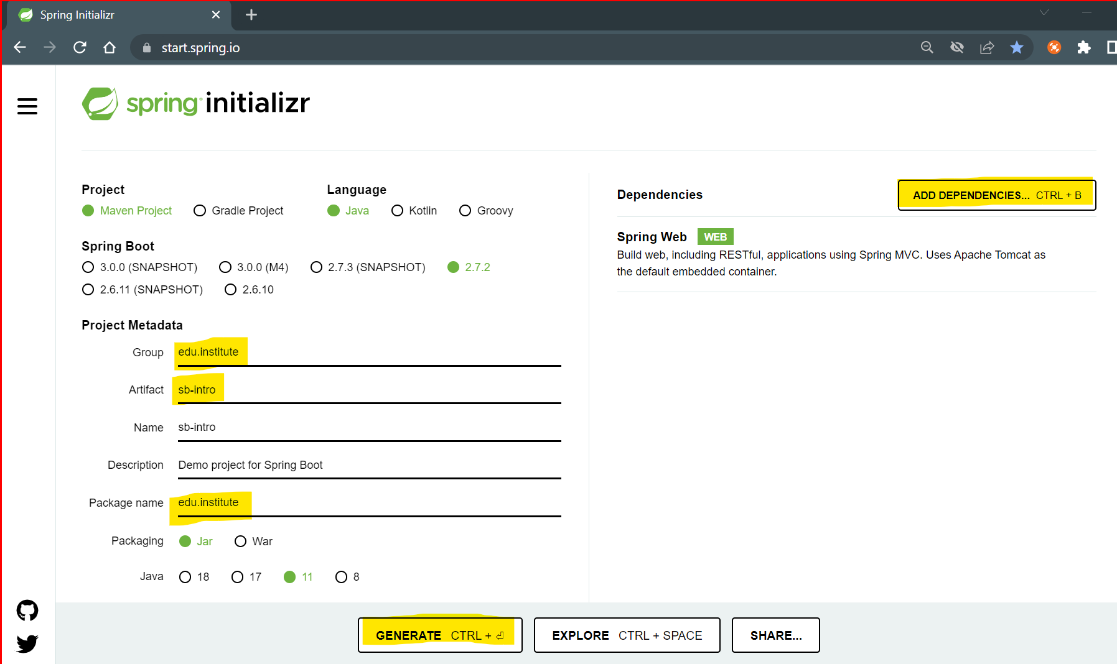

Spring Boot Project Structure

Spring Core/IOC
- Spring Core is the base module of the spring.
- In this module you can get the java classes object created and managed by spring.
- To create and maintain the java objects spring use container which is also known as ApplicationConext container.
- ApplicationContext container is use to create, manage java Objects, it will also perform the DI injection.
- Spring has Bean classes. Beans classes means the java classes whose object will be created and maintain by Spring.

Dependency Injection (DI)
- DI is a process in which you can inject an object one class into another class.
- In java this process is called as HAS-A relation.
- This Dependency Injection can be done by spring boot automatically using @Autowire annotation.

@SpringBootApplication :
- This is the main annotation of the spring boot which is the combination of 3 annotation.
  - @Configuration: to load the configurations at the time of spring boot application startup.
  - @EnableAutoConfiguration: It will add a configuration automatically on the bases of dependencies added inside application.
  - @ComponentScan: using this annotation spring will scan all the classes which is annotated with @Component or its child annotation and create an Object of those classes.

@Component
- This annotation is use to mark any java class as a spring bean class.
- There are child annotations of this annotation
  - @Controller
  - @RestController
  - @Service
  - @Repository
  - @ControllerAdvice

REST API using Spring Boot
- REST APIs are a way to access application functionality from any other application which can be based on different platform.

JSON
- JSON stands for Java Script Object Notation
- It is use to transfer data from one application to another based on different platform and languages.
- JSON is use as universal data transmission language.
- JOSN is always in Key and Value Pair. This key and value pair is also known as json element.
- Key must be in string and value can be any data type.
- Json also has a Object and Array concept.
- JSON Object
  - JSON object is a combination of key and values pair that is json elements
  - Denoted by {}
  - Syntax:
{
“Key” : Value,
“Key” : Value,
“Key” : Value
}

- JSON Array
  - JSON Array is a combination of values, or it can have a json objects also.
  - Denoted by []
  - Syntax:
“skills” : [“Java”, “Servlet”, “JSP”, “Maven”, “Spring Boot”, “Git and GitHub”]

JSON To Java Class and Vice-versa

- JSON Object to Java Class

- JSON Object with JSON Array to Java class

- JSON Object with another JSON Object to java class
- JSON array with JSON Object inside another JSON Object

Creating Rest API in spring boot
- Use @RestController annotation for the java class.
- Create a Rest API (Endpoints)
  - You can use any Http Method as per the requirement.
  - Use a Http Method specific annotation to create REST API.
  - Every Rest API will have a URL

- Spring Boot REST API can consume (request) and produce (response) a JSON internally.
- In the Spring Boot the json will be converted into Java Object and Java Object will be converted into JSON using Jakson Library.
- @RequestBody: This annotation is responsible to accept a JSON and convert it into a java object also It will set all the JSON values into java variable.

Download and Install Postman for Rest API execution
https://www.postman.com/downloads/

HTTP Methods for REST APIs
- As per recommendations you should a different Http method for the different type of operations.
- The following recommendations has to consider while creating REST API
  - GET:
    - If you wanted to return the information as a response of the REST API then this method used. The operations such as select can be created by GET method.
    - If you wanted to get the information from the user (request) then you can use Request Parameter or path variable.
    - In the Spring Boot To create HTTP GET method you can use @GetMapping annotation.
  - POST
    - If you wanted to create new record/entry then you can use HTTP POST method. The operations such as Insert can be done using POST method.
    - To accept the values form the user you can use JSON.
    - In Spring Boot you can use @PostMapping annotation to create HTTP POST method.
  - PUT
    - To update the existing records/entry you can use HTTP PUT method. The operations such as Update can be achieve using this method.
    - You can accept the data in the form of JSON on this method.
    - In Spring Boot @PutMapping annotation can be used for HTTP PUT method.
  - DELETE
    - To delete the existing entry/records you can use HTTP DELETE method.
    - Can accept a data using request parameter in this method.
    - Can use @DeleteMapping annotation to create HTTP DELETE method in spring boot.

Swagger Tool
- Swagger is a REST API documentation. Along with documentation you can also test you REST APIs.
- Swagger is also known as Open API in its updated version.
- To Implement Swagger UI into Spring boot application follow the steps. (https://springdoc.org/)
  - Add the Swagger UI dependency into pom.xml
<dependency>
<groupId>org.springdoc</groupId>
<artifactId>springdoc-openapi-ui</artifactId>
<version>1.6.9</version>
</dependency>
  - Use the following URL to get the Swagger UI
http://localhost:8080/swagger-ui.html
Spring Boot JDBC
- You can connect Spring boot application to the Database.
- To connect with Database you have to add 2 new dependencies
  - Spring JDBC
  - MySql Connector
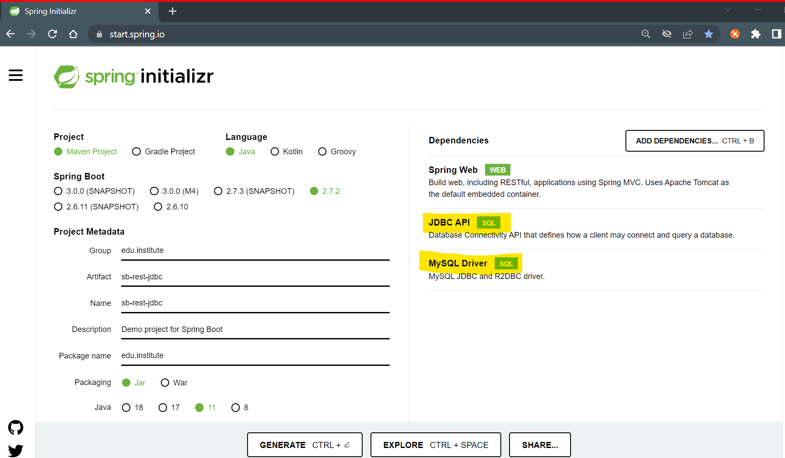
- Spring JDBC Provides inbuild APIs to interact with the Database
- There are 2 main APIs (Class/Interface/predefine functions)
  - DriverManagerDataSoruce
    - This is the spring build in class.
    - Using this class you can connect with the database.
    - To create an Datasource you have to provide driver, url, username, password properties. (provide these properties inside src/main/resources/application.properties file)
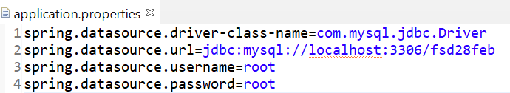

  - JdbcTemplate
    - This is also a spring build-in class
    - Using this class you can execute the Queries and get the result back in to spring program.
    - Has methods to execute the queries
      - update(): to execute DML, DLL queries except Select.
      - query(): to execute select type of query.

Task : PhBookApplication
Create a REST API to insert the contact details and get list of contact from DB
Contact Table must have following columns
id (PK auto_increment)
name
email
phonenumber

Create POST endpoint (/add-contact)
Pass Data using JSON and insert the record into table
Create GET Endpoint (/contact-list)
Get all the available contact from the table and return in the form for JSON Array

Spring Boot JPA
- JPA stands for Java Persistent APIs.
- JPA is a ORM tool. It is a set of standards for all the ORM tools in java such as hibernate, ejb etc.
- Spring JPA internally used Hibernate for the processing.
- Spring JPA is mainly used for DB interaction like DB connection, Queries Generation and Queries execution.
- Advantage of the Spring Boot JPA
  - It provides the auto configuration of the JPA and Hibernate framework.
  - It provides efficient way to communicate with the Database.
  - It map your java class (Entity) with the Tables from the database, so you don’t have to use tables manually JPS will take case about the Mapping of Java class and table.
  - Using this framework you can make you application Database agnostic.
  - To work with JPA you always have to pass the Entity class Object to a Framework and you will always receive result in the entity class Object from the JPA/Hibernate.
  - JPA/hibernate can generate the DDL and DML queries internally and also executes then.
  - JPA/Hibernate manage the Database exception internally.
  - It provides the cache to make the Db operations faster.
  - It supports the collection mapping.
  - To work with spring boot JPA you have to use a build in JPA functionality called as JpaRepository(interface)

Steps for Spring Boot JPA Application
- Create a Spring Boot JPA application
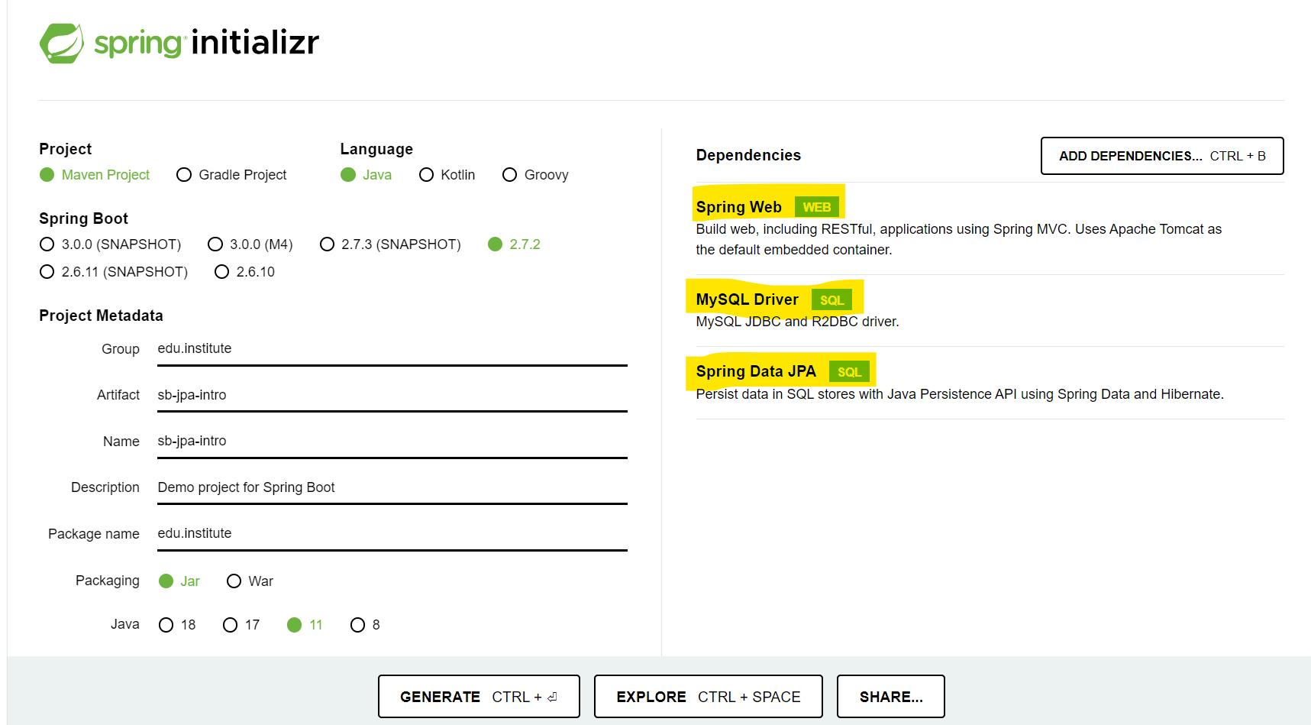

- Provide a Db and JPA configuration
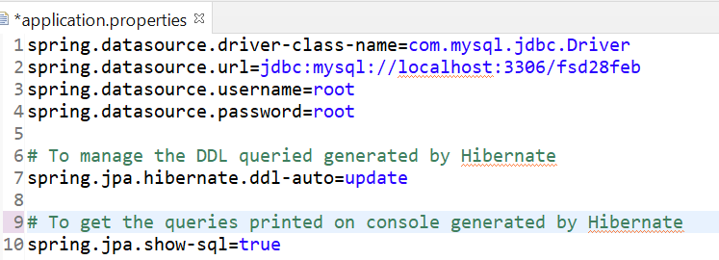

- Create an Entity class.
  - Create an encapsulated java class which has private variable and getter/setters.
  - To convert this java class into Entity class use @Entity annotation on class from the javax.peristence package.
  - As per the ORM tool rules every entity class must have a primary key. To mark any column as a primary key user @Id annotation on the variable which you wanted to make primary key.
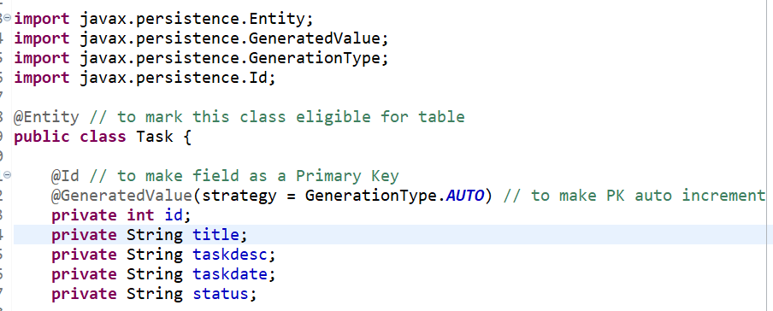

- Create a repository interface.
  - Using repository class, you will get a feature to execute database DML, DQL operations.
  - To create repository, create an Interface and extends the interface by using JpaRepository build-in interface.
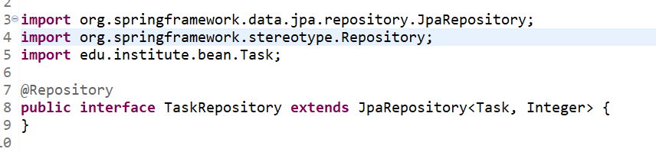

- Use Rest API to Test the JPA implementation.

Database Operations in Spring Boot JPA
- In the Spring Boot JPA you can perform DB Operation using 3 ways.
  - Using Predefine Methods for the JpaRepository
    - save() : to insert or update the Data.
    - delete()/deleteById() : Can delete the data from the DB
    - findAll()/findById() : can select a records.
  - Creating Custom methods by JPA recommendations.
    - You just have to create a method inside repository interface. With the recommended way from the spring boot jpa.
    - By Just looking into the method name JPA will generate and execute a query.
    - Follow the recommendation.
https://docs.spring.io/spring-data/jpa/docs/current/reference/html/#jpa.query-methods
  - By writing a SQL/HQL query.
    - To Execute your own query JPA provided an annotation @Query
    - Using this annotation you can execute the queries which of two types.
    - HQL:
      - Hibernate Query Language
      - Is a query language in which Entity and its variable name will be used instead of Table and Column name.
      - This makes your query database and table independent.
      - Every HQL query gets converted into SQL by Hibernate before execution.
    - SQL:
      - Structure Query Language
      - In SQL you used a table and column name.
      - It is also known as Native queried in JPA/Hibernate.

Relational Mapping in JPA/Hibernate
- You can create an entity classes having the primary and foreign key reference.
- To achieve this you have to follow 2 steps
  - Create a HAS-A relation between the class.
  - Use any one of the following annotation on the reference variable.
    - @OneToOne
    - @ManyToOne
    - @OneToMany
    - @ManyToMany
- While create a HAS-A relation you have to create a reference of one class into another class. it can be decided by following rule.
  - You needs to create a reference of the class in to a class where you need a foreign key and reference will of the class whose Primary key used as a Foreign key.

Task –
ToDoApplication
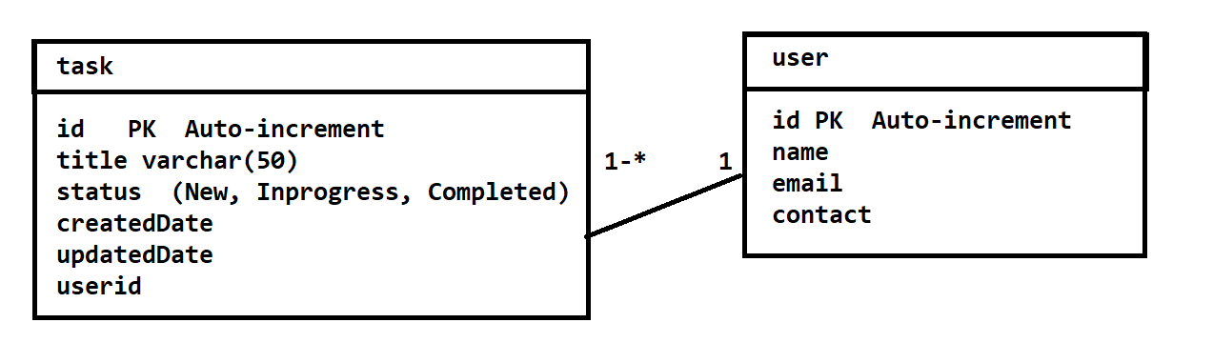
Create Following REST APIs/Endpoints and Swagger REST API Document:

HTTP Method | Endpoint | Description
User Endpoint
POST | /user/save | Save The user details
PUT | /user/update | Update user details
GET | /user/get-all | Get List of all available users
Task Endpoint
POST | /task/save | Add User Task
PUT | /task/update | Update Task Details
PUT | /task/update/{id}/{status} | Update Task status by ID Use HQL
GET | /task/task-by-id?id=<val> | Get Task by task ID
GET | /task/task-by-user?id=<val> | Get List of tasks by User Id USE HQL
GET | /task/task-by-status?id=<val>&status=<val> | Get list of tasks by status and user Id (All task for user by status)
DELETE | /task/delete-by-id/{id} | Delete Task by ID

Install Git on The System
Git On Local System:
https://git-scm.com/downloads
Open Account on GitHub
https://github.com/

