**Git:**

It is VCS (Version Control System) tool. This has installed on the local system. Using which you can work with the local repositories. It will also use as local client for GitHub.

Link to download Git: <https://git-scm.com/downloads>

Installation Guide: <https://www.youtube.com/watch?v=4xqVv2lTo40>

**GitHub:**

It is a web application which provides cloud repository also known as remote repository

Create Account on GitHub: <https://github.com/signup?ref_cta=Sign+up&ref_loc=header+logged+out&ref_page=%2F&source=header-home>

**GitHub Desktop**

Installation Link:<https://desktop.github.com/>

**VCS (Version Control System)**

1. Version control System is use to create a backup of your files and maintains the version of the file.
2. You can easily switch between a versions.
3. It will also store all details related to version like owner, files, date time, message etc.
4. You can also compare file from two version easily.
5. It is an efficient and easy way to maintain a backup/version of your file.
6. There are 2 types of version control tool.
   1. Centralized VCS
      1. All the files, their version and their details will be store at the central system.
      2. There will be a single service to which other systems will be connected.
   2. Distributed VCS
      1. All file, version and details will store on all client system.
      2. Every client work as a client and server both.

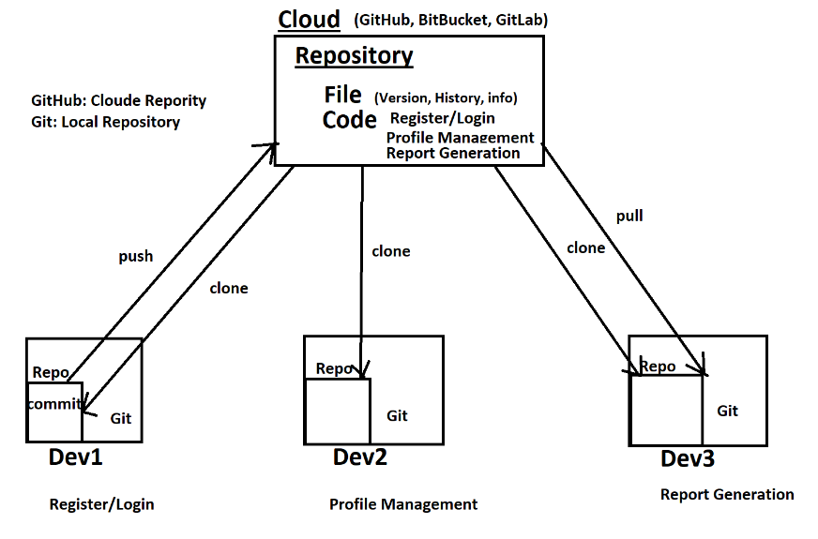

**Git Commands**

1. To execute a Git commands you can use Git Bach which is a Linux CMD.

**Create Local Repository**

**git init** : this command is use to create a local repository. After this command you will get a .git folder created which is by default hidden.. This folder is used by git for internal purpose.

**File Level Stage in Git**

1. Untrack File: The file created newly and git do not have any track for this file.
2. Track File: the file which is known to git and git manages the versions of the file. There are different status of the track file.
   1. New file
   2. Modified file
   3. Deleted File
   4. Rename or Moved file
3. Staging area: It is a location where you are currently working.

**To check the file status**

**git status:** This command is use to check the files status in the git.

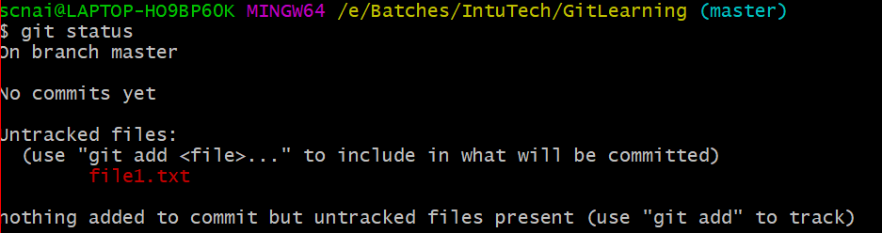

**To Add files into git staging area**

**git add <fileName>:** To add single file

**git add . :** To add all files at a time

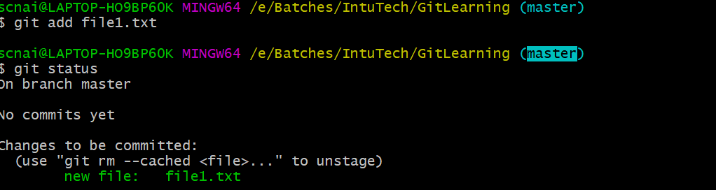

**git commit**: using this command you can start managing a version of the file. Every commit will have a commit Id which is always unique this Id can be used for tracing and for switching between commit. You can also provide a message to a commit for further tracing.

git commit -m “Commit Message”

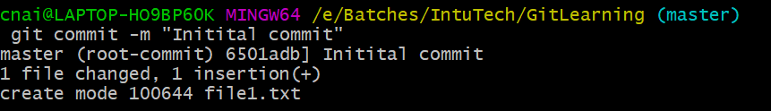

**Git log**: to check the commits details

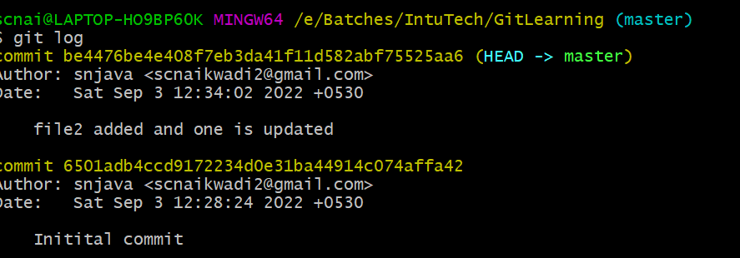

**git checkout :** Using this command you can go from one commit to another or one branch to another.

git checkout <commit-id>

to switch from one commit to another.

git checkout <branch-name>

to switch from one branch to another.

**Branch**

1. It is a sperate working copy of the original code.
2. This is use to perform any modifications in the code such as developing new feature, defect resolution, hotfix etc.
3. Due to branch the original code remain clean.
4. In the git the default branch is **master**.
5. In GitHub the default branch is **main**.
6. To get the list of all branches you use following command

**git branch**

1. To create a new branch you can use following command

**git branch <Name>**

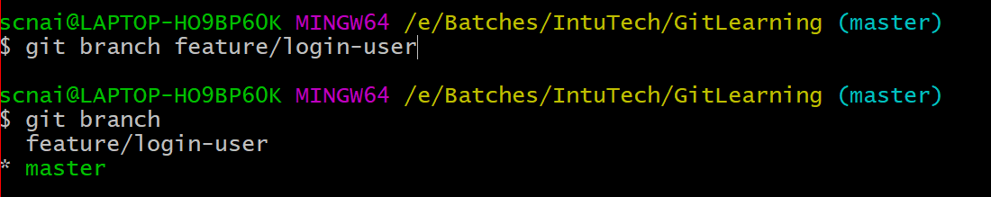

**Merge the branch**

1. Switch to a branch where you want to merge the changes.
2. Use the following command to merge the changes.

**git merge <branch-name>**

the branch name must be a branch which you want to merge.

**GitHub**

1. GitHub is a cloud repository. Which can be accessible using a network.
2. This is also known as cloud repository.
3. You can create a repository on github by creating account.
4. There are two types of repository GitHub support
   1. Public Repository
      1. Can be access by any user in the network.
   2. Private Repository
      1. Can be access only the owner or the collaborators.
      2. In the free account of GitHub you can add up to 3 collaborators.

**To Link local repo with cloud repo**

**Git remote**

1. This command is use to link the local repo with cloud repo.

**Git remote add origin <Cloud repo url>**

**To Push the local changes into cloud repo**

**Git Push**

Git push command is use to push the local branch changes into cloud repo

**git push -u origin main**

**to Get the cloud repo changes into local repo**

**git pull**

this command is use to get the changes happened on cloud into local repository.