
C PROGRAMMING ASSIGNMENT

Student Name | JANANI P
Register Number | 1912260382
Course Code & Name | CSA0210 & C - PROGRAMMING
Slot | SLOT - C
Assignment / Task Title | CO – 1 & ASSIGNMENT - 1
GitHub Repository URL | ________________________________________________
Submission Date | 28 / 10 / 2026

Instructions to Students
- Complete every section for each assigned task.
- Write your own explanation, algorithm/pseudocode, and program.
- Run the program and insert a clear screenshot of the output.
- Include test cases and a short analysis where applicable.
- If code is maintained on GitHub, provide the correct repository link.

TASK 1 — [ELECTRICITY BILLING SYSTEM]

Task / Problem Statement
To write a C program to calculate the electricity bill using meter readings and consumer category.

Aim
To calculate the electricity units consumed and total bill amount using C programming.

Concept / Theory
C programming uses variables to store data, "scanf()" to get input, "printf()" to display output, arithmetic operators to calculate values, and "if-else" statements to select billing rates.

Procedure / Algorithm
1. Start the program.
2. Enter household number, previous reading, current reading, and category.
3. Calculate units consumed.
4. Calculate energy charge and total bill.
5. Display the bill.

Program / Source Code
#include <stdio.h>
int main()
{
int house_no, previous, current, units;
char category;
float rate, fixed, energy_charge, total;
printf("Enter household number: ");
scanf("%d", &house_no);
printf("Enter previous reading: ");
scanf("%d", &previous);
printf("Enter current reading: ");
scanf("%d", &current);
printf("Enter category (D/C): ");
scanf(" %c", &category);
units = current - previous;
if (category == 'D' || category == 'd')
{
rate = 5;
fixed = 50;
}
else
{
rate = 8;
fixed = 100;
}
energy_charge = units * rate;
total = energy charge + fixed;
printf("\n--- Electricity Bill ---\n");
printf("Household Number: %d\n", house_no);
printf("Units Consumed: %d\n", units);
printf("Energy Charge: Rs. %.2f\n", energy_charge);
printf("Fixed Charge: Rs. %.2f\n", fixed);
printf("Total Bill: Rs. %.2f\n", total);
return 0;
}

Output Screenshot
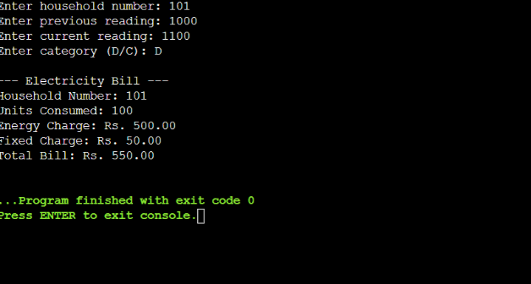

Analysis / Discussion
The program calculates units consumed by subtracting the previous reading from the current reading.
Energy charge is calculated by multiplying units by the rate. The fixed charge is added to calculate the total bill.
The program uses "if-else" to select the billing rate.
- Domestic rate = Rs. 5 per unit.
- Commercial rate = Rs. 8 per unit.
- Time complexity = O(1).
- Space complexity = O(1).

Result
Thus, the electricity billing program was successfully developed using C. It calculates and displays the electricity bill of a household.

TASK 2 — [Choose the Data Types]

Task / Problem Statement
To select suitable C data types for storing electricity billing details.

Aim
To choose appropriate data types for the electricity billing system.

Concept / Theory
C provides data types like "int", "char", "float", and "double" to store different values.
Data Type Table
Data| Type| Size
Household number| int| 4 bytes
Meter reading| unsigned short| 2 bytes
Units| unsigned int| 4 bytes
Bill amount| double| 8 bytes
Category| char| 1 byte

Procedure / Algorithm
1. Start the program.
2. Declare the data types.
3. Calculate meter consumption.
4. Display the result.

Program / Source Code
#include <stdio.h>
#include <limits.h>
typedef unsigned short meter_t;
unsigned int consumption(meter_t previous,
meter_t current)
{
return (current - previous) & USHRT_MAX;
}
int main()
{
printf("Size: %zu bytes\n", sizeof(meter_t));
printf("Maximum: %u\n", USHRT_MAX);

printf("Consumption: %u units\n",
consumption(1200, 1530));

printf("Consumption: %u units\n",
consumption(65400, 120));

return 0;}

Output Screenshot
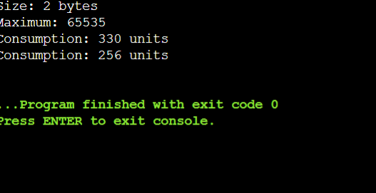

Analysis / Discussion
- int" stores whole numbers.
- "char" stores characters.
- "double" stores decimal values accurately.
- A 16-bit unsigned meter stores values from 0 to 65535.
- After 65535, the meter resets to 0.
- The second consumption is 256 units due to rollover.
- Time complexity: O(1).
- Space complexity: O(1).
Result
Thus, suitable data types were selected, and meter consumption was calculated successfully using C programming.

TASK 3 — [DEFINE THE CONSTANTS]

Task / Problem Statement
To define electricity tariff values and limits as constants in a C program and use them to calculate the electricity bill.
Aim
To use constants in C programming for calculating electricity charges easily and accurately.

Concept / Theory
Constants are fixed values that cannot be changed during program execution.
C provides the following methods to define constants:
- "#define" – Used to define symbolic constants.
- "const" – Used to declare constant variables.
- "enum" – Used to define named integer constants.
Constants make the program easy to understand and modify.

Procedure / Algorithm
1. Start the program.
2. Define electricity tariff rates using "#define".
3. Read the electricity units consumed.
4. Calculate the energy charge based on the units.
5. Add the fixed charge to the energy charge.
6. Display the total electricity bill.
7. Stop the program

Program / Source Code
#include <stdio.h>
#define SLAB1_UNITS 100
#define SLAB2_UNITS 200
#define RATE1_PAISE 0
#define RATE2_PAISE 225
#define RATE3_PAISE 450
#define FIXED_CHARGE_PAISE 5000
long compute_bill(int units)
{
long paise = FIXED_CHARGE_PAISE;
if (units <= SLAB1_UNITS)
{
paise += units * RATE1_PAISE;
}
else if (units <= SLAB2_UNITS)
{
paise += SLAB1_UNITS * RATE1_PAISE;
paise += (units - SLAB1_UNITS) * RATE2_PAISE;
}
else
{
paise += SLAB1_UNITS * RATE1_PAISE;
paise += 100 * RATE2_PAISE;
paise += (units - SLAB2_UNITS) * RATE3_PAISE;
}
return paise;
}
int main(void)
{
int units;
long bill;
printf("Enter units consumed: ");
scanf("%d", &units);
bill = compute_bill(units);
printf("Total Electricity Bill: Rs. %ld.%02ld\n",
bill / 100, bill % 100);
return 0;
}

Output Screenshot
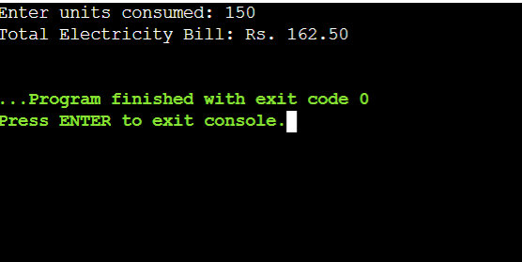

Analysis / Discussion
- "#define" is used to define fixed tariff values.
- Constants make the program easy to modify.
- "const" provides type checking.
- "enum" is used for integer constants.
- The program calculates the electricity bill based on the units consumed.
- The fixed charge is added to the energy charge.
- Integer paise is used to avoid decimal rounding errors.
- Time complexity: O(1).
- Space complexity: O(1).

Result
Thus, the electricity billing program was successfully developed using C programming. Constants were used to define tariff rates, and the total electricity bill was calculated based on the units consumed.

TASK 4 — [USE MACROS SAFELY]

Task / Problem Statement
To use macros for repeated calculations in an electricity billing system.
Aim
To define and use macros safely in C programming.

Concept / Theory

Macros are defined using "#define". They are expanded by the preprocessor before compilation.

Macros reduce repeated code and make calculations easier.

Parentheses should be used to avoid errors in macro expansion.

Procedure / Algorithm
1. Start the program.
2. Define macros for square, maximum value, and rupees to paise conversion.
3. Read two numbers.
4. Calculate the square and maximum value.
5. Convert rupees into paise.
6. Display the results.
7. Stop the program.

Program / Source Code
#include <stdio.h>
#define SQUARE(x) ((x) * (x))
#define MAX(a, b) ((a) > (b) ? (a) : (b))
#define RUPEES_TO_PAISE(x) ((x) * 100)
int main(void)
{
int a = 5, b = 10;
int rupees = 50;
printf("Square: %d\n", SQUARE(a));
printf("Maximum: %d\n", MAX(a, b));
printf("Paise: %d\n", RUPEES_TO_PAISE(rupees));
return 0;
}

Output Screenshot
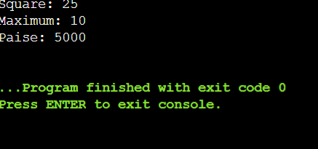

Analysis / Discussion
- Macros are expanded before compilation.
- Parentheses prevent calculation errors.
- "SQUARE(x)" calculates the square.
- "MAX(a, b)" finds the larger value.
- Functions are safer than macros.
- Time complexity: O(1).
- Space complexity: O(1).

Result
Thus, macros were defined and used safely for repeated calculations in C programming.

Test Cases / Validation Table
Record different inputs, expected results, actual results, and whether each test passed.
Test No. | Input / Scenario | Expected Output | Actual Output | Status
1
2
3
4
5

Final Submission Checklist
☐ Student and course details completed
☐ Task statement, aim, theory, and algorithm included
☐ Program code is readable and runs successfully
☐ Output screenshot included
☐ Analysis and result written in own words
☐ Test cases completed where applicable
☐ GitHub repository link added if required

