Please follow below steps to integrate the Pivotal Single-Signon service with Spring-Security -Oauth2 Project.

**Adding SSO Service in Pivotal WorkSpace:**

1. Login to Pivotal App Manager
2. Select the Space and select the Services tab



1. Click on “ADD A Service” button and search for “Single Sign-on” 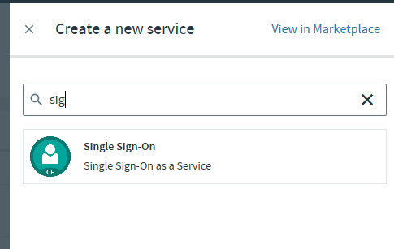
2. Select “Manulife ADFS – DEV” feature and click on “Select Plan” button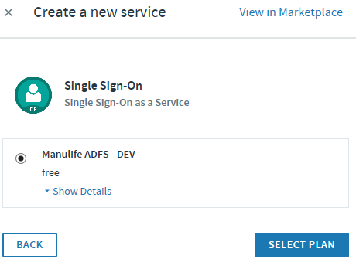
3. Enter the Instance Name for SSO Service and Click “Create” button.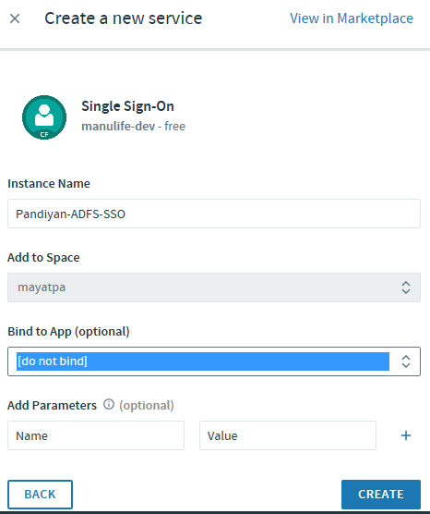
4. Now the service appears in “Services” list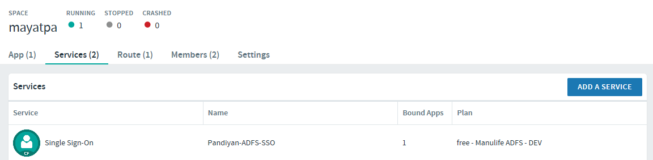

Note: We need to select the ADFS Service after creating the Spring Security APP.

**Building Spring Security App**

1. Please refer Application.yml to configure SSOService URL, AccessToken URL, JWT Token URL etc
2. Configure Manifest.yml to configure the CloudFoundry Application name and SSO Service to bind to spring Security APP

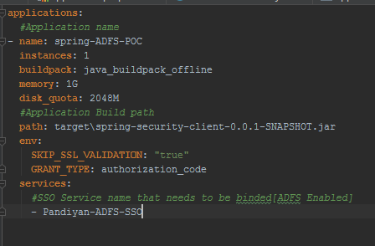

1. CF Push the app to the Work Space
2. In Pivotal APP Manger, select the Application you created and Stop the Application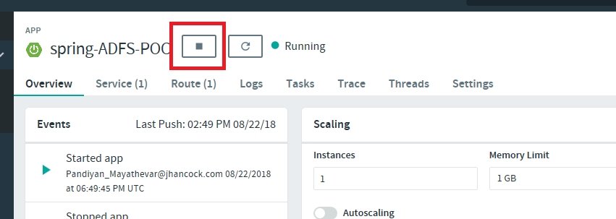
3. Go to the “service” tab and select the “Single Sign-on” service and select the Application name

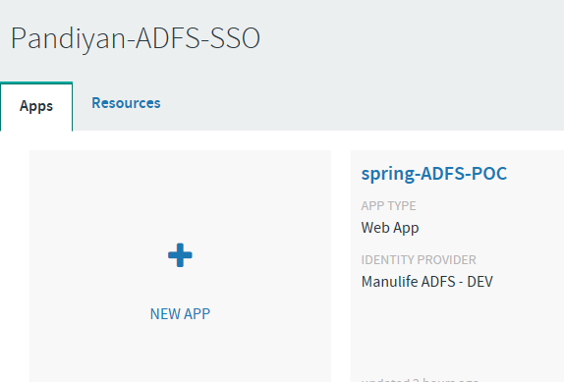

1. In the Identity Providers select “Manulife ADFS – Dev” and click on “Save Config” Button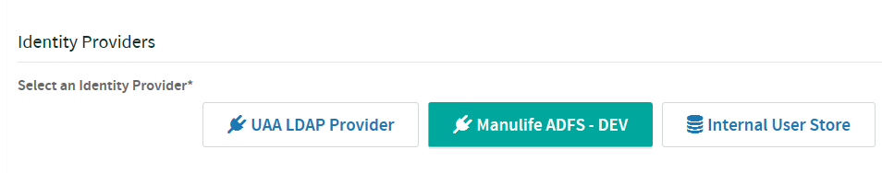
2. Now start the app