Goal:
To combine all departments in a single web app for monitoring, improvement, efficiency, optimization etc. with the help of AI
Log-in Page:
Every user has “role”
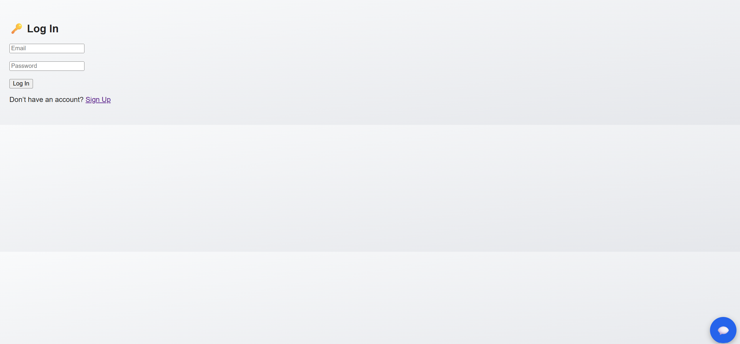
HomePage:
Features will be displayed depending on “role” of the user
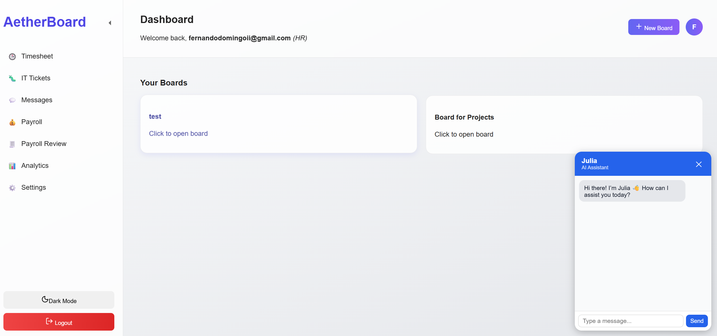

Timesheet:
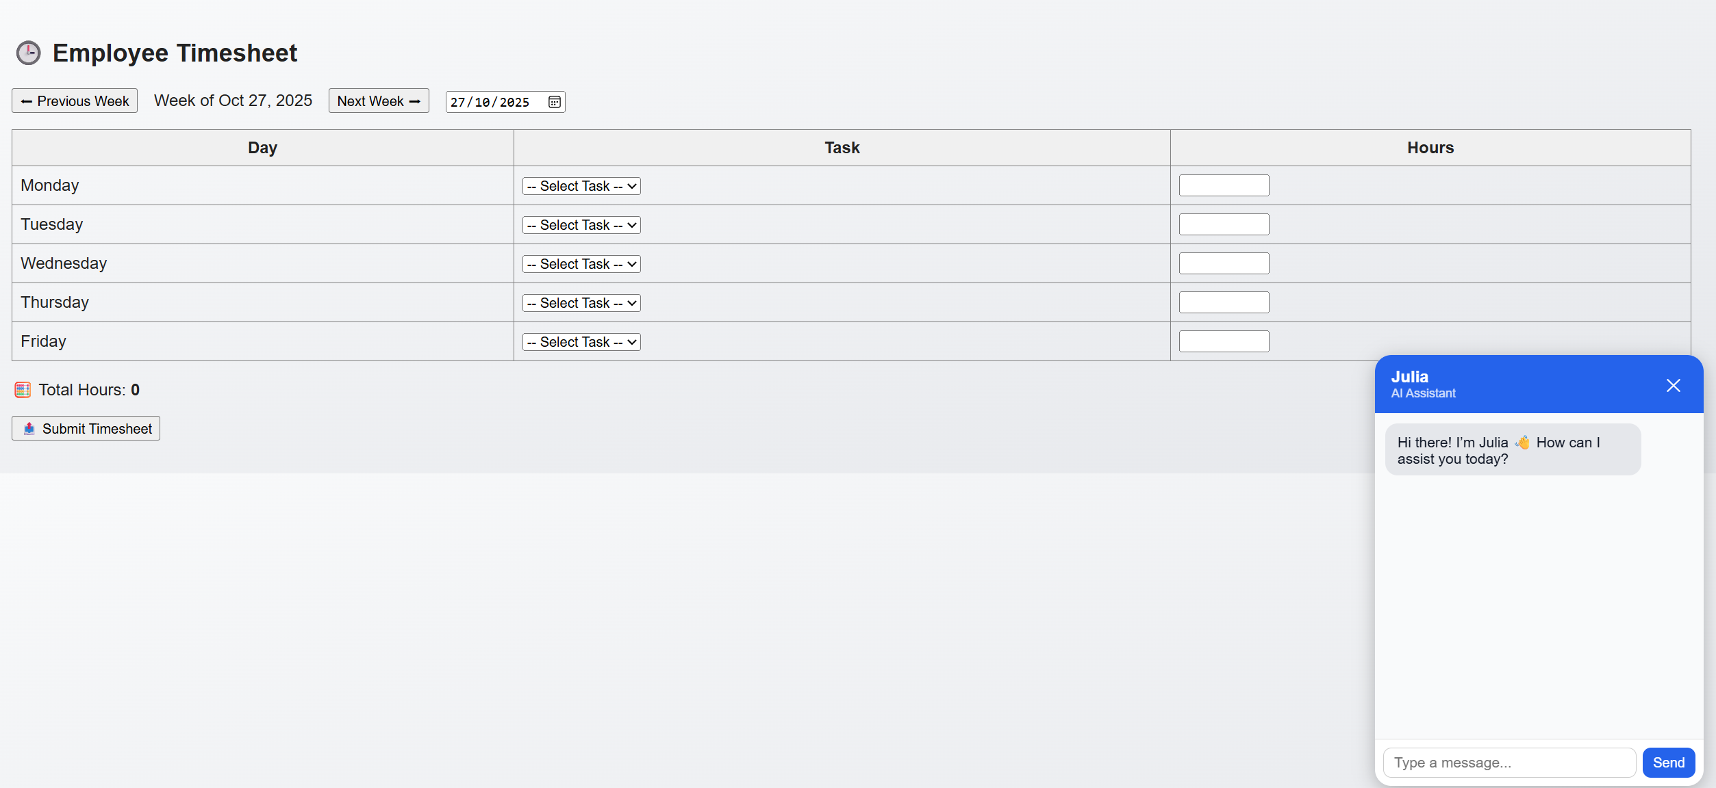

IT Tickets:
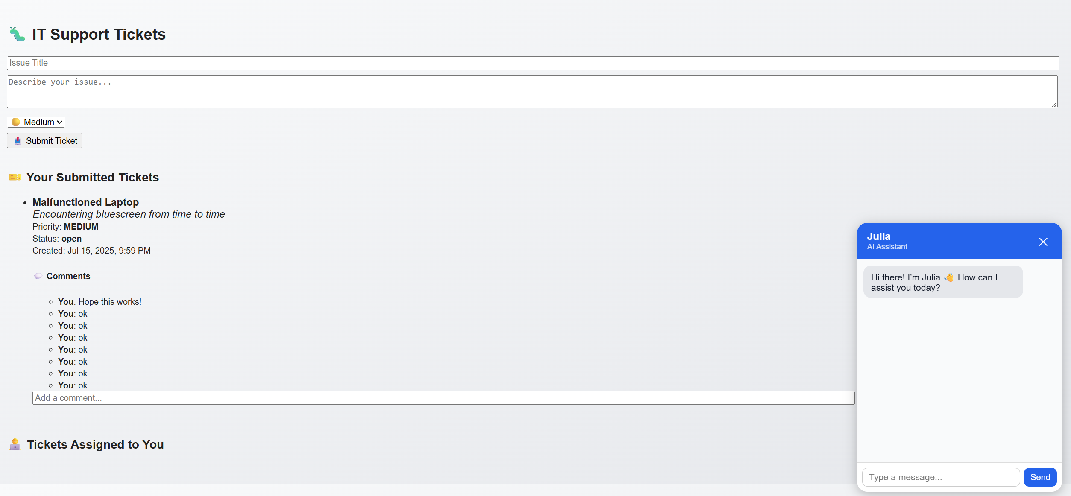

Messages:
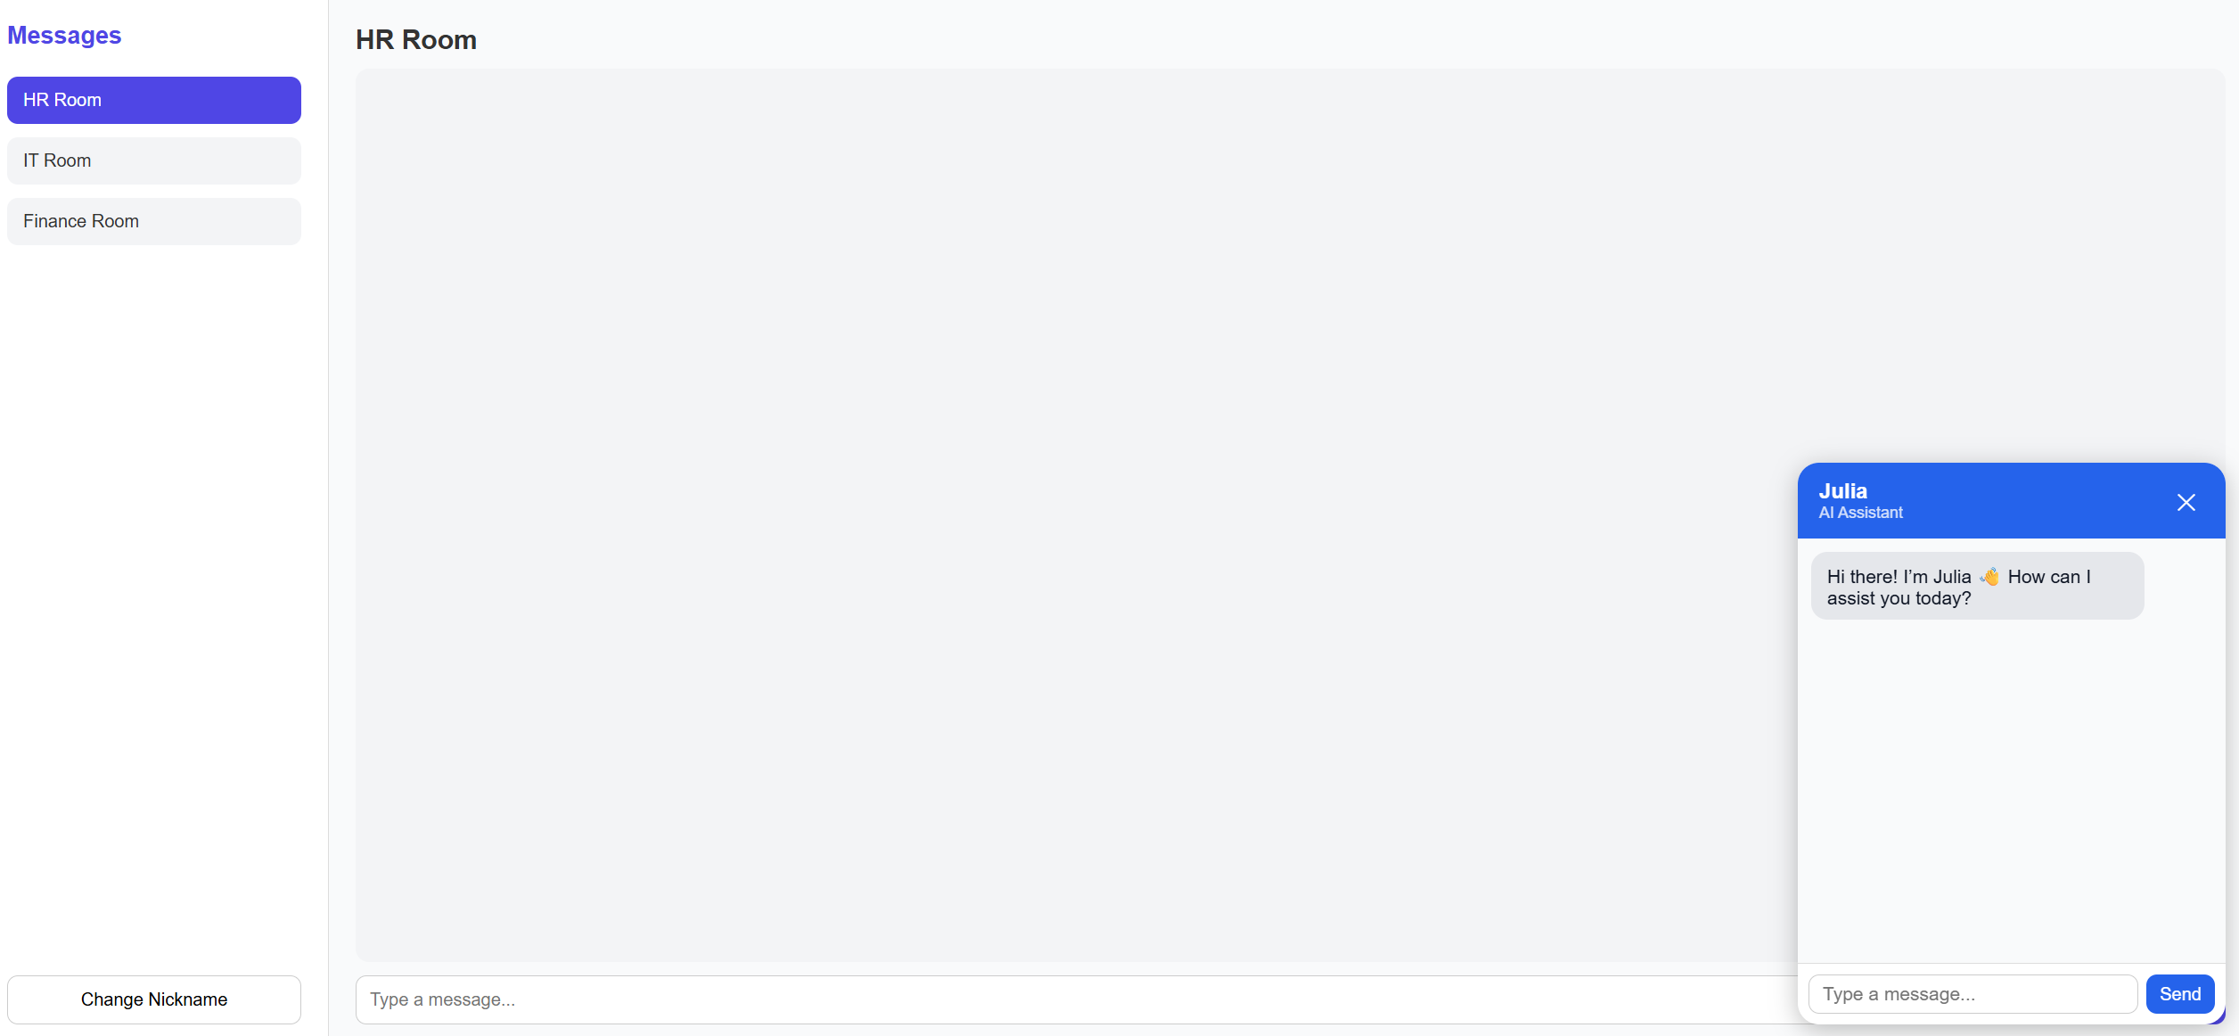
Payroll
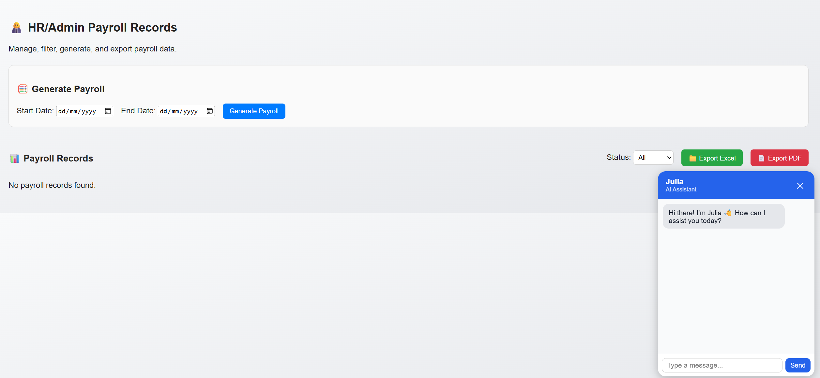

Payroll Review: Only HR/Admin can see this page.

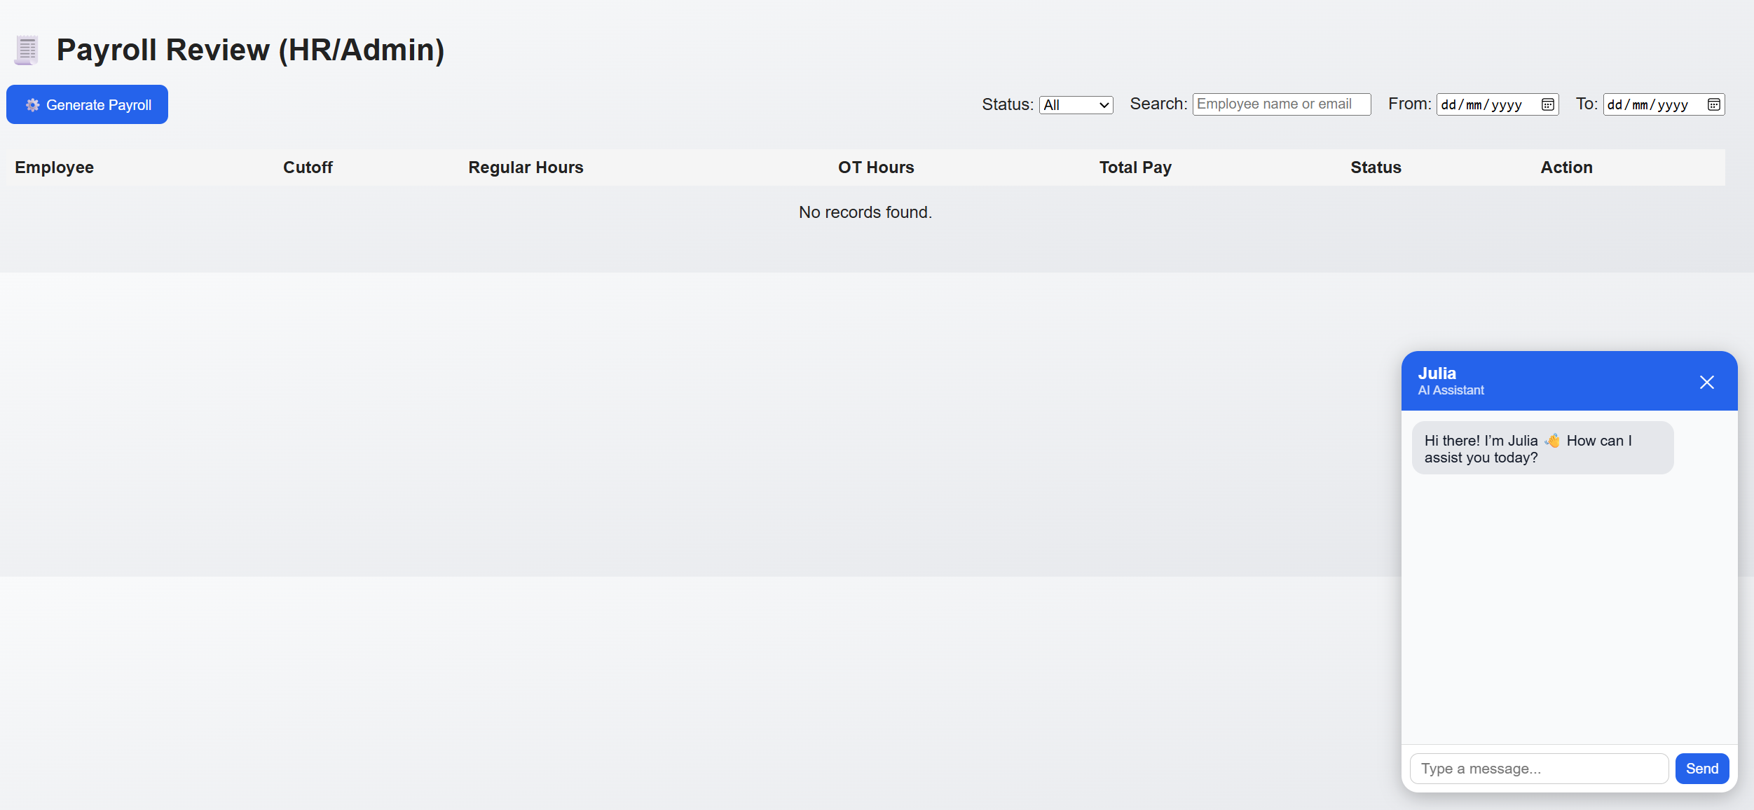

Analytics:
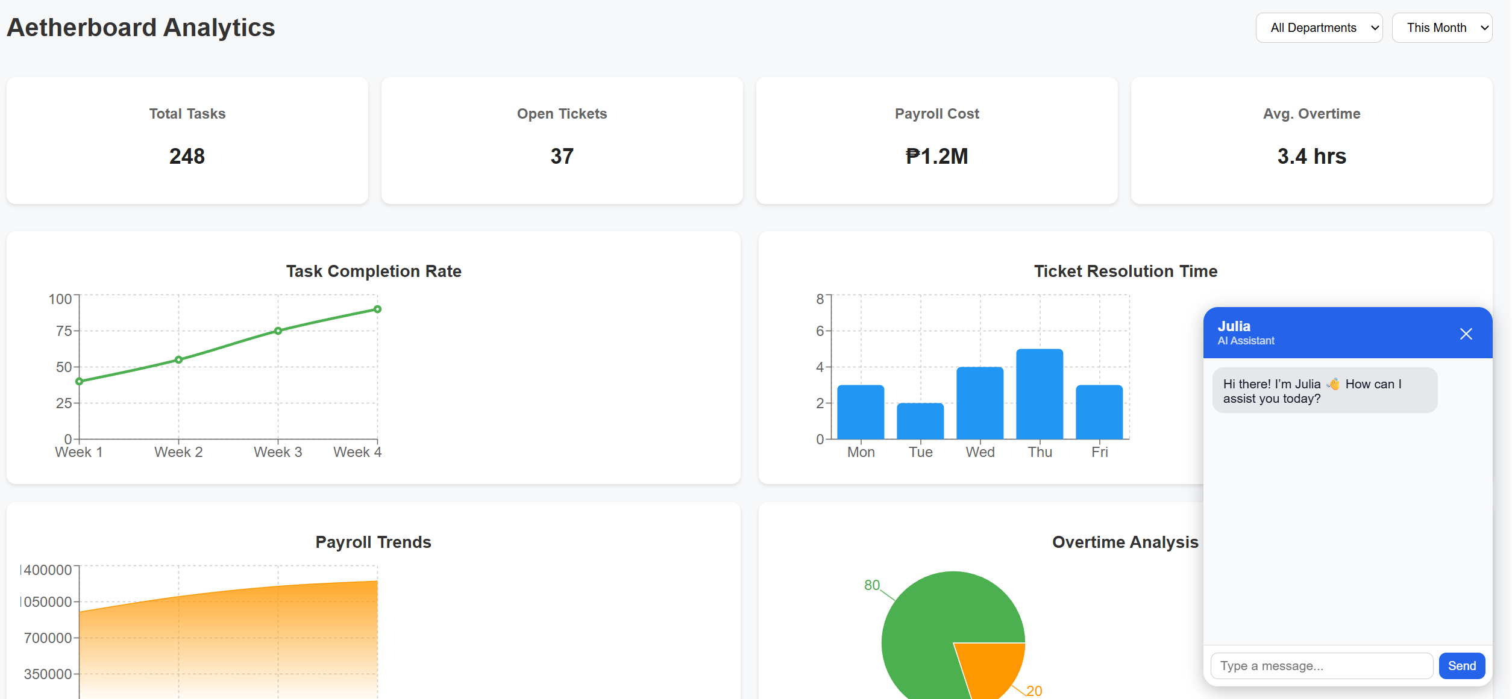

Settings:
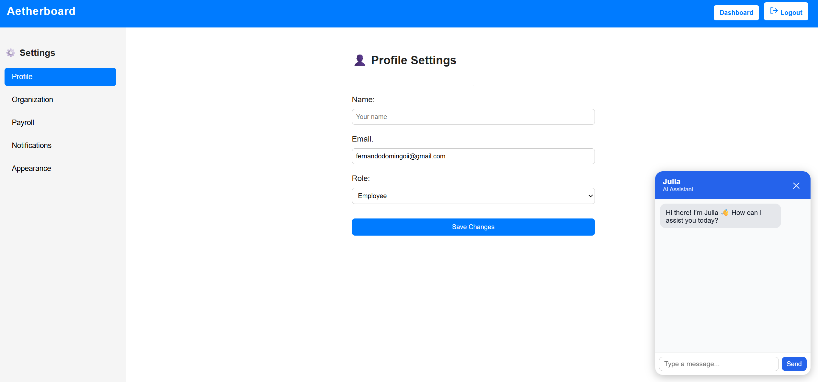

If you have any questions or concerns, don’t hesitate to contact me.
fernandodomingoii@gmail.com
09672873560

