

Table of Contents
Last Updated: January 2015
CRM Users guide

ORLANDO HEALTH

CRM User’s Guide
The Evariant Platform

Chapter 14: Events 4
14.1 How to Access the Events Module 4
14.2 The Events Module Main Page 4
14.3 Adding a NEW Event 5
14.4 TO ENTER A NEW LOCATION 7
14.5 A Recurring Event 7
14.6 Registering a Provider or Patient for an Event 8
14.7 Deleting a Registrant 12
8.7 Editing an Event 12
14.8Deactivating an Event 12
14.9 To view registration activity 13
8.10 To Change /Update Status of Registrants 13
Chapter 15Campaigns 15
15.1 Campaigns 15
15.2 Campaign Hierarchy 16
15.3 Campaign Members 17
15.4 Marketing Asset 18
15.5 Campaign Service Lines 19
Chapter 16: Evariant Support 20
16.1Introduction of the Support Portal 20
16.2Log In to the Support Portal 20
16.2 Ticket Requests 20
16.3 Support Assistance through Ticket Requests 21
16.4 Creating a Ticket 21
16.4 Entering Ticket Request Information 23
16.5 Accessing your submitted ticket 24
16.6Community Forum 25
Using the Community Forum 26
16.7 Knowledge Base 28
CHAPTER 17: THE EVARIANT PLATFORM GLOSSARY 30
Naming Standards Summary 35
Web Campaign Setup Checklist 37
Setup Campaign 37
Setup Campaign Tactics 37
Setup WebForm 37
Setup Email Template 37
Setup Email Alert 37
Setup Workflow 37
Web Campaign QA Steps 37
Campaign Setup Checklist 39
Workflow Setup Checklist 40
Email Alert Setup Checklist 42
Email Template Setup Checklist 43
WebForm Setup Checklist 45
Web Campaign QA Steps 46

Chapter 14: Events
The Evariant Platform Events Application is an administrative tool to create, edit and cancel events as well as manage the overall events registration, waitlist, and registrant processes. In addition to the events administration tool, the client will have a web presence for events in the form of either a Web site, listing all events, or individual landing pages specific to an event category.

Events will be implemented both for Evariant Platform administration as well as the Web experience as part of the initial implementation.
If an organization is going to be registering users for events via a call center, there is also capability to tie the names of the events to the events as they are listed in that call center by customizing your events module. Upon subsequent implementations, just the web experience will likely need to be updated for: for additional landing pages and updates that may be needed to the Categories, and Event types, as well as the standard landing page needs for forms.

14.1 How to Access the Events Module
- You can access the Events Module by clicking on the PLUS (+) sign on the top navigation menu bar


- Then click the Events link

14.2 The Events Module Main Page
The Events Module Main Page consists of three primary components:
- Filter for Events
- Number of results (including number of results per page)
- Number of Results pages
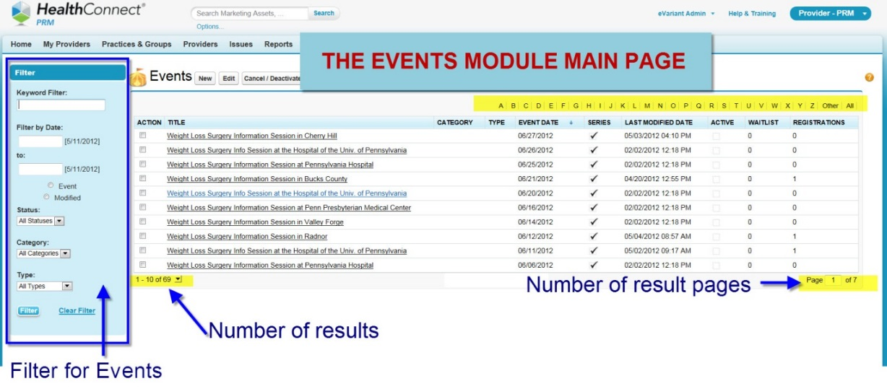
Using the Events filter
The Events filter is very helpful when searching a specific event or events, or your results return many records.
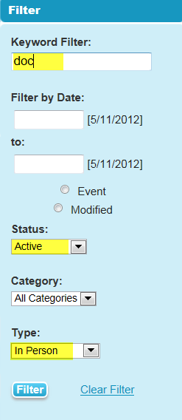

14.3 Adding a NEW Event
The process of adding a NEW Event is fairly simple. Begin by selecting the Events module.
.

- Then, Select the NEW button

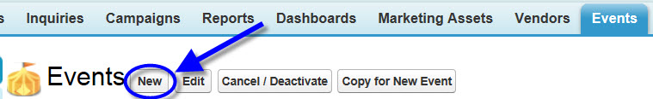

- Then enter the REQUIRED FIELDS of Event Name, Category, and Type (Event Description is NOT REQUIRED, but recommended)

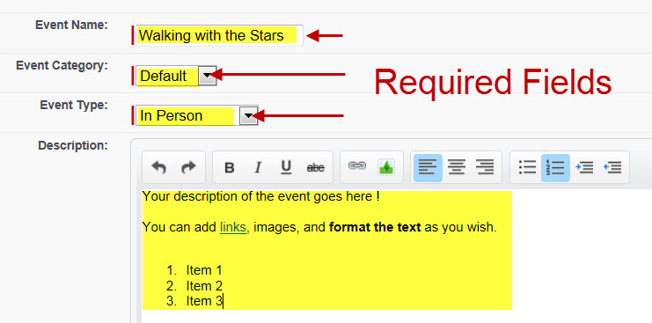

NOTE: If you select the Event Category of Program, an Event Date will not be required. All other types require an Event Date.

In the example to the left, the original search returned over 2000 records.

Example: Search for any event that CONTAINS the word “doc” in the event title, AND are “active” and are delivered “in person”.

The filter can also be done by using a date range for the event or when the event was modified

This returned 26 records. Down from 2000!

- Select the Event Date
- Click Next

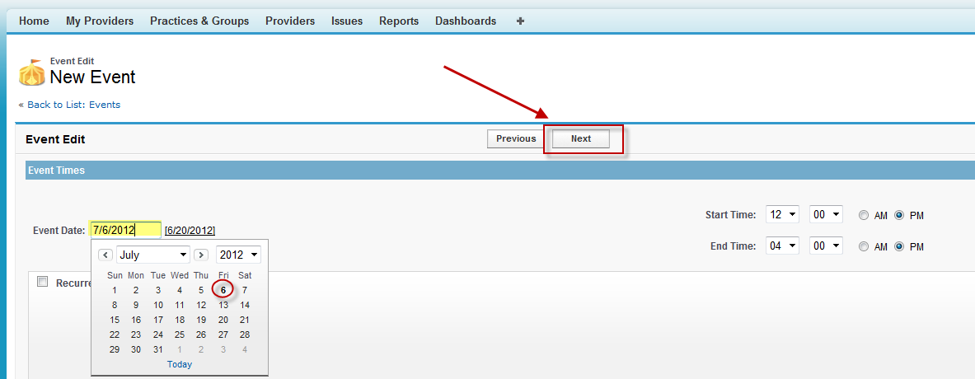

- Select the Event Location


TIP ! When searching for a location either enter the first or first two letters of the location before clicking Search. If the location has not been setup in the Evariant Platform, click New Location

14.4 TO ENTER A NEW LOCATION
- Enter a Location Name (Required)
- Enter the mailing street of the location
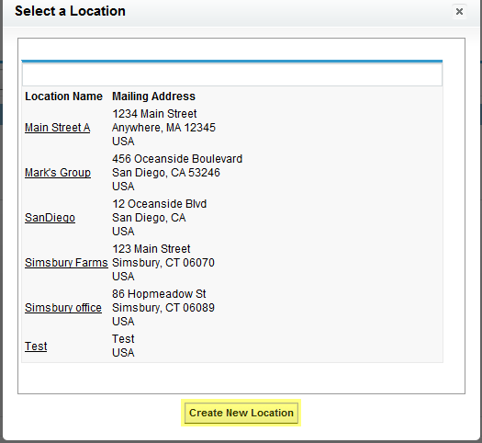
- Enter the City, State Zip of the location
- Click NEXT
- Select the Speaker (using the tip above)
- Select the Registration Options of choice. They Include:
  - Require Registration (yes or no)
  - Registration Limit (either check the box and enter a number or leave the box blank)
  - Allow Waitlist (yes or no)
- Click Next

14.5 A Recurring Event
Recurring Event
You can also setup an event as a recurring event
- To set up a recurring event, reference Step 3 in the section above. Click on the recurrence box and the following fields will appear.

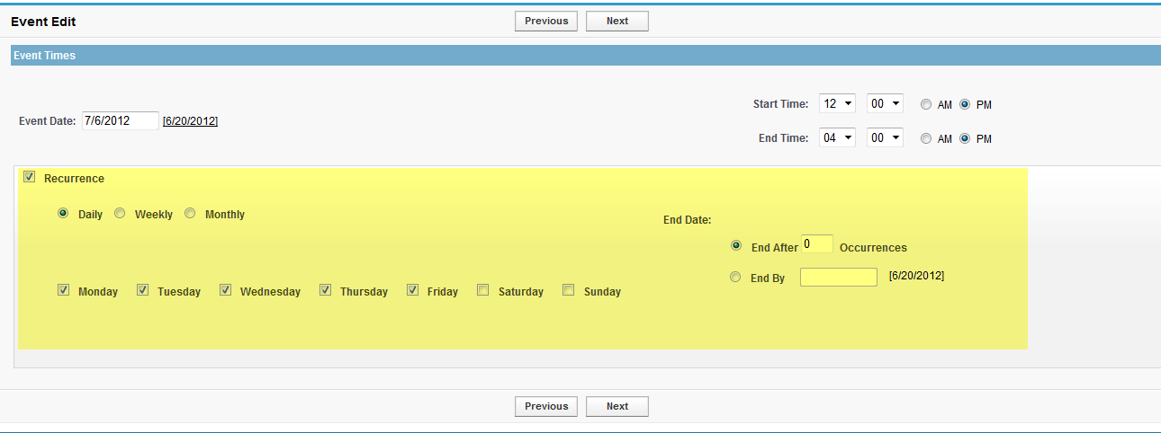
- Complete the recurring information fields and click next.
- Follow Steps 4-7 in the section above.
- When we set up forms, we have to make sure that when events have been set up as recurring, they are associated to a particular series, otherwise we run into issues with the form populating. Not sure if this is the place to add that, but it’s a thought.

14.6 Registering a Provider or Patient for an Event
There are two methods to register a Provider for an event. There are TWO assumptions that must be met prior to registering for an event.
- The event has been setup
- The event IS ACTIVE.

Method Number 1- From the Provider or Patient Record
- Either scroll down to or select the Events Registrants link
- Click on


- Click on the look up icon (magnifying glass) to locate the event that you are registering the provider for.

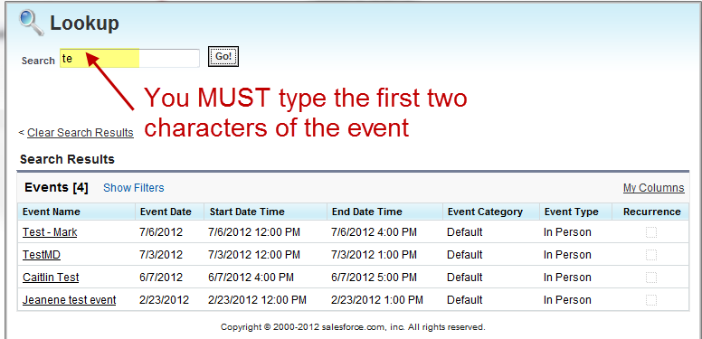
- Type in the first two characters of the event name

- Click Go
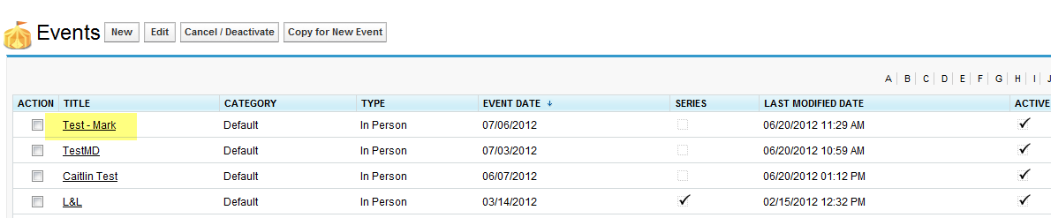
- Click on the Event Name
- Select the Status (recommended as a best practice, for reporting purposes)
- Select the Date and time that you are registering
NOTE: The default time is 12:55 PM, you will need to overtype the default with the correct time

- Check the Waitlisted box if you would like to be on the wait list should the event become full.
- Complete the other fields (optional)
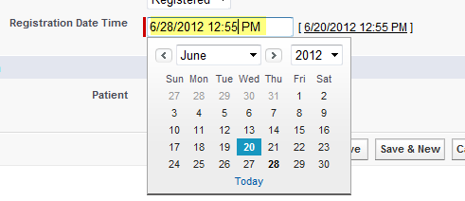
- Click on Save

TIP ! The Patient OR Provider must be specified but NOT BOTH
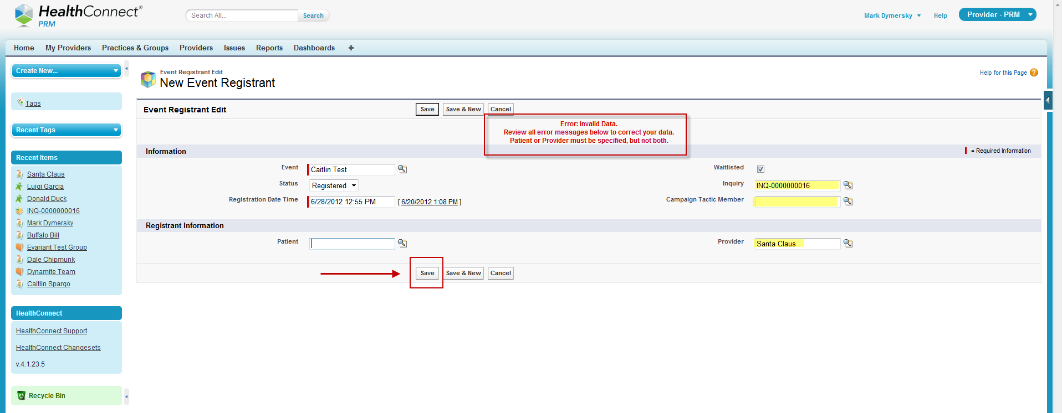
- The registration now appears under the Events Registrants.


Method Number 2- From the Events Record
THIS IS A GREAT WAY TO ADD MULTIPLE PROVIDERS OR PATIENTS! TIME SAVER

- Click on the Name of the Event
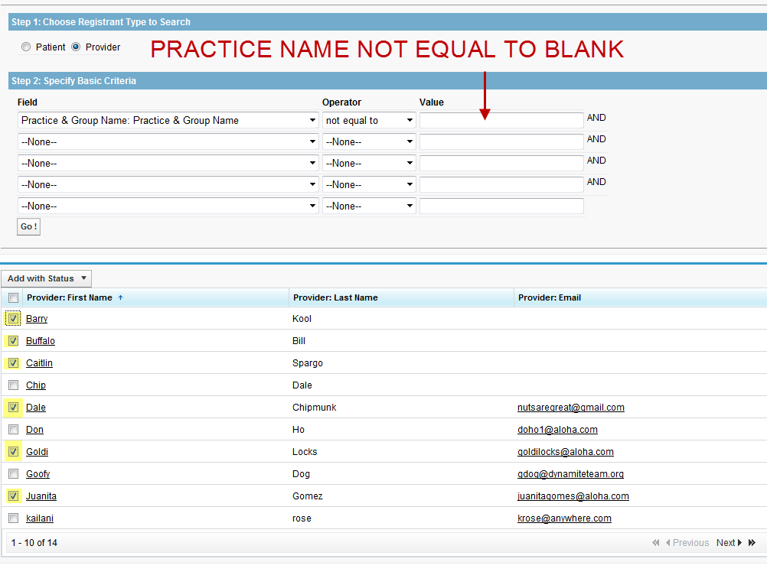
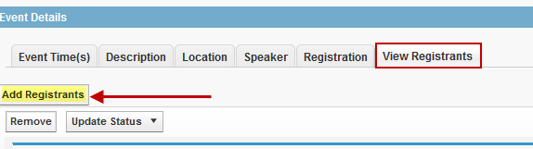
- Click on the View Registrants tab
- Click on Add Registrants
- Select either Provider or Patient
- Enter your criteriaI
- In this example, the criteria are that Provider and Group name is not blank. Now I select the SIX Providers that I want to register for the Event.

- Click on the Add with Status drop down list
- Select the appropriate status ( in the example, registered is selected)

- You will receive the confirmation message in the yellow box indicating that you have successfully registered 6 providers.

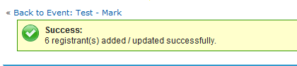

14.7 Deleting a Registrant
- Go to the Events Registrants section of the Patient or Provider record
- Click on DEL
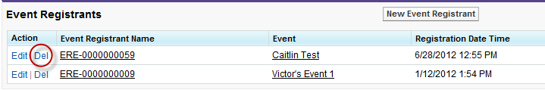

8.7 Editing an Event
- Click on the Name of the Event
- Click on Event object that you need to edit
- Make the necessary changes
- Click SAVE

14.8Deactivating an Event
- Click on the Name of the Event
- Click on Event object that you need to mark as inactive

- Click Deactivate Event

- If you have people registered for the event, you will receive the following warning.

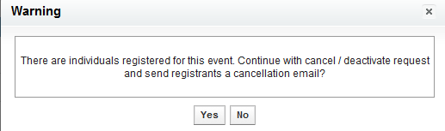

14.9 To view registration activity
- Click on the Name of the Event
- Click on Event object that you need to edit.
- Click on View Registrants

8.10 To Change /Update Status of Registrants

- Click on the Name of the Event
- Click on Event object that you need to edit.
- Click on View Registrants
- Check the registrants that you want to update the status of
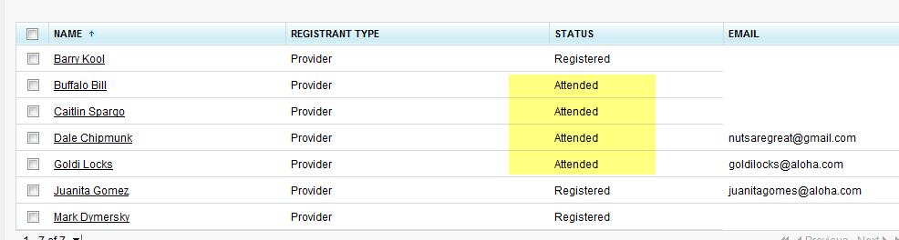
- Click the Update Status drop down box
- Select the status that you want to change the status on for those that you selected in step 4
- You will see that the status of those selected is now reflected in the status field

Chapter 15Campaigns

15.1 Campaigns
A Campaign is a marketing initiative to drive awareness around products or services.

You can associate patients to campaigns and lists, add marketing assets such as direct mail, email, and other online and offline tactics and track response and ROI through this Campaign object.

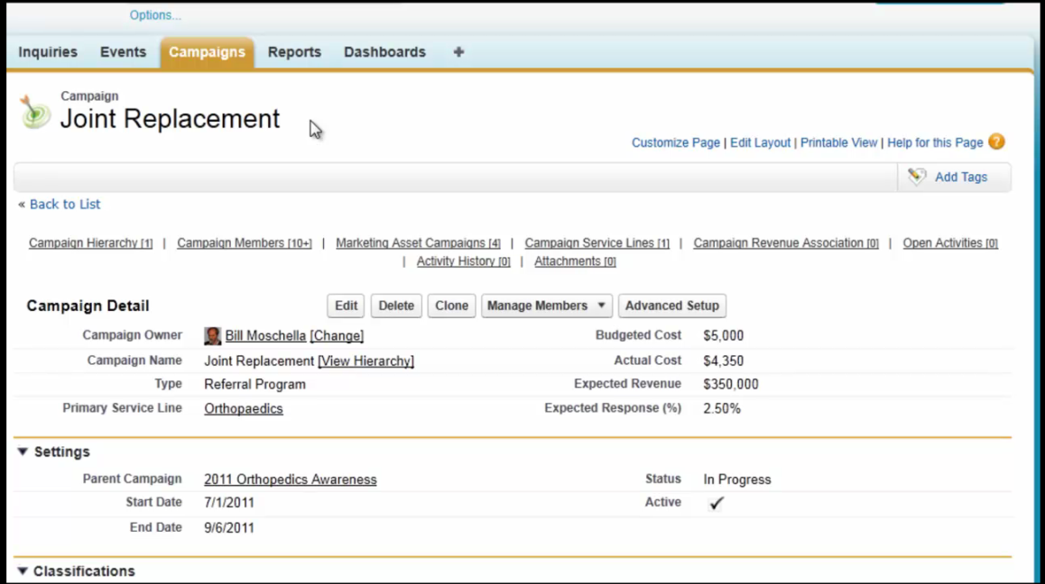
The Campaign main record details include:
- Name, Dates, Budget and Campaign Status
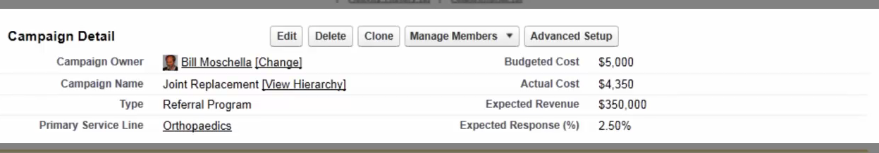

You can also assign additional data such as:
- Service lines and identification of a Parent Campaign

The last section of the Campaign record lists the Results and statistics of the Campaign which may include:

Total List numbers and Response Rate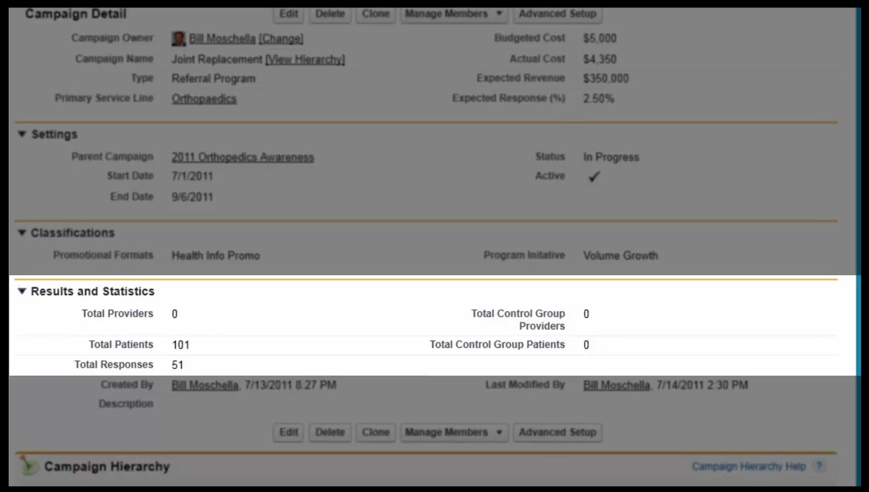

15.2 Campaign Hierarchy
The first related list is the Campaign Hierarchy
The Campaign Hierarchy lists the relationship between the campaign you are viewing and any Child Campaign Records.

In this example, there is no child campaign, but there is a parent campaign that can be viewed by selecting “View Parent” link to view the related record.
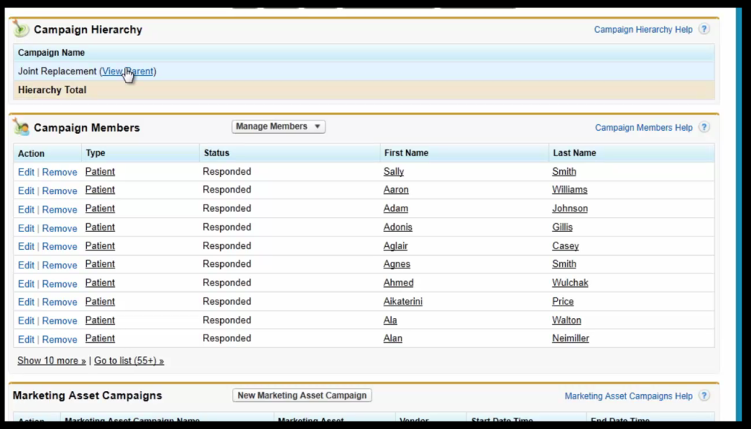

In this example, we can see that the Joint Replacement Campaign is one of many in the Campaign for the 2011 Orthopedics Awareness.

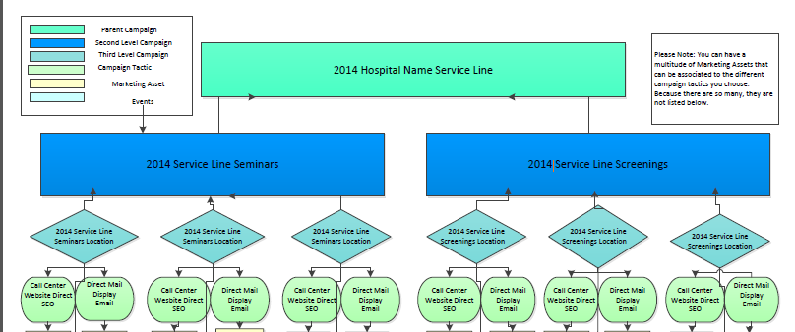
Parent Records allow the rollup of several campaigns to better understand response rates and revenue measurement around similar topics, service lines or other types of groupings.

15.3 Campaign Members
The Campaign Members list represents a de-duplicated list of all individuals who are part of the campaign who were either sent campaigns or responded to marketing tactics. This list can be used for direct mail and email initiatives.

Campaign members can also be added based on participation in web form submissions for individuals who were not initially marketed to but found online forms that they opted in to.

The default view for Campaign Members is:
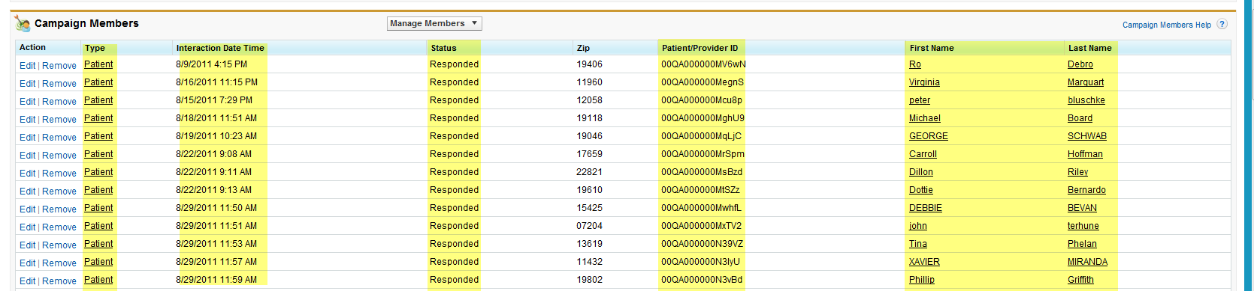

15.4 Marketing Asset
Marketing Assetare the specific creative pieces that are applied tacticsor methods used during a Campaign.

IMPORTANT: The Marketing Asset also allows us to view which tactics were most successful in driving the greatest response to the campaign message.

In this example we can see there are Facebook ads, Google Ads and an email associated to this campaign.
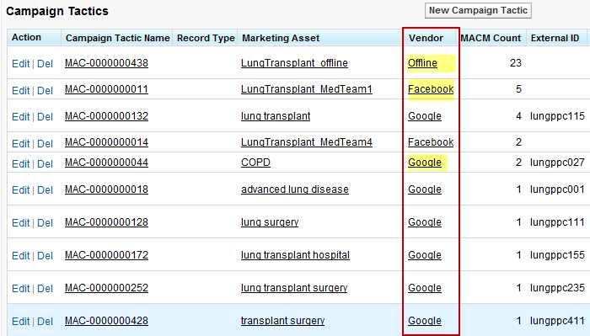

15.5 Campaign Service Lines
Campaign Service Lines associate revenue and clinical encounters to campaign members.
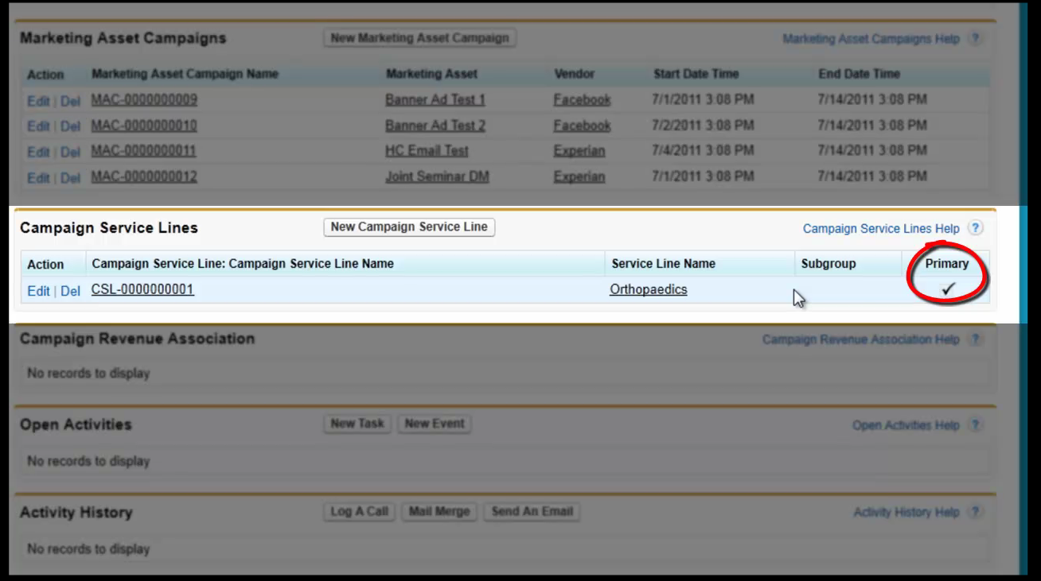Note : You can associate multiple service lines to a campaign.
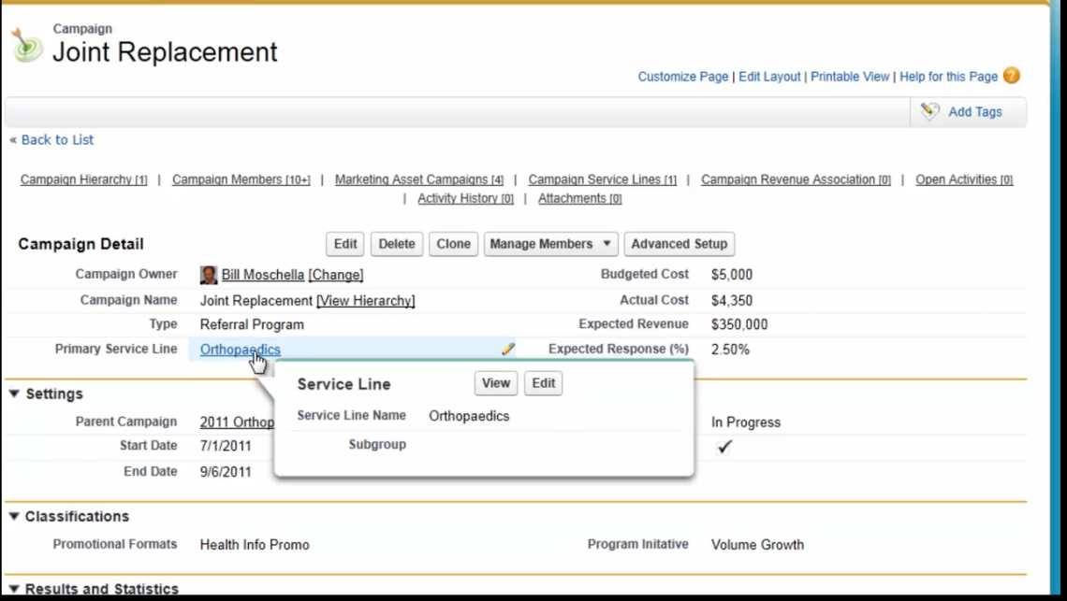
You can also select one of multiple service lines to be the primary service line. This primary service line will be linked and listed on the Campaign record in the details layout as shown in the example below.

Chapter 16: Evariant Support

16.1Introduction of the Support Portal
- Ease of use- the Support Portal is built off the same platform as the Evariant Platform!
- Familiar feel- similar layout and navigation as the Evariant Platform
- Community Forum – Connect and share with other the Evariant PlatformUsers!
- Knowledge Base- easier to locate documentation, job aids and videos by using the improved search functionality

16.2Log In to the Support Portal

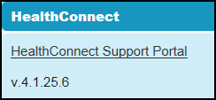 | To access the Support Portal:  - Click the link for The Evariant Platform Support Portal on the left in your Evariant Platform Navigation links.  - Enter your login ID and Password for the Support Portal.

Note: it is recommended that you reset your password for the portal to the same password you use for the Evariant Platform

Note: you should have received an automated email with your portal login information. If you have not received that information, please contact Customer Support at: The Evariant Platform@evariant.com

16.2 Ticket Requests

PURPOSE:
Submit a case to Customer Support for additional assistance on The Evariant Platform related questions or issues

16.3 Support Assistance through Ticket Requests
To access the Ticket Requests from the Home page, click the Support Image (1) in the center of the home screen or click the Ticket Requests tab (2) at the top of the screen.

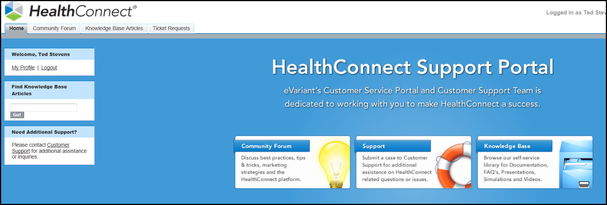

16.4 Creating a Ticket
- Click the Create New Ticket Request in the center of the Recent Ticket Requests field in the middle of your screen
-OR-
- Click the Create New drop down on the left in the Navigation Bar and choose Ticket Request
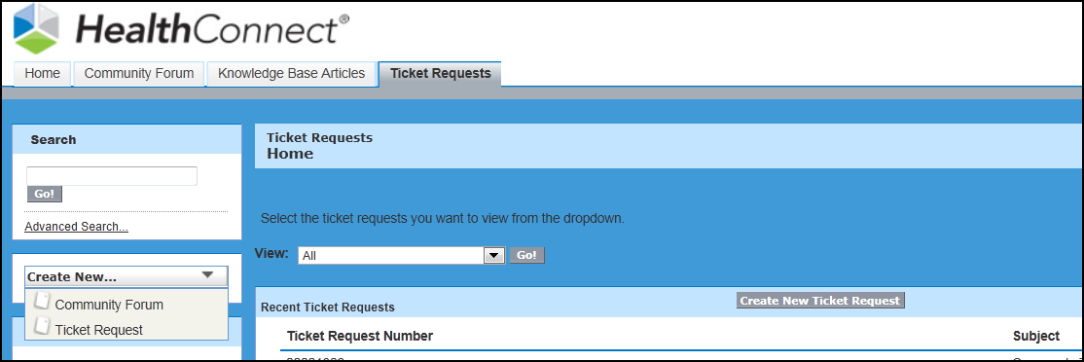

Note: When you submit a ticket request you will automatically receive an email confirmation if your ticket was successfully submitted. Additionally you will also be notified of any updates to your ticket status through your email as well.

DO NOT RESPOND to the email you receive (as it is just a confirmation of receipt)

Example email confirmation:

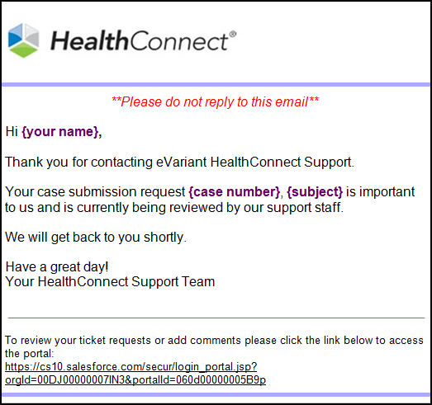

You will be provided with a link you may click on to give you quick access to your ticket in the Support Portal

16.4 Entering Ticket Request Information
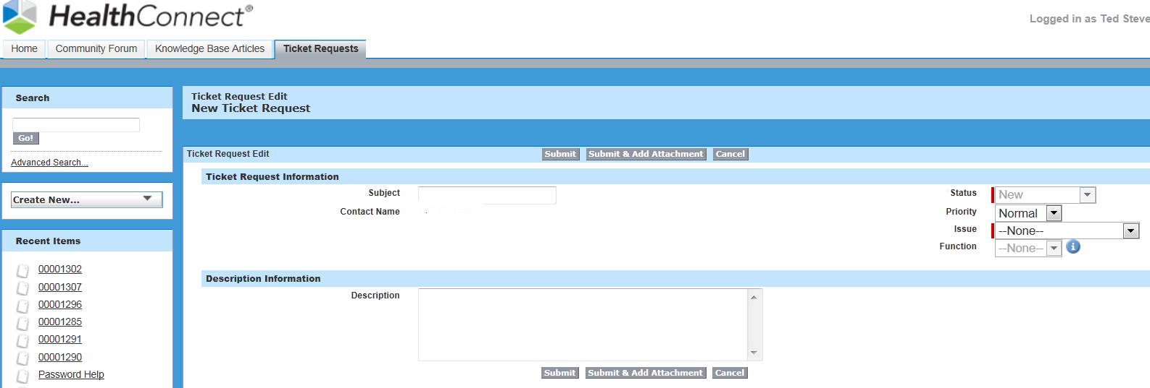

Ticket Request Information
- Subject- Enter the subject
- Contact Name – Your name will appear here
- Status- you are not able to edit this field (this field is updated by Customer Support)
- Priority- change the priority as needed to reflect Low, Normal, High or Urgent
- Issue- choose the appropriate issue (the Issue choices are based on the The Evariant Platform tabs, choose the issue based on what tab you first accessed for the item to which you have a question or issue with)
- Function- this is a dependent field that will give you more specific detailed choices based on the issue you had chosen (item #5 above)

Description Information
Description- detailed information about the issue. Please be sure to include the following information when applicable:
  - Full URL’s (directly from HC or Eloqua)
  - Browser name and version
    - For Eloqua issues please include what email client you are using and version (Outlook 2010, Lotus Notes, etc)
  - Sequence of steps to reproduce
  - Expected Result
  - Observed Result

Attachments
To add an attachment to a ticket request;
- Click the Submit and Add Attachment button at the bottom of the ticket screen.
The following screen will appear and allow you to browse for your file(s)

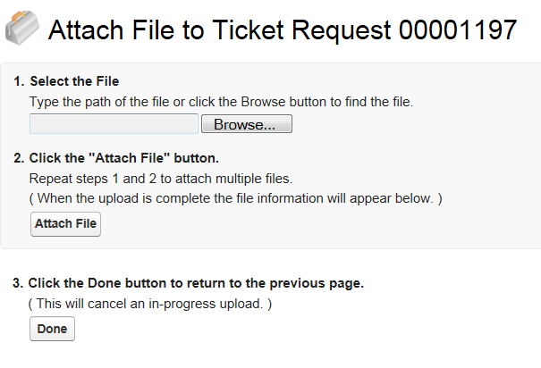

16.5 Accessing your submitted ticket
A few of the reasons that you may want to access a ticket that you have already submitted include:
- adding additional comments
- checking the status of the ticket
- revisiting the original ticket submission, view/add attachments and see the communication exchange on an as needed basis

Click the Ticket Requests tab to quickly access your submitted tickets. Your most Recent Ticket Requests will display. Click the Ticket Request Number to access your Ticket and to see the status and additional details.

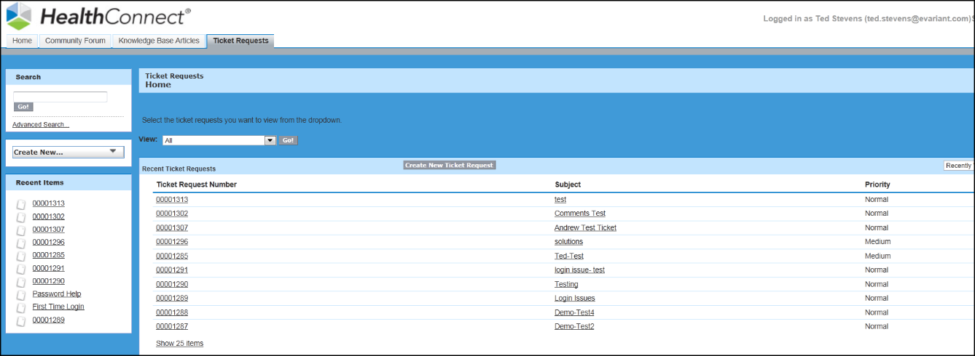

To add Attachments to your ticket, click the Attach File button in the Attachments area (see illustration on page 7), choose your attachments and then click Done.

To add Comments/Notes to the ticket, click the Add Comment button in the Ticket Request Comments area. Enter your additional comments and click Save

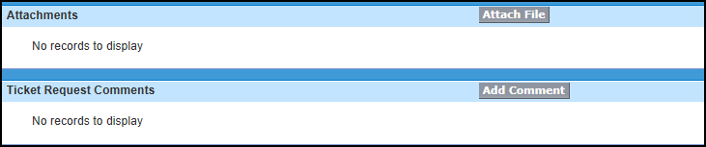

To check the status of your ticket, Open your ticket. [The status is indicated on the right hand side]
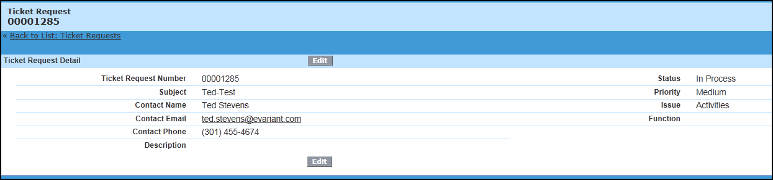

16.6Community Forum

The Community Forum is a group for Evariant Platform users to discuss best
practices, tips & tricks, marketing strategies and the Evariant platform

***This is a public meeting place for open discussion and participation for select EvariantPlatform users***

To access the Community Forum from the Home page, click the Community Forum Image (1) in the center of the home screen or you may access the Community Forum tab (2) at the top of the screen.

Using the Community Forum
There are three main tasks that you can perform inside the Community Forum:
- Post an Idea
- Navigate/Search
- Vote/Add Comments to existing posts

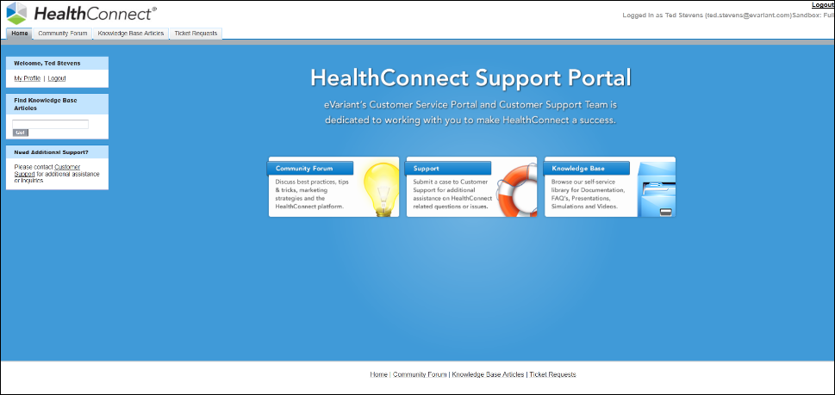
1 Post an Idea
(1) First, choose the Community Forum you would like to post to
(2) Then Post by using either the ‘Create New’ drop button on the left navigation pane or by clicking on the ‘Post Community Forum’ icon in the center of the screen
(3)Enter in your Post Title and your Description in the appropriate fields
(4)Chose a relevant Category, at the bottom of the window, to assign to your Post
(5) Lastly, click the Post button, at either the top or bottom of the screen

1
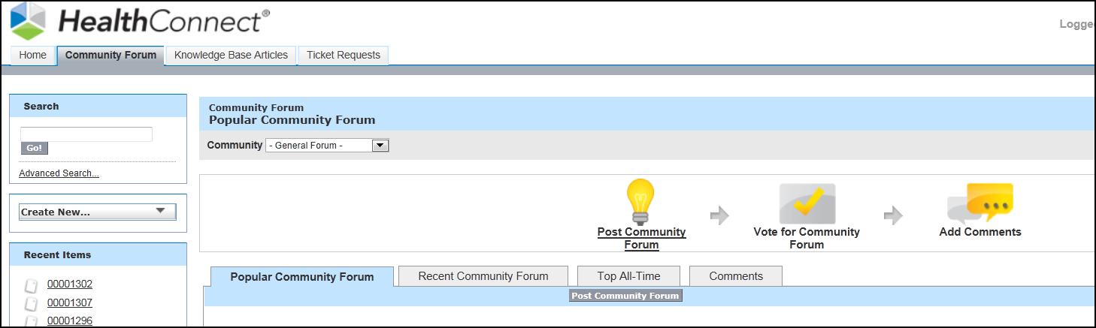
2
4

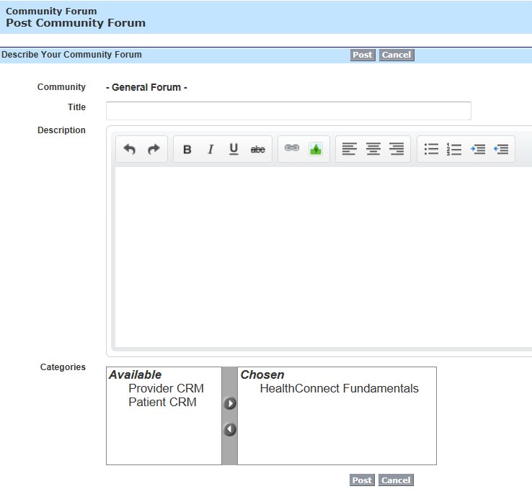
3

# 2 Navigate and Search-

1
2

Search for Posts by typing in a keyword using the search box (1) or navigating and browsing through the tabs available on your screen (2)
- Popular Community Forum: this tab houses ideas that are sorted by the age of an idea’s positive notes. Regardless of the number of points, the ideas with the newest positive votes display higher on this tab than ideas with older positive votes. This also allows you to browse ideas that have most recently gained popularity with less precedence given to long-established ideas that were voted on in the past.
|

- Recent Community Forum: this tab houses a summary of all the recent activity that relates to your participation within a community. For example, this page lists all the ideas and comments you have posted to a community as well as the ideas you have voted on
- Top All-Time: this tab houses the Top All Time ideas, sorted from most number of points to fewest. This allows you to see the most popular ideas in the history of the community
- Comments: To view all comments, click the Comments tab. This tab houses the list of comments that have most recently been submitted

16.7 Knowledge Base
The Knowledge Base is our self-service library Documentation, FAQ’s, Presentations, Simulations and Videos and is maintained and updated with contributions from the Training Department.

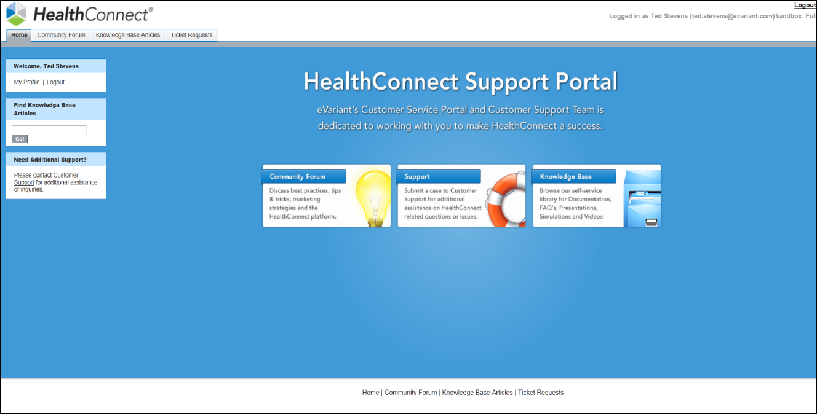

To access the Knowledge Base from the Health Connect Support Portal Home page, click the Knowledge Base Image (1) in the center of the home screen or you may access Knowledge Base Articles tab (2) at the top of the screen.

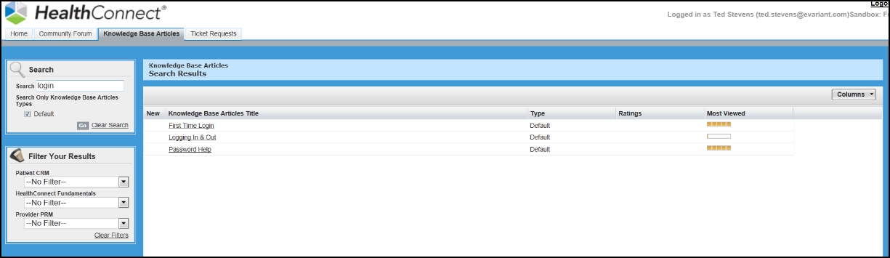

Note: The columns displayed above may not represent what you see on your screen, but you can add them using the columns button to modify your view
Search the Knowledge Base using one of two Search methods.
1 |  |  | 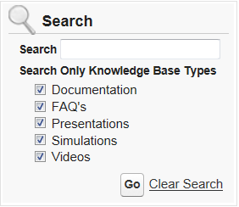 |  | - Type in your keyword in the Search field.  - Check or Uncheck any Knowledge Base types you would like to include as part of your search  - Click GO!
2 |  | 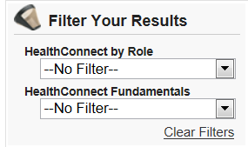 |  | - The Evariant Platform by Role (Field User, System Administrator, Data Management, Marketing User, or Web Developer) to find items specific to a particular role  - The Evariant Platform Fundamentals (Getting Started, Record Management, Health Connect Navigation, Search, Self- Paced Video Training, User Guides, and Release Notes)

Click the Knowledgebase Article Title to open the documentation window

Rate the Knowledgebase Documentation by clicking on the stars above the Article Body
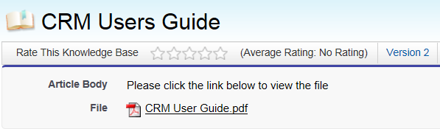

CHAPTER 17: THE EVARIANT PLATFORM GLOSSARY

Activities - Activities are the visits, phone calls, follow-ups and other meetings and conversations that occur between Providers or Practices and the Physician Liaison / Physician Relations groups.
Ad Groups - A Search Engine Marketing term used to describe a grouping of contextually similar keywords and ads used in Google, Bing, Yahoo, etc. search campaigns.
Areas of Expertise – The focal point within the specialty for a provider. Examples include Hand surgery, pediatric cardiology.
Batch Jobs – a group of records that can be executed at the same time.
Campaign Revenue Summary – Revenue that can be claimed outside of the campaign cost.
Campaign Service Lines – Focal point of a campaign that is attributed to a specific area of care within the hospital
Campaign Tactics- Campaign Tactic is what drives the marketing message to a consumer. It connects the marketing asset, campaign, and vendor to create a meaningful relationship in order to track the marketing effectiveness of a campaign.
Campaign Tactic Members -This is a junction object that joins a single campaign and a patient or provider record.
Campaign Tactic Member Revenue – The revenue directly associated with the cost of a visit after the campaign has ended.
Certifications – The actual credentials that are required by specific boards of medicine
Certification Boards – Group of designated personnel that establish the curriculum for the certification
Contact - An individual who is interested in doing business or currently does business with your organization. A contact may or may not be part of a larger organization (account).The Evariant Platform object that Providers must be loaded into when importing a list.
Cookie - also known as an HTTP cookie, web cookie, or browser cookie, is used for an origin website to send state information to a user's browser and for the browser to return the state information to the origin site. The state information can be used for authentication, identification of a user session, user's preferences, shopping cart contents, or anything else that can be accomplished through storing text data.
Cookie, Persistent - A persistent cookie will outlast user sessions meaning it will track user interaction with your digital tactics over a longer period of time per user.

DemandConnect - The module within Evariant Platform that allows options for forms, campaign submissions, and other definitions related to advanced campaign features.

DemandConnect Scripts – There are two different scripts that are generated by Evariant Platform. The scripts are generated as part of the development process of creating a Webform. The two scripts include a validation script and tracking script which passes the data entered in the form to The Evariant Platform.
Diagnoses – the medical terminology given to an outcome of a visit
DRG – Codes used for billing purposes
Education - list any one of several degree types, year of graduation and other simple information.
Events - an administrative tool used to create, edit and cancel events as well as manage the overall events registration, waitlist, and registrant processes. In addition to the events administration tool, the client will have a web presence for events in the form of either a Web site, listing all events, or individual landing pages specific to an event category
Event Categories – Indicates the specific category that the event is related to. Examples include : Bariatric, Cardiac Health, Orthopedics, etc.
Event Locations – This is the actual address of the event.
Event Registrants – The registrants are the actual consumers and/or providers that have either enrolled in an event via a web form or have attended the event and must now must be entered manually into The Evariant Platform. You are also able to update attendance for an event (no show, cancelled, attended)
Event Speakers – This field is optional. You are able to add a speaker to an event and include such information as a photo, area of expertise, availability, and contact info, all in the description field.
Event Types – The event type is the method that the event is being conducted. Types include in person, webinar, and program. Support groups. Id webinar is selected; you can include the URL, password, call in number and password of the collaboration meeting in your setup.
Existing Members: the current total of members in your Campaign List
Facilities – Is the building and/or room that an Event will be conducted in
Google Campaigns - The highest level in the hierarchy of the Google AdWords User Interface. A Google Campaign consists of ad groups, creative (text ads or display ads) and keywords.
Households – A rollup of all consumers who reside in the same dwelling. New consumers can be added to the household directly from the patient record
Inquiries – Inquiries in the Evariant Platform are the means that consumers are asking for information. They are either calling a number (which would be the inquiry type of call center) or they are completing and submitting a form on a webpage (which is the inquiry type of (Webform)
Insurance Plans - an insurance policy that pays for medical treatment and procedures.
Insurance Providers -Provider is a term used for health professionals who provide health care services.
Issues - In conversations with Providers issues and a need for follow-up activities may surface. The issues section allows you to track issues / concerns / requests from Providers, and track them directly on the Provider record to track a conclusion or remedy to the request.

Interaction Date: which shows the first time the member interacted with your marketing tactic

JavaScript file - The DemandConnect script is a JavaScript file that should be placed on every page of your website including any landing pages or microsites. This file should be placed on and around the footer of your web templates similar to how Google Analytics tracking scripts are placed. We recommend placing the script just before the Google Analytics script in your HTML code.
Keywords - These are select words or phrases that are used by advertisers to bid against their competitors, based on content the advertiser wants to promote.
Lists: A list is a unique group of patients or providers that you associate to a specific campaign. The list is unique in that you cannot have the same record more than once in the list unless you have duplicate records.
List, Imported: any user with appropriate permissions can import up to 50,000 records from an external list such as a .csv file through the The Evariant Platform import wizard.
Locations – The physical address of a Provider or Practice and Group
Marketing Assets – Marketing asset is the actual tactic used in a marketing program (campaign) or initiative. It could be the creative for a banner ad, a direct mail piece or specific keyword.
Marketing Asset Campaign (MAC): Joins an Asset, Vendor and Campaign into a unique combination. This relationship / combination relate these items to one another while allowing the flexibility to use a single asset for more than one campaign, possibly more than one vendor.

Match fields: the field you identify for the system to uniquely identify records to avoid duplication imported lists and existing The Evariant Platform records for Patients / Providers.
My Diagnoses – The specific outcome of a medical visit for a given patient
My Insurance – The specific insurance provider for an individual patient
My Procedures – Medical procedures performed for an individual patient
My Visits – Unique patient visits for a specific patient
Parameters – A parameter is a variable in the action link of a marketing asset that includes the ID that links that asset back to a campaign in The Evariant Platform. The Evariant Platform allows you to define specific parameters to monitor.

Patient Scores – The likelihood that the patient will encounter a certain condition or require a specific procedure
Procedures – The medical resolution to a determined diagnosis
Provider - The standard providers’ records available through The Evariant Platform PRM, this details the physicians, office staff and other clinicians (by Provider Type) in the system.

Provider Certifications – individual credentials held by a Provider
Provider Credentials – Facility where the Provider is privileged to practice medicine
Provider Education – Grad school, Med school, residency

Provider Locations - Location records list specific geographic information that link directly to a Practice & Group. A Practice & Group record can have multiple locations associated to it.
Provider Practices & Groups- The Practice and Group object is used to roll up any number of related Provider records. The Practice & Group record can represent a physician practice, clinic, skilled nursing facility or any related business. A Provider can also be associated with many Practices & Groups.
Provider Scores – Scores that represent the loyally of a provider to a specific medical facility
Provider Specialties – The primary area of care for a provider. Examples include: cardiology, orthopedics, family medicine.
Referrals – There are two types of referrals. Referred Referrals are those where the provider you are viewing has been referred to for a visit / encounter. Inquiry referrals are those where the provider you are viewing referred a patient to another provider for a visit / encounter.
Search Phrases –A method of locating information using the search function
Search Engine Results Page (SERP): Is the web page containing results of a search query that a user is taken to. These results are links to other web properties that have relevant content to the user’s query.
Service Lines – Specific areas of care
Specialties - The primary area of care for a provider. Examples include: cardiology, orthopedics, family medicine.
Status: indicates the level of this member’s interaction. For example if you have sent an email, the status would be “sent”. If the member clicked the email and filled out a form the status would be “responded” and so on.

Sub Service Lines –Specialized care under a service line. Example Women’s Health > Infertility
Tasks - Tasks are a fast and simple way to track follow-ups from conversations with Providers and Practice & Group personnel.

Territories- Personalized groupings of Providers and/or Practices and Group
Text Ads- Creatives that contain a headline (25 characters), two description lines (35 characters each) and a display URL. They appear on the Search Engine Results Page (SERP) after a user entered in their search query.
Vendors – A 3rd party media outlet responsible for the delivery of the campaign tactics (Facebook , Google, etc.)
Web Forms – Code that contains fields and enables data to be passed to The Evariant Platform
Web Form Fields – Lets you define the data you want to collect as well as the business rules for when and how to update and create the primary record

Web Form Match Rules – allow a developer to define the criteria to use when matching inbound data to existing patient and provider records. You can define as many rules as you want and set an order fore which they will run. If no match is found a new record is created and entered into the system
Web Form Submits – Shows a detailed view of each website form submission. Detailed message logs are included as well as the raw form submission data in XML format
Zip Codes – A trademark used for a system designed to expedite the sorting and delivery of mail by assigning a series of numbers to each delivery area in the United States.

Naming Standards Summary

Parent Campaigns
[Fiscal Year] - [Service Line]
example: FY14 - Oncology
 | Service Line |  | Abbreviation
1 |  | Bariatric |  | Bariatric
2 |  | Oncology |  | Oncology
3 |  | Orthopedics |  | Ortho
4 |  | Primary Care |  | Primary Care
5 |  | Neurology |  | Neuro
6 |  | Gynecology |  | Gynecology

Child Campaigns
[Fiscal Year] - [Service Line] - [Descriptive Campaign Name]
example: FY14 - Oncology - Adult Brain Spine Tumors

WebForms
[Fiscal Year] - [Service Line] - [Web Form Name] - [Web Form Type]
example: FY15 - Bariatric - Online Assessment - DG
 | Form Type |  | Description
1 |  | DG |  | Download Guide
2 |  | AR |  | Appointment Request
3 |  | AQ |  | Ask A Question
4 |  | DF |  | Download Facts
5 |  | SR |  | Support Request
6 |  | GI |  | General Inquiry

Email Alerts
[Fiscal Year] - [Service Line] - [Web Form Name] - [Web Form Type] - [Alert Type]
example: FY15 - Bariatric - Online Assessment - DG - Email Alert
 | Alert Type | Description
1 | Email Alert | Notification Email
2 | Auto Reply | Auto Reply

Workflow & Rules
[Fiscal Year] - [Service Line] - [Web Form Name] - [Web Form Type] - [Workflow Type]
example: FY15 - Cardio - Afib - DG - Auto Reply
 | Workflow Type | Description
1 | Email Alert | Notification Email

Web Campaign Setup Checklist

Setup Campaign ( see Campaign Setup Checklist for detailed steps)
Setup Campaign Tactics ( see Campaign Tactic Setup Checklist for detailed steps)
- Create Appointment Request Campaign Tactic
- Create Download Guide/Facts Campaign Tactic

Setup WebForm ( see WebForm Setup Checklist for detailed steps)
- Create Appointment Request WebForm
- Create Download Guide/Facts WebForm

Setup Email Template ( see Email Template Setup Checklist for detailed steps)
- Create Auto Response Email Template
- Create Notification Email Template

Setup Email Alert ( see Email Alert Setup Checklist for detailed steps)
- Create Appointment Request Email Alert
- Create Auto Reply Email Alert

Setup Workflow ( see Workflow Setup Checklist for detailed steps)

Web Campaign QA Steps ( see Web Campaign QA for detailed steps)

Campaign Setup Checklist

Create new Campaign using naming standards. (eg FY15 - Oncology - Campaign Name)
- Select Primary Service Line field.
- Select Parent Campaign
- Set Status, Active fields
- Edit Start Date, End Date
Create new Campaign Tactic.
- Click on New Campaign Tactic button
- Set Record Type = "Website Direct"
- Select Campaign Name
- Set Vendor = "Direct"
  - For website vendors use names without .com (eg: Google, Facebook, Bing)
- Edit Destination URL. System will generate Full URL.
- Save as new Campaign Tactic
Update WebForm default Campaign Tactic field with new tactic id.

Workflow Setup Checklist

Create new Workflow Rule.
- Navigate to Setup>>App Setup>>Create>>Workflow & Approvals
- Click New Rule button
- Select associated Object
- Edit Rule Name field using naming standards (eg FY15 - Oncology - Campaign Name)
- Edit Description field
Choose rule Evaluation Criteria
Edit Rule Criteria
- Select rule Run Criteria
- Select Field, Operator and Value for each criteria
- Add Filer Logic if more than 1 criterion is needed
Click Save&Next button to continue
Add Workflow Action
- Select Add Workflow Action = "Select Existing Action"
- Select Action Type = "Email Alert"
- Add Selected Email Alerts
Click Save button to save Workflow Actions
Click Done button to complete Workflow
Click Activate button to enable Workflow and Rules

Email Alert Setup Checklist

Create new Email Alert
- Navigate to Setup>>App Setup>>Create>>Email Alerts
- Click the New Email Alert button
- Edit Description Name using naming standards. (eg FY15 - Oncology - Webform Name - Email Alert)
- Select Object field
- Select Email Template
Select and Add Email Alert Recipients
Enter additional email addresses (5 emails maximum)
Select the From Email Address field
Click the Save button to save the Email Alert

Email Template Setup Checklist

Create new Email Template
- Navigate to Setup>>Communication Templates>>Email Templates
- Click New Template button
- Select template Folder field
- Edit Email Template Name field using naming standards (eg FY15 - Oncology - Campaign Name - Email Template)
- Edit Description field
- Edit Subject field
Edit Email Body textbox
- Select Field Type
- Select Field
- Copy Merge Field Value
- Paste into Email Body textbox
Click Save button to save Email Template
Test and Verify Email Template
- Click Send Test and Verify Merge Fields
- Select Recipient Record Type
- Enter Recipient Record Type value
- Select Related To Record Type
- Enter Related To Record Type value
- Check Send Email Preview To checkbox
- Enter Send Email Preview To email address
- Click OK button to send email

WebForm Setup Checklist

Create new Webform using naming standards. (eg FY15 - Oncology - Webform Name - AR)
- Edit mandatory field Form Type.
Update form with hidden and required Webform fields.
- Generate HTML to verify hidden fields , required fields and field order
- Verify Lead Source field is less than 40 characters
Add Webform match rule for FirstName , LastName and Birthdate.
Create new Campaign Tactic.
- Navigate to Marketing Assets Tab
- Select/Create Marketing Asset
- Create New Campaign Tactic
- Set Record Type = "Website Direct"
- Select Campaign Name
- Set Vendor = "Direct"
- Edit Destination URL. System will generate Full URL.
- Save as new Campaign Tactic
Update Webform default Campaign Tactic field with new tactic id.

Web Campaign QA Steps

WebForm Fields Test
- Go to WebForm detail page
- Click Generate HTML
- Review HTML hidden and required fields
- View HTML in browser to verify field order
Workflow Rules Test
- Go to Workflow Rules detail page
- Verify Rule Criteria and Values
- Verify Filter Logic
Email Template Test
- Go to Email Template detail page
- Click Send Test and Verify Merge Fields
- Select Recipient Record Type
- Enter Recipient Record Type value
- Select Related To Record Type
- Enter Related To Record Type value
- Check Send Email Preview To checkbox
- Enter Send Email Preview To email address
Lead Source Field Test
- Go to WebForm detail page
- Copy Value for Lead Source field
- Verify value length is less than 40 characters
Campaign Hierarchy Test
- Submit form values from web page url
- Go to Campaign detail page
- Verify updates patients / responses in campaign hierarchy counts
Campaign Tactic Test
End to End Web Campaign Test
- Verify Inquiry Record
- Verify Web Submit Record
- Verify Campaign Member Record
- Verify Notification Email Record

