

Table of Contents
Last Updated: January 2015
CRM Users guide

ORLANDO HEALTH

CRM User’s Guide
The Evariant Platform

Chapter 1: Evariant Platform – CRM 4
1.1 Introduction 4
1.2 Terms: 4
Chapter 2: Accessing the Evariant Platform 5
2.1 Logging In and Logging Out 5
2.2Password Management: 6
Chapter 3: Using theEvariant Platform 7
3.1 Navigation: 7
Chapter 4: - Personal Setup 10
4.1 Personal Setup 10
4.2Groups: 11
Chapter 5: Chatter 11
5.1 What is Chatter? 11
Chapter 6: Navigation and Objects 12
6.1Searching 13
6.2 Additional Search Information 14
6.3 Adding Additional Objects to Your Search 14
Chapter 7: Lists and Views 15
7.1 uNDERSTANDING VIEWS 15
7.2Creating a New View 16
7.2 Adding a Adding a Filter to Your Criteria for your Custom View 17
Chapter 8: Patients Information and Activity 18
8.1 Patients 18
8.2 Navigating the Patient Record 18
8.3 Editing a Patient Record 19
8.4 Related Records 20
8.5 Campaign History 20
Chapter 9: Patient Inquiry 21
9.1 Adding a New Inquiry 21
Chapter 10: Patient Referrals 23
10.1 Adding a Referral From an Inquiry 23
Chapter 11: Inquiries 24
CHANPTER 12: Dynamic List Builder 25
12.1 What is the new Dynamic List Builder (DLB)? 25
12.2 What are the new Dynamic List Builder (DLB) features? 25
12.3 How to use DLB (Dynamic List Builder) 26
12.4 Establishing a Criteria 27
Additional Selection (Using CPT or ICD Codes) 28
12.5 Grouping Fields in a Criteria 29
12.6 Removing a Field in a Criteria 30
12.7 Preview record count 30
12.8 Saving your report (Query) criteria 31
12.9 Saving your criteria to a campaign tactic 32
12.10 Running your report (list) 32
Chapter 13: Outbound Communications Engine 33
13.1 What is the Outbound Communications Engine 34
13.1 How to use Outbound Communications Engine 35
13.2 Selecting a Template (Style or Blank) 36
13.3 Establishing the Message Recipients – TARGET AUDIENCE 38
13.4 Using a Control Group 40
13.5 .Message Options 40
13.6 Scheduling and Send 42
Chapter 14: Events 44
14.1 How to Access the Events Module 44
14.2 The Events Module Main Page 44
14.3 Adding a NEW Event 45
14.4 TO ENTER A NEW LOCATION 47
14.5 A Recurring Event 47
14.6 Registering a Provider or Patient for an Event 48
14.7 Deleting a Registrant 52
8.7 Editing an Event 52
14.8Deactivating an Event 52
14.9 To view registration activity 53
8.10 To Change /Update Status of Registrants 53
Chapter 15Campaigns 55
15.1 Campaigns 55
15.2 Campaign Hierarchy 56
15.3 Campaign Members 57
15.4 Marketing Asset 58
15.5 Campaign Service Lines 59
Chapter 16: Evariant Support 60
16.1Introduction of the Support Portal 60
16.2Log In to the Support Portal 60
16.2 Ticket Requests 60
16.3 Support Assistance through Ticket Requests 61
16.4 Creating a Ticket 61
16.4 Entering Ticket Request Information 63
16.5 Accessing your submitted ticket 64
16.6Community Forum 65
Using the Community Forum 66
16.7 Knowledge Base 68
CHAPTER 17: THE EVARIANT PLATFORM GLOSSARY 70
Naming Standards Summary 75
Web Campaign Setup Checklist 76
Setup Campaign 76
Setup Campaign Tactics 76
Setup WebForm 76
Setup Email Template 76
Setup Email Alert 76
Setup Workflow & Rules 76
Campaign Setup Checklist 77
Web Campaign QA Steps 78
Workflow Setup Checklist 79
Email Alert Setup Checklist 81
Email Template Setup Checklist 82

Chapter 1: Evariant Platform – CRM

1.1 Introduction
The Evariant Platform Patient CRM application is, in the simplest terms, a two way platform for communicating with your patients and prospective patients.
Through the Patient CRM you are able to:
- View Patient records containing demographic and profile information
- Associate or add patients to marketing campaigns and communicate marketing messages to them
- View the response of the individuals you have marketed to both through measuring campaign response and referrals to physicians
- Create and manage Campaigns as they relate to Campaign Members, assets for a campaign and how the campaign is associated to your organization through Service Lines

1.2 Terms:
Patient:Otherwise known as Consumer can be a current patient or a potential patient
Campaign id: The unique identify for any campaign. The campaign id is used identify and to link various campaign objects together.
Tactic:The venue for your campaign, whether it is Direct Mail, Email, PPC, or other, each of these represents a tactic.
Campaign Member: A Patient/ potential Patient or provider who is identified in The Evariant Platform and will be the recipient / target of a campaign.
Vendor: 3rd party media outlets responsible for the delivery of your campaign tactics (Facebook, Google, etc.)
Marketing Asset: The low level of a physical campaign tactic such as a single graphic. An asset may be stored once in The Evariant Platform and used for more than one campaign as needed.
Campaign Marketing Asset(MAC): Joins an Asset, Vendor and Campaign into a unique combination. This relationship / combination relate these items to one another while allowing the flexibility to use a single asset for more than one campaign, possibly more than one vendor.
Marketing Campaign Asset Member(MACM): An automatically generated relationship or junction between a Campaign Member (such as a Patient or a Provider) and Marketing Campaign Assets that allows you to associate a Patient or a Provider to more than one campaign

Chapter 2: Accessing the Evariant Platform

2.1 Logging In and Logging Out
You will login to The Evariant Platform by going directly to https://login.evariant.com . You may bookmark the login page once there for return visits. Why Salesforce? The Evariant Platform is hosted on the Salesforce platform to provide optimum availability to our clients without ever needing to install software.

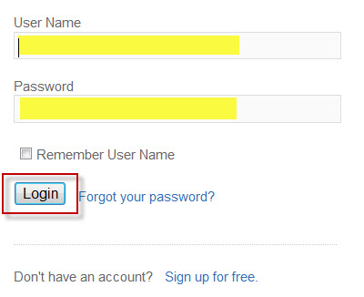

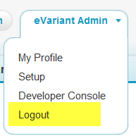
Once you have successfully logged into the application with your email address and password provided from your System Administrator or trainer, you may logout at any time by selecting the drop down arrow next to your name in the upper right hand corner of the screen

2.2Password Management:
ForgotPassword
If you have forgotten your password, select "Forgot your password?" link from the login screen. You will be asked for your User Name. Once entered, you will be sent a new temporary password to the email account on file for your The Evariant Platform account.

ForgotUsername

If you forget your username, please contact support at Support@evariant.com, On your very first support contact, if you have not yet created and verified your account, you will receive an email in response asking you to select a password. Once this is done, your request will be sent and you will be contacted by a member of support. You need only go through the process of account creation once for support.
Attempted too many incorrect logins (9) and received a message you are locked out?
Please contact Support@evariant.comto unlock your account. You will receive a new, system generated password as a result and be asked to select a new password on successful login.

Selecting a new Password/Password Rules:

If you are locked out or forget your password and need it reset, you will be required to select a new password.
When you enter your temporary password, it is recommended you COPY THE TEMPORARY PASSWORD from the password reset email and PASTE it into the password section to avoid any issue with zeros vs. the letter 0, the number 5 versus the letters, etc.

Password Rules:

- Password rules vary from organization to organization based on your administrator's preference for security options.
- Please check with your System Administrator if you have questions.

Chapter 3: Using theEvariant Platform

3.1 Navigation:

Upon logging into The Evariant Platform, you will see the Home tab. Navigation withinThe Evariant Platform is based on tabs for different logical sections of the application.

The Home Tab

On the Home tab you will see a configurable home page that lists a standard view that has been setup for your organization.
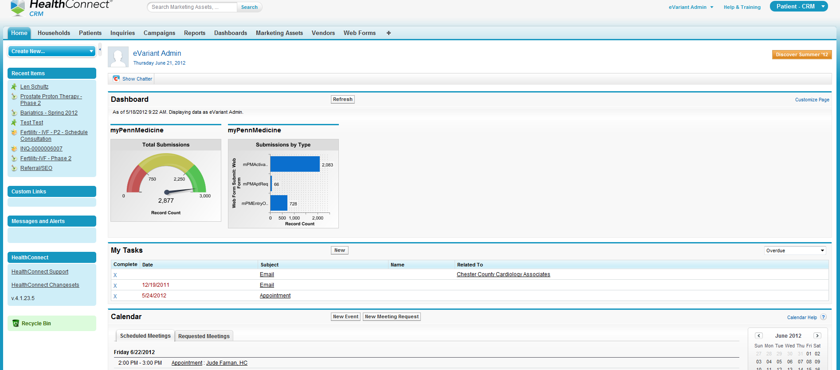

Page Navigation:
The homepage displays the four main parts of the screen that you will find through The Evariant Platformapplication.

The Header contains global search and options for person al preferences, help and selection of other Evariant Platform Modules

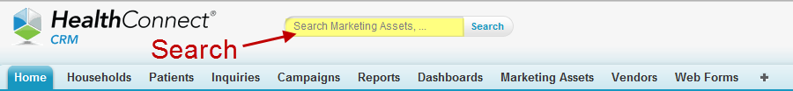

The Side Navigation Menu contains quick links and shortcuts to other areas and options
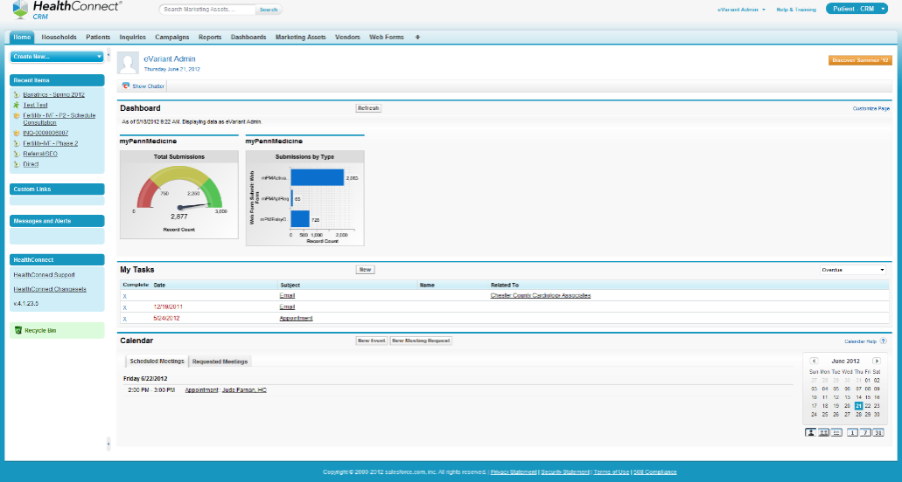
Main Navigation consisting of tabs for the application

The Main Content Area is where most of the information you view in the application will reside.
While on the "Home" tab, the main area may include dashboards and reports.

The Calendar is also located in the main center section.

Recent Items

You may see the most recent records you viewed through your own login in the left sidebar menu. Common items are listed with an icon to represent each type of record

 |  | 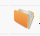
The Evariant Platform User Record | Inquiry | Practices & Group
 | 
Patient | Provider Record
3.5 Recycle Bin

Your recycle bin allows you to view items you have deleted such as your own tasks, events, issues, etc. that you have access to delete.
If you have moved a file to the recycle bin by deleting the record from The Evariant Platform, you may undelete the record or several records by selecting it in the recycle bin and selecting "undelete."
When opening the recycle bin you will see the files you have personally deleted. These files will stay in place until I unless they are removed from the recycle bin by selecting "empty your recycle bin." Items never need to be removed from recycling if there is no desire to remove them.

3.6 Administrator Recycle Bin
The Evariant Platform Administrator will have access to empty your organization's recycle bin in addition to being able to view all deleted items from your organization. If an individual user goes into the recycle bin and empties it, the data is removed and cannot be retrieved by the Admin. In addition, if the Admin removes materials from the recycle bin, it cannot be restored for a user.

If information has been sent to the recycle bin, and the user who deleted the record (and sent it to the recycle bin) wants to retrieve the information, simply select the item you want to retrieve by checking the checkbox next to the record and select “Undelete"

Chapter 4: - Personal Setup

4.1 Personal Setup

To view and edit your setup options, select the dropdown arrow next to your name in the upper right corner of the screen, and select Setup.

From Setup you may:
- View your profile information and set preferences for your The Evariant Platform experience.
- Within the setup section, your role will determine which options you may view.

You may view personal information about your account profile, name, and other account information such as:
- Change your password as needed
- View groups you have created
- Change display options for your navigation
- Share your calendar with other The Evariant Platform Users
- Set reminders for upcoming events and tasks.
- Set your email preferences
- View your email templates
- Set your Chatter preferences

4.2Groups:

You can setup your own groups for other Evariant Platform users for sharing information such as emails, notifications or other actions where it makes sense to consolidate these users versus always entering them separately.

Chapter 5: Chatter

5.1 What is Chatter?
Chatter is a chat / messaging tool used to share updates and comments with other The Evariant Platform users in your organization. With Chatter you may subscribe to others’ updates, comment on their messages as well as sharing links and files from Salesforce or your own desktop / server location.
Chatter will likely be the first thing you see when you login as it appears at the center of the home page. You can maximize or minimize it, as you choose, but may likely find it to be a useful communication resource across your team.
Using Chatter is simple; you can just enter a brief message into the text box at the top of the screen that asks “what are you working on” and Click Share.
Once you share a message, those who subscribe to your messages will see your message

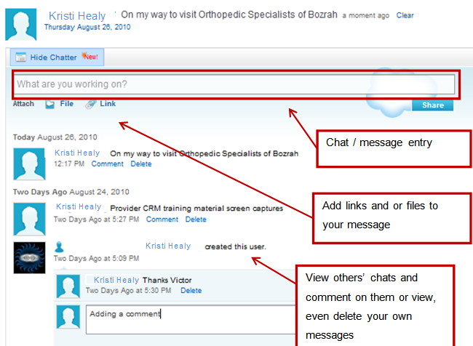

You may also delete your own Chatter messages that you have personally posted if desired by selecting the “Delete” link under any of your messages.

Chapter 6: Navigation and Objects
Within The Evariant Platform training and documentation you will likely hear the term “Objects" frequently. Objects are the term given to key groupings of data within The Evariant Platform database and application.

6.1Searching
On any page within the The Evariant Platform application, you can search for items in the universal search listed at the top center of the page.  By typing information into the search box, a type -head feature willdisplay items beginning with the letters you have typed. | 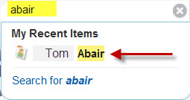

This example shows a recent record for Tom Abair based on the type-ahead feature. You may simply select “Tom Abair" from the dropdown to go directly to that record.

Other times a term entered will not find options for selection in the search dropdown.
Here, typing in "visit" did not find any real time results in the search quick results.By selecting "Search for Visit" all of the locations where the term visit appears will be displayed on one page as well as a count by category of where the results display.

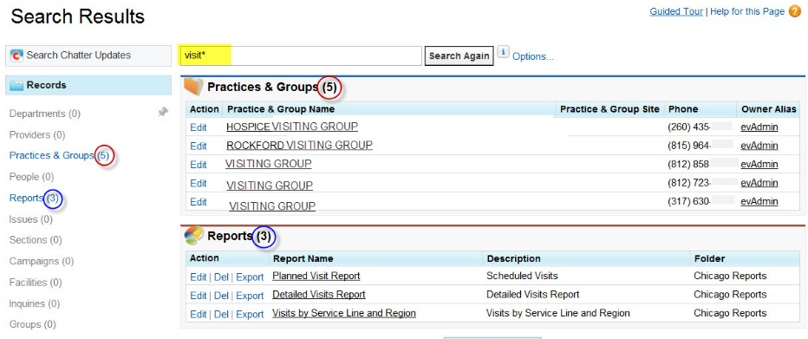

6.2 Additional Search Information
You have additional steps to maximize your search capabilities. When you “hover” your mouse over the search box, the objects that you are currently able to search will display.

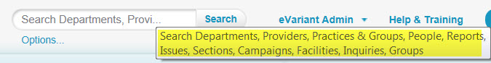

6.3 Adding Additional Objects to Your Search
You can add additional objects either before or after you have performed a search. The best practice is to select the objects you want to search for the key word(s) in BEFORE the search. This is accomplished by “pinning the object”

To PIN AN OBJECT:  - On the SIDE NAVIGATION MENU, select SEARCH ALL to display all of the objects | 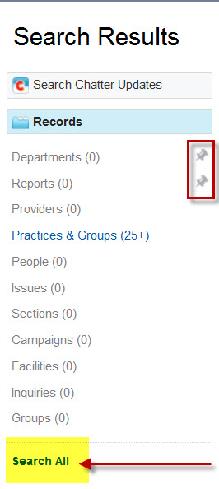
- To pin an object, hover your mouse to the right of the object that you need to add  - Click on the pin.  - By default the object chosen will be pinned to the top. | 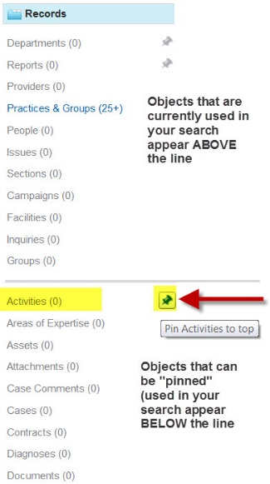
TO UNPIN AN OBJECT:  - After the object is pinned you can either  - Pin to top OR Unpin | 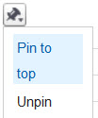

Chapter 7: Lists and Views

7.1 uNDERSTANDING VIEWS
When you view data within main tabs / objects such as Patients, Inquiries, and Campaigns, selecting the tab will display the most recent list of selected records.

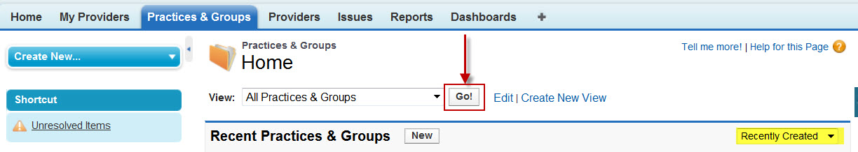

To view a list of all of the records, select the "Go" button at the top of the screen.

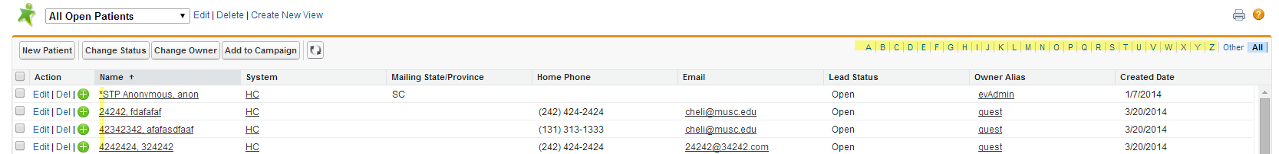

In this example we are viewing Practices & Groups, so after selecting "Go" a list of all Practices& Groups will be listed alphabetically. You may move from page to page within the list or select a letter to jump ahead in the alphabetic list.

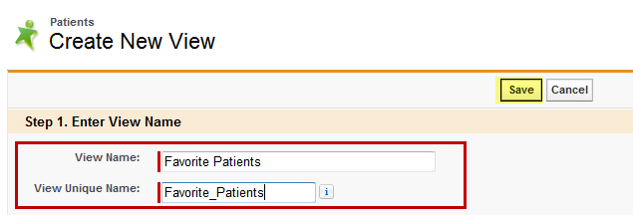

Tip: You can also sort data list by clicking on the header labels

7.2Creating a New View
You may also setup your own list based on filtered selections in order to view Patients that you commonly work with.

- To do this, select the "Create New View" button
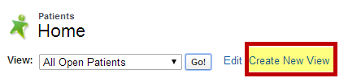

- From the resulting screen, name your view. Once entered, a required unique view name will be displayed as well.

- Click Save

7.2 Adding a Adding a Filter to Your Criteria for your Custom View
If desired for longer filter criteria, you may use filter logic to state the order and combination of filter information you wish to use
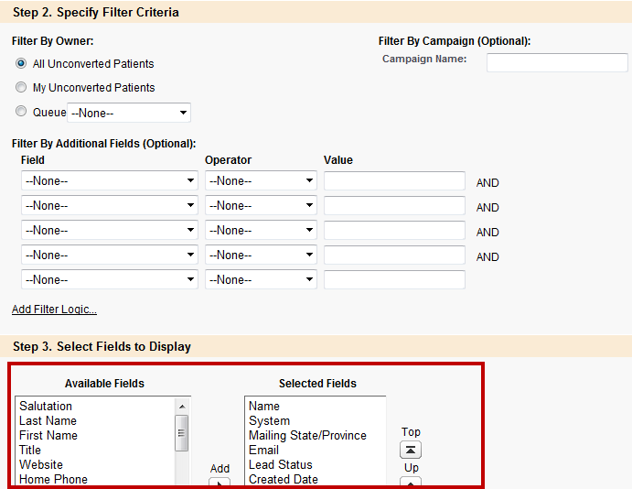

Select the fields that you want to add or remove for purposes of the output

Chapter 8: Patients Information and Activity

8.1 Patients
A patient is a record of any person that is; or may be interested in your services. Items such as subscription preferences for campaigns and other communications may also be stored on the patient record. The record also contains demographic information such as communication preferences and profile fields.

8.2 Navigating the Patient Record
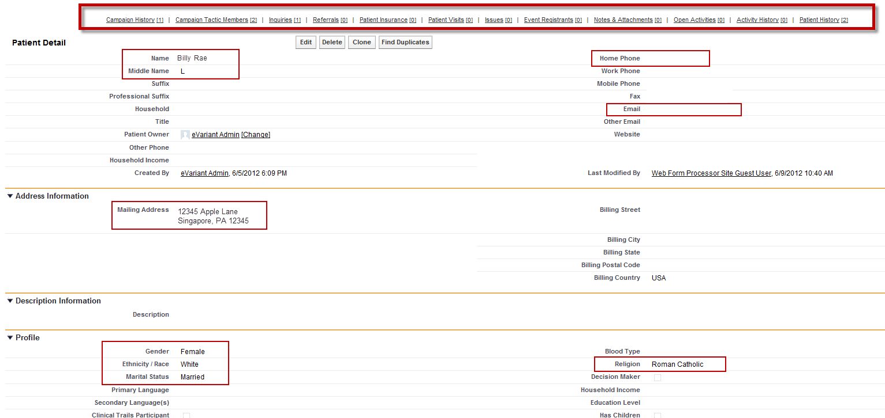
- Individuals in the “Patients” section may be existing hospital Patients or potential patients that you will market to.
- The Patient Record contains the individual’s name, demographic information such as address, email, phone, and other contact information. (as seen in the example above)

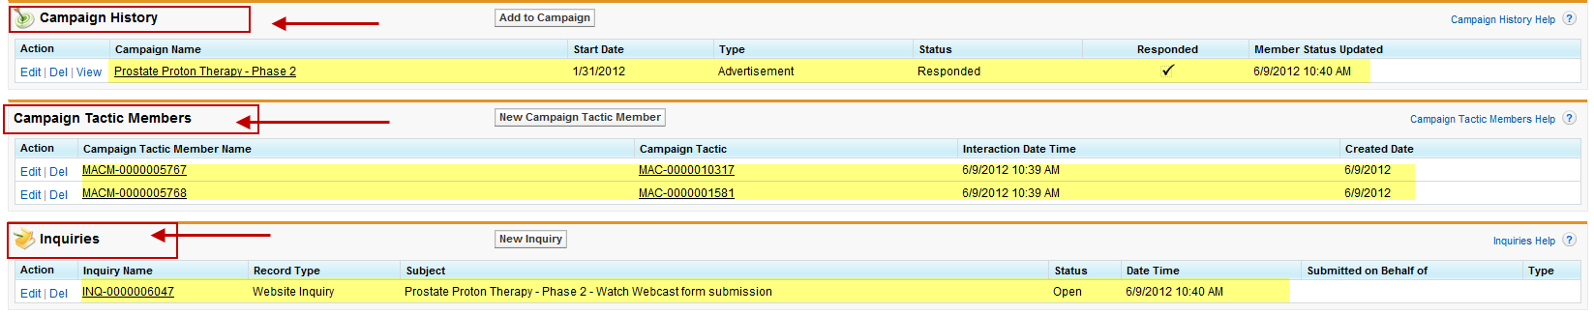
- The patient may also be tied to other related information such as a Campaign and/or Campaign Tactic

- As with any Object in The Evariant Platform, it is possible to customize fields and add additional custom fields on the detailed patient record.

8.3 Editing a Patient Record
In order to edit a patient record

- Locate the patient record by either Search or Most Recently Visited.
- Select the Edit button
- Make the necessary edits
- Click SAVE

8.4 Related Records
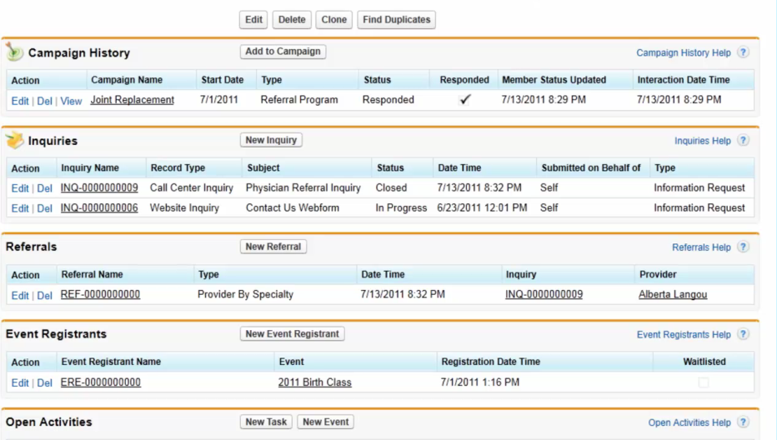
Related lists contain specific activities of the patient such as specific transactions and activities.
Examples of activities are recent campaigns, calls to the call center, class and event registration.

8.5 Campaign History
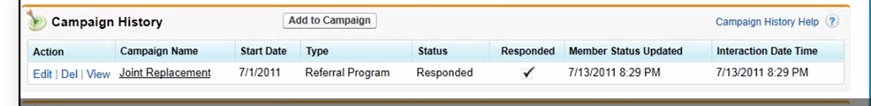

Campaign history shows any campaign the patient has recently been involved with.
- In this example we can see the campaign name (Joint Replacement)
- The start date of the campaign
- The Type of Campaign
- The Status
- Whether the patient has responded to the campaign – showing a checkmark for yes
- And important dates about the campaign and patient’s involvement with the campaign

Chapter 9: Patient Inquiry
On the patient record we can see any Inquiry requested / completed by the individual.
This may include call center activity or web form submission through the website, landing page or other for your organization.

9.1 Adding a New Inquiry
An inquiry can be added either through a call center or through a website.
To add a new inquiry:
- Click on the Inquiry tab
- Select NEW Inquiry
- Select the Inquiry type (either Call Center or Website)

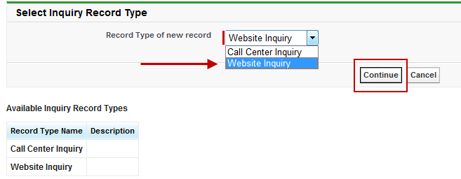

- Click Continue
- Fill in the Required field of Date / Time:
- **BEST PRACTICE** Fill in as much information as possible including
  - Patient
  - Campaign Tactic
  - Type of Inquiry
  - Status of Inquiry
  - Preferred Contact Method

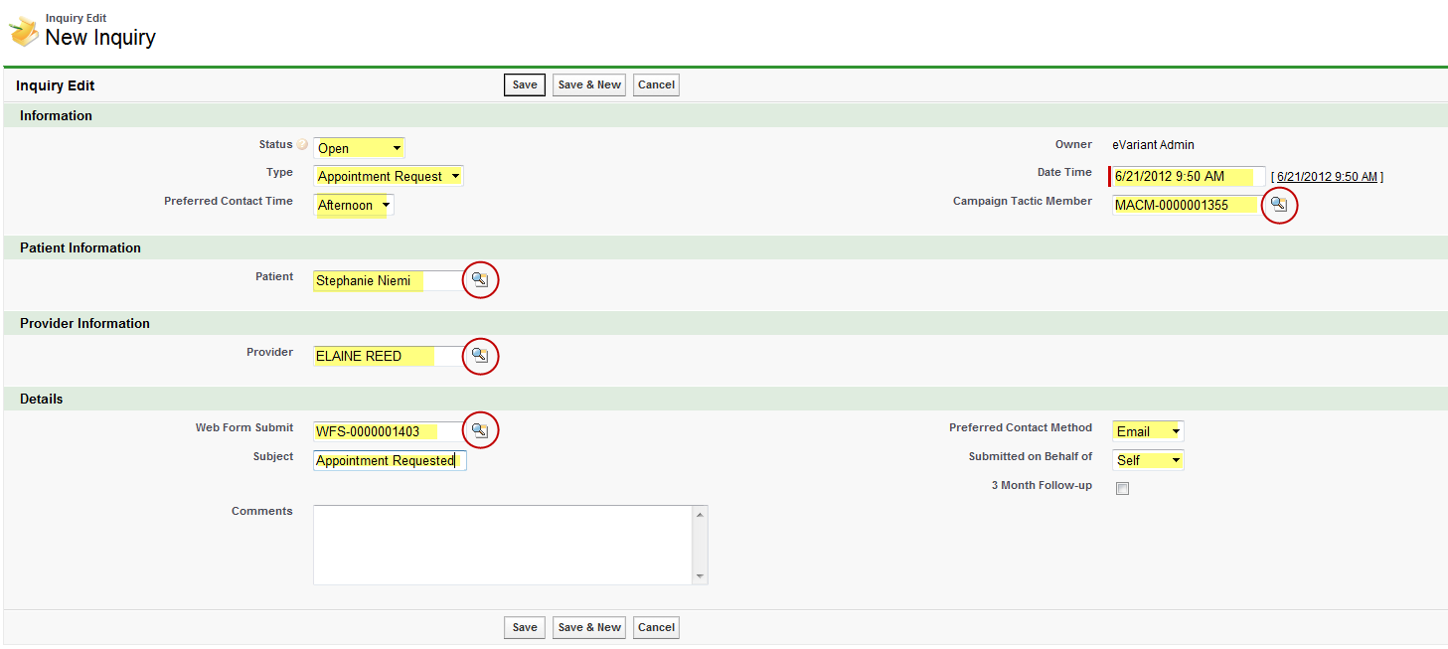
- Click Save

To verify the information on the Patient Record

- Click on the patient name (link)

- You will be brought to the Patient Record
- You will then see the inquiry that you just added

Example of a Website Inquiry
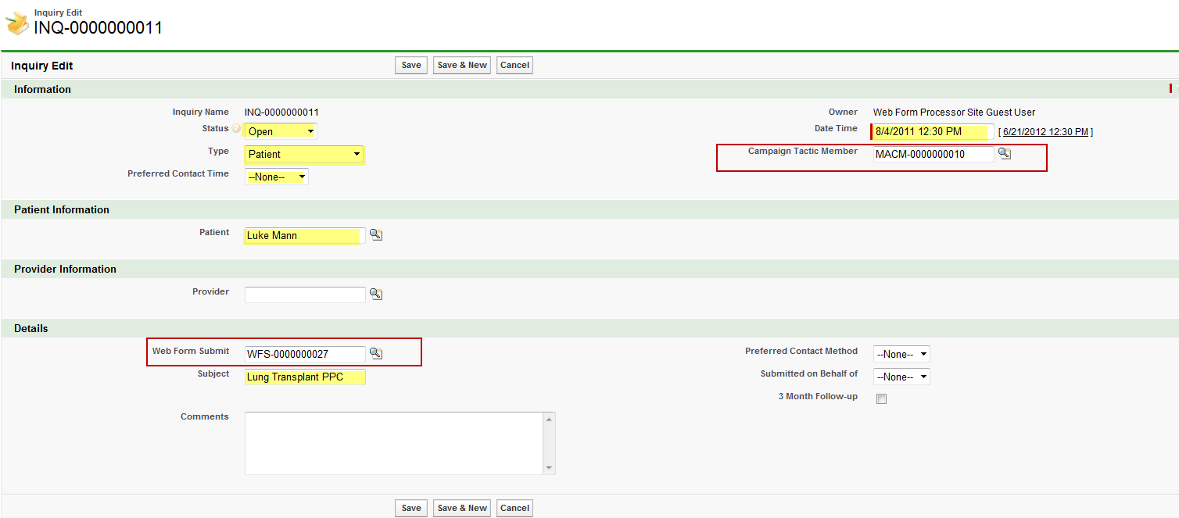

Chapter 10: Patient Referrals
On the patient record we can see referrals for the specific Patient. A referral is related to both an inquiry and a single patient. The referral tracks an appointment that is made at the request of the Patient based on either a call center request or a web form request (both inquiries).

Referrals link to both the patient and an inquiry.

As we can see in this example, the referral is most likely created from the Inquiry.

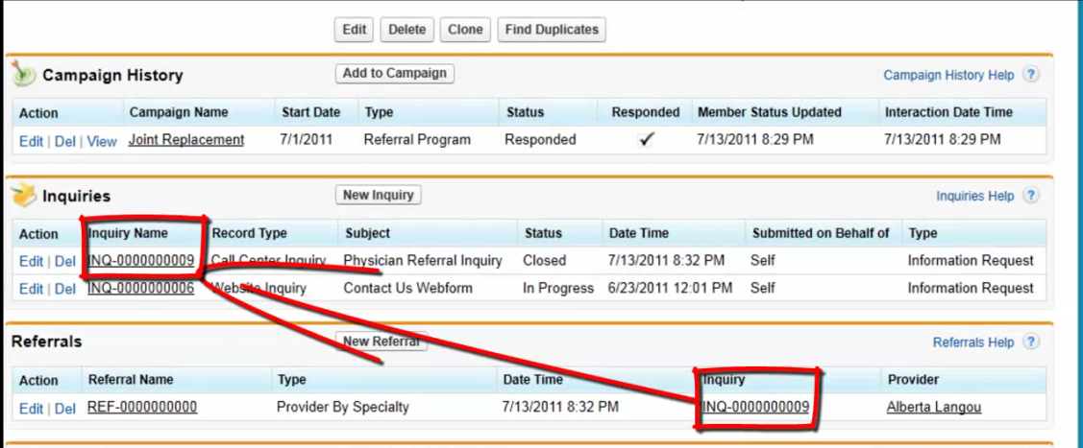

10.1 Adding a Referral From an Inquiry

From the Inquiry Record

- Click on New Referral
  - NOTE : Because you are creating the referral from the Inquiry Record the Inquiry and Patient fields are already filled in.
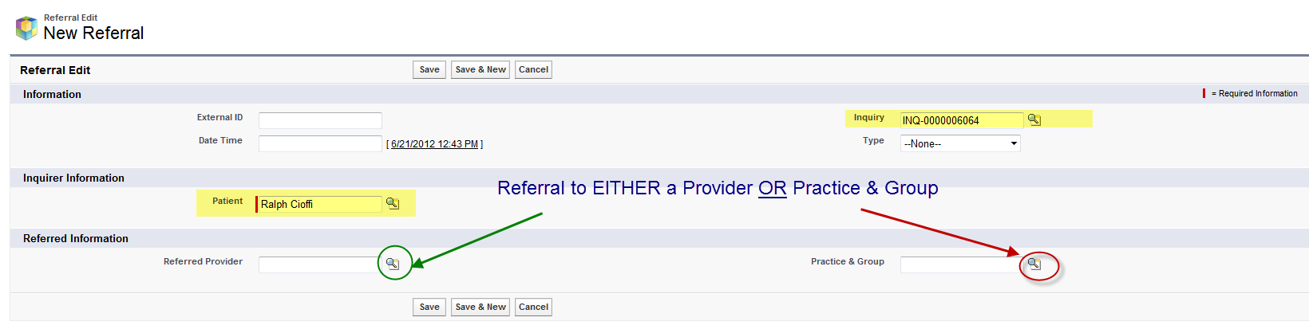
- Select either a Provider Referral OR Practice and Group Referral
- Click Save

Verifying the Referral
The referral will now be displayed under the Patient, Practice and Group and Inquiry Records

Chapter 11: Inquiries
Inquiries may come from either call center calls or Web form submissions. The existing or potential patient may be responding to a campaign that was sent to them directing them to a phone number or a landing page, or they may just have called or visited your site on their own based on offline advertising, or word of mouth.
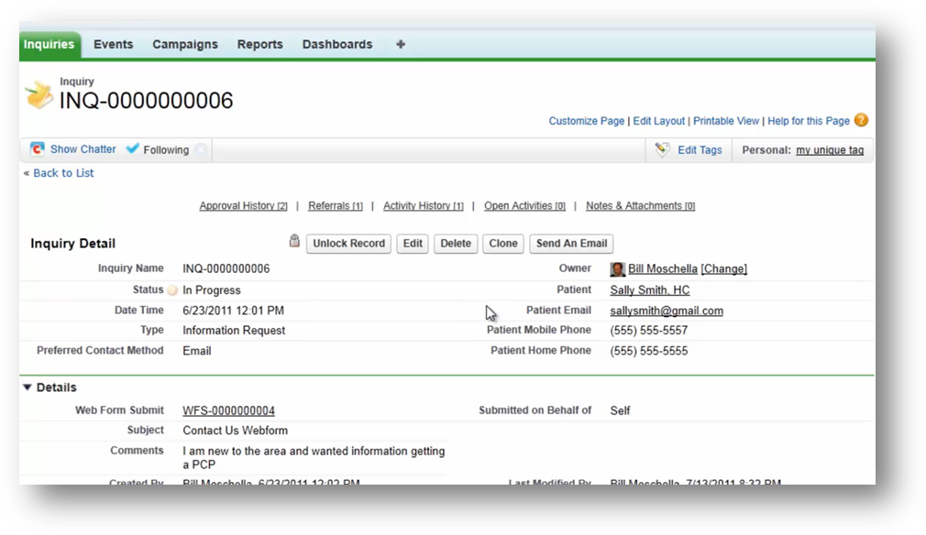
However an existing patient / potential patient communicates with your organization, these activities are vital to track, as they show interest and response and can help you understand what is of greatest interest to your patients.

Inquiries can also trigger workflows such as automated follow-up. Additionally inquiries can be used to process patient requests such as a request for a physician appointment.

The Inquiry Detail Record contains information such as the Patient Name, origin of the inquiry (in this example we can see the inquiry was a web form submission), reason, date and time of the inquiry, comments and data, and may contain information such as preferred contact method and other details.

CHANPTER 12: Dynamic List Builder

12.1 What is the new Dynamic List Builder (DLB)?
The new Dynamic List Builder is a feature that allows you to establish advanced and complex criteria when building a list for your campaign target audience without having to know any type of programming language.

12.2 What are the new Dynamic List Builder (DLB) features?
- New and Improved User Interface (UI)
A dramatically simplified, yet powerful and user-friendly look and feel for creating Dynamic Lists, and selecting filter criteria.
- Display of running total record count and total count breakdown
A new feature that displays record counts for eachfilter/criteria applied, including a display of the total count, allowing the user to quickly view how each criteria selection changes the total number of individuals selected.
- Ability to select by Head of Household (HOH)
Filter criteria now includes HOH so only one mailing is sent to a household/living unit. This feature eliminates a marketing piece from being sent to multiple people within the same household/living unit.
- Market Area builder
A new feature that supports creating and saving a new Market Areadirectly from the Dynamic List Builder via alink to the Market Area Builder. The newly created market area will display in the DLB instantly, with minimal disruptions to the user workflow.

- Ability to filter by ‘Insurance Type’
The Platform nowprovides the ability to filter by insurance type (i.e., Commercial, Medicaid, and Medicare). The insurance type values will be derived from the client-provided data.
- Ability to filter by CPT/ICD codes
The Platform nowsupports a user enteringCPT or ICD codeswhen leveragingpatient encounter criteria for list building.
  - In prior releases, the user could only select by diagnosis or procedure text, not codes.
- Segmentation of Patients vs. Prospects
The List Building functionality now clearly distinguishes between ‘patients’ and non-patient ('prospects'). The user can easily select distinctly among each when creating filter criteria.
- Ability to exclude opt-outs
The platform nowallows a user to exclude individuals who have indicated an opt-out of a contact method in their preferences, such as ‘Do Not Email’, or ‘Do Not Mail’.
- Ability to select ‘And’ or ‘Or’ between filter criteria
In prior releases, users could only ADD criteria when generating a list via the implied ‘And’ condition between filter sets. With this release, users can now select either ‘And’ or ‘Or’ criteria between each filter set as part of their overall list building criteria.
- Ability to create complex joins among criteria
The Dynamic List Builder nowenables the user to create user-friendly multiple-level condition statements among the different criteria in their list, via the use of Grouping. A user can now create complex conditions by selecting to group multiple criteria to be included or excluded.
- More intuitive UI terms
More intuitive terminology is utilized in the filters, such as ‘includes’ and ‘excludes’, to make it easier for the users to understand the logic of what is being selected from the CRM database.
- Ability to save the list as a template
Use the new ‘Save As’ feature to save the list building criteria as a template for reuse later.

12.3 How to use DLB (Dynamic List Builder)

Access
- To begin using the Dynamic List Builder you must access the feature by clicking on the plus (+) sign of your Evariant Platform Homepage
- Click on Dynamic Lists
- Click on New
- Select the appropriate target audience: Patients/Prospects or Providers
Note: Patients are anyone who has had a clinical encounter.

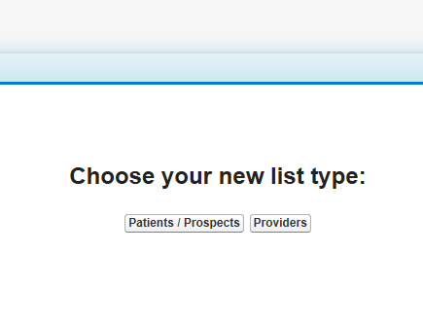

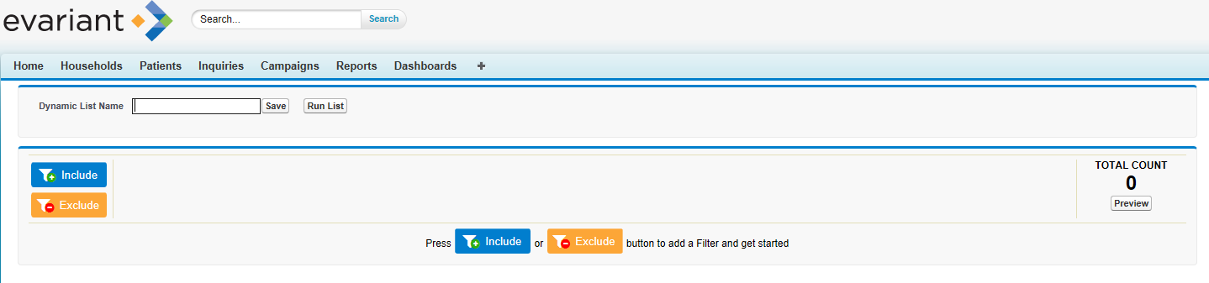
- Next, you must decide to INCLUDE a criteria or EXCLUDE a criteria

12.4 Establishing a Criteria
- After selecting the Include criteria or Exclude criteria, begin to select your criteria by clicking the Add button next to the field of choice
  - You can search for a field by typing in the search fields box
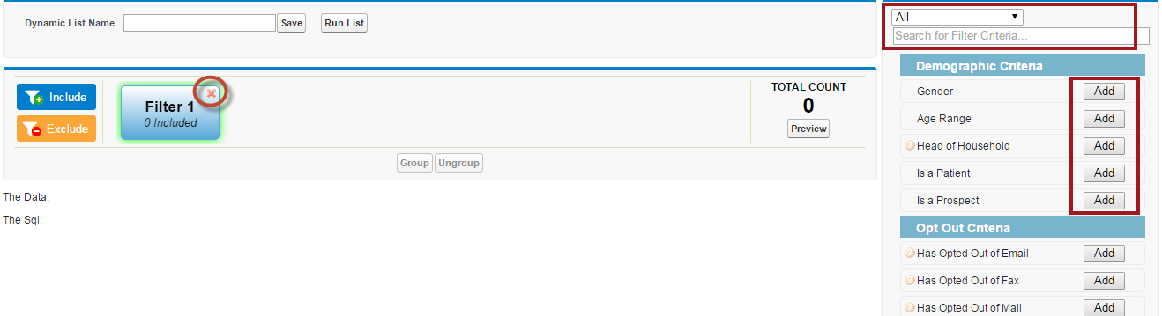

- You can delete a field by clicking on the “X” in the upper right hand corner of the filter

NOTE: Certain fields include an indicator that when hovered over will return a definition of that field
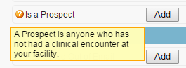

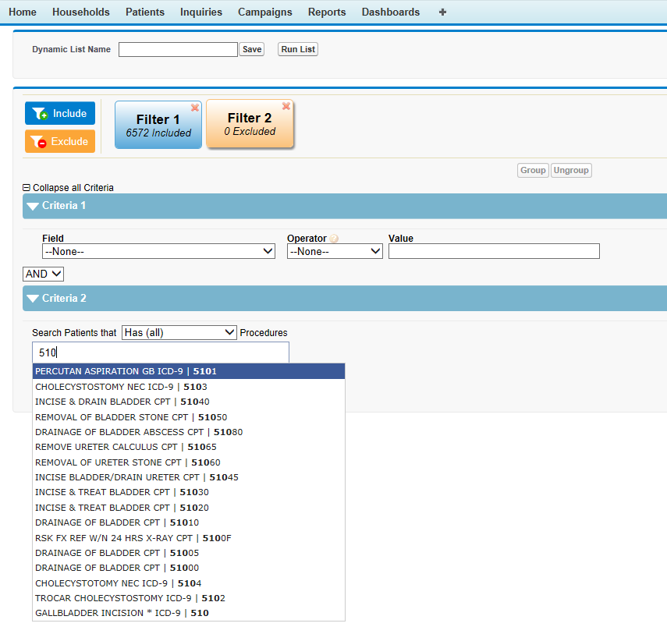

Additional Selection (Using CPT or ICD Codes)

- Users can enter a minimum of 3 charactersand the matching diagnosis or procedure codes will display
- Users can also enter text for diagnoses or procedures and the search results will display

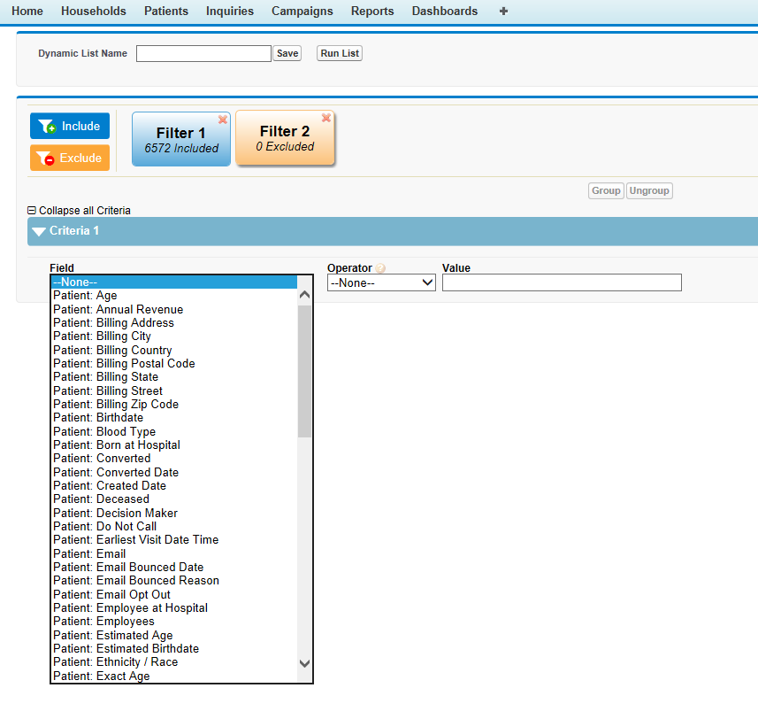


NOTE: Selecting the ‘Custom’ criteria will allow the user to view and select any field, including custom fields that exists in the client’s Patient ‘org’.

12.5 Grouping Fields in a Criteria
After selecting your criteria, you are now able to “group” your multiple fields together. This allows you to create a much more complex criteria.

To Group fields together
- Click on the criteria of choice
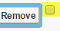
- Click on the check box next (to the right of the Remove button) to the criteria you wish to group

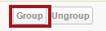
- Click on the “Group” button

- The “grouped fields” will display
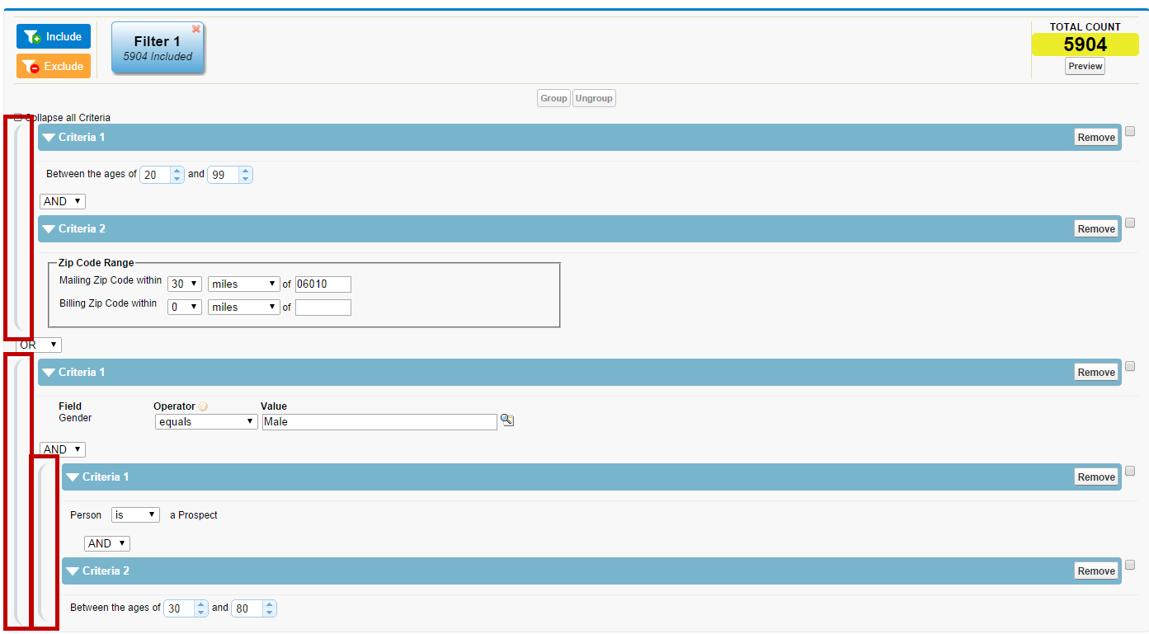

12.6 Removing a Field in a Criteria
If you have a need to remove a field simply
- Click on the Remove button located to the right of the criteria you want to remove

12.7 Preview record count
You now have the ability to preview a record count for the established criteria you have chosen before running the report.
- Click on the Preview button located under the TOTAL COUNT field

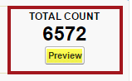


NOTE: It is a best practice to click on Preview after adding each criteria, to get an idea of the results as you continue to build your Dynamic List

Viewing Criteria
Clicking on the ‘Collapse Criteria’ button will display your selected criteria selection in the blue bar. This is an easy way to review your content in a user-friendly format. Alternatively, you may click on the arrow button on any single criteria to collapse the content.
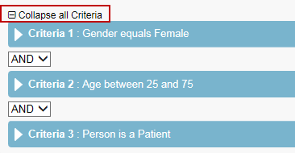

12.8 Saving your report (Query) criteria
Once you have fine-tuned your criteria, you save it as a template for reuse later, or simply save your criteria for a specific campaign tactic.
Saving a Query
- Type the name of your list (report) in the Dynamic List Name field box located towards the top of the window
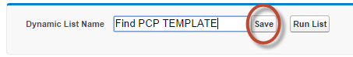

- Click on the Save button

12.9 Saving your criteria to a campaign tactic
Once you have saved your criteria, the next step is to assign the criteria to a campaign and a specific campaign tactic.
- Click on the search icon to search for a Campaign
- Once you select a Campaign, the system will display a field for Campaign Tactic
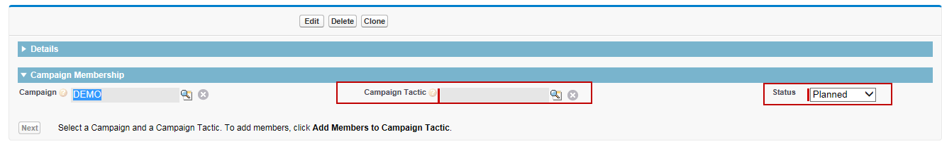
- Select a Campaign Tactic and Status

- Click the Next button
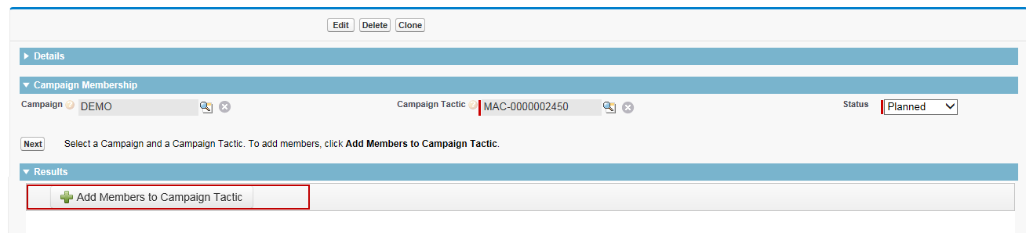
- Click the green ‘+’ symbol to add members to your campaign tactic based on your criteria.

*** IMPORTANT: Do NOT skip this step. If you do not click the green ‘+’ button, no campaign tactic members will be assigned.

12.10 Running your report (list)
It is now time to view the results of your report (list).
- Click on the Run List button
- The result is an encrypted patient ID listing in Microsoft Excel format

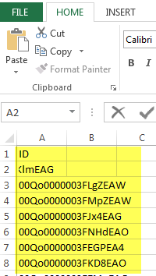
NOTE: Contact your system admin to create a list that contains the fields needed to send your list to a print house. The system admin will use standard the standard reporting tool to match the patient IDs with the desired fields.

Chapter 13: Outbound Communications Engine

13.1 What is the Outbound Communications Engine
The new Outbound Communications Engine available in this release provides the ability to create and send content rich email messages to the selected target audiences directly within the Evariant platform, without the need for an external Marketing Automation tool (i.e. Eloqua or ExactTarget). Below is an illustration of the options available to you, with the “On Platform” option now available.

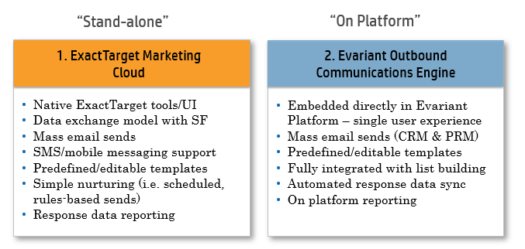

What are the new Outbound Communications Engine features?
- Embedded email send
The Evariant platform now includes an easy-to-use, embedded solution to create and manage email communications for marketing campaigns. This feature guides a user through all steps of an email campaign – from template selection and content edit to audience selection to scheduling the email send.
- User Interface wizard for audience selection
New easy-to-use format guides a user through the selection of previously-defined campaign tactic member list(s) to include.

What are the new Outbound Communications Engine features?CONTINUED
- WYSIWYG template editor
‘What You See Is What You Get’ editor guides the user through the campaign email template selection via a step-by-step workflow and guides the user as to which elements can be customized in the email template. Also includes the ability to leverage externally generated HTML for the email content, directly within the editor.
- Ability to include a Control Group
Randomized Control Groups (either as a percentage or a fixed count of records) can be created for a campaign tactic. The control group will be randomly pulled from the audience list selected for the particular campaign tactic.

13.1 How to use Outbound Communications Engine
Access
- To begin using the Outbound Communications Engine you must access the feature by clicking on the Campaigns tab of your Evariant Platform Homepage
- Click on an Existing Campaign or Create a New Campaign
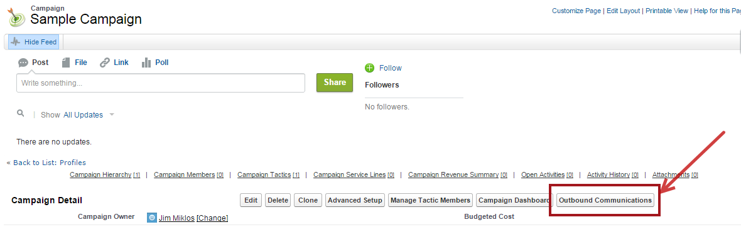
- Click on Outbound Communications button

- You will have the option to Create a New Message or to Edit a Partially Completed Message
- Enter the Name of your Message or Select a Message from Partially Completed list
- Click on Start or Continue to navigate to the next step

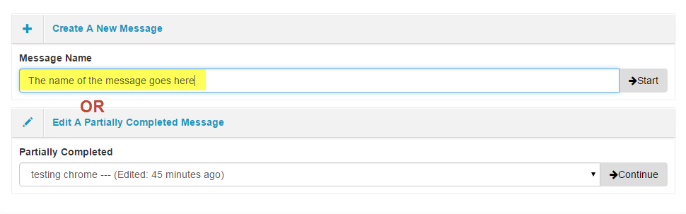

13.2 Selecting a Template (Style or Blank)

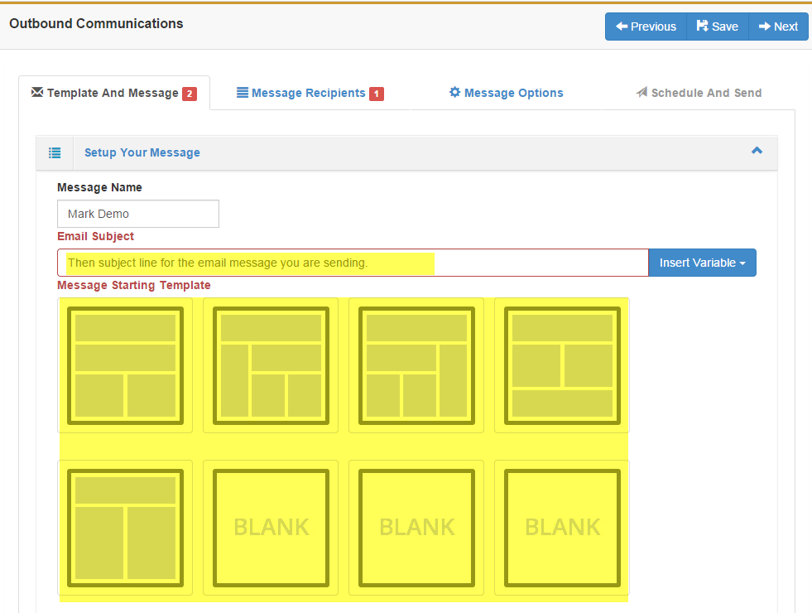
- Enter the text you want to appear in the Email Subject line.
  - You have the option to insert variables in the email subject such as Email Address, Full Name, Home and Mobile Phone, Organization, and Title
- Select a template style by double clicking on the template
- You have the option to edit content within the template selected
- You also have the option to create content by entering HTML directly into the Source code utility located within Tools
- Click on the Next button Select a template style by double clicking on the template
- Click Save to save your work

There are a variety of ways to create your message using the WYSIWYG editor. The example below displays entering the message in HTML using the "Source code" utility.
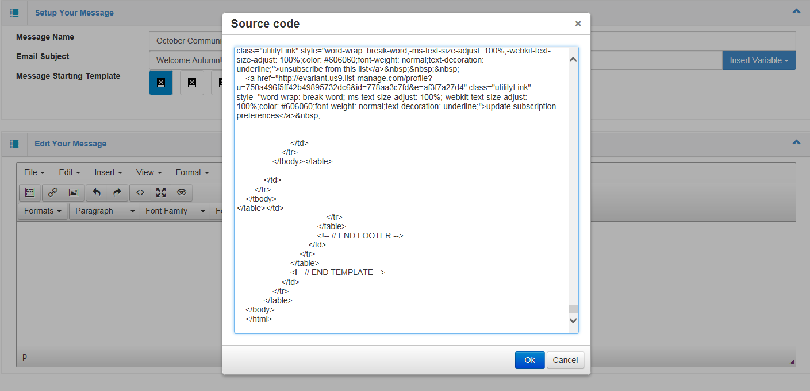

NOTE: Use the preview feature to view the message as it will appear to the customer.

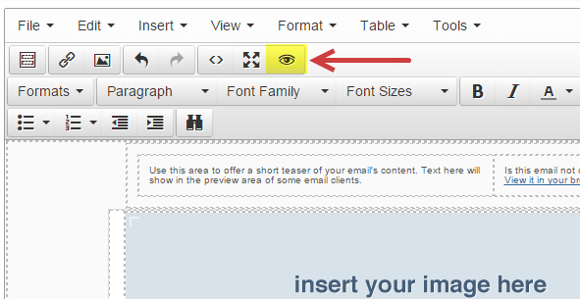

13.3 Establishing the Message Recipients – TARGET AUDIENCE

Define the message recipients (target audience) by reusing an existing campaign tactic member list (created using DLB) or create a new list of recipients.

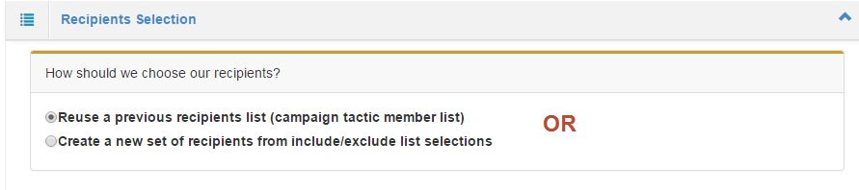

When selecting the option to reuse a previous list, search for a previous campaign tactic list and associate to this message.

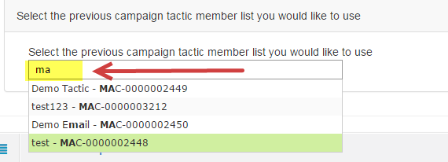
You can type in either the MAC ID or the name of the list you are using. As soon as you type one character the results will start to populate.

To create a new set of recipients, select that option and the Include/Exclude lists and tactics window will be made available
- Enter the name you wish to assign this new Recipients List
- Search for the lists you wish to include by entering the MAC ID or Name as described above
- If you wish to exclude a list, enter the MAC ID or Name as described above
- Click on Control Group if you wish to add a group to this communication, or click on the Next button
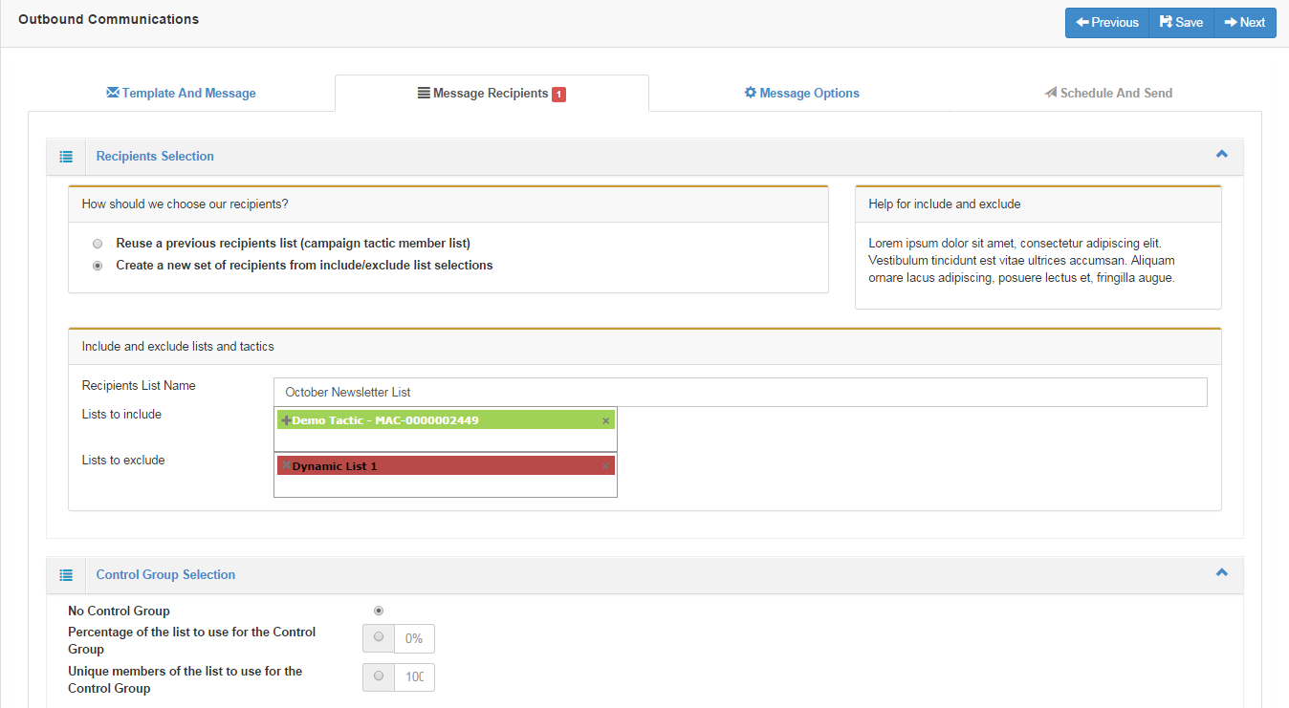

NOTE: when a new list of recipients is created, this becomes a fixed list of contacts, and updates are not applied.

13.4 Using a Control Group

Control groups in Evariant's Outbound Communications Engine are defined as a random sampling of the target audience who are excluded from receiving the marketing communications. The purpose of a control group is to serve as a standard for comparison against the audience who did receive the marketing communications, allowing a more complete understanding of the marketing communications’ efficacy. Clients requesting control groups often employ more traditional marketing tactics, such as direct mail.

When including a control group for a campaign tactic within the communications wizard:
  - Identify a percentage of the total list or fixed number
    - The platform will randomly remove the selected percentage or number from the campaign tactic member list
  - The members will be tagged and stored as a control group for the campaign tactic only
  - The Campaign ROI reporting will be enhanced in a future release to provide the results of how the campaign performed in relation to the control group
Note: The Control Group Selection will default to No Control Group, simply click on the banner to open the window to make your selection

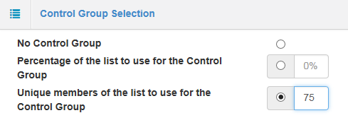

13.5 .Message Options
Use the Message Options section to:
- Send a test (ALWAYS RECOMMENDED)
- Add a Sent From name
- Add a Reply-to email address
- Add an address to receive the results of your send
- Add a Test to Address or Addresses
You have the ability to add a new email address to select from the Message Option dropdowns by clicking on the Add a new email address button

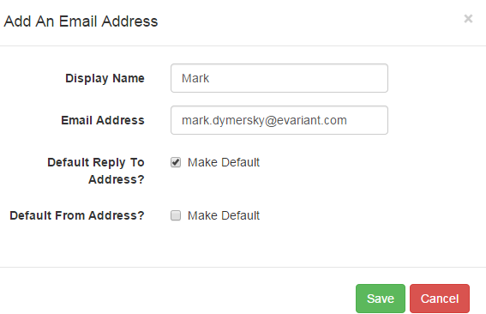

When selecting the option to create a new set of recipients, you will be prompted to create a new Recipient List Name and select the lists you wish to include and exclude.
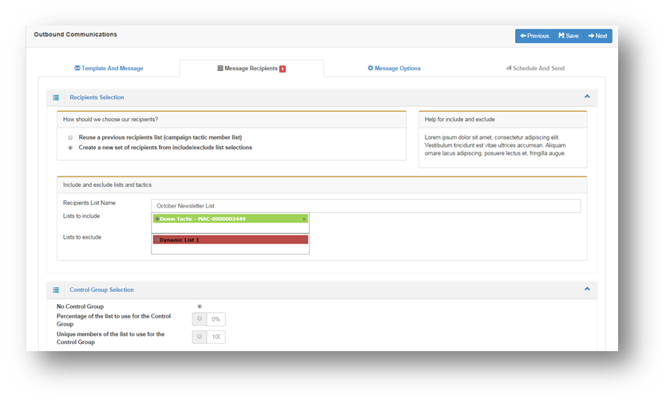
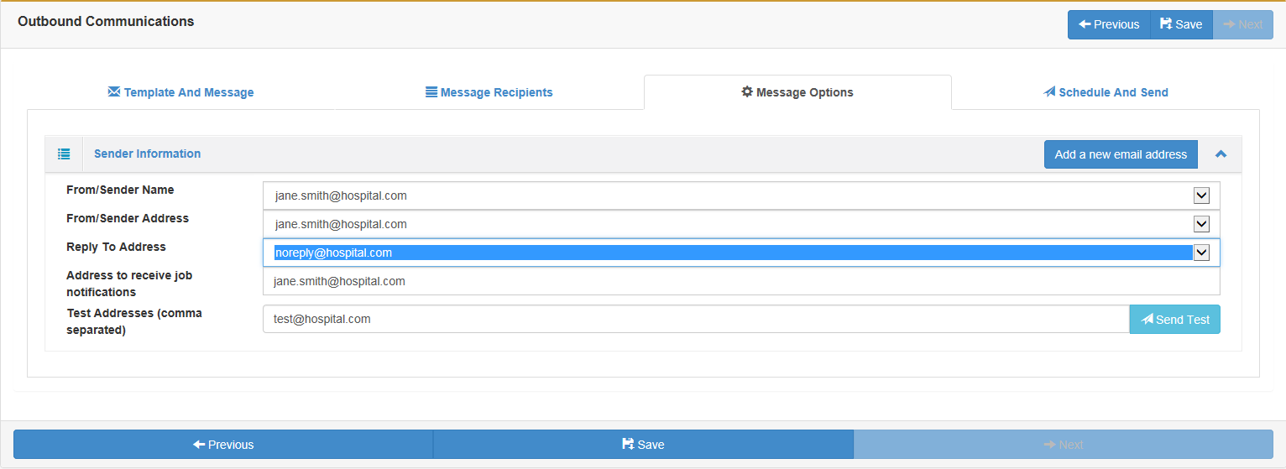
Use this page to define the email address handling for this message and execute a test for the communication.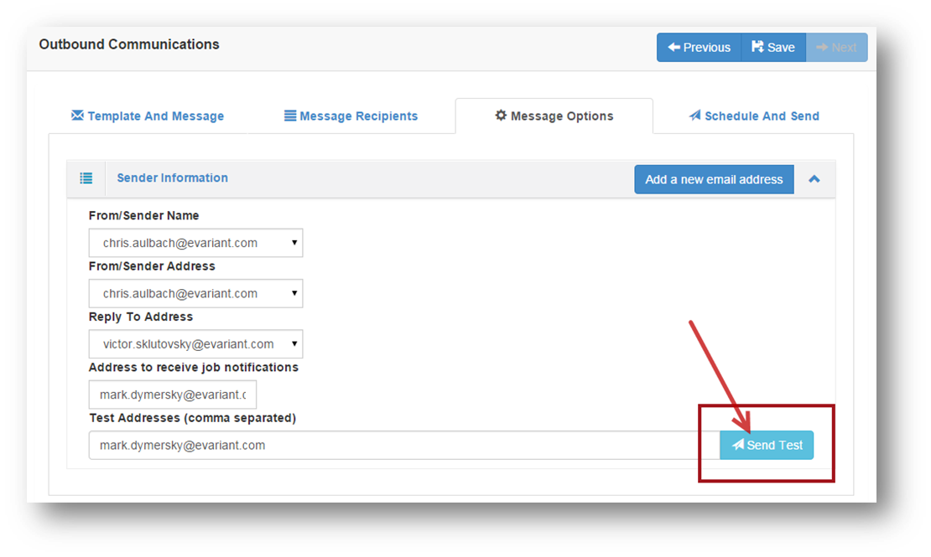
Joe.smith@hospital.com
Joe.smith@hospital.com
Bill.smith@hospital.com
Bill.smith@hospital.com
Bill.smith@hospital.com

13.6 Scheduling and Send

Select the date and time the communication should be sent and push the Complete button to schedule the email.
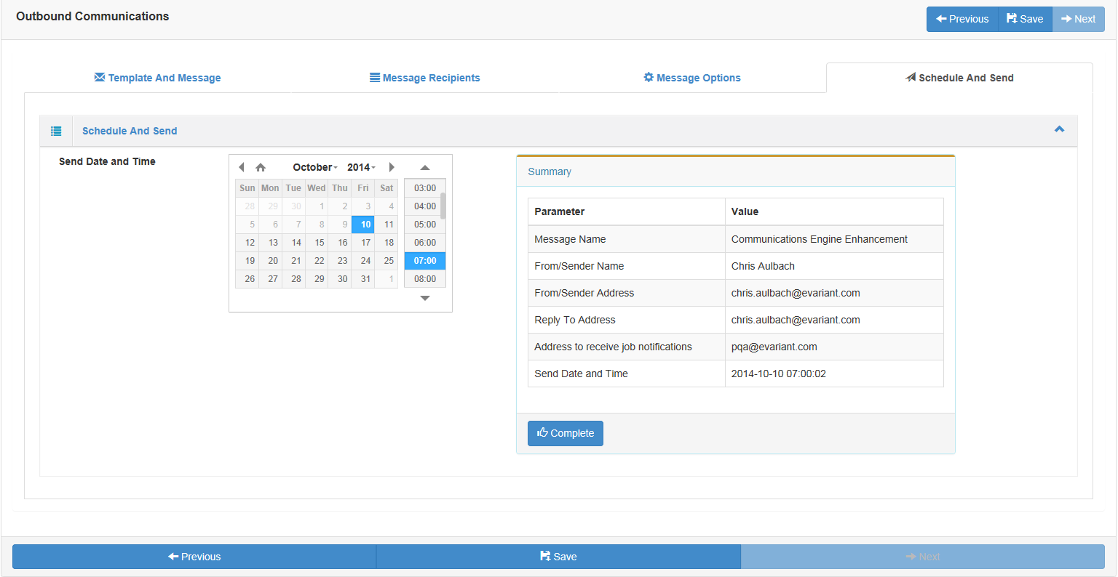

IMPORTANT NOTE:
If any of the tabs on the Outbound Communication are displaying a red box with a number (example below), you WILL NOT be able to send the message because errors exist in the setup.
You must correct the error in that section and Save prior to sending a message.

