What is Nodejs- JS runtime, run Js on the server apart from the browser

Uses V8(written in C++) – js engine build by google runs js in browser

V8 engine takes js code and compiles it to machine code

Node js adds feature like file access, which is not possible through browser using js alone due to security reasons

So in NodeJs we use Vanilla V8

Node js: post installation guidelines:-

This package has installed:

* Node.js v19.5.0 to /usr/local/bin/node
* npm v9.3.1 to /usr/local/bin/npm

Make sure that /usr/local/bin is in your $PATH.

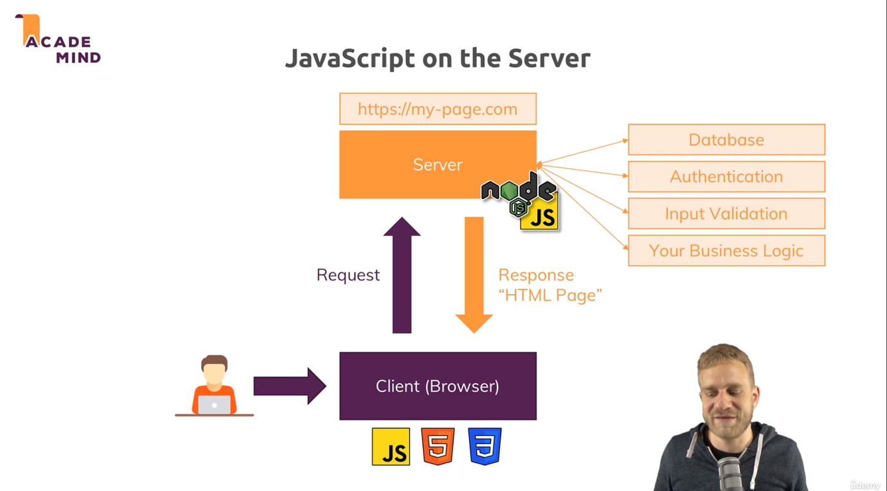

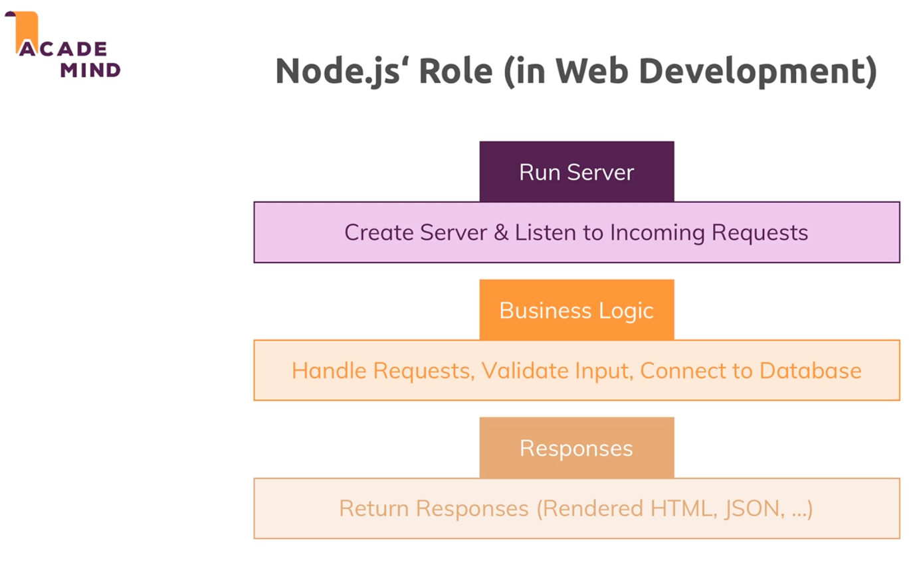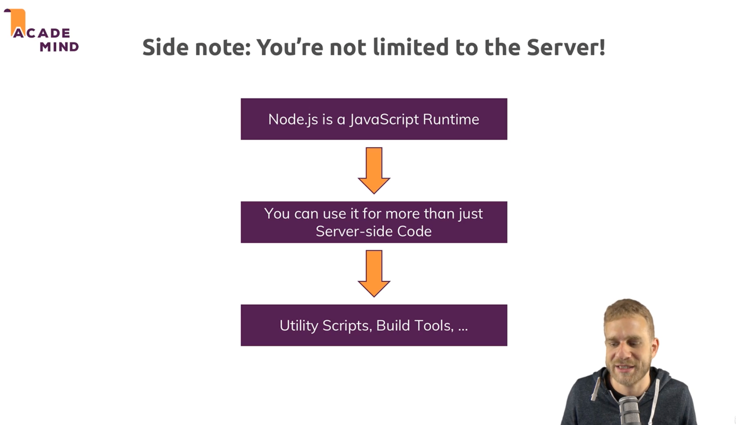

Node js uses – Single threaded JS. In the background it does multi threaded process to handle incoming requests.

Framework: - Basically a set of helper functions, tools & rules that help you build your application.

ExpressJs is all about middleware.

