import java.util.Scanner;
public class JavaExample {
public static void main(String[] args) {
double num1, num2;
Scanner scanner = new Scanner(System.in);
System.out.print("Enter first number:");
/* We are using data type double so that user
* can enter integer as well as floating point
* value
*/
num1 = scanner.nextDouble();
System.out.print("Enter second number:");
num2 = scanner.nextDouble();
System.out.print("Enter an operator (+, -, *, /): ");
char operator = scanner.next().charAt(0);
scanner.close();
double output;
switch(operator)
{
case '+':
output = num1 + num2;
break;
case '-':
output = num1 - num2;
break;
case '*':
output = num1 * num2;
break;
case '/':
output = num1 / num2;
break;
/* If user enters any other operator or char apart from
* +, -, * and /, then display an error message to user
*
*/
default:
System.out.printf("You have entered wrong operator");
return;
}
System.out.println(num1+" "+operator+" "+num2+": "+output);
}
}

UML:

Class Diagram:

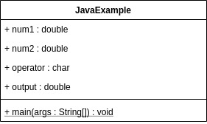

UML :

Sequence Diagram:

